

Applied Computing
Wales Institute of Science and Art (WISA)

Networks and Cybersecurity Essentials (ACCA4024)

Home Work 3: Straight Through and Crossover
Cables

Submission Deadline: On or before 06/11/2020 23.59 Hrs.
Submission Via Moodle Link.

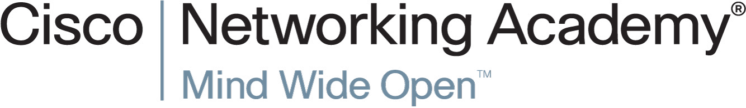
n.kaliyamurthy@uwtsd.ac.uk 1

Objectives
• Understand cabling standards for use in LAN cabling environments.

Background/ Scenario
The TIA/EIA has specified unshielded twisted pair (UTP) cabling standards for use in LAN cabling environments. TIA/EIA 568-A and 568-B stipulates the commercial cabling standards for LAN installations; these are the standards most commonly used in LAN cabling for organizations and they determine which color wire is used on each pin.
With a crossover cable, the second and third pairs on the RJ-45 connector at one end of the cable are reversed at the other end, which reverses the send and receive pairs. The cable pinouts are the 568-A standard on one end and the 568-B standard on the other end. Crossover cables are normally used to connect hubs to hubs or switches to switches, but they can also be used to directly connect two hosts to create a simple network.
Note: With modern networking devices, a straight-through cable can often be used even when connecting like devices because of their autosensing feature. With autosensing, the interfaces detect whether the send and receive circuit pairs are correctly connected. If they are not, the interfaces reverse one end of the connection. Autosensing also alters the speed of the interfaces to match the slowest one. For example, if connecting a Gigabit Ethernet (1000 Mb/s) router interface to a Fast Ethernet (100 Mb/s) switch interface, the connection uses Fast Ethernet.
The Cisco 2960 switch has autosensing turned on, by default; therefore, connecting two 2960 switches together works with either a crossover or a straight-through cable. With some older switches, this is not the case and a crossover cable must be used.
In addition, the Cisco 1941 router Gigabit Ethernet interfaces are autosensing and a straightthrough cable may be used to connect a PC directly to the router interface (bypassing the switch). With some older routers, this is not the case and a crossover cable must be used.
When directly connecting two hosts, it is generally advisable to use a crossover cable.
ACCA4024

Task 1: Analyze diagrams and tables for the TIA/EIA 568-A and TIA/EIA 568-B standard Ethernet cable.
The following table and diagrams display the color scheme and pinouts, as well as the function of the four pairs of wires used for the 568-A standard.
Note: In LAN installations using 100Base-T (100 Mb/s), only two pairs out of the four are used.
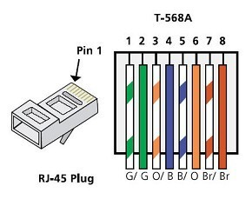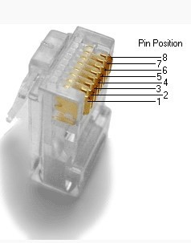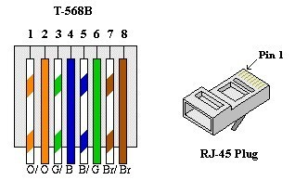

Record your reflection
- What are these TIA/EIA Standards? How do 568 A differs from 568 B? Are there any other standards? (100 – 300 Words)
The two most recognised UTP (Unshielded Twisted Pair Cable) wiring standards used in the Networking industry are the TIA/EIA standards. Telecommunications Industry Association (TIA)/Electronic Industries Alliance (EIA) developed the TIA/EIA 568A & TIA/EIA 568B standards for Unshielded Twisted Pair wiring.
TIA/EIA 568A and TIA/EIA-568B standards serve the same purpose, and that is to determine what order to place the wires in the RJ45 Connector. There is no difference functionally between TIA/EIA 568A and the TIA/EIA-568B standards. The only difference between the two standards is the Orange and Green wires positions are changed. There don’t seem to be any other major standards, just other variations of the TIA/EIA 568A & TIA/EIA 568B standards.

2 n.kaliyamurthy@uwtsd.ac.uk
2. What is a Straight through Cable and Cross over Cable? Which cable should be selected during a simple network installation (Topology includes Routers, Switches and End Devices)? (100 – 300 Words). You shall use Tables, Diagrams to clarify.

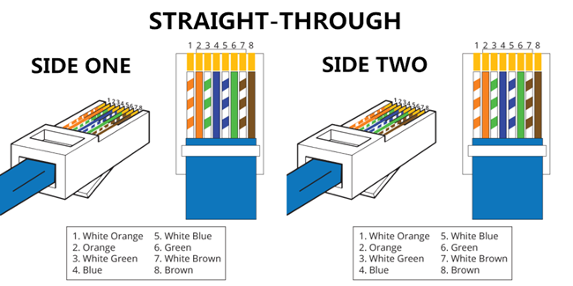
A straight through cable is a type of twisted pair cable that is used in local area networks to connect a computer to a network hub. This cable is an alternative to wireless connections where one or more computers access a router through a wireless signal. On a straight through cable, the wired pins match. Straight through cable use one wiring standard: both ends use T568A or the T568B wiring standard.

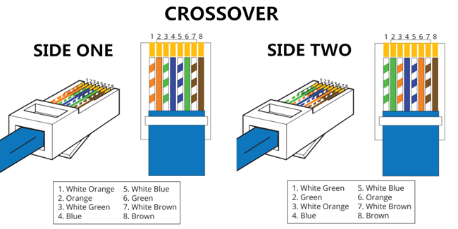
A crossover Ethernet cable is a type of Ethernet cable used to connect computing devices together directly. Unlike straight through cable, the RJ45 crossover cable uses two different wiring standards: one end uses the T568A wiring standard, and the other end uses the T568B wiring standard.
The internal wiring of Ethernet crossover cables reverses the transmit and receive signals. It is most often used to connect two devices of the same type, for example two routers, or two PC’s.
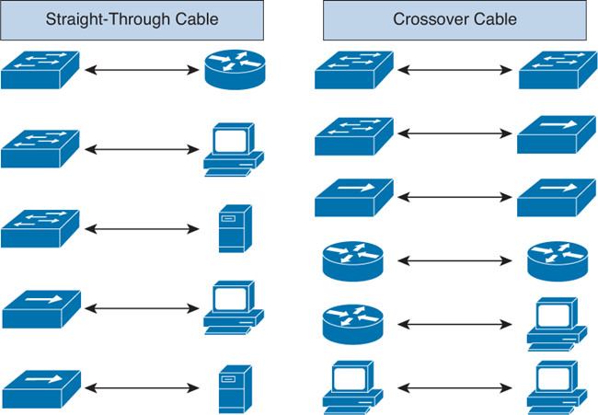
Which cable should be selected for the mentioned Topology? Well given it’s not to connect two devices of the same type it has to be the Straight-Through cabling. The below diagram although very basic, just add further end devices routers or switches to the left of the diagram, you then have the requested topology from the question.

Diagrams taken from
http://www.cables-solutions.com/difference-between-straight-through-and-crossover-cable.html

3 n.kaliyamurthy@uwtsd.ac.uk

