Royal Caribbean Sailing Towards Sustainability

Student: Elijah Thomas
Student Number: 2313487
Lecturer: Robyn Griffiths
Module: Managing Tourism, Leisure, and Events organisations (BMTP4004)
Word Count: 2189

Compare
Contrast
Analyse.
Evaluate
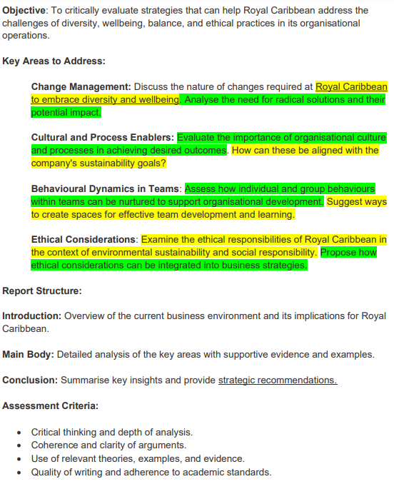

Contents Page

Overview of Royal Caribbean and the current business environment…

Change management and its implications in embracing diversity and wellbeing…

Cultural and process enablers importance and role within the Royal Caribbean…

Behavioural Dynamics in team learning and how this is used to support organisational development…

Ethical Considerations and the responsibilities of Royal Caribbean…

Key insights and strategic recommendations to improve management and procedures…

Introduction (200 Words)

This written report focuses on Royal Caribbean and the increasing challenges and implications in management over time. With the current Dynamic business environment large organisations such as Royal Caribbean face challenges of Diversity, Staff wellbeing, balance, and ethical practices. With the current business environment changing it is essential for Royal Caribbean to adapt to change. In this report we delve into the changing landscape of Royal Caribbean as a cruise company when it comes to Change Management underpinning the strategies they use to bring out the best from their employee’s and how not adapting can impact, Along with how cultural and process enablers within Royal Caribbean’s core creates a organisational culture of learning and development to Behavioural team Dynamics in how teams collaborate and how experiences between teams can shape organisations such as Royal Caribbean success to finally ethical considerations and how they affect Royal Caribbean and the public perception of the company when managing to finally come to a conclusion and provide strategic management recommendations to improve management and procedures

Change Management (375 words)

Change management in Organisations such as Royal Caribbean can be defined as “the knowledge required to offer clear, concise and well evidenced information in order to successfully enable change within an organisation” (Institute, 2022). Managing change and embracing it in Organisations is important in embracing diversity and wellbeing. Royal Caribbean statement on this is that they recognize the vital role of diversity and equality and see it as a competitive advantage in gaining success (Seastainability 2023 Environmental, Social and Governance Report, n.d.).

There are many ways that Royal Caribbean can effectively implement change to promote diversity and wellbeing among their staff. Some examples of some procedures they could implement are discussing diversity and bringing staffs feelings into consideration. This will foster a safe workplace culture for Royal Caribbean and encourage diversity, secondly they could hold culture days for staff to engage in activities and events that make them more comfortable which will lead to a more inclusive environment (Panel, n.d.)

When it comes to managing and implementing change there are specific models that would be beneficial for Royal Caribbean to use. It is important the Royal Caribbean to use is the ADKAR change model developed by Jeff Hiatt which is awareness, desire, knowledge, ability, and reinforcement working on clear communication between staff and the manager regarding the change which can be successful for Royal Caribbean because it helps staff feel valued and listened to (Mind Tools Content Team, 2023). Similarly, Lewin’s change theory model follows 3 stages in unfreezing, changing, and refreezing the business environment to adapt to change. Which is positive for Royal Caribbean to quickly to deal with change and managing it successfully with preparation time making change more effective and less daunting to employee’s (Thudium, 2023). These models will both provide success for Royal Caribbean. However, it can argue Lewin’s model will provide more simplicity whereas it can argue with ADKAR it takes a lot of skill and learning to implement change.
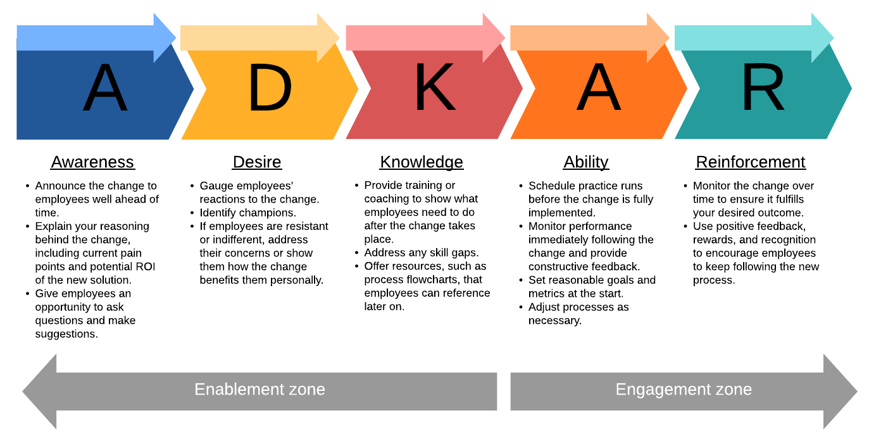
(Lucid Content Team, 2019)
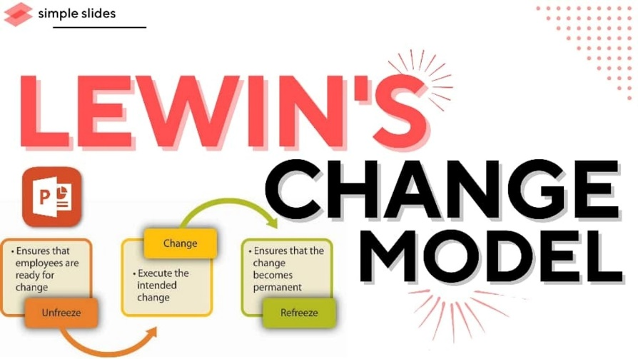
(www.simpleslides.co, n.d.)

Summing up Royal Caribbean implementing these will help them be able to foster a relationship and a great workplace culture in times of change. This promotes success and personal growth among employee’s having a great effect on production and the process of change, however not offering these practices or frameworks can make change daunting to employee’s and may have the opposite effect on Royal Caribbean. Overall, its potential impact is large and Royal Caribbean should govern wellbeing, change and diversity as one of its most important values.

Cultural and Process Enablers (375 Words)

Organizational Culture in Organisations such as Royal Caribbean can be defined as “ the collection of beliefs, values and methods of interaction that create an organisations environment” (Indeed, 2022b). In other words, an organisations culture makes up who they are making it so important as it governs how employees interact and how the organisation holds its core values. Royal Caribbean as organisation has a large culture variety for example their cultural diversity includes Europe, Africa, North America, Asia< Australia and Oceania. As well as within the U.S there is a 61% ethnicity diversity and an 81% diversity index showing a wide range of varying culture (Seastainability 2023 Environmental, Social and Governance Report, n.d.)

Culture can be seen and both a liability and a strength, However the processes inside an organisation can be complex. To gain a view of an organisational culture taking in the organisations people, environment, making observations and assessing communication is essential (Chartered Management Institute, 2015). According to handy there 4 different key types of culture being person, task, power, and role culture suggesting that most organisations will fall into one of those categories. (Learnsignal, 2022). However, Hofstede argue there are 6 dimensions to culture as shown below (Nickerson, 2023)

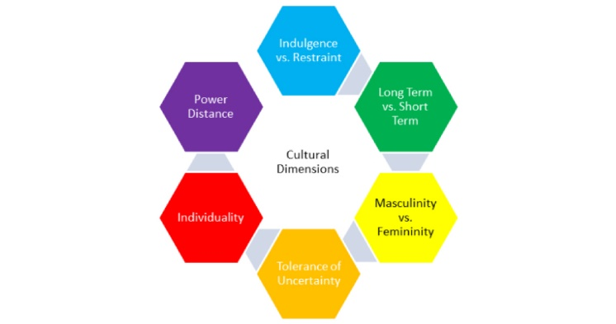
(van Rheenen, 2020)

Showing cultures in organisations can fall into a lot of different categories or circumstances.

With Royal Caribbean’s all-inclusive culture, it works towards them retaining themselves as a world leading cruise company. This is why retaining process is important, Royal Caribbean clarifying what they want to keep acting in accordance with their company values will help keep a clear culture and standards for staff, along with listen to viewpoints of others and knowing when to and not implement change will retain a successful process in culture retention (Newton, 2023). This overall can be aligned with royal Caribbeans goals as employee’s will be more inclined to work in a clear workplace culture as it creates team morale, engage and job satisfaction (Heinz, 2021). Creating unity this allows for Royal Caribbean to work towards constant social and environmental improvements in net zero targets and improving their workplace culture to become successful in providing constant improvement for the organisation to become more varied and inclusive.

Behavioural Dynamics in Team Learning (375 words)

Team Dynamics and learning has become increasingly important in large organisations like Royal Caribbean. A team generally refers to a group of individuals working towards a goal, five main teams are functionals teams with familiar expertise, Cross functional teams with variety of different expertise, Self-managed teams of employee’s, Virtual teams spread into locations and larger teams tended to be made up of multiple expertise and departments (Rossingol, 2023). These different teams make up different dynamics and all develop and learn differently, Royal Caribbeans statement on their learning opportunities is they offer a variety of learning and development programmes to educate employee’s, encourage innovation and help people grow their careers (Seastainability 2023 Environmental, Social and Governance Report, n.d.).

Teams can be nurtured throughout organisations to provide success, for this be the case individuals and the team as a whole need to be considered. This can be seen in Belbin’s 9 team roles where it outlines different team workers and provides them with strengths and weaknesses. The theory behind Belbin’s role is that realises strengths and weaknesses will help a team reach their business goals sooner (Belbin, 2022). Belbin’s theory isn’t the only way to nurture team growth. There are internal ways to develop team growth and learning within organisations. For example, Royal Caribbean to facilitate team learning will need to provide a safe environment. To achieve this, they have developed safe procedures such as all crew undergoing a ship familiarisation safety programme which is then followed by an assignment (Royal Caribbean Group, n.d.)

There are other ways Royal Caribbean can create spaces for effective team development and learning. One way is through following the hackman team development model which involves building a strong team structure, sending them in a compelling direction and providing a supportive context which will help Royal Caribbean develop teams and figure out what works best (www.linkedin.com, n.d.), Another different approach that could be taken is the GRPI model by Richard Beckhard which follows a different approach with the idea of goals, roles, interactions and procedures. This model holds advantages in developing relationships and establishing goa, identifying the 4 aspects provides a simple approach.

To sum up Royal Caribbean effectively facilitate deep team learning and understand the implications of it. Ways that Royal Caribbean can retain this is to follow models that work, Build and support teams with a safe environment and provide learning tools. One improvement Royal Caribbean could make is to integrate AI into team learning and training.

Ethical Considerations (375 Words)

It is also important for Royal Caribbean to consider ethical standpoints in their management strategies. Ethics when it comes to the business environment can be defined as accounting for Morales and Ethical Management is taking this into account when managing and organisation and decision making (Indeed, 2022). An example of an ethical consideration in the business environment could be providing all employees with fair and or the same pay (BBC, 2023). Debates like these rise a lot in the Management of business in what’s right or wrong. Royal Caribbean’s approach is that ethics is their philosophy, and they follow the strict code of above and beyond compliance (ABC) where they not only follow legislation when it comes to ethical rights but go beyond (Code of Business Conduct and Ethics, n.d.). Following this kind of business model is beneficial for the Royal Caribbean as being an ethical organisation mean’s that the company remains attractive to employee’s, are more likely to be targeted by investors with good work culture and are unlikely to be involved in any scandals or negative public perception (Smith and Kouchaki, 2021).

However Royal Caribbean as a company hold’s ethical responsibility when it comes to environmental and social factors. For example, taking climate change Royal Caribbean has an obligation to minimise their effects on the planet ethically speaking, Royal Caribbean as such being a large organisation and providing measures to protect the environment are powerful decisions which will affect Royal Caribbean positively as it will generate a positive public view, positive inside view and overall boost Royal Caribbean as an organisation (Garnett and Balmford, 2022). In terms of social responsibility could be diversity and inclusion programmes, ethically providing this provides a variety of benefits for employees’ such as having high morale, increasing their productivity, and having a sense of place (Pierre, n.d.). This is positive for Royal Caribbean image publicly displaying positive public image, inside view and Royal Caribbeans success. Which is sticking to these responsibilities or even going further is so important. To retain success, I would propose Royal Caribbean sets out Sustainability targets for the employees to help work towards as part of a team, creating net zero targets to bring together their team and fulfil their responsibilities towards the climate and their staff.

“Being good is good business” (Dame Anita Roddick) and “Ethics are important than laws” (Wynton Marsalis). These quotes reflect our business world today and how important ethical responsibility is. To sum up Royal Caribbean is successful in following these guidelines Jason liberty their CEO has stated a goal of “Reducing Carbon intensity double digits by 2025” and the ABC policy ethically is a very successful model.

Conclusion and Recommendations (200 Words)

To summarise this report, it essential for Royal Caribbean to integrate change management strategies into processes and procedures as it will create a diverse culture that promotes wellbeing. It is also important to provide a workplace culture and how to apply them in achieving outcomes towards the company’s goals in sustaining their business and people culture, as well as it being equally as important to nurture team development to reach organisational goals and take into consideration ethical arguments and the public’s perception of the organisation to act accordingly and be able to go above and beyond.

Taking this into consideration there 4 strategic management recommendations that can be put forth for Royal Caribbean. First off I would recommend in their change management strategies would be talk to staff and integrate them in the decision making process for change or to cast survey’s or anonymous votes which will be successful in gaining data and finding the best possible route to implement change, Secondly I would recommend for a more successful workplace culture applying special culture days and events where people who are diverse can feel more welcome which will be successful in creating a welcoming culture to produce results in, Thirdly with Team Dynamics I would recommend integrating AI and encouraging it across working teams which would be successful in providing new ideas and expertise where team lacks and finally I would recommend is opening up ethical discussions to staff to help share view points and find the appropriate way to respond to ethical concerns and keep a good public image

Executive Summary (100 Words)

The Royal Caribbean as a large cruise line, Is successful in many aspects of Management. In managing change Royal Caribbean is successful in their processes of managing diversity and wellbeing however when implementing change, they could discuss with staff more often, Royal Caribbean has a successful culture that’s inclusive and provides a great business environment however providing staff with cultural events and discussion would be beneficial, Royal Caribbean are successful in nurturing team development and creating a safe deep learning environment. However, integrating AI into group work and training could be beneficial and finally Ethically speaking Royal Caribbean puts ethics at the utmost importance however should include staff in ethical discussions and leave it as an open topic.

References

