University of Wales Trinity Saint David, School of Engineering BEng Motorcycle Engineering

Jason Sorg
Student Number: 1700589
Motion Simulation and FEA
Advanced Computational Methods, (M6X00408)

Contents

Introduction - 2 -
Background Research - 3 -
Modelling - 4 -
Triple Clamp - 4 -
Other Parts - 5 -
Equations - 5 -
Motion Simulation - 6 -
Assembly Mates - 6 -
Input Parameters - 6 -
Results - 7 -
FEA - 8 -
Results - 10 -
Design Optimization - 11 -
Validation & Comparison - 14 -
Limitations - 16 -
Conclusion - 16 -
CAD Links - 17 -
Complete Folder - 17 -
Assembly With Static Study - 17 -
Topology Study - 17 -
References - 18 -

Introduction

The purpose of this report is to explore how to systematically approach a problem while using a computer aided software such as SolidWorks motion simulation to transfer a specific loading case into a useable FEA scenario. The report will then explore how to properly perform and FEA on a lower triple clamp component and then how to optimize the component for specific loading conditions. The overall goal for this report is to highlight the need for competent users when using CAD software, because in order to generate accurate and valid results the input parameters that are used in the simulation must be accounted for.

Background Research

In order to correctly use any computer aided software the user must first understand the underlying principles that govern the software. For this assignment SolidWorks was chosen as the software, and this meant understanding how SolidWorks is able to calculate a motion analysis and more importantly how to extrapolate those results and preform a meaningful FEA within the assembly.
A motion study is most commonly used for complex loading situations, or when the designer is unsure of how the newly designed part will function within an assembly. The major benefit to using a motion study to acquire the forces acting on the part is that the designer is able to obtain a loading situation that will closely mimic real-world loading situations. This of course is only true if the designer is able to properly model and simulate all other parts within the assembly. If used correctly, the motion simulation within SolidWorks will then generate the proper loading conditions which can then be used to derive a design by transferring the loading conditions into an FEA (Wu, 2011).
Once the user has generated the loading conditions within the assembly the next step would be to transfer those forces to the individual part so an FEA can then be performed. The main reason why a CAD package is chosen to perform an FEA is due to the complexity that is brought about when dividing a part into potentially millions of elements which will then be solved to create the final result. Although this produces a method in which complex FEA problems can now be solved, it also creates potential oversight while setting up the simulation due to the lack of critical thinking from the user. The following steps are used in industry and academic research in order to prevent user error while setting up an FEA problem (Harish, 2019).
- Determine what the ideal end results should look like and what problems should be solved during the simulation. This step should make the user think critically about what the CAD package should be producing as results and this can then be used as a verification tool for the end results.

- The CAD model must then be properly modelled which includes choosing the correct material and ensuring that all the elements within the model can interact appropriately. This step must be done accurately because this will determine the loading situation that will be applied to the part. Which is why the mating conditions must also be scrutinized correctly.

- The next step is the pre-processing stage, and this is when the user must set up the pre-determined problem in the CAD software, see the below list for specific input parameters.
  - Mesh structure – The mesh should be fine enough to capture the complex detail within the part. This also means creating higher mesh densities at important locations which can be determined by running multiple or simulations or can be compared with historical data.
  - Boundary conditions – This involves determining the how the part is fixed within the assembly and where the loading should occur. This will then allow the simulation to apply the correct loading scenario to the part.

- The final step is the post-processing stage, and this is when the results from the simulation must be critically validated against either historical data or what the original result should look like. This will ensure that the simulation is providing accurate results that can then be used to produce topology studies or other relevant studies.

Modelling

The following sections outline the completed modelling that occurred to produce a valid FEA from motion loads. All components are modelled from a 2003 Suzuki GSX-R 750.

Triple Clamp
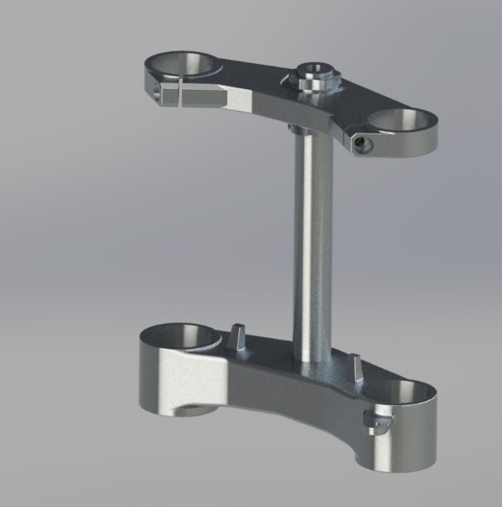
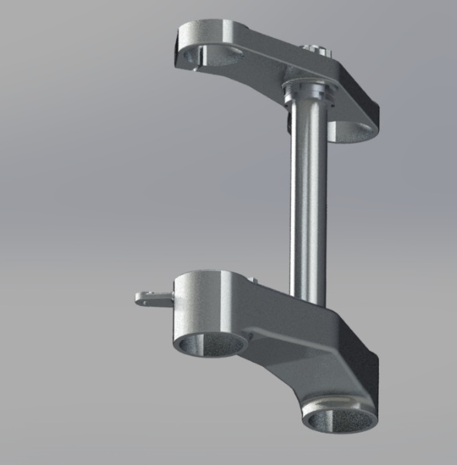
The lower triple clamp is the component that will be extracted from the motion load simulation the detail and accuracy applied to this model are the highest among all components within the assembly. The following figures depict the final renderings of the complete assembly and lower triple clamp.

Figure 1: Triple Clamp Assembly, Bottom
Figure 2: Triple Clamp Assembly, Isometric
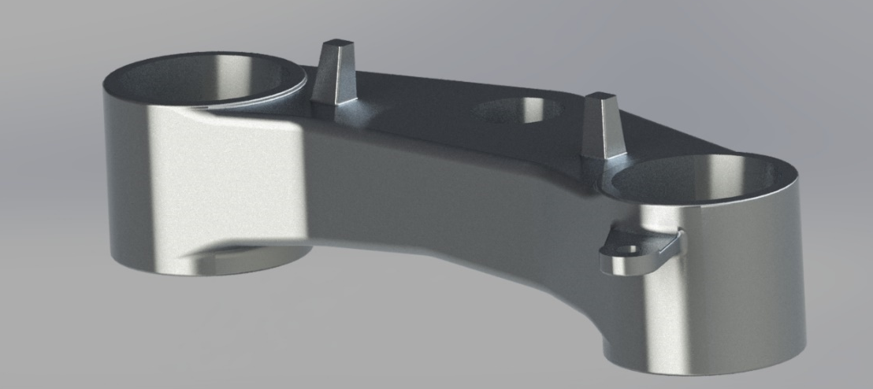
Figure 3: Lower Triple Clamp Closeup

Other Parts
The following list outlines the other components modelled for the simulation.
- Upper / lower fork tubes and dust seals
- Spindle assembly (bolt, nut and spacers)
- Dust seals
- Clip-on’s (simply to add a rider force that is applied to the assembly dynamically)
- Front disc brake assembly

The following parts were borrowed from various sources in order to correctly produce a motion simulation while reducing the time needed to model every part.
- Fork bottoms – Taken from M. Buckles GSXR750 model (Buckles, 2019).
- Front wheel and tire – Adapted from Radical 999 model (Chanson, 2019).

Equations
The following equations were implemented in order to ensure that if a specific component needed to be redesigned It would automatically change the related components that would need to be altered as well.
- The upper and lower triple clamp diameters were made to drive off the dimensions of the upper fork tube to allow for different fork tube sizes to be interchanged if necessary.
- The connection between the middle triple clamps and the upper and lower triple clamps were also made to change if the middle triple clamp needed to be enlarged / reduced. This also included the headset nut to change with the different diameters.

Motion Simulation

This section will outline all inputs parameters used to create a validated motion simulation that was able to successfully recreate the loading conditions experienced from slowing down a motorcycle from 124mph to a standstill.

Assembly Mates
In order to reduce the solve times and number of redundancies occurring during each simulation, all the concentric and coincident mates were changed to hinge mates. This reduced the number of redundancies from 107 to 24 and without the unnecessary components such as the disc brakes it resulted in 6 redundancies and a solve time that was 1/8 of the original time.

Input Parameters
The first step was to ensure that the model was correctly positioned in the model tab before starting a motion study to ensure the correct operation of the input variables used in the motion study. The following list highlights the key input variables used for the motion study.
- Linear Springs – Each fork tube had a linear spring with a spring constant of 9.5N/mm and a damping constant of 10.0 Ns/mm. The length for each spring was 583.04mm which included a preload of 20mm. These spring specifications produced a 37.5mm sag when the rider and bike weight was added to the model.
- Linear Motor – Data points were used to generate a top speed of 124mph and then slow down the components to 0mph. The acceleration / deacceleration parameters are based off a 2D data set which specify a maximum acceleration of 6.98(m/s²) and deacceleration rate of -9.68(m/s²), figure 4.
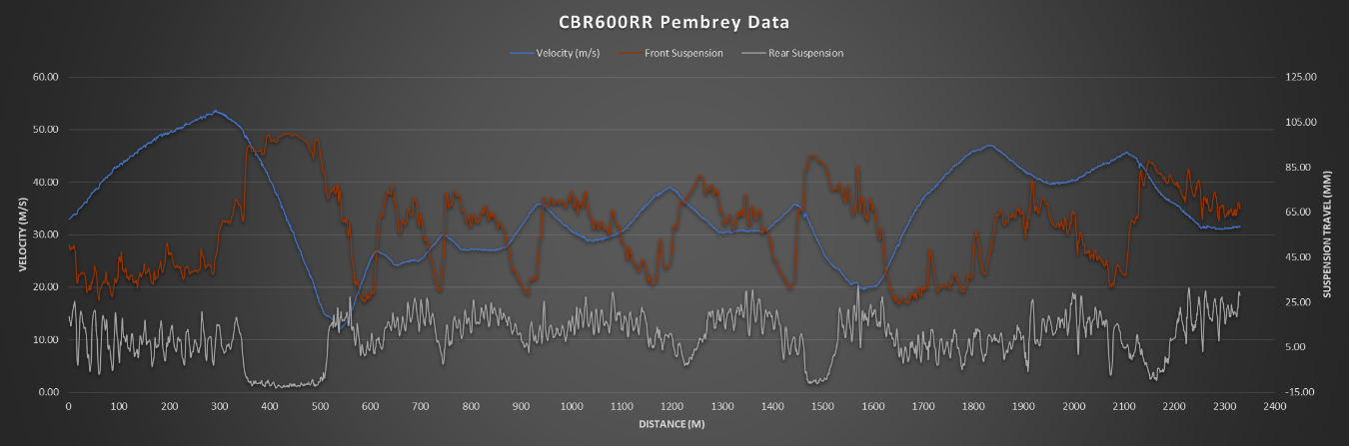
Figure 4: Linear Motor Parameters
- Rake Angle – 28º was used to simulate a worst case scenario for the bending moment around the triple clamp.
- Weight – The weight of the motorcycle was applied to the triple clamp and the force of the rider was applied through the clip on bars. Motorcycle weight = 110kg static weight on front wheel. The material chosen for the component was 6061 alloy.

Results
The above input parameters resulted in the following front fork displacement, figure 5.
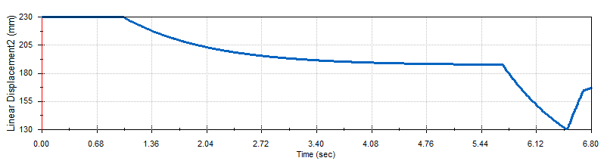
Figure 5: Front Fork Displacement
The total front fork compression was 62.76mm and when compared to the 2D data trace in figure 4 the results are very consistent under maximum braking conditions from similar velocities. Once the simulation was validated against real world data the forces generated from the simulation were transferred to the lower triple clamp from frame 670 to 730 which is when the largest loads occurred within the component.
The following figure is the result from the 60 iterations being simulated onto the lower triple clamp.
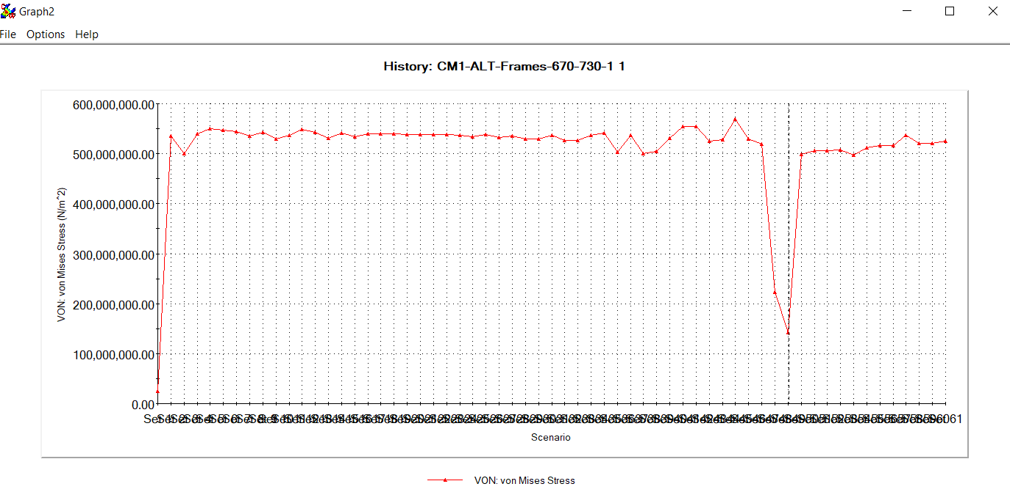
Figure 6: von Mises Stress

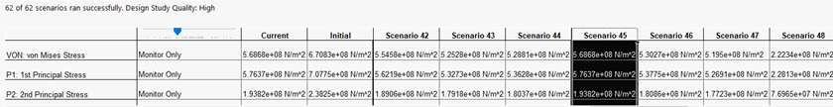
Figure 7: Maximum von Mises Stress
Figure 7 highlights the maximum loading situation occurring at scenario 45 which occurs at 6.4736 seconds of the motion study. Which makes sense due to the forks almost being fully compressed and when the motorcycle is almost stopped.

FEA
The motion study produced a loading condition that was unbalanced by 0.11 newtons in the lateral direction, so the assumption was made to create a static study with these slight errors removed and also relocating the middle triple clamp force to the centre of the lower triple clamp because that is what the component will experience in real world situations, figure 8.
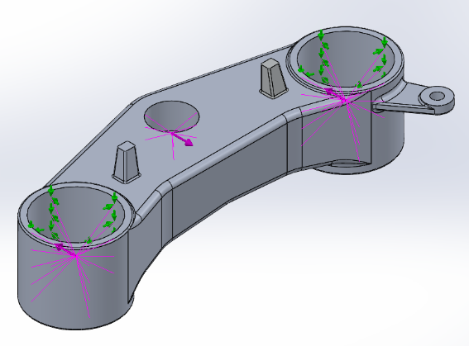
The following list illustrates the forces in better detail.
B
C
A) 4787.13N, 0.17m from the origin
B) -9531.53N, 0.032m from the origin
A
C) 4787.13N, 0.17m from the origin
The next step before running the static study was to create a suitable mesh. This was achieved by first running a coarse mesh and determining the critical areas of interest and then applying a mesh control to those areas. The final mesh parameters involved a maximum mesh size of 3mm for the main body of the component and a mesh control of 2mm around the diameters of the forces. The figures below show the final mesh created, along with the mesh quality which demonstrates an adequate number of elements used to fill the component.
Figure 8: Static Study of Lower Triple Clamp

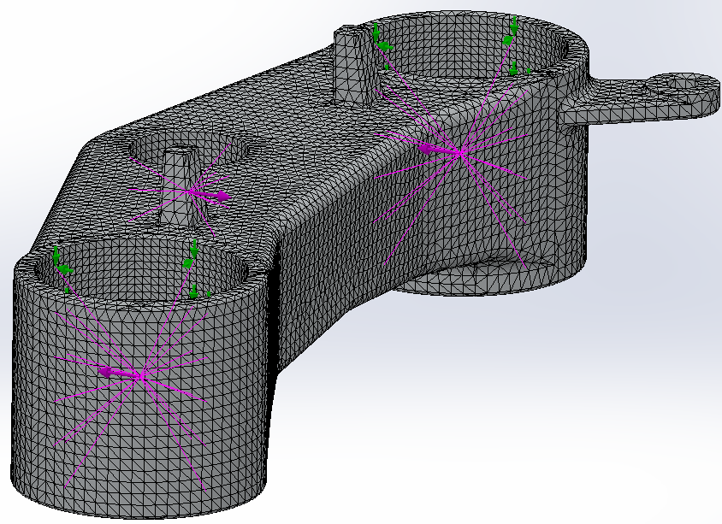
Figure 9: Final Mesh Strategy
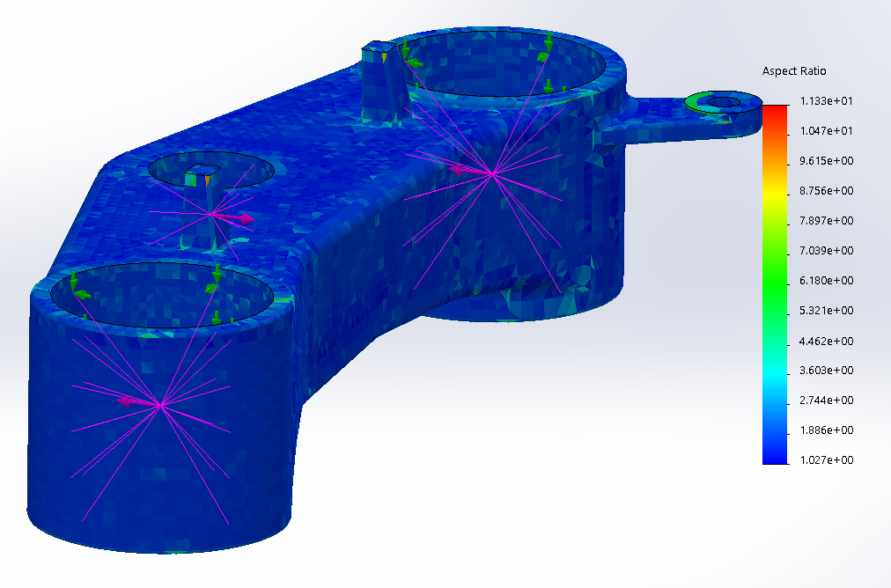
Figure 10: Mesh Quality

The final input parameter adjusted before running the simulation was applying a fixed hinge at the outside fork tube connections. Without restricting these forces the triple clamp would not be able to experience a bending moment which is the key force being applied to the component.

Results
The figures below are the results from the static loading simulation.
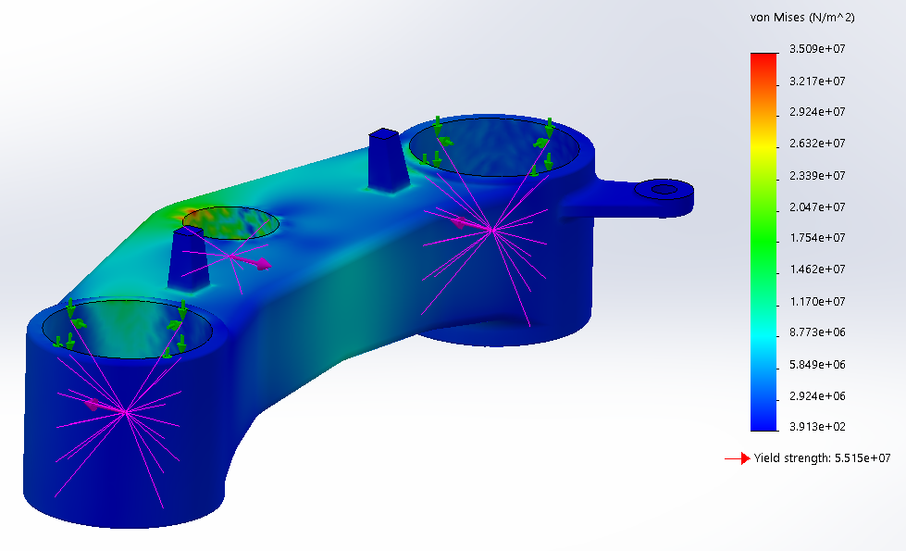
Figure 11: von Mises Stress, OEM
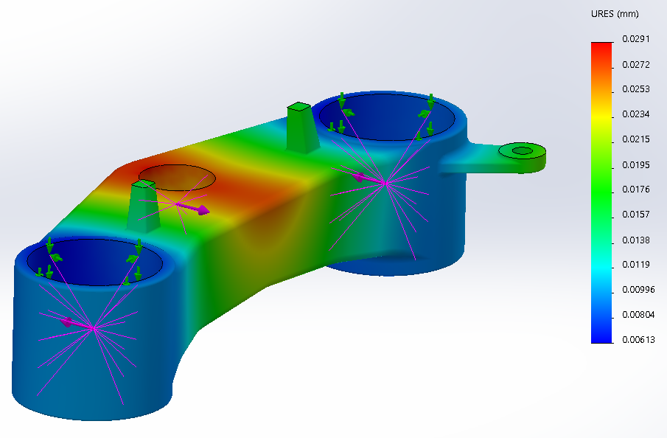
Figure 12: Displacement, OEM

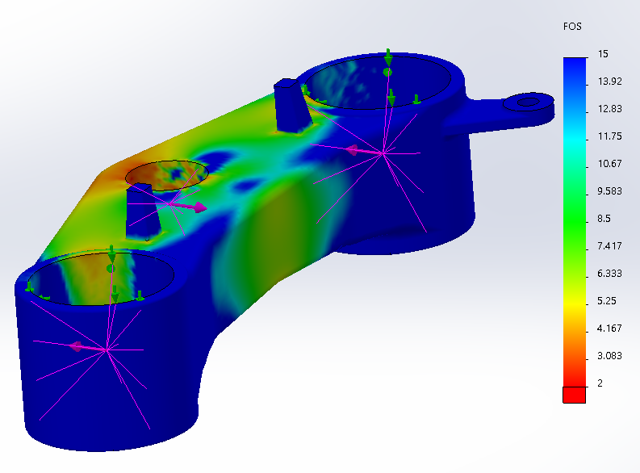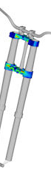
Figure 13: Safety Factor, OEM Figure 14: Typical Stress Concentrations, (Editors, 2014)
The results achieved from the FEA have demonstrated that the forces acting on the component are reasonable due to the fact that the safety factor generated from the simulation are similar to the safety factor OEM triple clamps have (Studybay, 2018). The other important comparison is the stress concentrations are comparable to historical data, as seen in figure 13 and 14. The other important results achieved from the FEA is that the stress concentrations are near the rear of the triple clamp which is expected due to the upper part of the triple clamps wanting to continue to move forward while the lower forks are wanting to stop and move towards the centre of the motorcycle which causes a larger moment arm on the lower triple clamp. This statement is only valid during braking scenarios and since the chosen loading for this assignment is based off worse case scenarios this assumption is valid.

Design Optimization
Since the OEM lower triple clamp have been validated and have proven to be strong enough to withstand the simulated forces the component can now be optimized. The chosen method of optimization was utilizing the topology study within the SolidWorks software. The topology study allows the software to determine the amount of material that can be removed or added to the component in order to meet certain goals and constraints.
The steps below outline the process used to create an optimized lower triple clamp.
- Transfer the static study case to a topology study. This transfer included all mesh parameters, fixture settings and loading conditions.
- The next step was to select the preserved regions, (e.g. the mounting locations and all the other regions that could not change).

- The key difference between a topology study and a static study is the goal and constraint setting. Since the FEA results for the OEM part was overly engineered the goal for the topology study was set to reduce the mass by 40% but retain the same stiffness. The reason why 40% was chosen is due to multiple iterations starting from 5% to 40% by 5% increments. The result from this percentage reduced study was that the maximum amount of material that could be subtracted was 40% with out compromising the structures stiffness. This of course is only due to the loading of the component during braking.

The results from the topology study can be seen below in figure 15.
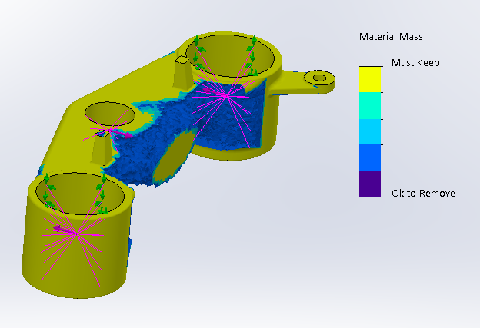
Figure 15: Topology Results
- The topology results were then transferred to the model by overlaying the results graphicly by using the simulation display setting so that the unnecessary material could then be removed.

The figures below display the final results after removing material from the component.
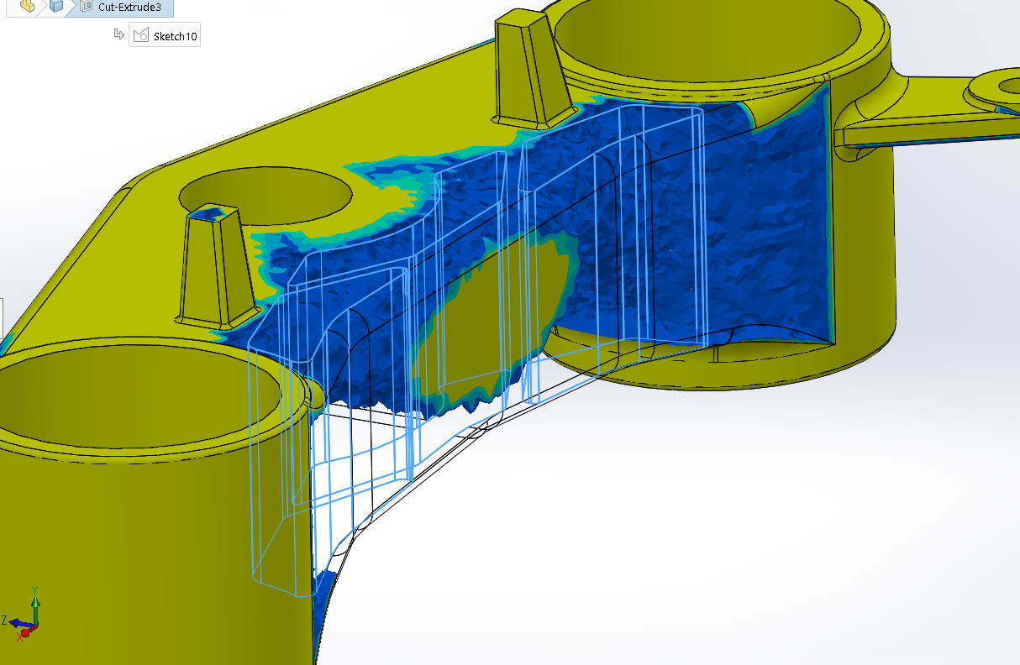
Figure 16: Material Removed Sketch
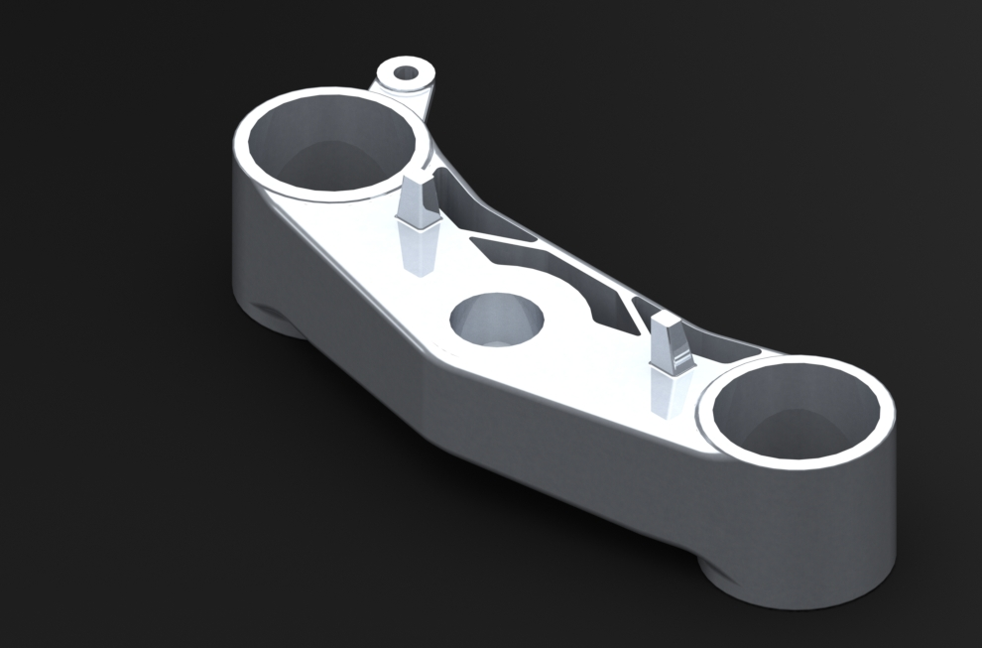
Figure 17: Lower Triple Clamp Redesign
The reason why the complete removal of material at the front of the component did not happen is due to the fact that although the part would function correctly if redesigned exactly how the topology study was displayed, it is not good practice to not allow for any anomalies. In this case the redesign was developed in conjunction with the topology study and historical data (figure 18) so that the newly designed part would be robust enough to handle a vast number of scenarios.
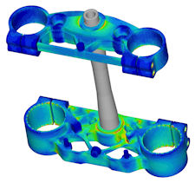
Figure 18: Validated Triple Clamp Optimization

Validation & Comparison
The next step was to ensure that the newly designed component was able to withstand the original loading conditions and did not create stress concentrations that would then compromise the part. The following figure is the von Mises results from the FEA on the redesigned component.
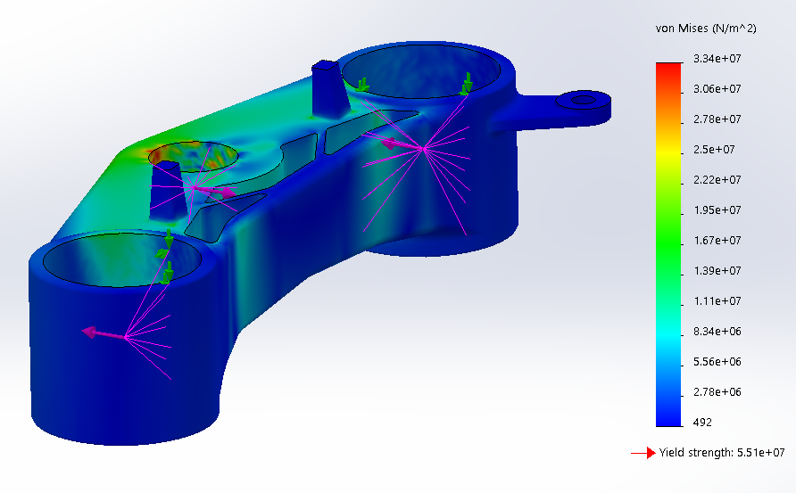
Figure 19: von Mises Stress, Redesign
The following figures are a comparison of the OEM (left) and redesigned component (right).
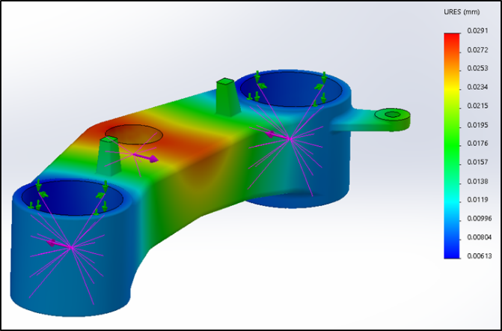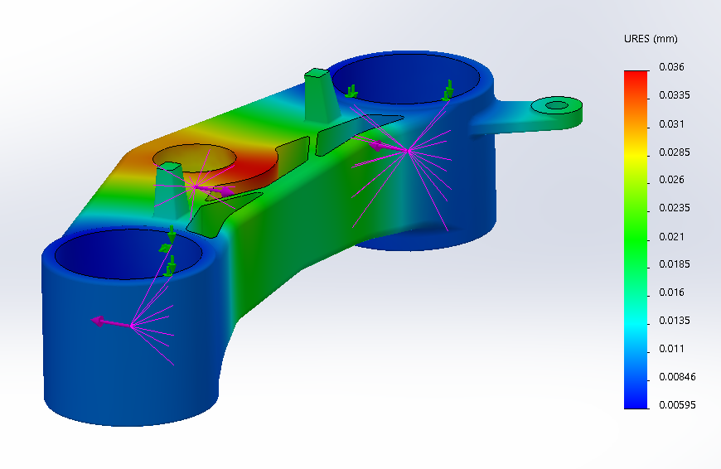
Figure 20: Displacement, OEM Figure 21: Displacement, Redesign

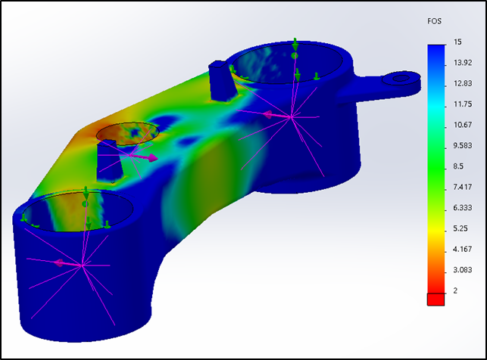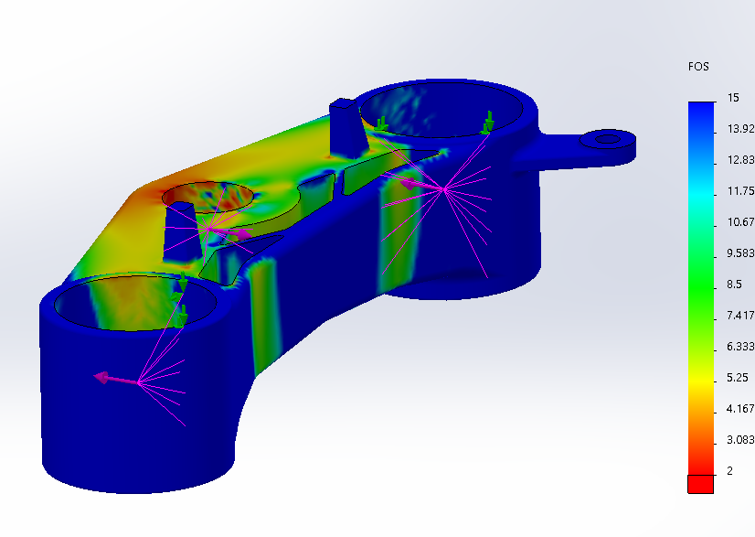
Figure 22: Safety Factor, OEM Figure 23: Safety Factor, Redesign
Figure 24: Result Comparison
When compared to the OEM design the redesigned component experiences an added maximum displacement of 0.0069mm and a drop in the factor of safety by 0.3 and an addition of 5.15E+06 of von Mises stress. These results confirm that the redesigned part does not surpass the components yield strength and does not compromise the part / assembly during braking conditions. Furthermore, the redesigned component allowed for a weight reduction of 13.72% while achieving critical operating performance.

Limitations

Due to the time constraints of the assignment only the maximum loading condition was used, which was determined to be under braking. This assumption is valid if only performing an FEA on an unoptimized component but since the component was redesigned with only certain loading conditions the design would need to be further tested with other loading conditions (e.g. during acceleration, cornering and anomalies such as curbs and bumps in the road).

Conclusion

The results achieved from the optimized lower triple clamp have been successfully validated against the maximum braking forces and have yielded a weight reduction of 13.72%. This specific case study has also been able to demonstrate that the motion load software in SolidWorks is able to generate reliable loading conditions when the static forces are not able to be computed by the user in other ways. It has then demonstrated that the motion loads can then be transferred into an FEA, which can then be used to determine the suitability of the part / assembly and then can be optimized if needed.
This report has also highlighted the fact that a CAD software such as SolidWorks is very capable of predicting real world results if the user is competently trained and is able to apply critical thinking towards the problem. On the other hand, the software is also capable of producing results that appear to be accurate but in actual fact are not reliable at all. This means that the user must take precaution when using programs like SolidWorks and must approach the problem in a systematic way which ensures that all input variables are validated in some way before moving onto the next step.

CAD Links

Complete Folder
https://uowtsd-my.sharepoint.com/:f:/g/personal/1700589_student_uwtsd_ac_uk/Ej_2m7nMpvlCnX9Ls7Cf51ABgOU-1G70Yq7LFERX-C5FIg?e=D9OJUu

Assembly With Static Study
https://uowtsd-my.sharepoint.com/:u:/g/personal/1700589_student_uwtsd_ac_uk/EeeoXNDFkU9OmumzuuCPnaoBP_YlB59LUaI7EvG46lJggg?e=tSHPSN

Topology Study
https://uowtsd-my.sharepoint.com/:u:/g/personal/1700589_student_uwtsd_ac_uk/EVdTGjtufwZMvOCjpXqF4HEBK_o2o6NQv9AXPXZ8J6MGdw?e=of1Hwc

References

Buckles, M., 2019. GSXR750 forks yokes hugger etc. s.l.:s.n.
Chanson, 2019. RADICAL 999. s.l.:GrabCad.
Editors, D., 2014. The Race for Light and Strong Parts. s.l.:s.n.
Harish, A., 2019. How Can I Learn Finite Element Analysis? The Complete Guide. Simscale, p. 1.
Slater, J. W., 2008. CFD Analysis Process, s.l.: NASA.
Studybay, 2018. Front suspension system system of motorcycle. s.l.:s.n.
Wu, T.-Y., 2011. SolidWorks Motion and Finite Element Analysis (FEA) Simulation, s.l.: s.n.

