Analysing rural and urban environments and their approach to art.

Lisa Giambra (P147176)

BA (Hons) Illustration

Word count: 5021

Tutor: Derek Bainton

Table of Contents

- Introduction……………………………………………………………….….……….2
- Chapter 1 – Framing Urban and Rural Art practice…....……………….4
  - How can urban and rural art be characterised?.............................5
  - How is urban and rural art measured?.........................................10
  - How is urban and rural art valued?..............................................12
- Chapter 2 – Context and Relationships…………………..……………….15
  - The Urban Space……………….…………………………………………..15
  - The Rural Space……………………………………………….................20
- Conclusion……………………………………..…………………………………...22

Introduction

The main aim for this dissertation is to critically analyse the differences in how art is approached in a urban environment, such as the city, and a rural environment, such as the countryside. This would also involve researching how art is approached from people that live in each of those environments, as well as how they react and get involved with illustration, fine art, poetry, music and other forms of art.

What relevance has the image and context relationship in this matter? Is the place and people relationship relevant and important when it comes to approaching art? How can the same image, piece of music or illustration receive a different reaction from people that come from two divergent backgrounds such as a city or the countryside? These are some of the questions that would be investigated through this paper. The structure will follow first of all the analysis of characterising urban and rural art, looking at different styles that represent each group, followed by the research of how rural and urban art are measured and valued. The second chapter will explore context and relationship, mentioning pyschogeography as one of the main fields of research and how it affects and relates with my topic.
Some of the artwork that will be analysed through the chapters will be graffiti, street art, logos and murals, as in an urban context. And Art Naïve, rural and folk art and indigenous art when it comes to a rural approach.

In our society, where information travels through the world in a matter of seconds, thanks to the internet and social media, it is clear that people from these two surroundings, even though they are connected so quickly to each other, are different in the way the cope with everyday life. According to what their everyday needs and customs are, it is still a fact that growing up in one place or another, makes you see the world differently, which may affect our globalised contemporary society as well as our concept of art.
Today, where it is not only the internet that help us connecting with each other, but also the way it has become so easy to travel in-between cities and countryside and in-between countries or in-between continents, the way we see ourselves(as individuals and in the world) is getting modified. The way we see others, the differences we have and the way we approach art and the reasons why we do it differently from one another depending on our cultural background.

As outlined above, as part of the research, pyschogeography, as is understood to be the study of how our geographical location affects separately each of us when it comes to our emotions, behaviours and ways of thinking, is going to take an important role through the chapters when it comes to understand why people act differently depending where they come from or where they live. This is not only going to be related to the place an individual currently lives or where one grown up, but also to where the individual finds oneself at home.

“You were so much a part of the system that it was impossible to see beyond it” (Hypernormalisation, 2016)

Chapter 1: Framing Urban and Rural Art Practice

Arthur C. Smith says […]Man trained in a country area where life is still more leisurely, and so provides a sphere where he can build up his spiritual reserves in a team, is fitted for both town and country work, whereas a man trained only in a town is not so equipped, and must learn much if and when he takes a country cure.” (1964 : 5)

As a starting point, this quote gives an opportunity to reflect upon the people that are based in the countryside and the way they live, which it is possible to believe that it would directly affect their way of reacting, practising or see art.

In contrast, Nicolas Whybrow, in his book Art and The City says: “And Bourriand insists: ‘what nowadays forms the foundation of artistic experience is the joint presence of beholders in front of the work’”(2011 : 6). This is trying to explain that, specially in the city, art takes a different place in relation with the viewer, where the concept of the “context” of the piece of art starts to be more important that the artwork itself, where the spectator is involved between the artwork and take action within it. So the artwork itself doesn’t exist without the action of perceiving from the spectator.

This leads us to the relation that exists between the artwork and its location, which is not only to be perceived, but it also affects its surroundings and the people that lives in it, one way or another.

How can urban and rural art be characterised?

How do we know when we are talking about urban or rural art? How can we describe each one? During the research for this topic, after a questionnaire given to people from both countryside and city, most of them when given the question “What would you define as traditional art?” gave the response as to be anything that isn’t drawn digitally, or that it’s done with more antique and traditional techniques such as oil painting or watercolors. On the other hand, when asking the same question about urban art, most of the answers where directed to graffiti, street art and contemporary art, saying that urban art it’s “any art that it’s in the public place” (answered by Carys, 2017).

As a starting point to slowly understand and structure this topic, we first have to understand how urban and rural art can be characterised or defined. Consequently, when discussing urban art, it is in mind of art in the urban environment, as it can usually be featured by existing in the public space, which is often view as vandalism, when it comes, for example, to Graffiti. Started as a breach of the private property, the graffiti culture is now known as one of the most famous and recognisable forms of “urban and street art”.
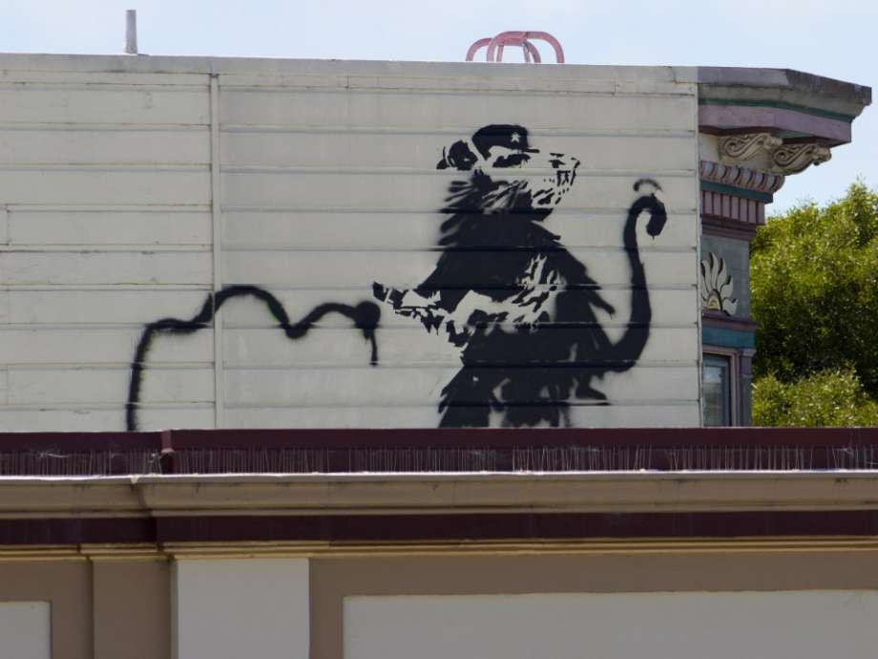
Graffiti is usually known to be part of what can be defined as Street Art, which is the art done in public locations, as it name says, in the streets. As it can be shown in this picture of the graffiti of a rat done by the artist Banksy in 2010, illegally, as it is explained in the documentary Saving Banksy (2014). Normally executed outside of traditional art venues such as museums, galleries, exhibitions, etc. Even though Graffiti is one of the most recognisable forms of art within the urban environment, we also need to include Murals when talking about Street Art. Thus, it is “displayed” or seen in a community or its surroundings including buildings, streets and other publicity viewed surfaces, so everyone who is walking past is able to view it. Even though, the existence of Museums of Modern Art are an exception to what it has been stated. This is because it collects urban art as well as architecture and sculpture, all of those arts done in the urban environment. It is to say that Modern Art it is often mistaken with contemporary art, but truly is a style that emerged roughly between 1860s until the 1970s, with various styles and with the use of new and uncommon materials.

On the other hand, traditional art is normally seen framed in galleries and museums, which also leads to have a different audience. With this, it is to say that where Street Art and Graffiti can be seen by everyone when walking through a city or a public place, even though not everyone stops to look at Graffiti, or Murals for instance, for being perceived as vandalism or just because not everyone pays attention to them, more traditional art is usually approached and viewed by those who enter a gallery, not by accident, but by their own will. In this sense, Street Art is more accessible when living in a city, because you don’t necessarily need to be wanting to see a piece of artwork, but you may accidentally see it on your way to work. In contrast, traditional art is normally safely kept inside a frame in a gallery, creating a barrier between the viewer and the piece of artwork. Not only because of the panel between the viewer and the painting, which doesn’t exist in murals or Street Art. But also because it means that the artwork in a gallery is not only more difficult to see, but it actually has to be wanted to see to be seen, rather than encountered.

In addition, a difference between what we have described as Street Art, and traditional art, is not only where it is displayed or what it represents, but also the materials that are used to create it. Where Street Art may use spray paint, LED art, mosaics or stencils, traditional art is more used to be approached and be thought to be done only with oil painting, acrylic or watercolours, all techniques understood to be traditional.

In characterising and defining rural art for the purposes of this study, it is important to clarify its distinction from traditional landscape painting.

It is important to say when talking about rural art, that in the rural environment it may be more difficult to learn about art from galleries, libraries or other public spaces that are more accessible in a city, as long as institutions like art universities or colleges. Even thought all of this is more accessible in the urban environment, not everyone makes the decision to approach it. So here it is when urban artists can be self taught or start learning from social circumstances such as local groups or trends. These situations can then affect the way they approach and create art as well as how and where they get their information about art from.

In the countryside, as outlined above, apart from what institutions would teach to a certain level of knowledge in schools, you may be more likely to be self thought when it comes to art. In a rural environment may be more difficult to reach a gallery for information or inspiration, a library for research or an art shop to buy art supplies. Usually, unless you explore and learn by yourself about art, composition, colour theory and proportions (as a vague resume of what you would need to know to create art). As Mohan Matthen tries to explain in “Play, Skill and the origins of Percetual Art”, the “primary sensory attractors” of the visual traditional art are “pattern (symmetry, continuation, occlusion, enclosure, repetition, the ‘line of beauty’, etc), colour and pictorial representation”(2015: 174). Unless you are using the right resources, you may be more directed to approach art in a more “natural” and “instinctive” way if you don’t have the right sources to perceive these ideas.

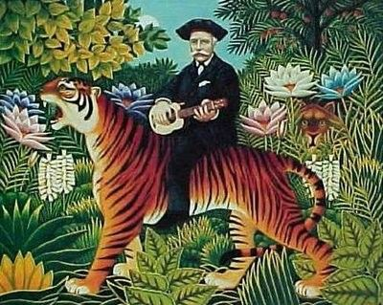
Art Naïve it’s an extreme example of this concept. This art style consists in work from artists that lack of the experience of common knowledge of representation or depiction of real objects, which means that they’re not aware of the previously mentioned concepts by Mohan Matthen to create art.
In short terms, Naïve artists approach art in a more primary, instinctive and “pure” way. As we can see in “Traumgarten” by Henri Rousseau, the figures seem to just be floating in what it seems to be a jungle where a representation of fauna and flora is depicted around the two characters (the man and the tiger) without any established rule, even though nothing is really studied in this painting, everything seems to come up together in harmony. In this case, art is approach directly from the painter itself, where without having any previous knowledge about the already mentioned basic concepts about art, tries to represent what he sees or wants to see in his painting.

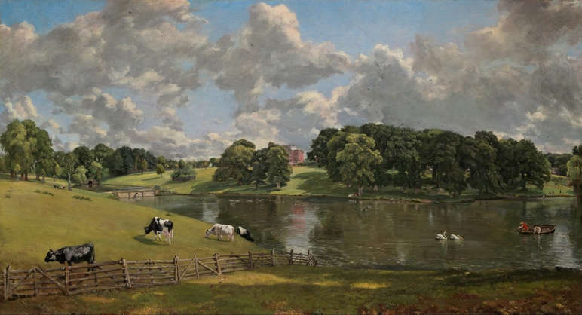
To contrasting Art Naïve and to look at traditional art, the countryside, as a rural environment, in the context of art, has a long history established idyllic and romantic representations and connotations. In traditional depictions of the countryside by masters, such as Constable, rustic romantic country compositions are often depicted. However, landscape painters such as Constable formally trained at established urban centres such as the Royal Academy as it is explained in “John Constable: the making of a master”(2014). Which leads us to the realisation that as we can see in the image above, Viwenhoe Park by John Constable (1816), Constable was instructed and acquired the knowledge to create real representations of what it was in front of him, following the knowledge acquired from the institutions where he studied.

How is urban and rural art measured?

"In conceptual art the idea or concept is the most important aspect of the work. When an artist uses a conceptual form of art, it means that all of the planning and decisions are made beforehand and the execution is a perfunctory affair. The idea becomes a machine that makes the art.” Sol LeWitt(1967).
With this first quote, it is established what we understand as conceptual, which can be often related with urban and modern art. But for instance, rural art is mostly approached in a perceptual way, where everything is mostly represented as it is seen in the real world.
After making this difference of what we intend as conceptual or perceptual within this context, it has to be analysed where each environment sits in between this two ideas.
Urban art, usually, is more approached in a conceptual way, where the concept of the artwork, is far more important of the image or piece represented.
On the other hand, rural and traditional art might be more likely to just represent exactly what it is seen in the natural world, representing real life as it is, most of the times without giving any meaning or concept apart from what it is depicted.
Given now the two extremes, it is to know that they’re not parallel and that they’re not the only examples we can encounter. A large amount of artwork finds a point where concept and perception merge together in order to not only represent something as it is in the real world, but to explain or show an idea and a concept with it.

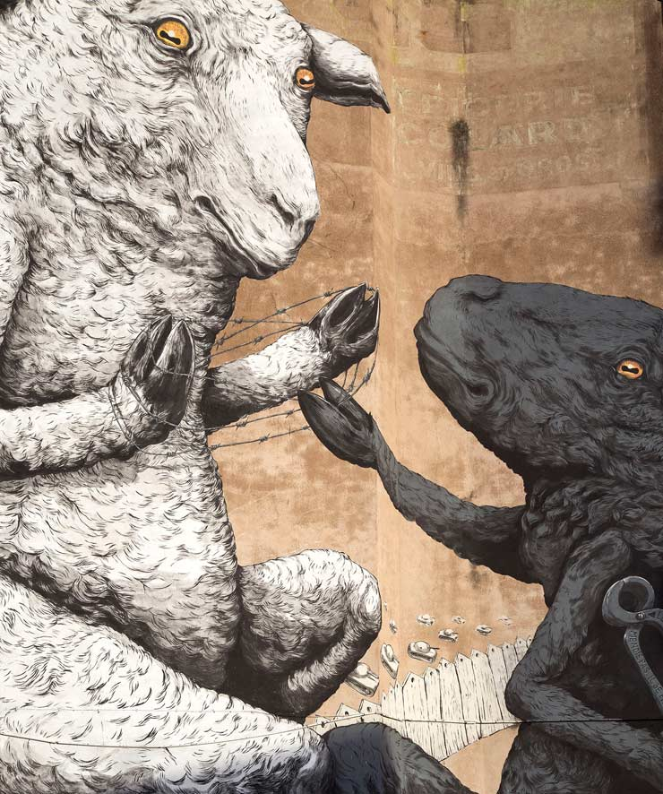
One good example of this statement is ERICAILCANE, an Italian muralist artist which has spread his art around the world by graffiti and murals. Formally graduated in Bologna, his artwork is highly charged of social and environmental concepts even though his pieces are approached in a really perceptual way, depicting realistic animals but with perhaps human clothes on, in certain positions or acting in a certain way in order to reflect the concept is trying to communicate. As we can see in this picture, two sheep are represented in a very realistic way, but the concept behind the image is more complicated. This mural is located outside of a museum exhibition that explores the different perceptions of how the world is seen by adults and children. For instance, this mural is trying to reflect this same concept, showing how the tool that can be used to free the white sheep is behind the back of the black sheep, who is “trying” to free the first animal. This mural has been located in France from May 2017.

How are urban and rural art valued?
When talking about how urban and rural art are valued, it’s important to state in the first place how rural and urban art are emotionally valued as well as financially.

In Art As Therapy (2013), Alain de Botton writes; ‘it lies in the way that art is taught, sold and presented by the art establishment. Since the beginning of the twentieth century, our relationship to art has been weakened by a profound institutional reluctance to address the question of what art is for.’ (2013 : 4). With this statement, what is trying to be analysed is the way the financial value that has been attached to art has become more important in the last century. Where sometimes an artwork is more valued and considered because of the financial value attached to it (depending on many reasons), rather than the artwork itself. But we cannot talk about financial value without mentioning the emotional value of an artwork, either from the rural or the urban environment.

When talking not only about Graffiti, Murals and Street Art in general, they have mostly been used to cover the grey buildings that started to emerge with industrialisation, but it has also began to have a meaning further than just the image itself. If we take the contemporary Graffiti artist Banksy as an example, his artworks usually has a powerful meaning. Not only when we talk about its skills, but what it represents is always trying to give a message within the urban environment about our society, directed sometimes to politicians, which is not always well received.

It is not possible to talk about Banksy without touching not only the symbolic value its artwork has, but also its financial one. In the documentary “Saving Banksy”(2014) it is explained step by step how Banksy’s artwork is often taken off the walls, buildings and other surfaces where he performs his Graffiti, from art traders to be sold in galleries and exhibitions. The problem is, not only that the artwork is sold without any permission of the artist, but also that since as previously mentioned Graffiti is often seen as vandalism and painting on a private property’s wall is illegal, Banksy does not receive any of the money that this art trades receive for selling his artwork. This is because if Banksy would want to be recognized as the performer of these Graffiti, he could perhaps end up incarcerated as it is explained in the previously mentioned documentary “Saving Banksy”.
In this context, the question is: Is then graffiti and street art less valued than other forms of art when it comes to recognize the artist rather than the artwork itself? Rural art for example, as already explained in the previous section, because is not done illegally and the artist is fully recognized for its artwork, the financial value its piece of art has it is completely given to the artist as well as all the rights to have and use that artwork until those are also sold to someone else. But even then the artwork it is still acknowledged to the artist.

Chapter 2 – Context and Relationships

In this chapter, the context and relationships between the artwork done in the rural or the urban space and the people living in each environment, is going to be analysed in the way of how the artists relate with their artwork and their environment, as well as how the people living in each surrounding react to this artwork, the context where the artwork is placed and what is the relationship with its habitants. Thus, this context and relationships it may be different when talking about rural or urban.

The Urban Space
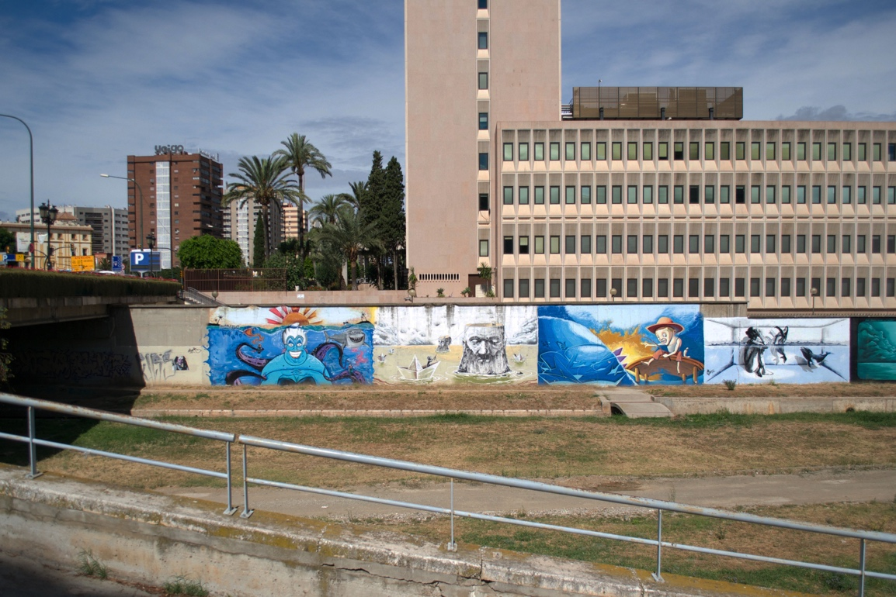
Sorcha O’Higgins says “The built fabric of cities and towns provides the canvas on which street artists exhibit their creations, inextricably linking it to its environment” (2015) when talking about how the urban environment in Buenos Aires mirrors the history of the city and its identity. There is a close relationship between where the art is executed, by who and the artwork itself. Not only when it comes with the reasons a certain artist has done certain artwork, but also the way it is displayed and how it affects its environment and the people in it.

As we can see in this photograph taken in Spain (2012), the graffiti are specifically located in a canal where the water usually runs through. Since the photo was taken during a dry season, no water is running through the canal and all the graffiti is clearly visible from top to bottom. But when it rains and the canal starts to fill with water, some of the graffiti is covered by the water, so only a part of it is clearly visible. Taking for example the first graffiti on the left, when the water runs through the canal, filling it up, you would only be able to see the part where the sun rises and not the rest of the artwork underneath the water. This is an example when it comes to talk about how urban/street artists play with the environment that is surrounding them, using the context where the art is placed and playing with it. It is here where the relationship between the artist and the environment that is surrounded by, takes a great part on how it approaches art. This way is where as Nicolas Whybrow mentions Francesco Bonami in his book “Art and the city”: “[…]the way we experience the world, art, architecture, and eventually life in general[…] through encounters, images, objects and spaces.” (2011 : 3). Is with this statement that he explains how our art is bonded with our experience of the everyday life and the environment that surrounds us.
These are some of the topics that are going to be analysed in this chapter, looking at the results obtained through a questionnaire handed in to different people from both rural and urban environments, as well as the influence that pyschogeography has in the way people relates with the context where they live.

This is how, as already mentioned at the beginning of this paper, psychogeography, has a great influence for this chapter. Psychogeography is the study of how our emotions, behaviours and ways of thinking are affected by our location and urban space and where we stand when it comes to describe the sense of home (which doesn’t necessarily have to be on a geographical location) as well as where someone has grown up, where it lives or where it works and how this affect his vision upon art. In fact, the questionnaires given in order to research about this topic, 60% of the people questioned, when describing where they would find themselves at home, they wouldn’t describe a specific location, but, for instance, family or friends.
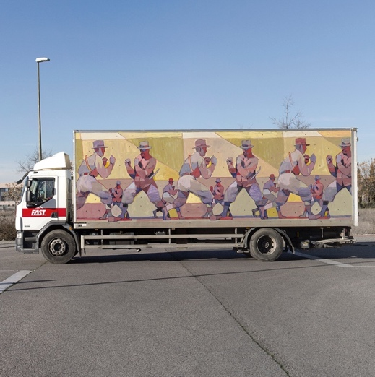
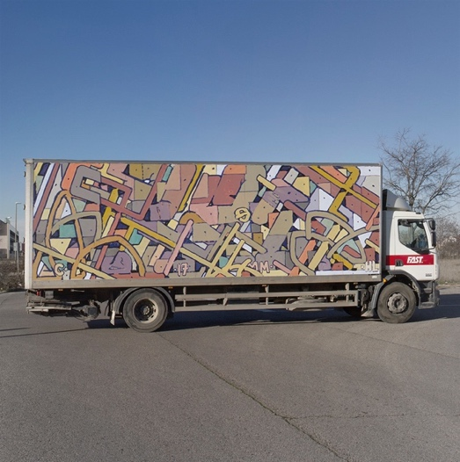
Guy Debord writes of vagueness in defining pyschogeography (2010 : 89). Often sites of urban and street art and graffiti, such as edge lands, street corners, wastelands and railway lines, are very much liminal spaces, transitional spaces where we don’t live or we don’t spend an important amount of time. Even though Street Art such as Murals are often located on walls, graffiti for instance is sometimes located on moving objects such as public transport (trains, buses…) or trucks. Aryz, a muralist artist from Spain, it’s a clear example with his Truck Art Project (2017), where explores the same style he uses for his murals in moving objects such as a truck as it can be seen in the pictures above. Here is where a same artwork, it’s visible in more than one place for the fact that becomes an object that moves, and for instance, from the perspective of the viewer, it can perhaps become a transitory artwork.

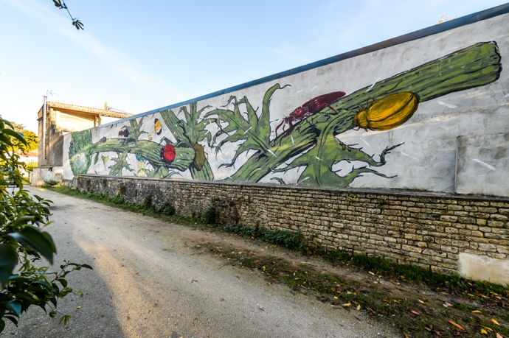
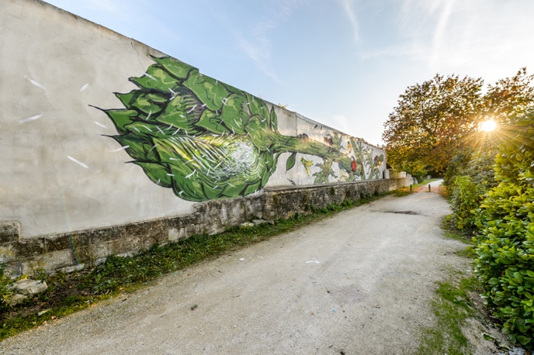
With industrialisation, comes urbanisation: raising more buildings and defining cities, separating even more the rural from the urban. And from this industrialisation, from all these grey buildings, it is conceivable that artists would want to respond to their environment, to get out of the canvas and taking walls, skyscrapers, bins and every empty space in the city, in order to break with the monotony, the system; to make it more colourful, trying in a way, perhaps, to imitate nature’s colours to make the city less grey, substituting with Street Art the lack of colours that can be on the other hand easily find in the countryside. So, is Street Art a way of covering up the industries and buildings that may be damaging and ruining our planet and nature and a way of reminding us the colours of the rural in the urban space?

As we can see in the pictures above, this mural by Hitnes and Ericailcane, representing various plants along with bugs and different insects, it is trying to reflect in the urban environment elements from the nature that is perhaps not easily found in a city. Even though this piece may not be intentionally done with this purpose, it reflects what it has been explore through the previous chapter and this same one.

The Rural Space

Psychogeography directly affects the way we see, approach and relate with art when coming from an urban environment, since psychogeography is normally applied to the city and urban environments. As Merlin Coverley explains in in Psychogeography “Under the the stewardship of Guy Debord, psychogeography became a tool in an attempt to transform urban life[…]” (2010 : 10)
But this same concept of pyschogeography can perhaps be applied to the rural environment. As its name says, pyschogeography is “the point at which psychology and geography collide” according to Merlin Coverley(2010 : 10). So why can’t the concept of psychogeography be applied in the rural environment as it is applied in the urban?

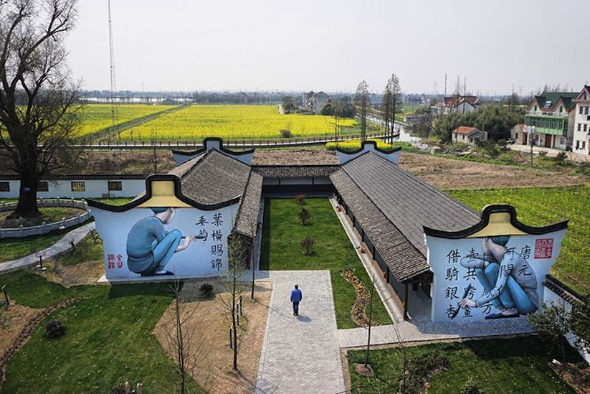
Even though, the psychogeographical relationship may be approached differently from the rural. This is because, it is first to understand that rural environments won’t perhaps directly relate with their environment as street art does. For instance, it is not usual to find graffiti or murals in the countryside and the rural space. Even though it is unusual to find graffiti and mural art in the countryside, the French street artist Julien Malland, more known as Seth Globepainter, is found in the countryside of China, as we can se in the picture below, taken in China, where in 2016 during two weeks, the muralist depicted children inspired by the environment where he was painting. With a more conceptual connotation, this is an example of how street art, that is originally performed in the city and urban environment, can also be found in rural surroundings.

As previously looked upon in this paper, rural art tends to be more perceptual, mostly avoiding having a concept behind the artwork, representing only what it is in front of the artist, depicting the real world. Even though the rural may not have the same kind of relation with the environment the urban as, there is an attachment with the surroundings when they are painted in landscapes for examples. The environment itself it is not directly painted, but it is reproduced onto another support such a canvas, which may create a relationship within the environment and the painter.

Conclusion
Through the writing of this dissertation, I have found myself struggling in finding information about this topic, researching how art is approached by rural and urban environments, since the original research question was to find out the difference between how each place approach art. What I have learned from exploring the image and context relationship between the artwork, the artist and the viewer, is that coming from a different environment does affect the way you see art. But perhaps, the only thing that is really different, is not the way it is approached, the process, but the final outcome.

Reading, investigating and analysing the information for this dissertation, I have perhaps notice that there is not much difference after all in the way we relate with our environment and its art. Thus, it has allowed me to research about different forms of art that were not familiar such as Art Naïve, which has been a really interesting style to come across; discovering artist such as ERICAILCANE and learn about how they relate with their artwork and their environment, as well as the meaning behind their artwork.

Watching the documentary “Saving Banksy” (2014), helped me understand how some graffiti artist, even though they are known worldwide, because of the nature of their artwork, the financial value that is attached to their pieces, it is not recognize to them.

Psychogeography, as one of the main keys to learn about how our emotions, behaviours and ways of thinking, has helped developing a cohesive content when it came to see how what surround us affect the way we see art and the importance of the context-relationships. For instance, the way the geographical location we live in, it psychologically affects the way we approach art and our everyday lives in general. Even though, through the research done about psychogeography, it was difficult to link it with the rural environment since this concept is mostly associated within the urban context and the cities because of where it emerged.

I have learned how important the relationship within the artwork and the viewer it is so important as well as its location, where graffiti and murals have been an important example and reference to help support the ideas stated. My notion of graffiti and murals had often been to see them in the urban environment, in cities. But through the research I have realised how murals can also be done in the rural environment as it is approached in chapter 2.
Not only this forms of art, but the questionnaire created with the purpose of getting to know what people from my everyday life think about the topic that I have been trying to research.
As a conclusion, exploring this topic, after writing about it, I found myself asking: is there really that much difference between how people from urban or rural environment approach art after all?

Reference List
BOOKS
- Alain de Botton, John Armstrong (2013), Art As Therapy, London : Phaidon Press
- Arthur C. Smith (1964), The Countryside, London : Prism Publications
- Mark Evans (2014), John Constable: the making of a master, London : V&A Publishing
- Merlin Coverley (2010), Psychogeography, Harpenden : Pocket Essentials
- Nicolas Whybrow (2011), Art and the City, London : I.B Tauris

ARTICLES

- Mohan Matthen (2015) ‘Play, Skill and the Origins of Perceptual Art’, British Journal of Aesthetics, Vol. 55 Issue 2, p173-197. Available at: http://web.a.ebscohost.com.ezproxy.uwtsd.ac.uk/ehost/detail/detail?vid=0&sid=b959dd47-4ae2-456d-945d-45512a6c2909%40sessionmgr4009&bdata=JnNpdGU9ZWhvc3QtbGl2ZQ%3d%3d#AN=109038605&db=asu accessed 20 November 2017

WEBSITES

- Sorcha O’Higgins (2015), Physical Graffiti – The connection between urban art and architecture in Argentina. Available at: https://graffitimundo.com/blog/articles/physical-graffiti-the-connection-between-urban-art-and-architecture-in-argentina/ (Accessed: 24 November 2017)

DOCUMENTARIES

- Hypernormalisation (2016) Adam Curtis. United Kingdom
- Saving Banksy (2014) Colin Day. USA

PAINTINGS, DRAWINGS, PHOTOS AND ARTWORK

- Aryz (2017), Truck Art Project [Mixed Media]. Location unknown. Available at: http://www.aryz.es/blog/2017/3/7/truck-art-project accessed 29 November 2017
- Banksy (2010) Banksy Rat [Mixed Media]. Location unknown.
- ERICAILCANE (2017) Bien Urbain Festival 2017 [Mixed Media]. Besançon, France. Available at: http://www.brooklynstreetart.com/theblog/2017/05/29/bien-urbain-2017-ericailcane-and-his-new-barbed-wire-story/ accessed 1 December 2017
- ERICAILCANE (2016) Niort 2016 [Mixed Media]. Niort. Available at: http://www.ericailcane.org/sito2/?p=446 accessed 27 November 2017
- Henri Rousseau (1997) Traumgarten [Oil and tempera on panel]. Location unknown
- John Constable (1816) Wivenhoe Park [Oil on canvas]. National Gallery of Art, Washington DC
- Julien Malland (2016), ) Fengjing Chine [Mixed media]. China. Available at: http://seth.fr/portfolio/fengjing-chine/ accessed 30 November 2017

INTERVIEWS

- Sol LeWitt (1967), interviewed by Saul Ostrow for Paragraphs on Conceptual Art, Art Forum. June

Bibliography

- Alain de Botton, John Armstrong (2013), Art As Therapy, London : Phaidon Press
- Arthur C. Smith (1964) The Countryside / by the Archdeacon of Lincoln. London : Prism Publications
- Chris Aldhous (2013) Ghosts of gone birds : resurrecting lost species through art. London : Bloomsbury
- Chris Barker (1999) Television, globalization and cultural identities. Buckingham : Open University Press
- Clive. Cazeaux (2007) Metaphor and continental philosophy : from Kant to Derrida. London : Routledge
- Dana Arnold ; Margaret Iversen (2003) Art and thought. Oxford : Blackwell Publishing
- Guy Debord (2009) Society of the spectacle. Sussex : Soul Bay Press Limited
- John Berger (1972) Ways of Seeing. London : British Broadcasting Corporation
- John Berger (2011) Bento’s Sketchbook. London : Verso
- John Storey (2003) Inventing popular culture : from folklore to globalization. Oxford : Blackwell Publishing
- Juhani Pallasmaa (2005) The eyes of the skin: architecture and the senses. Chichester : Wiley-Academy
- Junichirõ Tanizaki (2001) In Praise of Shadows. London : Vintage
- Marita Sturken ; Lisa Cartwright (2009). Practices of looking: an introduction to visual culture. New York : Oxford University Press
- Mark Evans (2014), John Constable: the making of a master, London : V&A Publishing
- Merlin Coverley (2010) Psychogeography. Harpenden : Pocket Essentials
- M. J Breheny (1992) Sustainable development and urban form. London : Pion
- Nick Perry (1998) Hyperreality and global culture. London : Routledge
- Nicolas Whybrow (2011), Art and the City, London : I.B Tauris
- Pam Meecham (2005) Modern art: a critical introduction. London : Routledge
- Paul Wood (2002) Conceptual art. London : Tate Publishing
- Peter Barry (2009) Beginning theory: an introduction to literary and cultural theory. Manchester : Manchester University Press
- Tristan Manco (2004) Street Logos. London : Thames & Hudson Limited

