BA International Hotel Management

Food & Beverage Operations

Student ID:2225011
Tutor Name: Jaliya de Silva
University Name:Univeristy of Wales Trinity Saint David
Submission Date: 09/06/2023

PART 1: Restaurant Concept
Introduction
Virtual Reality is a technology that is designed to make people confuse reality with the virtual one (Lacoma, 2023). By using VR technology, the VISION restaurant can offer guests an unforgettable experience

Business Model
The "VISION" restaurant is a restaurant that combines captivating virtual reality experiences with refined dining settings. This concept is based on combining the world of virtual reality with the art of food. In this concept, guests are offered VR headsets that transport them to different virtual environments while they enjoy the meal (Rahal, 2021)

Target Market
The target market for virtual reality, according to some studies, has been found to be between 16 and 34 years old, this estimate being people who are more likely to use such technologies (Blagojević, I., 2023). The target market is unlimited, and it extends to the family, couples as well as men and women. Due to the fact that virtual reality is very varied, it must correspond to different ages as well as wishes or tastes of the customers (Octopod VR, 2020). This makes VISION offer the individual opportunity to choose what customers want to see.
The use of VR is still in its infancy, but it has the potential to revolutionize dining experiences (Hello Lifestyle, 2023).

Motivation for this idea
The reason behind the choice of virtual reality in a restaurant is the fact that it brings the presentation of the product to a new level. This presents a great way to present products or even services as well as create a much more interactive experience allowing customers to eat in a fairy-tale environment, unreal as well as captivating. Another reason for adopting virtual realities is the benefits it brings like training simulation aid for employees. Employers can create accurate simulations of their operations with the equipment they use. Employees can gain experience and confidence based on simulations (Hurix, 2023). Thanks to virtual reality, customers can see exactly what food they will eat, how it will look, as well as interactive scenes such as projections on the tables (Hardy, M., 2018). Virtual reality can help immensely in restaurant advertising. Today, for the restaurant to become visible, a unique advertisement is needed as well as excellent marketing (Munjal, 2020). Customer satisfaction is the most important aspect in any business, and VR can offer one or another world to guests as well as practical training for employees (Petrenko, 2021).
‌
Reason Behind the Menu
There are a number of reasons why the VISION menu is unique and revolutionary. From "Stellar Sunrise" which is actually the drink originally called "Tequila Sunrise Cocktail" (Graham, C., 2023) to the fabulous sushi platter called "Futuristic Shushi Platter" which is a sushi platter modified and adapted to the design and theme of the restaurant (MUSEUM HALL, 2022)

Conclusion
In conclusion, this restaurant concept that uses virtual reality is exemplified by "VISION" which offers the revolutionary fusion of virtual reality experiences and refined meals. By transporting guests in various virtual environments, this concept offers multi-sensory experiences that go beyond traditional dishes.

PART 2: Menu Design
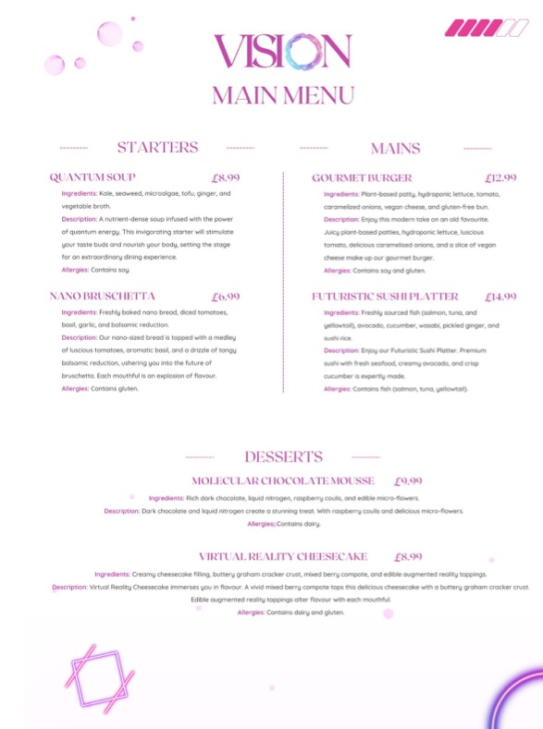
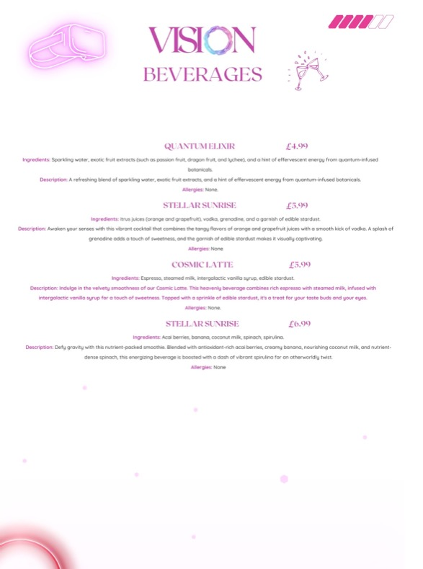

References
Blagojević, I. (2023). Virtual Reality Statistics - 2023 | 99firms. [online] Available at: https://99firms.com/blog/virtual-reality-statistics/#gref [Accessed 9 Jun. 2023].
Graham, C. (2023). Kick Back With a Classic Tequila Sunrise. [online] The Spruce Eats. Available at: https://www.thespruceeats.com/tequila-sunrise-recipe-760754 [Accessed 9 Jun. 2023].
Hardy, M. (2018). VR Is Coming to Restaurants: Here’s Why That’s Good News | Modern Restaurant Management | The Business of Eating & Restaurant Management News. [online] Modern Restaurant Management. Available at: https://modernrestaurantmanagement.com/vr-is-coming-to-restaurants-heres-why-thats-good-news/ [Accessed 9 Jun. 2023].
Hello Lifestyle (2023). Is Virtual Reality being used in restaurants. [online] Hello Lifestyle Magazine. Available at: https://hellolifestyle.co.za/is-virtual-reality-being-used-in-restaurants/ [Accessed 9 Jun. 2023].
Hurix (2023). 7 Benefits of Using AR/VR Technology in Employee Training. [online] Hurix Digital. Available at: https://www.hurix.com/benefits-of-using-ar-vr-technology-in-employee-training/ [Accessed 9 Jun. 2023].
Lacoma, T. (2023). What is VR? [online] Digital Trends. Available at: https://www.digitaltrends.com/computing/what-is-vr-all-the-basics-of-virtual-reality/ [Accessed 9 Jun. 2023].
Munjal, H. (2020). Council Post: Applications Of Virtual Reality For Restaurant Brands. Forbes. [online] 11 Dec. Available at: https://www.forbes.com/sites/forbesbusinesscouncil/2020/12/14/applications-of-virtual-reality-for-restaurant-brands/?sh=234ea3744295 [Accessed 9 Jun. 2023].
MUSUBI KILN. (2022). MUSUBI KILN. [online] Available at: https://musubikiln.com/collections/table-setting-24-modern-sushi-set-with-ash-graze-mino-plate [Accessed 9 Jun. 2023].
Octopod VR. (2020). Octopod VR - news and press releases. [online] Available at: https://www.octopodvr.com/blog/what-is-market-for-vr-venue-17 [Accessed 9 Jun. 2023].
Petrenko, V. (2021). 8 Uses of VR and AR in Food and Beverage Industry. [online] WeAR. Available at: https://wear-studio.com/8-uses-of-vr-and-ar-in-food-and-beverage-industry/ [Accessed 9 Jun. 2023].
Rahal, A. (2021). 3 enterprise uses for virtual reality. [online] CIO. Available at: https://www.techtarget.com/searchcio/post/3-enterprise-uses-for-virtual-reality [Accessed 9 Jun. 2023].

