

Assignment Title: Workplace Culture and Its Impact on Organisational Efficiency

Student name | Bola Makwaza
Student No | 1706320
Module BMSK | 5005

Executive Summary

Workplace culture is a common term to describe how the whole overall attitude and behaviour among the employees is within the workplace and also to understand the relationship dynamics between the organizational stakeholder. The workplace also provides many things such as long-term visions, creative ideas and excellent productivity.
On the contrary, organizational efficiency is the success of all the employees being able to deliver activities and tasks which are by the organisation. On other hand, organizational efficiency refers to the success of the organizational employees in delivering on tasks and activities as directed by organizational objectives. Hence, workplace culture as described as the attitude of employees in achieving organizational goals and objectives and it is one of the key driving forces in achieving organizational efficiency.
This is a detailed discussion over the various matters relating to workplace culture and its due impact over organizational efficiency in the context of my own experience from the Stratford Hotel situated in East London since the hotel is a branch of a global hotel chain and has multicultural implications over the organizational tasks and activities.

Table of Contents

Executive Summary 2
1.0 Introduction: 4
1.1 Background: 4
Critically assess the workplace culture of the organisation. 4
2.0 Organizational culture, ethos and values: 4
2.1 Organizational structure:[.Fayolism] 5
2.2 Different organizational relationship among people: 7
2.3 Communication channels in organization: 9
Critically evaluate the cultural and ethical behaviour present in the organisation and evaluate your own cultural and ethical behaviour in relation to the organisation. 10
2.4 Personal ethical standards, values and belief: 10
2.5 Corporate social and environmental responsibility: 10
2.6 Establishing a culture of sustainability for operation management: 11
2.7 Barriers within the organization impacting upon the operational management and decision-making: 12
Provide a critical evaluation of an organisation and the broader environment in which it operates. 13
3.0 SWOT Analysis: 13
4.0 PESTLE Analysis: 14
5.0 Conclusion: 16
References: 17
Appendices:………………………………………………………………………………...18

1.0 Introduction:

There has been a long-term debate on whether organisational culture is better than efficiency and has been an important issue that’s been discussed many times. Within various scholarly discussions and analysis, the most important motivational factor for employees to continue working to the best of their ability is the workplace culture.(Cork, 2011). In this assignment, the relation between organizational structure and workplace culture and the different modes for a relationship within the workplace will be discussed and covered. Ethical values and beliefs of mine will be shared and my thoughts on achieving organizational objectives within the Stratford Easy Hotel in East London. Other issues such as sustainable operations management, effective performances and the barriers that possibly will come with them will be discussed. A quick environmental business analysis for Stratford Hotel will be included also.

1.1 Background:

Stratford Easy Hotel is a London based super budget hotel chain that operates in 36 locations around the globe including Scotland, Germany, Spain and Netherlands. Presently, served country counts to 10 and cities to 30. Founded during 2004, the hotel chain started operating in 2005. Presently, the hotel chain provides super budget hotel rooms through 11 owned hotels and 25 other franchised hotels. The branch of Stratford Hotel in Croydon was acquired by the easy group in 2014 and is known for its clean, comfortable and safe accommodation. The hotel is also conveniently situated near Gatwick Airport and Brighton and is only a 15 minutes journey away from London (Stratford Easy Hotel, 2019). The widespread operation around the globe has impacted the hotel to acquire a global context in all its branches and franchises as employees and customers from various cultures interact regularly within this workplace and make up the workplace culture which is a contributing factor for its organizational efficiency.

Critically assess the workplace culture of the organisation.

2.0 Organizational culture, ethos and values:

Shared perception and communication amongst other people is culture. Principles, communication styles and behaviour led by value is organizational culture and it helps with the process of achieving company goals and objectives. Employees need to have the right attitude and behaviour for the workplace environment in order to maintain organizational culture (Hodgetts, 2003). There are also many other assumptions and rules that the whole workplace is included in.
Ethos are the behaviours and attitudes that are influenced by workplace culture and organizational strategies and objectives help form it. The workplace needs principles to keep everything maintained.
Every individual experience their own life experience which contribute to the specific norms and values and behaviours an employee has, which helps them from knowing the difference between right and wrong. (Shahzad, 2012). Their beliefs that they use while socially interacting are also known as their values.
For example, the ethos within Stratford Hotel Croydon is down to how each employee’s own particular aspects on values, also helping with customer service and providing a friendly workplace.

2.1 Organizational structure:

Fayolism
This work management theory has 14 principles to sum up how an individual should mange themselves as employees.

1.Division of work
2.Authority and Responsibility
3.Discipline
4.Unity of Command
5.Unity of Direction
6. Subordination of individual interest
7.Remuneration
8.The Degree of Centralization
9.Scalar Chain
10.Order
11.Equity
12.Stability of Tenure of personnel
13.Initiative
14.Esprit de corps
The third principle on Discipline was relatable to me, without having it would make you unemployable and many compagnies would not like to work with you.
Fifth principle is on unity of Direction which expands on the fact that working as a team is very important for the business.
The seventh principle is Remuneration, this to encourages employees to carry on working hard and get good compensation
His ninth principle is Scalar chain ,this principle give help to customer without challenging the hierarchy in any circumstance .
The tenth principle Order talk about organisation in the workplace. How to clean and safe the workplace for customer who coming in .
All these principles relating with any employees or any organisations ,encourages employees to be more involved at the workplace and get success.

The hierarchy of people in an organization that also helps understand the level of responsibilities and accountability is called an organizational structure. The authority over any issue in the organization is easily traced using such structure and hence can be helpful in smooth organizational activities as well as emergency operations (Lee, 2004). Therefore, organizational structure can be defined as the hierarchy of authority, responsibility and accountability over certain departments of activities among employees and management.
Organizational structure can vary by size and scope of an organization. For example, by size, an organization can be large, medium or small or a micro organization. While small or micro organizations are those earning up to £5.6m, medium business earn between £5.6m to £22.8m and large ones earn more than that. While the parent organization to this organization in discussion is a larger business, the Croydon branch can be termed as a medium business separately.
Although, by the businesses scope, they work as a public limited company and have a bureaucratic organizational structure for their central operations and other businesses are mostly post-bureaucratic.
The Easy Hotel’s organizational management is below-

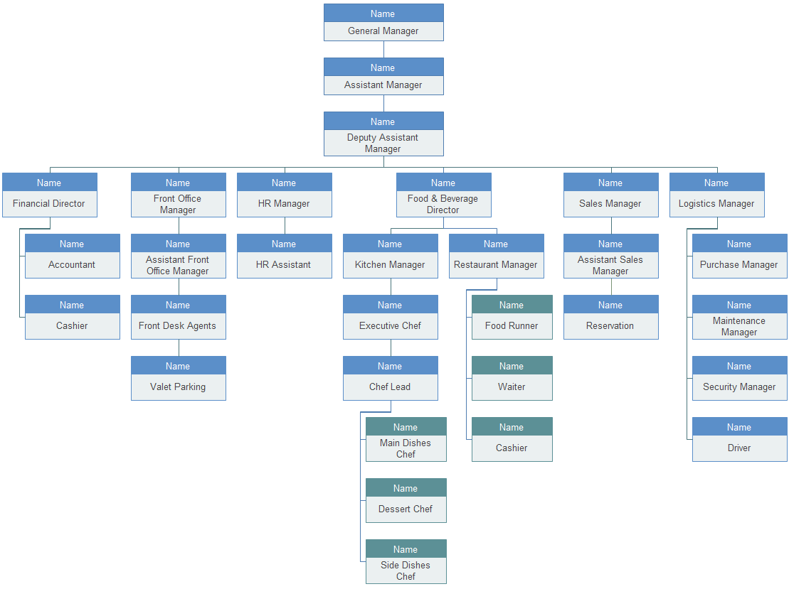
Appendix A

Administration, operators and executives. The main skill base department are administration, executives and operators where managers from each department have their own subdivisions to plan, organize, direct and control. The branches also maintain this, although each separate department has their own structures of hierarchy. For example, the following is an authoritative hierarchy of housekeeping in a hotel where there are subdivisions such as floor duty, horticulture, desk duty, linen, etc.
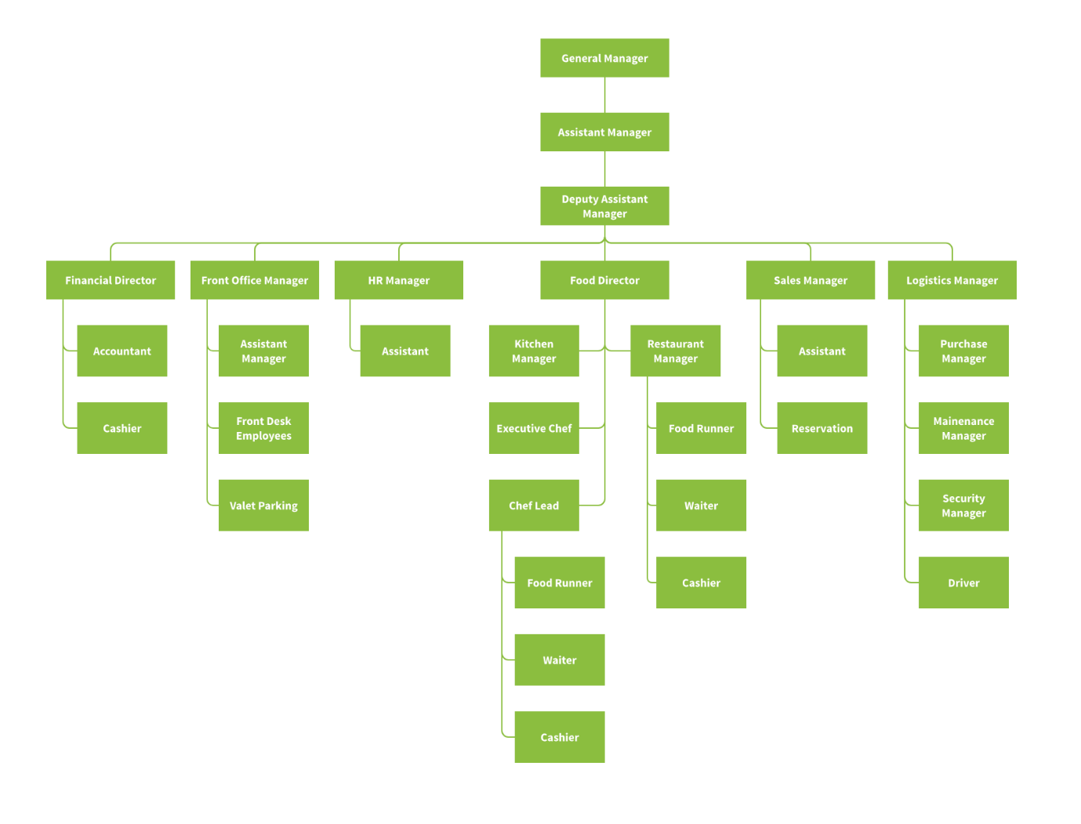
Appendix B:

2.2 Different organizational relationship among people:

Organizations consist of individuals, machines and resources, etc. The human resource team works together significantly to organise any financial or materialistic issues which determine organizational efficiency. Workplace culture makes sure everything is done in a specified and acceptable manner (Deal, 2011). So, formal and informal relationships come from that notion. Informal and formal relationships have to exist in order to successfully achieve organisational goals.
Formal relationship: These are the relationships that are built within the workplace and maintain organisational hierarchy and are mostly formal in nature. These relations are premeditated and have scheduled meetings once in a while. They maintain codes of conducts, regulations and responsibilities and formal relationships are mainly based on groups who possess skills and have a degree of excellence and qualifications.

Formal relationships are formal structures within organizations and are divided into 3 possible structures. The Matrix structure is where formal power and rapport remains in both up-to-down structures as well as informal side-to-side structures (Alvesson, 2012). Divisional structure uses special business units (SBUs) to help with taking care of specialized skills-based activities within organizations, although the functional structure is rigid with vertically distributed responsibilities according to accepted authority.
Appendix C:
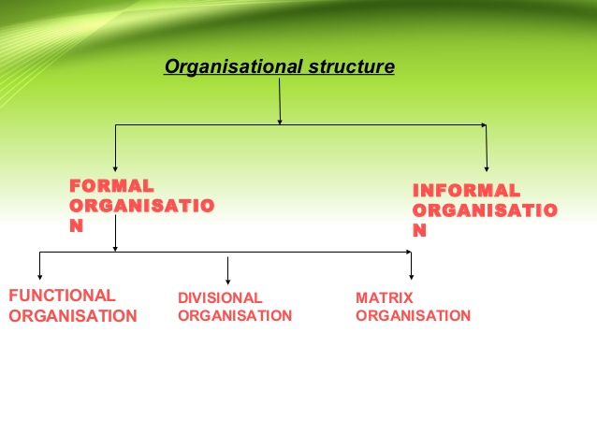
- Informal relationship: In post-bureaucratic organizational structures, informal relationships are very common. Informal relationships are built when ideas, values, professional skills are collaborated on the same level playing field among various positions of employees (Handy, 1985). These days, these kinds of organizational relationships are most common as I have experienced them as well. While formal relationships help give structure to responsibility and accountability over work allocation, informal relationship works as a bond among employees that drives them into achieving the same goals and objectives for their organization.
According to the assertion of Maslow’s need hierarchy, people tend to feel more obligated in achieving certain things in life. This need hierarchy shows that after earning own basic rights to food, shelter and safety, etc. what people crave for is feelings of social inclusion. Since, in global organizations such as the Stratford Easy Hotel branch in Croydon, there are employees and customers from different cultures, they can share information and build relationships based on collaborative creativity and social satisfaction of interaction with each other in unofficial contexts such as feedback provision by my seniors and cooperative decision-making for emerging problems.

Complexities in organizational relationships in transnational, global and international business:

Many hotels are constantly a working progress and so there are multiple workplace relations that are complex, and they become even more apparent if the business is a transnational, global or international organization. According to my workplace experience from Stratford Easy Hotel, I have found that complexities remain when using formal relations and communication channels to to use formal relations and relevant communication channels or whether to use informal communication among informally built organizational relations to be faster.
The effect of trans-national, global and international organizations in experiencing complexity lie in the fact that each accommodate multiple cultures and values from employees makes it harder to express the right way of work and communication since, ideas about gender, collective consciousness in society, power distribution, risk perceptions, etc. vary by different cultures and the country legislations such as employment law, workforce distribution policies, health and safety in workplace creates complexities as well in such organizations and balancing among various national always creates the complex situation. (Hodgetts, 2003).

2.3 Communication channels in organization:

Communication is a vital necessity in any organization in order to continue flow of work according to organizational management. When the organizational workplace is a place where different cultural employees cooperate, communication is the one bridge that fills all the gaps in this flow of work. Communication therefore is the sharing of ideas, expression of feelings, etc. in a successful manner so that others can understand the idea behind those ideas, feelings with proper exchange (Prince, 2011). Communication channels in organizations talk about the methods, or ways to approach and conduct a fruitful conversation among executives, managers or co-workers, etc. in workplaces. Some communication channels are Done.
Formal communication: The exchange of information that regularly maintains the chain of command inside organizations and can be in different forms for e.g. reports, business proposals, press release etc.
Informal communication: Social media and the non-organizational methods that have been sued by because of expressing feelings and information from workplaces because of the information being provocative.
Oral and verbal communication: Communication done by exchanging information and ideas through speech, word of mouth, call, etc. It is mostly informal, yet formal, so can be used in our organization.
Non-verbal communication: Hand gestures, body language, etc. Used when contributing to shared information by an organisation.
Written communication: The majority are formal affairs in day to day organizational activities. The methods in our hotel takes the form of organizational performance report, financial reports, memos, email, letters, etc. (Browaeys, 2011). Nowadays, written communication can be informal by being used in social media or formal if talking to another colleague.
My observation of the workplace inside Stratford Easy Hotel in Croydon suggests that there are various methods of communication channels used every day. The organization uses written communication channels mainly and some formal verbal communication as well in order to stay connected to the parent organization. Although with, daily information exchanges and for building professional relationships, either verbal or non-verbal and other communications they are used more extensively.

Critically evaluate the cultural and ethical behaviour present in the organisation and evaluate your own cultural and ethical behaviour in relation to the organisation.

2.4 Personal ethical standards, values and beliefs:

Personal ethical standard is defined by a person’s own perceived sense of right and wrong away form a group setting. These kinds of considerations are part and parcel of every human being and dictates much of the behaviours and attributes of each personnel (Rogoff, 2003). Ethical standards may shift upon encountering the consequences to go away from an intended consequence.
Values on the contrary are more rigid in terms of it being what an individual has grown to respect from childhood to present time. So, beliefs are similar as they’ve all stemmed from a person’s primary socialisation It is part of an individual’s upbringing and that upbringing can really affect how a person’s attitude and behaviour is like in certain situations at work. Beliefs, hence, refer to abstract ideas and understanding that have less to do with experience as opposed to values yet much more similarly inherent in nature.
From my experience at Stratford Easy Hotel in Croydon, personal ethical standard, beliefs and values really do play important roles when considering achievement of organizational objectives. For example, my values as an employee in the organization pushes me to deliver the best form of customer service, which reinforces my own personal ethical standards and values on individuals; to treat everyone the way you would want to be treated.

2.5 Corporate social and environmental responsibility:

Corporate social responsibilities refer to the business organization being responsible for Its own actions to the society and as a result contribute through charity, build better public infrastructure in communities, and providing better employment etc. Corporate social responsibilities or CSR is self-regulation implemented by private international organizations worldwide (Alvesson, 2012). It is evident that corporations and large firms following CSR rightly attract more customers to their business since their sense of responsibility speaks volumes of their positive mind set and aspirations for a better society and better living standards for these people. DONE
Environmental responsibilities refer to the business organization being well aware of their own impact over the degradation of the environment. In that sense, it is expected that after being aware of environmental damage, they are able to follow the proper steps to become an environmentally-friendly business. Environmental pollution and global warming and its increasing impact have made people around the world realise that many huge organisations are the root of these environmental issues and as an outcome organisations choose to follow environmental legislations, so carbon emissions are lessened and proper disposal is of use to make the surrounding environment better.
Hence, workplace cultures maintaining CSR and environmental concerns are being held in high regard and this is eventually helping gain job satisfaction among employees leading to better organizational efficiency. According to my experience from Stratford Easy Hotel in Croydon also it is true as well. We try being environmentally responsible to maintain all environmental laws and acts and employ a portion of our employee from surrounding the community as part of CSR.

2.6 Establishing a culture of sustainability for operation management:

Sustainability is the process that revolves around something being long-lasting by focusing on balanced actions and resource use. Culture of sustainability refers to workplace culture and how it maintains a balanced approach to work and policy generations for organizations and an equal work distribution in organisational management (Mujtaba, 2008). Establishing a culture of sustainability in organizational management creates workplace culture that involves sharing ideas in a dynamic and diverse learning environment. Refers to the creation of workplace culture that allows for idea sharing in a diverse dynamic and learnable environment. The next steps establish the different ‘cultures’ within Stratford Easy Hotel in Corydon:
- 1st Step: Understand how sustainability is important all while contributing to workplace culture.

Sustainability should be envisioned and translated to an organisational point of view.
Plans on sustainable initiatives should be realistic and appropriate and when implying to a different context too.
- 2nd Step: Follow plan through especially while making decisions and with every other aspect in order to reach sustainability goals within an organisational culture of work.
- 3rd Step: Make sustainable approaches a constant habit by actually promoting these concepts in normal day-to-day workplace scenarios.
- A significant consideration is not to only implement sustainability goals in professional activities but for personal reasons such as for leisure also, so individuals are used to these new ways and will also sustain organizational efficiency

2.7 Barriers within the organization impacting upon the operational management and decision-making:

Barriers are environmental components that can be a negative influence for a potentially progressive operations which in turn can be an effective process. To achieve better organisational management or making more useful decisions, barriers can slow down or even stop the progression of work by creating disorganisation, (Prince, 2011). Barriers are those components in an environment that act as a negative influence over progressive operations for an otherwise effective process. When considering organizational management and decision-making for important issues of organizational activities, barriers are those phenomena that slows down or stops the smooth progress of work by disorganizing the stops of activities in or posing negative consequences to a decision in organization (Prince, 2011). According to my workplace experience in the Stratford Easy Hotel in Croydon branch, the followings are the barriers within organization that have negative influence over organizational management and decision making:
- Language barrier
It is a figurative term referring to inefficient transmitting information amongst individuals. In our hotels, regular communications are vital in maintaining efficient work management and decision-making. Which can all be overcome by guidelines that deal with situations where employers may not always be able to understand other languages, and so it ensures rapport can be made.
- Cultural difference
Different cultures have their own set of acceptable and non-acceptable behaviours which are usually expected to be followed by. Although as Easy Hotel in Croydon and Stratford is set in both London and Croydon, different cultures collide on a daily basis and it does come with its disadvantages such as can cause confusion fox different acceptable behaviours which is expected to be maintained. But, in places like Easy Hotel in Croydon, different cultures collide, and this creates confusion for e.g. English natives are usually sharp with timing whereas Latin American tourists are more relaxed with their timing creating a barrier in effective management. However, being at all-time best performance during work hours for every employee can easily deviate any negative consequences.
- Emotional response
Every person perceives different situations differently and so everyone’s response is varied. Each person perceives certain situations differently and as a result their response is also varied. Emotional response can therefore be proven as an effective barrier for efficient organizational functioning and even decision making. Also, emotional responses to one situation while deemed appropriate can be completely offending in another situation quite similar in view yet dissimilar in content (Lee, 2004). The employees in our hotel are trained correctly from their first day to express standard emotional response and are always given supervision in handling situations where a customers’ emotional response may play a role.

- Hostile stereotypes
Hostile perception over stereotype can also be a barrier stopping efficient organizational functioning. A stereotype is a generalized concept about certain individuals or groups within society in social psychological terms. Harmful behaviour such as bullying can be formed within the workplace when hostile perceptions over stereotypes are created and it can also lead to disagreements between employees and customer negligence (Cork, 2011) And so, it is found that Hence, we found that, this barrier can be overcome by increasing awareness over issues such as equality of races, religions and ethnicities in all operational management steps of the hotel. Also, encouraging more acceptance for varying people among employees and praising better attitudes may prove to be helpful.

Provide a critical evaluation of an organisation and the broader environment in which it operates.

3.0 SWOT Analysis:

Analysing the company’s environment internally and externally helps notice specific attributes of the organisation’s business and the strengths and weaknesses from the company, which is very useful for analysing in detailing the possible flaws of a company. A micro environmental analysis is a type of analysis which helps with providing a detailed and thorough analysis on the behaviour of employees’ and employee-employer relationships, which all can regulate organisational performance (Mujtaba, 2008).
This following SWOT analysis uses the micro environmental analysis technique to conclude on all the useful and flawed components internally and externally of the Easy Hotel in Croydon: -

 | Helpful | Harmful
Internal Origin | Strength  - The Croydon branch of Easy Hotel has a convenient position for both international and local tourists.  - The room hire cost is very cheap and is attractive for customers.  - The organizational efficiency in providing safe and comfortable accommodation effectively in a multi-culturally accepting environment is extremely alluring about the business. | Weakness  - Legal rules and regulations in the industry is still forming and can be seen as a weakness to organizational operation management.  - There are a lot of competitors for Easy Hotel in Croydon posing threats of substitution.
External Origin | Opportunities  - Technology based operations in the future can help the business achieving better efficiency and thus better profitability.  - It has been helping employ unemployed population from communities making it positively regarded in the field. | Threat  - Parliamentary legislations at present are being newly formed and implemented and can be proven as a threat in future due to strict restrictions in achieving the already perceived workplace culture.

4.0 PESTLE Analysis:

Macro environment are the factors that affect the business which cause indirect implications to the company’s achievements and goals (Lee, 2004). They can be realigned with the economic operating region, parliamentary laws and governmental regulations, etc. There can be many positive and negative impacts because of the various associations, which will be discussed for the Stratford Easy Hotel in Croydon through using a PESTEL analysis.

Factors | Positive/Negative Impacts
Political | Political factors of macro environment include governmental stability, taxation regulations, foreign trade policy, and government expenditure over businesses, etc. The recent world politics as well as England’s decision to break away from EU (Brexit) has led to various changes in these aspects that have been affecting business in varying strengths both positively and negatively.
Economic | Economic considerations such as fiscal policies, interest rates, unemployment rate, inflation, monetary policies, etc. are part of company’s economic influences. The recent economy of the country has been changing and as a result uncertainty lead to various disruptive concerns relating this aspect which are usually negatively affecting the organization.
Social | Population distribution, demographic view over education and lifestyle, wealth distribution, etc. works as social factors of influence on business organizations. These aspects as well as changing values and norms being more accepting of diverse cultures is leading to better organizational efficiency.
Technological | New technological platforms as well as their speed of transforming various business aspects impact over business operations. The new age technological solutions are making organizational work across multi-cultural platforms more fruitful and achieving even greater organizational efficiency.
Environmental | Environment protection legislations and awareness relating to obtaining pollution free environment through responsible business operation is the talk of this generation. Businesses keeping its operations open for becoming better environment friendly organizations are deemed as more appropriate.
Legal | There are various legal obligations that dictate the organizational culture and determines effectiveness of organization operations such as labour law, contract law, data protection act, equality act, minimum wage and employment law as well as workplace health and safety law. The workplace of Easy Hotel, Corydon is influenced by any change in these legal rules.

The SWOT analysis found some relevant strengths and weaknesses of Stratford Easy Hotel in Croydon, while external macro factors such as social, political, legal and technological factors can be seen to have interrelated assertions with the issue. As Easy Hotel operates on a worldwide scale it has to respect and follow international laws. Although, the branch in Croydon has to cater specifically to the UK parliamentary legislations in terms of operating and employing individuals. A strength of the hotel is that it helps the unemployed population to earn for their livelihood within communities. On the other hand, as the use of technology gets more and more popular the business starts to realise how useful and effective technology can be, using it to their advantage. Finally, legal policies and rules can be complicating for a business as they can vary because of many different reasons which in turn can affect the business. Therefore, stating how macro factors are a huge influencing factor on the strengths and weaknesses of companies, affecting the organisational efficiency in a workplace.

5.0 Conclusion:

The culmination of many considerations that are deemed to be ethical is also known as organizational culture and can also include personal values of employees and collective beliefs. In a general work setting, being able to have effective work performance and productivity is organisational efficiency. The most significant factor is organizational culture which has an immense effect with organizational efficiency, because of many causes that start with the component of organisational structure. In many international businesses it is evident such as in The Easy Hotel in Croydon, London.

References:

easyHotel. (2019). AbouteasyHotel | easyHotel. [online] Available at: https://www.easyhotel.com/about-us.
Alvesson, M (2012) Understanding organisational change. (Online) London: Thousand Oaks, Calif: Sage Publications http://www.tsd.ac.uk/en/lrc/onlineresources/e-books/
Browaeys, M., Price, M., & Price, Roger. (2011). Understanding cross-cultural management (2nd ed.). Harlow: Financial Times Prentice Hall.
Cork, T. (2011). Unlocking great workplace culture. Canadian HR Reporter, 24(19), 34.
Deal, Prince, Deal, Jennifer J, & Prince, Don W. (2011). Developing Cultural Adaptability How to Work Across Differences (J-B CCL (Center for Creative Leadership)). Hoboken: Wiley.
Hodgetts and Luthans, F. (2003). International Management: Culture, Strategy, and Behavior. New York, McGraw-Hill/Irwin, Fifth Edition.
Shahzad, F. (2012). Impact of Organizational Culture on Organizational Performance: An Overview, Interdisciplinary Journal of Contemporary Research in Business, Vol 3, no.9.
Handy, C. B. (1985). Understanding Organizations: 3rd ed. Harmondsworth: Penguin.
Lee, S.K. J. and Yu, K. (2004). Corporate culture and organizational performance. Journal of Managerial Psychology, Vol. 19 Issue: 4, pp.340-359, https://doi.org/10.1108/02683940410537927
Mujtaba, B. G. (2008). Coaching sand Performance Management: Developing and Inspiring Leaders. ILEAD Academy Publications; Davie, Florida, USA. ISBN: 978-0-9774211-4-5.
Prince, Hoppe, & Prince, Don W. (2011). Communicating Across Cultures (J-B CCL (Center for Creative Leadership)). Greensboro: Wiley.
Rogoff, B. (2003). The cultural nature of human development. Oxford: Oxford University Press.

Appendix:

Appendix A:
http://www.orgcharting.com/hotel-organizational-chart/
Appendix B:
https://www.lucidchart.com/blog/org-chart-templates
Appendix C:
https://www.slideshare.net/aamishpandoh/different-organisational-structure-24766323

