  Component One:  What are the key skills required when working in the housekeeping team? 750 words (+/- 10%)  Contribution to Overall Module Assessment: 25% | Student No: | 2120134
 | Module Title: | Operating Hotel Facilities Autumn Term 2023
 | Module Code: | BMIH4006
 | Lecturer: | Natalie Brailsford  Dan Payne  Neil Dyer,  Muhammad Cassamo  Scott James
 | Student No: |  | 2120134
My readings, research and experience of working in the Travelodge hotel’s housekeeping team has helped me to realize that the following Qualifications and Skills are necessary to work in hospitality industry.
Persistence and determination.
- The ability to use initiative.
- Patience and the ability to remain calm in stressful situations.
- To be thorough and pay attention to detail.
- To be flexible and open to change.
- Customer service skills.
- Knowledge of human resources and employment law.
- Business management skills. (wiki How, n.d.)

According to (indeed, 2020), A Hotel Housekeeper must have excellent communication and organizational skills, strong interpersonal and problem-solving abilities and should be highly responsible & reliable. A Hotel Housekeeper also should have the ability to work cohesively as part of a team. (INTERPERSONAL SKILLS AT WORK, n.d.).
So to improve skills and to enhance experience, I believe, an employee should follow a model of reflection in work place.
Models of reflection are models which help us to engage in the process of reflection. (Canterbury Christ Church University, n.d.). There are different models of reflective practices used in work places to help to reflect on an employee’s skills, experience and link to theoretical principles. Such as KOLB’s Learning Cycle 1984, Gibbs’s Reflective Model and Donald Schön’s Model of Analytical Reflection.
After learning about different types of reflective models, I have chosen Kolb’’s model because I agree with Kolb’s theory that ‘learners must pass through four distinct stages and experience alone does not provide a sufficient learning experience in many situations. (Kolb et al., 1999).
Kolb described the four stages of his model in the name ‘cycle of experiential learning’ as per the following diagram.
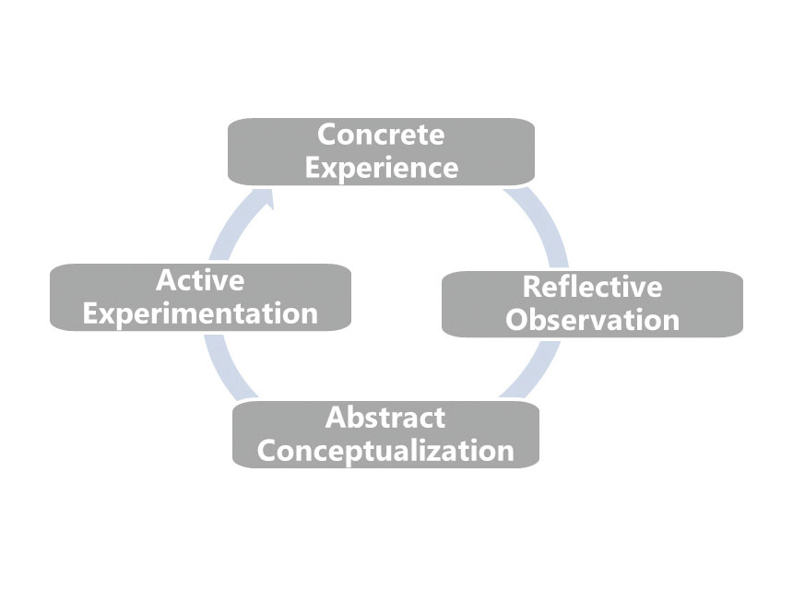
(The Training Thinking, 2015)

The first stage of Kolb’s reflective model is Concrete Experience. It relates to our everyday experiences, whether they occur in professional, personal or educational settings (Cress et al, 2013).

My concrete experience is my day to day duties in my job with my hotel colleagues. As a member of the hotel’s housekeeping team, every day I’m learning something. By utilizing my quick learning skill, I’m improving my professional dealing with hotel customers in a friendly manner. My daily experience of working as a part of a team is also making me a better team player. I also view this concrete experiences as learning opportunities for my team members. That is why I as a team manager, try to help my colleagues to see their own concrete experiences as valuable chances for their professional and personal development.

Reflective Observation is the second component of Kolb’s model of reflection. It naturally occurs after facing new experiences. It is important for managers to consistently reflect upon their experiences and adjust their approaches for solving new challenges and making critical organizational decisions (McLeod, 2013).

Here I can share my experience. Once one of my housekeeping team members failed to clean the hotel room to expected standard. I as her line manager, instead of criticizing her, reflected on her previous success and encouraged her to do her best. That worked well. I found that experience motivating.

Kolb’s next step is Abstract Conceptualization. It takes the reflective process a step further by focusing on channelling reflective observations into a set game plan or theoretical approach (Brown, 2015).

For example, once I had a negative experience communicating with one of my colleagues. When I suggested ways for his professional improvement, he did not respond well. So I thought he was not easily approachable. But through consistent positive interactions, I found that he responds better to different approaches. From that experience, I learned to reflect upon my assumptions and work out better strategies for self and others by observing their response. That also helped me to realize that ideas are not permanent, instead should be constantly revaluated, revised and tested at conceptualizing stage.

So from my learnt experience, I now practice new approaches, tactics and more effective interactions with my team members to maximize their job outcome and learning potential.

Active Experimentation is the fourth component of Kolb’s model of reflection which deals with the process of testing existing ideas by creating new experiences (coachfoundation.com, 2023). In my workplace, I use the active experimentation process and get hugely benefited. In the abstract stage, I learn theories based on observations in the reflective stage, and then I put those theories into practice in active stage. In the process,

I have learnt that, this stage of experiential learning is related to the concept of scientific experimentation, in which an individual forms a hypothesis based on existing ideas and tests the validity of these ideas in a structured experiment.

That is why in my managerial role, I try to use all available tools and resources to make effective decisions and carry forth action.

Word Count | 796

Component Two:
Contribution to Overall Module Assessment: 25%
Problem | Why did it happen? | What are you going to do? | How will you prevent this from happening in the future? | What measures would you introduce to improve team effectiveness?
The guest complained that the bed cover was dirty in his hotel room. | Investigation launched after complain made found that the bed cover was not changed after the previous guest left. | Will send an apology to the guest. Will thank him for drawing our attention to the issue. Will promise to fix and improve. Will offer a discount voucher for future booking. | Will check if the room is properly ready before the guest arrives. Will make sure the bed covers are changed and washed each time after guest leave. | Will hold daily morning briefing of the housekeeping team. Will arrange regular training and weekly staff meeting to improve team effectiveness.
Toilet was not clean enough, stains were visible in cistern | Staff forgot to clean the toilet after the previous guest left. Staff did not check the toilet before the new guest arrives. | Will send an apology to the guest. Will thank him for drawing our attention to the issue. Will promise to fix and improve. Will offer a discount voucher for future booking. | Will make sure the toilets are being cleaned every day and every time after a guest leave. Will check if the toilet has been cleaned properly before a guest arrives. | Will introduce and follow a model of reflection to evaluate staff and our work standard. Will communicate with team members with constant positive interactions. Will appraise for good work and will give corrective feedback for mistaken task.
Room had bad smell, | Room was not ventilated well. All the windows were shut. So the body odour from the previous guest could not escape, | Will send a letter to the guest to explain the reason and to ask for his/her discretion. Will give discount on future stay. | Will make sure the room is ventilated well. Will open windows and doors to allow fresh air to flow in and polluted air to go out. Will use air freshener before a guest arrive, | Will discuss customer issues with the team. Will welcome opinion and will implement effective suggestion.
Room TV did not work | TV remote was not working because batteries were out of charge. | Will send an apology to the guest. Will offer a discount voucher for future booking. | Will make sure the TV and remote are working before the guest arrives. Will check if new batteries needed after the guest depart. | Will provide examples of best industry practices to inspire team members to aspire for the best standards.
Floor was dirty, furniture were dusty | Housekeeping staff did not clean the floor properly. Furniture was not dusted regularly. | Will acknowledge the mistake and will say sorry to the guest. Will offer a discount voucher for future booking. | Will use Room Cleaning Check List to check if anything is left to do to prepare the room before guest arrive? | Will use an Employee Engagement Model to improve team effectiveness

References:
Brown, N. (2015). Reflective Model according to Kolb. [online] Dr Nicole Brown. Available at: https://www.nicole-brown.co.uk/reflective-model-according-to-kolb/.
Canterbury Christ Church University. (n.d.). Models for reflection. [online] Available at: https://www.canterbury.ac.uk/learning-skills-hub/introduction-to-reflection/models-of-reflection.
coachfoundation.com. (2023). Understanding Kolb’s Cycle Of Learning [Guide For 2023]. [online] Available at: https://coachfoundation.com/blog/kolbs-cycle-of-learning/.
indeed (2020). Guide to Housekeeping Skills (With Tips and Examples) | Indeed.com. [online] www.indeed.com. Available at: https://www.indeed.com/career-advice/career-development/housekeeping-skills
INTERPERSONAL SKILLS AT WORK. (n.d.). Available at: https://www.hzu.edu.in/uploads/2020/9/Interpersonal%20Skills%20at%20Work.pdf
Kolb, D., Boyatzis, R., Mainemelis, C., Sternberg, R. and Zhang, L. (1999). Experiential Learning Theory: Previous Research and New Directions. [online] Available at: https://learningfromexperience.com/downloads/research-library/experiential-learning-theory.pdf
Liston, K. (2021). 3 Employee Engagement Models for a Happier, More Profitable Workplace. [online] ContactMonkey. Available at: https://www.contactmonkey.com/blog/employee-engagement-models.
McLeod, S. A. (2013). Kolb - Learning Styles. Retrieved from www.simplypsychology.org/learning-kolb.html
setupmyhotel.com. (n.d.). Types of Room Cleaning Chemicals / Taski Cleaning Agents (R1 to R9) | Housekeeping. [online] Available at: https://setupmyhotel.com/train-my-hotel-staff/hk/457-taski-chemicals.html.
The Training Thinking (2015). The Training Thinking | The Four Stage Learning Cycle by David Kolb. [online] Thetrainingthinking.com. Available at: https://thetrainingthinking.com/en/the-four-stage-learning-cycle-by-david-kolb/.
Travelodge (2020). Our company - Travelodge. [online] Travelodge. Available at: https://www.travelodge.co.uk/about/our-company/.
wikiHow. (n.d.). 15 Basic Skills You Need to Be a Good Housekeeper. [online] Available at: https://www.wikihow.com/What-Basic-Skills-Do-You-Need-to-Be-a-Good-Housekeeper.
www.custominsight.com. (n.d.). What are the Key Principles of Employee Engagement? [online] Available at: https://www.custominsight.com/blog/what-are-key-principles-of-employee-engagement.asp [Accessed 31 Oct. 2023].
www.leapsome.com. (n.d.). 6 Employee Engagement Models for a Thriving Workplace. [online] Available at: https://www.leapsome.com/blog/employee-engagement-models.
www.rubbermaidcommercial.com.au. (n.d.). 7 safe housekeeping practices brands should follow. [online] Available at: https://www.rubbermaidcommercial.com.au/blog/hospitality/7-safe-housekeeping-practices-hospitality-brands-should-follow/.
www.tripadvisor.co.uk. (n.d.). THE 10 BEST Clean Hotels in England 2023 (Prices) - Tripadvisor. [online] Available at: https://www.tripadvisor.co.uk/HotelsList-England-Clean-Hotels-zfp14895483.html

