The Siege of Platea
Figure 1: Map of the Greek peninsular including Platea during the Peloponnesian War, by wildeastmofo (2011)
The Siege of Platea was a Spartan led siege over the Athenian stronghold city of Platea from 429-427 BC. The siege ended sometime around the summer of 427 BC after many of the troops fled in the winter of 428/7 BC after being besieged for 2 years (P.J. Rhodes, 2010). Our main source on the Siege is from Thucydides’ ‘History of the Peloponnesian War’. Thucydides is one of the main ‘historians’ writing about this period in history. However, Thucydides began writing his account of the Siege a number of years after the event, and he even wasn’t present at the siege to document its events (G. Cawkwell, 1997). An example being he states at the beginning of Book 2 that he only documents the events that occur in the winters and in the summers (Thucydides, 1954, Book 2. Chapter 7. Section 1). Therefore, his methodology approach effects the way we understand the siege as some of the details on the sequence of events are missing and his distance from the time of the siege means it’s his interpretation of events from the material, he had access to.
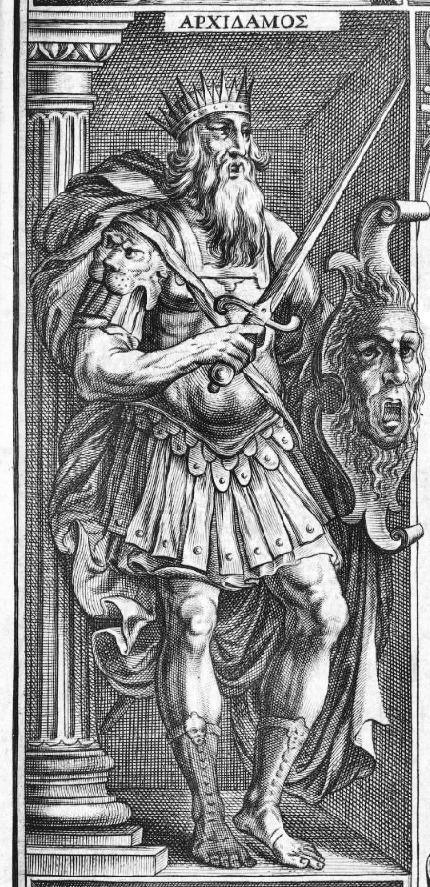
According to Thucydides, Platea was an Athenian ally and was on the crossroads between the poleis of Attica and Boeotia which made it a strategic stronghold to both the Athenians as a defensive city and the Spartans as a city to launch an attack into Attica (Thucydides, 1954, 2. 7. 2). When the outbreak of the Peloponnesian War happened, Thebes begun attacking the city in an attempt to capture it due to its strategic value (Thucydides, 1954, Book 2. Chapter 7. Section 2). However, by 429 BC, these attempts had gained no results (Thucydides, 1954, 2. 7. 71). So, in that year, the Spartan King Archidamos II (imaged on the left), moved his army to Platea and aided the Thebans in a siege of the city. The Peloponnesian decision to lay siege to Platea and not Attica again has been debated by scholars for years. In 429 BC, The Athenians were in the grip of the plague, which saw widespread cause in Attica but due to the naval blockade of the Peloponnese, the rest of mainland Greece wasn’t affected (Thucydides, 1954, 2. 4. 47+54), this meant that the Spartans were cautious about going near Athens in-case they caught the plague (Thucydides, 1954, 2. 4. 54-55). Also, growing pressure by Thebes on the Peloponnesian League to aid them in their attack on Platea (Thucydides, 1954, 2. 1. 2-3), may have influenced the Spartans reasoning to lay siege to the city as it meant that they could knockout an Athenian stronghold and help their Theban Allies, while avoiding contracting the plague ravaging Athens (P.J Rhodes, 2010).
Figure 2: King Archidamus II featured on the title page for the Eight bookes of the Peloponnesian Warre written by Thucydides the sonne of Olorus. (1629)
Due to uncertainty over Athenian support in the siege by the winter of 428 BC, many garrisoned inside the besieged city fled (Thucydides, 1954, 3. 3) and by the summer of 427 BC resulted in a Platean surrender to the Spartans and Thebans. In response to the end of the siege, the Spartans and her allies disused weather to allow Platea to survive by asking the soldiers who were captured whether they had done anything to help Sparta in the war? (Thucydides 1954, 3. 3. 68). The reply from each solider was no, and so the Sparta’s killed the 225 soldiers, enslaved the women and they raised the city to the ground and left it to dust (Thucydides 1954, 3. 3. 68).

Reference List:
G. Cawkwell (1997), ‘Thucydides and the Peloponnesian War’, New York, Routledge

P.J. Rhodes (2010), ‘A history of the classical Greek world, 478-323 BC’, 2nd ed, Chichester, West Sussex, U.K. ; Malden, MA: Wiley-Blackwell

Thucydides (1954), ‘History of the Peloponnesian War’, London, Penguin Group,

Unknown (1629), ‘Eight bookes of the Peloponnesian Warre written by Thucydides the sonne of Olorus. Interpreted with faith and diligence immediately out of the Greeke by Thomas Hobbes secretary to ye late Earle of Deuonshire’ [Ink Imprint], available at: https://commons.wikimedia.org/wiki/File:Archidamos_II_1629_woodprint.jpg (Accessed 19th January 2020)

u/wildeastmofo (2011), Reddit, available at: https://www.reddit.com/r/MapPorn/comments/68zb5u/a_detailed_map_of_the_peloponnesian_war_in_the/ (Accessed: 19th January 2020)

