

University of Wales Trinity Saint David

School of Engineering

Manufacturing Systems

Computational Methods
2D Diffusion Equation Model using the Explicit Finite Difference Method
ACMA6012

Joseph Lancastle
2214707
27/01/2025

Word Count: 5599
Adjusted Word Count: 3265

Contents
List of Figures and Tables 4
1. Introduction 5
2. Governing Equation 6
3. Numerical Method 7
3.1. Taylor Series 7
3.1.1. Forward Difference Approximation 7
3.1.2. Backward Difference Approximation 7
3.1.3. Central Difference Approximation to the First Derivative 8
3.1.4. Central Difference Approximation to the Second Derivative 8
3.2. Spatial Discretisation 9
3.3. Temporal Discretisation 10
3.4. Explicit Finite Difference Method 10
3.5. Stability Criterion 10
4. The Initial Boundary Conditions and Analytical Solution 11
4.1. Initial Conditions 11
4.2. Boundary Conditions 11
4.3. The Analytical Solution for Validation of Numerical Method 12
5. Code Detail and Explanations 13
6. Validation of the Code 20
7. Sensitivity Analysis 22
7.1. Grid Spacing 22
7.2. Time Step 23
7.3. Thermal Equilibrium Tolerance (TET) 24
8. Discuss Any Limitations of the Model 25
8.1. Limitations of the Model 25
8.1.1. Round-Off Error 25
8.1.2. Truncation Error 25
8.1.3. Stability 25
8.1.4. Geometric Limitations 25
8.2. Limitations of the Coding Approach 26
9. Suggested Improvements of the Model and Future Developments 27
10. Conclusion 28
11. References 29
12. Appendix 32
Appenix 1 32
Appendix 2 42

List of Figures and Tables
Figure 1: Example of Spatial Discretisation (Paipuri, 2014) 9
Figure 2: Opening Code Parameters 13
Figure 3: Code Main Loop. 13
Figure 4: Code Dimension Conversion. 14
Figure 5: Code Grid Spacing. 14
Figure 6: Code Stability Criterion. 15
Figure 7: Initial Temperature Condition. 15
Figure 8: Code Summary of Inputs. 16
Figure 9: Matrix Initialisation. 17
Figure 10: TET Display, 18
Figure 11: Analytical Solution Calculation 18
Figure 12: Display Results. 19
Figure 13: Comparison of Matrices. 20
Figure 14: Graphical Display. 21
Figure 15: Sensitivity Analysis Results: Grid Spacing. 22
Figure 16: Sensitivity Analysis Results: Time Step. 23
Figure 17: Sensitivity Analysis Results: TET 24
Table 1: Sensitivity Analysis Raw Data: Grid Spacing. 42
Table 2: Sensitivity Analysis Raw Data: Time Step. 42
Table 3: Sensitivity Analysis: Raw Data: TET 42

Introduction
This report details the development of a heat diffusion model using the Explicit Finite Difference Method (EFDM) to simulate the temperature distribution of a two-dimensional aluminium plate. The model allows user inputs, including plate dimensions, grid spacing, and initial boundary temperatures, using MATLAB for its implementation. The accuracy of the numerical solution will be verified via analytical solution comparison.
- Section 2: Governing Equation
Introduces the governing, parabolic heat equation, defining its importance and mathematical definition for an aluminium 2-Dimensional Plate.
- Section 3: Numerical Method
Describes how Taylor Series and EFDM are used to discretise the spatial and temporal domains and introducing the stability criterion.
- Section 4: Boundary Conditions
Defines the initial temperature conditions and the boundary conditions used for simulation. It also introduces the analytical solution used for comparison.
- Section 5: Code Details
Provides excerpts of the code in Appendix 1 and functional explanations.
- Section 6: Code Validation
Compares the numerical and analytical results to verify accuracy.
- Section 7: Sensitivity Analysis
Conducts a sensitivity analysis to assess changing various parameters and a discussion of their effects.
- Section 8: Limitations of the Model
Discusses the limitations of the EFDM and its implementation via MATLAB.
- Section 9: Improvements and Future Developments
Explores alternative numerical methods to remedy the limitations of the EFDM.
- Section 10: Conclusion
Summarises the findings of the report compares to the main aim of the report.
This report aims to developing an accurate, user friendly heat diffusion model that has verified efficacy via analytical solutions and a sensitivity analysis, highlighting improvement opportunities for modelling transient heat transfer problems.

Governing Equation

The governing parabolic heat equation used is fundamental for modelling heat transfer in solids. In this report, it describes how temperature evolves in a 2-dimensional aluminium plate, expressed by (Croft and Lilley, 1977) as:
$$\frac{∂^{2}T}{∂x^{2}}+\frac{∂^{2}T}{∂y^{2}}=\frac{ ρ ∙ c_{p}}{k}∙\frac{∂T}{∂t}$$
(2.1)

Where:
The aluminium plate’s material properties are predefined constants:
Thermal Conductivity: $k=143\frac{W}{m}.C$
Material Density: $ρ=2.8 ×\frac{{10}^{-3}kg}{m^{3}}$
Specific Heat Capacity: $c_{p}=795\frac{J}{kg}.C$
The equation models the rate of change of temperature within the material based on its thermal properties, developed by Joseph Fourier in 1822 to model heat diffusion in spatial areas. This work was fundamental for the development of diffusion study in materials in solid, liquid, and gas states (Narasimhan, 1999). Fourier also pioneered the concept of thermal diffusivity defined as $a=\frac{k}{ρ ∙ c_{p}}$, which defines the responsivity of a material to thermal changes. Though initially not widely accepted, Fourier’s heat equation has become central to the study of solving heat transfer problems, forming the basis for many practical solutions in industry. Thus, the 2D parabolic heat equation serves as a robust model for analysing temperature changes in materials over time.

Numerical Method
This report considers the transient heat evolution in an aluminium plate, calculated using the Explicit Finite Difference Method (EFDM). This chapter will start by introducing Taylor Series from which difference approximations to the first and second derivatives can be formulated. These difference approximations are the foundation of the finite difference method.

Taylor Series
The Taylor series expansion is a polynomial approximation of a function, given by (Hartman, 2017):
$f \left(x\right)=f\left(x_{0}\right)+f^{'}\left(x_{0}\right)\frac{{(x-x_{0})}^{1}}{1!}+\frac{{(x-x_{0})}^{2}}{2!}{f''(x}_{0})+\frac{{(x-x_{0})}^{3}}{3!}{f'''(x}_{0})+…$
(3.1)
Where $\left(x_{0}\right)$ is the location on interest in which the polynomial is derived.

Forward Difference Approximation
From the Taylor Series expression equation (3.1). The following Forward difference approximation can be derived. (Chasnov, 2024)
$$f^{'}\left(x\right)=\frac{f\left(x_{0}+h\right)-f\left(x_{0}\right)}{h}+O(h)$$
(3.1.1)
Where:
$h$ defines the step size
$O(h)$) is the truncation error of order h.
This means that $h$ must be suitably small enough for the error to be negligible and the approximation to the first derivative to be sufficiently accurate. (Yew, 2011)

Backward Difference Approximation
From the Taylor Series expression equation (3.1). The following backward difference approximation can also be derived. (Chasnov, 2024)

$$f^{'}\left(x\right)= \frac{f\left(x_{0}\right)-f(x_{0}-h)}{h}+O(h)$$
(3.1.2)

Central Difference Approximation to the First Derivative
The central difference approximation to the first derivative is given by (Chasnov, 2024)
$$f^{'}\left(x_{0}\right)= \frac{f\left(x_{0}+h\right)-f\left(x_{0}-h\right)}{2h}+O(h^{2})$$
(3.1.3)

Central Difference Approximation to the Second Derivative
The central difference approximation to the second derivative is given by (Chasnov, 2024):

$$f^{''}\left(x_{0}\right)=\frac{f \left(x_{0}+h\right)+f \left(x_{0}-h\right)-2f\left(x_{0}\right)}{h^{2}}+O{(h}^{2})$$
(3.1.4)
Both central difference approximations have truncation errors of $O{(h}^{2})$, making them second-order accurate. This quadratic relationship between error and grid spacing $h$, ensures that significant improvements in accuracy can be achieved by reducing h at the cost of computational effort.

Spatial Discretisation
Modelling the temperature evolution of an aluminium plate at every physical location will have an infinite number of points. Modelling the plate this way would be impractical. Therefore, the plate is divided into a finite number of discrete points, known as spatial discretisaton (Trefethen, 1996). These points are defined on the plate as a grid structure. The centre of each grid spacing is the region of interest, referred to as a node. These nodes represent the discretised points where the temperature evolution is approximated, as displayed in Figure 1.
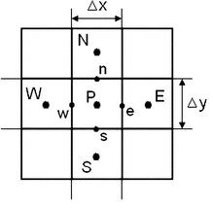
Figure 1: Example of Spatial Discretisation (Paipuri, 2014)
Where:
$∆x=$ $∆y=h$ the difference between two consecutive nodes.
$P=$ The point of interest.
$N=$ The North node.
$S=$ The South node.
$E=$ The East node.
$W=$ The West node.
By using this notation, we can express the difference approximation to the second derivative. As defined by (Chapra and Canale, 2021):
$$\frac{∂^{2}T}{∂x^{2}}= \frac{T_{E}-2T_{P}+T_{P}}{h^{2}}+O{(h}^{2})$$
(3.2.1)
$$\frac{∂^{2}T}{∂y^{2}}= \frac{T_{N}-2T_{P}+T_{S}}{h^{2}}+O{(h}^{2})$$
(3.2.2)

Temporal Discretisation
It is not possible to calculate the evolution of temperature continuously at every moment in time. Therefore, time is discretised into iterative time steps ($∆t)$, defined by Croft and Lilley (1977) as:
$$\frac{∂{T_{P}}^{t}}{∂t}=\frac{{T_{P}}^{t+∆t}-{T_{P}}^{t}}{∆t}+O(∆t)$$
(3.3)
Where:
${T_{P}}^{t}=$ Superscript $t$ defines the time level of the solution.
t = current time step.
$t+∆t$ = next time step.
$∆t$ = time step.

Explicit Finite Difference Method
The EFDM implements the FDA to the first derivative and the CDA to the second derivative to discretise the heat equation. The EFDM form of the heat equation as per Croft and Lilley (1977) is:
$${T_{P}}^{t+∆t}= F_{0}(T_{E}+T_{W}+T_{N}+T_{S}-(h-\frac{1}{F_{0}})T_{P}$$
(3.4)
Where $F_{0}$is the Fourier number defined as: (Croft and Lilley, 1977)
$$F_{0}= \frac{α∆t}{h^{2}}$$
(3.5)

Stability Criterion
The stability criterion, $F_{0}$is the Fourier number defined as: (Croft and Lilley, 1977)
$$F_{0}= \frac{α∆t}{h^{2}}$$
(3.5)
The stability criterion ensures that numerical errors from round-off and truncation are reduced over time. When grid spacing $(h)$ is reduced to improve spatial resolution, the time step $∆t$ must also decrease to maintain stability (Carnahan, 1969).

The Initial Boundary Conditions and Analytical Solution

Initial Conditions
The initial temperature distribution $(T)$ at points $x$ and $y$ a time $t$ across the domain is zero:
$$T\left(x,y,0\right)=0 0<x<Xdim 0<y<Ydim$$(4.1)

Boundary Conditions
The north and south constant have fixed, constant temperature (Dirichlet boundary conditions), expressed as:
$$T\left(0,y_{dim},t\right)= T_{0}$$
(4.2.1)
$$T\left(x,0,t\right)= -T_{0}$$
(4.2.1)
However, at the east and west boundaries, the temperature gradient is specified as zero:
$$\frac{∂T\left(0,y,t\right)}{∂x}=0$$
(4.2.3)
$$\frac{∂T\left(x_{dim},y,t\right)}{∂x}=0$$
(4.2.4)
This means that whilst the boundary surface temperatures $\left(T\right)$ at the east and wst edges are not explicitly defined, the gradient of temperature $\left(\frac{∂T}{∂x}\right)$ is zero, indicating that there is no heat flux through the boundaries. Such boundary conditions are known as Neumann boundary conditions, which specify the derivative of the temperature rather than its absolute value (Chapra and Canale, 2021; Croft and Lilley, 1977; Sheko et al., 2024).

The Analytical Solution for Validation of Numerical Method
To validate the numerical method for calculating the temperature at thermal equilibrium within the plate of user-defined dimensions, the analytical solution, provided by Chang and Ma (2001) is used:
$$T\left(x,y\right)=-T0​+\frac{2∙ T_{0}}{Y_{dim}}​∙y+\sum_{k=1}^{∞}{\left(\frac{1}{{\left(100∙k∙π\right)}^{2}}∙\left[1-{\left(-1\right)}^{k}\right]∙\frac{\sin\left(\frac{k∙π∙y}{Y_{dim}}\right)}{\sinh\left(\frac{k∙π∙X_{dim}}{Y_{dim}}\right)}∙\left[\cosh\left(\frac{k∙π∙x}{Y_{dim}}\right)-\cosh\left(\frac{k∙π∙\left(x-X_{dim}\right)}{Y_{dim}}\right)\right]\right)}$$
(4.3)
Formula 4.3 describes the temperature distributions $T\left(x,y,0\right)$ within the plate, considering the boundary conditions and thermal properties of the aluminium plate. The solution will validate the numerical solution results by comparing the numerical method results temperature distribution matrix with the analytical solution derived matrix values.

Code Detail and Explanations
The ethos that was kept in consideration from the outset in all coding works throughout this assignment was to ensure that the code was as user-friendly and as intuitive as possible whilst attempting to preempt and mitigate any user faults or oversights, full code content in Appendix 1.
For example, the code excerpt in Figure 2 contains functions ‘clc’, ‘clear’, and ‘close all’ to ensure that the command window and outputs are cleaned, not taking previous code iterations into account.
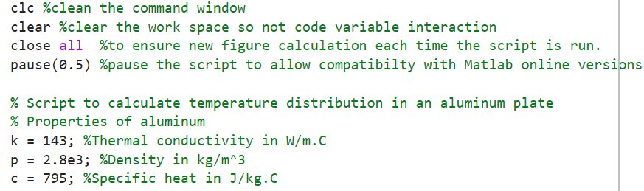
Figure 2: Opening Code Parameters
The next section (Figure 3) is the beginning of the main loop that calculates the rate of thermal diffusion in the plate, based on the prior predefined constants from Figure 2. This loop allows users to input the dimensions of the aluminium plate to be analysed. Figure 3 allows the input of X and Y dimensions of the plate. There is a contingency in place to ensure only positive integers can be input. Once all user inputs have been completed, a Summary of Inputs is displayed. This gives the user an opportunity to review their inputs and correct them without the necessity of running the full script. The restart = true, while loop allows for this feature.
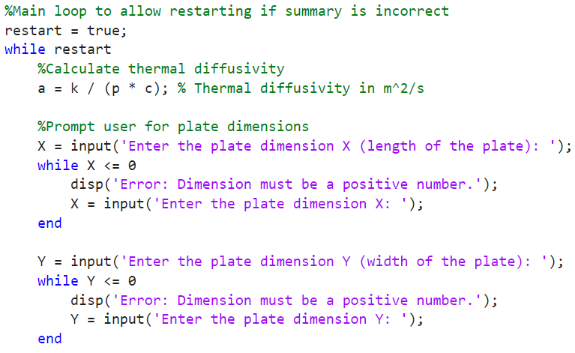
Figure 3: Code Main Loop.
Figure 4 shows the code allowing user to input X and Y dimensions in the units: meters, millimeters, feet, or inches. It uses a numerical selection to avoid text input errors, ensuring a valid unit selection via a while loop and the ‘ismember’ function. Once a valid input is chosen, a switch statement converts the input unit to the base SI unit (meters) for use in subsequent calculations.
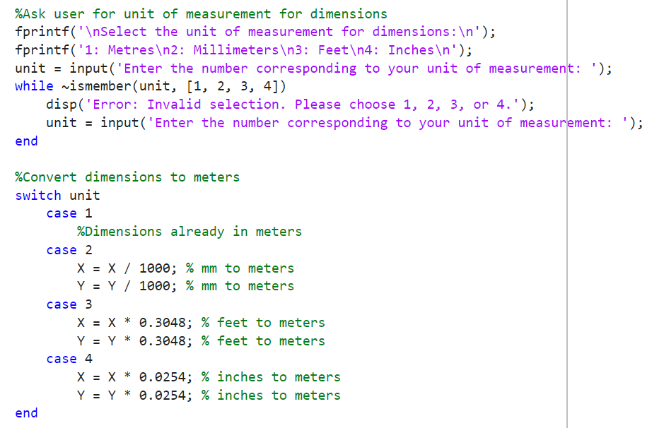
Figure 4: Code Dimension Conversion.
Figure 5 prompts the user for grid spacing (H) for plate calculations. An ‘if’ statement ensures the input is both positive and divisible by both X and Y dimensions, looping until the condition is met, with the units matching that of the plate dimensions.
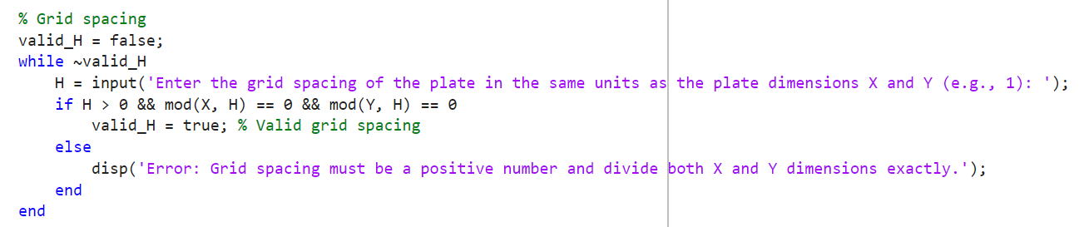
Figure 5: Code Grid Spacing.

In Figure 6, an ‘if-else’ statement ensures a valid Fourier Number, as defined in section 3.5. If the calculated Fourier Number exceeds the limit, the ‘else’ statement prompts the user to input a timestep that will be within the limits required to proceed with calculations.
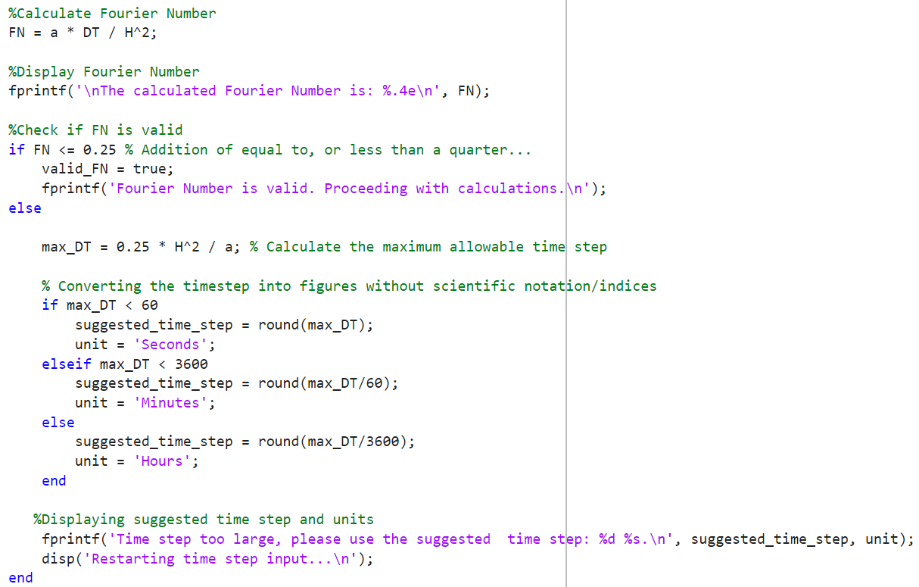
Figure 6: Code Stability Criterion.
Figure 7 displays the prompt for the user to define the initial temperature to be input that cannot be a negative integer.
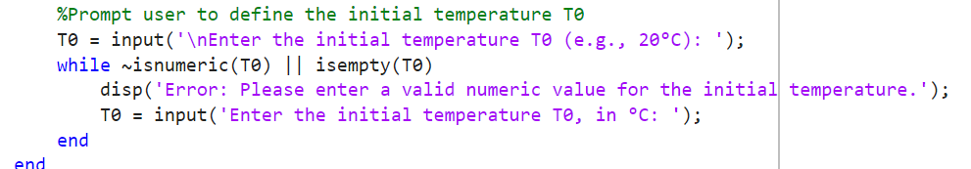
Figure 7: Initial Temperature Condition.

Figure 8 displays the summary of user inputs, allowing the user to restart the program before running the main script. The data is shown using ‘fprintf’ for easy interpretation. If an error is detected, the user can restart the main loop to the point highlighted in Figure 3.

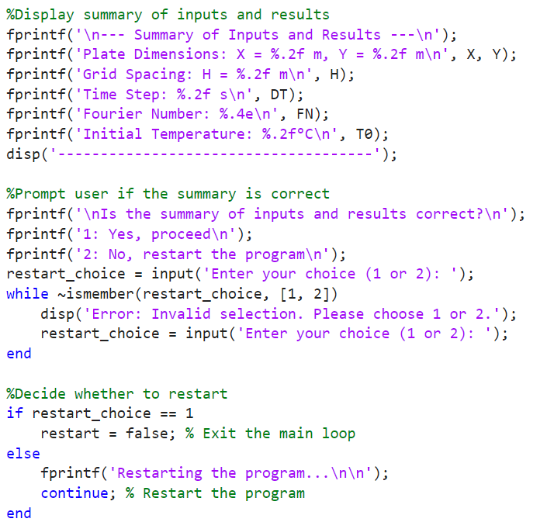
Figure 8: Code Summary of Inputs.

Figure 9 shows the initialization of the temperature matrix where NR and NC define the number of rows and columns. T=zeros initialises the matrix and T(:) = 0 sets the initial temperature condition.
It also highlights the outer loop using the finite difference method to simulate heat transfer. The loop stops when the temperature matrix T2 reaches thermal equilibrium within 0.01ºC matrix T. The inner loops iterate over all temperature nodes, updating them different for boundary and internal nodes. Figure 9 illustrates the internal nodes updating equally to neighboring nodes. The left and right boundary conditions repeat adjacent nodes where no neighboring nodes exist.

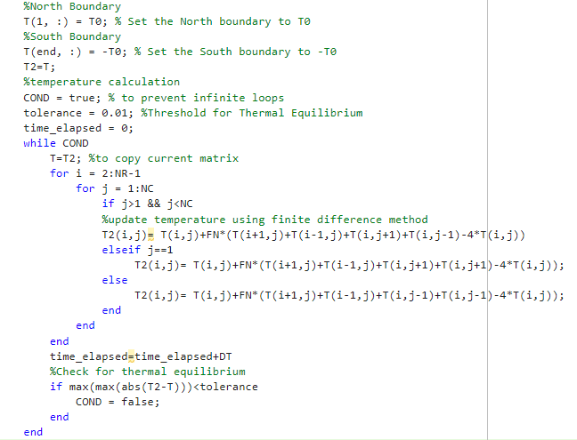
Figure 9: Matrix Initialisation.

Figure 10 highlights the check to ensure that when thermal equilibrium is achieved, it will display the time taken in a user appropriate unit. This is due to the potential dimensions of the aluminium plates to be simulated. Thermal equilibrium can take varying amounts of time, from seconds to days.
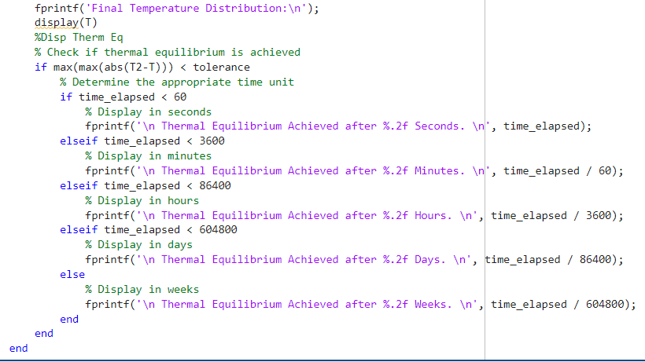
Figure 10: TET Display,
Figure 11 shows the calculation of the analytical solution as in section 4.3. However, the series has been truncated at $k=100$ to make sure the calculation is feasible, rather than using an infinite number of terms.
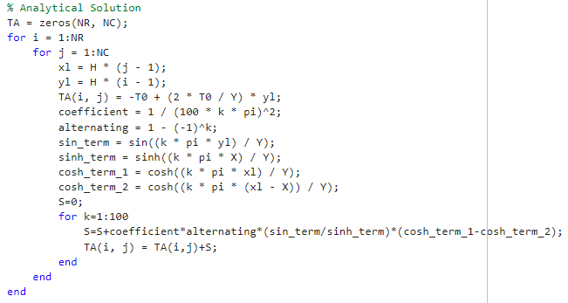
Figure 11: Analytical Solution Calculation
Figure 12 is used to accumulate the matrix data in the calculated and analytical solutions and display it in a comparative heatmap displaying the numerical difference between each method.
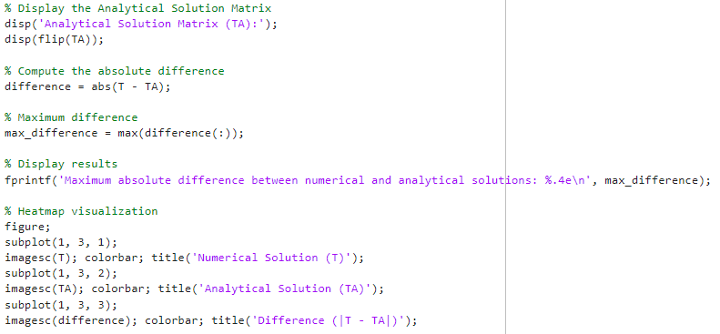
Figure 12: Display Results.

Validation of the Code
This section validates the effectiveness of EFDM in achieving a TET of 0.01ºC. Figure 13 depicts the Numerical and Analytical solution comparison, with the summary showing the maximum difference between successive matrix nodes. Figure 14 displays the graphical representation of the results. Said results confirm that the EFDM model is functioning correctly, staying within a logically reasonable and stipulated tolerance by Roomi (2021). Large discrepancies would indicate issues requiring investigation.
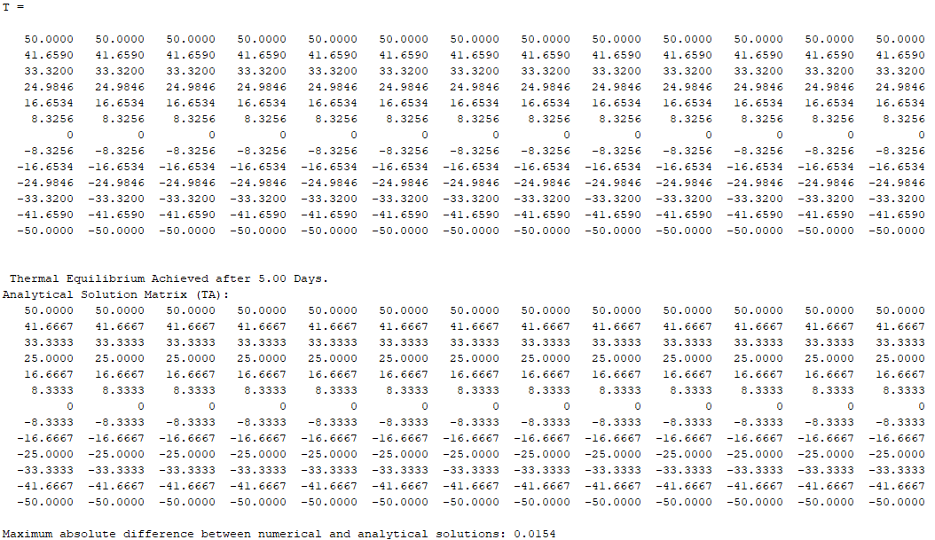
Figure 13: Comparison of Matrices.
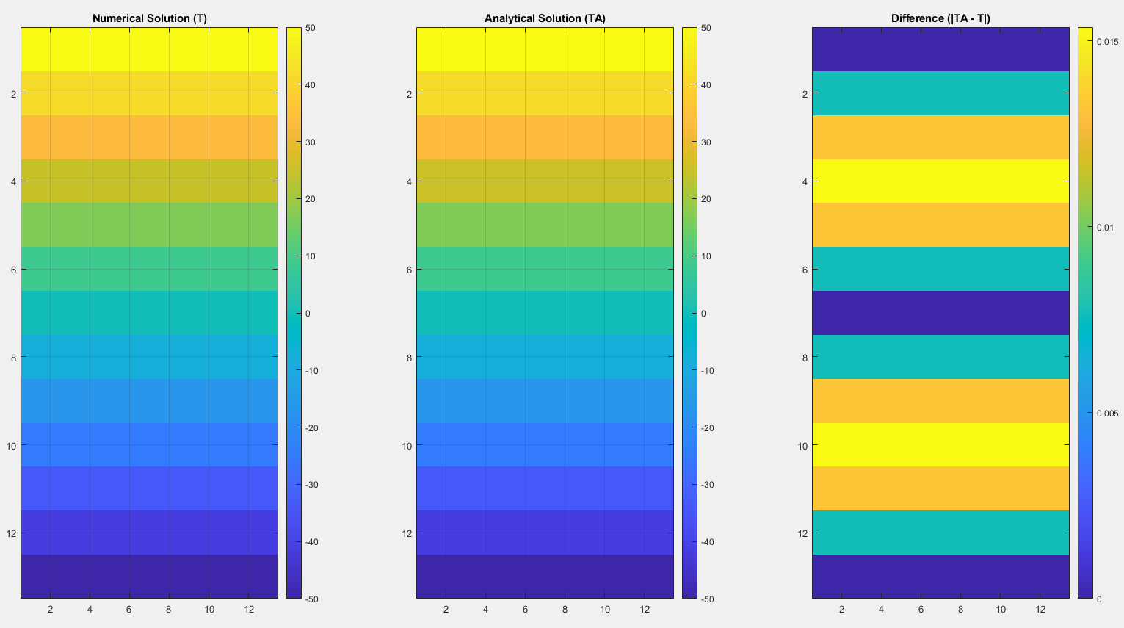
Figure 14: Graphical Display.

Sensitivity Analysis

Grid Spacing
Exemplified by Figure 14, as the grid spacing $(h)$ decreases, the time to reach thermal equilibrium converges to a more accurate result. This aligns with LeVeque’s (2007) principle that a consistent numerical method ensures the discretisation error diminishes as the grid spacing gets smaller. The second derivative approximation, central to the heat equation, is influenced by the truncation error term $O{(h}^{2})$. A smaller grid spacing will reduce this error term result in a more precise approximation of the thermal equilibrium time. The diminishing returns of the accuracy of approximation are at the expense of computation time, which increase vastly with a finer grid spacing (Rostamian, 2014).
$$\frac{∂^{2}T}{∂x^{2}}= \frac{T_{E}-2T_{P}+T_{P}}{h^{2}}+O{(h}^{2})$$
(3.2.1)
The finite difference formulation clearly highlights the relationship between $O{(h}^{2})$ and $(h)$, where simply reducing the grid resolution reduces the error term, increasing the approximation accuracy. This point is neatly surmised by:
$$Consistence+Stability →Convergence$$
(LeVeque, 2007, p.29)

Figure 15: Sensitivity Analysis Results: Grid Spacing.

Time Step
Akin to grid spacing, the time step $(∆t)$ is influence by the error term $O(∆t)$. A smaller $(∆t)$ leads to a more precise the approximation, as seen in the finite difference formula:
$$\frac{∂{T_{P}}^{t}}{∂t}=\frac{{T_{P}}^{t+∆t}-{T_{P}}^{t}}{∆t}+O(∆t)$$
(3.3)
However, as per Figure 15, no clear convergence is observed to determine to optimal time step. Whilst a finer time step $(∆t)$ reduces truncation error, it also increases the accumulation of round-off error due to more frequent calculations between the iterative temperature matrices. The precision of computations and the degree in which round-off errors accumulate depends on the numerical precision of the system, such as if it operates on a 16-bit, 32-bit or 64-bit precision. The number of bits refers to the length of the binary digit string used to store numbers, where a larger string enables values in the temperature evolution calculations to more closely approximate their true values (Chasnov, 2024).

Figure 16: Sensitivity Analysis Results: Time Step.

Thermal Equilibrium Tolerance (TET)
As shown in Figure 16, decreasing the TET increases the time to reach equilibrium exponentially, as finer tolerances require increased iterations for TET achievement. The code is sensitive to tolerance values; too large a tolerance may display an artificial TET achievement. A finer tolerance increases computational cost for a level of precision of little value. The ideal tolerance depends on the system, the required measurement sensitivity, and available resource.

Figure 17: Sensitivity Analysis Results: TET

Discuss Any Limitations of the Model

Limitations of the Model

Round-Off Error
The model approximates the temperature evolution of the spatial domain using the Explicit Finite Difference Method (EFDM). Through each successive iteration, the accuracy of the diminishes due to round-off error. Dependent on the bit-width of the computer system (e.g., 16, 32 or 4 bits) being used for the calculation, determines how many binary digits are available to store the number. So, through each successive iteration, a portion of the values after the decimal place are not used for calculations. Therefore, over time the approximation gets further away from absolute accuracy. For small timesteps, a finer Thermal Equilibrium tolerance or any parameter manipulation that increases the number of iterations will compound the deviation from the true value.

Truncation Error
The Explicit Finite Difference Method is derived from Taylor Series. The Taylor series has an infinite sum of terms. The later in the series it is truncated, the more accurate the approximation. However, any truncation of terms will induce uncertainty of output, therefore neglecting the series’ higher-order terms will reduce the model’s output accuracy by removing data that is used for the calculations, especially for small time steps or large grids (LeVeque, 2007).

Stability
Stability in EFDM ensures that numerical errors decrease over iterations approaching the true solution (Convergence). This is maintained by the stability conduction $F_{N}=\frac{1}{4}$, which ensures a balance between temporal and spatial resolutions. If this tolerance is increased, errors may cause results to diverge or oscillate, leading to non-physical behavior such as heating and cooling values that are unrealistic for heat diffusion. While divergence prevents thermal equilibrium, oscillations can still meet the thermal equilibrium tolerance, indicating stability despite ongoing fluctuations (Chapra and Canale, 2021).

Geometric Limitations
The Explicit Finite Difference Method (EFDM) is constrained to Cartesian geometries primarily due to its reliance on uniform grids for its calculations. Its simplicity in discretising spatial and temporal derivatives naturally aligns with Cartesian coordinates. However, adapting EFDM to complex geometries introduces challenges such as implementing irregular grid structures, increased computation costs and inherent stability issues. These complications, coupled with the difficulty of developing an accurate and efficient code, make EFDM unsuitable for non-Cartesian geometries. Although this is theoretically feasible, simple implicit methods are better suited to the task (Chapra and Canale, 2021).

Limitations of the Coding Approach
The fundamental limitation of the coding approach lies in how the Thermal Equilibrium Approximations (TEA) is modeled, where the temperature difference between successive matrices is compared against a predefined Thermal Equilibrium Tolerance (TET). This is a practical method as it simplifies and accelerates the TET convergence. However, the choice of TET resolution impacts the computational effort and accuracy of the solution. A lower TET resolution ensures greater accuracy but increases the number of matrix iterations, thus computational effort. Conversely, a higher TET resolution will decrease the computational effort but may lead to premature convergence accuracy (Chasnov, 2024; Givi and Strayer, 2019).

Suggested Improvements of the Model and Future Developments
The Explicit Finite Different Method (EFDM) is computationally efficient for simple cases but is limited by stability limitations at large time steps, as highlighted in section 7.2. Chapra and Canale (2021) note that implicit methods guarantee stability, even for larger time steps. EFDM calculates the future state term ${T_{P}}^{t+∆t}$solely from current state terms: $T_{E}+T_{W}+T_{N}+T_{S}$
relying on the stability criterion $F_{0}$ to limit truncation and round off errors, preventing divergence. Implicit methods incorporate both the current and future state terms into each iteration. This ensures stability at the cost of computational load due to continually solving complex simultaneous equations, especially for multidimensional problems.
The Finite Element Method (FEM) can model temperature evolution of even complex geometries and regions, using non-uniform grids allowing for precise representation of irregular shapes. Though possible in EFDM, the relative difficulty in deriving solutions for intricate geometries make it impractical (Chapra & Canale, 2021; LeVeque, 2007). Both FEM and the Boundary Element Method (BEM) excel in handling complex boundary conditions, such as radiative heat transfer or time dependent flux by using variable discretisation techniques and focusing computation effort on boundary behavior (Qi et al., 2004). These features make FEM and BEM more suitable to real world scenarios where both geometric complexity and dynamic boundaries are more prevalent (Wang et al., 2024).

Conclusion
This report successfully developed a user-friendly, accurate heat diffusing model using the EFDM to simulate a 2D aluminium plate. The model was validated through comparison with an analytical solution and a sensitivity analysis which highlighted the model’s accuracy and responsiveness to changes in grid spacing, time step and TET. While the model proved effective for simple geometries and boundary conditions, it demonstrated limitations for more complex scenarios. Future improvements could apply alternative numerical methods to better handle intricate geometries and boundary conditions to enhance solution applicability to real world heat transfer problems.

References

Al-Regib, E. (1995) ‘Transient heat transfer through insulated walls’, Energy, 20(7), pp. 687–694. doi:10.1016/0360-5442(94)00098-n.
Bartosik, A. (2022) Numerical Heat Transfer and fluid flow 2021. Basel: MDPI - Multidisciplinary Digital Publishing Institute.
Carnahan, B. (1969) Applied Numerical Methods. Available at: https://www.researchgate.net/publication/50332070_Applied_Numerical_Methods (Accessed: 15 January 2025).
Chang, C.-Y. and Ma, C.-C. (2001) ‘Transient thermal conduction analysis of a rectangular plate with multiple insulated cracks by the alternating method’, International Journal of Heat and Mass Transfer, 44(13), pp. 2423–2437. doi:10.1016/s0017-9310(00)00292-1.
Chapra, S.C. and Canale, R.P. (2021) Numerical Methods for Engineers. New York, NY: McGraw-Hill.
Chasnov, J.R. (2024) ‘6: Finite Difference Approximation’, in Scientific Computing. LibreTexts Engineering, pp. 34–35.
Cintolesi, C. et al. (2017) ‘Numerical simulation of conjugate heat transfer and surface radiative heat transfer using the ’, International Journal of Heat and Mass Transfer, 107, pp. 956–971. doi:10.1016/j.ijheatmasstransfer.2016.11.006.
Courant, R., Friedrichs, K. and Lewy, H. (1967) ‘On the partial difference equations of mathematical physics’, IBM Journal of Research and Development, 11(2), pp. 215–234. doi:10.1147/rd.112.0215.
Croft, D.R. and Lilley, D.G. (1977) Heat transfer calculations using finite difference equations. London: Applied Science.
Givi, P. and Strayer, S. (2019) ‘Finite Difference Method: Applied to a two-dimensional, steady-state, heat transfer problem’, Computer Aided Analysis in Transport Phenomena, 12 February. Available at: https://sites.pitt.edu/~sts106/ugReports/MEMS1055_Project_1.pdf (Accessed: 26 February 2025).
Hartman, G. (2017) Apex calculus: Und Edition, pp. 538–538. doi:10.31356/oers002.
Hartman, G. et al. (2020) 8.8: Taylor Series, Mathematics LibreTexts. Available at: https://math.libretexts.org/Bookshelves/Calculus/Calculus_3e_(Apex)/08%3A_Sequences_and_Series/8.08%3A_Taylor_Series (Accessed: 02 January 2025).
Jaiswal, S. (2024) Courant–Friedrichs–Lewy Condition, Alchetron. Available at: https://alchetron.com/Courant–Friedrichs–Lewy-condition (Accessed: 19 January 2025).
LeVeque, R.J. (2007) Finite difference methods for ordinary and partial differential equations: Steady-state and time-dependent problems. Philadelphia, PA: Society for Industrial and Applied Mathematics.
Libretexts (2022) 6: Finite difference approximation, Mathematics LibreTexts. Available at: https://math.libretexts.org/Bookshelves/Scientific_Computing_Simulations_and_Modeling/Scientific_Computing_(Chasnov)/I%3A_Numerical_Methods/6%3A_Finite_Difference_Approximation (Accessed: 19 January 2025).
Narasimhan, T.N. (1999) ‘Fourier’s heat conduction equation: History, influence, and connections’, Reviews of Geophysics, 37(1), pp. 151–172. doi:10.1029/1998rg900006.
Paipuri, M. (2014) ‘Numerical Modelling of Membrane filtration using Lattice Boltzmann and Finite Volume Methods’, French National Centre for Scientific Research [Preprint]. doi:10.13140/RG.2.2.26191.79524.
Powell, A. (2002) Finite Difference Solution of the Heat Equation, pp. 1–6.
Qi, H., Ruan, L.M. and Tan, J.Y. (2004) ‘Development of a Finite Element Radiation Model Applied to Two-Dimensional Participating Media’, in Heat Transfer—Asian Research, pp. 547–550.
Reddy, J.N. (1993) An introduction to the finite element method. New York, N.Y: McGraw-Hill.
Roomi, T.O. (2021) ‘Numerical Weather Prediction’, Explicit Method of Finite Difference. Available at: https://www.uomustansiriyah.edu.iq/media/lectures/6/6_2021_11_16%2112_16_20_PM.pdf (Accessed: 26 January 2025).
Rostamian, R. (2014) Programming projects in C: For students of engineering, Science, and Mathematics. Philadelphia: Society for Industrial and Applied Mathematics.
Sheko, A. et al. (2024) Finite Difference Method and Numerical Simulations on Heat Transfer Problem, Research Gate. Available at: https://www.researchgate.net/publication/380890968_Finite_Difference_Method_and_Numerical_Simulations_on_Heat_Transfer_Problem (Accessed: 21 January 2025).
Trefethen, L.N. (1996) Finite difference and spectral methods for ordinary and partial differential equations. Ithaca, N.Y: Cornell University Dept. of Computer Science and Center for Applied Mathematics.
Wang, Y. et al. (2024) ‘Numerical simulation and experimental verification of the steady-state heat transfer similarity theory based on dimensional analysis’, Case Studies in Thermal Engineering, 60, p. 104714. doi:10.1016/j.csite.2024.104714.
Yew, A.C. (2011) ‘Numerical differentiation’, Finite Differences, 22 April. Available at: https://www.dam.brown.edu/people/alcyew/handouts/numdiff.pdf (Accessed: 22 January 2025).

Appendix

Appenix 1
clc %clean the command window
clear %clear the work space so not code variable interaction
close all %to ensure new figure calculation each time the script is run.
pause(0.5) %pause the script to allow compatibilty with Matlab online versions

% Script to calculate temperature distribution in an aluminum plate
% Properties of aluminum
k = 143; %Thermal conductivity in W/m.C
p = 2.8e3; %Density in kg/m^3
c = 795; %Specific heat in J/kg.C

%Main loop to allow restarting if summary is incorrect
restart = true;
while restart
%Calculate thermal diffusivity
a = k / (p * c); % Thermal diffusivity in m^2/s

%Prompt user for plate dimensions
X = input('Enter the plate dimension X (length of the plate): ');
while X <= 0
disp('Error: Dimension must be a positive number.');
X = input('Enter the plate dimension X: ');
end

Y = input('Enter the plate dimension Y (width of the plate): ');
while Y <= 0
disp('Error: Dimension must be a positive number.');
Y = input('Enter the plate dimension Y: ');
end

%Ask user for unit of measurement for dimensions
fprintf('\nSelect the unit of measurement for dimensions:\n');
fprintf('1: Metres\n2: Millimeters\n3: Feet\n4: Inches\n');
unit = input('Enter the number corresponding to your unit of measurement: ');
while ~ismember(unit, [1, 2, 3, 4])
disp('Error: Invalid selection. Please choose 1, 2, 3, or 4.');
unit = input('Enter the number corresponding to your unit of measurement: ');
end

%Convert dimensions to meters
switch unit
case 1
%Dimensions already in meters
case 2
X = X / 1000; % mm to meters
Y = Y / 1000; % mm to meters
case 3
X = X * 0.3048; % feet to meters
Y = Y * 0.3048; % feet to meters
case 4
X = X * 0.0254; % inches to meters
Y = Y * 0.0254; % inches to meters
end

% Grid spacing
valid_H = false;
while ~valid_H
H = input('Enter the grid spacing of the plate in the same units as the plate dimensions X and Y (e.g., 1): ');
if H > 0 && mod(X, H) == 0 && mod(Y, H) == 0
valid_H = true; % Valid grid spacing
else
disp('Error: Grid spacing must be a positive number and divide both X and Y dimensions exactly.');
end
end

%Loop until a valid Fourier Number is achieved
valid_FN = false;
while ~valid_FN
%Prompt user for time step
DT = input('\nEnter the time step (e.g., 1): ');
while DT <= 0
disp('Error: Time step must be a positive number.');
DT = input('Enter the time step (e.g., 1): ');
end

%Ask user for unit of measurement for time step
fprintf('\nSelect the unit of measurement for the time step:\n');
fprintf('1: Seconds\n2: Minutes\n3: Hours\n');
time_unit = input('Enter the number corresponding to your unit of measurement: ');
while ~ismember(time_unit, [1, 2, 3])
disp('Error: Invalid selection. Please choose 1, 2, or 3.');
time_unit = input('Enter the number corresponding to your unit of measurement: ');
end

%Convert time step to seconds
switch time_unit
case 1
%DT already in seconds
case 2
DT = DT * 60; % minutes to seconds
case 3
DT = DT * 3600; % hours to seconds
end

%Calculate Fourier Number
FN = a * DT / H^2;

%Display Fourier Number
fprintf('\nThe calculated Fourier Number is: %.4e\n', FN);

%Check if FN is valid
if FN <= 1 % Addition of equal to, or less than a quarter...
valid_FN = true;
fprintf('Fourier Number is valid. Proceeding with calculations.\n');
else

max_DT = 0.25 * H^2 / a; % Calculate the maximum allowable time step

% Converting the timestep into figures without scientific notation/indices
if max_DT < 60
suggested_time_step = round(max_DT);
unit = 'Seconds';
elseif max_DT < 3600
suggested_time_step = round(max_DT/60);
unit = 'Minutes';
else
suggested_time_step = round(max_DT/3600);
unit = 'Hours';
end

%Displaying suggested time step and units
fprintf('Time step too large, please use the suggested time step: %d %s.\n', suggested_time_step, unit);
disp('Restarting time step input...\n');
end
%Prompt user to define the initial temperature T0
T0 = input('\nEnter the initial temperature T0 (e.g., 20°C): ');
while ~isnumeric(T0) || isempty(T0)
disp('Error: Please enter a valid numeric value for the initial temperature.');
T0 = input('Enter the initial temperature T0, in °C: ');
end
end

%Display summary of inputs and results
fprintf('\n--- Summary of Inputs and Results ---\n');
fprintf('Plate Dimensions: X = %.2f m, Y = %.2f m\n', X, Y);
fprintf('Grid Spacing: H = %.2f m\n', H);
fprintf('Time Step: %.2f s\n', DT);
fprintf('Fourier Number: %.4e\n', FN);
fprintf('Initial Temperature: %.2f°C\n', T0);
disp('-------------------------------------');

%Prompt user if the summary is correct
fprintf('\nIs the summary of inputs and results correct?\n');
fprintf('1: Yes, proceed\n');
fprintf('2: No, restart the program\n');
restart_choice = input('Enter your choice (1 or 2): ');
while ~ismember(restart_choice, [1, 2])
disp('Error: Invalid selection. Please choose 1 or 2.');
restart_choice = input('Enter your choice (1 or 2): ');
end

%Decide whether to restart
if restart_choice == 1
restart = false; % Exit the main loop
else
fprintf('Restarting the program...\n\n');
continue; % Restart the program
end

%Initialize Temperature Matrix (dependent: only if the summary is correct)
NR = Y / H + 1; % Number of Rows
NC = X / H + 1; % Number of Columns
T = zeros(NR, NC); % Initialize temperature matrix to zero
T(:) = 0; % Initial Temperature Condition

%Boundary Conditions
%North Boundary
T(1, :) = T0; % Set the North boundary to T0
%South Boundary
T(end, :) = -T0; % Set the South boundary to -T0
T2=T;
%temperature calculation
COND = true; % to prevent infinite loops
tolerance = 0.001; %Threshold for Thermal Equilibrium
time_elapsed = 0;
while COND
T=T2; %to copy current matrix
for i = 2:NR-1
for j = 1:NC
if j>1 && j<NC
%update temperature using finite difference method
T2(i,j)= T(i,j)+FN*(T(i+1,j)+T(i-1,j)+T(i,j+1)+T(i,j-1)-4*T(i,j))
elseif j==1
T2(i,j)= T(i,j)+FN*(T(i+1,j)+T(i-1,j)+T(i,j+1)+T(i,j+1)-4*T(i,j));
else
T2(i,j)= T(i,j)+FN*(T(i+1,j)+T(i-1,j)+T(i,j-1)+T(i,j-1)-4*T(i,j));
end
end
end
time_elapsed=time_elapsed+DT
%Check for thermal equilibrium
if max(max(abs(T2-T)))<tolerance
COND = false;
end
end
fprintf('Final Temperature Distribution:\n');
display(T)
%Disp Therm Eq
% Check if thermal equilibrium is achieved
if max(max(abs(T2-T))) < tolerance
% Determine the appropriate time unit
if time_elapsed < 60
% Display in seconds
fprintf('\n Thermal Equilibrium Achieved after %.2f Seconds. \n', time_elapsed);
elseif time_elapsed < 3600
% Display in minutes
fprintf('\n Thermal Equilibrium Achieved after %.2f Minutes. \n', time_elapsed / 60);
elseif time_elapsed < 86400
% Display in hours
fprintf('\n Thermal Equilibrium Achieved after %.2f Hours. \n', time_elapsed / 3600);
elseif time_elapsed < 604800
% Display in days
fprintf('\n Thermal Equilibrium Achieved after %.2f Days. \n', time_elapsed / 86400);
else
% Display in weeks
fprintf('\n Thermal Equilibrium Achieved after %.2f Weeks. \n', time_elapsed / 604800);
end
end
end

% Analytical Solution
TA = zeros(NR, NC);
for i = 1:NR
for j = 1:NC
xl = H * (j - 1);
yl = H * (i - 1);
TA(i, j) = -T0 + (2 * T0 / Y) * yl;
coefficient = 1 / (100 * k * pi)^2;
alternating = 1 - (-1)^k;
sin_term = sin((k * pi * yl) / Y);
sinh_term = sinh((k * pi * X) / Y);
cosh_term_1 = cosh((k * pi * xl) / Y);
cosh_term_2 = cosh((k * pi * (xl - X)) / Y);
S=0;
for k=1:100
S=S+coefficient*alternating*(sin_term/sinh_term)*(cosh_term_1-cosh_term_2);
TA(i, j) = TA(i,j)+S;
end
end
end

% Display the Analytical Solution Matrix
disp('Analytical Solution Matrix (TA):');
disp(flip(TA));

% Compute the absolute difference
difference = abs(flip(TA) - T);

% Maximum difference
max_difference = max(difference(:));

% Display results
fprintf('Maximum absolute difference between numerical and analytical solutions: %.4f\n', max_difference);

% Heatmap visualization
figure;
subplot(1, 3, 1);
imagesc(T); colorbar; grid on; title('Numerical Solution (T)');
subplot(1, 3, 2);
imagesc(flip(TA)); colorbar; grid on; title('Analytical Solution (TA)');
subplot(1, 3, 3);
imagesc(difference); colorbar; title('Difference (|TA - T|)');

Appendix 2
Table 1: Sensitivity Analysis Raw Data: Grid Spacing.
Grid Spacing (H) | Time Step (Fixed) | Tolerance (Fixed) | Thermal Equilibrium Time (In Seconds)
0.25 | 150 | 0.001 | 246300
0.3 | 150 | 0.001 | 246450
0.4 | 150 | 0.001 | 246300
0.5 | 150 | 0.001 | 246900
0.6 | 150 | 0.001 | 247200
0.75 | 150 | 0.001 | 247800
1 | 150 | 0.001 | 249150
1.2 | 150 | 0.001 | 247500
1.5 | 150 | 0.001 | 252900
2 | 150 | 0.001 | 249150
3 | 150 | 0.001 | 278700
4 | 150 | 0.001 | 282600

Table 2: Sensitivity Analysis Raw Data: Time Step.
Grid Spacing (H) | Time Step (S) | Tolerance (Fixed) | Thermal Equilibrium Time (In Seconds)
0.75 | 2000 | 0.0001 | 528000
0.75 | 1500 | 0.0001 | 513000
0.75 | 1000 | 0.0001 | 492000
0.75 | 800 | 0.0001 | 480000
0.75 | 600 | 0.0001 | 463800
0.75 | 400 | 0.0001 | 441200
0.75 | 200 | 0.0001 | 402000
0.75 | 100 | 0.0001 | 362400
0.75 | 50 | 0.0001 | 322600
0.75 | 25 | 0.0001 | 282775

Table 3: Sensitivity Analysis: Raw Data: TET
Grid Spacing (H) | Time Step (Fixed) | Tolerance (TET) | Thermal Equilibrium Time (In Seconds)
1 | 500 | 0.000001 | 723500
1 | 500 | 0.00001 | 590500
1 | 500 | 0.0001 | 457500
1 | 500 | 0.001 | 324000
1 | 500 | 0.01 | 191000
1 | 500 | 0.1 | 57500

