Mohammad Assadujjaman
Student No: 2207975
BA International Hotel Management
Module: Personal Resourcing and Development
BMIH5005
Module Lead: Deborah Lloyd
Assignment Title: Employee Engagement and Motivation

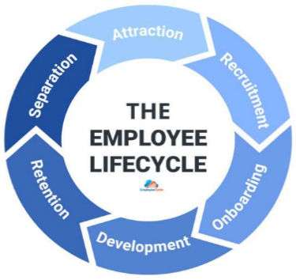
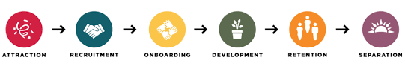
The employee lifecycle consists of six different phases (Marchington and Wilkinson, 2016). Premier Inn's attraction phase may benefit from Generation Z's tech-savvy and drive to succeed by tapping into their skills and enthusiasm. They should make good use of online communities and social media to spread the word about Premier Inn's dynamic workplace environment, job openings, and charitable initiatives. To attract members of Generation Z, it is important to draw attention to the projects, job opportunities, and technological advances that will most appeal to them. In the second phase, Premier Inn must actively involve members of Generation Z in the recruitment phase. According to Singh and Dangmei (2016), they may make use of social media to post engaging and engaging employment ads that highlight the company's dedication to technology innovation and corporate social responsibility. To attract tech-savvy members of Generation Z, provide them with honest and open glimpses inside the workplace through videos and virtual tours. Premier Inn should also highlight the organization as a place where they may achieve their goals of professional growth, entrepreneurial success, and meaningful global impact in professional career.
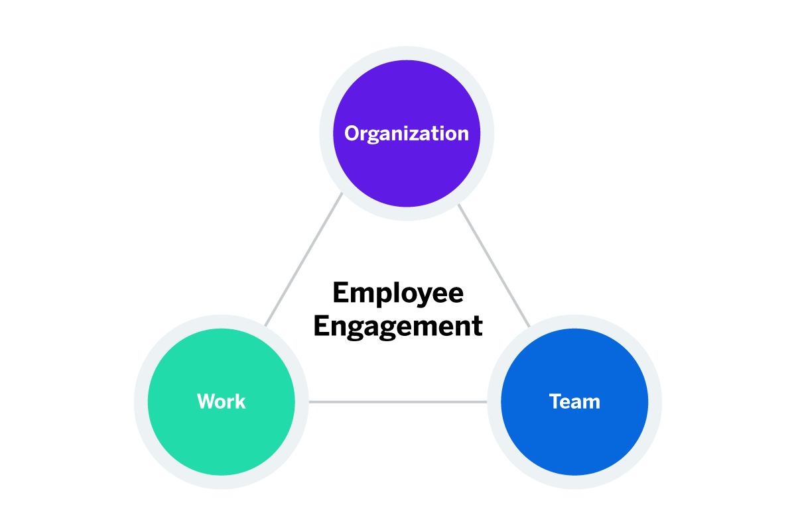
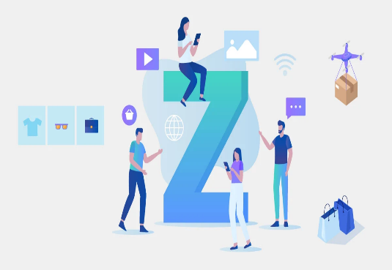
In the third phase, Premier Inn uses a tech-driven, interactive strategy to enlist the help of Generation Z employees during the onboarding process. The company should launch a mobile-friendly digital onboarding portal that provides concise, aesthetically appealing information on the organization's guiding principles and expectations. According to Ghandour et al., (2015), Premier Inn can establish the framework for long-term commitment and productivity by combining technology, mentoring, and meaningful engagement to give them a sense of belonging from day one. Premier Inn's development phase includes individualised learning opportunities to captivate Generation Z employees. They allow Generation Z workers to study at their own pace by implementing individualised digital training modules that can be accessed via mobile devices. To help employees better match their goals with those of the organisation, offer constant feedback through digital platforms and mentorship programmes (Horn, 2009). Premier Inn can ensure long-term commitment and productivity from its Gen Z workforce by promoting a culture of lifelong learning, mentoring, and meaningful work.
Sidorcuka and Chesnovicka (2017) stated that in the retention phase, Premier Inn can retain Generation Z workers by providing them with a positive and meaningful work environment. They recognise their efforts and provide regular feedback through digital platforms, allowing them to try out new positions within the organisation to broaden their skill set, helping them find a healthy balance between work and personal life, and paying attention to their emotional well-being (Torrington et al., 2020). In the last phase, engaging Generation Z employees at Premier Inn during the separation phase entails conducting departure interviews to know the reasons for leaving. Premier Inn can keep the separation process professional, highlighting the importance of their past work.

In this competitive business environment, employee engagement is a key to success for business organizations, especially for large hotels. Focusing on the Generation Z employees of Premier Inn, which is one of the largest hotel chains in the United Kingdom, this essay will discuss the ways to effectively engage to the Gen Z employees throughout their employee lifecycle. As hotel chains require more millennial employees to manage their clients, understanding the ways to effectively engage the employees should be one of the top priorities for hotels like Premier Inn to sustain their success. Employee engagement refers to the emotional commitment of employees towards the organization and achieving organizational success. It is crucial for organizations where the employees directly get involved with their customers. Generation Z are the most recent people in the labour market who were born between 1997 to 2012. As this British hotel chain has over 40000 employees among which a large portion is from Generation Z, Premier Inn has to engage with this generation a lot which will be a major part of the discussion of this essay (Whitbread, 2023). Now, it is time to focus on the role of HR in employee engagement.

Human resources (HR) at Premier Inn is crucial in retaining talented employees because of the good work environment they create and maintain. The goal of human resources experts should be to boost morale, job satisfaction, and employee engagement (Sun and Bunchapattanasakda, 2019). To increase Premier Inn employee engagement, they devise programs including training and development courses, performance evaluations, and rewards for outstanding work. According to Armstrong and Taylor (2020), human resources also plays a critical part in fostering an environment where all employees feel comfortable voicing their opinions and concerns. HR at Premier Inn helps workers feel appreciated and inspired to do their best job for the company's success by providing opportunities for professional development, flexible scheduling, and competitive benefits. As a result of HR's continuous efforts, Premier Inn has become a place of employment of choice, where employees are enthusiastic about coming to work and committed to providing excellent customer service. So, what are the differences between of Gen Z and Gen Y?
Generation Z is made up of people born between 1997 and 2012. They are not the same as Generation Y, which is also called the Millennials. Gen Z grew up in a digital world, making them real digital natives. Millennials were around when the internet and other digital technologies first came out. As a result of seeing older generations struggle with the economy, Gen Zers tend to be more practical and realistic, which is different from how Millennials are often seen as optimistic. Gen Z also values diversity and acceptance more than generations before them, and they put more value on individuality and self-expression. They are very active and look for side jobs and creative ways to express themselves from a very young age. Gen Z prefers visual and instant forms of communication like photos, videos, and emojis, and likes to use apps like Instagram and TikTok. Millennials, on the other hand, were early users of social media but mostly used text-based apps like Facebook and Twitter. These differences show how social norms, technology, and the economy have changed over time, affecting how each generation is different. Between these two, Generation Z has been selected for this task and now the characteristics of this generation will be discussed now.
According to Francis and Hoefel (2018), Generation Z, born between 1997 and 2012, are the generation that follows the Millennials. Because of their upbringing in the digital age, they are fluent in the latest technologies and are often referred to as "digital natives." They value online relationships, social media profiles, and rapid access to information. Young people of Generation Z are known for their collaborative mindset and creativity. As for employment needs, members of Generation Z look for job security, good salaries, and career advancement opportunities. At work, they place a premium on work-life balance, adaptability in scheduling, and opportunities for advancement. According to Friedman (2012), members of Generation Z's workforce place a premium on values-aligned work, mentorship opportunities, and career development. They do best in groups where they are encouraged to work together and think beyond the box. The most effective ways to engage Generation Z workers are through digital communication channels, individualised learning opportunities, and reward and recognition programmes. Organisations that want to recruit and keep members of this generation must focus on their unique blend of technological expertise, social consciousness, and entrepreneurial spirit. According to Glassdoor (2023), Premier Inn gets 3.4 out of 5 stars from its 1200 anonymous employees where 56% of employees suggest that it is a good place to work. So, how Premier Inn can ensure employee engagement and what the advantages of engaging a team are?
Premier Inn can get its team engaged in several ways, such as by encouraging open communication, giving employees chances to learn new skills and advance in their careers, recognising and rewarding excellent performance, and encouraging a healthy work-life balance. They encourage team members to take an active role in making decisions and show that they value employee feedback. This boosts morale and commitment to work (Gallagher, 2016). Premier Inn employees are much more likely to be engaged when they have regular feedback sessions, and mentorship programmes, and are encouraged to feel like they fit on the team. There are many benefits to employee engagement at Premier Inn. When employees are engaged, they are more motivated, which means they work harder and provide better customer service, which are both very important in the hospitality business for retaining customers. Teams that are engaged are more likely to be creative and come up with new ideas, which helps the company grow and change. According to Lapoint and Liprie-Spence (2017), employees who are involved tend to leave their jobs less often, which cuts down on the costs of hiring new people and training them while keeping experienced and skilled workers.
According to Gaidhani et al., (2019), Premier Inn can be better engaged with Generation Z by learning about their digital savvy and objectives for the future. Workshops on cutting-edge technology that encourage employees to participate and share their ideas for how to use these tools to better serve customers are one way in which management may boost employee involvement. In keeping with their desire for ongoing education and improvement, providing them with access to online skill development platforms is a great move. Digital platforms for regular feedback allow team members to have their voices heard and know they are appreciated. Mentorship programmes, in which more seasoned workers teach the skills of Gen Z team members and encourage a feeling of team spirit, are also beneficial. Murton et al. (2010) stated that involving employees in socially responsible efforts, such as community service or environmental projects, helps them feel like their work has a greater purpose and is in line with their values. Let’s incorporate the IES model of employee engagement.
According to Imandin et al., (2014), the IES (Involvement, Influence, and Information) model's implementation can have a significant effect on employee engagement in organisations, especially among members of Generation Z. Gen Z employees gain a sense of agency through participation in decision-making when they are given opportunities to do so. To do this, it is helpful to hold regular team meetings when everyone has the opportunity to share their thoughts and opinions. The IES model's second pillar, influence, gives Gen Z workers a voice in workplace decisions. Their demand for influence and creativity can be met by giving them opportunities for autonomy, fostering self-directed projects, and including them in cross-functional teams. The third pillar is open communication. Given their upbringing in the digital age, members of Generation Z recognise the need to be kept abreast of business objectives, key performance indicators, and structural shifts. According to Johnston et al. (2012), open-door policy, town hall meetings, and digital means for regular updates are all great ways to keep people informed and engaged. Let’s learn industry practices from other hotels.
Ma (2021) stated that Hilton has been a leader in attracting and retaining Generation Z workers in the hospitality business. By setting up mentorship programmes, they give younger workers access to advice and opportunities for advancement. Since members of Generation Z value immediate responses, Hilton uses a mobile app to provide appreciation for good work. Further, Hilton emphasizes sustainability initiatives, which aim to appeal to the environmental concerns of Generation Z. On the other hand, digital onboarding, with interactive courses especially designed for Generation Z, is Premier Inn's approach. They recognise this generation's need for a healthy work-life balance by providing a variety of scheduling options and putting an emphasis on online platforms for skill development (Falton, 2016). Premier Inn, in contrast to Hilton, could improve employee engagement even further if it prioritised mentorship and immediate acknowledgement. Premier Inn may improve its employee engagement initiatives by adopting the most effective practices of its competitors and adapting them to the specific needs of Generation Z.

Premier Inn, which operates in the competitive and ever-changing hospitality business, relies heavily on the enthusiasm and dedication of its Generation Z workforce. Premier Inn can build a work atmosphere that is conducive to the goals and aspirations of Gen Z employees by incorporating cutting-edge employee engagement methods like the IES model and learning from the experiences of industry leaders like Hilton. By providing Gen Z with digital onboarding, customised training modules, and mentorship programmes, Premier Inn can instil a feeling of community and purpose from the start of their job. Aligning with their values and strengthening their commitment to the organisation, encouraging their participation in decision-making processes, recognising their achievements through digital platforms, and promoting social responsibility programmes are all great ways to do this. Motivating Generation Z workers is essential in today's competitive job market when keeping top talent is a constant battle. Premier Inn can build a workplace where Gen Z employees thrive by valuing their technological expertise, entrepreneurial spirit, and desire for meaningful work. This will lead to the development of each employee and the company's long-term success in the highly competitive hospitality industry.

References
Armstrong, M. and Taylor, S. (2020) Armstrong’s handbook of human resource management practice. 15th edition. London, United Kingdom: Kogan Page.
Fallon, P., 2016. 10 Crisis Management and the Future of the Travel Industry. Operations management in the travel industry, p.272.
Francis, T. and Hoefel, F., 2018. True Gen’: Generation Z and its implications for companies. McKinsey & Company, 12, pp.1-10.
Friedman, A. (2012) Continuing professional development: lifelong learning of millions. London: Routledge.
Gaidhani, S., Arora, L. and Sharma, B.K., 2019. Understanding the attitude of generation Z towards workplace. International Journal of Management, Technology and Engineering, 9(1), pp.2804-2812.
Gallagher, K. (2016) Essential study and employment skills for business and management students. Oxford: Oxford University Press.
Ghandour, R., Bilal, J. and Mudassar, H., 2015. Relationship between Service Quality, Customer Retention and the role of Social Media-Case study Premier Inn Hotel (UK). Journal of Organizational Studies and Innovation, 2(4), pp.1-12.
Glassdoor (2023) Premier inn reviews: What is it like to work at Premier Inn?, Glassdoor. Available at: https://www.glassdoor.co.uk/Reviews/Premier-Inn-Reviews-E37496.htm (Accessed: 16 October 2023).
Horn, R. (2009) The business skills handbook. London: Chartered Institute of Personnel and Development.
Imandin, L., Bisschoff, C. and Botha, C., 2014. A model to measure employee engagement. Problems and Perspectives in Management, (12, Iss. 4 (contin. 2)), pp.520-532.
Johnston, R. Clark, G. and Shulver, M (2012). Service Operations Management, Pearson, London.
Lapoint, P.A. and Liprie-Spence, A., 2017. Employee Engagement: Generational Differences in the Workforce. Journal of Organizational Psychology, 17(5).
Ma, R., 2021. Human resource management in multinational companies——from the perspective of Hilton Hotels. In E3S Web of Conferences (Vol. 235, p. 02058). EDP Sciences.
Marchington, M. and Wilkinson, A. (2016) Human resource management at work. 6th ed. London: Chartered Institute of Personnel and Development.
Murton, A., Inman, M., and O’Sullivan, N. (2010) Unlocking Human Resource Management, Hodder Education.
Sidorcuka, I. and Chesnovicka, A., 2017, September. Methods of attraction and retention of generation Z staff. In CBU International Conference Proceedings (Vol. 5, pp. 807-814).
Singh, A.P. and Dangmei, J., 2016. Understanding the generation Z: the future workforce. South-Asian journal of multidisciplinary studies, 3(3), pp.1-5.
Sun, L. and Bunchapattanasakda, C., 2019. Employee engagement: A literature review. International Journal of Human Resource Management, 9(1), pp.63-80.
Torrington, D, Hall, L, Atkinson, C, and Taylor, S (2020) Human Resource Management, Pearson Education, Limited, Harlow.
Whitbread (2023) About Us, Whitbread PLC. Available at: https://www.whitbread.co.uk/about-us/ (Accessed: 17 October 2023).

