Exploring Operating System Functions and Command-Line Interfaces: A Comparative Study of Windows and Linux
Name: Aaron Ahmed Student No: 2419108
Course Name: ACC04022
Module Name: Computer Architecture and Operating Systems

1. Introduction
The operating system can be described as the spine of every computing environment which organises the hardware components and allows users to use their systems efficiently. Windows and Linux are two of the most widely used operating systems currently used and each of them has its own feature set, interface and capability that will suit different users with different requirements in technical aspects and organization. The report has embarked in a comprehensive study on the functionalities of both windows and Linux whereby the focus was on their command-line interfaces (CLI) and scripting capabilities that play crucial roles in system administration, automation and troubleshooting processes.
Graphical user interface (GUI) has become quite dominant in modern computing user interaction, but the command-line interface is still a useful tool to power users, program developers, system administrators, cybersecurity experts, and others. The CLI provides fine-grained access to the operating system, and the user can execute complicated tasks with precision, performance, and automation. Learning the usage of CLI and the opportunities offered by the CLI environments of Windows and Linux is the necessary skill to get by everyone willing to learn how to run in the operating system, improve his/her productivity, and create scripts to automate repetitive actions.
Additionally, the report delves into the native scripting languages of these systems, such as Batch scripting in Windows and Bash scripting in Linux. By utilizing these scripting tools, users can automate a wide range of activities, including file manipulation, software installation, user management, and system monitoring. Developing and employing scripts allows users to minimize manual labor and errors, making repeatable administrative processes more scalable.
There is also in-depth analysis of scripting languages native to these systems, such as Batch scripting in Windows and Bash scripting in Linux. Using the scripting tools, users can automate an extremely broad collection of activities, including file manipulation, software installation, user management, and system monitoring. Using and developing scripts, the user can save manual work and errors and make solutions to repeatable administrative processes scalable.

2. Key Functions of General Operating Systems
Operating Systems (OS) form the base-software layer that makes every computing equipment to work. They serve as the excellent mediator between the hardware parts and the software, and they secure their convenient operation, effective resources management, and safe interaction between the user and the software. OS carries out many critical tasks, which include process scheduling, memory manipulative, file operation, communication with devices, and accessibility. The important functional areas in any general-purpose operating system are represented in detail below followed by examples of Windows and Linux environment.

a. Process Management
One of the core responsibilities of an OS is managing active processes—programs that are currently running on the system. The OS handles process creation, scheduling, suspension, termination, and context switching between processes, ensuring best CPU usage and system responsiveness.
Windows: The Task Manager allows users to visually check running applications and background processes, along with CPU and memory usage.
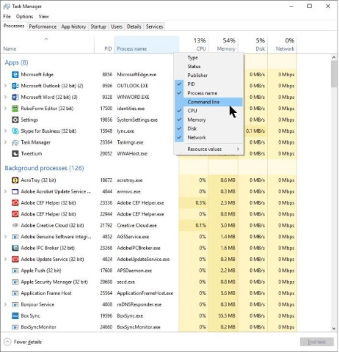
Linux: The top command in the Linux terminal provides a dynamic, real-time view of system processes, sorted by resource usage.
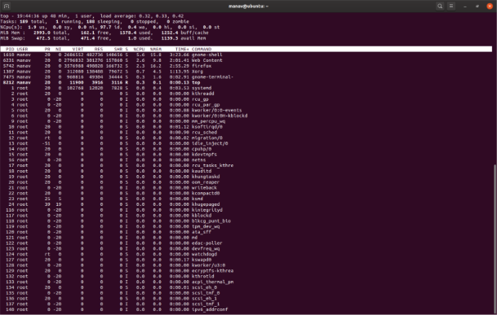

b. Memory Management
Memory management refers to how the OS handles RAM allocation, swapping, paging, and caching. Efficient memory management ensures that each process gets the memory it needs without interfering with others and helps prevent memory leaks and crashes.
Windows: The Resource Monitor within the Performance tab of Task Manager offers detailed insights into memory usage and available resources.
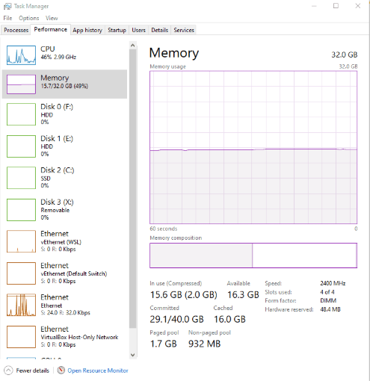
Linux: The free -m command shows total, used, and free memory in megabytes, offering a quick overview of system memory consumption.
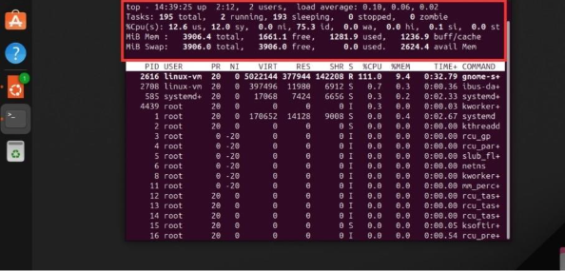

c. File System Management
File system management enables the OS to organize, store, retrieve, and secure data on storage devices. It handles directory structures, permissions, metadata, and file read/write operations.
Windows: File Explorer offers a graphical view of the hierarchical directory structure and file properties.
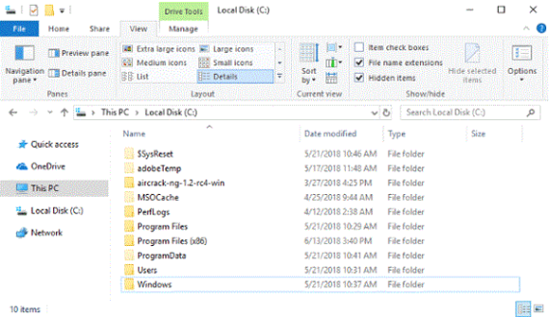
Linux : The command ls -l lists files in a directory along with details like permissions, ownership, and file sizes.
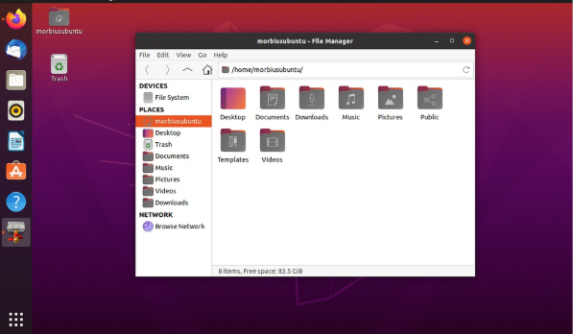

d. Device Management
The OS interacts with all hardware devices translating high-level commands into low-level instructions that hardware understands. This includes managing keyboards, printers, displays, hard drives, and external peripherals.
Windows: The Device Manager allows users to view and manage hardware devices and update or troubleshoot their drivers.

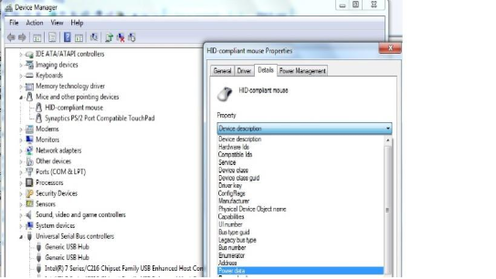
Linux: Commands like lsblk (for block devices) and lspci (for PCI devices) offer detailed hardware information through the terminal.
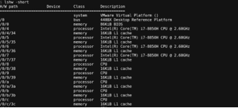

e. User Interface (UI)
The UI allows one to communicate with the operating system in Graphical User Interface (GUI) or Command-Line Interface (CLI). GUIs are easy to understand not like CLIs which are strong in automation and intricate tasks.
Windows: The more common Graphical user’s desktop includes the Start menu, taskbar, directory structure explorer, and command box.
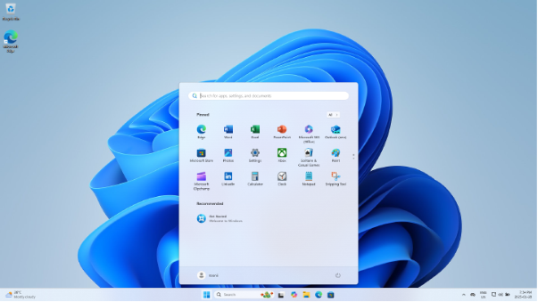
Linux: Many distributions offer both GUI (like GNOME, KDE) and CLI interfaces such as Bash shell for command-line tasks.
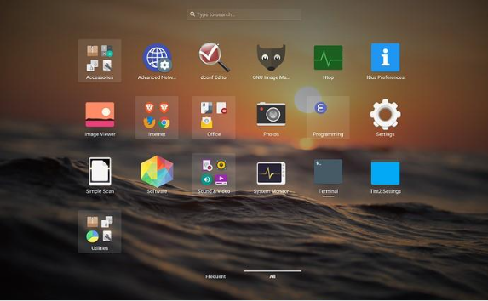

f. Security and Access Control
Operating systems take an important part in supporting security of the system because they support the implementation of mechanisms after user authentication, file system permissions, encryption, and role-based access control. These protection measures ensure only approved users can access doubtfulness data or execute sensitive works.
Windows: Windows comes with protection features such as User account control (UAC), BitLocker encryption, and file permissions through the Windows interface.
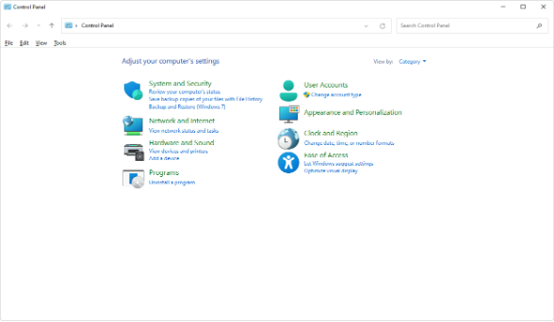
Linux : Linux uses user/group permission models, chmod for setting access rights, and commands like sudo for privilege escalation.
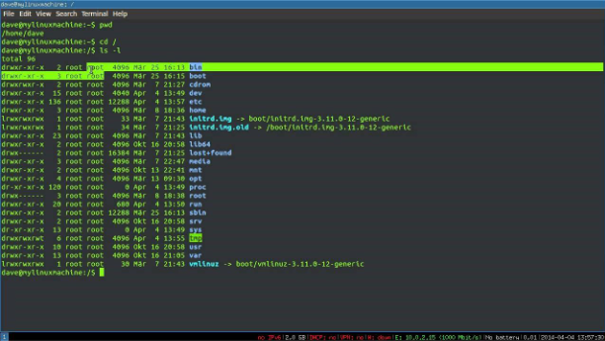
3. Use of Windows OS CLI Commands
Windows Command-Line Interface (CLI), which is also known as the Command Prompt (cmd.exe) is an effective tool enabling the users to communicate with the operating system by using text-based commands. Administrative work, debugging, and automation cannot be possible without it.
1. dir – List Directory Contents
Command:
dir
Description:
The dir command displays the name of all the files and subdirectories in the current directory. It presents information about file type, size and date last changed.
Use Case:
Their use may be helpful when a path is subject to multiple directories or when one is checking whether a file exists before using on a file such as copy or remove.
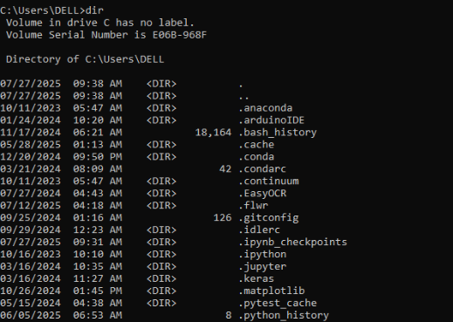
2. cd – Change Directory
Command:
cd Documents
Description:
cd (change directory) command can be used so that you can move to a desired folder of the file system.
Use Case:
The prerequisite to open files in other folders or directories through the CLI.
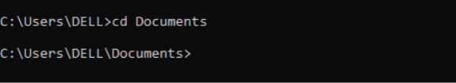
3. copy – Copy Files
Command:
copy file1.txt E:\Backup\
Description:
The command called copy resorts to copying a file to a different location.
Use Case:
It is extensively used to backup the files or to transfer information in various folders and disks.
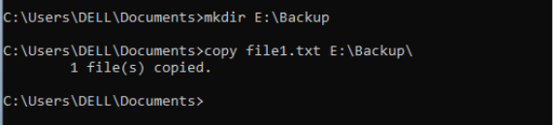
4. del – Delete Files
Command:
del file1.txt
Description:
Drops the specified file permanently from the current directory.
Use Case:
Used for clearing out old or unnecessary files quickly from the command line.
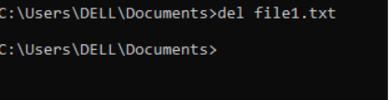
5. ipconfig – Display Network Configuration
Command:
Ipconfig
Description:
Shows more information like your network interfaces, the default gateway, the subnet mask, and the IP address.
Use Case:
Required for to show and troubleshoot network issues or confirm IP address assignments.
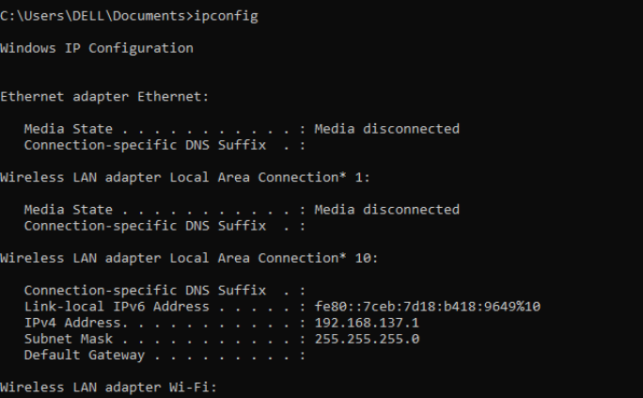
6. ping – Test Network Connectivity
Command:
ping google.com
Description:
Sends test packets to an IP or a domain to verify ways to network connectivity.
Use Case:
Employed to appreciate network issues and confirm whether an external host can be reached or not.
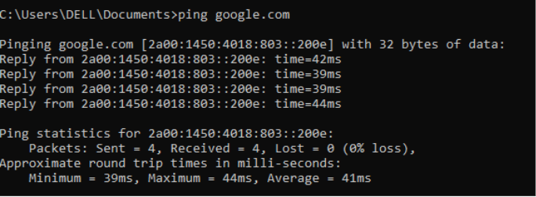
7. tasklist – List Running Processes
Command:
Task-list
Description:
Shows a list of all the processes which are running and how much memory they are using.
Use Case:
Can be useful to keep track on resource consumption or processes that have to be killed.
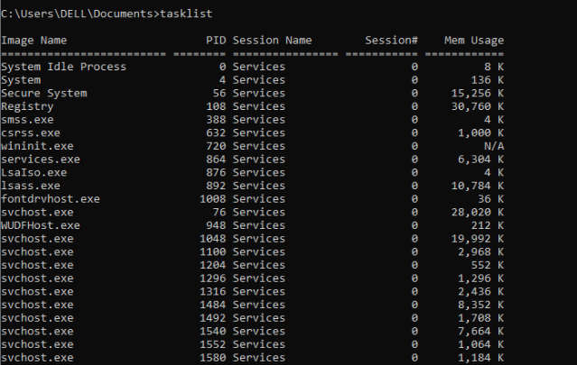
8. systeminfo – Display System Information
Command:
Systeminfo
Description:
Detailed description of the system, the version of OS, amount of installed memory, booting time and so on.
Use Case:
Perfect for auditing or have a record of system setups.
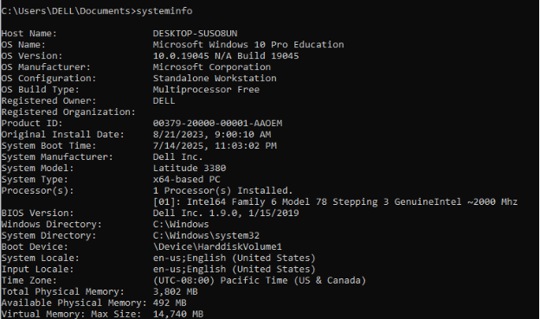
9. netstat – View Active Connections
Command:
netstat –an
Description:
Displays all active network connections and their ports, including the protocol being used and the connection state.
Use Case:
Often used in security assessments and to check for open or listening ports
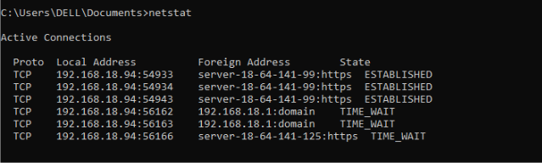
10. shutdown – Shut Down or Restart the System
Command:
shutdown /s /t 0
Description:
Shuts down the system at once. /s is for shutdown and /t 0 sets the timer to 0 seconds.
Use Case:
Useful for remotely powering off machines or automating shutdown processes in scripts.
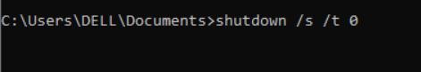

4. Use of Linux OS CLI Commands
1. ls – List Directory Contents
Command:
ls
Description:
Displays all files and directories in the current working directory.
Explanation:
This command is used to view contents of a directory quickly. Useful for file management and verification of directory structure.
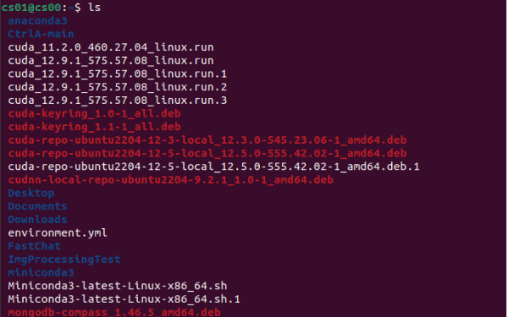
2. cd – Change Directory
Command:
cd Documents
Description:
Changes the current working directory to Documents.
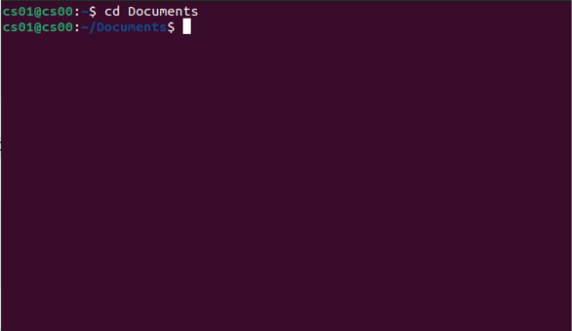
3. cp – Copy Files or Directories
Command:
cp file1.txt backup/
Description:
Copies file1.txt into the backup directory.
Explanation:
Used to duplicate files or directories. Add -r for recursive copy of directories.
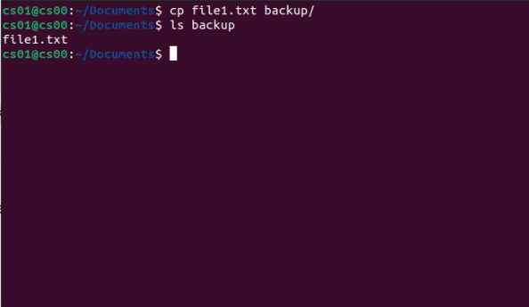
4. rm – Remove Files or Directories
Command:
rm oldfile.txt
Description:
Deletes oldfile.txt permanently.
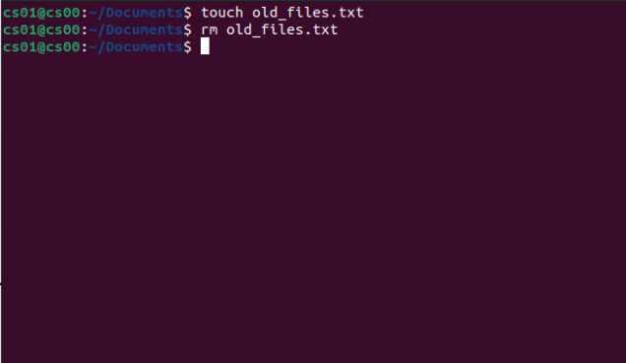
5. ifconfig – View Network Configuration
Command:
Ifconfig
Description:
Shows current network interfaces and IP configuration.
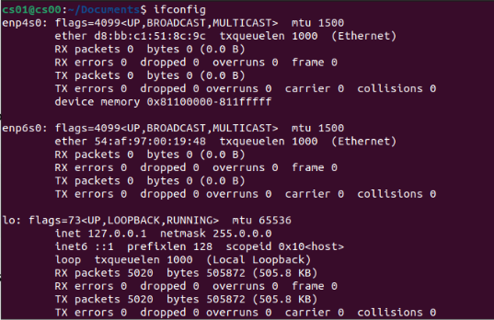
6. top – View Running Processes
Command:
top
Description:
Real-time view of system processes, CPU, and memory usage.
Explanation:
Useful for monitoring system performance and finding resource-heavy processes. Press q to exit.
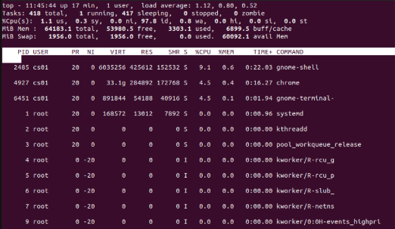
7. uname -a – Show System Information
Command:
uname –a
Description:
Displays system kernel name, version, and architecture.
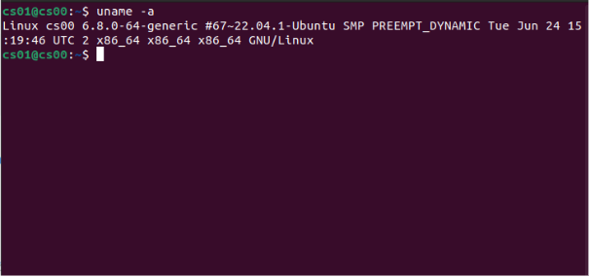
8. df -h – Disk Usage
Command:
df –h
Description:
Shows used and available disk space in human-readable format.
Explanation:
Helps identify how much storage is left and if any partition is nearing full capacity
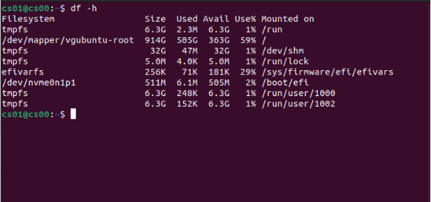
9. ps – List Active Processes
Command:
ps aux
Description:
Displays currently running processes with detailed information.
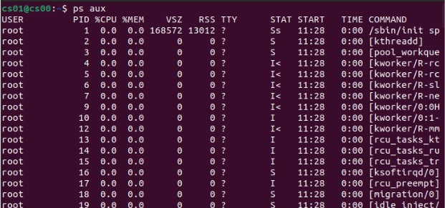
10. shutdown – Power Off the System
Command:
sudo shutdown now
Description:
Immediately shuts down the system.
Explanation:
Used to power off the system safely. Use shutdown -r now for immediate reboot.
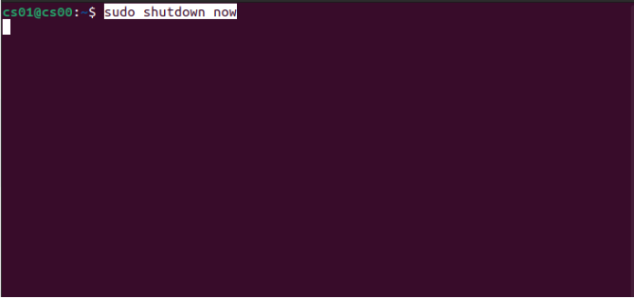
5. Use of Windows OS Scripts
Example using Batch script
@echo off
echo Displaying IP Config
ipconfig
pause

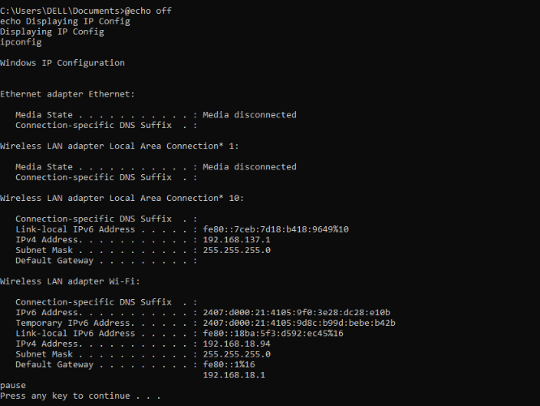
6. Use of Linux OS Scripts
Example Bash script:
#!/bin/bash
echo "System Information"
uname -a

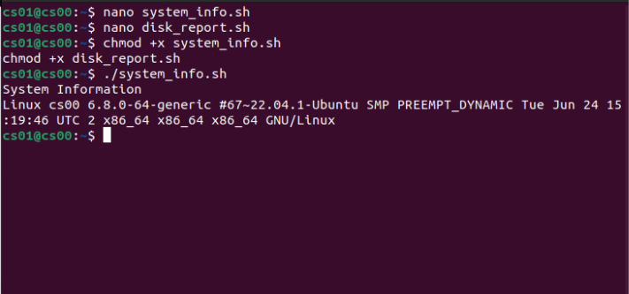
Another example:
#!/bin/bash
echo "Disk Usage Report"
df -h > disk_usage.txt

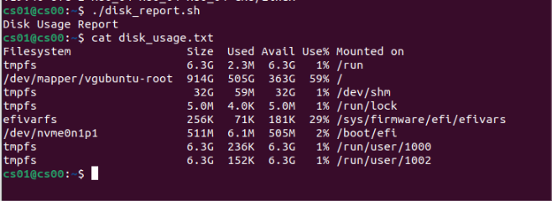

7. Conclusion

This report has explored the primary functions of general-purpose operating systems,
focusing on how both Windows and Linux implement and support these functions through their distinct tools, interfaces, and philosophies. The comparative analysis presented throughout the report aimed not only to describe the theoretical foundations of process management, memory allocation, file systems, device communication, and interaction methodologies, as well as user interfaces and security, but also to illustrate their practical applications using command-line utilities and scripting capabilities.
While Windows and Linux serve essentially similar roles, their approaches to system management are fundamentally different. Windows emphasizes user-friendliness and graphical interaction through a well-developed Graphical User Interface (GUI), allowing users to operate the system without requiring advanced technical expertise. Tools like Task Manager, Resource Monitor, Device Manager, and File Explorer enable both end users and administrators to interact easily with the system. Additionally, PowerShell and traditional Batch scripting offer automation and control capabilities, though they are generally considered less flexible than their Unix-like equivalents.
In contrast, Linux adopts a command-line-first philosophy, which, despite presenting a steeper learning curve, provides greater power, control, and transparency. Linux users can engage directly with the system's low-level functions using tools such as top, free, ls -l, chmod, lsblk, and sudo. Automation and system configuration can be executed swiftly and precisely with its built-in Bash shell and scripting features. This design makes Linux an excellent platform for system administrators, programmers, and security professionals who require robust control and configuration capabilities.

References:
- Silberschatz, P. B. Galvin, and G. Gagne, Operating System Concepts, 10th ed. Hoboken, NJ, USA: Wiley, 2018.
- Microsoft Corporation, "Windows Command Line documentation," Microsoft Learn, 2024. [Online]. Available: https://learn.microsoft.com/en-us/windows/terminal/
- The Linux Foundation, "Introduction to Linux," edX, 2024. [Online]. Available: https://www.edx.org/course/introduction-to-linux
- J. Shotts, The Linux Command Line: A Complete Introduction, 2nd ed. San Francisco, CA, USA: No Starch Press, 2019.
- Microsoft Corporation, "PowerShell Documentation," Microsoft Learn, 2024. [Online]. Available: https://learn.microsoft.com/en-us/powershell/
- Sommerville, Software Engineering, 10th ed. Harlow, UK: Pearson, 2015.

