Gower College Swansea
ACCA5022 - Web Technologies
HND Applied Computing
WIL13807181
1/28/2020

Contents
Introduction 2
JavaScript: Feature 1 2
The Battle simulator 2
JavaScript: Feature 2 3
Rollover images and to top button 3
JavaScript: Feature 3 3
The Events page (Maps) 3
Conclusion 4
Bibliography 5
Appendix 6

Introduction
The task at hand is to create a website with 3 appropriate JavaScript features, for my features I have decided to use Pokémon [1], this is a great hobby of mine and I think it will help the task be a lot more enjoyable, I will be basing my approach of Pokémon showdown [2], and will be creating my own website that has an events page where people can see Pokémon events that are available in the uk and a battle simulator where players a will choose a Pokémon and then battle them until one of the Pokémon's wins, the report will be used to dictate my approach and outcome of the website and I will then conclude how I found the task. by using JavaScript, I will be able to implement complex and useful features in order to make my website more productive. I will use a range of techniques and implement them over a serious of three pages” index". "battle simulator” and the events page.

JavaScript: Feature 1

The Battle simulator
The approach taken for the battle simulator was very basic, for starters all characters were listed and their attributes, move set and level were determined [3]. (As seen in appendix A). From this point my intention is to then create the front end of the battle simulator so that the user chooses a Pokémon from the six premade, and then will select the rival Pokémon from the remaining five. The player will then choose the Pokémon’s first move from the move set provided for that Pokémon and the rival Pokémon’s move will be determine at random, I will then loop this process until one of the Pokémon’s hp is equal to “0”. If the enemy Pokémon’s hp reaches zero first then a message will pop up saying “congratulations you win”, but if the users Pokémon hp reaches”0”, then a message will pop up saying “to bad Your Pokémon has Fainted”. And then the simulator will end.
My main purpose for the battle simulator was to have it so it resembled the original way that the Pokémon game dictated its fights [4], as there’s not much more you can do to the original way the game intended. For the front I used a range of classes to do each step of the battle process (as seen on appendix B), my muse for taking this approach was from a variety of readymade simulators that I researched online [5], the trainer will select a Pokémon then a rival will choose there from that point the battle can commence, as stated the battle will continue until either of the players or computer Pokémon reaches a hp of 0.
For future development I would like for the Pokémon to be animated even the slightest of movement darning a move phase makes it seem more realistic. I would also like to add the potential for a versus so that you don’t have to battle a computer [2] although this function is not best utilized if the player has no partner to battle against which is why the battle option can be a decision to battle a friend or a random, this option is a great way task for future development as it will need a lot of extra key parts for example it's going to need a database to run long side of the website to allow players to store information and login to see past battles and win streak, having a win streak is a great way of keeping a player's interest. From the point of the battle against others by adding a timer so that either user will not be able to take a ridiculous amount of time to make move choices.

JavaScript: Feature 2

Rollover images and to top button
A fun JavaScript feature that I found useful putting into my website was the rollover images I used them to show the Pokémon on the first page in different battle poses so the standard photos as seen on the website (appendix.....), once hovered over the photos of the Pokémon change from playful mode to battle mode [6], it's helpful option for the user of the website to better get a feel of what Pokémon they should choose for the battle, as a bonus once hovered over an alt shows their stats and moves of the Pokémon. Appendix C
The website also has a back to top button as there are six Pokémon it takes up a bit of the page so there is a fair bit of scrolling need for the website to get to the last Pokémon, so when you go out of the parameters of the website the “top button” will appear and once pressed you will return to the top of the page [6]
Both features help with the functionality of the website and make the usability a lot simpler also, upon my research I found a great website known as code gym [7], this gave me some ideas toward my website and what I like about the website is that it doesn’t show the answer just tasks that you will perform in order to get the answer.
I found that it was a good option to have these tools in my website as they are a good use of web skills and add great functionality to website.

JavaScript: Feature 3

The Events page (Maps)
For this page of the website I added an events page to my website, for now there are only two events, so they have been added to the website with individual maps to show users where the events are located upon clicking the map the user can then get directions to the event from the location they are at, the events page displays event information such as time, date and thanks to the map it also shows the location.
I was able to get event information from the serebii website [8] the information I got was for events that were around the globe, but I needed to get events from a specific location so by using the Pokémon website [9] the allowed me to locate with a certain region and I was able to find event in London and Cardiff, but as for the coding of the maps [6]I was able to get relative code that edited so that the location would be different for each of the events, both maps have in website functionality so you can do street view and pan in and out of the map to the users preference.
The maps allowed me to physically add my own pin points to show events so if in one area there were multiple events in the same day then I could show all points rather than just having an unnecessary amount of maps on the same page, this is a better use of design and a better sources instead of hard coding different maps and positioning them into the website

Conclusion
I have found that the battle simulator was the main JS feature of the website and if the time management for the website was better initiated a better version of the battle simulator could have been reached, potentially have a display of the battle moves or a damage calculation in the battle phases, if I was to revisit the task in the future I would better manage myself and the work load, I discovered a battle simulator [10], I wish that it was discovered sooner as it was the approach I should’ve taken rather than using showdown [2], this version of the battle simulator would’ve been better suited as there are a lot more JavaScript features I could’ve used, for example I could’ve had drop down menus for a trainer to choose moves out of a provided list and then select the opposing to then have the battle processed and the outcome predicted, making the battle simulator become a tool rather than a game which I found is what people more look for. I also think It would be a good idea to add a new page using a form I would like to add a feature so that players could add their own Pokémon and then use those to battle against others, potentially after adding a Pokémon it can get approved and then added to the actual database so other users can choose them as well making the options for Pokémon to battle be a lot greater than just six,

Bibliography

[1] | “Pokemon,” [Online].
[2] | “Pokemon showdown,” [Online]. Available: https://pokemonshowdown.com/.
[3] | t. p. company, “Pokemon Dtatbase,” Nintendo, [Online]. Available: https://www.pokemon.com/uk/pokedex/.
[4] | “Wikipedia,” [Online]. Available: https://en.wikipedia.org/wiki/Gameplay_of_Pok%C3%A9mon.
[5] | H. Springsteen, “codepen,” [Online]. Available: https://codepen.io/hollyos/pen/QNRXYK.
[6] | “W3Shcools,” [Online]. Available: https://www.w3schools.com/.
[7] | “CodeGym,” [Online]. Available: https://codegym.cc/projects/games.
[8] | “Serebii,” [Online]. Available: https://www.serebii.net/games/currentevents.shtml.
[9] | “Pokemon events,” [Online]. Available: https://www.pokemon.com/uk/play-pokemon/pokemon-events/find-an-event/.
[10] | “Battle simulator for pokemon,” [Online]. Available: https://pvpoke.com/battle/1500/pikachu/raichu/11/1-5-6-DIG-1/1-5-1/.

Appendix A
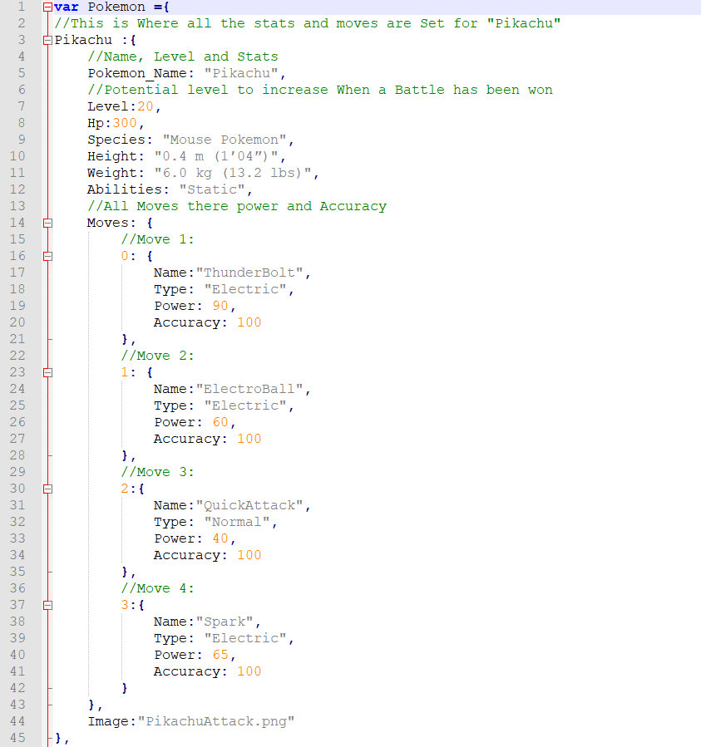
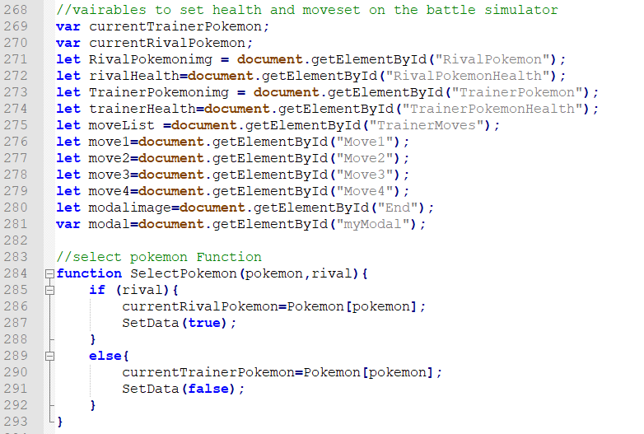
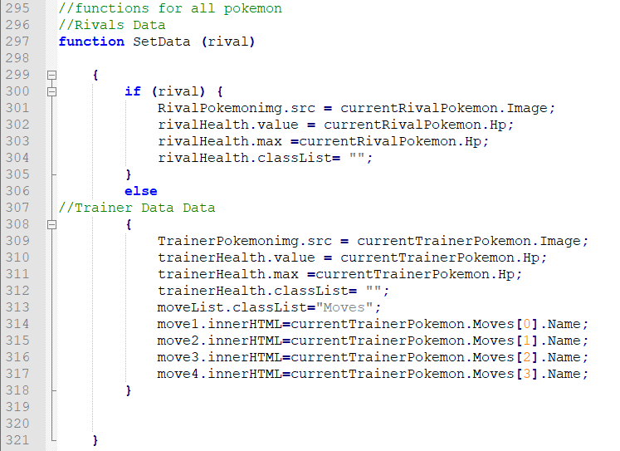
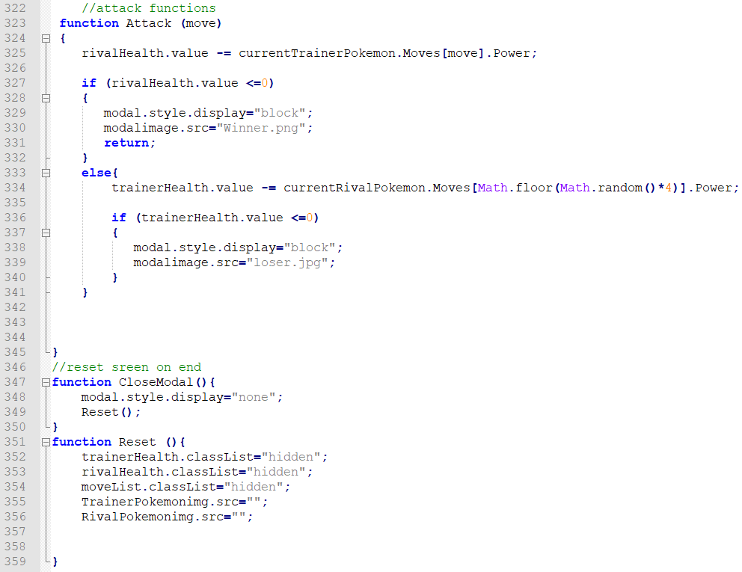

Appendix B

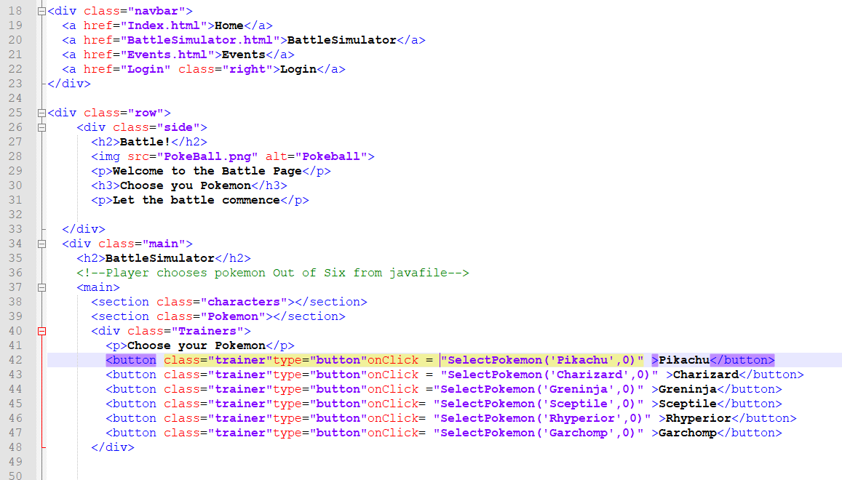
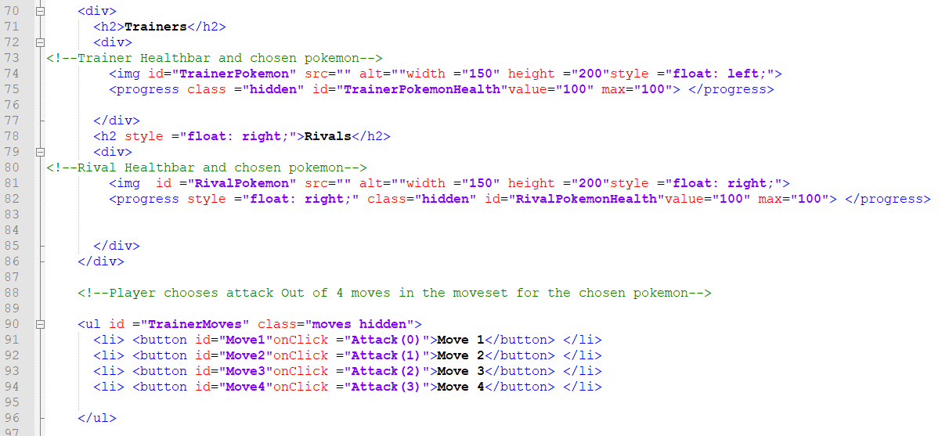

Appendix C



