
Learning and Development Factsheet
Benefit to organisation (6.1)
Learning and development initiatives are vital to organisations to allow their workforce to develop their skills and knowledge which in its turn enriches the quality of work carried out by the workforce. In a competitive market currently, it’s vital we are ensuring our workforce are up to date with training opportunities, as Page-Tickell (2014, p. 152) notes in their discussion “The benefits of sending employees on the courses include learning the content of the course as well as picking up ideas from other organizations.”
Learning can often be used to develop a workplace. This often will involve improving a workplaces’ culture to be one “that values individual’s performance, continuous improvement, innovation and customer service.” as Patton, Higgs and Smith (2018, p. 32) discusses. If a company are investing time in their employees, they will feel valued, which improves culture within the workforce. This in the long term will benefit the organisation as it will improve retention ease pressures on recruitment strategies.
It's discussed that there are numerous benefits of learning and development on the whole wider team. It notes that team training and learning can be beneficial to improving organizational performance as “teamwork enable employees to actively participate on the job and produces better performances.” (Elnaga et al., 2013)
Whilst undertaking a study on the effect of training and development, (Karim et al., 2019), 50% of the respondents in the study noted that they strongly agree that training and development improved their job satisfaction. We must consider this as a factor. If our employees are satisfied, they will produce better work more effectively, creating better results within our workforce.

Employee development is important for both existing employees and new starters at Healthcare on Hand and this is the responsibility of the People Team. Please use the content below to raise awareness of the benefits of learning and development schemes, including the types of learning needs and the various approaches to learning and development, individuals’ requirements and preferences and how learning and development can be evaluated.
Learning Needs (6.2)
Learning needs must be assessed for both the individual and organisation, and the effect on an individual often influences an organisation. Patton, Higgs and Smith (2018, p. 223) discusses in their work how professional development “opens up powerful pedagogical possibilities” and then to benefit the organisation this can “harness contextual clinical workplace influences and opportunities to shape the overall development of future health professional graduates.” Professional development can often arise when there is a need within the department or if an employee has points needing to reach following an appraisal or for the needs of wages for example.
In the field that we are carrying out our work, it is vital that we are updating our skills and knowledge through learning and development schemes to ensure we have the latest information. As Crowley (2022) has noted, “In today’s competitive and fast-changing world, the skills and capabilities of the workforce are vital to economic sustainability and growth.” Therefore, we can conclude from this, as legislation regarding economic policies for example are changing, we need to ensure our relevant departments are armed with the best and most relevant knowledge to carry out their work within our organisation.
In many workforces, there will be gaps in the skills sets. It is vital we as an organisation recognise the learning needs of the workforce and use Learning and Development schemes to bridge “skills gaps by identifying the gaps, designing effective training programmes, promoting continuous learning” as Cholteeva (2023) notes in their work.

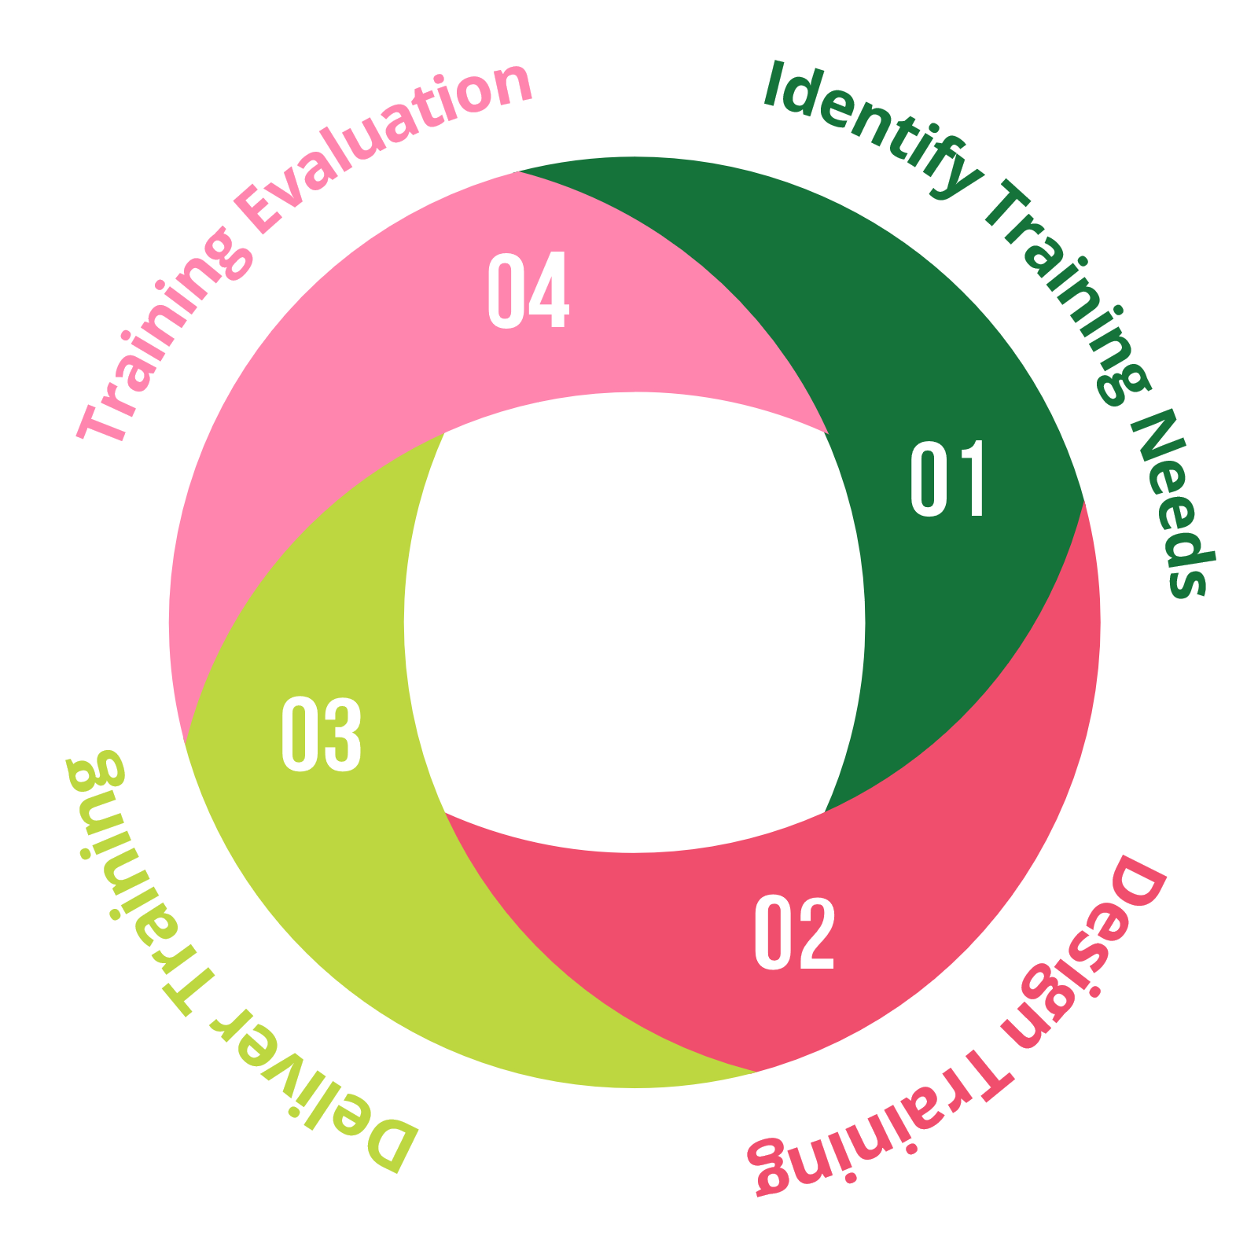
(Professional Development, no date)
Declared Word Count: 1,370
Evaluating Learning and Development (6.5)
In their work, Goel (2021) defines evaluation in the context of learning and development as, “the process of judging or putting a value on a learning process using established criteria to identify the degree to which knowledge or skill has been gained and applied.” To ensure the effectiveness of our learning and development therefore the evaluation needs to be a vital part of the cycle, which is identifying training needs, designing the training, delivering the training and finally evaluating the training (Professional Development, no date). We must consider that before we restart the cycle to identifying the training needs, we must evaluate the training that has been carried out to ensure it is fulfilling the needs for the employee and the employer.
As Waite et al. (2021, p. 225) notes, timing of evaluation is key to the success of learning and development initiatives. They discuss how a large majority conduct evaluation after the programme has finished, but they note that “To be useful, evaluation needs to be considered from the beginning of a training/learning process.” To do this, it needs to be integrated into the learning as it is carried out, a factor that we as a workforce must be considering as part of our learning and development schemes.
There are various methods to collect feedback and from various aspects, i.e., from the learners and the learning providers perspectives and these can be collected through the methods of open discussions verbally or written, assessments at various stages in the process, anonymous surveys, interviews and feedback at the end of the process. It is vital that a combination of all the above is considered when evaluating learning and development schemes within our organisation.

Design and Delivery of Learning and development (6.4)
Evans (2007, p. 77-78) in her work discusses the skills learnt whilst learning from first hand experiences. They note that whilst considering adult learners following college courses, they can use previous experience that they may have had and “use them in the learning process as a key to deepening and extending knowledge and skills to unlock new capabilities.”
This therefore highlights the need mix methods for certain individuals, whilst also taking into consideration whilst in this example, adult learners may have already gained this first hand experience, when we consider a wide range of backgrounds and age range, we must be careful to ensure that our learning methods are not reliant on first hand experiences as perhaps a large percentage of the audience will not have experienced this prior.
It is vital whilst developing training opportunities that they are fulfilling the needs of the employees but as importantly are being delivered in a way that the employees can engage and benefit from the training provided. In a report (Perna, 2022) where they look at the effectiveness of learning and training initiatives, out of the ones who noted they were unhappy with the training provided 50% noted that this was because they felt it could be more relevant and 37% of them noted they would have liked to be given more control over their learning and development needs. It is vital therefore that we are constantly evaluating the need for learning and development within out teams noting if there are needs within the audience and what suits them regarding delivery method, time, location and topics discussed. This will enable employees to engage more and in the long term, feed more effective benefits back within the wider team and workforce.

Learning and Development approaches (6.3)
When considering learning and development approaches there are numerous methods that can be used. Firstly, Page-Tickell (2014, p. 156) highlights the benefits of blended learning, as it puts the learner in the centre and gives them the freedom to learn at a pace that suits and works best for them as an individual.
If we consider the benefits of on-the-job training where an individual learns the requirements of the role by observing and being assisted by a college within the same team. Hayden (2022) notes the benefits of this as it is a “specified, planned and structured activity.”
E-learning is now playing a vital role within the approach to learning and development. Rennie and Smith (2019, p. 73) in their work discuss the benefits of learning online as “computer-based materials can be more motivating, interactive and dynamic than print.” It’s important to consider learning online learning as a vital approach to ensure we’re engaging our employees.
Coaching and Mentoring are also two key approaches to consider with different purposes. As he discusses this, Hayden (2023) notes that coaching “focuses on specific skills and goals” whilst mentoring “describes a relationship in which a more experienced colleague shared their greater knowledge to support the development of an inexperienced individual.”
We as an organisation must utilise in house and external training and use these to our benefit for the various topics of training. For example, in house training will work effectively when delivering on a process we have established and is working well for us. If a process is new to us, with no employees confident or trained in this field, we must then utilise external training opportunities to gain the knowledge and skills we require.
References
Cholteeva, Y. (2023) The UK is facing a green skills crisis - what can we do?. Available at: https://www.peoplemanagement.co.uk/article/1826654/uk-facing-green-skills-crisis-%E2%80%93-do (Accessed: 28/07/2023).
Crowley, L. (2022) Skills development in the UK workplace. Available at: https://www.cipd.org/uk/knowledge/factsheets/skills-factsheet/ (Accessed: 26/07/2023).
Evans, K. (2007) Improving Workplace Learning. New York: Nova Science.
Elnaga, A. et al. (2013) 'The Effect of Training on Employee Performance', European Journal of Business and Management, 5(4)
Goel, T. (2021) Assessment and Evaluation in Learning. Available at: https://www.linkedin.com/pulse/assessment-evaluation-learning-taruna-goel/ (Accessed: 02/08/2023).
Hayden, David. (2022) Learning Methods. Available at: https://www.cipd.org/uk/knowledge/factsheets/learning-methods-factsheet/ (Accessed: 26/07/2023).
Hayden, David. (2023) Coaching and mentoring. Available at: https://www.cipd.org/uk/knowledge/factsheets/learning-methods-factsheet/ (Accessed: 27/07/2023).
Karim, M. et al. (2019) 'The Impact of Training and Development on Employees' Performance: An analysis of Quantitative Data', Noble International Journal of Business and Management Research, Vol. 03, No. 02, pp: 25-33e.
Patton, N., Higgs, J. and Smith, M. (2018) Developing Practice Capability, Transforming Workplace Learning. Netherlands: Brill.
Page-Tickell, R. (2014) Learning and Development. London: Kogan Page.
Perna, M. (2022) Why Learning And Development Is Now A Competitive Differentiator. Available at: https://www.forbes.com/sites/markcperna/2022/04/12/why-learning--development-is-now-a-competitive-differentiator-and-how-to-get-on-board/?sh=68e6066a30ff (Accessed: 1/08/2023).
Professional Development (no date) Why is completing the Training Cycle important?. Available at: https://www.professionaldevelopment.ie/the-training-cycle (Accessed: 01/08/2023).
Rennie, F. and Smyth, K. (2019) Digital Learning: The Key Concepts. London: Routledge.
Waite, K. et al. (2021) People Practice A Complete Guide. London: Kogan Page.

