

Internet Protocols

Author- Ion Gabriel Matei
Module-Internet Protocols
Programme-BSc Cloud Computing

Table of Contents

Table of Contents.....................................................................................................................1
Figures.....................................................................................................................................2
Icons........................................................................................................................................3
Introduction.............................................................................................................................4
IPv4 transition ........................................................................................................................5
Ipv6 addressing .......................................................................................................................8
IPv6 Terminology....................................................................................................................8
IPv6 special addresses...........................................................................................................11
IPv6 Transition Techniques...................................................................................................11
Dual Stack.............................................................................................................................11
Translation.............................................................................................................................12
Tunnelling..............................................................................................................................14
Summary................................................................................................................................15
Scenario..................................................................................................................................16
Resolution..............................................................................................................................17

Figures

Figure: Scenario...................................................................................................................4
Figure: Subnet Mask............................................................................................................6
Figure: Subnetted Subnet.....................................................................................................6
Figure: Variable Length Subnet Masking (VLSM) ............................................................6
Figure: IPv4 address format.................................................................................................8
Figure: IPv6 address format.................................................................................................8
Figure: Unicast Address Format...........................................................................................9
Figure: Multicast Address Format........................................................................................9
Figure: Anycast Address Format..........................................................................................9
Figure: IP source/destination address for IPv6-host only.....................................................9
Figure: Dual Stack...............................................................................................................11
Figure: IPv6-translation-with-IPv4.....................................................................................12
Figure: IPv6-tunnelling-with-IPv4......................................................................................14
Figure: Available IPv6 Transition Techniques...................................................................14
Figure: Packet Tracer Network Simulation.........................................................................17

Tables

Table: Class, Subnet Mask and IP Range.................................................................................5
Table: Classless Inter-Domain Routing...................................................................................10
Table: Adopting IPv6..............................................................................................................15
Table: VLSM............................................................................................................................18
Table: Servers Allocated Addresses.........................................................................................18
Table: Linked ISP.....................................................................................................................18

Introduction
The report is created in order to cover a brief description of networking in terms of concept and evolution from the fourth version of the Internet Protocol- IPv4 to the Internet Protocol Version 6-IPv6.
First part is concentrating attention over Ipv6 addressing and second part is creating a scenario:
Design an IP addressing scheme for School of Management and Engineering.
As a network administrator, you are asked to design a hierarchical IP addressing scheme for Faculty’s networks.
Choose a suitable network address to support more than 2000 users and future growth.
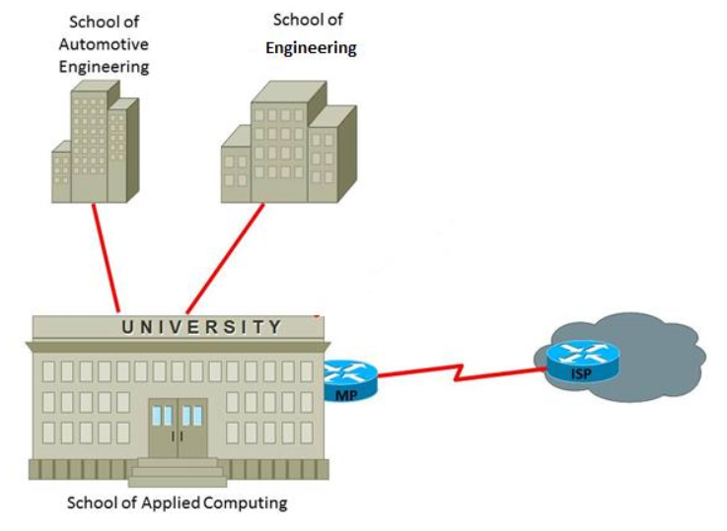Figure: Scenario
IP addressing scheme to support:
- School of Applied Computing: 20 staff, lab301 –60 pcs, Lab302 –30 pcs, Lab303 –36 pcs, Lab 304 –45 pcs, Lab306 –40 pcs, Lab308 –140 pcs, Lab309 –50 pcs and Lab310 –18 pcs.
- School of Automotive Engineering: 25 staff, lab101 –40 pcs, Lab102 –25 pcs, Lab103 –35 pcs, Lab205 –40 pcs, Lab206 –48 pcs, CAD lab –20 pcs and Lab301 –50 pcs.
- School of Engineering: 18 staff, lab201 –20 pcs, Lab202 –80 pcs, Lab203 –65 pcs, Lab205 –25 pcs, Lab404 –45 pcs, Lab408 –28 pcs, Lab409 –80 pcs, Lab410 –45 pcs.
- A Test centre –20 pcs, 1 IP phone, a printer
- An Open Access lab with 245 pcs and 5 printers
- Assign appropriate Ipv6 address for 6 servers located at the University building
- The servers are DNS, Email, Finance, Registry, File server and a Print server. Assign appropriate Ipv6 address for the link between MP and ISP.

IPv4 transition
Taking in consideration the importance of the communication in the way we are living today and specially how data networks are growing, social media development, multi media traffic needs, new domains application and according to a report made by Cisco Systems (Cisco White Paper, “Cisco Visual Networking Index: Forecast and Methodology, 2016–2021”, September 15, 2017) , both private network and internet, require equipment that supports this demands, that are reliable in the transmission of information, and that present a scalable architecture and greater processing capacity.
In order to avoid dependency with the manufacturers, spending high amount of money and other resources to expand the capacity of the networks it was possible a development of the new network architecture and techniques.
Subnetting is a technique used to divide a network into sub-segments of networks by dividing available IP address range into different sub-networks with advantages such as: increases routing efficiency, enhances the security of the network and reduces the size of the broadcast domain.
There are two main types of subnetting :
- First based on number of networks required
- Second based on number of hosts required per network.
Internet Protocol- IPv4 is described as connectionless protocol and used in packet-switched layer networks, such as Ethernet.
One great capacity is to be able to provide logical connection between network devices using unique identification of devices.
IPv4 provide an IP structure where each address consists of 4 octets, 4 sets of 8 bits:
Class ID | Default Subnet Mask | Range of IP
Class A | 255.0.0.0 (/8) | 1.0.0.0 – 126.255.255.255
Class B | 255.255.0.0 (/16) | 128.0.0.0 – 191.255.255.255
Class C | 255.255.255.0 (/24) | 192.0.0.0 – 223.255.255.255
Table: Class, Subnet Mask and IP range.
A subnet mask defines the network part and the host’s part in an IP address and the size of the subnet which means the number of host addresses in the subnet.

Fixed-Length Subnet Masking (FLSM) creates equal sized subnets.
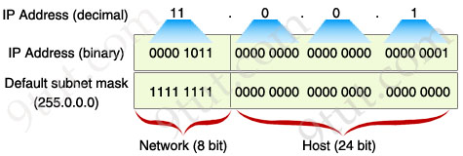Figure: Subnet Mask
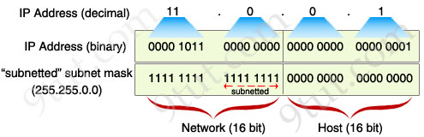Figure: Subnetted Subnet
To avoid a bad inefficient distribution of hosts having many unused addresses, or some sets of hosts being too big to fit into a subnet was developed Variable-Length Subnet Masking (VLSM)
The aim of VLSM is "subnetting subnets" which means that with this technique it can be divided an IP address space into a hierarchy of subnets of different sizes, with very different host counts without wasting large numbers of addresses.
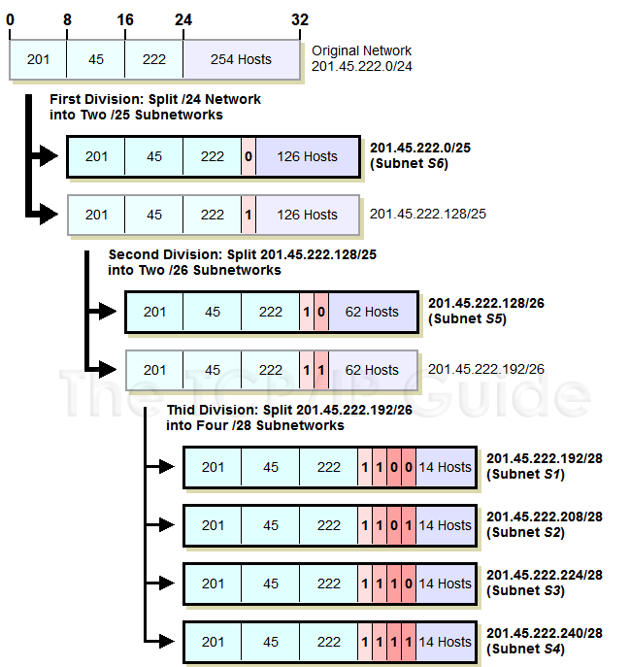
Figure: Variable Length Subnet Masking (VLSM) Exampled VLSM diagram illustrates a Class C (/24) network divided on three hierarchical levels.
First two subnets where:
- One subnet is divided into two sub-subnets;
- Other sub-subnet get divided into four sub-sub-subnets.
The resulting six subnets have a maximum capacity of 126, 62, 14, 14, 14 and 14 hosts. (www.tcpipguide.com/free/t_IPVariableLengthSubnetMaskingVLSM-3.htm)
However subnetting is limited when physical architecture doesn’t allow integration of new devices that may cause huge impact in the performance of the network.
More users accept often to access unsecure networks that are providing great speed and bandwidth allocation instead of overprotected networks.
John Chambers, President and CEO of Cisco Systems conclude: Internet Protocols defines how computers communicate over a network. IPv4 contains over 4 billion unique IP addresses, which were completely allocated to specific geographic regions on February 3, 2011. (www.cisco.com, accessed 26, August, 2019)

Ipv6 addressing
In order to integrate the need of great experience and security over the network with almost infinite capacity of development was introduced and is in the process of implementation the next generation of Internet Protocol-IPv6.
IPv6 Terminology
- End Terminal (node)- device that implements IPv6
- Router- device that forwards IPv6 packets
- Host- any and user terminal different than router
- Upper layer- protocol layer immediately above IPv6
- Link- communication medium
- Subnet- one or more links with the same 64-bits address prefix
- Neighbour Nodes- network devices attached to the same link
- Data Packet- IPv6 header + payload
Looking to provide enough unique addresses over the networks IPv6 introduce 128bits address format instead 32bits format at IPv4.
192 | 168 | 1 | 10
Figure: IPv4 address format
0 | 0 | 0 | 0 | 0 | ffff | c0a8 | 10a
Figure: IPv6 address format
IPv6 advantages
- increase address space for any possible user
- have a simplified header (5 fields)comparing with IPv4 (12 fields)
- no need of broadcast
- integrated security and mobility features
- no fragmentation needed (each session initiate maximum transmission unit discovery)
IPv6 addressing
- Example of a IPv6 address: 2019:1e00:0000:0000:0000:0000:5:1234
- Any four-digit group of zeroes within an IPv6 address will be reduced to a single zero or altogether omitted.
New IPv6 addresses are similar and equally valid:
2019:1e00:0000:0000:0000:0000:0005:1234
2019:1e00:0:0:0:0:0005:1234
2019:1e00 :: 0005:1234
- The URL for the above address will be:
http://[2019:1e00:0000:0000:0000:0000:0005:1234]/
IPv6 addresses are classified into three categories:
- Unicast address is an identifier for a single interface.
The packet sent to a unicast address is delivered to the interface identified as unique address.
Adress assignet by Internet Assigned Numbers Authority (IANA)
Start with 2000::/3
000/3b | Global routing prefix/45b | Subnet ID/16b | Interface ID/64b
Figure: Unicast Address Format
- Multicast address is an identifier of different interfaces form the same network.
The packet send to multicast address is delivered to the multiple interfaces.
Every address has ff as first 2 hexadecimal digits
ff00/8b | Flag/4b | Scope/4b | Group ID/112b
Figure: Multicast Address Format
- Anycast address is an identifier for a group of interfaces from the same network.
The packet is delivered to one of the interfaces identified by the address.
When a unicast address is assigned to more than one interface became anycast address.
Prefix (aa00::/8 -preferred or fa00::/8-formal) | 0 –only
Figure Anycast Address Format
Network Notation in IPv6
IPv6 Header
Source address | 2001:1234:5678::/48
Destination address | 2001:1234:5678:0001::/64 | IPv4 address  192.168.21.100
Figure IP source/destination address for IPv6-host only

The IPv6 networks are using Classless Inter Domain Routing (CIDR) notation.
According with KeyCDN.com, CIDR, which stands for Classless Inter-Domain Routing, is an IP addressing scheme that improves the allocation of IP addresses. That means replacing the old system based on classes A, B, and C.
This source admitted that CIDR scheme also helped greatly extends the life of IPv4 but with negative impact resulting on slow growth of routing tables (www.keycdn.com, accessed 25 Aug 2019)

CIDR | 255.255.255.240/24
Netmask | 255.255.255.0
IP range | 255.255.255.0 – 255.255.255.255.255
Total hosts | 256
Table: Classless Inter-Domain Routing
A network or subnet using the IPv6 protocol is denoted as a group of IPv6 addresses whose size must be a power of two. (www.ipv6.com, last access 25, Aug, 2019)
The initial bits of an IPv6 address are identical for all hosts in the network and form the networks prefix.
If we consider network address 2019:1234:0105::/48 then next 15 subnets are:
2019:1234:0105:0001::/64
2019:1234:0105:0002::/64
2019:1234:0105:0003::/64
2019:1234:0105:0004::/64
2019:1234:0105:0005::/64
2019:1234:0105:0006::/64
2019:1234:0105:0007::/64
2019:1234:0105:0008::/64
2019:1234:0105:0009::/64
2019:1234:0105:000A::/64
2019:1234:0105:000B::/64
2019:1234:0105:000C::/64
2019:1234:0105:000D::/64
2019:1234:0105:000E::/64
2019:1234:0105:000F::/64
The size of bits in a network prefix are separated with “a / “
- 2019:1234:0105:000F::/64 denotes the network address 2019:1234:0105:000F
- Range from 2019:1234:0105:000F:: up to 2019:1234:0105:000F:ffff:ffff:ffff:ffff
A single host may be denoted as a network with a 128-bit prefix.
IPv6 special addresses
::/96 Zero at prefix indicates addresses that are compatible with the previously used IPv4 protocol.
::/128 Zero inside address indicates an unspecified address and is used for addressing purposes within a software.
::1/128 The loop back address is used to refer to the local host. An application sending a packet to this address will get the packet back.
Only 0:0:0:0:0:0:0:1/128 represents the Loopback address. After loopback address, it can be represented as ::1/128.
fec0::/10 This is a site-local IPv6 prefix. This address is valid only within the local organization.
fc00::/7 Unique Local Address (ULA). These addresses are routed only within some recognised sites and were introduced in the IPv6 to replace the site-local addresses and to reduce the risk of address conflicts.
ff00::/8 Prefix for multicast addresses.
fe80::/10 Link-local prefix. This prefix indicates that the address is valid only in the local physical link.
IPv6 Transition Technologies
IPv6 Transition is referring about the methodology used to connect the hosts or networks using different IP protocols according with specific IPv6 transition environment.
Dual Stack, Translation and Tunneling are commune transition technologies.
Dual Stack
Dual stack method: IPv4 and IPv6 protocol stacks are used on the same node.
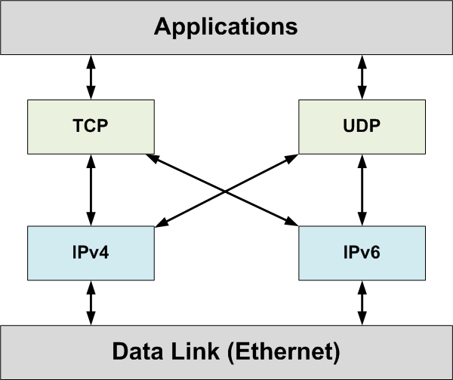
Figure Dual Stack Source: www.researchgate.net, accessed 25, August, 2019
Dual stack is a transition technology in which IPv4 and IPv6 operate in tandem over shared or dedicated links.
Configuration and routing protocols handle both IPv4 and IPv6 addressing.
Disadvantages:
• Current network infrastructure has to be capable of handling IPv6 addresses. Require ne resources such as hardware and software upgrades.
• IPv6 needs to be activated over the network elements this may cause network design improvement and business impact.

Translation
With Translation technique, information and message format are translated between different IP protocols.
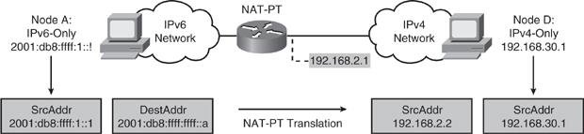
Figure: IPv6-translation-with-IPv4 Source www.researchgate.net, accessed 25,August, 2019
Address Family Translation (AFT), or simply translation, facilitates communication between IPv6-only and IPv4-only hosts and networks by performing IP header and address translation between the two address families.
IPv6/IPv4 Translation technologies:
- Network Address Translation-Protocol Translation (NAT-PT)
- Network Address Translation 64 (NAT64)
NAT-PT is not recommended by IETF because of is interfering with Domain Name System (DNS) and because of general limitations in translation, documented in RFC 4966 (C. Aoun,
E. Davies, Reasons to Move the Network Address Translator - Protocol Translator (NAT-PT) to Historic Status, July 2007).
Once was lost the interest for NAT-PT the increased need of IPv6 transition determine IETF to propose NAT64 as the best option to replace previews technique.
NAT64 means Network Address Translation IPv6 to IPv4
This technology creates the base of communication between IPv6-only and IPv4-only hosts and contained networks.
The new formed DNS64 and NAT64 functions are completely separated ant this represent the most important argument comparing with NAT-PT technology.
Translation offers two major advantages, as discussed in RFC 6144 (K. Yin, Cisco Systems, April 2011)
- Translation provides a gradual migration to IPv6. Users are experiencing seamless Internet connection while accessing IPv4 Internet services, being able to switch the services and applications over their different range of devices.
- Content providers and media control authorities can provide services to IPv6 Internet users by using translation technology.
Network infrastructure has a minimal impact in terms of new devices or applications, securing existing businesses.
Following Juniper TechLibrary (www.juniper.net, accessed 24,August,2019) specific protocols File Transfer Protocol (FTP) and Session Initiation Protocol (SIP) that embed IP address information within the payload require application-layer gateway (ALG) support for translation:
- ALG intercepts and analyzes the specified traffic, allocates resources, and defines dynamic policies to permit the traffic to pass securely through the device
- When a packet arrives at the device, the flow module forwards the packet according to the security rule set in the policy.
- If a policy is found to permit the packet, the associated service type or application type is assigned and a session is created for this type of traffic.
- If a session is found for the packet, no policy rule match is needed. The ALG module is triggered if that particular service or application type requires the supported ALG processing.

Tunnelling
Tunnelling methods: Virtual links are provided over the physical network.
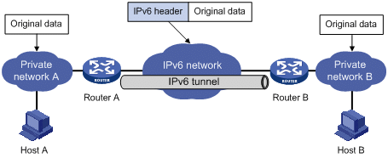
Figure: IPv6-tunnelling-with-IPv4 Source www.researchgate.ne, accessed 24, August, 2019
With tunnelling technique is able to create tunnels where one protocol is used over the other and IPv6 packets converge within IPv4 packets and vice-versa, without any disturbance between protocols or any user negative experience.
Tunnelling has two disadvantages presented in RFC 6144 (IETF):
- Users of the new architecture cannot use the services of the underlying infrastructure.
- Tunnelling does not enable users of the new protocol to communicate with users of the old protocol without dual-stack hosts, which affect interoperability.
Source: RFC 6144 Framework for IPv4/IPv6 Translation, April 2011
Figure: Available IPv6 Transition Techniques
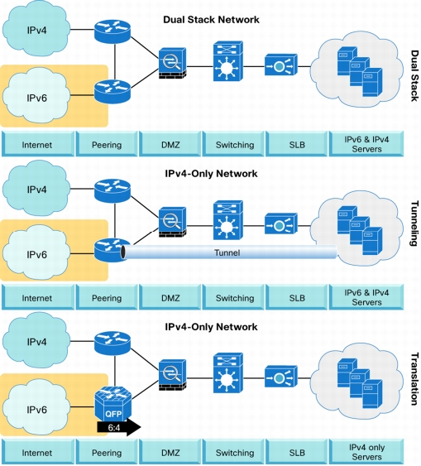
Everyone has a different reason to adopt IPv6:
IPv6 user | Destination | Impacted Domain
Officials | Meet regulations, compete in the global market, and ensure service availability.  Data protection | Public Sector
Business owners | Ensure customers IPv6 access.  Deal with address exhaustion, globalization, and technology innovation. | Service Providers
First users | Deal with address exhaustion, products selection | Utilities (smart grid) and mobile service providers
Global users | Business continuity, maintain customer reach, protect investments, personal data security. | Large enterprises, smaller business, entrepreneurs, home users
Table: Adopting IPv6
Summary
IPv6 is such called The Next Generation Internet Protocol or IPng.
IPv6 was recommended by the IPng Area Directors of the Internet Engineering Task Force at the Toronto IETF meeting on July 25, 1994 in RFC 1752, The Recommendation for the IP Next Generation Protocol.
The recommendation was approved by the Internet Engineering Steering Group and made a Proposed Standard on November 17, 1994.
The core set of IPv6 protocols were made an IETF Draft Standard on August 10, 1998. Internet Protocol Version 6 is abbreviated to IPv6 (where the "6" refers to it being assigned version number 6).
The previous version of the Internet Protocol is version 4 (referred to as IPv4).
Regarding global connectivity of a immense variety of user-devices and computer networks is important to conclude that is achieved through TCP/IP stack.
IP is used in every end system as well as every intermediary network devices such as routers.

Scenario
As a network administrator, you are asked to design a hierarchical IP addressing scheme for Faculty’s networks. Choose a suitable network address to support more than 2000 users and future growth.
The requirements are:
- IP addressing scheme to support:
- School of Applied Computing: 20 staff, lab301 –60 pcs, Lab302 –30 pcs, Lab303 –36 pcs, Lab 304 –45 pcs, Lab306 –40 pcs, Lab308 –140 pcs, Lab309 –50 pcs and Lab310 –18 pcs.
- School of Automotive Engineering: 25 staff, lab101 –40 pcs, Lab102 –25 pcs, Lab103 –35 pcs, Lab205 –40 pcs, Lab206 –48 pcs, CAD lab –20 pcs and Lab301 –50 pcs.
- School of Engineering: 18 staff, lab201 –20 pcs, Lab202 –80 pcs, Lab203 –65 pcs, Lab205 –25 pcs, Lab404 –45 pcs, Lab408 –28 pcs, Lab409 –80 pcs, Lab410 –45 pcs.
- A Test centre –20 pcs, 1 IP phone, a printer
- An Open Access lab with 245 pcs and 5 printers
- Assign appropriate IPv6 address for 6 servers located at the University building.
The servers are DNS, Email, Finance, Registry, File server and a Print server.
- Assign appropriate IPv6 address for the link between MP and ISP.
Figure: Scenario

Resolution
1. IP addressing scheme
Total IP addresses distribution over locations:
- School of Applied Computing-439
Test Centre-22
Open Access Lab-250

- School of Automotive Engineering-283
- School of Engineering-406
- Link1 (MP to Automotive)-2
- Link2 (MP to Engineering)-2
- Link3 (MP to ISP)-2
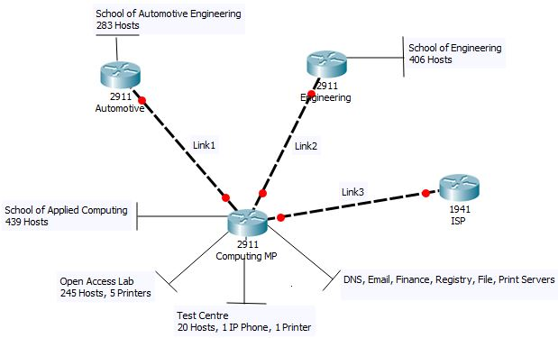
Figure: Packet Tracer Network Simulation

I have considered next public, B class, IP Address: 172.35.0.0
Location/ Addresses | Network Address | First usable IP Address | Last usable IP Address | Broadcast Address | Subnet Mask Address
School of Applied Computing/439 | 172.35.0.0 | 172.35.0.1 | 172.35.1.254 | 172.35.1.255 | 255.255.254.0
School of Engineering/406 | 172.35.2.0 | 172.35.2.1 | 172.35.3.254 | 172.35.3.255 | 255.255.254.0
School of Automotive Engineering/283 | 172.35.4.0 | 172.35.4.1 | 172.35.5.254 | 172.35.5.255 | 255.255.254.0
Open Access Lab/250 | 172.35.6.0 | 172.35.6.1 | 172.35.6.254 | 172.35.6.255 | 255.255.255.0
Test Centre/22 | 172.35.7.0 | 172.35.7.1 | 172.35.7.31 | 172.35.7.31 | 255.255.255.224
Link1 (MP to Automotive)/2 | 172.35.7.32 | 172.35.7.33 | 172.35.7.34 | 172.35.7.35 | 255.255.255.252
Link2 (MP to Engineering)/2 | 172.35.7.36 | 172.35.7.37 | 172.35.7.38 | 172.35.7.39 | 255.255.255.252
Link3 (MP to ISP)/2 | 172.35.7.40 | 172.35.7.41 | 172.35.7.42 | 172.35.7.43 | 255.255.255.252
Table: VLSM
2. IPv6 address for 6 servers located at University
Servers | IPv6 Address
DNS | fc00::
E-mail | fc00::1
Finance | fc00::2
Registry | fc00::3
Files | fc00::4
Print | fc00::5
Table: Servers Allocated Addresses
3. Assign appropriate IPv6 address for the link between MP and ISP
Considered public domain address | 2019:db:555::/40
Expanded Address | 2019:00db:0555:0000:0000:0000:0000:0000/40
Range | 2019:db:500:0:0:0:0:0
Range | 2019:db:5ff:ffff:ffff:ffff:ffff:ffff
Interface ISP | 2019:db:500::/48
Interface MP | 2019:db:501::/48
Table: Linked ISP
BIBLIOGRAPHY

Cisco White Paper, “Cisco Visual Networking Index: Forecast and Methodology, 2016–2021”, September 15, 2017.
Introduction to Networks Companion Guide by Cisco Networking Academy, Cisco Press, December 20, 2013.
Network Protocols and Algorithms, online journal, Macrothink Institute, Vol 10, No 4, 2018.
R. Graziani, IPv6 Fundamentals: A straightforward approach to understanding IPv6, Cisco Systems, Cisco Press, 2013.
F. Baker, X. Li, C. Bao, K. Yin, RFC 6144, Internet Engineering Task Force (IETF), Center/Tsinghua University, Cisco Systems, April 2011
N. Olifer, V. Olifer, Computer Networks Principles, Technologies and Protocol for Network Design, John Wiley and Sons, 2006.
M. A. Dye, R. McDonald, A. W. Rufi, Network Fundamentals, CCNA exploration companion guide, Cisco Press, 2011.
M. Sportack, IP Addressing fundamentals, Cisco Press, 2003.
F. Baker, X. Li, C. Bao, K. Yin, RFC 6144 Framework for IPv4/IPv6 Translation, April 2011
Websites
www.netacad.com
www.iana.org
www.cisco.com
www.ibm.com
www.tcpipguide.com
www.keycdn.com
www.tools.ietf.org

