The importance of effectively monitoring guest service strategies

Module name: Hospitality and guest service management (BMIH4003)
Student name: Antonela Costiuc
Student number: 2117337
Lecturer name: Charlotte Joyner

Executive summary
In the report, which provides information through examples and case studies, the crucial relevance of monitoring guest service methods in the hotel and hospitality business is emphasised. It emphasises how important brand consistency, service culture, reputation management, and adherence to hotel standards are for fostering customer loyalty. It also emphasises the significance of technology development and efficient service failure management. The report ends with thorough suggestions for the sector, highlighting the necessity of ongoing consumer preferences and expectations adaption to preserve a competitive advantage.
Table of Contents
Executive summary 2
Introduction 4
Main Findings 5
Reputation Management 5
Service Culture 5
Brand Consistency 6
Importance of brand consistency 7
Hotel Standards 7
Customer Loyalty 8
Future Technological Impacts 8
Service Failure 9
Conclusion 11
Recommendations to the Industry 12
References 13
Table of Figures
Figure 1 Brand Consistency 6
Figure 2 Smart Rooms 9

Introduction
Staying ahead and succeeding in the brutally competitive hotel and hospitality sector depends on consistently adjusting to the most recent trends and providing top-notch client experiences. It is essential for companies in this industry to successfully analyse and adjust their guest service strategy to keep a competitive advantage. This report examines the value of keeping track of these tactics and how they may affect the hospitality sector. With the use of case studies and real-world situations, it gives a thorough report.

Main Findings

Reputation Management
Every prosperous hospitality company understands the importance of reputation management. A good reputation may be a potent marketing weapon, drawing in new customers and keeping the business of returning ones (Chang and Busser, 2020). On the other hand, a single bad experience might damage a hotel's reputation. Take the Ritz-Carlton, for instance, which is renowned for its outstanding service. In one extraordinary case, the hotel staff not only discovered and returned a costly item that a visitor had left behind but also gave the person a picture book documenting the item's prolonged stay. These kinds of tales enhance the brand's reputation and foster consumer loyalty.
The Ritz-Carlton's remarkable dedication to guest service created a lasting effect on the visitors, who then spread the word about it through word-of-mouth and online reviews (Floricic, 2016). In the era of social media and online review sites, such touching tales not only spread goodwill but also act as effective marketing tools. This incident emphasises how crucial reputation management is in the connected world of today. The Ritz-Carlton's reputation for excellent service may be solidified and the loyalty of not just the guest in question but also other guests who hear the tale can be assured by a single act of remarkable service that transforms an isolated occurrence into a potent marketing narrative.

Service Culture
A solid service culture serves as the cornerstone for consistently providing top-notch customer service. In this sense, The Four Seasons Hotels and Resorts stands out as a model for excellence, demonstrating how a constant dedication to a customer-centric culture can result in a long-lasting reputation for first-rate service (Webb, 2016).
Four Seasons commitment to establishing a service culture is demonstrated by several fundamental values and procedures:
Employee Development: Four Seasons places a high priority on employee training, making sure that every member of staff—from housekeepers to front desk agents—has the information, abilities, and attitude required to deliver unmatched client experiences.
Empowerment: Four Seasons workers may respond to specific requirements by giving them the freedom to handle client complaints or perform unplanned, kind gestures, resulting in highly personalised and memorable visits.
Teamwork: Four Seasons promotes open dialogue and cooperation among its employees because it understands that providing excellent service is a team effort. A seamless guest experience from check-in through check-out is achieved when teams work together effectively.
Celebrating Success: The service culture is strengthened when workers who regularly go above and beyond to provide great service are recognised and celebrated (Groysberg et al., 2018). Employee motivation is increased when exceptional performance is recognised and rewarded.

Brand Consistency
Maintaining brand consistency across numerous locations and properties in the dynamic hotel and hospitality sector is more than simply a part of business strategy—it is a crucial element in attaining long-term success (Gulati, Mathur, and Upadhyay, 2023). When it comes to promoting brand consistency, Marriott International, one of the biggest and most recognisable hotel companies in the world, offers an excellent case study.

Figure 1 Brand Consistency
Source:(marketing91.com, 2021)

Importance of brand consistency
Customer Expectations: Client expectations Brand consistency serves as a reassuring anchor in a world where tourists are looking for one-of-a-kind experiences (Master, 2018). When they see the recognisable Marriott emblem, visitors have certain expectations, whether they are travelling for business or pleasure.
Loyalty and Retention: Guests tend to stay with what they are familiar with and confident in. Bonvoy, Marriott's loyalty programme, is evidence of this. For customers to stick around the Marriott ecosystem, it gives rewards, exclusive privileges, and recognition to members across all of its brands.
Guest Confidence: When guests make a reservation at a Marriott property, they do so with some degree of trust in the company's reputation. They have faith that Marriott will consistently provide a specific level of quality and service, independent of the location or brand segment (Lukanova and Ilieva, 2019).

Hotel Standards
To achieve excellence and guarantee customer happiness in the hotel and hospitality business, monitoring and adhering to set industry standards is a crucial component. One organisation that offers standardised certification programmes and a structured framework for hotels to follow is the American Hotel and Lodging Educational Institute (AHLEI) (Martínez, Herrero, and Gómez‐López, 2019).
Hotels may get some benefits by strictly upholding these standards, which not only improves their operational effectiveness but also improves the entire visitor experience:
Quality Control: Standardised certificates issued by organisations like AHLEI cover a wide range of standards, including management procedures, food safety, cleanliness, and guest services. Hotels may ensure uniform quality across all departments with limited tolerance for error by following these rules.
Improved Training and Development: To achieve these requirements, hotels frequently make significant investments in staff training and advancement (Sheehan, Grant, and Garavan, 2018). The ability to deliver exceptional service is directly impacted by a staff's level of training. For instance, Marriott's dedication to training, which is heavily influenced by AHLEI standards, produces informed and productive employees.
Guest satisfaction and loyalty: When guests' expectations are fulfilled or surpassed, they are more likely to be pleased with their stay. Increased customer loyalty follows higher levels of visitor pleasure. For instance, Wyndham Hotels and Resorts used the AHLEI criteria to develop a guest-centric strategy, which has led to high levels of patron loyalty.

Customer Loyalty
Customer retention and satisfaction strategies in the hotel sector now include loyalty programmes as essential elements (Elgarhy, 2022). Although Hilton's Honours programme was previously noted, many other effective loyalty programmes have had a big impact on the market.
By providing a variety of benefits, such as exclusive access to VIP lounges, room upgrades, and a wide range of participating properties, from luxury resorts to affordable options, Marriott Bonvoy, which encompasses a sizable network of hotels and resorts, has successfully fostered customer loyalty. This wide range of choices appeals to a wide range of tourists, strengthening Marriott's attractiveness and making sure that visitors may discover the ideal fit for their interests.

Future Technological Impacts
The world of hospitality is constantly changing as a result of technological advancements, which promise better guest experiences, more operational effectiveness, and increased sustainability. The future of the sector is expected to be significantly impacted by some crucial technical developments.
Smart Rooms: As was previously indicated, voice-activated gadgets like Amazon's Alexa or Google Home are increasingly being incorporated into hotel rooms (Buhalis and Moldavska, 2022). With the use of these gadgets, visitors may use voice commands to manage room amenities, order services, and access information.
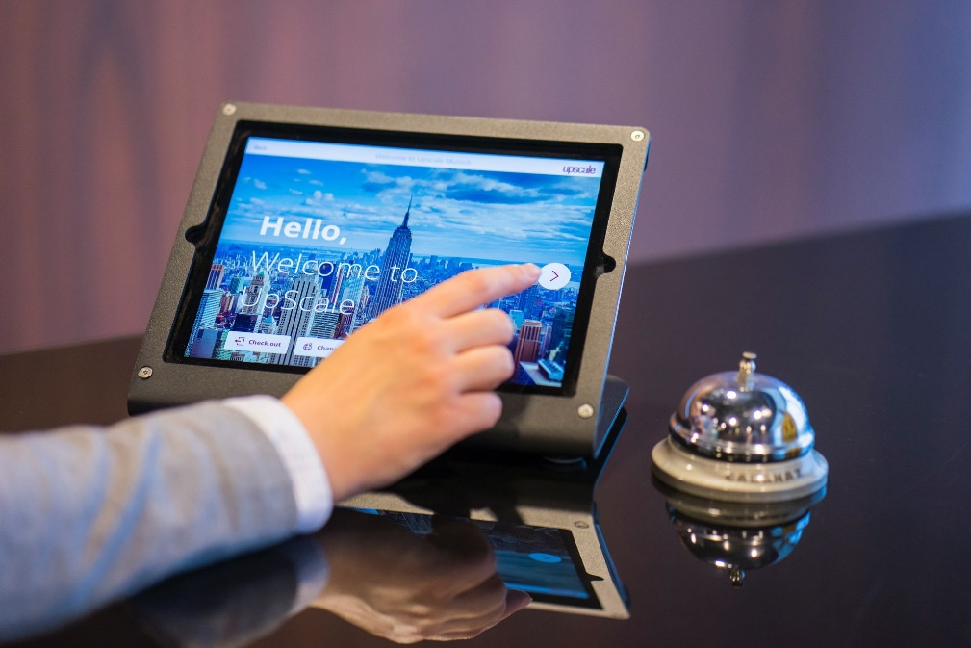
Figure 2 Smart Rooms
Source:(faundit.com, 2023)
Sustainability Initiatives: The usage of eco-friendly technology is expanding, with hotels making investments in water-saving technologies, waste-reduction strategies, and energy-efficient lighting (Rodríguez-Antón and Alonso-Almeida, 2019). For instance, Marriott's Green Hotels Global programme encourages sustainable practises across all of its hotels, minimising environmental effects and luring eco-aware travellers.
Virtual Reality (VR) and Augmented Reality (AR): Before booking a reservation, potential visitors may explore hotel facilities, rooms, and neighbouring activities thanks to these immersive experiences (Nayyar, Mahapatra, and Suseendran, 2018). For instance, Hilton uses virtual reality to let visitors see properties and plan their vacations.

Service Failure
Although service lapses are unavoidable, hotels must manage them properly. A prime example is the situation with the Miraval Resort in Arizona. They swiftly handle customer complaints and offer tailored solutions, transforming unpleasant encounters into chances for improvement and education.
Another crucial aspect is making sure that personnel is ready to manage service problems. To give their staff the knowledge and abilities to successfully handle customer concerns, Miraval Resort makes ongoing training investments (Yfantidou et al., 2019). They provide their workers the freedom to make decisions on the spot so that the visitors receive a prompt and satisfactory conclusion. In addition to improving the visitor experience, this empowerment of the employees also raises employee morale.

Conclusion
In the hotel and hospitality sector, it is crucial to effectively monitor customer service tactics. Businesses that accomplish this may improve their reputation, establish a culture of great customer service, assure brand continuity, follow hotel standards, encourage client loyalty, accommodate technology advancements, and manage service failures with tact. The industry's success and viability in a brutally competitive market will depend on its capacity to heed this advice and continuously enhance its guest service tactics.

Recommendations to the Industry
The analysis leads to the following recommendations for the hospitality sector:
- Maintain a constant eye on consumer feedback and adjust your methods accordingly.
- To guarantee constant service quality, invest in personnel training and establish a strong service culture (Khassawneh, 2018).
- Implement and uphold brand coherence throughout all properties.
- Establish certifications and industry norms, and uphold them.
- Create and maintain programmes that reward loyal customers.
- Accept technological progress for better visitor experiences.
- Create thorough strategies for dealing with service lapses with an emphasis on using them as opportunities for development.

References list

Buhalis, D., and Moldavska, I. (2022). Voice assistants in hospitality: using artificial intelligence for customer service. Journal of Hospitality and Tourism Technology, 13(3), 386-403.
Chang, W., and Busser, J. A. (2020). Hospitality career retention: the role of contextual factors and thriving at work. International Journal of Contemporary Hospitality Management, 32(1), 193-211.
Elgarhy, S. D. (2022). Effects of service quality, loyalty programs, pricing strategies, and customer engagement on firms’ performance in Egyptian travel agencies: Mediating effects of customer retention. Journal of Quality Assurance in Hospitality and Tourism, 1-29.
Floricic, T. (2016). Comprehention of innovative solutions in hospitality industry. Economic and Social Development: Book of Proceedings, 695.
Groysberg, B., Lee, J., Price, J., and Cheng, J. (2018). The leader’s guide to corporate culture. Harvard business review, 96(1), 44-52.
Gulati, C., Mathur, G., and Upadhyay, Y. (2023). Internal branding: Connecting links to establish employees’ brand behaviour in hospitality sector. FIIB Business Review, 23197145221143831.
Khassawneh, O. (2018). An Evaluation of the Relationship Between Human Resource Practices and Service Quality: An Empirical Investigation in the Canadian Hotel Industry (Doctoral dissertation, University of Gloucestershire).
Lukanova, G., and Ilieva, G. (2019). Robots, artificial intelligence, and service automation in hotels. In Robots, artificial intelligence, and service automation in travel, tourism and hospitality (pp. 157-183). Emerald Publishing Limited.
Martínez, P., Herrero, Á., and Gómez‐López, R. (2019). Corporate images and customer behavioral intentions in an environmentally certified context: Promoting environmental sustainability in the hospitality industry. Corporate Social Responsibility and Environmental Management, 26(6), 1382-1391.
Master, A. (2018). The significance of holistic marketing on motivations, expectations and experiences of travellers: A case study on Queenstown’s first-time tourists (Doctoral dissertation, Auckland University of Technology).
Nayyar, A., Mahapatra, B., Le, D., and Suseendran, G. (2018). Virtual Reality (VR) and Augmented Reality (AR) technologies for tourism and hospitality industry. International journal of engineering and technology, 7(2.21), 156-160.
Rodríguez-Antón, J. M., and Alonso-Almeida, M. D. M. (2019). The circular economy strategy in hospitality: A multicase approach. Sustainability, 11(20), 5665.
Sheehan, M., Grant, K., and Garavan, T. (2018). Strategic talent management: A macro and micro analysis of current issues in hospitality and tourism. Worldwide Hospitality and Tourism Themes, 10(1), 28-41.
Webb, N. (2016). What customers crave: How to create relevant and memorable experiences at every touchpoint. Amacom.
Yfantidou, G., Spyridopoulou, E., Chatzigeorgiou, T., and Malliou, P. (2019). Hotel innovation and the creation of competitive advantage. In Smart Tourism as a Driver for Culture and Sustainability: Fifth International Conference IACuDiT, Athens 2018 (pp. 135-144). Springer International Publishing.

