Welsh Language Development

Throughout my experience within placement, I have constantly ensured that I have incorporated Welsh into my lessons, through comments, praise and general discussion. For this section of my portfolio, I will be discussing a lesson I completed with the Reception Class. The lesson I completed with the pupils was a ‘Drillo’ session. This lesson consisted a range of different Welsh words and phrases that the pupils have been learning. The lesson really focused on the pupils Welsh language literacy skills, as each slide really tested their existing knowledge. For example, the whole point of the PowerPoint ‘Drillo’ session, was to enable children to expand on their Welsh Development. Multiple questions were posed throughout including: Barod? Sut mae’r twydd heddiw? Pa liw? Sut wyt ti? Beth wyt ti’n gwisgo?

With regards to my own personal performance, I feel that it did go extremely well and followed my lesson plan. I ensured I spoke and pronounced words to the best of my ability and enabled my pupils to understand what I was addressing. From observing within the classroom setting, I was aware of how to adapt my voice when speaking to the pupils. For example: when addressing a question in Welsh, I used a higher pitched tone. The pupils Welsh literacy skills were developed throughout and I thought it was necessary at times to question the pupils, to see if they truly understood what Welsh phrase, sentence or even word they were saying.

Throughout, I frequently asked the children to explain what I said in Welsh to the English language. This really developed their Welsh literacy and oracy skills, as it gave them a chance to really understand what I was asking them. However, I did face some challenges along the way, as to begin with I completed the ‘Drillo’ session with the whole class, however, with discussion with the class teacher, she advised me to complete the task again with a small group of children, where I can ask them more complex questions. I agreed with the class teacher, and said in order for me to have a more complex decision with children, I should complete the task another time with a group of children.

The task was completed during St Davids week, with a smaller group of children. I wanted all children to feel ready for the lesson, so to begin with I asked them: ‘barod’ and they replied ‘barod’ back to me.I started the lesson with asking all the pupils ‘pwy wyt ti?’ Pupils were able to provide me with an answer of their name. When starting this task, I thought it would be interesting to work with a German child, who is very interested in learning the Welsh Language. I ensured I supported the children throughout and guided them at times, only if necessary to the answer. For example: I would ask all children a question in Welsh and then if they found it arduous to answer, I would give them the question but whisper the meaning in English. I thought this was necessary at times, seeing as these children are four to five years old and are working at Outcome Two in their Welsh Development. I thought that it was extremely essential for me to praise the children at all times and this was completed in both English and Welsh language. I used words such as: “da iawn ti”, “gret” “bendigedig”, “gwaith da”, as well as saying “good work”.

The next question posed was “sut wyt ti?”, I allowed all the pupils to answer to me but then I wanted them to further their language skills by asking them ‘pam’. They would have to say why they were feeling this way. This was completed, however the children’s language skills were shown as they felt more comfortable to tell me their answer in English, which was completely fine seeing as they are Reception class. I asked all children individually and all gave me an answer. I tested the pupils at the end of each question asked by simply saying: “what does achos mean yn gymraeg?”, this further developed their Welsh Literacy skills.

Moreover, I asked the pupils a question in Welsh for example: Sut mae’r twydd heddiw? I would then further the children’s knowledge by asking them what this exactly means in English. I got all the pupils to answer together and they responded by saying: “what’s the weather like today?”. I would then praise the ‘merched’ for answering correctly. At times, other pupils would step in to speak when I asked the other pupil the question, in order to tackle this, I ensured I would get the pupil speaking over other to think for the next question. I placed the PowerPoint onto my laptop, which allowed me to incorporate digital technology into my lesson. I would point at an animation, ask the pupil to tell me what the weather is like. For example, i pointed at a cartoon whom was in the snow, I asked the pupil to explain to me what the weather was then. I would then praise the pupils by saying “da iawn”.

The next slide, ensured that the children understood the different colours in Welsh. There were different animations placed on the slide and I pointed to different animations and asked ‘pa liw’ to the pupils. Then I found that some pupils would try to speak over each other again, in order to deal with this, I asked one child to answer and then to speak the others would have to place their finger on their nose (this is what the teacher does in the class with the children). General discussion continued throughout, then I asked the children to expand on their Welsh language and tell me how many numbers they could count to in Welsh. I had a variety of answers: 20 and 29. So in order for my lesson to move on smoothly, I wanted the pupils to count to ten in Welsh together. I counted with the pupils but they were more than capable of counting to ten in Welsh.

The next question posed was ‘beth wyt ti’n gwisgo?’. I then stated to the children ‘what am I asking you here?’, then I would ask individuals at a time, this allowed me to not have pupils shouting at me all at once. I would then allow the pupil to answer in Welsh and then test her knowledge by saying: ‘what was I asking you again?’ and she would answer with ‘what am I wearing.’ I then asked all pupils and they expanded their knowledge by saying something different.

I then wanted to relate the lesson to everyday things we do in class. The pupils often ask each other if they can have a pen or pencil. I wanted them to express these sayings in Welsh, so I asked the pupils “Ga I?”. The children then had to explain what this meant in Welsh and I pointed to objects from the screen and they had to say these in Welsh. I then furthered their Welsh language by asking them ‘beth wyt ti’n hoffi? I provided the children with an example of what I like, in which I answer Dw i’n hoffi ysgol. The children then answered me individually with different answers. I then asked them ‘beth wyt ti’n ddim yn hoffi?’ This really got the children thinking, as this was a concept they did not usually use. I gave the children an example of saying ‘dw i’n ddim yn hoffi moron’, they then provided their own answers. They were not aware that moron meant carrots in Welsh. I then tested a child by asking her what is carrots in Welsh, this enabled me to know if she was listening to what I was saying. I then got her to repeat the word ‘moron’ with me, to enable her understanding. I then taught the pupils different fruits in Welsh that they had never heard before, they found these words interesting and through discussion with their other peers, I was aware they were excited to have learnt this concept. The next slide included ‘dyma’, this activated their prior knowledge, as this is a concept they used in class often. The pupils answered to what characters I pointed to on the screen and they all answered my question.

To conclude, I finished the lesson by praising the pupils in Welsh and saying “diolch” for their cooperation. Through discussion with my class teacher, we had developed what went well during the session and what needed to be improved. From the first session, we had agreed that with the whole class session, all children were shouting at once. So my target was to ensure the control and behaviour of the class. However, with the smaller group I found this a lot easier to manage and told them to not speak all at once and to ‘place their fingers on their nose to talk’. We both agreed this was a solution to this problem. The class teacher also stated that due to the class ability, I was unable to show my potential, as they would not understand complex sentences. This could be overcome by working with smaller groups at a time. But overall, I was very happy with the lesson and the teacher agreed that I was achieving Foundation Level but easily working towards intermediate Level.

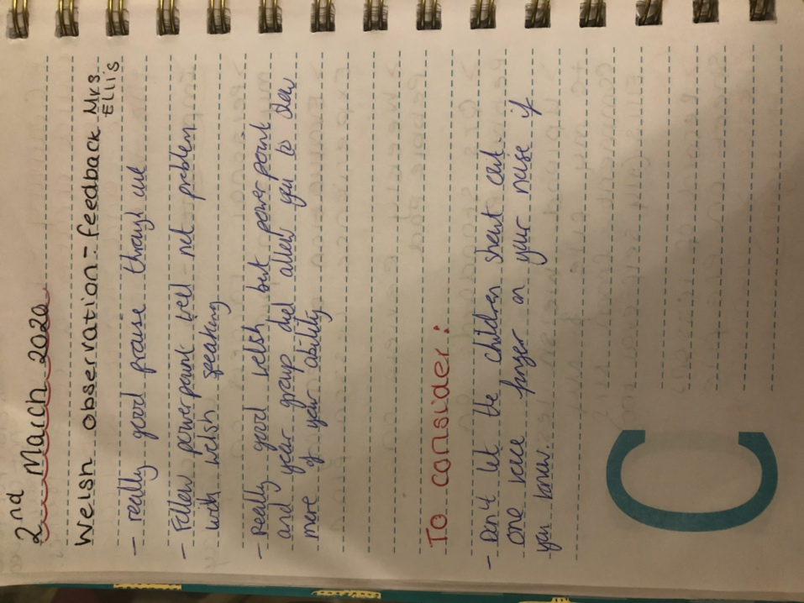
This is evidence from my discussion with the class teacher.

