

Structural and Fluid Analysis ACHA6010
Application of CAE Processes
Hannah Bathgate 2408566
04.12.2025

Contents
1. Introduction 2
2. Methodology 2
3. Modelling 3
3.1. CAD Geometry 3
3.2. Constraints and Joints 4
3.3. Material Selection 4
4. Boundary Conditions 5
4.1. Dynamic Loads 5
4.2. Crown Pressure 6
4.3. Thermal Boundary Conditions 6
5. Validation 7
5.1. Structural Validation 7
5.2. Thermal Validation 8
5.3. Rigid-Body Dynamics Validation 9
6. Mesh Study of the Piston 9
7. Baseline Results 10
7.1. Equivalent Stress 10
7.2. Normal Stress 11
7.3. Strain 12
7.4. Fatigue 13
8. Optimised Piston Results 15
8.1. Ansys Strucutral Optimisation 15
8.2. Manual Redesign and Structural Improvements 16
9. Discussion 18
10. Limitations 18
11. Conclusion 19
References 19
Appendix 20

Introduction
Computer-Aided Engineering (CAE) has become an essential part of modern engineering design, allowing engineers to interrogate structural, thermal and dynamic behaviour in virtual form before committing to physical prototypes. CAE is useful because it allows engineers to test ideas quickly and identify issues before committing to physical prototypes. However, it cannot fully reproduce real behaviour. Every simulation is built on numerical approximations, idealised boundary conditions and material models that simplify how components respond in service. These assumptions mean that CAE results need careful interpretation. As Shumak (2025) states, ‘a simulation is only as accurate as the assumptions and inputs applied to it’.
This report uses a high-performance aluminium piston as a framework for evaluating the strengths, challenges and limitations of CAE workflows. A piston is appropriate as it experiences extreme cyclic loading, steep thermal gradients, rapid inertial reversal and complex geometry, and it incorporates small-scale features that are difficult to mesh. Rather than aiming to produce an industrially optimised piston, the purpose is to expose and discuss the limitations of CAE processes across the entire workflow.
Rigid-body dynamics, thermal modelling, structural simulation, mesh refinement, material evaluation, fatigue assessment and topology optimisation are all included, but the priority is to show how each stage is shaped and constrained by modelling decisions. Baseline results are presented, followed by an optimised variant informed by topology-optimisation insight. Throughout the report, the limitations of the modelling approach are highlighted so that the broader implications for CAE practice can be understood.

Methodology
The workflow resembled a realistic engineering analysis pipeline. A full piston-rod-pin-crank assembly was created in CAD to ensure that the inertial and geometric load paths presented to the solvers reflected a genuine high-performance engine configuration. The piston geometry originated from a McLaren M840T dataset; the connecting rod and gudgeon pin were modelled from real components, while the crank was replicated from published specifications. This ensured that the rigid-body dynamics stage and the subsequent structural and thermal analyses operated on physically representative geometry.
After import into Ansys Workbench, the kinematic behaviour of the slider-crank mechanism was established using revolute joints at the crank-ground, crank-rod and rod-pin interfaces. Between the piston and ground, a general joint was used to prevent movement other than tangential translation, approximating the cylinder interactions without modelling explicit contact. A rotational velocity of 7500RPM was applied, representing the maximum expected operating speed of the M840T engine and therefore the most severe inertial loading condition for dynamic analysis.
Cylinder pressure applied to the crown was generated using a MATLAB combustion script. The script applied a polytropic compression and expansion process, instantaneous volume and the ideal gas equation to produce a full pressure trace across the engine cycle. This aligns with classical modelling described by Heywood (1988), who notes that polytropic approximations provide reasonable cycle-averaged representations of combustion loading. The peak pressure was exported for application to the rigid-body model, enabling identification of the maximum compressive load. Similarly, the maximum tensile load was extracted from the inertial peak shown in the Ansys dynamics output. These two extremes were then used to define the alternating load for fatigue analysis.
Thermal boundary conditions were established using heat-transfer coefficients and film temperatures averaged from several SI-engine studies (table 2). Published values vary due to differences in swirl, cooling strategies, mixture temperature and combustion type, so averaging was used to obtain a representative, steady-state thermal field. This approach is common in CAE piston analysis because transient heat-flux simulation is computationally intensive and requires detailed in-cylinder flow modelling, which was beyond scope for this work.
Weak springs were used to stabilise the piston in the static structural model. This is a widely accepted method for isolated FEA components because it prevents rigid-body motion without imposing non-physical constraints, and it is recommended in piston thermo-mechanical studies (Singh and Sharma, 2014). The temperature field from the thermal model was imported into the structural model, along with inertial and gas forces. Fatigue analysis used Goodman correction to estimate life under alternating tensile-compressive loading.
Finally, topology optimisation was conducted using compliance minimisation with 90%, 75% and 50% mass-retention targets. The designable region was restricted to the underside of the piston so that functional regions such as the ring belt, pin bosses and skirt were preserved. The optimiser’s suggestions were then used to inform a manual redesign to produce a manufacturable and smoother geometry.

Modelling

CAD Geometry
The CAD model represents an idealised version of a piston. Small casting defects, worn surfaces, ovalisation and temperature-dependent shape changes were not included, as these are difficult to capture and would prevent the mesh from generating reliably. Such simplifications are usual in CAD, but they also mean that the model is smoother and more uniform than a real piston. Studies such as Kumar et al. (2019) show that this loss of geometric detail can change local stress predictions, so results should be viewed as representative rather than exact.
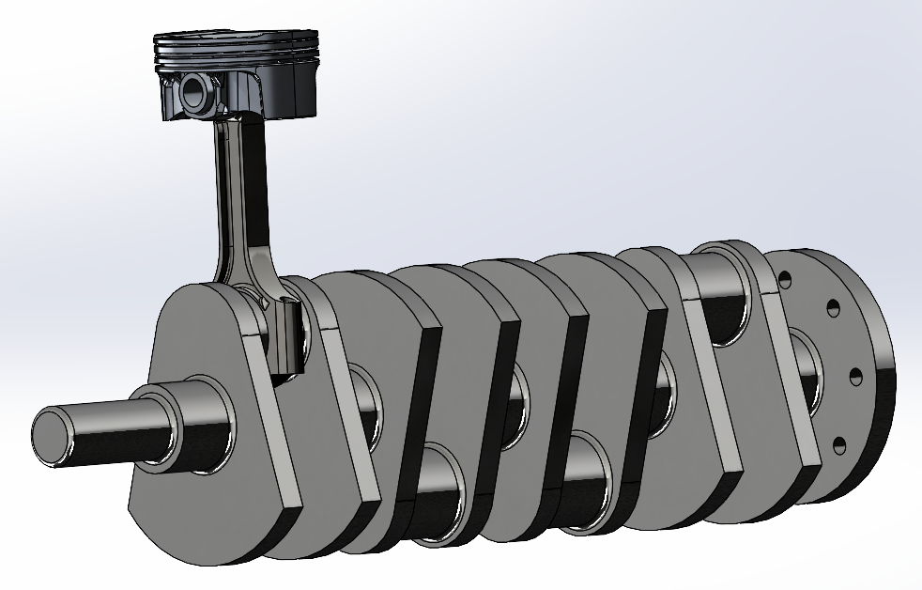
Figure 1. Full CAD assembly of the piston-rod-crank system.
These simplifications highlight a key limitation, that geometry is always idealised, and the true stress state in a physical piston will include additional local peaks associated with microstructural or geometric imperfections that CAE does not capture.

Constraints and Joints
The rigid-body assembly used revolute joints to replicate the movements in a real slider-crank mechanism. Explicit contact between piston and liner was not included because it is computationally expensive, prone to instability and unnecessary for extracting axial inertial forces.
For structural analysis, stabilisation was provided by weak springs, which prevented rigid-body motion without constraining deformation patterns. This approach is consistent with recommendations in thermo-mechanical piston research, where isolated components require numerically stable but physically unobtrusive constraints.

Material Selection
Four aluminium alloys were examined: 4032-T6, 2618A-T6, 332-T5 and A390-T6. Literature consistently notes that 4032 and 2618A are common in forged racing pistons due to their ductility, fatigue resistance and stability at high temperature (Mahle, 2016), while 332 and A390 are typical cast alloys with high silicon content that improves hardness, wear resistance and dimensional stability (figure 2).

Figure 2. Material properties of chosen alloys (Ansys Granta, 2025)

The thermo-structural results showed that A390-T6 produced the lowest overall stresses and deformation, mainly because of its high stiffness and low thermal expansion. This aligns with the known behaviour of high silicon cast alloys. However, 4032-T6 performed similarly well in several areas and is widely used in forged pistons because it offers better ductility and fatigue resistance at elevated temperatures. Overall, A390 had the best properties and physical results, so this was used moving forward.
Alloy | Max equivalent stress (MPa) | Max deformation (mm) | Min normal stress (+) | Max normal stress (MPa) | Max strain | Max body temp (°C)
4032-T6 | 2384.6 | 0.44516 | 1601.2 | 832.8 | 0.030544 | 304.68
2618a-T6 | 2494.9 | 0.51165 | 1674.5 | 874.7 | 0.03507 | 304.68
332-T5 | 2442 | 0.51496 | 1654 | 778.28 | 0.036147 | 323.63
A390-T6 | 2207.9 | 0.42646 | 1484.8 | 758.68 | 0.029426 | 308.51
Table 1. Material study results.

The material comparison is useful for seeing general trends, but it should not be treated as exact because the CAE models assume perfectly uniform material. Real pistons have porosity and uneven silicon distribution, so their behaviour will never match the simplified models exactly.
Low-alloy 4340 steel was applied to the crankshaft and conrod, as is used in the physical components. As the piston was the focus of this study, alternatives were not investigated.

Boundary Conditions

Dynamic Loads
Peak compressive and tensile loads acting through the gudgeon pin were taken from the output of the rigid-body simulation. The compressive peak corresponded to the point of highest combustion pressure acting on the crown, obtained from the MATLAB model. The tensile peak corresponded to the inertial reversal point at high speed. These extremes formed the input for structural and fatigue analysis.
Because the rigid model assumes perfectly rigid components, it neglects rod bending, pin ovalisation, crankshaft twist and bearing elasticity. Real dynamic load transfer is more complex, and the extracted forces therefore represent simplified load paths. The values are realistic in scale but idealised in distribution.

Crown Pressure
The combustion-model pressure was applied as a uniform pressure on the crown. In reality, pressure distribution varies due to flame asymmetry, swirl, turbulence and bowl geometry. Ahmed et al. (2016) note that local pressure variations can meaningfully influence stress localisation in the crown and ring belt. The uniform-pressure assumption therefore produces a smoothed loading field, which may underpredict peak stresses.

Thermal Boundary Conditions
Heat-transfer coefficients were averaged across four literature sources (Table 2), creating a steady-state thermal distribution representative of a high-performance SI engine. Various were assigned different HTC-temperature pairs.
Table 2. Source HTCs and their associated temperatures. (Kumar et al, 2019; Chen et al., 2019; Zhao, 2021; Xu and Yang, 2012)
Part | Source 1 |  | Source 2 |  | Source 3 |  | Source 4 |  | Average
Part | HTC, W/m²K | Temp, °C | HTC, W/m²K | Temp, °C | HTC, W/m²K | Temp, °C | HTC, W/m²K | Temp, °C | HTC, W/m²K | Temp, °C
Crown | 460 | 741 | 415 | 663 | 600 | 678 | 475 | 1096 | 487.5 | 794.5
Crown side | 88 | 250 | 260 | 300 | 885 | 425 | 550 | 650 | 445.75 | 406.25
1st ring groove land | 384 | 180 | 246 | 180 | 650 | 197 | 458 | 235 | 434.5 | 198
2nd ring groove | 390 | 160 | 182 | 160 | 500 | 187 | 650 | 160 | 430.5 | 166.75
Oil groove | 277 | 140 | 150 | 140 | 500 | 170 | 500 | 110 | 356.75 | 140
Underside | 717 | 110 | 800 | 95 | 630 | 90 | 600 | 80 | 686.75 | 93.75
Pin | 220 | 122 | 300 | 120 |  |  |  |  | 260 | 121
Skirt | 341 | 120 | 300 | 90 | 800 | 100 |  |  | 480.3333 | 103.3333

The use of averaged heat-transfer coefficients is a common simplification in piston modelling. Fully transient heat-flux simulation requires CFD and is not practical for an early-stage CAE workflow. Studies such as Kubicki et al. (2007) show that steady-state HTC averaging typically predicts piston temperatures within roughly 20–30% of measured values, which is acceptable for structural trend analysis. This means the thermal field used here does not capture cycle-to-cycle variations but still provides a reasonable representation of the overall temperature distribution.

Validation
Validation was essential before applying any thermo-mechanical solver to a piston, because such components have no closed-form analytical solution and are extremely sensitive to mesh quality, boundary assignment and load transfer. The solvers therefore had to be tested on problems with known behaviour, because ‘a simulation is not evidence of truth unless it can be shown to reproduce known physical behaviour’ (Cook, 1974).
Three benchmarks were used: a classical structural bending case, a mesh-method sensitivity study, and a thermo-mechanical bimetallic strip. Analytical solutions were paired with convergence behaviour and mesh-quality metrics, allowing confidence that the outputs arose from correct physical modelling rather than numerical distortion.
Because no analytical solution exists for a full thermo-mechanical piston, validation must be carried out on simpler cases where the answer is known. Doing this confirms that the structural, thermal and dynamic solvers are behaving correctly before applying them to a complex geometry such as a piston.

Structural Validation
The Dlubal verification case for a 10m cantilever subjected to a 7.65kN transverse load and 1.6kN axial load was used to verify linear-elastic structural behaviour. The analytical tip deflection was calculated manually using:
$$δ=\frac{F_{z}Lαe^{αL}+Lαe^{-αL}-e^{αL}+e^{-αL}}{F_{x}α(e^{αL}+e^{-αL})}$$
giving 3266.46mm, in agreement with the published reference of 3266.136mm. This confirmed that the analytical solution was correctly implemented (Dlubal, 2015).
Ansys predictions ranged between 3554.6mm and 3555mm for refined meshes, showing strong agreement with the analytical value. Coarser meshes produced larger error, illustrating the dependency of accuracy on discretisation quality.
Mesh quality plots showed that a 40mm tetrahedral mesh had good skewness (below 0.4) and a moderate aspect ratio (~1.75), whereas an 80mm mesh exhibited skewness above 0.6 and aspect ratios above 2, known to reduce bending accuracy. Hex-dominant and multizone meshes produced low aspect ratios but poorer skewness distribution and significantly longer generation times. Sweep meshes struggled with the geometry and showed element distortion.

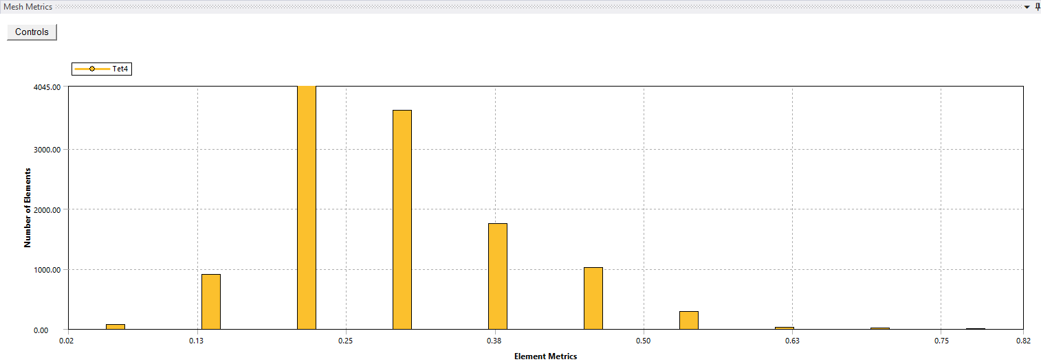
Figure 2. Skewness graph for a 40mm tetrahedral mesh on a cantilever beam.

This confirmed that for slender-beam bending, tetrahedral elements offered the most reliable balance between quality and computational cost. This established that the structural solver accurately reproduced known bending behaviour and highlighted the sensitivity of CAE accuracy to mesh quality.

Thermal Validation
The copper-invar strip heated by 100°C provided the thermal validation case. Using the Timoshenko curvature relationship (Dlubal, 2018):
$$k=\frac{6ΔT(α_{1}-α_{2})}{t(1+4ρ+ρ^{2})}$$
the analytical curvature predicted a free-end deflection of 7.049mm (Appendix B).
Ansys results converged toward 7.120mm at mesh sizes of 0.8mm and below. Coarser meshes severely underpredicted deformation (e.g., 1.227mm at 10mm), demonstrating that thermal-mechanical coupling is extremely sensitive to mesh (Appendix C).
Mesh quality metrics showed improvement between 10mm and 0.4mm meshes. At 10mm, aspect ratio approached 10, skewness was high and element quality clustered around 0.17. At 0.4mm, aspect ratio reduced to ~1.2, skewness collapsed to low values and element quality approached 1, explaining why the solver produced correct deflection only at refined meshes.

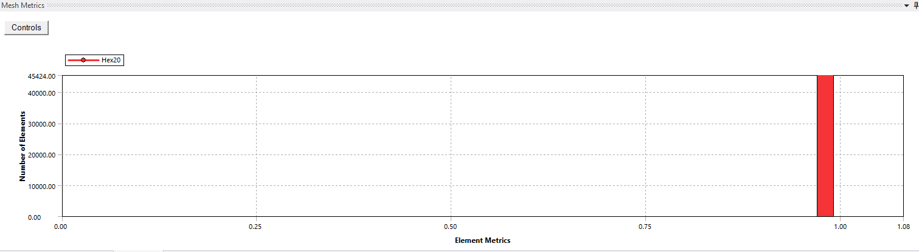
Figure 4. Element quality metrics graph at a 0.4mm mesh on a bimetallic strip.

This validation confirmed that when mesh quality is sufficient, the solver reproduces correct thermal bending behaviour, confirming its reliability in consequent simulations.

Rigid-Body Dynamics Validation
The MATLAB combustion model predicted a maximum downward force of 84.5kN. The corresponding Ansys rigid-body simulation predicted 83.1kN, a difference of 1.6%, attributable to small mass differences and load extraction methods. The close agreement indicated that the dynamic loads extracted for structural and fatigue analysis were appropriate.

Mesh Study of the Piston
The piston geometry created significant meshing challenges due to thin ring lands, deep grooves, pin-boss curvature and rapid thermal gradients. Literature recommends skewness below 0.5, aspect ratio below 4 and Jacobian ratio above 0.7 for reliable structural behaviour (Shumak, 2025).
A global 3mm tetrahedral mesh produced inconsistent peak stresses and aspect ratios above 5. Reducing global size to 2mm improved convergence and provided acceptable skewness. Adding 1mm face sizing to ring lands with a defeature tolerance of 0.5mm captured sharp gradients more effectively. Reducing defeature tolerance to 0.1mm caused instability as the mesher attempted to resolve very small CAD features. Multizone meshing produced long solve times without improved accuracy, while sweep and hex-dominant meshing failed due to geometric complexity.

Figure 5. Element size convergence with a 1mm face sizing on ring lands with 0.5mm defeature size.

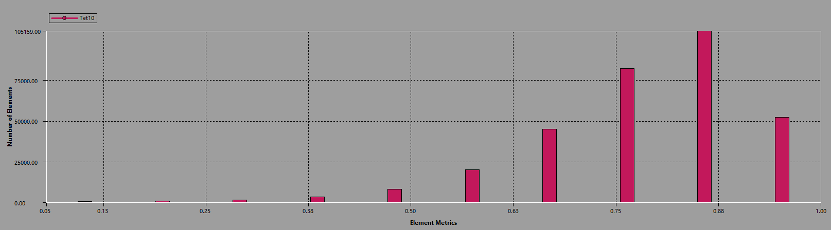
Figure 6. Element quality at established mesh.

Despite refinement, peak stresses still showed mild sensitivity, an unavoidable limitation recognised in piston literature, where ring-belt stress convergence is notoriously difficult due to steep temperature gradients and thin sections.

Baseline Results

Equivalent Stress
The baseline piston produced a peak von Mises stress of ~1778MPa, concentrated beneath the ring belt in a continuous band. This localisation is characteristic of thermal-mechanical piston behaviour, driven by expansion and discontinuities in the ring belt (Reyes Belmonte et al, 2015).
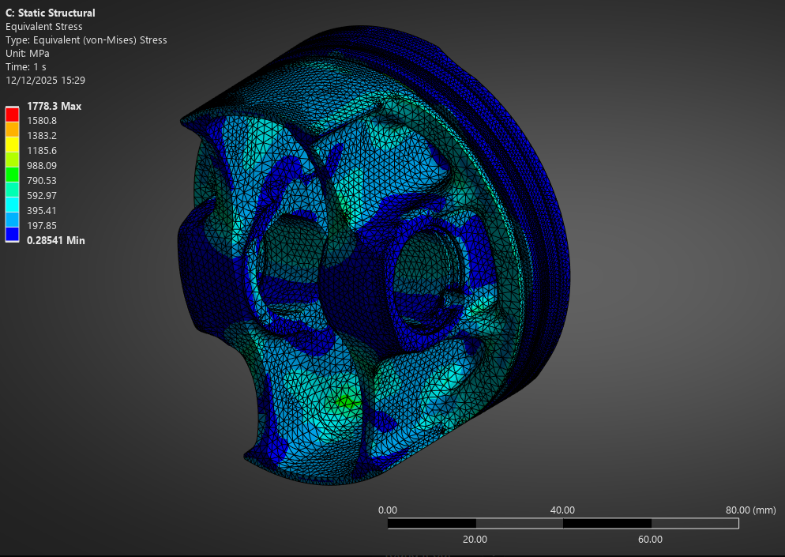
Figure 7. Equivalent stress on original piston.
Because the thermal field was steady-state and averaged, these stresses represent smoothed behaviour. Real combustion causes sharper gradients and transient spikes that would likely raise peak stress further.

Normal Stress
Normal stress peaked at ~430MPa along the major thrust axis, where side thrust from the connecting rod acts on the skirt. The magnitude is influenced by the simplified general joint used instead of full piston-cylinder contact, but the location and trend are correct.
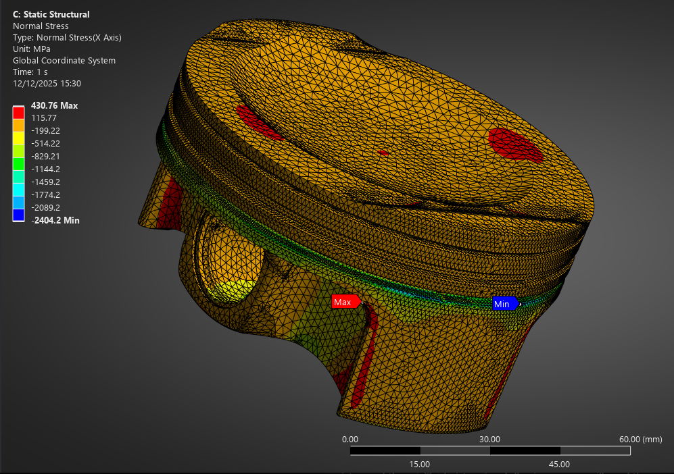
Figure 8. Normal stress distribution on original piston.

Strain
Equivalent strain reached 0.024, largely mirroring the equivalent-stress distribution. Local strain concentrations were visible beneath the ring belt and around pin-boss transitions (figure 9).
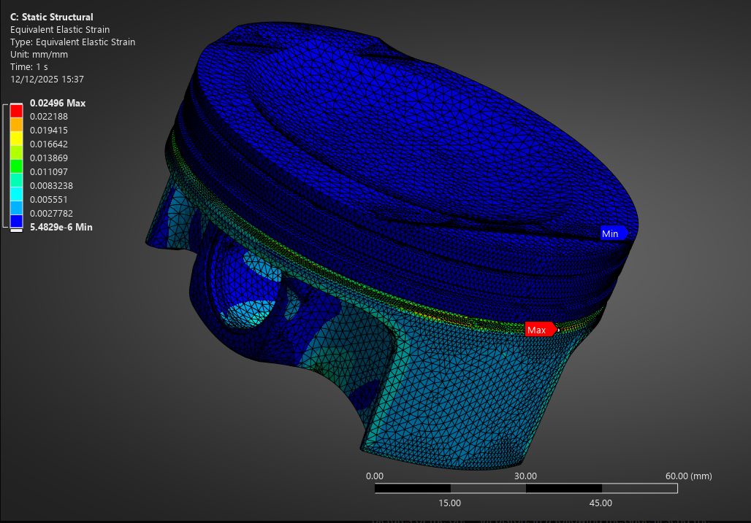
Figure 9. Strain distribution on original piston.

Fatigue
Fatigue life was lowest where the pin interior meets the ring belt. This agrees with thermo-mechanical fatigue studies, which identify this intersection as a hotspot for crack initiation (Silva, 2006).
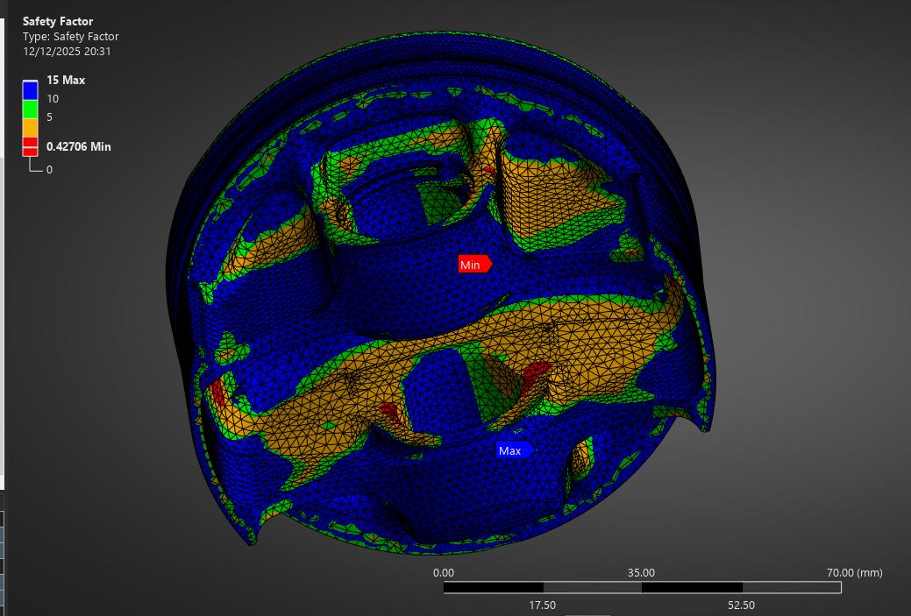
Figure 10. Fatigue safety factor distribution on the original piston.

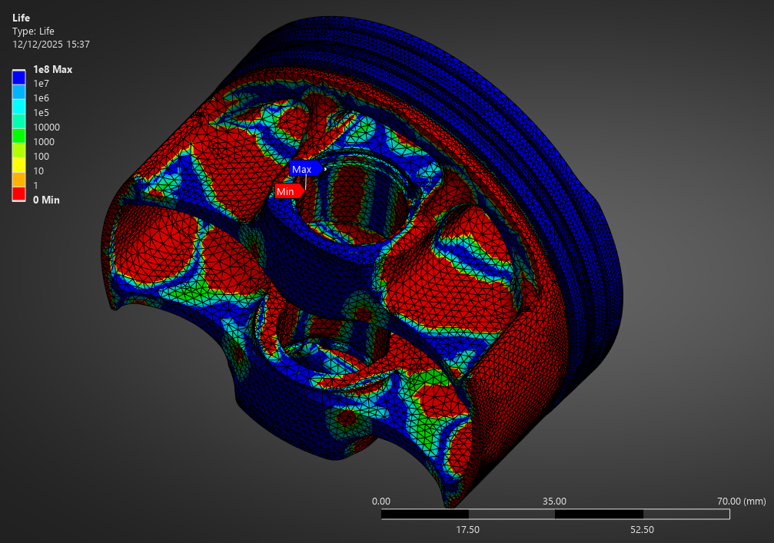
Figure 11. Fatigue life distribution on the original piston.

Fatigue was assessed using non-proportional loading by combining the maximum compressive and maximum tensile forces taken from the rigid-body simulation. This approach captures the alternating behaviour of the piston over a cycle more realistically than a proportional model. However, the analysis still has limitations. It does not account for the full multiaxial stress or phase lags between thermal and mechanical loading, both of which contribute to real piston fatigue. The results therefore show relative fatigue trends rather than absolute life predictions.

Optimised Piston Results

Ansys Strucutral Optimisation
Topology optimisation was conducted using compliance minimisation with 90%, 75% and 50% mass-retention targets. In all three cases, only the underside was left unconstrained. The optimiser consistently removed material from the same region, independent of mass-retention settings.
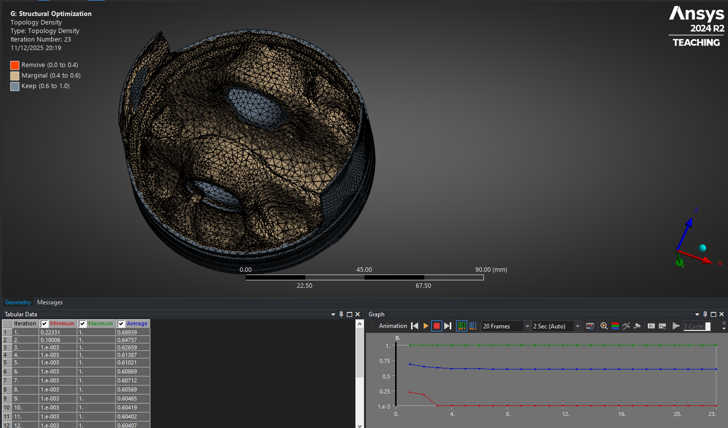
Figure 12. Topology optimisation result with 50% mass retention.

This consistency indicated that the underside contributed little to stiffness under the load case. However, topology optimisation cannot handle thermal stresses, fatigue behaviour, manufacturability or dynamic effects, and it cannot add material back, all clear limitations. The shapes produced at lower mass targets included thin webs and unmanufacturable forms. The optimiser therefore served as a guide to areas of surplus stiffness rather than an actual design solution.

Manual Redesign and Structural Improvements
Material was removed from the underside between pin bosses and skirt, following the optimiser’s guidance but using smoother, manufacturable transitions. Fillets were added around the pin arches, where baseline stresses and strains peaked.
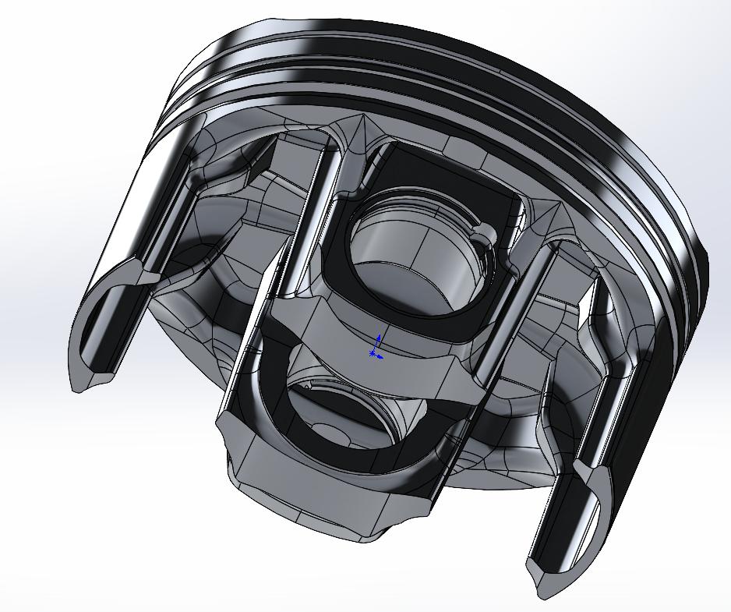
Figure 13. Manually optimised piston.

The piston was re-meshed using the previously validated mesh strategy. Peak von Mises stress dropped from ~1778MPa to ~1584MPa. The ring-belt band became broader and less intense, showing improved load distribution. Strain gradients became smoother, especially on the underside (figure 13).
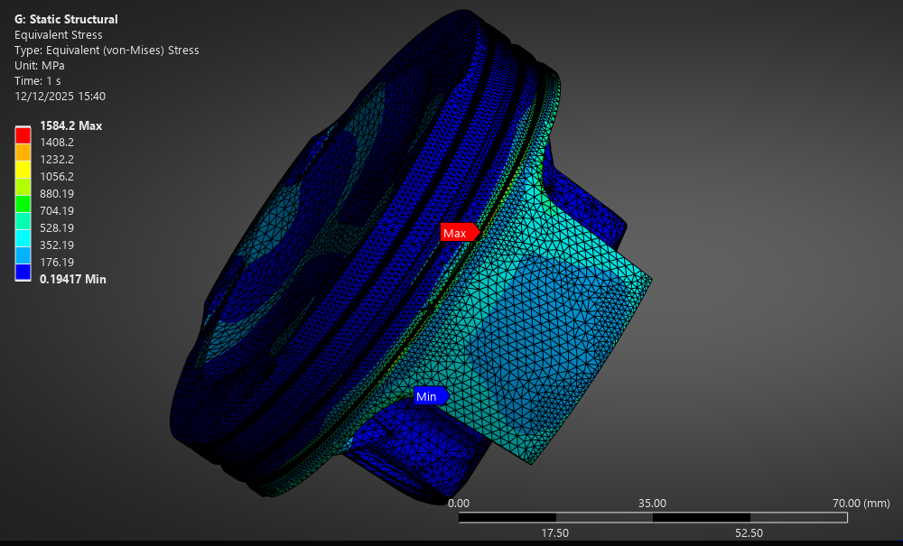
Figure 14. Equivalent stress on optimised piston.
Fatigue behaviour improved on the whole underside, most notably around the pin-boss region, where filleting reduced alternating stress amplitude (figure 14).

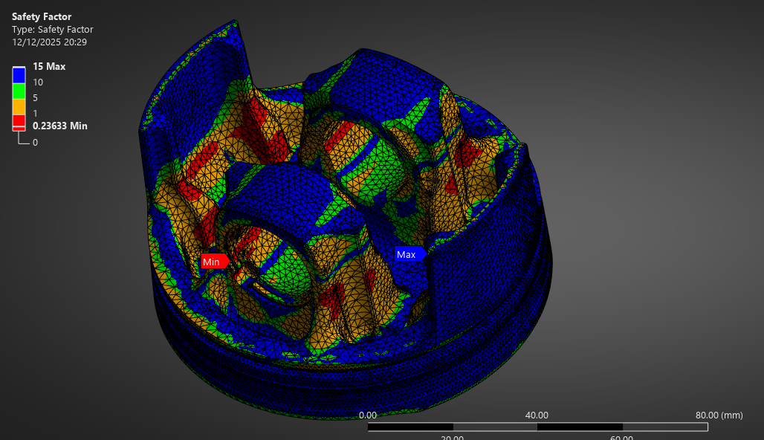
Figure 15. Fatigue safety factor on optimised piston.

The redesign reduced mass by ~300g, which in a reciprocating component reduces peak tensile loading, lowers rod and crank stresses and improves engine responsiveness.

Discussion
The piston results demonstrate the value of CAE while revealing its limitations. The baseline model produced stress and fatigue trends consistent with real piston behaviour, indicating that the modelling choices captured the correct mechanics. The optimised design showed improvements in stress distribution, strain smoothing and fatigue trends, illustrating how CAE can guide refinement.
However, the values of stress, strain and fatigue life depend strongly on modelling assumptions. The thermal model’s steady-state averaging smoothed real transient peaks. The rigid-body model neglected elasticity, bearing compliance and friction. The structural analysis assumed linear elasticity, despite pistons experiencing temperature-dependent yield, cyclic loading, creep and ratcheting (Silva. 2006). Fatigue was modelled using the Goodman theory, which assumes proportional uniaxial behaviour, yet piston fatigue is multiaxial and non-proportional.
Mesh sensitivity was also a major limitation. Despite careful refinement, convergence in the ring belt remained imperfect because of steep thermal gradients and thin geometry. As Shumak (2025) notes, mesh refinement improves accuracy only to the extent that boundary conditions and physical models are correct.
Nevertheless, CAE provided useful qualitative insights and demonstrated trends that are meaningful for engineering decision-making. The optimised piston is demonstrably better under the assumptions applied, and the workflow shows how CAE can inform early design despite its limitations.

Limitations
The limitations of this study reflect common constraints in CAE workflows. The thermal model relied on averaged heat-transfer coefficients and steady-state assumptions, so it did not capture the temperature swings that occur during combustion. This smooths the thermal gradients and affects the predicted stresses in temperature-sensitive regions such as the ring belt. The rigid-body dynamics stage also treated all components as perfectly rigid, meaning effects such as rod flex, bearing clearances and crankshaft deformation were not represented, even though they influence real load paths in an engine.
In the structural analysis, the aluminium alloys were modelled as linear-elastic and isotropic, while real pistons experience temperature-dependent yielding, microstructural variation and in some cases creep or early cracking. This limits the accuracy of the absolute stress and strain values. Mesh sensitivity was also an important factor. Sharp gradients in the ring-belt area made full convergence difficult, and although the chosen mesh provided stable results, some sensitivity in peak values remained, which is typical for small, highly curved piston features.
The fatigue analysis used non-proportional loading based on the extracted tensile and compressive peaks, which better reflects the basic load cycle, but it still cannot reproduce the full multiaxial thermo-mechanical fatigue behaviour of a real piston. The fatigue tool also treated the skirt as a critical region because that was where the dynamic loads were applied, even though fatigue damage usually develops around the ring belt or pin bore. This shows how fatigue predictions can be influenced by how loads are applied in the model.
Topology optimisation offered useful guidance on where excess material could be removed, but it was based on a single static load case and did not account for manufacturability, thermal stresses, fatigue, secondary piston motion or lubrication effects. Its outputs therefore needed to be interpreted carefully rather than followed directly.
Taken together, these limitations show that while the analysis provides reliable trends and comparisons, the numerical values should be treated as approximate estimates rather than exact predictions of real piston behaviour.

Conclusion
This report used the analysis of a high-performance piston to examine the capabilities and limitations of CAE. By progressing through CAD modelling, rigid-body dynamics, thermal analysis, structural simulation, mesh refinement, material selection, fatigue assessment and topology optimisation, a complete workflow was explored. Validation demonstrated that the solvers behaved correctly for known problems, and the mesh study established the discretisation requirements for reliable results.
The baseline piston exhibited high stresses and limited fatigue life in the ring-belt region, consistent with physical piston behaviour. The manually optimised piston, guided by topology-optimisation insight, displayed improved stress distribution, smoother strain fields, enhanced fatigue characteristics and a mass reduction of 300g.
While CAE provided valuable qualitative insights, the results were strongly influenced by assumptions in boundary conditions, material models, loading simplifications and meshing limitations. It is very useful for comparing designs and understanding overall behaviour, but the results need to be validated because they are based on simplified models.
The piston case study highlights both the potential and the constraints of modern CAE, demonstrating that simulations must always be interpreted critically to ensure responsible and informed engineering decisions.

References
Ahmed, A., Wahab, M. S., Raus, A. A., Kamarudin, K., Bakhsh, Q., & Ali, D. (2016). Mechanical Properties, Material and Design of the Automobile Piston: An Ample Review. Indian Journal of Science and Technology, 9(36). https://doi.org/10.17485/ijst/2016/v9i36/102155
Cha, S.-W., Ha, E.-J., Lee, K.-W., & Chang, H. (2009). Development of Fatigue Durability Analysis Techniques for Engine Piston using CAE. SAE International Journal of Materials and Manufacturing, 02(1), 2009-01–0820. https://doi.org/10.4271/2009-01-0820
Chen, Z., Li, J., Liao, J., & Shi, F. (2019). Stress and fatigue analysis of engine pistons using thermo-mechanical model. Journal of Mechanical Science and Technology, 33(9), 4199–4207. https://doi.org/10.1007/s12206-019-0815-y
Cook, R.D. (1974) Concepts and Applications of Finite Element Analysis. New York: Wiley.
Dlubal Software (2016). Bending Cantilever with Axial Force. [online] Dlubal Software. Available at: https://www.dlubal.com/en/downloads-and-information/examples-and-tutorials/verification-examples/000042?srsltid=AfmBOoqdJSTXEoIPEDkwUahcrYnQsYhnDlRquCEYgdd1vuSDkeV1F_lS
Dlubal Software (2018). Bimetallic Strip. [online] Dlubal Software. Available at: https://www.dlubal.com/en/downloads-and-information/examples-and-tutorials/verification-examples/009078?srsltid=AfmBOorkJUAxRJhkctJeuQsSTGuxbRWliBNjRjb-Hkgdf0Da3Knjv-8t
Heywood, J. B. (2018). Internal Combustion Engine Fundamentals (2nd ed.).
Kubicki, M., Watson, H. C., Williams, J., & Stryker, P. C. (2007, April 16). Spatial and Temporal Temperature Distributions in a Spark Ignition Engine Piston at WOT. https://doi.org/10.4271/2007-01-1436
Kumar, C., & Singh, N. K. (2019). Responses of Aluminium Alloy Pistons under Mechanical and Thermal Loads. Materials Science Forum, 969, 231–236. https://doi.org/10.4028/www.scientific.net/MSF.969.231
Lee, Z. R., & Ku, P. X. (2021). Geometry design and optimization of piston by using finite element method. Journal of Physics: Conference Series, 2120(1), 012013. https://doi.org/10.1088/1742-6596/2120/1/012013
Mountune. (n.d.). Comparing Forged Pistons - 4032 Alloy Vs. 2618 Alloy. Retrieved November 27, 2025, from Comparing Forged Pistons - 4032 Alloy Vs. 2618 Alloy
Mahle. (2016). Pistons and engine testing. Springer Fachmedien Wiesbaden. https://doi.org/10.1007/978-3-658-09941-1
Reyes Belmonte, M. A., Copeland, C. D., Hislop, D., Hopkins, G., Schmieder, A., Bredda, S., & Akehurst, S. (2015, April 14). Improving Heat Transfer and Reducing Mass in a Gasoline Piston Using Additive Manufacturing. https://doi.org/10.4271/2015-01-0505
Shumak, Y. (2025). The Fundamentals of Mesh Quality in FEA. [online] SDC Verifier. Available at: https://sdcverifier.com/structural-engineering-101/the-fundamentals-of-mesh-quality/
Silva, F. S. (2006). Fatigue on engine pistons – A compendium of case studies. Engineering Failure Analysis, 13(3), 480–492. https://doi.org/10.1016/j.engfailanal.2004.12.023
Singh, A. R., & Sharma, P. K. (2014). Design, Analysis and Optimization of Three Aluminium Piston Alloys Using FEA. International Journal of Engineering Research and Applications , 4(1), 94–102.
Xu, Y., & Yang, M. (n.d.). Structure Design and Simulation of Titanium Engine Piston Based on Thermal-Mechanical Coupling Model.
Zhao, F. (2021). Modeling and Thermal-Mechanical Coupling Analysis of Piston in Car Engines. Annales de Chimie - Science Des Matériaux, 45(1), 83–92. https://doi.org/10.18280/acsm.450111

Appendix

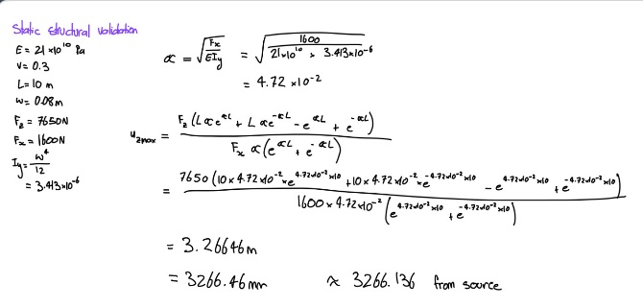
Appendix A. Static structural validation hand calculations.
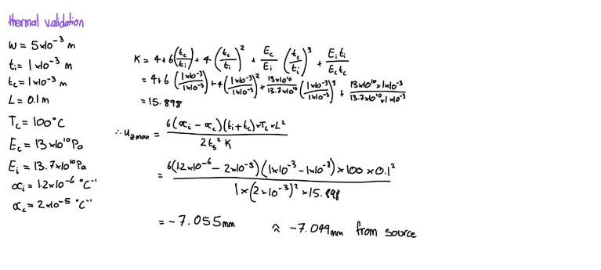
Appendix B. Thermal validation hand calculations.

Appendix C. Bimetallic strip element size convergence graph.

