The Global Business Environment
Assignment 1

Module Code: LCBB4005
Student Name: Roxana Baciu
Student ID: 2133388
Lecturer: Dr Rexon Nting
Evaluating opportunities and challenges
for Aston Martin’s business expansion plan in Poland

Introduction

The aim of this report is to critically evaluate the opportunities and challenges of luxury vehicle manufacturer, Aston Martin, opening a new plant in Poland. This evaluation will explore how to manage aspects of corporate governance, business strategy and cultural sensitivity when doing business in Poland. The various barriers experienced by international business will be discussed in more detail with supporting examples.

Theories of business environment such as SWOT and PESTLE analyses will be applied to fully paint the picture of the challenges Aston Martin can potentially experience when opening a new factory in Poland.

Moreover, an inclusive introduction to the context of international business, environmental analysis and organisational strategy will be outlined. This report will conclude by providing appropriate strategies to enable Aston Martin to increase their market share while reducing production, distribution and workforce costs.

International business

Pressing global problems such as poverty, human rights violations and climate change have put more pressure on multinational enterprises to make a positive impact through international business (Peng and Meyer, 2016). Companies are encouraged to play a key role in the international business environment and contribute to a more sustainable development as they have more power to influence a wide range of stakeholders and institutional context in both home countries and host countries and therefore, tackle issues at global scale (Tulder and Kolk, 2010).

Companies doing international business have a big potential in playing an active role in solving some global problems and their presence has been crucial in the research of corporate social responsibility (CSR) initiatives (Rugman and Collinson, 2012).

The globalisation era continues to unfold each year and companies are learning to better balance their day-to-day business strategies, as well as broader CSR considerations in developing countries (Peng, Wang and Jiang, 2008).

Only by thoroughly analysing and understanding the business environment in the chosen country through political, economic, social, technological, environmental, ethical and legal lenses, multinational companies can design the necessary entry strategies, manage stakeholder relationships and adjust the product portfolio in order to be successful (Pinkse, Kuss and Hoffman, 2010).

Consequently, exploring and understanding both the macro-environment or the general forces and trends impacting Poland, as well as the micro-environment or all the individuals affecting Aston Martin directly and indirectly such as customers, intermediaries, suppliers and stakeholders, will be crucial for this report to outline the challenges and limitations for opening a new production factory in Poland (Bennett, 1996).

The continuous monitoring and analysis of the international macro-environment is essential in designing a strong strategy for the enterprise internationalisation. Depending on how much the international macro-environment is affecting the company, this is an important factor which ultimately can decide whether branching out in foreign markets will be successful (Drabik, 2022).

The following section will leverage the PESTLE analysis model in better understanding some of the key external factors impacting Poland in the context of international business.

Poland overview

Poland is a country in the European Union, with a population of 38 million people. The automobile industry accounts for approximately 11% of Poland's industrial production. As one of the largest producers of passenger cars in Central and Eastern Europe, Poland has been ranked as the 23rd largest automaker in the world (Buliński, 2010).

PESTLE Analysis

Political
- Brexit – In the macro-economic context, Great Britain’s departure from the European Union will have a negative impact on the overall gross domestic product (GDP) growth for Poland. In other words, this will impact the country’s economy (Radlo, 2018).
- Poland is a politically stable country in the EU.
- Historically, Poland has good relationships with the UK and the USA.
- CIVICUS, an NGO have put Poland on the human rights watchlist.

Economic
- Poland offers one of the cheapest labour in the European Union (Country Economy, 2022).
- Poland managed to diversify its economy through significant developments in energy, manufacturing, telecommunications, transport, construction and IT.

Social
- Poland’s nation is one of the hardest working nations in the world, rated 2nd in Europe and 8th in global ranking (World Population Review, 2022).
- Poland’s population is aging very rapidly and creating massive shortages in the labour market.
- Youth unemployment rates are high in Poland.

Technology
- Poland’s software companies and technical universities have seen a recent development and growth.

Legal
- Any foreigners wishing to work in Poland must obtain a work permit (except EU, EEA and Switzerland).

Environmental
- Waste management, carbon emissions and flooding are some of the key environmental factors affecting the country.
Aston Martin Overview

Aston Martin was founded by Lionel Martin and Robert Bamford in 1913 in a small workshop in London. It grew to become an international luxury brand with a projected revenue of almost $250m in 2022. What is unique about their manufacturing process is that every single Aston Martin model is hand built by skilled workers in England.

The following section will leverage the SWOT analysis model to better understand Aston Martin’s capabilities in opening a new manufacturing facility for passenger vehicles in Poland.

SWOT Analysis

Strengths
- High brand equity and strong legacy
- Rich historical heritage
- Cutting edge technology and engineering team
- Strong presence at motorsports events
Weaknesses
- Small market share
- Limited product portfolio

Opportunities
- Increase market penetration through extensive distribution
- Attract more customers through competitive pricing

Threats
- Increasing fuel costs
- Stringent government regulations on carbon emissions
- Strong competition from other luxury automobile giants

Key challenges
One of the biggest challenges for Aston Martin in opening a new factory in Poland is the high cost for building an automotive plant which it is estimated at over £150 million (Formula 1, 2021). This means that the company needs to have a strong investment at the beginning in order to fully finance this initiative.

Moreover, Poland has a poverty rate of 4.2% for extreme poverty and 12% for relative poverty (Statista, 2022). This factor contributes to the fact that Poland is a developing country. Thus, opening a luxury car factory can incite the general population and international media to profile Aston Martin as a company that is taking advantage of developing countries and their labour to reduce costs.

The unstable geopolitical landscape, mostly caused by the invasion in Ukraine, has impacted many businesses across the world. Inflation rates are rising in the UK, currently at 9.4%, and in Poland, reaching 15.6% (Trading Economics, 2022). This is forcing many countries to go into recession where businesses are affected by delays and reduced order volumes. High inflation rates and economies going through recession can negatively impact companies trying to do international business.

The effects of the COVID-19 pandemic were felt very strongly by the automotive industry. In the first quarter of 2020, Aston Martin lost £119 million, with sales down by 45% compared to previous year (The Guardian, 2020). As a result, Aston Martin is still recovering after a very challenging year where people did not have any disposable income and were not in a good position to buy luxury cars which are regarded as the second biggest purchase of a lifetime.

Key opportunities
One of the key opportunities posed by Aston Martin building a new production plant in Poland is that it can significantly reduce shipping costs. At the moment, exporting a car from the UK to the EU faces a up to 24% VAT tax + 10% custom tax (Revenue, 2022). Therefore, a new factory located in Poland will reduce the exporting costs and ensure direct and secure connections to all countries in the European Union.

Based on the fact that Poland offers inexpensive labour and the national minimum wage in 2022 remained fixed at £553 per month or £6,641 per year (Country Economy, 2022), this gives Aston Martin an opportunity to reduce costs and outsource less expensive human resources. This is especially prosperous for business growth when compared to the UK where the minimum wage is approximately £1,400 per month and £19,700 per year.
Poland is a key country that supplies automotive parts for various vehicle giants across the world (McKinsey, 2015). One of the country’s best assets in this sector is the cost to quality ratio. The production quality is comparable to Western European countries, but the cost of production remains lower in Poland when compared to other countries.
Poland attracts new players to move up the value chain especially as global original equipment manufacturers (OEMs) maintain high performing operational practices in Poland that are focused on labour-intensive and lower value-added production (McKinsey, 2015).
On the other hand, Poland’s automotive industry specialism is focused on a range of lower- and mid-range models such as Fiat, Volkswagen and Opel. When it comes to the luxury market and high-value components, Poland can improve its operations.
A recent report from Aston Martin found that the global luxury market is growing and the personalisation as well as the customisation trends are on the rise (Aston Martin, 2022). Hence, the global luxury market is expected to increase with a 27% rise in Ultra-High-Net-Worth households globally by 2025. The luxury car market has been growingly steadily over the past year and there is a large scope of taking Aston Martin’s manufacturing capabilities in Poland.
Vehicle electrification represents another key opportunity for Aston Martin in this context. Vehicle electrification is on the rise because stricter policies are in place for all automotive manufacturers. The most recent ‘Fit for 55’ legislation sets targets to cut CO₂ emissions from cars by 55% and vans by 50% by 2030. As a consequence, more car owners are transitioning from internal combustion engine (ICE) to a range of hybrid and all-electric cars (EU, 2021) in order to remain fully compliant for the next 30 years.
Following on from this, sustainability is another topic that continue to move up the agenda for many companies across the globe. There is more pressure than ever on businesses to act on climate change and build stronger ESG strategies (Hirose and Funk, 2021). A new car factory in Poland can make Aston Martin a more sustainable business by reducing emissions associated with direct transportation generated by shipping vehicles around the world and indirect transportation generated by delivering vehicle parts.
Strategic recommendations
By the nature of this project, the upfront investment will be very high as discussed above. A recent theory of corporate governance says that investors are most likely to pay more for a share and fund ambitious projects (Zhan, 2021). Promoting this project as an opportunity for shareholders to increase their dividends and future investments is a great strategy for Aston Martin to increase its pool of investors and ultimately position the overall brand as one that will be highly profitable in the coming years (Borlea & Achim, 2013).

In the light of the latest governmental sustainability-related targets, another strategic recommendation for Aston Martin is to build a factory in Poland that is powered by renewable energy. In addition, the company can view this as a new opportunity to pair the factory with other initiatives to recycle parts as part of the waste management strategy (Griffin and Pustay, 2020).

The potential backlash on Aston Martin opening a new factory in Poland can be counteracted by the company’s bigger mission to extend in the industrial market, create jobs and boost the economy in Poland. Creating jobs in a developing country is part of every company’s corporate social responsibility program (Ndiaye, Razak, Nagayev and Ng, 2018).

Opening a new factory in Poland is a great alternative for the company to avoid the impact of Brexit on supply chain. Aston Martin has a supply base of around 302 direct suppliers and 126 indirect ones (Aston Martin, 2022). Moreover, 66% of Aston Martin’s suppliers are based in Europe and this will ensure that automotive parts can be delivered in any EU countries.

Since the UK has left the EU, the process of importing automotive parts hasn’t been as easy as before. As all Aston Martin engines are made in Germany by Mercedes, there are higher delivery costs. So, opening a new factory in Poland can reduce those costs on the long-term and enable a full distribution plan in Europe by minimising the supply chain disruptions (Hamilton and Webster, 2018). The new factory in Poland will ensure that the company’s value distribution network remains intact.
Limitations
The following section will explore some of the potential limitations that can be encountered by Aston Martin in building a new manufacturing plant in Poland.
Due to the fact that all Aston Martin cars are hand built by very skilled staff, the company will need to create an efficient training and handover programme for Polish workers to have the same skills. As mentioned above, Poland’s nation is very hard working and the labour is cheaper than the UK, however the output when it comes to luxury products does not meet the same quality standards as Western Europe or USA.
As part of corporate governance theory, Aston Martin will need to convince all shareholders to invest in a new factory in Poland before proceeding. At the moment, the company has ten shareholders, including Mercedes Benz and Investec (Aston Martin, 2022). That said, Ford became the primary stakeholder in Aston Martin in 1987. In 2020, however, Mercedes-Benz became the primary shareholder, increasing their stake to 20%.

Finally, one of the biggest limitations and challenges for the company is the forecast of a recession in Europe (The Economist, 2022). Poland’s economic environment, currently characterised by higher consumer prices, variable rates for 90% of loans to households and businesses and weak local currency, is not the most favourable international business landscape for a luxury car manufacturer to start building a new factory that requires a high investment upfront (Daniels, Radebaugh & Sullivan, 2019).

Conclusion

Based on the above critical analysis and arguments, Aston Martin’s initiative of opening a new manufacturing facility in Poland is a great opportunity for the company to avoid the long-lasting effects of Brexit and reduce a wide range of costs across shipping, custom taxes and labour.

The SWOT analysis proved that the company’s high brand equity and strong legacy coupled with cutting edge technology placed Aston Martin as a front-runner and pioneer in the automotive industry. As the luxury car industry and the personalisation trends are due to evolve in the comings years, opening a new manufacturing point in a developing European country will enable Aston Martin to better penetrate a new market, increase market share and offer the opportunity to extend the product portfolio.

The PESTLE analysis outlined that Poland is a developing country with a lot of potential and can be a great host for Aston Martin to allow the company to strengthen the relationships with all suppliers based in Europe.

Finally, the strategic recommendations based on a wide range of corporate governance theories and accompanying limitations have fully painted the macro-economic picture for this initiative.

Presentation Slides
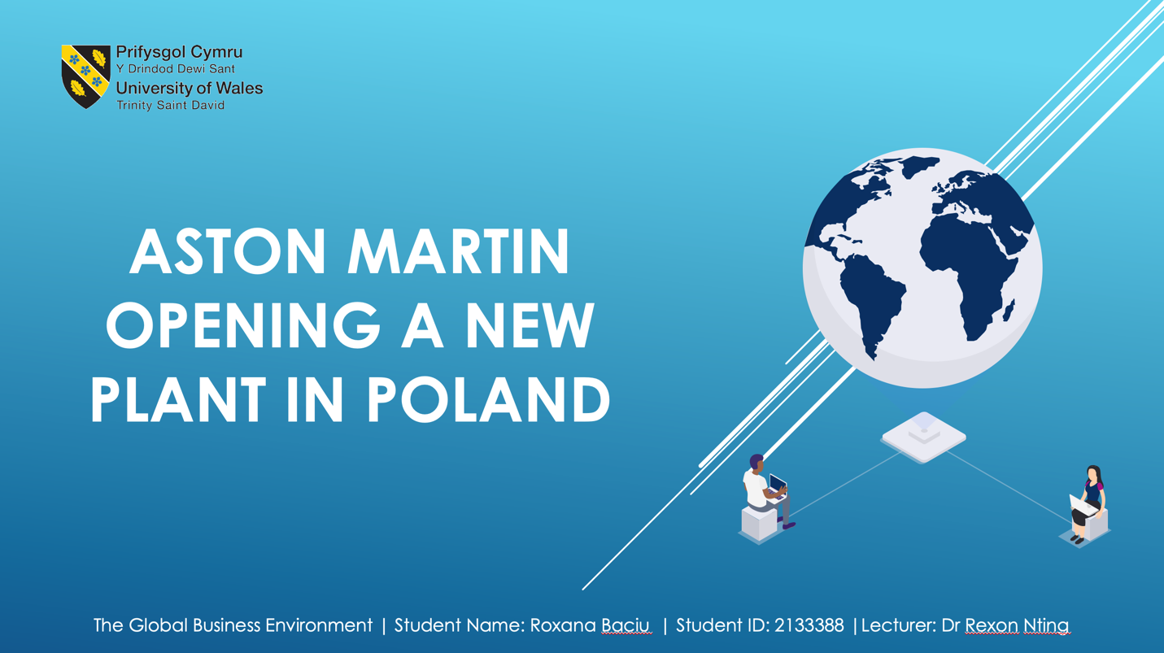
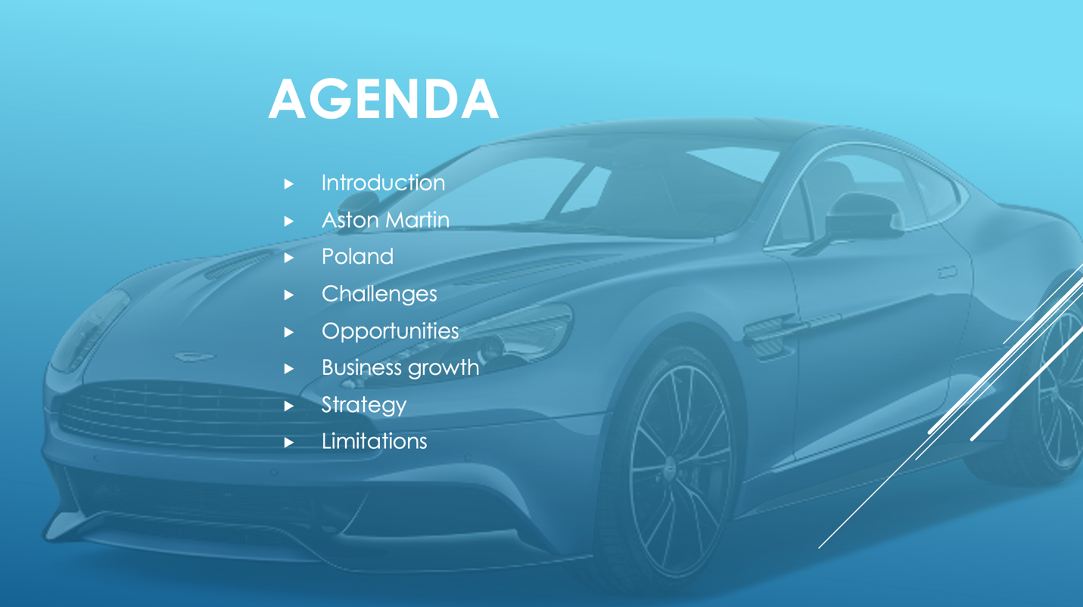

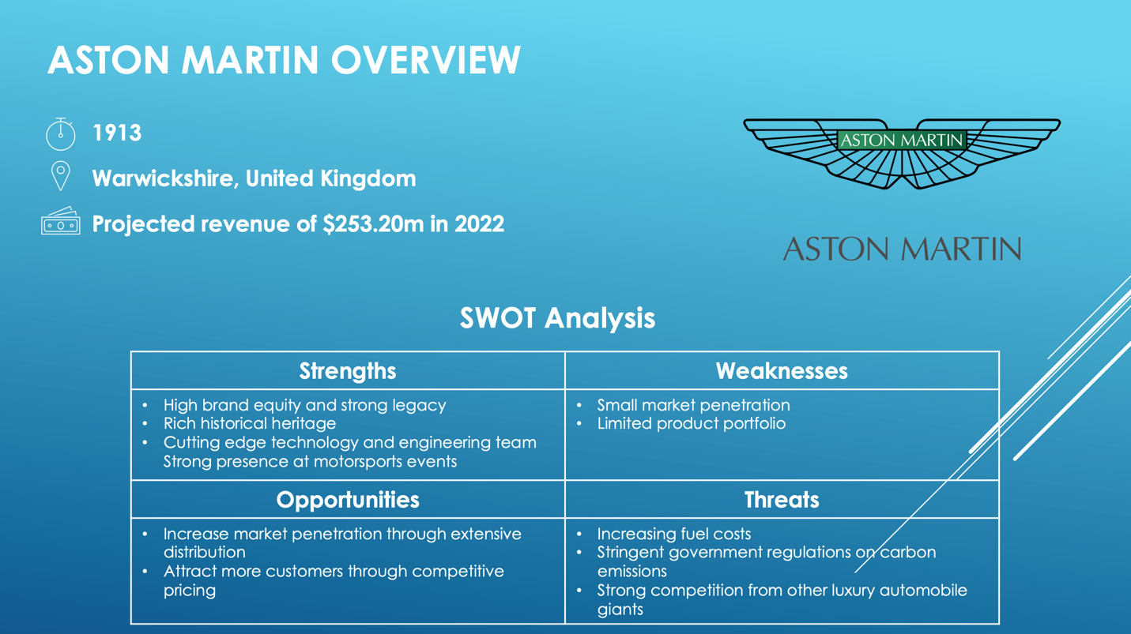
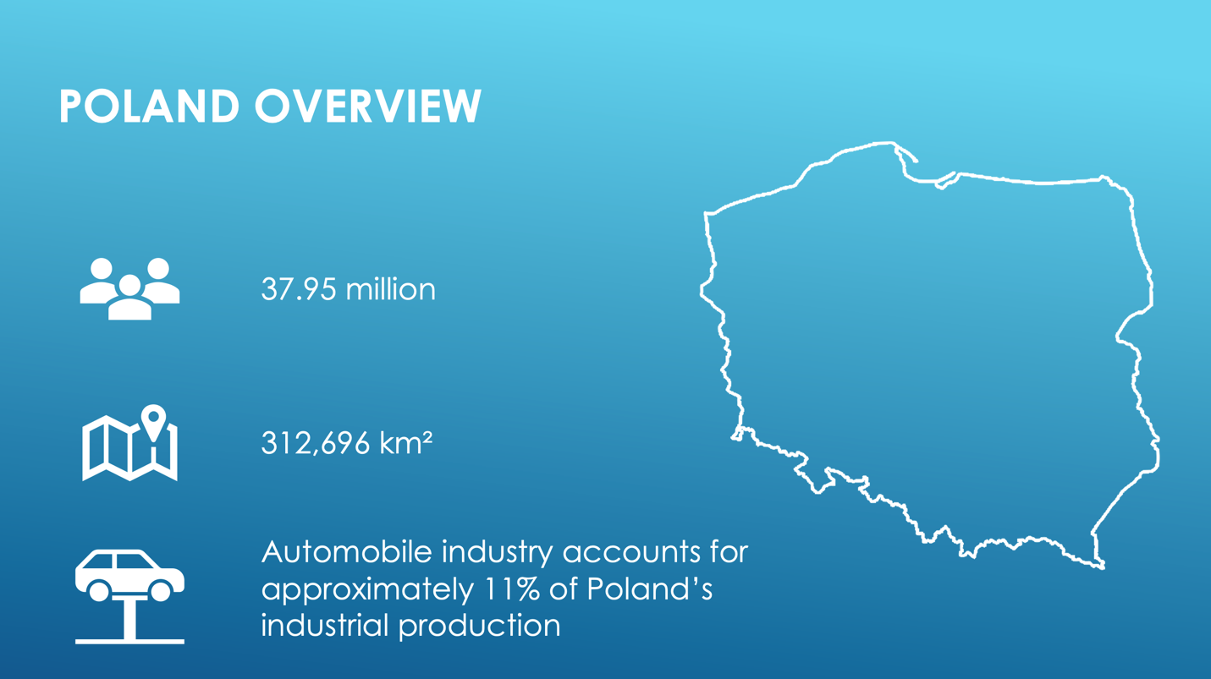
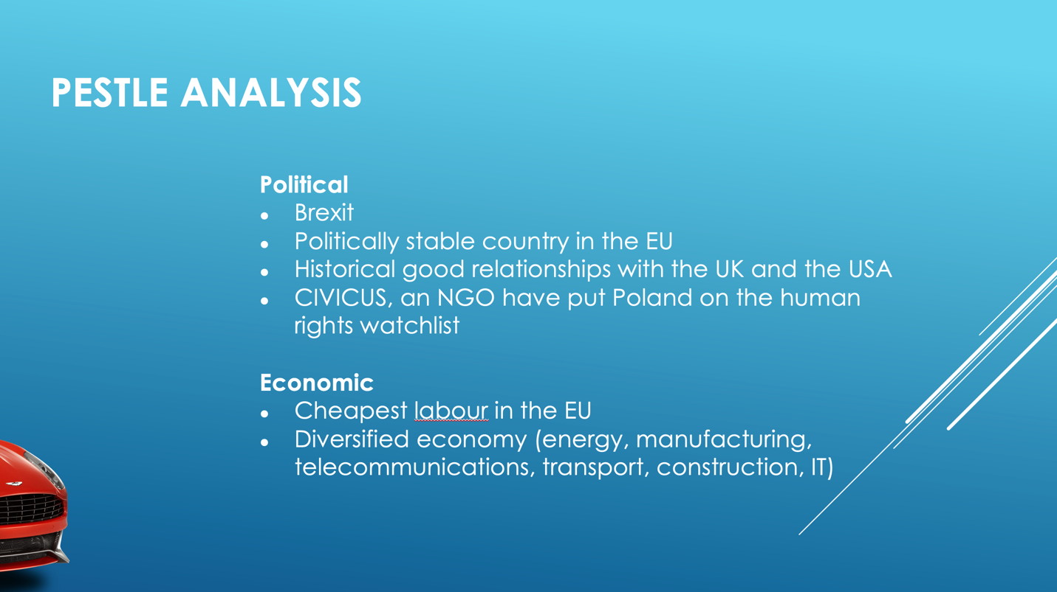

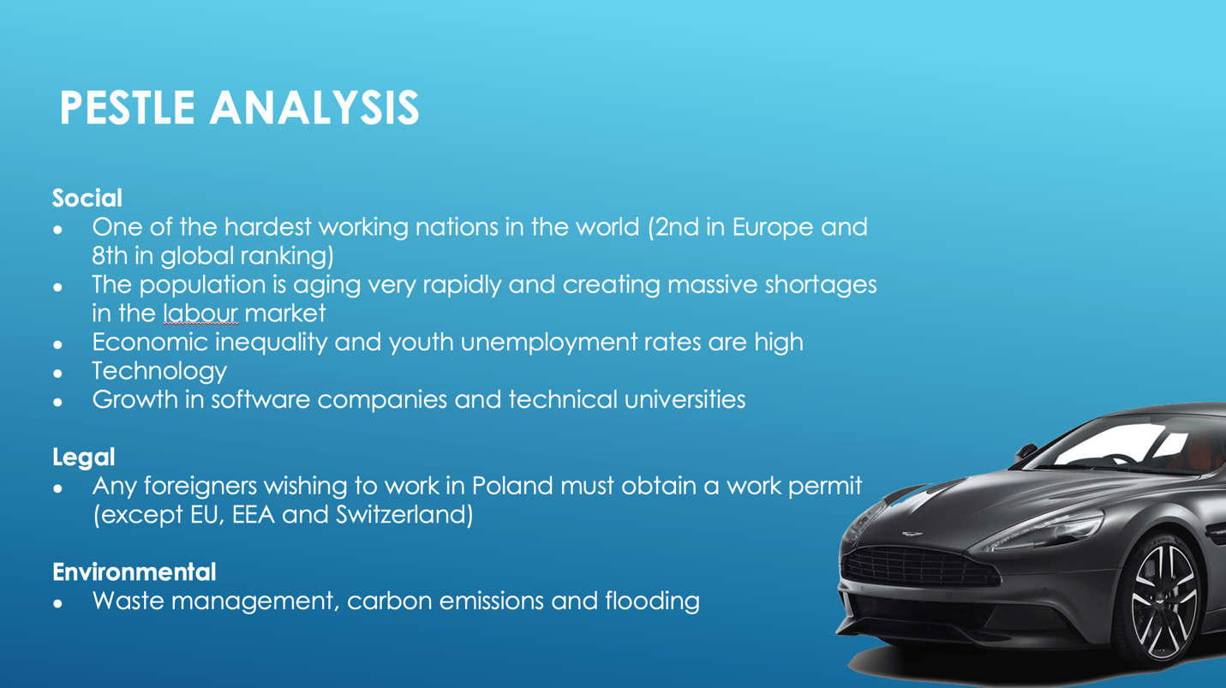

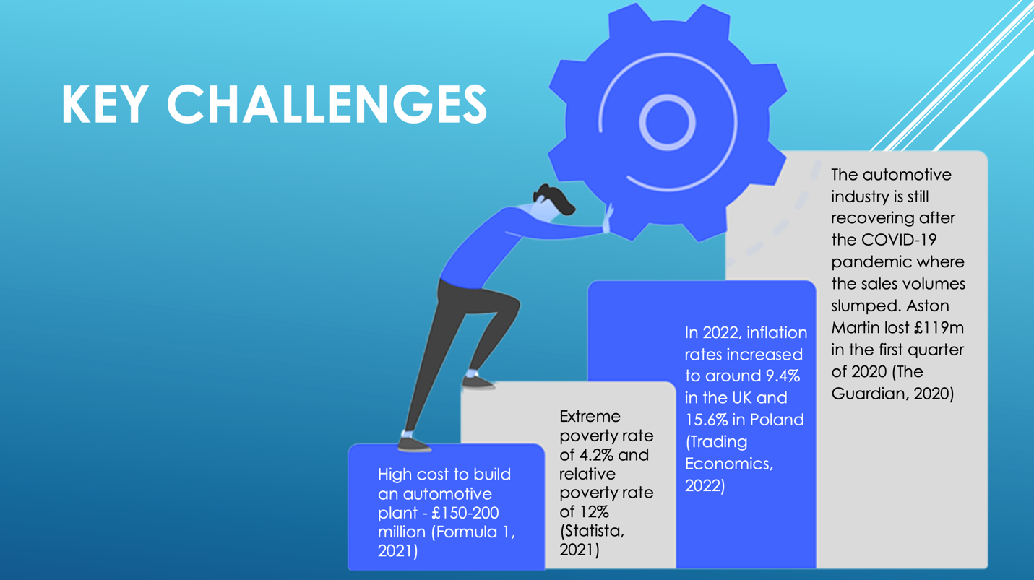
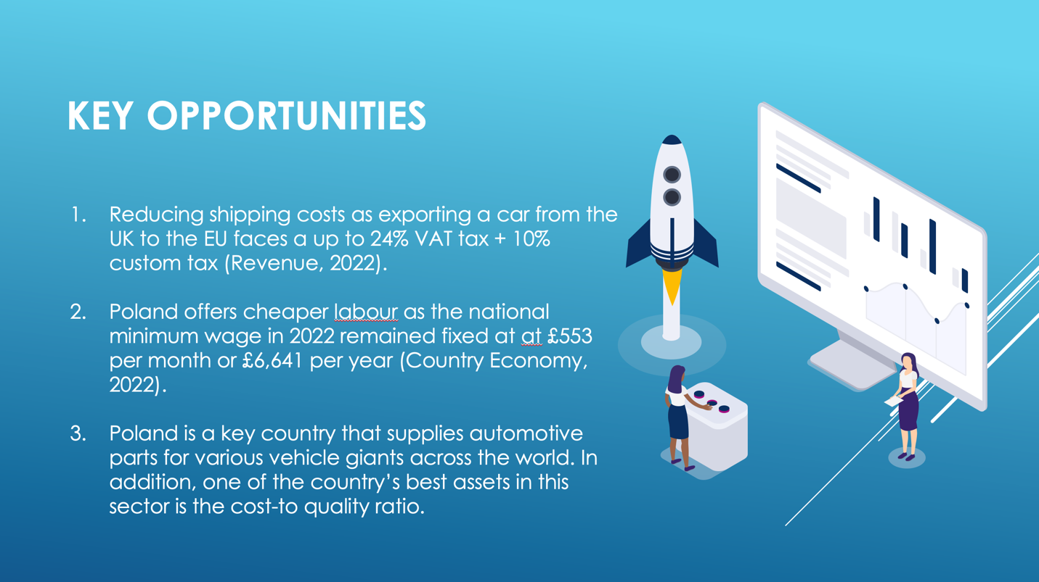

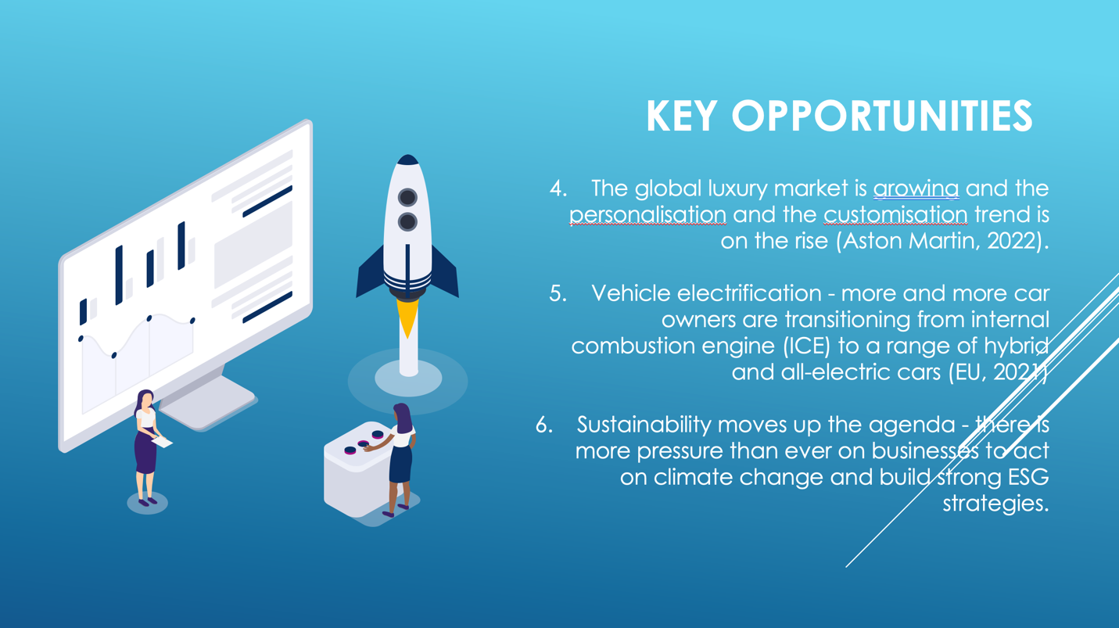
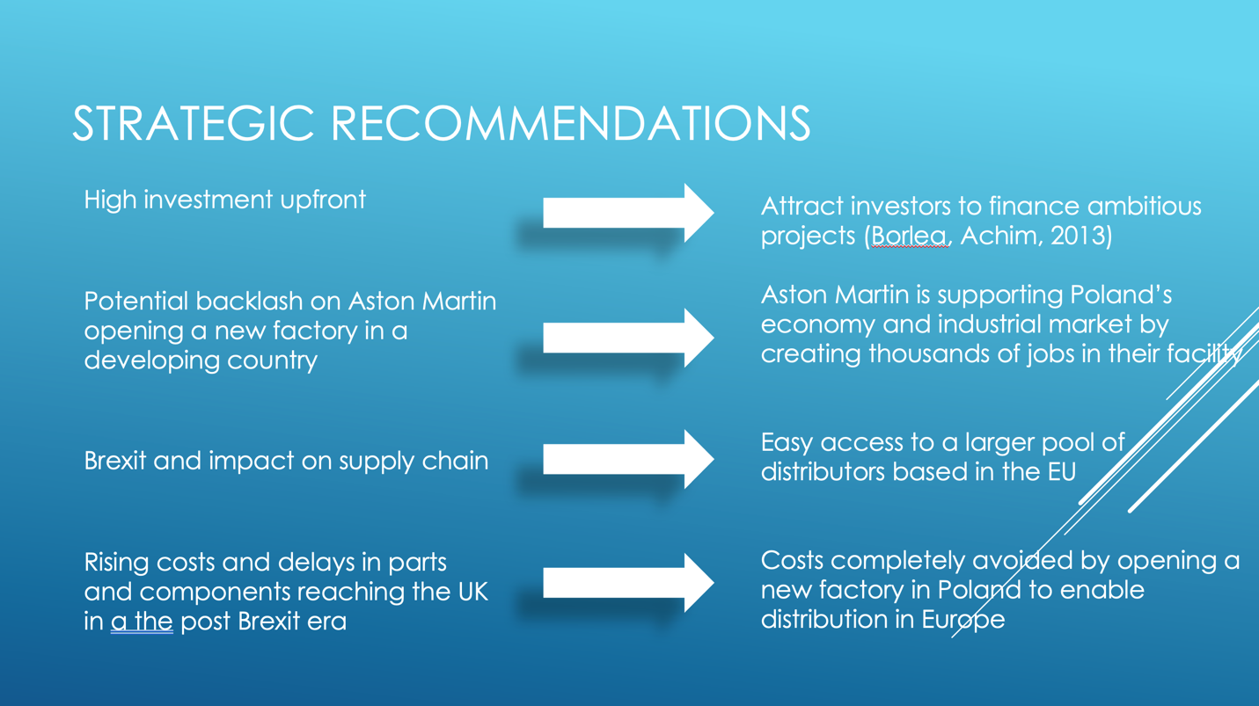

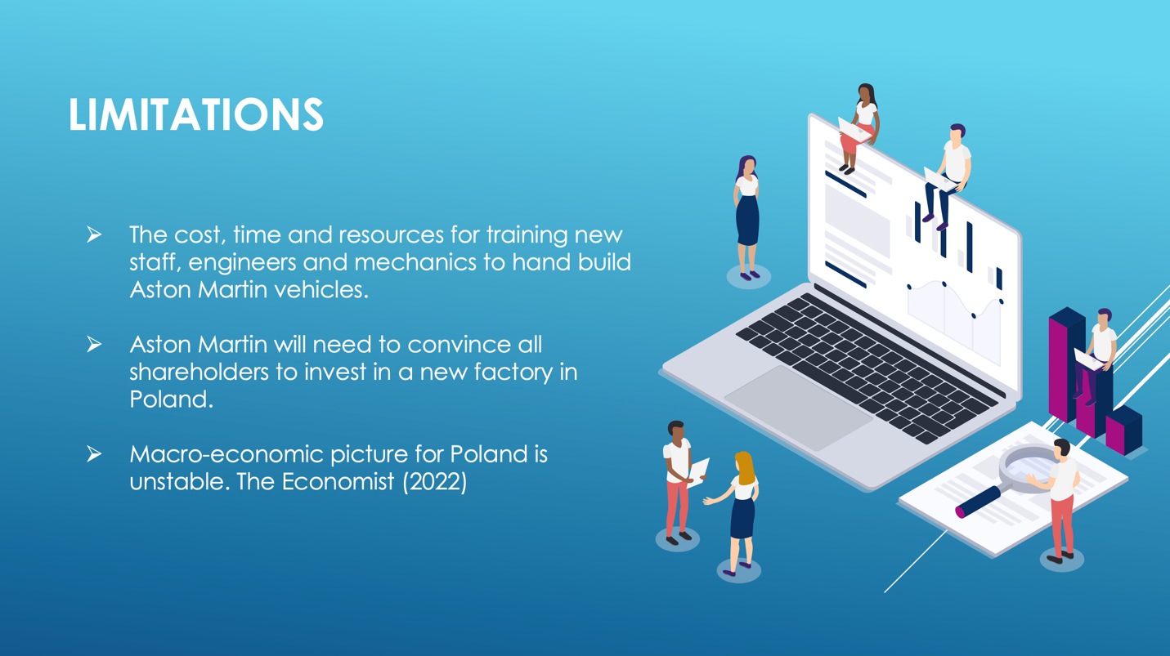


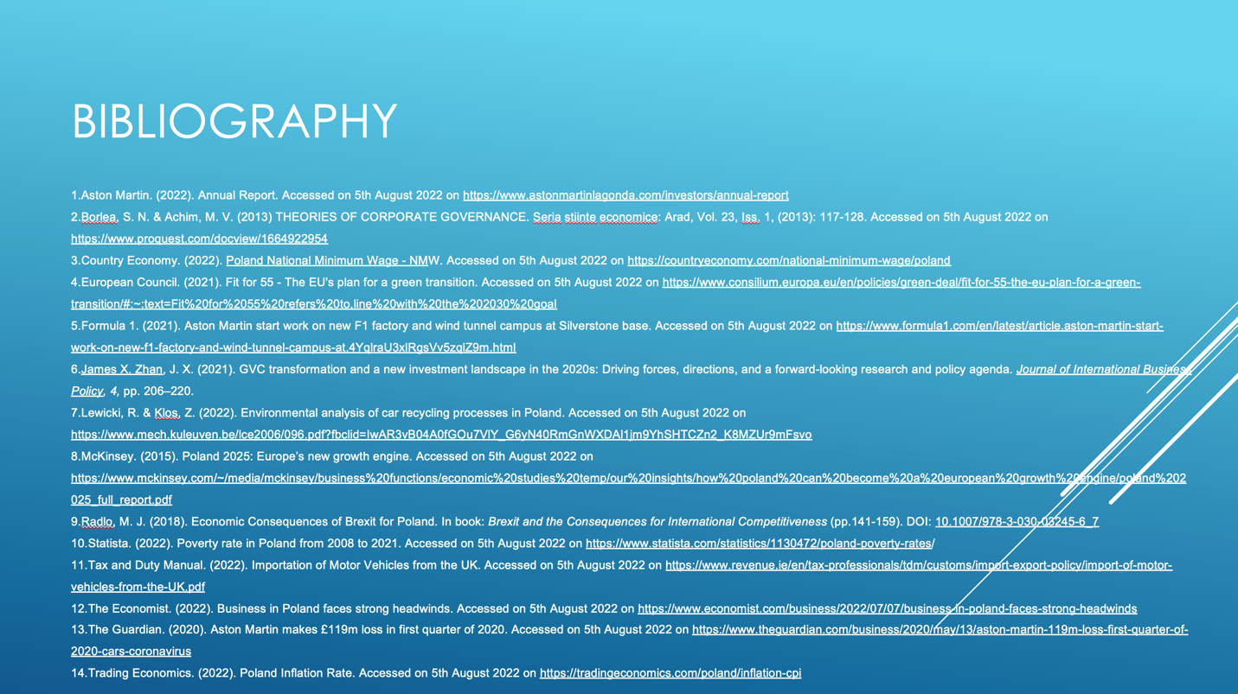

Bibliography

- Aston Martin. (2022). Annual Report. Accessed on 5th August 2022 on https://www.astonmartinlagonda.com/investors/annual-report
- Bennett, R. (1996). International business. London: M&E Pitman.
- Borlea, S. N. & Achim, M. V. (2013). THEORIES OF CORPORATE GOVERNANCE. Seria stiinte economice: Arad, Vol. 23, Iss. 1, (2013): 117-128. Accessed on 5th August 2022 on https://www.proquest.com/docview/1664922954
- Buliński, J. (2010). The Automotive Industry in Poland. Economic Information Department. Polish Information and Foreign Investment Agency S.A. Accessed on 20th August 2022 on https://www.paih.gov.pl/files/?id_plik=14305
- Country Economy. (2022). Poland National Minimum Wage - NMW. Accessed on 5th August 2022 on https://countryeconomy.com/national-minimum-wage/poland
- Daniels, J. D., Radebaugh, L. H. & Sullivan, D.P. (2019). International business: environments & operations. Sixteenth edition, Global edition. Harlow, England: Pearson.
- Drabik, I. (2022). The impact of international macro environment factors on the internationalization of Polish enterprises. Ekonomia i Prawo. Economics and Law, 21(2), pp. 335–353. https://doi.org/10.12775/EiP.2022.018
- European Council. (2021). Fit for 55 - The EU's plan for a green transition. Accessed on 5th August 2022 on https://www.consilium.europa.eu/en/policies/green-deal/fit-for-55-the-eu-plan-for-a-green-transition/#:~:text=Fit%20for%2055%20refers%20to,line%20with%20the%202030%20goal
- Formula 1. (2021). Aston Martin start work on new F1 factory and wind tunnel campus at Silverstone base. Accessed on 5th August 2022 on https://www.formula1.com/en/latest/article.aston-martin-start-work-on-new-f1-factory-and-wind-tunnel-campus-at.4YqlraU3xlRgsVv5zqlZ9m.html
- Griffin, R. W. & Pustay, M.W. (2020). International business a managerial perspective. Ninth, global edition. Harlow, England: Pearson.
- Hamilton, L. & Webster, P. (2018). The international business environment. Fourth edition. Oxford: Oxford University Press.
- Hirose, P. & Funk, T. M. (2021). Assessing ESG Risks for Businesses in the COVID-19 Era (2021). Bloomberg Law 2021. Available at https://ssrn.com/abstract=4000088
- Lewicki, R. & Klos, Z. (2022). Environmental analysis of car recycling processes in Poland. Accessed on 5th August 2022 on https://www.mech.kuleuven.be/lce2006/096.pdf?fbclid=IwAR3vB04A0fGOu7VlY_G6yN40RmGnWXDAl1jm9YhSHTCZn2_K8MZUr9mFsvo
- McKinsey. (2015). Poland 2025: Europe’s new growth engine. Accessed on 5th August 2022 on https://www.mckinsey.com/~/media/mckinsey/business%20functions/economic%20studies%20temp/our%20insights/how%20poland%20can%20become%20a%20european%20growth%20engine/poland%202025_full_report.pdf
- Ndiaye, N., Razak, L. A., Nagayev, R. & Ng, A. (2018). Demystifying small and medium enterprises’ (SMEs) performance in emerging and developing economies. Borsa Instanbul Review, 18 (4), pp. 269-281.
- Peng, M.W. & Meyer, K. (2016). International business. 2nd edition. Andover, Hampshire, United Kingdom: Cengage Learning EMEA.
- Peng, M. W., Wang, D. Y. L. & Jiang, Y. (2008). An institution-based view of international business strategy: A focus on emerging economies. Journal of International Business Studies, 39, pp. 920-936.
- Pinkse, J., Kuss, M. J. & Hoffmann, V. (2010). On the implementation of a ‘global’ strategy: The role of absorptive capacity. International Business Review, 19 (2), pp. 160-177.
- Radlo, M. J. (2018). Economic Consequences of Brexit for Poland. In book: Brexit and the Consequences for International Competitiveness (pp.141-159). DOI: 10.1007/978-3-030-03245-6_7
- Rugman, A. M. & Collinson, S. (2012). International business. 6th edition. Harlow, England: Pearson.
- Statista. (2022). Poverty rate in Poland from 2008 to 2021. Accessed on 5th August 2022 on https://www.statista.com/statistics/1130472/poland-poverty-rates/
- Tax and Duty Manual. (2022). Importation of Motor Vehicles from the UK. Accessed on 5th August 2022 on https://www.revenue.ie/en/tax-professionals/tdm/customs/import-export-policy/import-of-motor-vehicles-from-the-UK.pdf
- The Economist. (2022). Business in Poland faces strong headwinds. Accessed on 5th August 2022 on https://www.economist.com/business/2022/07/07/business-in-poland-faces-strong-headwinds
- The Guardian. (2020). Aston Martin makes £119m loss in first quarter of 2020. Accessed on 5th August 2022 on https://www.theguardian.com/business/2020/may/13/aston-martin-119m-loss-first-quarter-of-2020-cars-coronavirus
- Trading Economics. (2022). Poland Inflation Rate. Accessed on 5th August 2022 on https://tradingeconomics.com/poland/inflation-cpi
- Tulder, R. & Kolk, A. (2010). International business, corporate social responsibility and sustainable development. International Business Review (19), 2, pp. 119-125.
- World Population Review. (2022). Hardest Working Countries 2022. Accessed on 20th August 2022 on https://worldpopulationreview.com/country-rankings/hardest-working-countries
- Zhan, J. X. (2021). GVC transformation and a new investment landscape in the 2020s: Driving forces, directions, and a forward-looking research and policy agenda. Journal of International Business Policy, 4, pp. 206–220.

