Natalee Perks 1705222
Transition in early years
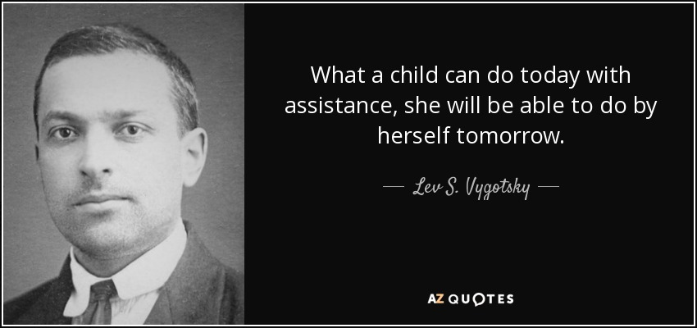
(AZ quotes, no date).

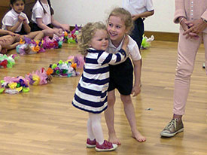
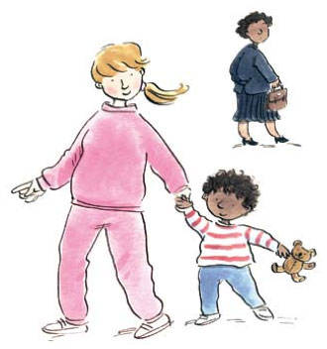
(Understanding Childhood, 2014) (Sherborne House School, 2017)
CONTENTS PAGE
- Aims of this booklet
  - What is transition in early years
  - Transition in child’s thinking
- Adults role during transition
- Questions for a parent to ask a new setting
  - What is a key person
- Individual child during transition
  - Importance of play
- Transition into the setting
- Practical strategies and activities that will assist transition
  - Culture differences in early years
- Proposed outcomes
  - Theorists
- Theorists
- Different types of transition
- The needs of the child
10.1 Common worries a parent might have during the transition process and how to prevent them
- References
- References

AIMS OF THIS BOOKLET
This booklet is intended for all those involved with the child to make the transition from home to nursery as easy as possible for all. It will provide guidance on ways to make transition smooth and enjoyable for children and possible strategies, depending on the needs of the individual child. This will promote understanding of the importance of effective communication for young children’s learning and development during transitions. The content included in this booklet for parents and guardians discusses the transition of a child’s early years, and providing information on how to make the transition smoother and less stressful for that parent/guardian. Followed there will be a brief display of an early year’s transition from the thoughts of the child experiencing the transition. For further support there will be listed, the roles of the parent or guardian for added information and a clear explanation. Continued with a list of questions parents and guardians could ask, within this new setting to have a peace of mind. Continued with brief discussions of the topics on the key person and their role, strategies to assist the transitions, culture differences and proposed outcomes. To finish, there will be an informative diagram displayed, to explain the different types of transitions for parents and guardians to know which type their child is experiencing.
what is transition in early years ?
Every child goes through transitions at different parts of their life. Every child is different, and their transition process is handled differently. They could be going to a new setting such as a first school, moving to another, or changing classes or teachers. Transitions are milestone events in children's lives and getting the transition process right is vital. Transition is a process, not an event. It is an ongoing journey rather than a destination (Us et al., 2017).
transition in childs thinking
Many children find transition a culture shock, so transition activities need to be implemented, such as mutual visits before they start school to help the transition process. Preschool teachers should provide activities to help the development of children's motivation to learn (Informing Transitions in the Early Years: Research, Policy and Practice, 2017).

Adults role during transition
The adults involved in the transition can assist by making it easier and smoother for the individual child:
- Leaving their toys at home: stopping all toys instantly could cause real and unnecessary stress or upset to the child. The child needs to learn gradually that toys need to be kept in a toy box at home which will help the child going into a new setting.
- Encouraging a child’s independence: when a child goes to a new school rather than nursery they are encouraged to be independent e.g. with personal hygiene going to the toilet themselves and washing their hands. This should be encouraged whilst at home as it would be helpful for a child to address these needs themselves.
- Talking to the child about new changes: to encourage the child to be less anxious and nervous about starting school, talk to them about the simple things like what their uniform will look like, who they can play with if you have neighbours or friends starting the same time as them, what their uniform looks like and how wonderful school will be for them. The more preparation you can do, the better it will be for the child.
- School things: as children love to have new possessions, taking them to get a new uniform, bag or lunchbox can be really exciting for them. Encourage the child to make their own decisions regarding these items – this will help with their decision-making skills when starting a new school (McCann, 2014).

To make the transition easier the parent or carer could put together an
‘All about Us’ booklet, which would include photos from home, the individual child’s likes and dislikes and any important information the school may need to know about the child. It would also be useful to include previous experiences and interests the child might have.

An adult should ensure that the child is school ready:
- Have strong social skills
- Can cope emotionally being separated from parents
- Are relatively independent with their own personal care

Questions for a parent to ask a new setting
- What are your admission and settling in procedures?
- What kind of welcome do your parents and children receive?
- How does your environment look? What kind of impression does it give? Is it warm and welcoming?
- How do staff interact with each other?
- Do staff make time to talk with parents and carers?
- Do the children see their parents sharing friendly conversation and laughter with practitioners?
- How does the environment in your setting, both physically and emotionally, support the children?
- Are the children happy when they arrive and when they leave? If not, are discreet efforts made to find out why?
(Allingham, 2012)

What is a key person?
A key person is somebody who works closely with the child. They know the child well, so they can react sensitively to the child’s feelings, behaviours and emotional needs. They can give reassurance, such as when they are new to a setting or class and support the child’s well-being. The key person supports physical needs too, helping with issues like nappy changing, toileting and dressing. That individual is a familiar figure who is accessible and available as a point of contact for parents and one who builds relationships with the child and parents or carers. Good communication between parents, key workers and the school is important. The Early Years Foundation Statutory Framework states that every child must have a key person (Department for Education, 2015).

Individual child during transition
Although every child should be treated the same, some children need their transitioning to be adapted to suit their needs. For example, if they have special needs or a disability, additional planning is needed to ensure it is a smooth and enjoyable transition from the start. A multi-agency approach would be essential to make sure their medical and educational needs were met.
It is recognised as good practice for early years providers to arrange a meeting to discuss the individual’s needs. Realistically, this should be done the term before they are due to start so it is possible to sort out any additional supplies or support to be put in place.
Parents and any individual that is involved should be invited to this meeting, so all plans, training, resources and adaptations are put in place before the individual child starts to make it as enjoyable as possible App.croneri.co.uk, (2017)

The importance of play
All theorists within this booklet stress the importance of play at challenging stages of a child’s life, including transition. Play has been the focus of a good deal of attention recently as some parents and educators believe that superhero play should be banned. Teachers of young children believe that there are real concerns for the safety of the children when superhero play is and that such play could encourage children to be more violent later in life (Bergen, 1994; Carlsson-Paige & Levin, 1995).

5 different types of play:
- Games with rules
- Role play
- Symbolic play
- Play with objects
- Physical play
(Whitebread, 2012)

Transition into the setting
Planning and preparation for transition may involve a range of different elements, though these are not necessarily separate activities. They are likely to include:
- Establishing relationships
- Sharing information
- Visits
- Creating continuities
- Preparation in the setting
- Training and support
- Settling in and follow up

Successful transitions for disabled children and those with additional learning needs must have a foundation of good practice for all children. All the child’s needs should be assessed before they are admitted to a setting. Transition is more likely to require increased planning; preparation is likely to involve the Additional Learning Needs Coordinator (ALNCO) as well as the given key person and for some children the involvement of a wider range of professionals. Different settings plan and prepare differently and decide how to support the transition and the ALNCO may be more involved in some settings or with some children more than others (Foundationyears.org.uk, 2017)

As much as possible, the child also needs to be involved in the planning process for their transition. It is important for the needs of the child to be met, rather than making the child fit the new setting. Article 12 of the UNCRC stresses that a child has a right to be listened to (UNCRC,1989).

Practical strategies and activities that will assist transition
- Picnics for children to get used to packed lunches
- Photos of the new setting for the child to see and get familiar with
- Books and stories about the new setting. Perhaps make a special book to prepare the child
- Children taking some of their own work to the new setting to be displayed for when they arrive
- Role play

(Kirklees Council, No date).

Culture differences in early years
Children in the United Kingdom are being bought up in a society made up of different sources of cultural diversity. Good early years’ practice needs to support equality from the earliest months of the child’s life.
Play material, books and other learning resources can be a way for a child to learn about culture and cultural identity.
Young children of every culture, diversity and ethnic background need to create a secure and positive sense of their own identity. A child’s family life would be the most significant source of identity and the setting the child is within should reinforce this.
Practitioners should offer to develop the child’s understanding of different cultures and in this way, a child will not feel different or humiliated even though they may be unique.
It is vitally important that all children can see themselves and their family reflected in all resources and therefore practitioners have a responsibility to extend a young child’s understanding beyond their own background. Also, all children and families should be respected and listened to and all opinions valued.
It is important to avoid racial stereotyping, prejudging or discrimination to ensure all children get a fair start. It is also essential to make sure a plan is put in place for the children that are learning English as a first language to get a good start in their new setting (Lindon, 2017).

Proposed outcomes
If all the strategies and interventions discussed in this booklet are met, then the outcomes for the child would be:
- Happy
- Settled into the new setting
- Able to make friends and socialise well
- More confident
- Less emotional and behavioural problems
- Ability to learn
- Contented parents

Theorists
Maslow’s Hierarchy of Needs talks about a child not being able to reach their
full potential unless their basic needs are met. This is important to consider during transition. If they are unhappy in their new setting it will impact on their learning (Maslow, 1943)

Bruner believed that a child’s environment is important to the development of their learning and that adults need to be actively involved in assisting that learning. If a child is not happy with a new school or classroom they will not be able to learn to the best of their ability. If they are not comfortable with the adults around them this will also prevent them learning. This is another reason why transition needs to be managed well (Bruner, 1957)

Bowlby argues that if a child is neglected they will not be able to form healthy relationships with adults (Bowlby, 1958). This underlines the importance of listening to the child and keeping them involved in the transition process.

Lev Vygotsky, a psychologist, spent much of his career focused on the development of children. Unlike Freud and Piaget, Vygotsky believed that culture and social situations were the greatest teachers for children. He taught that make-believe play was a chance for children to practise those skills and situations that they have observed or encountered. As they play more and practise those skills, they are more confident in real life situations. They have the chance to practise social rules and to separate ideas from reality.

Another concept Vygotsky introduced is that of the Zone of Proximal Development. He believed that children had a level that they could reach on their own, and that they had a higher level that they could reach with help from adults, siblings, or friends. That help provides scaffolding for the child, lifting them higher and higher in their abilities (Nelson, 2016). Vygotsky advocated taking a child from what they can do and enabling them to achieve more.
Lev Vygotsky created the zone of proximal development as shown

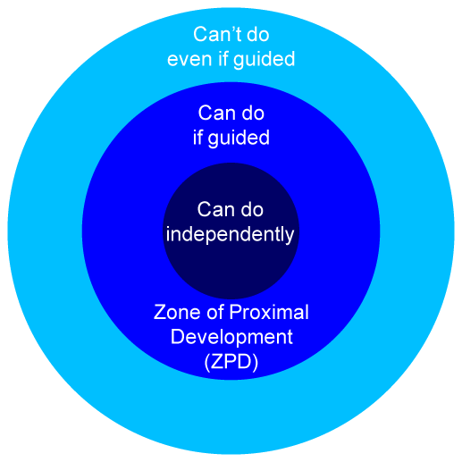
(matbury.com,2015).
Vygotsky also came up with the idea of scaffolding which consists of:
- Motivating the child’s strong points of the task
- Breaking the task down to easy steps
- Providing some direction to maintain being focused
- Reducing factors that cause stress
- Perfecting and outlining the expectations of the task given
Vygotsky developed the scaffolding theory for children learning new tasks and the scaffolding supports this and the this is taken away after completion when the task is understood.
Vygotsky became the basis of much research and theory in cognitive development over previous decades. It has become known as social development theory.
Vygotsky has developed a sociocultural tactic to cognitive development. He established his theories at around the same time as Piaget, but he died at the age of 38 and his theories are unfinished, with some of his texts still being read from Russian.
Like Piaget, Vygotsky believed young children are also involved in their own learning and development of new understandings. However, Vygotsky placed more emphasis on social contributions to the process of the development whereas Piaget emphasized self-initiated discovery McLeod, S. A. (2014).

DIFFERENT TYPES OF TRANSISTIONS

From playgroup to school
From a school nursery to a different school reception class

Different transition in early years
Between adults in a setting
Between rooms in a setting

From a day nursey to a school
From parent to a setting

the needs of the child
Transitions are at highest quality when they are organized around the needs of the child and not the needs of an adult or school. For a good transition for the child the school needs a policy that ensures there is an elective member of staff to deal with. The school needs to ensure that the policy is stuck to and is used as an effective practice. Part of the policy is to include smooth transition for every individual child and that they also put additional support in place for vulnerable families. A good transition helps towards the positive learning and future success of the individual child. It also contributes to the social and emotional development of the child (Transition from pre-school setting into school, no date.)
COMMON WORRIES A PARENT MIGHT HAVE DURING A TRANSITION PROCESS AND HOW TO PREVENT THEM
During the transition process, a parent has worries for their child that they might not be able to express easily. They may, for instance, feel emotional and upset that they have been separated from their child. This could be addressed by having a relative or friend look after your child in the run up to the transition to make it less upsetting and stressful for both you and the child. Parents or the carer might be worried if they are unsure what happens in the setting on a day to day basis or the child’s first day of school. If the parent or carer communicates with the teacher or the school, they might feel at ease knowing what their child is doing on a day. The use of a home school book would be helpful to keep the parent informed. Parents may also be worried about practical issues for their child in new surroundings. For example, if they can find the way to the toilet and if they will have the confidence to ask for help. A parent or adult might worry that their child might be lonely or struggle to make friends, get bullied or be led astray. If the child is socialised, then that might help the child’s confidence to make friends more easily. Parents or carers can have anxiety about their child’s safety and what will happen if they get hurt or feel unwell. This worry could be minimized by the carer or parent asking about how safe the school is with getting in and out and what their policy is when a child is unwell or hurt during school time.
REFERENCES

allingham, S. (2012). Full Access Transitions in the Early Years. andrews uk ltd, p.25.
App.croneri.co.uk. (2017). Managing transitions in early years provisions | Croner-i. [online] Available at: https://app.croneri.co.uk/feature-articles/managing-transitions-early-years-provisions [Accessed 15 Nov. 2017].
AZ Quotes. (No Date) Lev S. Vygotsky Quotes. Available at: http://www.azquotes.com/quote/600210 (Accessed 20 November 2017).
Bergen, D. (1994). Should teachers permit or discourage violent play themes?Childhood Education, 70(5), 300-301
Foundationyears.org.uk. (2017). SEN and disability in the early years: A toolkit. [online] Available at: https://www.foundationyears.org.uk/files/2015/06/Section-10-Transitions.pdf [Accessed 15 Nov. 2017].
http://www.earlyyearsmatters.co.uk/eyfs/positive-relationships/transitions/ [Accessed 12 Nov. 2017].
Informing Transitions in the Early Years : Research, Policy and Practice. (2017). [e Maidenhead : McGraw-Hill Education. 2007, p.61.
Kirklees Council. (No Date) Kirklees Guidance For Transitions In The Early Years. Available at: https://fixby.org/kgfl/primary/fixbypri/web/early-years-transition-guidance-booklet-2013.pdf (Accessed 20 November 2017).
Lindon, j. (2017). Community Playthings | Cultural diversity in the early years. [online] Communityplaythings.co.uk. Available at: https://www.communityplaythings.co.uk/learning-library/articles/cultural-diversity-in-the-early-years [Accessed 19 Nov. 2017].
Matbury.com (2015) Learning Styles, Mindset, And Adaptive Strategies. Available at: https://matbury.com/wordpress/ (Accessed 13 November 2017).
McLeod, S. A. (2014). Lev Vygotsky. Retrieved from www.simplypsychology.org/vygotsky.html (accessed 14 November 2017).
Nelson, K. (2016). “Play is the Highest Form of Research”. [online] The Baby Cubby Community Blog. Available at: http://www.babycubby.com/baby-cubby-blog/play-is-the-highest-form-of-research/ [Accessed 13 Nov. 2017].
Sherborne House School (2017). Early Years Transitions. Available at: http://www.sherbornehouse.co.uk/education-and-learning-early-years-transitions.aspx (Accessed 20 November).
Simply Psychology. (n.d.). Maslow's Hierarchy of Needs. [online] Available at: http://www.simplypsychology.org/maslow.html [Accessed 15 Nov. 2017].
Simplypsychology.org. (n.d). Bruner - Learning Theory in Education | Simply Psychology. [online] Available at: http://www.simplypsychology.org/bruner.html [Accessed 19 Nov. 2017].
Simplypsychology.org. (n.d.). John Bowlby | Maternal Deprivation Theory | Simply Psychology. [online] Available at: http://www.simplypsychology.org/bowlby.html [Accessed 10 Nov. 2017].
Team, F. (n.d.). Statutory Framework for the Early Years Foundation Stage | From pregnancy to children aged 5. [online] Foundationyears.org.uk. Available at: http://www.foundationyears.org.uk/statutory-framework [Accessed 15 Nov. 2017].
Transition from pre-school setting into school. (n.d.). [pdf] norfolk: norfolk county council. Available at: http://file:///C:/Users/Invate/Downloads/Transitionspreschooltoschool1.pdf [Accessed 20 Nov. 2017].
Understanding Childhood. (2014) Separations And Changes In Early Years. Available at: http://www.understandingchildhood.net/posts/separations-and-changes-in-the-early-years/ (Accessed 20 November 2017).
Unicef UK. (n.d.). What does Unicef do? - Unicef UK. [online] Available at: http://www.unicef.org.uk/what-we-do [Accessed 19 Nov. 2017].
Us, A., Us, C., Support, S., Support, P., Consultancy, L., EYFS, I. and News, E. (2017). Transitions - Early Years Matters. Early Years Matters. Available at:
Whitebread, d. (2012). the importance of play. [ebook] Belgium, pp.18-24. Available at: http://www.importanceofplay.eu/IMG/pdf/dr_david_whitebread_-_the_importance_of_play.pdf [Accessed 19 Nov. 2017].

