Synthesize a solution to a potential real-life scenario
By Thomas Evans

Student number: 1810164

Internet Technology and Security
School of Applied Computing

Abstract
IT Consumerism has led to massive growth in the variety and number devices available to the average person and in turn, this has led to an increased amount of pressure on businesses to allow their staff to use their personal devices for work purposes. The term for allowing the use of personal devices for work purposes is ‘Bring your own device’, or BYOD. There are myriad benefits and problems with allowing the use of BYOD and this report intends to highlight and discuss both before coming to a conclusion on whether the rewards outweigh the risks for companies.

Contents
 | Page Number
- Introduction | 1
- Potential Benefits of BYOD | 1
- Potential Issues of BYOD | 1-2
- BYOD User policy | 2-3
- MDM Solutions | 3-4
- Hyper-fort network | 4
6.1 Wireless Security | 4-5
6.2 Switch and router security | 5-6
6.3 Switch and router redundancy | 6-7
6.4 Virtual private networks (VPN’s) | 7
6.5 Physical Security | 7
- Conclusion | 7

1.Introduction
BYOD really began to grow in popularity around 2010 after Intel recognised an increasing trend of their employees bringing their personal devices into work and connecting them to their corporate network [1]. Since then the number of personal devices used in the workplace has skyrocketed, with studies now estimating that in the US 60% of companies now have BYOD policies in place and almost 90% really on at least part of their workforce using personal devices to access work-related applications [2]. With such an influx of personal devices now requiring access to corporate networks, the scope of the possible dangers has also increased. Companies need to make sure they have the correct infrastructure, security and policies in place in order to mitigate any potential issues.

2. Potential Benefits of BYOD
Allowing staff to work from their personal devices opens up a lot of advantages for companies. Increased productivity from staff is arguably the most noticeable benefit from BYOD. Intel, an early adopter of the BYOD movement, reported in 2012 that their staff saved 57 minutes of their time per day thanks to using their personal devices for work purposes. This equates to an annual productivity gain of 5 million hours in 2012 alone [3]. Aside from allowing users to work more productively during office hours, BYOD also opens up the option for staff to work more flexibly, whether that’s in terms of the location they work from, or what time of day. Allowing personal devices to connect remotely to corporate resources securely allows staff to work from their home or anywhere with an internet connection. It can also allow employees to catch up on work in their own time if they choose to, although it is important to distinguish in any company policy the details of this arrangement. This flexibility massively increases the satisfaction of employees which in turn can improve rates of employee retention. It can also help to attract a higher level of applicant when hiring for new positions [4].
Another massive benefit of BYOD is the decrease in capital expenditure a company needs to make on computer equipment. Allowing staff to use their own devices reduces the need for buying expensive computer equipment. With the smaller number of company-owned devices, running maintenance and replacement costs are also a fraction of what they would have been before BYOD implementation. Whilst some staff may be against using their personal devices in lieu of company-owned equipment, the growing trend now seems to be that employees are more than willing to sacrifice using company purchased computers for their smartphones and laptops [4].

3. Potential Issues of BYOD
Whilst allowing staff to access company data and resources from their personal devices does provide benefit, it can also pose huge security concerns for data administrators. Prof Roumen Varbanov [5] poses the common risks associated with BYOD:
- Malware
- Date leakage due to loss or theft of the personal device being used
- Infringement of rules on access control and safety policies
- Sending business emails from personal devices and email accounts
- Deliberate actions to extract confidential information

There are no one-stop solutions to successfully implementing a secure BYOD system. An all-encompassing policy needs to be created in order to cover the range of issues posed, from by the hardware and software being used to the end users themselves.

4. BYOD User Policy

Initially, it should be determined exactly who within the organisation is permitted to use their personal devices for work purposes. Giving unrestricted access to all employees to connect their personal devices to the corporate network may not be best practice. If certain staff will only ever need to access work resources during standard office hours and are already permitted to access work devices that are readily available, then allowing these members of staff to participate in BYOD programs may not make sense from a security standpoint. If the companies focus is cost benefit, then encouraging all members of staff onto BYOD programs may make more sense. Encouraging the use of personal devices and slowly decreasing the number of company-owned devices would see a marked decrease in both the expenditure on new equipment and the maintenance of the existing equipment. Whether it’s decided that all or part of the workforce are permitted access to the BYOD program, the company still needs to determine exactly what it is that the user needs access to. It is likely that staff will be permitted access to limited resources such as their business email, business contacts and calendar but allowing personal devices to access sensitive data may not be the most sensible option [5]. This data could constitute financial records, medical records and intellectual property to name but a few.
When it comes to how the data is stored on the device, efforts need to be made to mitigate the potential negative effects caused by loss of data from theft or loss. Users must be required to PIN or passcode their devices at a very minimum. They should be forced to abide by the company’s password enforcement policy and made to use passwords that satisfy the complexity criteria.
Ideally, there will be a clear definition between personal and company data. In any acceptable use policy, the company should set out a reasonable expectation of privacy to assure the user that their personal data is not being monitored or stored. On the device being used, there will be ways to remotely wipe company data from devices in the event of theft or loss. This functionality will be handled by a mobile device management (MDM) and mobile application management (MAM) software application which will be described in more detail later in this report. By implementing MDM and MAM solutions, this removes the potential of personal and company data blending. Aside from allowing company data to be remotely wiped, it also helps to alleviate privacy concerns. Only company applications and data will be wiped and the company will only have access to its own data, not any of the user’s personal data. This is particularly useful in the case of an employee leaving the company where the device belongs to them, but the data belongs to the company [6].
To enforce these policies, there must always be a reasonable threat of legal consequences. When signing the acceptable use policy, employees must be aware that deliberately accessing, amending or deleting data they are not authorised to will result in punishment.

5.MDM Solutions

An effective method of adopting BYOD involves the introduction of a Mobile Device Management solution, or MDM. The MDM software allows the monitoring and management of mobile devices and also the centralised distribution of applications [7]. There are many reasons to implement an MDM. MDM’s allow access policies to be pushed out to end devices to ensure they comply with company policy. An advantage of using MDM software platforms lies with the unified approach administrators can take to all devices accessing the corporate network. MDM’s allow for administrators to have overall visibility of any connected devices and allow reporting of any device not complying with security or device policies [7]. Another positive factor to implementing MDM solution lies with the control administrators have over the connected devices and the corporate data found on these devices. As noted by Garba et al [7] “MDM servers can be used to send configuration profiles such as user policy, remote wipe, remote lock, and clearing device passcodes, for
example, to devices through the network. Camera, application and Cloud usage can be
restricted on devices using application management systems”. Many modern MDM solutions such as the Blackberry Enterprise Mobility Solution provide virtualised apps for staff to download. Use of virtualised applications grants administrators the following benefits [7]:
- Allows applications and desktops to run on back-end servers instead of the mobile devices.
- Secured remote access to resources.
- Leaves no corporate apps and data on users’ devices.
- Corporate and personal data separated.
- Virtualized apps offer more functionality than mobile apps.
- Malware and viruses cannot be sent through virtualized apps.
- Easier centralized approach to update applications on devices.
Apps, such as the dedicated email clients and secure web browsing apps provided by blackberry, allow the clear division of work and personal data. Administrators can be confident that corporate data will be stored safely and securely within these applications. As mentioned by Garba et al, common mobile phone functions such as screenshotting can be disabled whilst using these apps, which provides a higher level of security and protection against data leakage. The benefit for staff is, if administrators ever need to wipe the data, then only these applications are wiped, leaving the rest of the user’s personal data untouched.
One of the main issues that used to hinder the implementing of an MDM would be the limited coverage of different operating systems. However, this doesn’t tend to be such an issue now. As you can see below, the Blackberry Enterprise Mobility Solution covers a wide range of operating systems [8]:
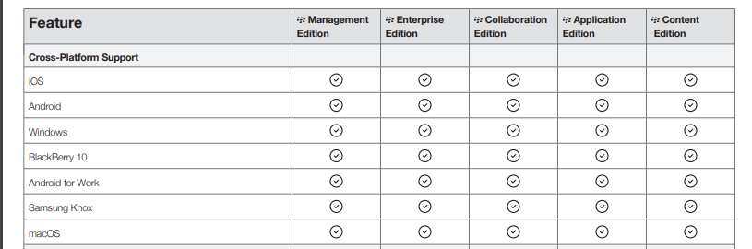
https://uk.blackberry.com/content/dam/blackberry-com/PDF/enterprise/ds-blackberry-enterprise-mobility-suite.pdf
By covering such a wide range of operating systems, the amount of compatible devices doesn’t tend to be such an issue. As long as devices comply with security and device policy documented by the organisation, the majority should be able to access the corporate network with no issues.

6. Hyper-fort network
Before an organisation can effectively incorporate BYOD policies, the existing network infrastructure needs to be properly organised and secure. If the foundations of a secure network are not already there, then the risks that BYOD already brings are multiplied.
6.1 Wireless Security
The general nature of BYOD means that wireless connectivity for devices will be the most common method of connection to the corporate network. To ensure that all devices don’t have carte blanche access to the corporate network, wireless security needs to be properly enforced.
Below we can see a section of the Hyper-Fort network, namely the inner corporate network

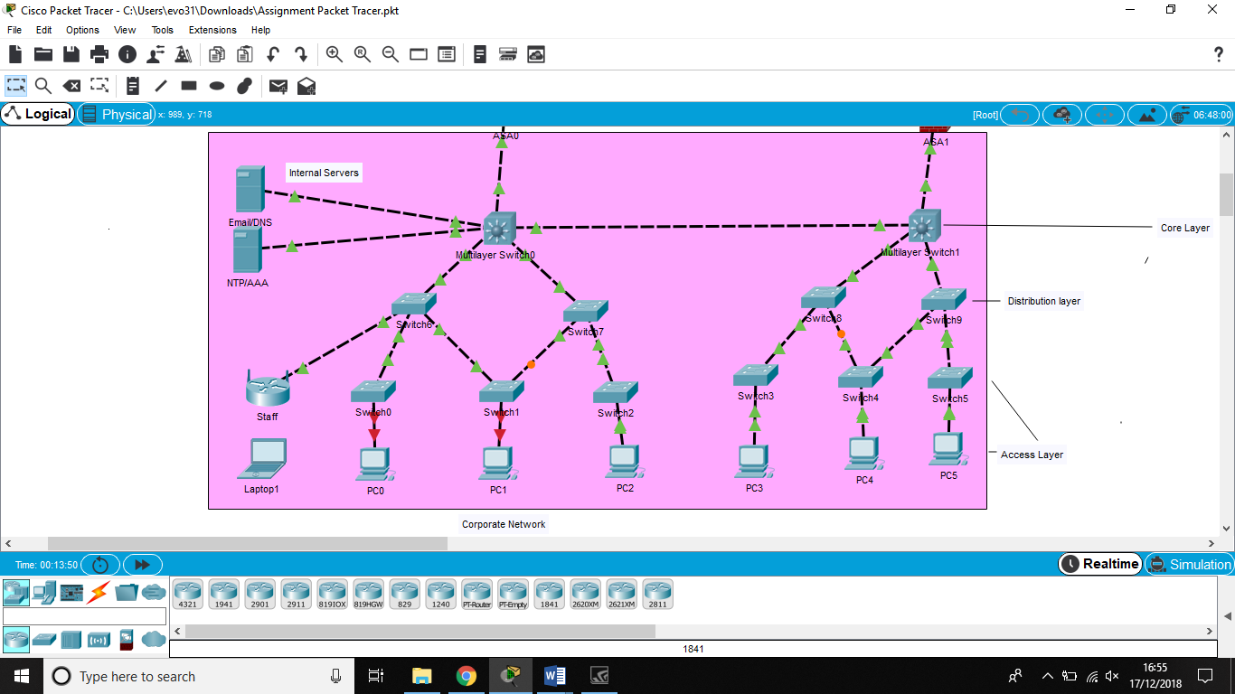
Figure 1 Hyper-Fort network - Corporate network

A wireless LAN controller has been used to manage access to the wireless network. Wireless LAN controllers offer a number of advantages for large-scale wireless networks. Firstly, they offer centralised authentication with usernames and passwords when integrated with the RADIUS server. This allows authorised staff to connect to any of the access points across the network. Network administrators can configure new users on the RADIUS server and these changes take effect across the entire network. Using RADIUS servers can also allow accounting of the users on the network. This is particularly useful for logging when users have logged on, for how long and what they’ve accessed whilst being logged on.
The wireless network of the organisation uses WPA2-enterprise security. WPA2 is the current standard for wifi security and is considerably more secure than WEP and WPA. WPA2 uses AES (American Encryption Standard). AES is approved by the U.S. government for encrypting the information classified as top secret [9] which shows the strength of the encryption involved.
Wireless LAN controllers also offer the ability to offer network access control to users based on their identity. Wireless users can be managed and separated into groups which offer different access to different network resources. Some staff can be denied access to things such as the internet while guests may be allowed temporary access to the internet whilst not being allowed access to the corporate network [10].

6.2 Switch and router security

To ensure nefarious actions can’t be carried out on the switches and routers across the organisation, they need to be properly configured and secured. Devices need to be password protected and access must only be granted to network administrators who have responsibility for managing and maintaining the network. Cisco switches have two types of password protection. The first allows a standard password to be set up on the switch, which stops unauthorised access to privileged exec mode. Whilst this is better than no security, the ‘enable password’ command saves the password as plain text in the configuration file. Running the ‘show running-config’ command displays this password. To properly secure the devices, the ‘enable secret’ command is more secure. The password is saved in the config file but encrypts it with a one-way MD5 hash. Anyone who happens to see this hashed password will be none the wiser as to the real password.
For the remote connection to switches and routers, SSH (Secure Shell) has been set up to be used instead of telnet. “Telnet is a network protocol that allows a user to communicate with a remote device” [11]. The issue with telnet is that all network traffic and commands are sent using in plain text. This includes both passwords and usernames, so if there are people using packet sniffers on the network it may be possible to gather this information and in turn gain logon credentials. SSH uses encryption to secure all the data being communicated and keep it safe from anyone trying to listen in. If set up securely, allowing remote access of devices is highly advantageous. Without it, network administrators would have to physically visit any devices and plug their laptops in to configure. This may not be a massive issue in smaller organisations, but for medium to larger size companies, the network may be spread over vast distances.
An additional security feature that may be configured is switch port security. Switch port security allows ports to be tied to down to individual devices by identifying the MAC addresses of the workstations which are allowed access. The benefit of having this set up is that if someone with an external device comes into the organisation, they aren’t able to disconnect the ethernet cable from a connected workstation and connect a personal laptop to try and access the network. If the maximum number of MAC addresses is reached and the new device trying to connect to the port is not any of the authorised MAC addresses, a security violation will occur on the port [12]. Once this violation has occurred, the port can either be configured to restrict data or completely shut down until a network administrator reenables the port.

6.3 Switch and router redundancy

The topology of the network follows the hierarchal model. This model allows for the best performance across the organisation.

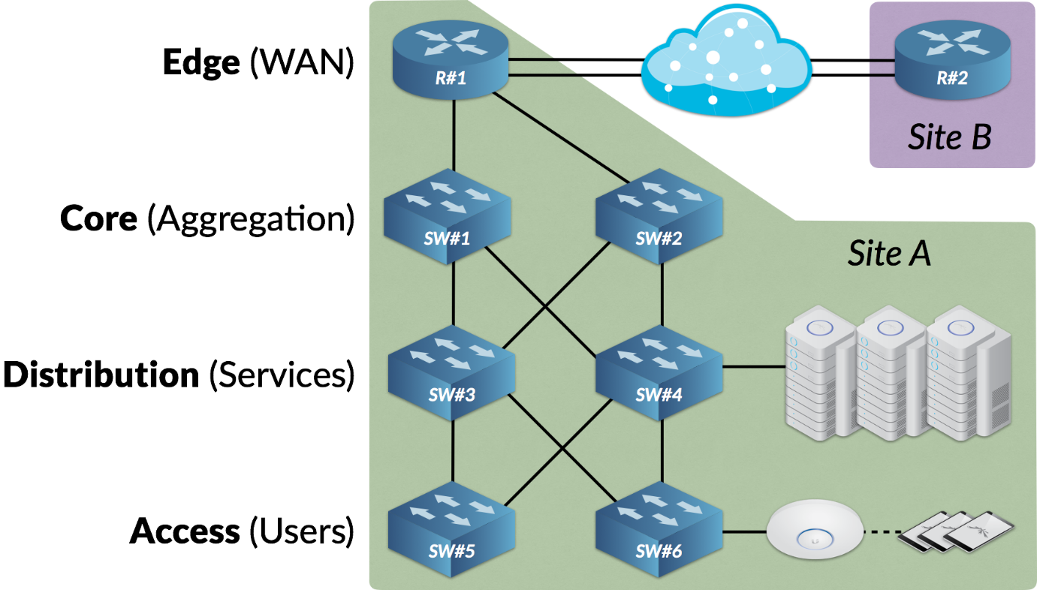
Figure 2 https://help.ubnt.com/hc/en-us/articles/115007129507-Intro-to-Networking-Hierarchical-Network-Topology

As we can see above, there are four layers to this network. The access layer contains switches responsible for connecting up user devices to the network. The distribution layer contains high-performance switches located at network areas dealing with important services such as DNS. The core layer contains ultra-high performance switches and routers in high bandwidth areas and the edge layer contains switches or routers located at WAN or MAN boundaries. [13]. To ensure high availability of the network, switches and routers need to be configured so in the case of one device failing, the network traffic is automatically directed via another route to where it needs to go. Spanning tree protocol is a protocol that provides for redundancy. Spanning tree prevents loops on the network when switches interconnect via multiple paths. It ensures all physical links are loop free and only one logical path exists for all destinations on a network. It intentionally blocks redundant paths that can cause loops and compensates for network failure by rerouting the network traffic [14]. This automatic routing of network traffic should mean that users are unaware of any issues and should experience no downtime. This gives the network administrators time to swap out the failed hardware with new hardware and add the redundancy back into the network. It’s advisable that to minimise this risk even further, spare switches and routers should be configured ready and kept as spare so in the event of hardware failure, a straight swap should be all that’s needed, saving time on the configuration of new hardware.

6.4 Virtual Private Networks (VPN’s)

Steve Cassidy [15] describes a VPN as “a secure way to of transporting private data across unknown networks”. This is particularly useful in a work setting where an employee may need to access company resources from numerous organisational sites, or even from external connections such as their home. As we can see on the hyper-fort network, there are currently two examples of VPN’s being used. The first allows users to connect to the corporate network through their personal devices at home. The second shows a VPN tunnel connecting two separate sites of the same organisation. Both of these methods allow the transfer of encrypted data over the network. For all intents and purposes, the employee logging on through their laptop at home is logging on to a machine on the organisational network and should allow them secure access to anything they are able to access in work.

6.5 Physical security

Physical security of devices is just as important as the administrative access controls that need to be applied to the devices in the network. This helps to prevent theft, damage or attempts of unauthorised access to equipment. Critical devices such as switches, routers, and servers should be secured in locked cabinets or in locked rooms/areas away from members of the general public and employees. These rooms should be well ventilated to make sure that the hardware doesn’t overheat. If possible, remote temperature monitoring will be used to monitor for any temperature spikes and fire suppression systems should be installed to put out any fires in the event they occur. UPS’s should also be used to mitigate the effects of any unexpected power losses.
Access to the room should be limited to as small a number of staff as possible. Identity swipe cards are beneficial as logs can be recorded of who accesses certain at rooms and at what times. CCTV monitoring should also be used to record these areas for any attempts of unauthorised access.

7. Conclusion

With almost every employee today using some form of portable device, it seems that the adoption of BYOD for companies is a case of when not if. By resisting the adoption of a BYOD policy, a company has BYOD forced upon them by employee pressure before being totally prepared. By accepting that BYOD will happen, companies that prepare a thorough policy are more likely to reap the rewards associated with BYOD adoption whilst minimising the associated risks. The incentives of increased productivity and staff morale alongside lower hardware costs should more than outweigh the potential negative possibilities, particularly when these negative possibilities should be minimised through proper security planning.

Bibliography

[1] | M. Harkins, “Gov Info Security,” [Online]. Available: http://www.govinfosecurity.com/webinars/mobile-learn-from-intels-ciso-on-securing-employee-owned-devices-w-264. [Accessed 20th November 2018].
[2] | Syntonic, “Syntonic,” 2016. [Online]. Available: https://syntonic.com/wp-content/uploads/2016/09/Syntonic-2016-BYOD-Usage-in-the-Enterprise.pdf. [Accessed 22 November 2018].
[3] | Intel, “Accelerating Business Growth through IT,” Intel, 2013.
[4] | M. R. Waterfill, “BYOD: Where the Employee and the Enterprise Intersect.,” Employee Relations Law Journal, vol. 40, no. 2, pp. p.26-37, 2014.
[5] | P. R. Varbanov, “APPLICATIONS OF THE BYOD CONCEPTION - BENEFITS, RISKS AND APPROACHES,” Business Management / Biznes Upravlenie., vol. 24, no. 2, pp. 80-99, 2014.
[6] | C. CALDWELL, S. ZELTMANN and GRIFFIN, “BYOD (Bring Your Own Device),” Competition Forum, vol. 10, no. 2, pp. 117-121, 2012.
[7] | A. Garba, J. Armarego, D. Murray and W. Kenworthy, “Review of the Information Security and Privacy Challenges in Bring Your Own Device (BYOD) Environments,” Journal of Information Privacy & Security, vol. 11, no. 1, pp. 38-54, 2015.
[8] | Blackberry, “Blackberry Enterprise Mobility Solution,” 2 November 2017. [Online]. Available: https://uk.blackberry.com/content/dam/blackberry-com/PDF/enterprise/ds-blackberry-enterprise-mobility-suite.pdf. [Accessed 10th December 2018].
[9] | netspotapp, “netspotapp,” 2018. [Online]. Available: https://www.netspotapp.com/wifi-encryption-and-security.html. [Accessed 17 December 2018].
[10] | “excitingip,” 8 march 2010. [Online]. Available: http://www.excitingip.com/673/features-of-todays-centralized-wireless-wi-fi-networks/. [Accessed 17 December 2018].
[11] | study-ccna, “study-ccna,” 2018. [Online]. Available: www.study-ccna.com/telnet-ssh. [Accessed 28 December 2018].
[12] | “Cisco Systems,” 13th February 2018. [Online]. Available: https://www.cisco.com/c/en/us/td/docs/switches/lan/catalyst4500/12-2/25ew/configuration/guide/conf/port_sec.html. [Accessed 28th December 2018].
[13] | “UBNT Support,” UBNT, 27 October 2017. [Online]. Available: https://help.ubnt.com/hc/en-us/articles/115007129507-Intro-to-Networking-Hierarchical-Network-Topology. [Accessed 28 December 2018].
[14] | D. C. Campbell, Lec 6 - The Realm of 5 nines - Cyber Security, 2018.
[15] | S. Cassidy, “VPN,” PC Pro, no. 245, p. 108, 2015.

