DS 1 Assignment

My Screenshots/Photos

Screenshot/Photo 1
Phone/map  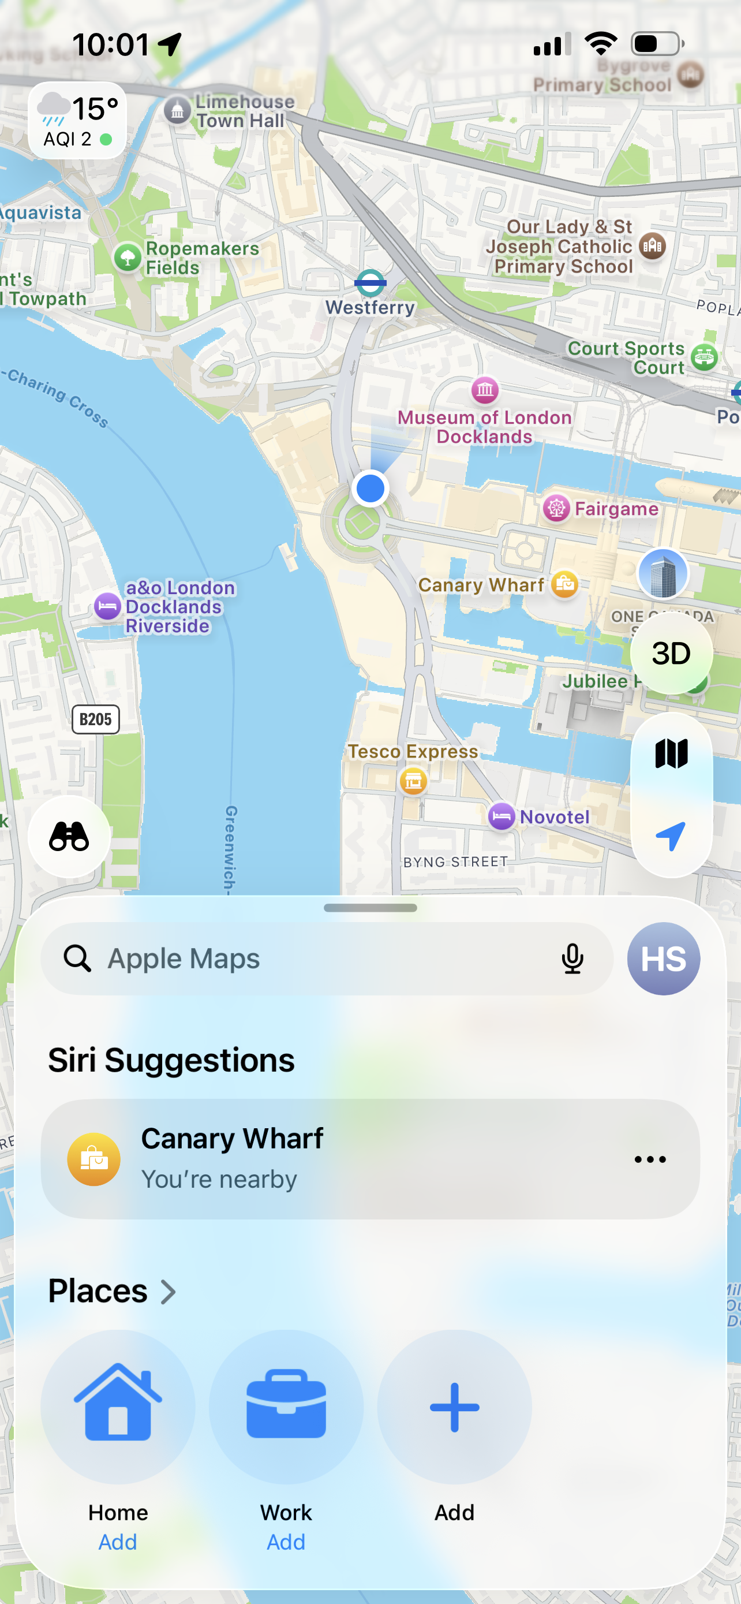  I use my phone to find a location. I use digital maps to me travel and find place. | blob:https://outlook.cloud.microsoft/b0b2cfd8-90a3-4648-b818-e55a053d1693

Screenshot/Photo 2
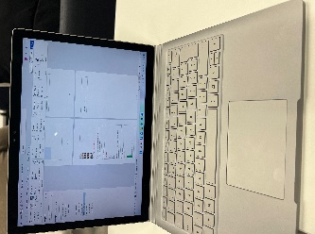
Laptop
I use my laptop for studying. I use it to complete my college work, research information and communicate online.

Screenshot/Photo 3

Screenshot/Photo 4
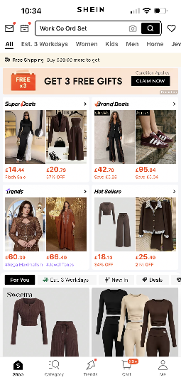
shopping online
Shopping online for clothes. I use website and apps to look at different products and compare prices before buying.

Screenshot/Photo 5
Instagram
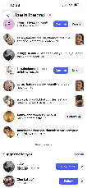
I use Instagram to keep in Toch with friends and family. I use Instagram to see posts. Share photos and communicate with people.

Screenshot/Photo 6
Online banking
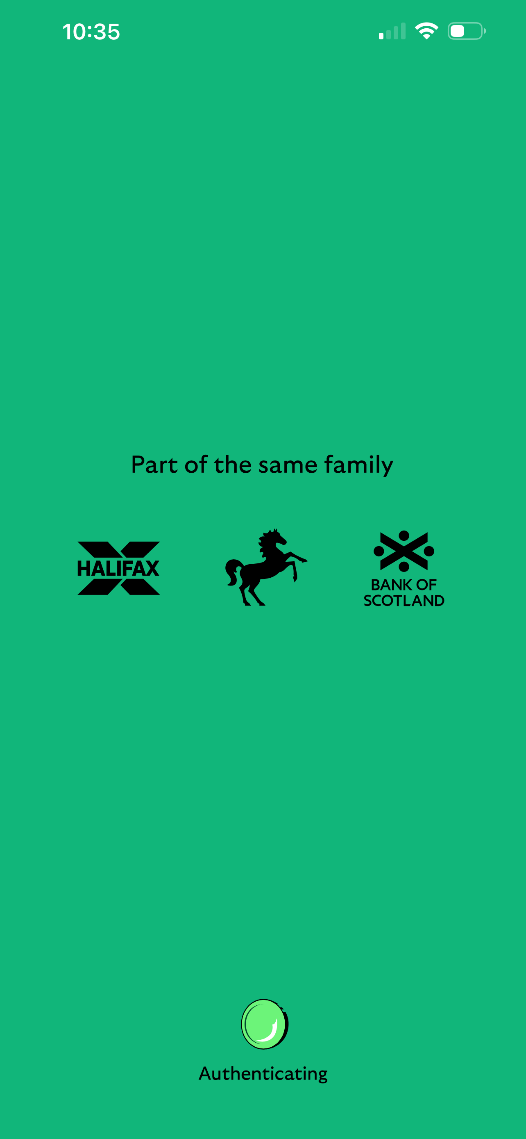
I use online banking on my phone. It makes it quick and easy to manage my money without going into a branch.

My Short Reflection
- Write 5–8 simple sentences about your digital life.
- You can use the sentence starters below if helpful.
- I use digital tools to complete my assignments and join online classes.
- I feel confident when I browse the internet for information.
- I want to improve my skills in managing data online.
- I often use these tools: a laptop and education websites.
- I hope this module will help me become more secure and responsible online.
- Digital skills are important for me because they help me stay connected to the word.

Sentence starters
- I use digital tools to …
- I feel confident when I …
- I want to improve …
- I often use these tools: …
- I sometimes feel nervous about …
- I hope this module will help me …
- Digital skills are important for me because …
You can write more if you want.

Submission Checklist
Before you submit, please check:
​​​ ☐ I added 4–6 screenshots
☐ I wrote short sentences for each screenshot
☐ I wrote my short reflection
☐ My work is my own
☐ My file opens correctly
​​☐ My file opens correctly

