

Name : Sammar Zaman
Student ID : 2522365
Module Code : LCHS4003
Module : Introduction to Health & Social Care
Lecturer : Dr Helen Parsons

Content :
Task 1: Ambulance Services Poster
Task 2 :Community Mental Health Services
:References

HHJ
HOW THE AMBULANCE SERVICES WORKS TODAY
CHALLENGES FACED BY THE AMBULANCE SERVICE
. demand for ambulance services has increased substantially due to the population growth, an ageing population and rising numbers of paitents with complex health needs.high demand can result in longer wait times and increased pressure on emergency deparments (national audit office 2017)
. ambulance services face significant operational and workforce pressures.excessive WORKLOADS, STAFF SHORTAGES, RECRUITMENT challenges and concerns about staff wellbeing have contributed to ongoing workforce pressure across the sector (nhs england 2024)
.
SERVICE OVERVIEW
EMERGENCY RESPONSE AVAILABLE 24/7 TO RESPOND TO 999 CALLS AND DISPATCH HELP QUICKLY (NHS 2022)
ON SCENE CARE- TRAINED CLINICIANS ASSESS, TREAT AND STABilizE PAITENTS AT THE SCENE
SAFE TRANSPORT-PAtients ARE TRANSPORTED SAFELY TO THE MOST APPROPRIATE HEALTH FACILITY (who 2020)
continunity of caRE- WORKS WITH HOSPITALS AND OTHER SERVICES FOR SEAMLESS ONGOING CARE (NHS 2022)
COMPASSION & RESPECT- CARE DELIVERED WITH EMPATHY, RESPECT AND DIGNITY
HISTORY OF AMBULANCE SERVICE
1800S– PAITENTS WERE TRANSPORTED BY VOLUNTEERS AND EMERGENCY PERSONNEL USING HORSE-DRAWN VEHICLES (LONDON AMBULANCE SERVICE N.D ) (FIG 1)
early 1900s- motor vehicles replaced horse drawn transport, improving response speeds and service coverage
1948 – nhs established and ambulance services become more intergrated
today- advanced paramedic led care supported by digital technology and evidence based practise (nhs ENGLAND) (fig 2)

WHAT IS THE AMBULANCE SERVICE
THE NHS AMBULANCE SERVICE PLAYS A VITAL ROLE IN EMERGENCY HEALTHCARE, PROVIDING RAPID ASSESSMENT, TREATMENT AND TRANSPORT FOR PAtiENTS WITH SERIOUS ILLNESS OR INJURY. HIGHLY TRAINED TEAMS, INCLUDING PARAMEDICS AND EMERGENCY CALL HANDLERS, WORK TOGETHER TO DELIVER URGENT CARE AND SAVE LIVES. (NHS ENGLAND 2024)

AMBULANCE SERVICES
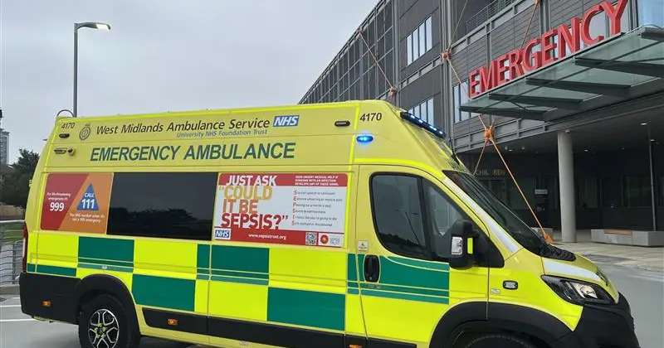Modern day ambulance (West midlands ambulance service 2026)

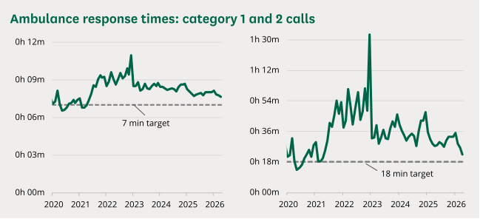
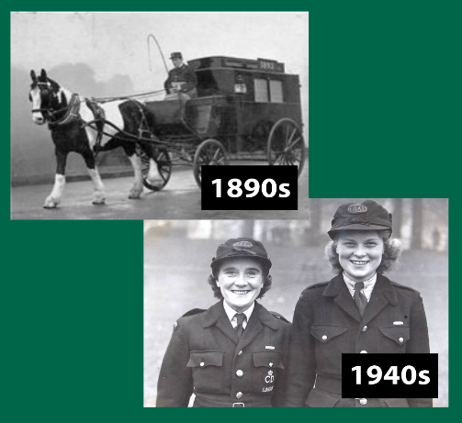
Fig 1
Fig 2
AMBULANCE SERVICES IN ENGLAND ALONE ANSWER MORE THAN 7 MILLION EMERGENCY CALLS EVERY YEAR (NHS 2024)
www.commonslibrary.parliament.uk/research (2026)

Community mental health services (CMHS) are a principal component of modern mental healthcare, providing support and treatment within community settings rather than institutional environments. Their development reflects significant changes in societal attitudes towards mental illness, with greater emphasis placed on human rights, recovery and social inclusion. Although CMHS are widely recognised as a more person approach to care, debates remain regarding their effectiveness, accessibility, and ability to meet increasing demand.
The origins of CMHS intricately linked to the process of deinstitutionalisation that occurred during the twentieth century. Before this period, many individuals’ experiencing mental illness were treated in a large psychiatric hospital where care often prioritised containment over rehabilitation (Jones 1993). Concerns regarding the restrictive nature of institutional care, combined with the introduction of psychotropic medications encouraged policymakers to consider alternative methods of treatment (Thornicroft and Tansella 2013). As a result, healthcare systems gradually shifted towards supporting individuals within their local communities. In the United Kingdom policy reforms promoted community-based care as a means of improving autonomy and reducing dependence on long term hospitalisation (Jones 1993). However, the transition from institutional care to community-based provision was not without difficulties. While the principle of enabling individuals to live independently was widely supported, the closure of psychiatric hospitals was often not matched by sufficient investment in community services (Pilgrim & Rogers 2023). Consequently, some service users experienced gaps in support increasing their risk of homelessness, social isolation and repeated hospital admissions. This highlights a key criticism of deinstitutionalisation. Although it sought to improve the lives of people with mental health conditions, its implementation was frequently constrained by limited resources and inconsistent planning (Pilgrim & rogers 2023).
Today community mental health services operate through multidisciplinary teams that include psychiatrists, mental health nurses, psychologists, occupational therapists, social workers, and peer support practitioners (NHS England 2024). These professionals collaborate to provide assessment, treatment, crisis intervention, rehabilitation, and ongoing support. Current practise is largely informed by recovery-orientated principles which focus on helping individuals achieve meaningful lives despite the presence of mental health challenges (WHO 2022). Rather than concentrating solely on symptom reduction, services increasingly recognise the importance of social participation, personal choice, and overall wellbeing.
An evaluation of contemporary community mental health services reveals several strengths. Delivering care within community settings can reduce the stigma associated with mental illness and enable service users to remain connected to family, education, employment, and social networks (WHO 2022). Research also suggests that community-based interventions can improve continuity of care and reduce reliance on inpatient treatment (Thornicroft & Tansella 2013). Furthermore, multidisciplinary working allows professionals to address the complex social, psychological, and physical factors that influence mental health. Despite these benefits significant challenges remain. Demand for mental health services has increased considerably creating pressure on staffing levels and available resources (NHS England 2019). Long waiting times can delay access to support potentially worsening mental health outcomes. In addition, the quality and availability of services may vary across regions resulting in inequalities in care provision (NHS England 2024. Some critics argue that fragmented communication between healthcare organisations and social care providers can also undermine effective service delivery particularly for individuals with complex or long-term needs (Pilgrim & Rogers 2023). Community mental health services play a vital role in enhancing quality of life for service users by supporting individuals within familiar environments. They promote independence, empowerment, and social inclusion (WHO 2022). Access to timely support can help people maintain employment, education, housing and personal relationships all of which contribute to overall wellbeing. Additionally early intervention and continuous support may prevent mental health crisis and reduce the need for hospital admission.
In conclusion CMHS emerged from efforts to replace institutional care with more humane and recovery focused approaches. Although challenges relating to funding, workforce pressures and access remain. CMHS continue to play a vital role in supporting recovery and improving quality of life for individuals experiencing mental health difficulties.

Jones K (1993) asylums and after: a revised history of the mental health services from the early 18th century to the 1990s.
London Ambulance Service (nd) Our history: a timeline Available at Our history - a timeline - London Ambulance Service NHS Trust
National Audit Office (2017) NHS ambulance services. London: national audit office available at www.nao.org.uk/reports/nhs-ambulance-services
NHS west midlands ambulance service (2024) WMAS prepares to transfer 600 patients. WMAS prepares to transfer 600 patients - West Midlands Ambulance Service University NHS Foundation Trust
NHS England (2024) community mental health framework for adults and older adults London NHS England available at community-mental-health-framework-for-adults-and-older-adults.pdf
NHS England (2024) Culture review of ambulance trust available at : www.england.nhs.uk/publication/culture-review-of-ambulance-trusts/
NHS England (2019) The NHS long term plan. London NHS England
Thornicroft G & Tansella M (2013) The balanced care model for global mental health psychological medicine 43(4) pp 849-863
World health organisation (2022) world mental health report: transforming mental health report for all.
World health organisation (nd) prehospital toolkit available at Prehospital Toolkit

