What is the role of the designer/maker in the 21st century and how might this role change in the next 10 years?
Emyr Owen Pritchard
1800771
Product Design
Word count: 2458
Julia Lockheart

What is the role of the designer/maker in the 21st century and how might this role change in the next 10 years?
The role of a designer is a much-debated question in the world of art and design with everyone having their own views and opinions to the answer. I believe that designers are a vital part of a large collective which drives humanity forward and which looks to create a better future for not only ourselves, but generations to come. With so many differing views on the topic, it is hard to find a definitive answer. Through my investigation, I will look at 4 key areas to help break down the role of the designer in the 21st century and how it may change over the years to come. These sections I have deemed to be critical to help place the role in our modern world, these range from; Social, Environmental, Technological and finally Political. These areas will help me build a simpler picture to try and answer the question. At the conclusion of this investigation I hope to prove that designers should be key figures in our society and leaders in each of these areas.
Social
Designers create society. From the clothes that we wear, to the apps that we use to communicate, the role of the designer has always been integral to the creation and development of our lives. Most citizens through the 21st century, are in some way a designer or maker. Most jobs are a creation of a product or a service, most of these mean creating something whether the outcome is physical or not. Nick Offerman, say this at his interview at the Oxford Union saying, “No matter what your course of study is, there’s something you can make with your hands that can enrich your life” (Offerman 2019, Interview with Oxford Union). His view points out, that whether you’re a designer or not, you can still make things with your hands, making you a creator on some level. That could be as simple making food for your family or maybe taking part in some form of crafts in your spare time. This is relates closely to metadesign, in this case where the “designers/makers” are non-practicing designers. Bringing design into everyday life helps us further society by helping people understand development and structure in design. This in turn allows for greater influence from consumers on day-to-day products and even as big as influence on city architecture and planning.
In modern society, consumers are put in a crossroads when it comes to purchasing products, either pay a high price for a product that works well or purchase a cheaper option that will not function as is should. This should not be the case as design should never be about designing to a bare minimum, design teams should make a product that works to a quality standard. Designers currently do not have a great amount of say in how much a product is worth, in most large companies it is usually an accounting decision made to maximise the profit for each product, forcing users into a corner to pay over the odds for a product that is made for a 10th of the price. In the future designers must demand better form their employers, getting better prices for the consumers to help fight a rise in consumerism. The iPhone is a great example of this. According to Techinsights, the recent iPhone X is sold with a profit margin of “64%” while the iPhone 8 sold at a lower “59% profit margin” (TechInsights, 2017). If this continues it could have big consequences in industry, with smaller businesses not being able to sustain themselves against commentators who control the sector. Disney are an example of a company becoming too large and gaining a monopoly on the sector, we have already seen many other companies fall under the Disney banner such as Fox and Lucasfilm as they can’t compete. Right now, designers can make a difference, by working with their companies to make a product that is fair to everyone that is involved with it, from the consumer to the workers who build it.
When considering the future of design in society, there is not enough being done to encourage young designers and to show the design is a real pathway in life. In secondary school art and design is not given the same treatment other “major” subjects are, such as maths and English, this shows in the school budget when art and design departments are often in the lower end of the funding budget. Designers should work with schools and colleges to bridge this gap in funding by providing workshops for students who feel they want to go down the path of art and design. Designers should also be pressuring schools to encourage students to take up design, this would not only be good for the students from a design standpoint but also in other subject area because design helps students develop their problem solving skills which will come into use in the sciences or maths, and even in future employment even if it is not in design.
Environmental

I think there are many people who would agree that the environment is increasingly becoming the most important issue within our current world, with global warming rising at an ever more dangerous rate, we all must look to help save the planet is our day to day lives but more so as a designer. As previously stated, designers create everything we use in our lives, this puts designers in a position where they can have a positive effect on many areas in design, including manufacture, packaging and even distribution. By making changes to a design a we can reduce waste through the system such as; reducing single use plastics to only the absolutely necessary, limiting the amount of material in a design to bring down the amount of raw virgin material required, and even adapting designs to incorporate recycled materials such as re-graded metals or recycled manufactured wood boards instead of new raw material. For example, the clothing brand Patagonia have been doing this since 1993, recycling old plastic bottles into their nano puff jacket, this both gets rid of some plastic waste and decreases the need for new plastics to be made. I believe that designers should work towards a fully sustainable and carbon neutral way of making their designs. Another way they can move towards this is by working with scientists and engineers to create new materials and technologies whilst making advancements to current methods so that products can be made more efficiently and even move towards a carbon neutral position to combat climate change.
(Patagonia recycled nano puff jacket, 2019)
The world is currently trying to move towards cleaner manufacturing, with many countries both building new clean factories and encouraging and incentivising companies to do the same. In the US companies like Tesla are making “Giga factories” to produce their latest line of vehicles, these are very clean factories and extremely effective. It is these kinds of manufacturing facilities that we should be encouraging and creating here in the UK. These will mean new jobs without compromising the environment which is a key priority for designers right now and for the foreseeable future.
Technological
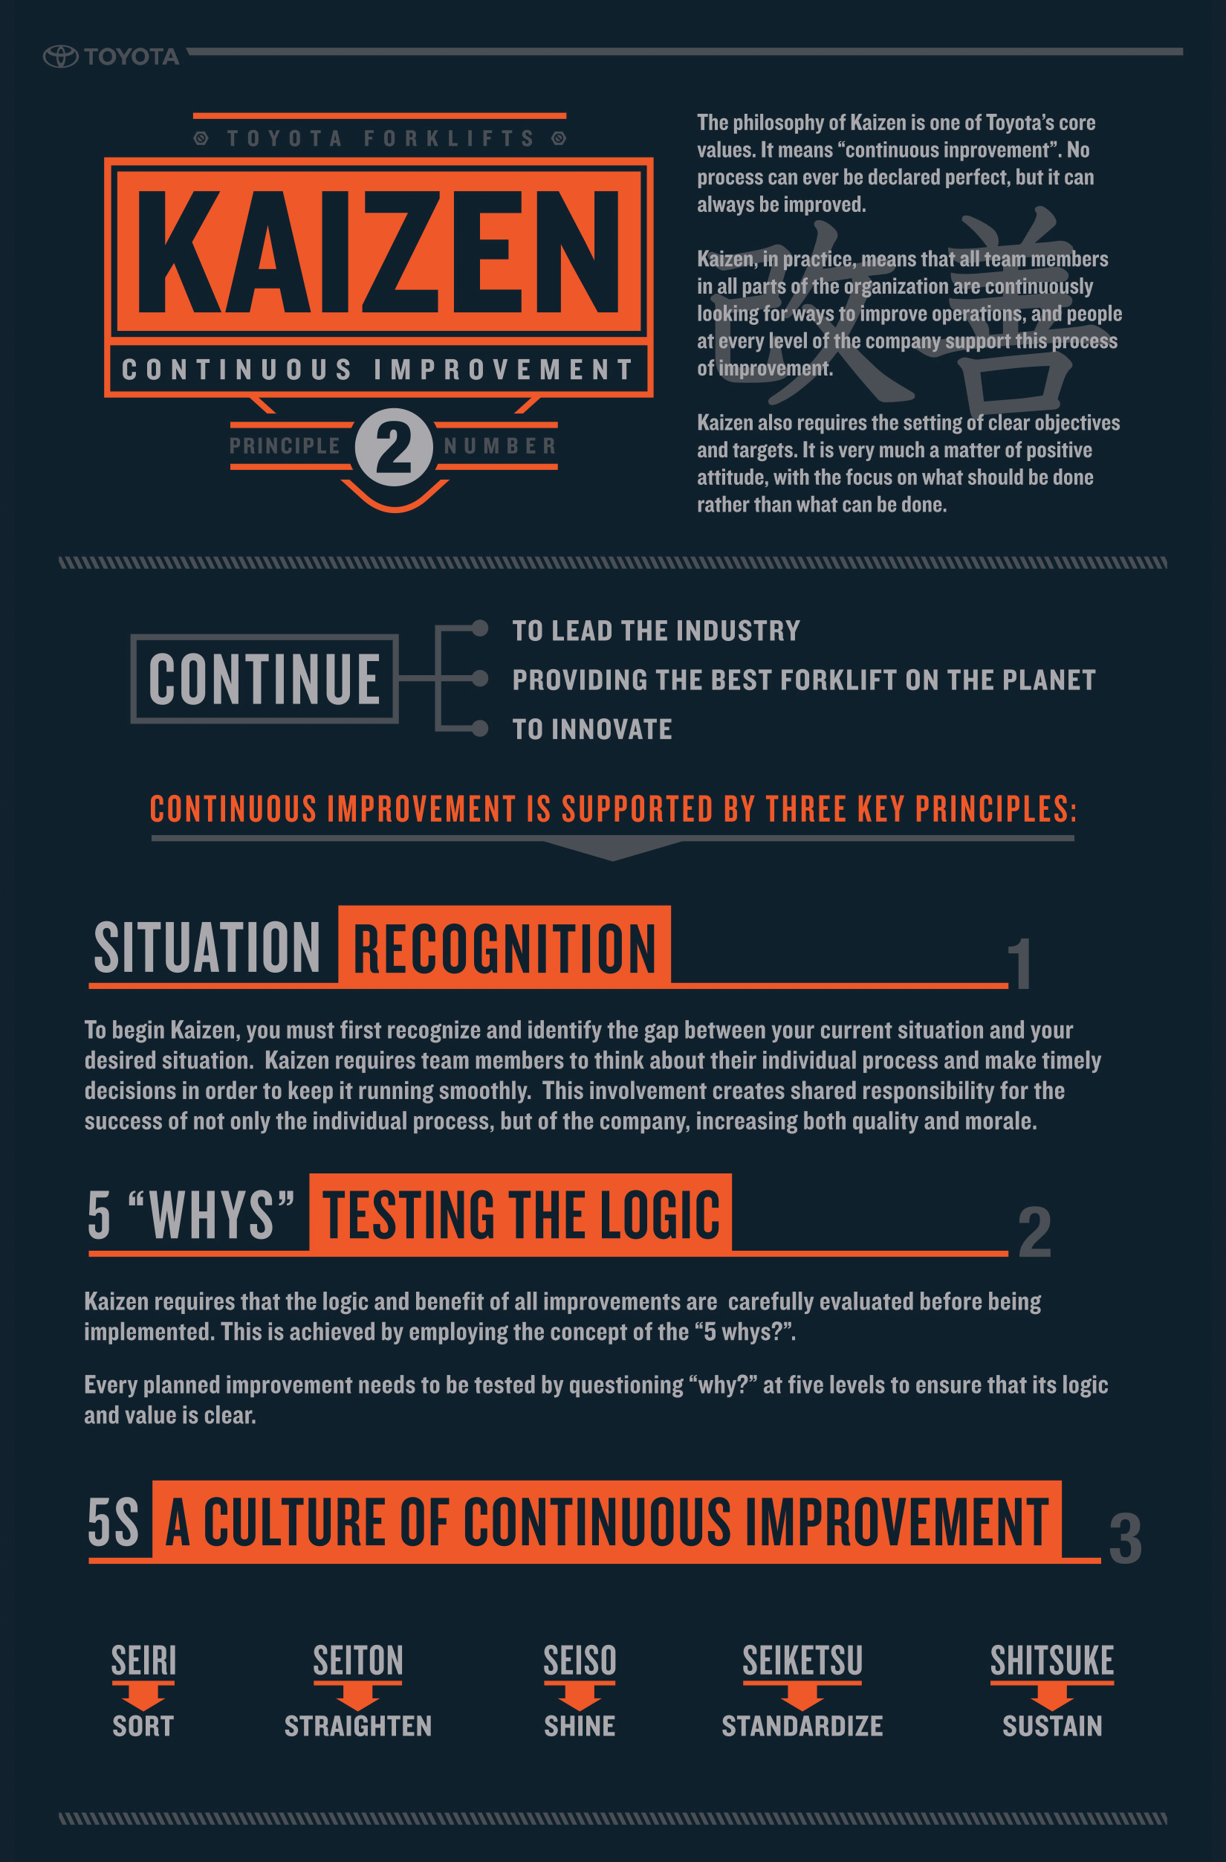
Technology is always adapting throughout the design world, designers currently have a high involvement with their design when it comes to technology, if a designer doesn’t understand the product they may be making or advancing then it is unlikely that they can make an effective contribution to the design. Most household products are moving swiftly towards the “smart” advancements, this ranges from appliances like smart kettles and smart refrigerators. This technology is becoming increasingly difficult to service and repair, this has created a culture of throwing appliances into landfill at the first sign of damage, this is because machines are being designed this way and very few companies are coming up with solutions to the waste that it is generating. A Which? Survey of 1007 consumers found that “More than half (53%) agreed it was easier just to throw them away with other refuse” (Which? Survey 2009). In the coming years designers will have to adapt to this problem by either coming up with solutions for the end of life for their product or allowing their products to be easily fixed. Designers should look to implement a modular part system for their products allowing them to be easily adapted, replaced and even upgraded. By doing this, designers will increase the products lifespan which will help reduce waste by cutting down the number of products being thrown away.
Over the next few years makers will become more responsible for their role in the creation and development of their product, moving the responsibility from the engineers and designers. This method of development in the manufacturing process comes from the Toyota production system and its use of what they can “kaizen” which is a system that allows for continuous improvement by giving individual workers the ability to develop and improve their own small section of the production system. This style of development will become a big part of future manufacturing systems, it allows bigger improvements to be implemented and a greater rate allowing for a more efficient system.

(Kaizen information poster, Toyota, 2019)
Political
Many factories today are populated with low skill, low payed jobs. These jobs are often minimum wage and require long hours at high intensity work which impacts on the lives of the workers. In a blog for the Trades Union Congress, Tim Page found that “between 1960 and 2015, of all advanced economies, the UK saw a greater drop in manufacturing employment than any country apart from Switzerland.” This is a huge loss for the 6th largest economy in the world. In Britain we have lost much of our manufacturing and industrial jobs, this is due to manufacturers moving work away to different countries which have lower wage caps and less workers’ rights. I believe that by working with designers, makers and engineers, the UK government can work to get new manufacturing jobs back into the UK. One of the biggest industries to leave Britain is the car industry, many plants have shut down from Austin and Rover factories shutting down in the 90s to Ford closing its engine plant in Bridgend earlier this year. Removing Brexit as a major contribution to these recent closures, a recent BBC report said “Another thing affecting car manufacturers is a new trade deal between the EU and Japan that came into force in February. It will see tariffs on cars exported from Japan to Europe reduced to zero over the next 10 years.” (BBC report into the decline into the UK car industry, 2019) This shows that it is cheaper for Japanese manufactures like Honda to build their cars on the other side of the world and ship them over than it is for them to produce them here, in the UK. It is in designers that we must trust to work with both our government and the EU to change current tariffs and laws to help move manufacturing back to Britain. By offering incentives to the manufacturers, the UK could re-gain its car industry without compromising on international trade deals by including tariffs and without compromising the rights of the workers and their wage.
On the topic of wages, designers should start to do more for those who are building their designs, day in day out. As previously stated, many manufacturing jobs are at lower wage for lower skill. Whilst this does make it easier for manufacturers to consider the UK as a future investment for their business it does put a large amount of pressure onto the workers as the minimum wage/living wage in this country is far below the real cost of living according to livingwage.org “the UK minimum/living wage is £8.21 an hour whilst the cost of living is at £9.30 an hour.” (Data of UK wages, 2019) This is a huge difference and it puts a huge amount of pressure on families who many only have earners on minimum wage. The £8.21 is currently a statutory enforcement for what the government calls the “living wage” but it is still far below the cost of living, this amount is also lower for those under 25 who live off of £7.70 an hour and the price only gets lower for younger people and those in apprenticeships. Designers must do more in the coming years to force manufacturers to give a fair wage to their employees. Designers can also be working alongside campaigners and politicians to effect change in the government to get our elected officials to change the law so that the minimum wage will change to be at the same price for the coast of living.
Conclusion
In conclusion of my investigation, I believe I have highlighted areas in which designers need to focus their effort right now and years to come. The evidence I have provided has come from a variety of sources which all have their own views and opinions, but I think they all provide the right evidence for my investigation. The role of designer is more varied and adaptive than ever before. I think in the future designers will have to continue to look further to the bigger picture in their design work, asking more of their manufacturers and consumers, to bring growth and prosperity to the design industry and the economy. Designers will also have to push the government, those who create the laws controlling design and its surrounding factors to create a better environment for those within it. Most importantly designers will have to control these factors to help the environment before it is beyond saving. These factors all link together and often work in symbiosis and I believe that designers can have a big impact on them all and should continue to do so.

Bibliography
Oxford union, (2019), Nick Offerman | Full Q&A | Oxford Union, Available at: https://www.youtube.com/watch?v=WbGDpfYZaFY&t=1984s (Accessed: December 03rd 2019)
Yang, D, Werner, S & Morrison, J (2017) Techinsight Apple iPhone X teardown [Online], Available at: https://www.techinsights.com/blog/apple-iphone-x-teardown (Accessed: December 03rd 2019)
Smithers, R (2009), The guardian article including a Which? Survey on recycling [Online], Available at: https://www.theguardian.com/environment/2009/oct/15/which-survey-electric-recycling (Accessed: 2nd December 2019)
Toyota Motor Company (n.a.) Toyota forklifts resource library on Kaizen [Online], Available at: https://www.toyotaforklift.com/resource-library/material-handling-solutions/products/valuing-the-toyota-production-system-and-lean-manufacturing (Accessed: 2nd December 2019)
Jones, L (2019) BBC report: Car industry: What's behind recent closures? [Online], Available at: https://www.bbc.co.uk/news/business-47291627 (Accessed: 3rd December 2019)
Anonymous (2019) Livingwage.org: what is the real living wage [Online], Available at: https://www.livingwage.org.uk/what-real-living-wage (Accessed:2nd December 2019)
Patagonia (2019) Patagonia clothing brand’s jacket [Online], Available at: https://eu.patagonia.com/gb/en/product/mens-nano-puff-jacket/84212.html (Accessed: 3rd December 2019)

