Waseem Haider

Username – 1817419

Assignment 2
(The recruitment process)



Role overview

JD Sports is currently looking to employ a front-line manager. The role will consist of managing the store team and maximising the stores’ profit with the main focus being driving sales and providing an excellent service on the high street. The role requires you to follow the company’s guidelines and maintain the company standards. The most important factor to consider is that you will be representing the business so must have a professional manner.

Skills required from the candidate

Good customer service skills as you will need to provide the best service for the stores customers. You will also be dealing with complaints as well as general enquiries so must be able to resolve all issues and help with requests. You will be working closely with the store team to ensure that all goals are met and targets are reached. Most importantly, the customer should be satisfied with the efforts provided.

Sales skills are necessary to ensure that all targets are achieved and even exceeded. There will be important key sales decisions that will need to be made and store devices to be managed to get the most out of the wider range of products.

Your role will also consist of working heavily with the store team with the need to train and develop. You will ensure that the existing team members progress within the company and new employees settle in with ease. There will also be regular meetings held within the store to ensure that there aren’t any issues and making sure that the team are able to keep with the high standards that are required. It is important to keep track of the progression internally to make sure all staff are up to date with training and assessments.

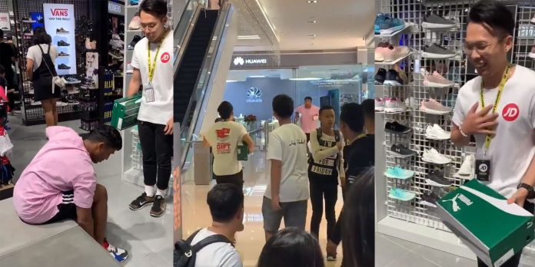

What we look for in an ideal candidate;

- Previous retail management experience
- Leadership skills
- Excellent time management skills
- Strong verbal and written communication skills
- IT skills – Microsoft Outlook, Word and Excel
- Problem solving skills
- Team management skills
- Organisation and presentation skills
- Planning skills

If you fit the job description, hand in your CV in store to a manager or apply online at www.jdsports.com

References

https://www.Indeed.co.uk

www.venuemanager.net/demo?utm

https://uk.linkedin.com>chrisbrierliey-jdsportsfasionplc/linkedin

https://www.glassdoor.co.uk/reviews/jdsports-fashion

https://m.jdsports.co.uk

https://www.retailhumansources.com/jobseekers/employers-we-work-with/jdsports-jobs

Bibliography

https://www.Indeed.co.uk

www.venuemanager.net/demo?utm

https://uk.linkedin.com>chrisbrierliey-jdsportsfasionplc/linkedin

https://www.glassdoor.co.uk/reviews/jdsports-fashion

https://m.jdsports.co.uk

https://www.retailhumansources.com/jobseekers/employers-we-work-with/jdsports-jobs

