Programs in C and documentation
Parts A and B
Brian Morris (1809130)
2019

Abstract

This report is in two parts the first part split into three sections. Firstly offers a brief definition of variables and discusses the use of variables in the C programming language. Secondly discusses the use of a counting For-Loop. Where its used and why one would look to implement such a loop as opposed to different looping methods. The final section briefly covers the use of Arrays within C programming.
The second part of this report documents four C programming solutions with annotated code listing, additional screen shoots of output produced during testing and screen shoots of errors outside of the running application.

Table of contents
Contents
Abstract 1
Part A Understanding 4
A1. What is a variable and why are they important in writing programs? 4
A2. Explain why the for-loop can also be referred to as a counting-loop and give an example of when you would use it. 4
A3. Explain what an array is, what their features are, and give an example of when you would use one 5
Part B 6
Exercise 1: 6
Exercise 1 Annotated Code 7
Exercises 1. Testing with normal values 8
Exercise 1. Testing with negative numbers 8
Exercise 1. Testing with boundary values 9
Exercise 1. Testing with impossible values 10
Exercise 2: 11
Exercise 2. Interpreted requirements 11
Exercise 2. Annotated Code 13
Exercises 2. Initial testing with normal values 14
Exercise 2. Testing the validation loops 15
Exercise 2. Testing with impossible values 16
Exercise 3: 18
Exercise 3. Annotated Code 19
Exercise 3. Testing with normal values 20
Exercise 3. Testing with extreme numbers 20
Exercise 3. Testing with negative values to enter the validation loop 21
Exercise 3. Testing with negative values to ensure the loop isn’t tripped 22
Exercise 4: 23
Exercise 4. Requires the the following:- 24
Exercise 4. Annotated Code 25
Exercise 4 .Testing with valid input 27
Exercise 4. First points 27
Exercise 4. Another combination of 5s produce an additional score 27
Exercise 4. A different combination of 5s produce an additional score 28
Exercise 4. Three numbers in a row 28
Exercise 4. A different three numbers in a row 28
Exercise 4. Jackpot score 29
Exercise 4. Clean Exit 30
Exercise 4. Quitting the game on initial run with expected input 31
Exercise 4. Quitting the game with a non ‘y’ answer 31
Bibliography 32

Part A Understanding

A1. What is a variable and why are they important in writing programs?

A variable is a value that can be changed by a process, that is acted upon as information to feed into a process to affect an outcome. The variable is defined and labelled within a section of code to ensure a consistent area of physical memory can be referenced to store and retrieve information from a reserved memory location.
A variable is typically defined as a data type of the following :-
Integer a whole number declared using INT
Decimal a decimal number declared using FLOAT
Character an alpha numeric value declared as CHAR
String a collection of character declared as a CHAR[n] where n represents the number of characters required to be stored within the strings array plus 1.
There are other types of variables that can be used such as short int, long int and double to name a few however these variable types are not required or used in the solutions below.

A2. Explain why the for-loop can also be referred to as a counting-loop and give an example of when you would use it.

A for-loop is used when a specific value or condition needs to be met a specific amount of times and when met allow the process can continue as planned. This helps reduce the amount of code needed to be rewritten, allows for more flexibility in designing a solution and reduces the line count of the software ensuring the final code remains smaller. Code size is no too much of an issue with today’s computers but when C was originally developed by Dennis Ritchie and his colleagues at Bell laboratories during the early 1970s [1] [2] it was a time when computers had severely limited memory and storage capacities compared to modern day systems.
In practice we could use a for loop to count a process a specific amount of times with the count being incremented by a value until conditions are met. The for-loop would cycle through the loop a set amount of times before continuing with further processing. As opposed to replicating the same part of the code a set amount of times until the exit condition exists.
Exercise 3 of this assignment contains an example of a known number count. The loop is set to count 5 times and the increment is used to address the memory space within an array to store prices and products
Conversely within the for loop a while loop has been utilized to check a condition of the data entered. If the condition is meet the loop repeats indefinably until a defined action until exit conditions are true.

A3. Explain what an array is, what their features are, and give an example of when you would use one

An array is a useful way of storing multiple variable values of the same type within a specified area. Typically, we would also declare its type, identifying what data type the array structure was going to hold eg integer, character, decimal or string.
Strings within C are already a single dimensional array for example the string ‘Brian’ could be declared as follows:-
Char name[6]=”Brian”;

The above example would be broken down as follows

 |  | Char name[6]=”Brian”;
Declaration of variable Type | Variable name | Array dimension (Size) | Assignment | Value

An array of strings would be a multi-dimensional array where the structure is two dimensional having both length and height for example:

 | Char family[7][4]={“Brian”,”Oliver”,”Helen”,”Katie”];
Variable Type | Variable name | Array dimensions. Notice length and height values. | Assignment | Values

Its possible for arrays to extend far beyond a 3rd dimension and the limits of a multi-dimensional array are limited only by the complier of the software and the ability to manage and understand the data in arrays that big when diagnosing issues.

Part B

Exercise 1:
Show how variables can contain different types of values by declaring three variables that contain a name, a measure of height (e.g. 1.81cm) and a person's age (e.g. 32). Input these values and display them on the screen.

This exercise is requesting the following:-
- Declare a string variable to be labelled ‘Name’
- Declare a floating point variable captured to two decimal places to be labelled ‘Height’
- Declare an integer variable to be labelled ‘Age’ .
- Output the variables as required on the screen not defined in the original specification but could be displayed in a row or a column or as part of a sentence.

Exercise 1 Annotated Code
#include <stdio.h>

void main()
{
/* Declare the variables we need for this code*/

int Age; //Declare Age and an INTeger
char name[10]; //Declare String name with space for 9 characters
float Height; //Declare floating point variable for Height

printf("Please enter an age between 0-150:"); //Output to screen a request for user input
scanf("%d", &Age); //capture an input and store the input as an integer in the declared variable Age
while ((Age < 0) || (Age > 150)) //check int value (Age) outside a valid range while it its true repeat
{
printf("Please enter an age between 0-150:"); //Output to screen a request for user input
scanf("%d", &Age); //capture an input and store the input as an integer in the declared variable Age
}

printf("Please enter a name:"); //output to the screen a request for user input
scanf(" %s", &name); // Capture a string variable 'name'

printf("Please enter a height between 0 and 2.9:"); //output to the screen a prompt for user input
scanf("%f", &Height); //Capture a floating point value
while ((Height <0)|| (Height > 2.9000001)) //check floating point value and repeat whilst its true
{
printf("Please enter a height:"); //output to the screen a prompt for user input
scanf("%f", &Height); //Capture a floating point value
}

// Output all the values as a separate line in a coloumn
// note \n is an escape character to instruct the program to add a new line where ever it finds this
printf("\nAge: %d\n", Age); //output the stored variables not \n is an escape character to instruct the rpogram to add a new line
printf("Name: %s\n", name);
printf("Height: %0.2f\n", Height); //Output the floting point value to two decimal spaces

//Output the values again within a line of text
printf("\nThe name entered was %s the age entered was %d the height entered was %0.2f\n\n\n", name, Age, Height);
}

Exercises 1. Testing with normal values

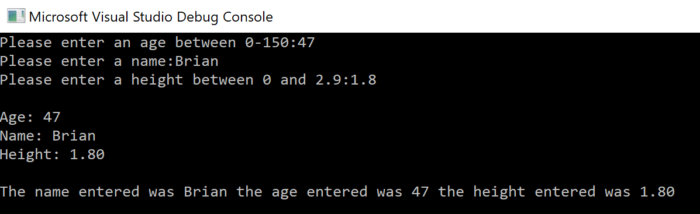

All worked perfectly no issues here move along.

Exercise 1. Testing with negative numbers
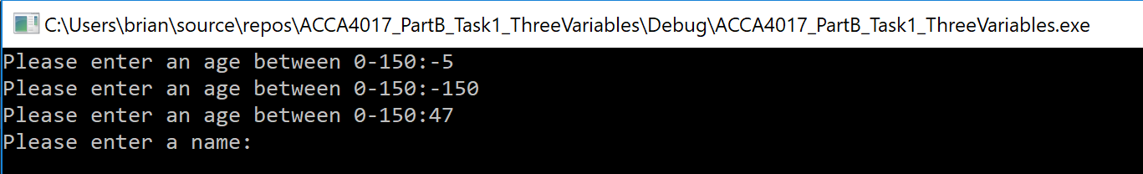

A while loop was included to check for a valid number input a number lower than 0 or greater than 150 will cause the system to loop until a ‘valid’ integer is input.
A similar loop was implemented for the height floating point variable as well.

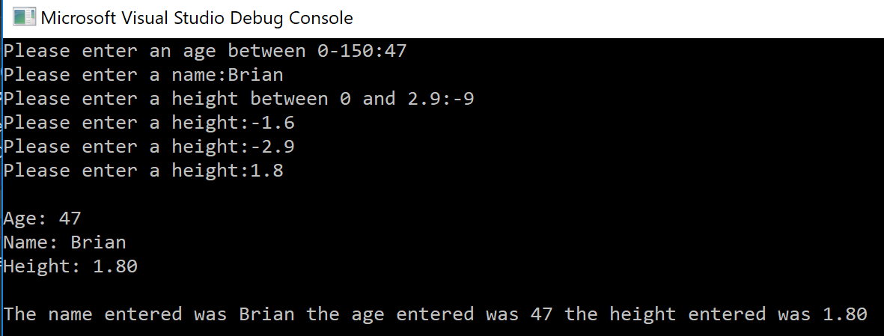

Exercise 1. Testing with boundary values

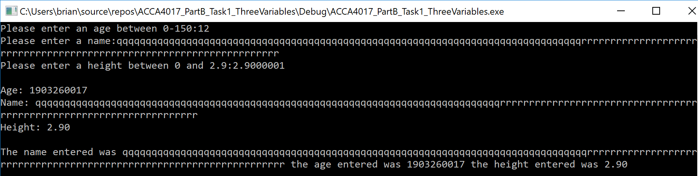
Age variables did loop through as required until a valid input was accepted.
Inputting a large volume of characters for the string beyond the 9 characters requested in the array returned the input but still threw out an exception and the application itself failed to end cleanly.
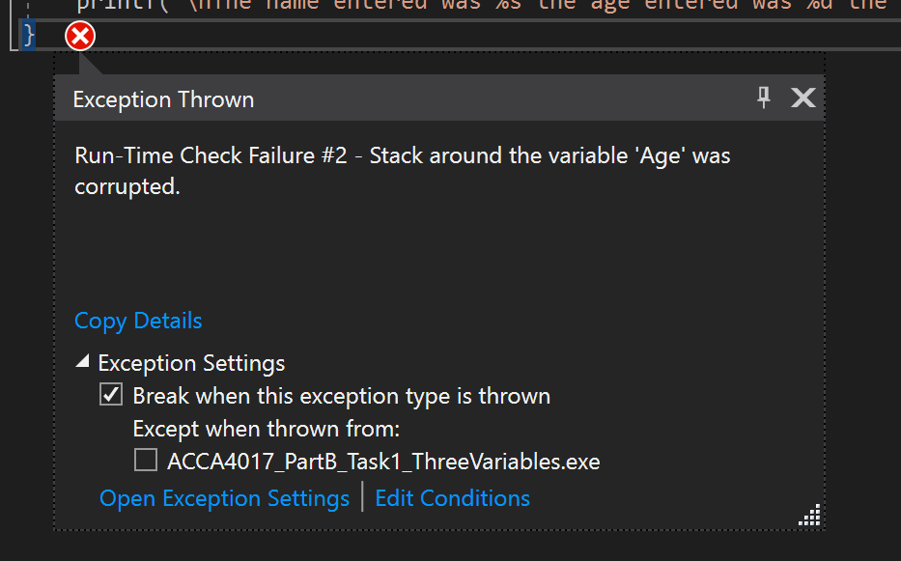

Exercise 1. Testing with impossible values

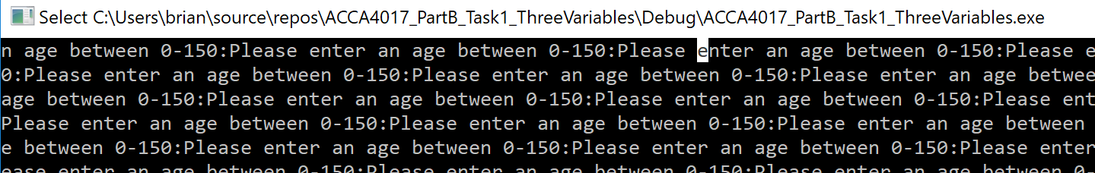

Testing with impossible values threw out unexpected results. Entering a non numerical value returned a looping issue where the printf statement looped through and the application had to be forcibly closed.

Exercise 2:
Allow the user to enter the dimensions of shapes shown below (Figure 1), then calculate the area of the blue shaded part. Note: The triangular area in the centre is empty.

Figure 1 Calculate Shaded Area
Note:
Area of circle is given by $A=πr^{2}$
Area of triangle is given by $A=\frac{\left(b×h\right)}{2}$

Exercise 2. Interpreted requirements
The exercises requires the following:-
- It was originally assumed from the diagram that the Radius is the same value as the height of the triangle however after clarification its been confirmed it’s a separate value. So the Radius needs to be entered as a separate floating point variable
2.While the base and height could be integer values they will be declared as floating point numbers.
3.The area will also be calculated as a decimal value I will format the decimal to 2 decimal places for readability.
4.Find the area of the triangle store that value in a float Area_Triangle
5. Find the area of the circle store that value in Area_Circle
6. Create a float variable to store Shaded_Area = Circle_Area -Area_Triangle

Psudo code
Declare variables for height,base,radius
Enter radius
Enter base
Enter height
Calculate area of circle Pi*(Radius*Radius)
Calculate area of Triangle (Base*Height)/2
Calculate area of shaded area (circle-triangle)
Output results

After the initial plan additional items were incorporated to cover error checking loops on the values for Radius , Base length and height. An additional layer of validation was also added to ensure that the height of the tringle was not to large.
Whilst the value of the height variable could be larger than the diameter of the circle this height was validated against a calculation of the remaining shaded area the area of the triangle. If the result returned was a negative value the user would be prompted to re-enter a new value. This would repeat until the shaded are was not a negative value

Exercise 2. Annotated Code
#include <stdio.h>
#define PI 3.141592653; //declare the value of PI
void main()
{
float Base,height,radius,Area_circle,Area_Triangle,Calculated_Area,new_height; //declare floating point variables for calculations
radius = 0; //Set initial value for radius

while (radius <= 0) //test value is less than or equal to zero, if false loop until true
{
printf("\nPlease enter the radius of the circle:"); //Prompt user for input for Radius
scanf("%f", &radius); // Accept user input
}

Base = 0; //set initial value for base
while (Base <= 0) //test value is less than or equal to zero if false loop until true
{
printf("\nPlease enter the length of the base of the triangle:"); //Prompt user for input for Triangle base
scanf("%f", &Base); //Accept user input
}

while (radius <= Base) //loop through until Base is an acceptable value ie equal or smaller than radius
{
printf("\nBase is too large please enter a smaller base value: ");
scanf("%f", &Base);
}
Area_circle = (radius*radius)*PI; //Calculate the area of the circle

height = 0; //loop to ensure valid entry of hight
while (height<=0)
{
printf("\nEnter the height of the Triangle:"); //Prompt user for input for Triangle Height
scanf("%f", &height);
}
Area_Triangle = (Base*height) / 2; //Calculate triangle area
Calculated_Area = Area_circle - Area_Triangle; //calculate shaded area

new_height = height; //Intialize variable prior to a conditional entry into a loop
while (Calculated_Area < 0 || new_height > height) //Enter loop if shaded calculated area is less than zero
//or new traingle height is larger than previous entry
{
printf("\nTriangle too high please make it smaller: ");
scanf("%f", &new_height);
while (new_height<=0) //loop to ensure positive number is entered
{
printf("\nPlease enter a valid height:");
scanf("%f", &new_height);
}
Area_Triangle = (Base*new_height) / 2; //Recalculate Area of the triangle
Calculated_Area = Area_circle - Area_Triangle; //Recalcultate the shaded area
height = new_height; //Reset value of height to new height value
}

printf("\nThe area of the Triangle is %.2fcm squared\n\n ", Area_Triangle); //Output Area of the Triangle
printf("\nThe area of the Circle is %.2fcm squared\n\n ", Area_circle); //Output the area of the triangle
printf("\nThe area of your circle minus the area of the triangle is %.2fcm squared\n\n", Calculated_Area); // Output the value of the shaded area

}

Exercises 2. Initial testing with normal values
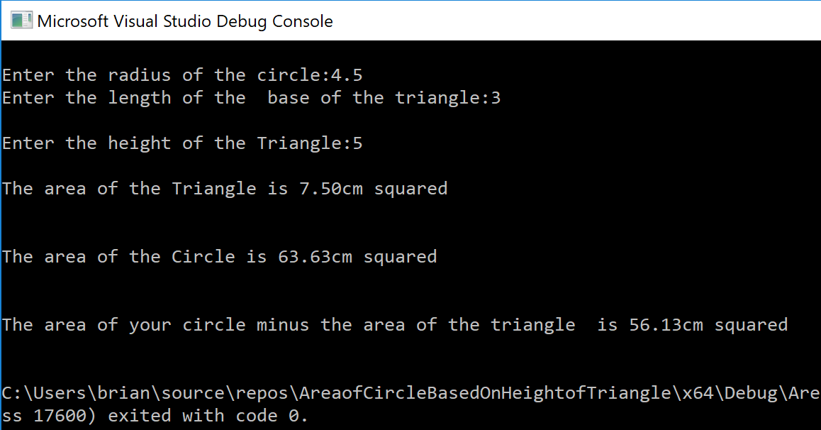

Whilst manually calculating the values they were off slightly as the constant defined Pi as 3.142 even when accounting for rounding. The constant value was amended to a slightly more granular 3.141592653. Revised testing produced a result that mirrored the manual calculations.

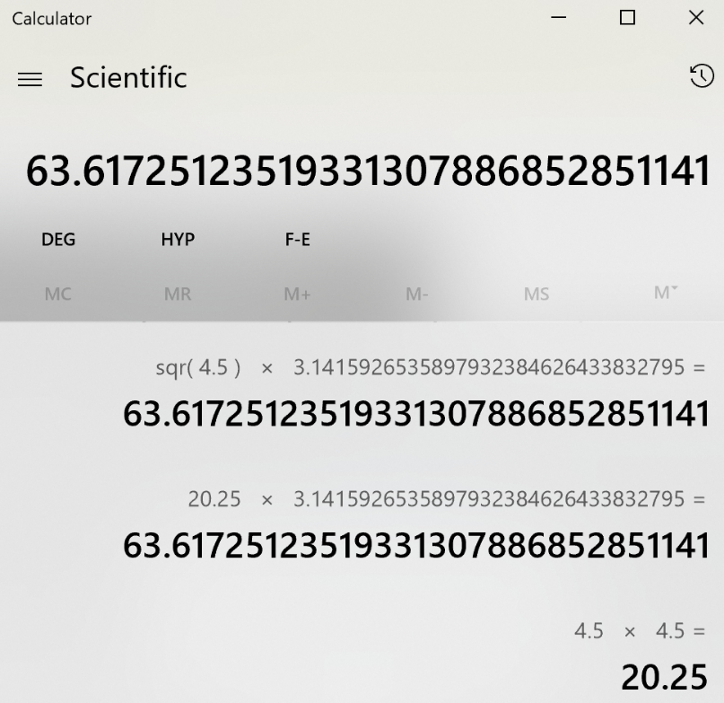

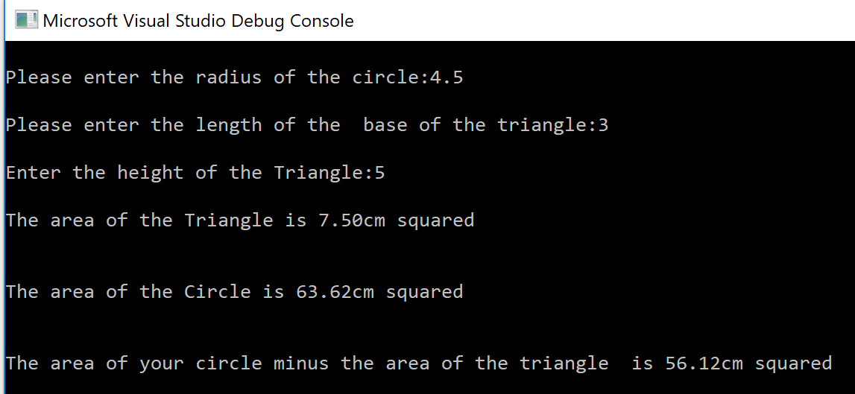

Exercise 2. Testing the validation loops
A number of loops were added to validate input values against negative numbers and steer the input to produce a valid response to the answer for the shaded area. Without these loops its was possible to input negative lengths or produce a triangle that was larger than the circle resulting in a negative value for the shaded area.

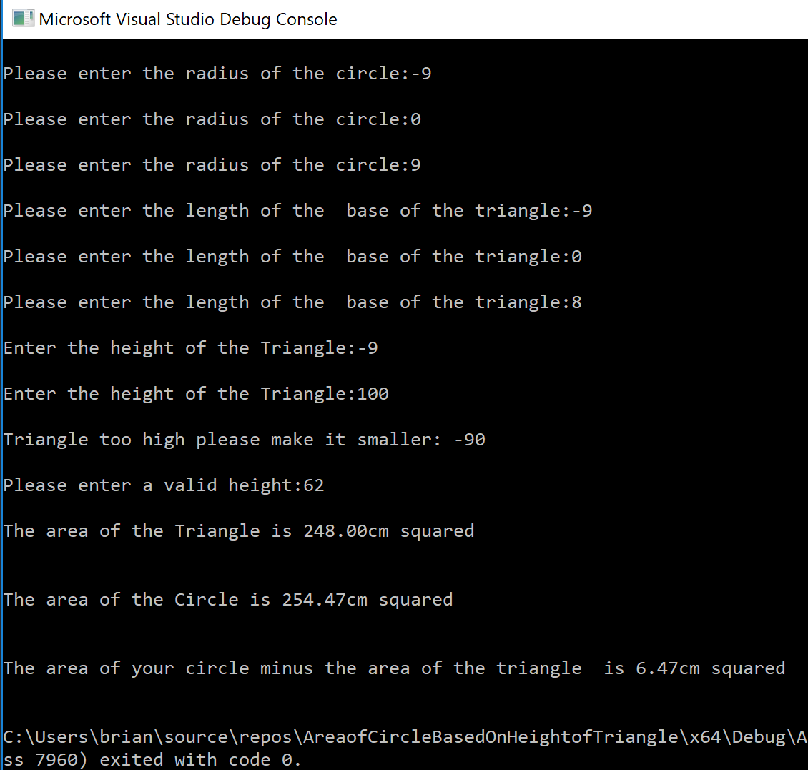

Exercise 2. Testing with impossible values
Entering non numerical values produce an expected failure: -
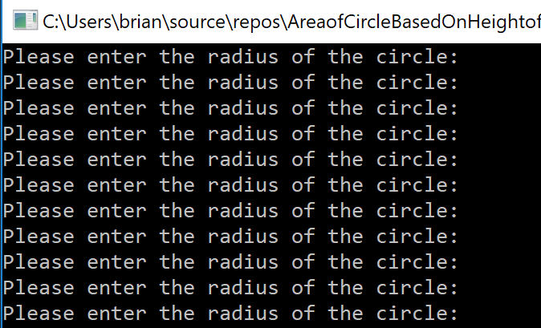

Exercise 3:
Write a program that allows the user to enter the price of 5 products into an array. Once all the prices are entered calculate the total price, and then calculate the total price plus 20% VAT.

Exercise 3. Sudo code
Sudo code
Define value of VAT
Declare an array for Price
Declare variables for price,total,total+vat ,counter
Declare a String Array for products //not required but I added anyway
Initialize array of products with data.
Initialize counter variable
Set total variable
Create counter loop for a 5 count
Request prices
Input prices
Add input to total cost
Increment loop
Calculate vat costs
Output results

Exercise 3. Annotated Code

#include <stdio.h>
#define vat 1.2 //define constant for VAT
void main()
{

float Price[5],total,total_plusvat; //declare float array for prices total and total+vat
char Products[5][20] = { "Tin of Peas", "Frozen Chips", "4 Cans of Beer", "Ready made Curry","Fresh Chicken"}; //declare string array for products

int counter, i; //declare intergers for loop counter
total = 0; //initalize variable
for (counter = 0; counter < 5; counter++) //create a counted loop starting at 0 ending at 5 and incrementing by 1 each time its looped
{

printf("Please enter a price for %s: ", Products[counter]); //call string value by position in array
scanf("%f", &Price[counter]); //store corresponding price in array
while (Price[counter] < 0) //check that a non negative value is not entered
{
printf("\nPlease re-enter a valid price for %s: ", Products[counter]); //overwrite array value if required
scanf("%f", &Price[counter]);

}
total = total + Price[counter]; //calculate total value by previous total value and price stored in Price[counter]
}

total_plusvat = total * vat; //calulate total inclusive of vat
printf("\nThe total of the bill is: %0.2f", total_plusvat); //output totals
printf("\nThe total excluding vat is: %0.2f", total); //output total ex vat
printf("\nVat charge: %0.2f", total_plusvat - total); //vat charge

}

Exercise 3. Testing with normal values

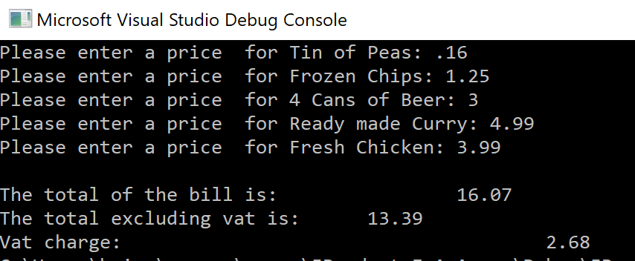

Exercise 3. Testing with extreme numbers
Testing with large numbers didn’t crash the system but did produce issues with rounding producing an inflated price;
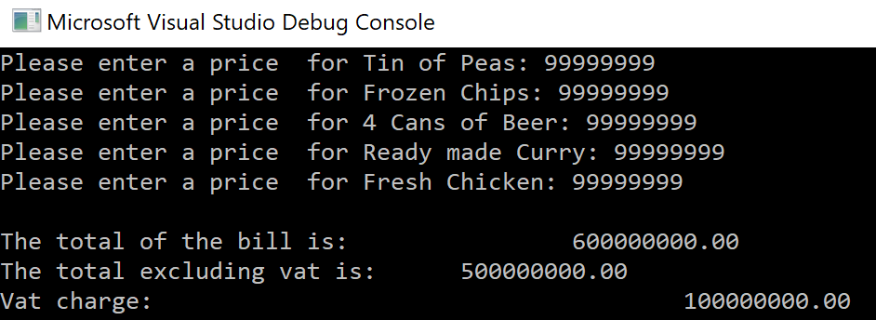

Exercise 3. Testing with negative values to enter the validation loop

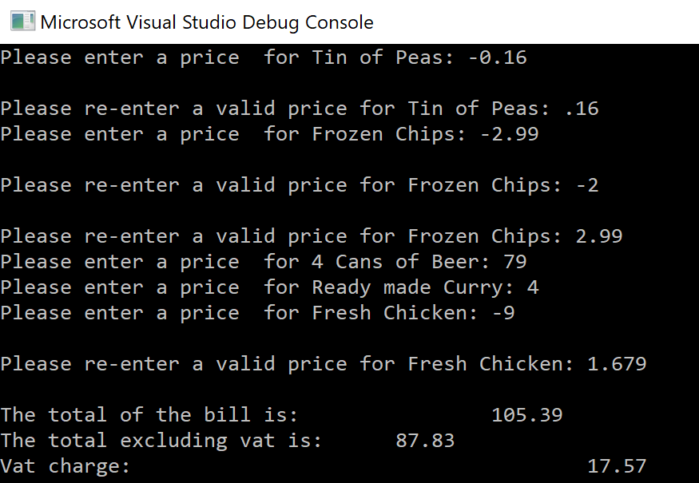

Exercise 3. Testing with negative values to ensure the loop isn’t tripped
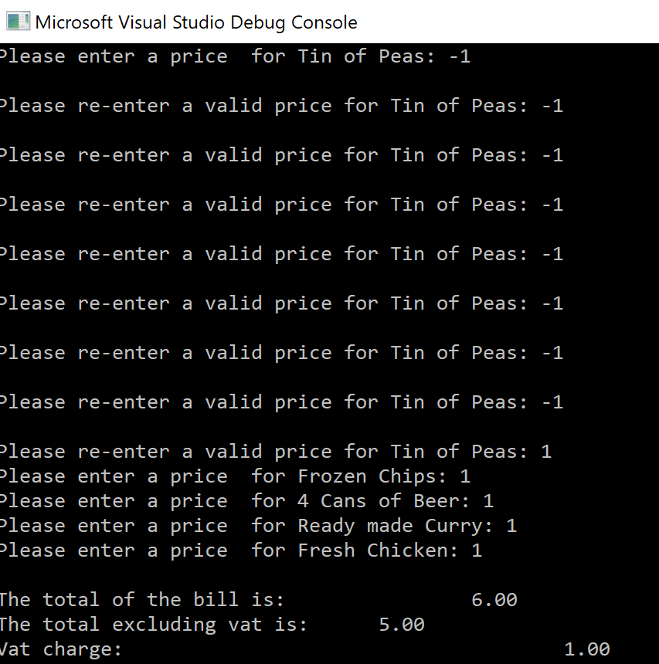

Exercise 4:
Build a fruit machine game which represents the 3 reels of symbols using numbers ranging from 1 to 5. Allow the user to have as many goes as they like (the numbers are chosen randomly each time).

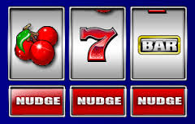

The value of 5 will be treated as the “Jackpot” symbol. The scoring will be as follows:

- Any three of the same numbers (excluding fives) will pay a bonus of 20 points e.g.
4 4 4
3 3 3
1 1 1, etc.

- Any combination of two fives will pay out 100 points e.g.
5 5 3
5 4 5
5 5 1, etc.

- Three fives pay out the big jackpot of 2000 points.

The points the player has scored should be displayed and the player should be asked if they wish to make another spin. It could look something like this:

Non-cumulative score version Cumulative score version
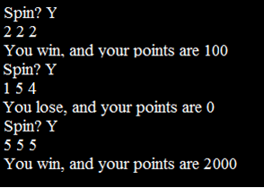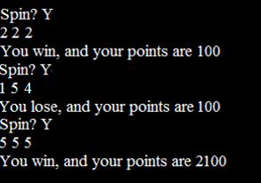

Exercise 4. Requires the the following:-

1.Include libraries to assist in generating numbers

2.Declare integer variables for the numbers

3.Declare integer variables for the extremes of the numbers

4.Declare Char variable for yes no response

5.Declare and initialize integer variable for the running total

6.Create a seed for random number

7.Ask user to play
7.1 Begin while choice is yes loop
7.2 Generate three separate numbers
7.3 Check for winning numbers
7.4 Add to running total
7.5 Ask user to play until loop is broken

8. Output final running score

Exercise 4. Annotated Code
#include <stdio.h>
#include <stdlib.h> //include additonal libraries
#include <time.h> //include additonal libraires

void main()
{
int rand_1,rand_2,rand_3; //declare three interger variables for random numbers 1-3
int low = 1; //declare interger and set value for lowest number in the range
int high = 5; //declare interger variable and set highest number in the range
char choice; //decalre a Character variable for user Yes/No Response
int score = 0; //declare and initialize interger for running score total
srand(time(NULL)); //seed randomness

printf("SPIN?");
scanf(" %c", &choice);

while (choice == 'y')
{
// printf("\nYour Spin results are");
rand_1 = rand() % (high - low + 1) + low; //get random number 1
rand_2 = rand() % (high - low + 1) + low; //get random number 2
rand_3 = rand() % (high - low + 1) + low; //get random number 3
printf("%d" " " "%d" " " "%d\n", rand_1,rand_2,rand_3); //Output result

if (rand_1 == 5 && rand_2 == 5 && rand_3 == 5)
{
score = score + 2000;
printf("You win, and your points are %d \n", score);
}
else if (rand_1 == 5 && rand_2 == rand_1)
{
score = score + 20;
printf("You win, and your points are %d \n", score);
}
else if (rand_2 == 5 && rand_2 == rand_3)
{
score = score + 20;
printf("You win, and your points are %d \n", score);
}
else if (rand_3 == 5 && rand_3 == rand_1)
{
score = score + 20;
printf("You win, and your points are %d \n", score);
}
else if (rand_1 != 5 && rand_2 == rand_1 && rand_1 == rand_3)
{
score = score + 100;
printf("You win, and your points are %d \n", score);
}

else if (rand_1 != rand_2)
{
score = score + 0;
printf("You lose, your points are %d \n", score);

}

else if (rand_2 != rand_3 )

{
score = score + 0;
printf("You lose, your points are %d \n", score);
}
else if (rand_1 != rand_3)

{
score = score + 0;
printf("You lose, your points are %d \n", score);
}
else if (rand_1 != rand_2)
{
score = score + 0;
printf("You lose, your points are %d \n", score);
}
else if (rand_2 != rand_3)
{
score = score + 0;
printf("You lose, your points are %d \n", score);
}

// printf("Your Running score is: %d \n", score);
printf("SPIN?");
scanf(" %c", &choice);
}
printf("\nAnother time, maybe? Bye!\n\n");
printf("\nYour final score was: %d \n", score);
}

Exercise 4 .Testing with valid input

Exercise 4. First points
Screen shots are from one game.
0 points from first spin but second spin has two 5s so adds 20 points to the score.
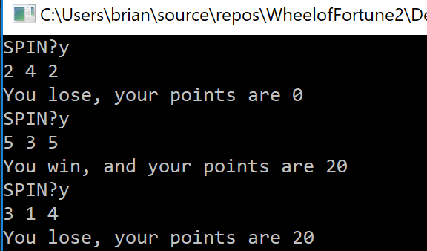

Exercise 4. Another combination of 5s produce an additional score

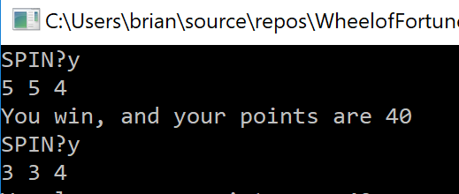

Exercise 4. A different combination of 5s produce an additional score

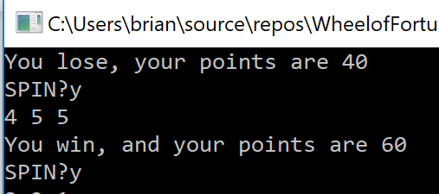

Exercise 4. Three numbers in a row
Further on into the game a run of three numbers but not three fives produce a win and add to the running total.
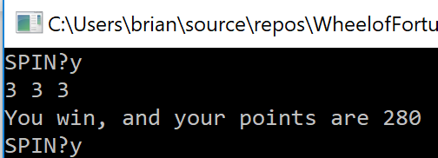

Exercise 4. A different three numbers in a row
A run of three different numbers but not three fives add to the running total

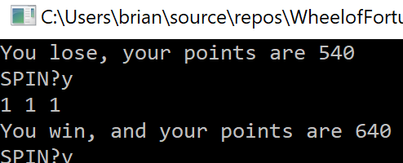

Another three number win

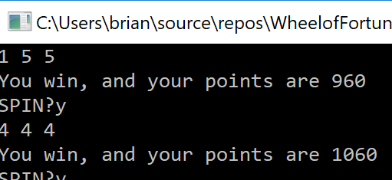

Exercise 4. Jackpot score
Finally, a Jackpot win.

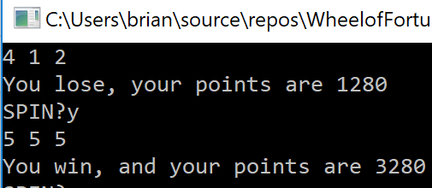

Exercise 4. Clean Exit
Quitting the game and outputting the final score

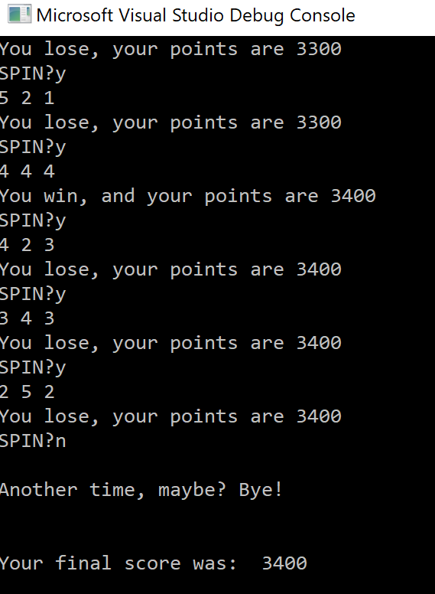

Exercise 4. Quitting the game on initial run with expected input
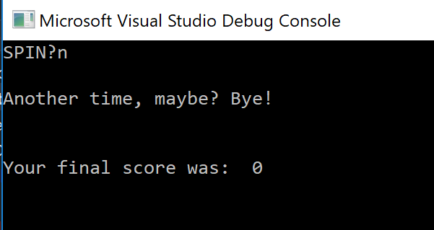

Exercise 4. Quitting the game with a non ‘y’ answer

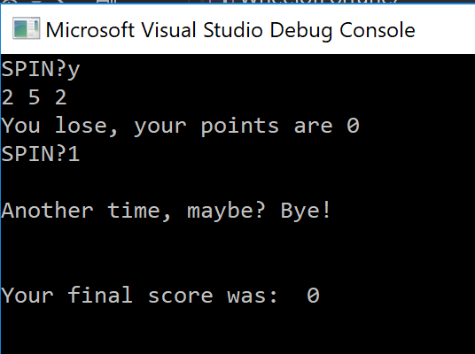

Bibliography
[1] | K. Pal, “The History of the C Programming Language,” [Online]. Available: https://www.techopedia.com/the-history-of-the-c-programming-language/2/32996. [Accessed 16 January 2019].
[2] | D. M. Ritchie, “The Development of the C Language*,” [Online]. Available: https://www.bell-labs.com/usr/dmr/www/chist.html. [Accessed 16 January 2016].

