Dissertation

The Impact of Internet of Things for UK Travel and Tourism Businesses: An Examination of London Sightseeing and UK Tourism from Management Perspective

Name: Lucian Pop
Programme of Study: BA (Hons) Business Management
Student number: 2023565
London Campus
Supervisor: Sadeque Iman Shaikh

Dissertation Declaration
I, Lucian Pop, declare that this dissertation titled "The Impact of Internet of Things for UK Travel and Tourism Businesses: An Examination of London Sightseeing and UK Tourism from Management Perspective." and the work presented in it are my own. I confirm that:
- This work was done wholly or mainly while in candidature for a BA at University of Wales Trinity Saint David United Kingdom.
- Where any part of this dissertation has previously been submitted for any other qualification at University of Wales Trinity Saint David UK or any other institution, this has been clearly stated.
- No part of this dissertation has been submitted elsewhere for any other degree.
- All sources used or referred to in this dissertation have been duly acknowledged.
- I have adhered to all ethical guidelines and principles in the conduct and reporting of this research.
- I am aware that if I have intentionally misrepresented or falsified any data, my degree may be revoked.
Signature: ________________________
Date: 02.01.2024

Abstract
This dissertation investigates the impact of the Internet of Things (IoT) on the United Kingdom's Travel and Tourism industry, with a specific focus on London Sightseeing and overall aspect of UK Tourism. Given the upcoming consumer connectable product security legislation effective from April 29, 2024, the research explores into the current state of IoT adoption, managerial strategies, challenges faced, and the resulting influence on operational efficiency and customer experiences.
Employing a mixed-methods approach, the study draws insights from surveys conducted within the UK Travel and Tourism sector, especially within the London sightseeing industry. Additionally, it synthesizes information from scholarly articles, industry reports, and existing IoT literature to offer a comprehensive perspective.
The discoveries intend not just to enhance our comprehension of IoT application but also to provide a clearer understanding of the dynamics for individuals engaged in these enterprises. As the UK Travel and Tourism industry navigates regulatory changes and technological integration, this research contributes to the pragmatic discourse, bridging the gap between technological advancements and strategic application within the dynamic tourism landscape.
This research contributes by highlighting gaps in existing knowledge and offering recommendations, and a foundation for future research in the dynamic intersection of IoT and the UK Travel and Tourism industry.

Acknowledgements
I would like to express my sincere gratitude to the following individuals and organizations for their invaluable support and contributions to the completion of this dissertation:
- My supervisor, Sadeque Iman Shaikh, for guidance, expertise, and support throughout the research process.
- The members of Dissertation Committee, Library and Learning Resources, my friends and family for their understanding, encouragement, during the dissertation journey.
This dissertation would not have been possible without the collective efforts of these individuals and institutions. Thank you for your support and encouragement.
Lucian Pop

Table of contents:
Chapter 1: Introduction
1.1: Introduction
1.2: Background of the study
1.3: Problem Statement
1.4: Aims, Objectives, Research Questions, Hypothesis, Propositions ………………………..5
1.5: Rationale/Importance of the Research…………….………............................. ..............6
1.6: Methodology
1.7: Scope of study ……………………………………………………………………………..………..…………..7
1.8: Structure of the dissertation
1.9: Summary of Chapter
Chapter 2: Literature Review……………………………………………………………………………………….8
2.1: Introduction
2.2 Base theory of the sub-discipline/different background aspects to the concept…....9
2.3: Theoretical frameworks/models, and related research issues ……………………………..10
2.4: Previous studies and lessons learnt……………………………………………………………………..12
2.5: Gaps identified to situate own research
2.6: Summary of Chapter 2 ……………………………………………………………………………………….13
Chapter 3: Research Methods & Methodologies
3.1: Introduction
3.2: Philosophical position of the research and why?
3.3: Paradigm position of the research and why? ………………………………………………….….14
3.4: Position of Research Approach and why?
3.5: Methodological stance of the Research and why? ……………………………………………..15
3.6: Stance of the Research Strategy and Design and why?
3.7: Research Sample and Population……………………………………………………………………….16
3.8: Data Collection and Data Analysis Tools/Techniques ………………………………………….17
3.9: Ethical Consideration of the Research ..………………………………………………………………18
3.10: Summary of Chapter 3
Chapter 4: Data Analysis and Discussions
4.1: Introduction
4.2: Analysis and Discussions of findings
Fig.1 …………………………………………………….…………………………………………………………………..19
Fig.2
Fig.3 ………………………………………………………………………………..……………………………………….20
Fig.4 ………………………………………………………………………………………………………………………….21
Fig.5.1
Fig.5.2 ……………………………………………………………………………………………………………………….22
Fig.5.3
Fig.5.4
Fig.5.5 ..……………………………………………………………………………………….…………………………….23
Fig.6 …………………………………………………………………………………………………………………………..24
Fig.7 ……………………………………………………………………………………………………………………..…..25
Fig.8 ..……………………………………………………………………………………………………………………..….26
Fig.9
Fig.10 ………………………………………………………………………………………………………………..………27
4.3: Research validation ..………………………………………………………………………………….……….28
4.4: Summary of Chapter 4 ….…………………………………………………………………………………….30
Chapter 5: Conclusion, Limitation and Recommendations
5.1: Introduction
5.2: Conclusions on each research issues/objectives/proposition
5.3: Conclusions on the research problem
5.4: Summary of the research findings and outcomes
5.5: Original Contribution of the Research………………………………………………………….………31
5.6: Limitations of the Research
5.7: Recommendations ………………………………………………………………………………………………32
5.8: Summary of Chapter 5…………………………………………………………………………………………33
Reference ………………………………………………………………………………………………………………….34
Terms of Glossary ………………………………………………………………………………………………………35
Appendix 1 (The Questionnaire) …………………………………………………………………………..…...36
Appendix 2 (Time prospect)
Appendix 3 (Application for Ethical Approval) …………………………………………………………….38
Appendix 4 (Responses summary) …………………………………………………………………………..…50
1.1: Introduction

One sector that has witnessed substantial changes due to the integration of IoT is the Travel and Tourism industry. This dissertation aims to explore the impact of the Internet of Things on UK Travel and Tourism Businesses, with a particular focus on London Sightseeing and comprehensive aspects of UK Tourism. As technology continues to shape and redefine the dynamics of various sectors, the management perspective becomes increasingly crucial for businesses to harness the full potential of IoT.
The United Kingdom, renowned for its rich cultural heritage, historical landmarks, and vibrant tourism sector, stands at the forefront of global travel destinations. London, as its iconic capital, attracts millions of tourists annually. This study endeavours to investigate the ways in which IoT technologies are being adopted and adapted by businesses within the UK Travel and Tourism industry. Through a meticulous examination from the management perspective, this research seeks to explain the strategies employed, challenges faced, and the overall implications of integrating IoT in the day-to-day operations of businesses involved in London Sightseeing and UK Tourism.
1.2: Background of the study
The integration of IoT technologies, involving interconnected devices and systems, has the potential to revolutionize how businesses operate and deliver services. In the area of Travel and Tourism, this could translate into enhanced customer experiences, operational efficiency, and innovative offerings. However, the management perspective in navigating this transformative journey remains a critical yet underexplored aspect in the existing literature.
Existing studies have acknowledged the general impact of technology on the Travel and Tourism industry, but there is a notable gap in the understanding of how businesses, especially in iconic tourist destinations like London, strategically manage and leverage IoT. This research seeks to fill this gap by conducting a comprehensive examination from a management perspective, contributing valuable insights that can inform industry practices, guide decision-making processes, and promote sustainable growth within the UK Travel and Tourism sector.
Legislation:
On 29 April 2024, the UK government will enforce the consumer connectable product security legislation, and the full details have been officially published. (Department for Science, Innovation and Technology, 2023)
1.3: Problem Statement
While the Travel and Tourism industry in the United Kingdom is a vital contributor to the economy, the full potential of the Internet of Things (IoT) in enhancing the operational efficiency and customer experiences of businesses within this sector remains insufficient explored. Existing literature acknowledges the general impact of technology on the industry but lacks a comprehensive understanding of how businesses, particularly those engaged in London Sightseeing and broader UK Tourism, strategically manage, and integrate IoT from a managerial standpoint.
1.4: Aims, Objectives, Research Questions, Hypothesis, Propositions
Aim:
The primary aim of this dissertation is to investigate the impact of the Internet of Things (IoT) on UK Travel and Tourism Businesses, with a specific focus on London Sightseeing and wide aspects of UK Tourism.
Objectives:
- To assess the current level of adoption of IoT technologies by businesses in the UK Travel and Tourism sector.
- To examine the managerial strategies employed by businesses in London Sightseeing and UK Tourism in integrating IoT into their operations.
- To identify the challenges faced by Travel and Tourism businesses in the UK in effectively implementing IoT technologies.
- To analyse the impact of IoT on customer experiences and operational efficiency within the context of London Sightseeing and wide UK Tourism.
Research Questions:
The research questions are structured to investigate the current utilization of IoT technologies in the UK travel and tourism industry, specifically focusing on London sightseeing.
The questionnaire is attached in Appendix 1 and at link: https://forms.office.com/e/82myUYfY7Z
Hypothesis:
The effective integration and strategic management of IoT technologies in the UK Travel and Tourism sector positively correlate with enhanced customer experiences and operational efficiency.
The findings will not only enrich our understanding of the current state of IoT adoption but also offer valuable insights for businesses, policymakers, and industry stakeholders to navigate the complexities of integrating and managing IoT technologies successfully.
Propositions:
- Extensive adoption of IoT technologies in UK travel and tourism businesses, especially in London sightseeing, correlates with higher levels of customer satisfaction.
- Enhancing operational efficiency and improve the overall customer experience.
- Real-time monitoring, positively correlate with the extent of IoT adoption in the UK travel and tourism industry.
- Challenges in implementing IoT technologies, particularly in London sightseeing, associated with high implementation costs, integration issues, and data security concerns.
- The successful adoption and strategic management of IoT significantly influence decision-making processes, particularly in resource allocation and strategic planning, for UK travel and tourism businesses.
1.5: Rationale/Importance of the Research
- Technological Landscape in Tourism:
Examining the current use of IoT in the UK travel and tourism sector fills a gap in understanding technological trends.
- Strategic Managerial Insights:
The study provides insights into managerial strategies for effective IoT integration, supporting decision-making in the sector.
Enhance Customer Experiences:
Understanding how IoT impacts customer experiences is vital for improving satisfaction and overall tourism experiences.
Operational Efficiency in Tourism:
Better clarify the operational implications of IoT adoption offer practical guidance for optimizing business operations.
Identifying Challenges and Opportunities:
Recognition of challenges and opportunities, especially in London sightseeing, informs strategies for successful IoT adoption.
1.6: Methodology
Sources:
- Primary sources include direct input from UK Travel and Tourism Businesses, especially in London sightseeing, gathered through surveys from individuals: managers, employees, stakeholders all involved in decision-making processes within their companies and/or acting in this industry.
- Secondary sources encompass scholarly articles, and existing literature on IoT adoption in the travel and tourism sector.
Population:
The population comprises businesses in the UK Travel and Tourism industry, with a specific focus on London sightseeing enterprises.
Sample:
A stratified random sampling approach will be employed for this study. Stratification is based on business size, geographical location, and type (London sightseeing or other travel and tourism companies)
Measuring instrument:
A structured questionnaire, outlined in Appendix 1, served as the primary measuring instrument. Likert scales, multiple-choice, and open-ended questions will capture both quantitative and qualitative data.
Data collection:
Microsoft Forms was used to create the survey, collect data. The link was sent online via WhatsApp, LinkedIn and e-mail it to the targeted respondents.
Data analysing:
Microsoft Forms automatically generate summary information and individual results for surveys and other types of forms providing real-time analytics.
The time prospect is attached in Appendix 2.
1.7: Scope of study
The scope of this study is delimited to the United Kingdom, specifically focusing on the impact of the Internet of Things (IoT) on Travel and Tourism Businesses. The study enclosed its analysis to the national context, excluding an international scope. The demarcation ensures a concentrated investigation into the management perspective of IoT implementation within the specified UK travel and tourism domain, with a focused examination of London sightseeing and a managerial perspective.
1.8: Structure of the dissertation
Title Page
Declaration
Abstract
Acknowledgements
Table of contents
List of tables
List of figures
Chapter 1: Introduction
Chapter 2: Literature Review
Chapter 3: Research Methods and Methodologies
Chapter 4: Data Analysis and Discussions
Chapter 5: Conclusion, Limitation and Recommendations
List of References
Terms of Glossary
Appendixes
1.9: Summary of Chapter 1
This chapter provides an introduction to the dissertation, emphasizing the transformative impact of IoT on the UK Travel and Tourism industry. It highlights the significance of exploring this impact from a management perspective, with a particular focus on London sightseeing. The chapter outlines the background, problem statement, aims, objectives, research questions, hypotheses, and propositions. Additionally, it accentuates the rationale for the research and establishes the importance of understanding the technological landscape in tourism. The methodology section briefly outlines the sources, population, sample, measuring instrument, data collection, and data analysis methods. The structure of the dissertation is outlined for a clear understanding of its organization.

Chapter 2: Literature Review
2.1: Introduction
In the rapidly evolving landscape of the Travel and Tourism industry, the integration of Internet of Things (IoT) technologies may play a crucial role in transforming traditional perspectives. As businesses adjust to these significant changes, it's crucial to thoroughly explore existing literature to understand the full extent of how IoT is influencing the UK Travel and Tourism industry.
Historical background
The term IoT was firstly used and described in 1999 by Kevin Ashton, the executive director of Auto-ID Labs at MIT, who also pioneered the radio frequency identification (RFID) which allow to each device to be uniquely identified, however the creation of IPV6 (Internet Protocol version 6) is considered a foundational element in realising the IoT concept. (Raad, 2021)
2.2 Base theory of the sub-discipline/different background aspects to the concept
IoT refers to a system of connected intelligent "things" enabled by smart technologies. This system can be utilized to facilitate the development of intelligent services and applications in a dynamic context, including tracking, monitoring, and real-time information sharing to meet various contextual needs. (Lu, et al., 2018)
Theoretical approaches to the Internet of Things (IoT) encompass a range of perspectives which guide the understanding, development, and implementation of IoT systems:
Cyber Physical Systems incorporating large-scale heterogeneous networks, destined to bring undetermined technological changes, aims to integrate the physical world with the cyber ecosystem. (Kumar, et al., 2020)
Big Data and Analytics:
While there are numerous definitions of Big Data, there is a consensus that the term fundamentally encompasses the new possibilities of managing and analysing large sets of both structured and unstructured data.
Big Data analytics has the potential to enable the move from IoT to real-time control desired for Smart and Connected Communities (SCC). ( Löfgren & Webster , 2020)
The processes involved in big data analytics include searching a database, mining, and analysing data.
Real-time analytics is commonly applied to data gathered from sensors where constant data changes occur. Swift analytics techniques are essential in this context to achieve rapid analytical results.
Off-line analytics- used when a quick response in not required.
Memory-level analytics-suitable for conducting real- time analytics is applied when the size of data is smaller than the memory of an allocation unit.
Business Intelligence (BI) analytics is utilized when data size exceeds memory levels. In such cases, data can be imported into the BI analysis environment.
Massive analytics is employed when the data size surpasses the entire capacity of both BI analysis products and traditional databases.
Although the advancement of Big-Data is currently not aligning, these technologies are interdependent and need for collaborative development. (Marjani, et al., 2017)
Additional theoretical viewpoints for further developments of Big Data in IoT:
Category theory-A branch of pure mathematics that weaves together formal representations of structures and dynamic transitions between structures found in algebra, geometry, topology, computation, and the natural sciences.
Process Algebras-Consists in a utilization of different calculi related to interactive, sequential, concurrent, and communicative systems. (Khan & Yuce, 2019)
Machine Learning and Artificial Intelligence:
Machine learning (ML) can be used to automate a variety of processes that would often be done manually. For instance, data analysis, pattern recognition, and decision-making might indeed benefit from the use of machine learning. The more data an algorithm analyses, the more accurate its predictions become, as ML algorithms can learn from data and improve in accuracy over time.
Artificial Intelligence (AI)
Is the approach through which computers may be programmed to think like humans and has a vast utilisation including tourism and hospitality, manufacturing, healthcare, marketing research and development.
Deep learning- is a subfield of artificial intelligence that mimics human brain’s complex neural structure. (Kumar, et al., 2020)
Currently, the tourism and hospitality industry utilize a form of AI called chatbots, which respond with different answers based on responses from customers. (Goel, et al., 2023)
Ethical and Social Theories-examine the societal impact of IoT, addressing issues such as privacy, consent, and equity.
The government (UK) is actively engaged in safeguarding both UK citizens and businesses from the risks associated with inadequately secured consumer connectable products, commonly referred to as 'IoT' or 'smart' devices.
The UK Code of Practice for Consumer IoT security and the globally recognized standard for consumer IoT security, ETSI EN 303 645 (https://www.gov.uk/government/publications/code-of-practice-for-consumer-iot-security/code-of-practice-for-consumer-iot-security) are the standards implemented in UK legislation and would come in force starting with April 29, 2024, requiring manufacturers to adhere at foundational security standards. (GOV.UK, 2019)
2.3: Theoretical frameworks/models, and related research issues
In the context of Internet of Things (IoT) several theoretical frameworks help guide the development and study of IoT systems.
Key components:
Sensing and actuation
Almost all IoT applications, whether in consumer, industrial, or hobbyist contexts, sensing forms the first step. Sensing initiates the process, while actuation often concludes it in many scenarios. The core principle underlying sensing and actuation is transduction, the conversion of energy from one form to another.
Sensors- Converts various forms of energy into electric signals. These devices can quantify, measure, or respond to changes in their environment or within their designated deployment zone.
Actuators-Converts electric signals into various forms of energy, typically mechanical energy. An actuator is a component within a machine or system that influences movement or controls the mechanism. In control systems, actuators bring about changes in the controlled environment or property, activated by a control signal, which can be either digital or analogue.
Transducers-Converts energy (such as electrical, mechanical, light, or sound) into another form, covering a range of possibilities. Sensors and actuators are deemed as transducers. (Misra, et al., 2021)
Sensor networks
Disposed at the lowest layer are smart objects integrated with sensors, facilitating the interconnection of the physical and digital worlds for real-time information collection and processing. Various types of sensors serve different purposes, measuring temperature, air quality, speed, humidity, pressure, flow, movement, electricity, etc. Some sensors may also possess memory capabilities to record a specific number of measurements. (Patel & Patel, 2016)
Communication Protocols
Communication protocols provide instructions on data coding, transmission, flow controls, sequencing, and error correction. A diverse array of technologies is employed for IoT communication, encompassing Bluetooth, Wi-Fi, Radio Protocols, LTE-A, Wi-Fi-Direct, Zigbee, MQTT, OPC-UA, Cellular, Z-Wave, NFC, RFID, Ethernet, WiMAX, Low rate WPAN, and 5G, 4G, and 3G mobile communication. (Gaetanino, et al., 2022)
Layered Architecture Model
IOT architecture consists of different layers of technologies supporting IOT.
Sensor’s layer-is the lowest layer comprising smart objects integrated with sensors.
Gateways and Networks- A massive volume of data produced by these tiny sensors necessitates a robust and high-performance wired or wireless network infrastructure as a transport medium.
The management service layer enables the processing of information through analytics, security controls, process modelling, and device management.
The IoT application layer covers "smart" environments in domains like transportation, buildings, cities, lifestyle, retail, agriculture, factories, supply chain, emergencies, healthcare, user interaction, culture and tourism, environment, and energy. (Patel & Patel, 2016)
Edge and Fog Computing Model
To address the issue of transferring large volumes of data from the environment to the cloud, which increases energy consumption, resource consumption, and network latency, and is not suitable for time-critical applications, the models of edge and fog computing have been proposed. These will enable data storage and processing at network edges rather than on a distant cloud data centre. (Gaetanino, et al., 2022)
Several research issues are correlated with the Internet of Things (IoT), reflecting the evolving nature and challenges within this field.
Security and Privacy:
(Kumar, et al., 2020) Covers the viable issues, reasonable concerns, and challenging data privacy associated with the integration, heterogeneity, interoperability, scalability, reliability, complexity, resource sharing, distributed management and control, power consumption, big data management, and more. Challenges in cyber-physical systems (CPS) include physical security due to their large and distributed nature, the need for robust authentication and encryption, the risk of unauthorized access to resources, compromised or hotspot nodes, multitenancy concerns with shared CPS, undefined information and control flows, potential service interruptions, and the exploitation of software bugs.
They’ve categorised different types of attacks which can bring consequence to user and the industry and possible countermeasures to mitigate or prevent these attacks. (Kumar, et al., 2020)
Energy Efficiency:
To meet the diverse requirements of IoT applications, a varied mix of communication technologies is employed. Adaptations are necessary to address key aspects like energy efficiency, security, and reliability. This diversity might eventually be streamlined into a manageable set of connectivity technologies that have demonstrated effectiveness, gained market adoption, and are backed by a robust technology alliance. Examples of standards across various communication categories encompass both wired and wireless technologies. These include Ethernet, Wi-Fi, Bluetooth, ZigBee, and Z-Wave. (Vermesan & Peter, 2014)
However, (Zainab, et al., 2015), identified a model of the proposed self-organized power consumption approximation algorithm, employed by the Energy-Saving Agent (ESA) which locates devices and continuously estimates energy consumption. The source node, equipped with GPS, identifies other nodes. ESA updates internal variables based on observed local energy consumption before moving to another node. (Zainab, et al., 2015)
2.4: Previous studies and lessons learnt
(Wise & Heidari, 2019), opine that collecting data from different categories is essential for building a network that enhances the travel experience. Whether it's personal food choices or daily activities tracked by personal sensors, recognizing individual differences is crucial for improving IoT applications. This allows for personalized suggestions, like recommending restaurants with favourite foods, suggesting locations matching a person's interests, or highlighting attractions suitable for a traveller’s demographics (such as age, gender, or nationality). They conclude that
enhancing the travel experience for every visitor involves minimizing delays and unforeseen disappointments by providing precise directions and information on when attractions are less crowded. IoT applications are already making travel more convenient and personalized. By delivering tailored and intelligent information to tourists, services based on IoT can facilitate better decision-making, ensuring a more enjoyable journey.
After highlighting various areas of application of IoT in the Tourism Industry, such as: IoT Trains, Internet of Flights, Internet of Airport, Internet of Hotels, Internet of Destination, Internet of Travel, Internet of Tourism Attractions, focusing attention on improvements and applicability of IoT for each area, (Verma & Shukla, 2019) are analysing the trends and impacts identifying positive impacts including accurate data collection, personalized user control, seamless travel, connectivity, and smart solutions for sustainability goals, energy savings, maintenance, and repairs. Real-time data analysis enables detailed understanding of users, and forecasting is based on up-to-date information for instant decision-making. This enhances user experience, service efficiency, and allows easy monitoring of service providers' quality. Staff can focus more on customer service rather than real-time inventory tracking, leading to higher standards of efficient, effective, and flexible services with cost reduction.
However, they identified as negative impacts data security risks from cyber-attacks, technological and regulatory challenges in data sharing and collection, installation costs, interoperability issues, device replacements, challenges in harsh uncontrolled environments, and concerns about the self-sustainability of sensors. Overdependence on sensors, data security, volume data management, data authenticity, and a lack of sufficient knowledge are also potential drawbacks. Data holds no value unless analysed correctly, and effective measures are implemented to meet desired requirements.
Talking about advantages using IoT, (Car, et al., 2019) opined: Geo-location technologies enhance travel experiences by providing real-time information on routes and accommodations, ensuring comfort and security. Ecotourism benefits from IoT-driven quantification of destinations and personalized travel guide services, promoting cultural experiences. Retail tourism services utilize IoT for understanding customer needs and providing location-based services, fostering customer loyalty. Virtual concierge services streamline long vacations, offering wardrobe management and luggage tracking, augmented reality used to provide guests with services such as digitally guided tours.
Hospitality Industry also can benefit from IoT implementation to improve efficiency and provide a better customer experience offering solutions as: personalised hotel rooms (users are able to control many of the room’s features, e.g., Hilton and Mariott), inventory management, maintenance (by installing sensors, hotels can track the condition of electronic devices), business financial benefits (through automated or smart energy saving)
Identified Challenges
The adoption of IoT faces challenges in scalability, self-organization, handling large data volumes ('big data'), ensuring data interpretation accuracy, and establishing interoperability. Additional hurdles include automatic service discovery, managing software complexity, addressing security and privacy concerns, implementing fault tolerance, and addressing power supply constraints for mobile objects. Efficient wireless communication, particularly in short-range interactions, poses further challenges. Successful integration of IoT applications requires innovative solutions to overcome these obstacles. (Car, et al., 2019)
2.5: Gaps identified to situate own research
The existing literature on the Internet of Things (IoT) in the travel and tourism industry presents several gaps that offer opportunities for focused research. Notably, there is a need for geographical specificity, particularly in examining IoT applications within the UK, with a special emphasis on London. Existing studies touch upon the advantages and challenges of IoT in tourism but lack a comprehensive exploration of the decision-making implications. Therefore, a research gap exists in understanding how IoT technologies impact decision-making, operations, and strategy within UK travel and tourism businesses.
Additionally, there is an opportunity to delve into the challenges related to familiarity and adoption, motivations and benefits, influence on decision-making, impact on customer-experience, security, barriers to IoT adoption, and future expectations. Understanding how UK travel and tourism businesses overcome these challenges and the strategies they employ for successful integration is essential.
2.6: Summary of Chapter 2
This chapter explores the role of IoT in the UK Travel and Tourism industry. Beginning with historical context, it covers theoretical aspects, key components like sensing and communication, and models such as edge and fog computing. Research issues, challenges, and lessons learned are discussed. Identified gaps emphasize the need for focused research on decision-making implications, challenges, and strategies for successful IoT integration in UK travel and tourism. The review sets the foundation for understanding the specific impact of IoT technologies in this industry.

Chapter 3: Research Methods & Methodologies
3.1: Introduction
This chapter set-down the foundation for the comprehensive exploration of the impact of IoT on the UK Travel and Tourism industry, with a focus on London Sightseeing. Embracing a pragmatic approach, the research methodology combines quantitative and qualitative methods to address real-world issues. The strategic choice of pragmatism as the philosophical position guides the research in identifying tangible solutions and contributing to the enhancement of future practices.
3.2: Philosophical position of the research and why?
The philosophical position of this research is aligning with the pragmatic approach. Originated in the early 20th century in the philosophers Charles Pierce, Wiliam James and John Dewey strive to reconcile both objectivism and subjectivism, facts and values, accurate and rigorous knowledge, and different contextualised experiences. Pragmatists recognise that there are various ways to interpret the world and approach research. Pragmatists acknowledge that no single point of view can provide the complete picture and that multiple realities may exist. In this philosophical posture, research begins by identifying a problem, and the goal is to contribute practical solutions that can inform and improve future practices. The emphasis is on addressing real-world issues and generating knowledge that has tangible applications. (Saunders, et al., 2019)
In the given context, pragmatism is chosen as the philosophical position for research due to its acknowledgment of diverse perspectives in interpreting the world. Pragmatists recognize the complexity of reality and the need for multiple viewpoints. The choice is driven by the belief that research should start with addressing practical problems and contribute solutions that have real-world applications, aligning with the goal of informing and improving future practices.
3.3: Paradigm position of the research and why?
Pragmatism contends that the research questions should determine the research philosophies and that methods from more than one paradigm can be used in the same study. (Collis & Hussey, 2014). Pragmatism involves research designs that incorporate operational decisions based on 'what will work best' in finding answers for the questions under investigation. Pragmatist researchers focus on the 'what' and 'how' of research, considering its intended consequences. Reality is defined through what is useful, practical and works.
Here's why pragmatism is suitable for this research:
- Focus on practical solutions- In the context of IoT in the travel and tourism industry, researchers are likely interested in identifying solutions and strategies that can be practically implemented by businesses to enhance their operations.
- Operational decision-making- The research involves examining the impact of IoT technologies on decision-making processes within travel and tourism businesses. Pragmatism encourages making operational decisions based on what will work best in real-world scenarios.
- Utility and Practicality- Pragmatism defines reality through what is useful, practical, and works. In the context of IoT in travel and tourism, the research is likely oriented towards identifying practical applications, solutions, and strategies that prove beneficial for businesses in the real world.
- Empirical data collection (Questionnaire)- The introduction of a questionnaire for empirical data collection aligns with pragmatism because pragmatist researchers often use a mix of qualitative and quantitative methods to gather data that informs practical decision-making.
3.4: Position of Research Approach and why?
- Exploration of Existing Knowledge: The text starts by exploring existing theoretical frameworks and models related to IoT in the travel and tourism industry. This initial exploration suggests a focus on understanding existing knowledge rather than testing a pre-established theory, which is a characteristic of inductive reasoning.
- Lessons Learned and Identified Challenges: The research reviews previous studies and lessons learned from IoT implementations in the tourism sector. It also discusses challenges associated with IoT adoption. This involves synthesizing information from various sources to draw broader conclusions and identify patterns, which aligns with inductive reasoning.
- Gaps Identified: The text explicitly mentions identifying gaps in the existing literature, signalling a need for further exploration and research. This process of recognizing gaps and proposing areas for future investigation is a key aspect of inductive reasoning.
- Empirical Data Collection (Questionnaire): The introduction of a questionnaire for data collection indicates an intention to gather empirical evidence from real-world cases. The questionnaire is designed to collect data on the adoption and impact of IoT technologies directly from practitioners in the field. This empirical data collection is a characteristic of inductive research, where specific observations and instances contribute to the development of broader theories or understandings.
- Building Understanding: Overall, the research aims to build understanding of the specific impact of IoT technologies in the UK travel and tourism industry, especially within the context of London Sightseeing. This emphasis on understanding, exploring, and deriving insights from the available information and empirical data supports the classification of the research as primarily inductive.

While there are elements of deductive reasoning in presenting theoretical frameworks, the overall approach, especially in addressing gaps and proposing a questionnaire for empirical data collection, aligns more closely with an inductive research approach. The research aims to build understanding, identify patterns, and derive insights from existing literature and real-world experiences, which are characteristic features of inductive reasoning.
3.5: Methodological stance of the Research and why?
Mixed methods research is the branch of multiple methods research that integrates the use of quantitative and qualitative data collection techniques and analytical procedures in the same research project. (Saunders, et al., 2019)
This integration allows researchers to gather numerical data (quantitative) and in-depth insights (qualitative), providing a more comprehensive understanding of the research questions.
This approach enables the research to leverage the strengths of both qualitative and quantitative methods, providing a more nuanced and comprehensive exploration of the impacts of IoT adoption and managerial perspectives.
3.6: Stance of the Research Strategy and Design and why?
Research strategy:
Two philosophical positions are often associated with mixed methods design: pragmatism and critical realism. Critical realism, like pragmatism, has implications for research design that may support the use of mixed methods research. (Saunders, et al., 2019)
Indicating a pragmatic stance, this approach is acknowledging the need for a comprehensive understanding of the research problem. This aligns with the complexity of studying the impact of IoT on UK travel and tourism businesses, where both quantitative data (e.g., adoption rates) and qualitative insights (e.g., challenges faced) are valuable.
It provides a nuanced perspective by capturing both the measurable impacts of IoT adoption and the qualitative managerial perspectives, offering a more holistic view of the subject.
Research design:
Exploratory research
This literature review seeks to find out what actually exists in the academic literature in terms of theory, empirical evidence, and research methods as they pertain to a specific research topic and its related wider subject area. (Adams, et al., 2014)
The inclusion of exploratory review through literature review signifies a pragmatic and empirical stance. It suggests a commitment to understanding the existing knowledge landscape before diving into primary data collection.
Exploratory research helps in identifying gaps, defining key concepts, and refining research questions.
Surveys/Questionnaires
Pragmatic processes play a significant role in survey interviews. These processes have considerable impacts on how respondents interpret questions, the unfolding of survey dialogue, and the conclusions researchers should draw from survey findings. (Conrad, et al., 2013)
The inclusion of surveys and questionnaires aligns with a pragmatic stance, emphasizing the collection of empirical data from a wide range of stakeholders.
Surveys enable the gathering of quantitative data on IoT adoption rates, perceived benefits, and challenges. The structured nature allows for statistical analysis, contributing to the overall accuracy of the research.
3.7: Research Sample and Population
As in this case is not possible to collect and analyse data from every case or group member, term known as census, we will need to select data from a subgroup or sample of all possible cases.
The full set of cases or elements from which a sample is taken is called the population. The researcher may redefine the population as something more manageable. This is often a subset of the population and is called target population. (Saunders, et al., 2019)
- In this context: Population: Entirety of entities, individuals, or elements within the UK travel and tourism industry. This includes all businesses, organizations, and relevant stakeholders involved in this sector.
- Target Population: A more manageable subset, such as decision-makers in London sightseeing businesses.
- Sample: The specific group of participants selected for data collection, representing the target population.

Given the nature of the study, a purposive or judgmental sampling method is suitable.
In judgmental or purposive sampling, the participants are selected by the researcher on the strength of their experience of the phenomenon under study. (Collis & Hussey, 2014)
The targeted respondents are decision-makers, managers, stakeholders, administrative employees from London Sightseeing Businesses, and UK Travel and Tourism Companies, as they could provide valuable insights into IoT adoption and its impact.
After examining the specific literature and previous studies in the field, the gaps were identified, and the questionnaire was built. The questionnaire was effective distributed electronically via Internet, using a hyperlink and could be accessed from the computer, tablet, phone or directly by scanning a QR code into mobile device. The platform used was Microsoft Forms and the questionnaire was sent to a number of 55 targeted respondents identified using LinkedIn, or other different ways and 47 returned a response.
3.8: Data Collection and Data Analysis Tools/Techniques
To investigate the impact of IoT on UK travel and tourism, particularly in London sightseeing, the research employs a diverse methodology:
- Secondary Data Analysis: Utilizing existing datasets and previous research in tourism, IoT, and related businesses. Supplements primary data with established knowledge and trends.
- Observations: Conducting on-site observations to understand how businesses integrate IoT. Provides firsthand information on practical implementations and challenges.
- Surveys/Questionnaires: Gathering qualitative and quantitative data from a broad range of stakeholders. Gathers quantitative and qualitative data on the level of IoT adoption, challenges faced, and perceived benefit.
- Data analysis allows for a comprehensive analysis of both quantitative and qualitative data.
- Interpretations will be presented in a clear, concise, and coherent manner using tables, charts, and visualizations to support explanations, findings will be clearly stated and backed up with evidence from the data.
- The researcher will use a combination of statistical analysis and thematic analysis to derive meaningful insights from both quantitative and qualitative data.
3.9: Ethical Consideration of the Research
Ethical considerations:
- Ethical approval- signed and submitted prior the beginning of research in accordance with university policy. A copy is attached in Appendix 3.
- Participation Information Sheet
- Participant Consent Form- both integrated with the questionnaire which can be accessed at the link: https://forms.office.com/e/82myUYfY7Z
Honesty and Integrity:
- The research was conducted using honesty and integrity throughout the process, ensuring accurate representation of findings and data.
- All appropriate sources are cited to avoid plagiarism in the literature review and any other sections where external sources are referenced.
Confidentiality:
- All participant information is kept confidential, with both stored data and all information collected on devices being safeguarded by antivirus software and password protection. Survey participants were provided with the choice to opt for anonymous status or the use of pseudonyms.
Privacy:
- We respect the privacy of participants and businesses by avoiding intrusive methods during observations or data collection.
Transparent communication:
- Transparent communication is maintained with participants, colleagues, and stakeholders regarding the research's goals, methods, and potential outcomes.
A continuous monitoring and transparent communication in maintaining ethical standards in all aspects of the study is engaged.
3.10: Summary of Chapter 3
This chapter outlines the research methodology, adopting a pragmatic approach to address real-world issues. The mixed methods strategy combines quantitative and qualitative techniques for a comprehensive understanding. The research involves exploring existing knowledge, identifying gaps, and using surveys for data collection. Purposive sampling targets decision-makers in London sightseeing and UK travel businesses. Ethical considerations, including approval, confidentiality, and transparency, are prioritized. The chapter provides a concise overview of the chosen methods and ethical considerations.

Chapter 4: Data Analysis and Discussions
4.1: Introduction
This chapter is providing a clearer picture of the industry types represented. Combined journey through the exploration of the driving motivations behind the IoT technological evolution, challenges faced during its implementation, the perceived impact of IoT in decision-making processes, resource allocation and strategic-planning as well as key performance indicators and metrics used to assess the success and effectiveness of IoT implementation providing a concise overview, facilitating a clear understanding for industry professionals, researchers, and enthusiasts about the challenges, and future prospects of IoT adoption in the dynamic landscape of UK Travel and Tourism.
Summary link: https://forms.office.com/Pages/AnalysisPage.aspx?AnalyzerToken=iaDjWM9O9UgiJN42rW3KYI9XomRIp9FO&id=-REPTm4EBUWcuNshUjEeIePR3GeQMwtDvR4_kYgZBptUNlE4RVJSMThWOUpIWUFYVUpNU0w3NjVWWC4u
The summary of these responses is also attached to Appendix 4.
4.2: Analysis and Discussions of findings
Q1. Please select the type of organization you represent:
 | London Sightseeing Business | 22
 | UK Travel and Tourism Company (excluding London Sightseeing) | 25
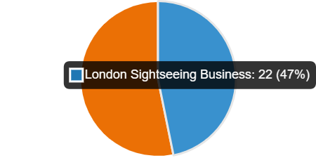
Fig. 1
As shown in Fig. 1, from 55 questionnaires sent we’ve got a number of 47 answers representing 22 (47%) associated with London Sightseeing Businesses, and 25 answers (53%) associated with UK Travel and Tourism Businesses.
The next question categorised the responses into five levels of familiarity with IoT:
Q2. How familiar are you with Internet of Things technologies?
Not familiar at all: 11%
Somewhat familiar: 13%
Moderately familiar: 23%
Very familiar: 43%
Extremely familiar: 5%
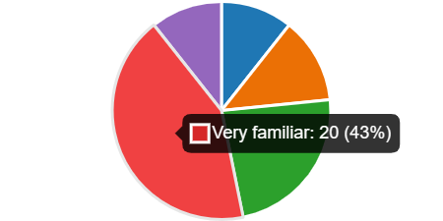
Fig. 2
The majority of respondents fall into the "Very familiar" category, (Fig.2) constituting 43% of the total, suggesting a significant level of knowledge about IoT technologies within the surveyed population.
Combining the percentages of respondents who are "Moderately familiar," "Very familiar," and "Extremely familiar," we see that a substantial 77% of respondents have at least a moderate level of familiarity with IoT technologies. While the percentages for "Not familiar at all" and "Somewhat familiar" are comparatively lower, it's essential to note that a total of 24% of respondents still fall into these categories indicating that there is a portion from surveyed population with limited familiarity of IoT technologies. Having a relatively high percentage of respondents with moderate to high familiarity, there may be opportunities for engaging this audience in discussions, or initiatives related to IoT technologies.
Q3. To what extent has your organization adopted IoT technologies in its operations and services?
Not adopted at all: 2%
Limited adoption in some areas: 26%
Partial adoption across various functions: 47%
Extensive adoption across the organization: 26%
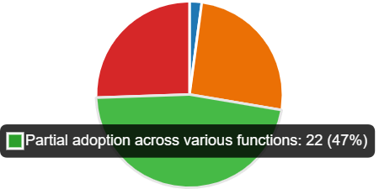
Fig. 3
The majority of respondents fall into the "Partial adoption across various functions" category (Fig.3), representing 47% of the total suggesting that a significant portion of the surveyed organizations has integrated IoT technologies to some extent.
While the percentages for "Not adopted at all" and "Limited adoption in some areas" are relatively lower, it's important to note that a total of 28% of respondents still fall into these categories, indicating that there is a portion of organizations with limited or no adoption of IoT technologies.
Combining the percentages of respondents with "Partial adoption across various functions" and "Extensive adoption across the organization," we see that a substantial 73% of respondents have adopted IoT technologies to some degree.
Combining the percentages of respondents with "Partial adoption across various functions" and "Extensive adoption across the organization," we see that a substantial 73% of respondents have adopted IoT technologies to some degree, indicating that there may be opportunities for further growth and integration of IoT technologies in various functions.
Q4. What are the main reasons your organization decided to adopt IoT technologies?
Improving operational efficiency: 18.35% of responses
Enhancing customer experience: 31.19% of responses
Gaining a competitive advantage: 20.18% of responses
Optimizing resource allocation: 19.26% of responses
Meeting industry standards and regulation: 11% of responses

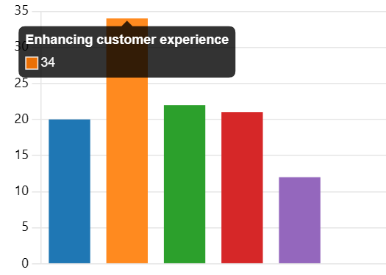
Fig. 4
As shown in Fig. 4, the highest percentage of respondents identified enhancing customer experience (31.19%) as a primary reason for adopting IoT technologies. This suggests that a significant portion of organizations sees IoT as a valuable tool for improving how customers interact with their products or services.
While a lower percentage than enhancing customer experience, improving operational efficiency (18.35%) is still a notable reason for IoT adoption which may indicate a recognition that IoT technologies can streamline internal processes.
A substantial portion of respondents sees IoT adoption as a means to gain a competitive advantage (20.18%), suggesting that organizations perceive IoT technologies as a strategic investment that can differentiate them from competitors in the market.
Optimizing resource allocation (19.26%) is a significant factor for organizations adopting IoT technologies. This could mean that organizations view IoT as a way to use resources more efficiently and effectively.
While the lowest percentage, meeting industry standards and regulations (11%) is still a notable factor indicating that compliance with standards and regulations plays a role in the decision-making process for a portion of organizations.
Q5. How do you perceive the benefits of IoT adoption in your organization? (Rate on a scale of 1 to 5, where 1=Not beneficial and 5=Highly beneficial)

Fig. 5.1

Enhancing customer satisfaction, Fig.5.1: 1(8.5%); 2(2.1%); 3(17%); 4 (12.8%); 5(59.6%)

Fig. 5.2
Improving data-driven decision making, Fig. 5.2: 1(10.6%); 2(6.4%); 3(17%); 4(19.1%); 5(46.8%)

Fig 5.3
Reducing operational costs, Fig 5.3: 1(4.3%); 2(8.5%); 3(14.9%); 4(14.9%); 5(57.4%)

Fig 5.4
Enabling real-time monitoring and control, Fig. 5.4: 1(4.3%); 2(0%); 3(25.5%); 4(17%); 5(53.2%)

Fig.5.5
Enhancing product/service offerings, Fig.5.5: 1(10.6%); 2(6.4%); 3(19.1%); 4(17%); 5(46.8%).
Enhancing Customer Satisfaction, Fig. 5.1: 59.6% rated it as 5 (Highly beneficial), indicating a strong positive impact on customer satisfaction, suggesting that a significant portion of respondents perceives IoT adoption as having a strong positive impact on customer satisfaction. Additionally, 17% rated it as 3, indicating a moderate level of perceived benefit.
Improving Data-Driven Decision Making, Fig.5.2: 46.8% rated it as 5, showing a significant positive perception of IoT's impact on decision-making processes. Another 19.1% rated it as 4, indicating a significant positive perception of the impact of IoT on decision-making processes.
Reducing Operational Costs, Fig 5.3: The highest percentage of respondents (57.4%) rated the benefit of reducing operational costs as 5 (Highly beneficial). This suggests that a majority of respondents views IoT adoption as a highly effective means of cost reduction. Additionally, 14.9% rated it as 3 and 14.9% rated it as 4.
Real-Time Monitoring and Control, Fig 5.4: 53.2% rated it as 5, indicating a majority sees IoT as highly beneficial for real-time monitoring. A notable 25.5% rated it as 3, indicating a moderate level of perceived benefits.
Enhancing Product/Service Offerings, Fig. 5.5: Similar to other categories, a significant percentage (46.8%) rated the benefit of enhancing product/service offerings as 5 (Highly beneficial). Additionally, 19.1% rated it as 3, suggesting a moderate level of perceived benefits.
Across all categories, there is a consistent pattern of respondents perceiving IoT adoption as highly beneficial, with the majority assigning a rating of 5.
Q6. What are the primary challenges, your organization has faced during IoT implementation?
High implementation costs: 15.18% responses
Integration with existing systems: 10.12% responses
Data security and privacy concerns: 25.31% responses
Lack of skilled personnel: 36.70%
Interoperability issues: 12.6%
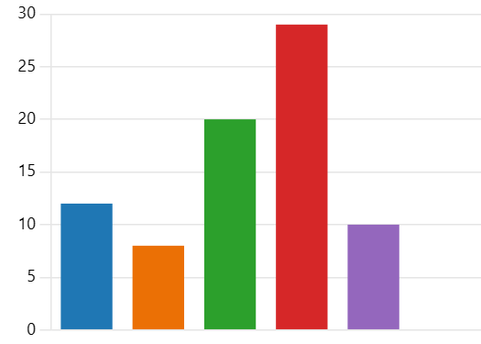
Fig. 6
The highest percentage of respondents identified a lack of skilled personnel (36.70%) as the primary challenge during IoT implementation, (Fig. 6) suggesting that finding and retaining qualified individuals with expertise in IoT is a significant obstacle for the surveyed organizations.
A substantial portion of respondents indicated that data security and privacy concerns (25.31%) constitute a significant challenge during IoT implementation, highlighting the importance of addressing security issues to ensure successful adoption.
While not the highest, a notable percentage of respondents identified high implementation costs (15.18) as a challenge. This suggests that financial considerations play a role in hindering the smooth implementation of IoT technologies.
Interoperability issues (12.5%) were identified by a relatively lower percentage of respondents. Nonetheless, this challenge underscores the importance of ensuring that different IoT components and systems can work together.
Integration with existing systems (10.12%) was identified as a challenge by the smallest percentage of respondents. While less prominent, this challenge still indicates a need for careful planning and execution to integrate IoT with current organizational systems.
Q7. How has IoT adoption influenced your organization's decision-making processes, particularly in resource allocation and strategic planning?
Significantly influenced: 40%
Somewhat influenced: 50%
Minimally influenced: 8%
Not influenced at all: 2%
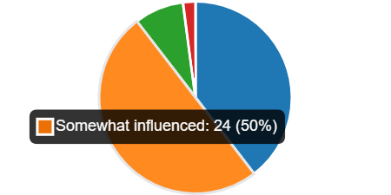
Fig. 7
As shown in Fig. 7, (40%) a significant portion indicated that IoT adoption has had a substantial impact on their organization's decision-making processes suggesting that IoT technologies plays a key role in formulating the strategic plans.
The majority of respondents (50%) reported that IoT adoption has had a moderate impact on decision-making processes still indicating a widespread influence.
A smaller percentage (8%) indicated that IoT adoption has had a minimal impact on decision-making processes. While not the majority, this group suggests that, for some organizations, the influence of IoT on decision-making is limited, and a very small percentage (2%) reported that IoT adoption has not influenced their organization's decision-making processes at all.
Q8. What key performance indicators (KPI) does your organization use to measure the success and effectiveness of IoT implementation?

Customer satisfaction metrics: 40%
Return on investment (ROI): 12%
Operational efficiency metrics: 31%
Revenue growth: 16%
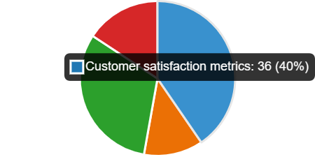
Fig. 8
The highest percentage of respondents (40%) indicated that customer satisfaction metrics are a key performance indicator for measuring the success of IoT implementation (Fig.8) suggesting that organizations place significant importance on how IoT technologies impact the satisfaction of their customers.
Operational efficiency metrics were identified by a substantial percentage (31%) of respondents. This indicates a focus on evaluating how IoT implementation contributes to simplifying the internal processes.
While not the highest, a notable percentage (12%) identified ROI (return on investment) as a key performance indicator. This suggests that financial considerations are important factors in measuring success.
Revenue growth was identified by 16% of respondents as a key performance indicator. This indicates a focus on assessing the financial impact and business growth resulting from IoT implementation.
Q9. In your opinion, how has IoT adoption impacted customer experience and satisfaction levels in your organization?

Improve significantly: 42%
Improve moderately: 44%
Remain unchanged: 15%
Declined moderately: 0%
Declined significantly: 0%
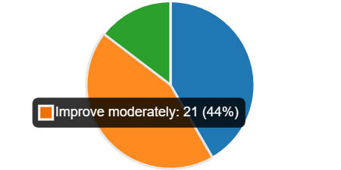
Fig. 9

A significant portion of respondents (42%) reported that IoT adoption has had a substantial positive impact on customer experience and satisfaction levels. (Fig. 9)
The majority of respondents (44%) reported a moderate improvement in customer experience and satisfaction levels.
A smaller percentage (15%) reported that customer experience and satisfaction levels have remained unchanged following IoT adoption.
No respondents reported a significant decline in customer experience and satisfaction levels.
A combined 86% of respondents reported either a significant or moderate improvement in customer experience and satisfaction levels following IoT adoption, indicating a positive overall impact.
The absence of reported declines suggests a general consensus that IoT adoption has not led to negative consequences for customer satisfaction.

Q10. Looking ahead, how do you foresee IoT technologies shaping the future of your organization's operations and services in UK travel and tourism industry?

High potential for growth and innovation: 60%
Moderate impact with incremental changes: 27%
Limited impact with minimal changes: 13%
No foreseeable impact: 0%
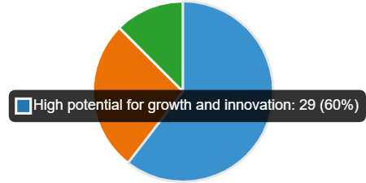
Fig. 10
As shown in Fig.10, the majority of respondents (60%) foresee a high potential for growth and innovation resulting from IoT technologies. This suggests a strong belief that IoT will play a significant role in driving advancements and transformative changes in the organization's operations and services within the UK travel and tourism industry.
A notable percentage (27%) anticipates a moderate impact with incremental changes.
A smaller percentage (15%) foresees a limited impact with minimal changes, and no respondents indicated that they foresee no impact from IoT technology.
The dominant expectation is positive, with a significant majority anticipating high potential for growth and innovation through IoT adoption.
A consensus is being suggested by the absence of respondents foreseeing no impact of IoT playing a role in shaping the organisation’s future.
4.3: Research validation
While global IoT deployment is on the rise, expert opinions on its societal impact vary. Some predict radical changes and job losses, while others foresee incremental developments leveraging existing infrastructure. Using the multiple linear regression statistical method (Shenkoya, 2020), studied the impact of the IoT on businesses and daily life of the Japanese, German, and Australian people. The study concentrated on these countries due to their early and extensive adoption of IoT, along with advanced capabilities and infrastructure. While arguing the focus on the impact of IoT on the society due to the fewer similar studies as the majority focused on the development framework of the technology, architectures, usage, and its future in the fourth industrial revolution, he is suggesting that a key question remains unanswered: What is the impact of the IoT in the societies in different regions. By raising questions related with the impact of IoT on jobs, R&D, averagely working time and business process in the society he concluded that the IoT indeed has a positive impact on the employment of IoT researchers, R&D funding in the research relating to the IoT, number of businesses that use the IoT and the amount of hours employee work in Japan. In Germany the IoT's impact on the society is equally positive. However, the IoT had the greatest impact on the number of businesses that use IoT enabled tools in their business processes.
The analysis of data collected on the Australian society reveals a positive impact of IoT, with a notable distinction from the Japanese and German cases. In Australia, the IoT's most significant impact was observed in the average number of hours worked by employees, despite positive effects on all variables examined. Conclusionary, despite the positive impacts an efficient deployment of IoT necessitates existing institutional changes and prerequisite infrastructures. Consequently, governments should encourage IoT developments, as its positive impact on social innovation can contribute to improving the living standards of their citizens. (Shenkoya, 2020). Comparing with the findings from ‘’Chapter 4.2’’ we’ve found couple of analogies:
- Focus on Societal Impact: Both studies concentrate around the theme of IoT (Internet of Things) and its impact on different aspects of society and businesses, discussing the societal impact of IoT adoption (London and UK vs. Japan, Germany, and Australia).
- Positive Perceptions: Both studies delve into the influence of IoT on decision-making processes, resource allocation, and strategic planning within Tourism Companies.
- Adoption Levels: Both studies touch upon the level of IoT adoption. Based in different regions both are highlighting the positive perception of IoT adoption.
Focusing on the willingness to adopt IoT innovations among Greek accommodations businesses, ( Pappas, et al., 2021) is using a comparison of asymmetric with correlational (regression) analysis identifying four types of decision-making based on the combinations of the cases investigated as follows:
- Rational: Evaluates risks and opportunities in adopting IoT.
- Enthusiast: Embraces competitive benefits from IoT adoption.
- Cautious: Focuses on potential drawbacks of IoT introduction.
- Futurist: Anticipates future needs of the hotel industry regarding IoT adoption.
Each decision-making type impacts the strategic behaviour of accommodation businesses. While the study didn't assess IoT adoption's performance, it suggests that IoT can offer a competitive advantage by enhancing customer experiences and improving operational efficiency. The paper also contributes methodologically by refining the use of fuzzy set qualitative comparative analysis (fsQCA) logics in management studies, specifically in tourism, services, innovation, and business model research.
Similitudes found comparing with ‘’Chapter 4.2’’ findings:
- Common Theme - IoT Adoption in the Hospitality/Tourism Industry.
- Impact on Decision-Making Processes: Both studies touch upon the impact of IoT adoption on decision-making processes, the first suggesting that decision-making types impact the strategic behaviour of businesses, while the second provides survey results indicating how IoT adoption has influenced organizations' decision-making processes.
In their discussion of cultural heritage in Italy, ( Cuomo, et al., 2021) construct a theoretical framework proposing the application of "big social data" in co-designing the tourist experience. The aim is to enhance the value for visitors and facilitate improved decision-making for managers.
The focus of their study is on the utilization of Big Social Data to support the co-design of tourism experiences, specifically emphasizing cultural offerings. They conclude stating that impact of smart tourism technology on travel decision support is significant, particularly in relation to factors such as information quality, source credibility, interactivity, and accessibility.
Comparing with findings in ‘’Chapter 4.2’’ both studies present findings from research and surveys related to technology adoption, focus on the importance of technology in enhancing customer experience. Both texts touch upon the impact of technology adoption on decision-making processes within organizations providing insights into the future outlook related to technology adoption.
Highlighting the beneficial perception of IoT for short travel experiences ( Hu, et al., 2023) are comparing data obtained from British and Chinese short-term travellers. Their study aims to compare consumer markets in the UK and China to explore the impact of IoT technologies on individuals' well-being in the context of short-term travel, extending the results for the tourism industry. The study focuses on individual city break tourists in the UK and China who have engaged in short-term travel within the last 12 months prior to research. The choice of the short-term travel context is deliberate, as short-term travellers are more receptive in utilizing technology to meet their specific travel requirements. The research identified critical factors, including task-technology fit, perceived usefulness, and perceived enjoyment, influencing travellers’ subjective well-being. The study analysed data from 1998 short-term travellers in the UK and China, ensuring high reliability and validity and confirmatory factor analysis, affirming the suitability of the data for further analysis. Tourism managers can apply these findings to improve user experiences by focusing on both the practical benefits and enjoyable aspects of IoT offerings. Despite valuable contributions, the study has limitations, such as its focus on a specific industry and the use of data from two countries. Future research could explore broader contexts and include more diverse geographical samples.
Another view of IoT application is provided in the research made by (Brous & Janssen, 2015) who after a rigorous review of literature identified potential benefits and risks of IoT implementation categorised as follows:
- Strategic-Benefits: improved trend analysis, improved citizens empowerment.
Risks: non-compliance with regulations, data privacy, data security.
- Tactical-Benefits: cost reduction, improved planning with regards to management and maintenance.
Risks: interoperability and integration, acceptance, costs, trust related issues.
- Operational-Benefits: improved efficiency, effectiveness, and flexibility of services.
Risks: lack of sufficient knowledge, incorrect data, data managements issues, infrastructure limitations.
Research similarities:
- Challenges of Implementation: A comparison of this research and findings presented in ‘’Chapter 4.2’’ will highlight the challenges of the implementation of IoT, categorising potential benefits and risks.
- Impact on Decision-Making: Both studies touch upon the impact of IoT adoption on decision-making processes. While the first emphasizes the potential benefits of IoT for tourism managers in improving user experiences, the second (presented in Chapter 4.2) provides insights into how IoT adoption has influenced organizations' decision-making processes.
While these studies offer valuable insights, there's a consensus on the need for further research to comprehensively understand and address the evolving impact of IoT including in Travel and Tourism industry.
Despite their distinct focuses, the above studies share common themes. They highlight the strategic importance of IoT adoption, particularly in decision-making processes, and recognize its positive influence on various aspects of operations, whether in the business sector or societal context.
Combining insights from the above studies to compare IoT's impact in specific industries and across diverse regions could result in a more comprehensive understanding of its overall influence filling the gap in the research field and complementing each other.

4.4: Summary of Chapter 4
This chapter provides a comprehensive analysis of the impact of IoT adoption on organizations in the UK travel and tourism industry.
Key drivers for adoption include enhancing customer satisfaction, improving decision-making, and reducing operational costs. Challenges such as a lack of skilled personnel and security concerns are acknowledged. Despite challenges, organizations largely perceive IoT adoption as highly beneficial, focusing on customer satisfaction metrics. The findings highlight the IoT influence on decision-making processes and concludes with a positive outlook, with the majority foreseeing high potential for growth and innovation through IoT technologies.

Chapter 5: Conclusion, Limitation and Recommendations
5.1: Introduction
This chapter summarizes key findings on IoT adoption in the UK travel and tourism industry, covering familiarity, adoption levels, challenges, and perceived impacts. It reflects on the research's contributions to management, academia, and scholars, acknowledging study limitations. Practical recommendations for challenges are provided, and potential areas for future research are highlighted.
5.2: Conclusions on each research issues/objectives/proposition (based on the results in Chapter 4)
The analysis reveals a balanced representation of London Sightseeing Businesses (47%) and UK Travel and Tourism Companies (53%) among the respondents, providing a comprehensive perspective on IoT adoption in the UK travel and tourism industry.
The substantial knowledge base (77% of respondents show moderate to high familiarity with IoT technologies) presents promising opportunities for involvement in IoT initiatives.
The positive perceptions (IoT is precepted as highly beneficial across various aspects, with customer satisfaction (59.6%) and reducing operational costs (57.4%), underscore the impactful role of IoT in improving organizational processes.
The lack of skilled personnel (36.70%) followed by data security and privacy concerns (25.31%) and high implementation costs (15.18%) are the most significant challenges during the IoT implementation.
A substantial impact on decision-making processes is reported suggesting that IoT play a crucial role in shaping organizational strategies and resource allocation.
Customer satisfaction metrics (40%) are identified as the primary key performance indicators in this industry as well as a combined 86% of respondents report either a significant or moderate improvement in customer experience following IoT adoption.
The majority (60%) anticipates a high potential for growth and innovation through IoT technologies, signalling a positive expectation for the future of organizations in the UK travel and tourism industry.
5.3: Conclusions on the research problem
In conclusion, the analysis provides a nuanced understanding of IoT adoption in the industry, highlighting its positive impact, challenges, and the potential for future growth and innovation. The findings offer valuable insights for industry professionals, researchers, and stakeholders navigating the dynamic landscape of IoT in the UK travel and tourism sector.
5.4: Summary of the research findings and outcomes
The research findings reveal a promising landscape for IoT adoption in the UK travel and tourism industry. Moreover, 73% of organizations have adopted IoT to some extent, indicating a positive trend. Overall, the findings highlight a positive perception of IoT's benefits, particularly in customer satisfaction, and a strong belief in its potential for growth and innovation in the future of the industry.
5.5: Original Contribution of the Research (i.e.: management, academia, scholars)
Management
Informed Decision-Making: The research provides with data-driven insights into the motivations, challenges, and outcomes associated with IoT adoption.
Strategic Planning: The findings empower management teams to strategically position their organizations in the dynamic landscape of the travel and tourism industry.
Academia
Research Gap Addressed: The study addresses a potential research gap by focusing on the specific context of the UK travel and tourism sector and serves as a foundational study that can inspire and guide further academic investigations.
Scholars
Contribution to Knowledge: Scholars can benefit from the detailed analysis of the motivations, challenges, and perceived benefits of IoT adoption in the industry and the study identifies area for future research such exploring the long-term impacts of IoT adoption.
5.6: Limitations of the Research
Sample Size and Representation:
The study’s sample size may not fully represent the entire UK travel and tourism industry.
Self-Reporting Bias:
Participants might provide answers that may not accurately reflect their actual practices and experiences.
The research is capturing an overview of the industry at a specific point in time. This limits the ability to observe changes or trends over an extended period.
Single Geographic Focus:
The study focuses specifically on the UK travel and tourism industry, and the findings might not be directly applicable to other regions or industries.
Temporal Relevance:
Due the rapidly evolving nature of technology, the research's findings might have a limited life. The dynamic landscape of IoT adoption means that certain challenges and opportunities may have evolved since the data collection period.
5.7: Recommendations
Addressing the lack of skilled personnel can be achieved through strategic initiatives such as training programs, workshops, forming partnerships with educational institutions, or adopting talent acquisition strategies.
To overcome data security and privacy concerns, organizations should prioritize the implementation of robust cybersecurity measures and privacy safeguards. This includes investing in state-of-the-art security technologies, conducting regular security audits, and staying informed about the latest cybersecurity developments to ensure a resilient defence against potential threats.
Mitigating challenges related to high implementation costs involves careful budgeting and exploring cost-effective solutions. Organizations can consider phased implementation approaches, prioritize essential functionalities, and seek out affordable IoT solutions. This strategic financial planning can contribute to the successful integration of IoT technologies without compromising fiscal stability.
IoT Integration with Existing Systems: Developing a comprehensive integration strategy, considering the compatibility of IoT systems with existing infrastructure.
Overcoming Interoperability Issues are possible trough standardisation of communication protocols and ensuring compatibility between different IoT devices and systems, collaboration with industry partners to establish interoperability standards.
Areas for further/future research:
Global Comparative Analysis: Extend the scope of research to include a global perspective, comparing IoT adoption in the UK travel and tourism industry with other regions.
Sector-Specific Investigations: IoT adoption variances across specific sectors within the travel and tourism industry, such as transportation, accommodation, or attractions. This focused approach can reveal sector-specific challenges and opportunities.
Cybersecurity Implications: To investigate the cybersecurity implications associated with increased IoT adoption.
Policy and Regulation Impact: To investigate the influence of government policies and regulations on IoT adoption.
Collaborative Initiatives: To explore collaborative initiatives and partnerships among organizations in the travel and tourism sector.
5.8: Summary of Chapter 5
This chapter summarizes key insights on IoT adoption in the UK travel and tourism sector. It covers familiarity, adoption, challenges, and perceived impacts. Acknowledging contributions and limitations, the chapter offers practical recommendations and suggests future research areas. A concise guide for industry and academia in navigating the dynamic IoT landscape in UK travel and tourism.

References
Cuomo, M. T. et al., 2021. Digital transformation and tourist experience co-design: Big social data for planning cultural tourism. Technological Forecasting and Social Change, Volume 162.
Hu, M., Pantano, E. & Stylos, N., 2023. “Home alone” no more: How does the internet of things (IoT) enhance travellers' subjective well-being. Technological Forecasting and Social Change, Volume 192.
Löfgren, K. & Webster , W., 2020. The value of Big Data in government: The case of ‘smart cities’. Big Data and Society, 7(1).
Pappas, N. et al., 2021. The complexity of decision-making processes and IoT adoption in accommodation SMEs. Journal of Business Research, Volume 131, pp. 573-583.
Adams, J., Khan, H. T. & Raeside, R., 2014. Research Methods for Business and Social Science Students. second ed. London: Sage Publications Limited.
Boes, K., Buhalis, D. & Inversini, A., 2016. Smart tourism destinations: ecosystems for tourism destination competitiveness. International Journal of Tourism Cities, 2(2), pp. 108-124.
Brous, P. & Janssen, M., 2015. EFFECTS OF THE INTERNET OF THINGS (IOT): A SYSTEMATIC REVIEW OF THE BENEFITS AND RISKS. Hong Kong, ResearchGate.
Car, T., Stifanich, L. P. & Šimunić, M., 2019. INTERNET OF THINGS (IOT) IN TOURISM AND HOSPITALITY: OPPORTUNITIES AND CHALLENGES. ToSEE – Tourism in Southern and Eastern Europe, Volume 5, pp. 163-175.
Collis, J. & Hussey, R., 2014. Business Research: A practical guide for ubdergraduate and postgraduate students.. fourth ed. Basingstoke, Houndmills: Macmillan Publishers Limited.
Conrad, F. G., Schober, M. F. & Schwarz, N., 2013. Pragmatic Processes in Survey Interviewing. In: The Oxford Handbook of Luanguage and Social Phychology. Oxford: Oxford University Press, pp. 420-437.
Department for Science, Innovation and Technology, 2023. Secure by design. [Online]
Available at: https://www.gov.uk/government/collections/secure-by-design
Gaetanino, P. et al., 2022. A Holistic Overview of the Internet of Things Ecosystem. IoT , Volume 3, pp. 398-434.
Goel, N., Kumar, R. & Kumar, R. Y., 2023. Pattern Recognition by IoT Systems of Machine Learning. In: R. K. Y. Neha Goel, ed. Handbook of Research of Machine Learning. Enabled IoT for Smart Applications Across Industries. Hershey PA: IGI Global, pp. 51-55, 67-81.
GOV.UK, 2019. Secure by Design. [Online]
Available at: https://www.gov.uk/government/collections/secure-by-design
[Accessed 23 November 2023].
Khan, J. & Yuce, M., 2019. Big Data in IoT Systems. In: Internet of Things (IoT) Systems and Applications. Singapore: Jenny Stanford Publishing Pte, pp. 25-32.
Kumar, P., Ponnusamy, V. & Jain, V., 2020. Industrial Internet of Things and Cyber Physical Systems: Transforming The Conventional to Digital. Hershey: IGI Global.
Lu, Y., Papagiannidis, S. & Alamanos, E., 2018. Internet of Things: A systematic review of the business literature from the user and organisational perspectives. Technological Forecasting and Social Change, Volume 136, pp. 285-297.
Marjani, M. et al., 2017. Big IoT Data Analytics: Architecture, Opportunities, and Open Research Challenges. IEEE Access, Volume 5, pp. 5247-5261.
Misra, S., Mukherjee, A. & Roy, A., 2021. IoT Sensing and Actuation. In: Introduction To IoT. Cambridge: Cambridge University Press, pp. 97-114.
Patel, K. K. & Patel, S. M., 2016. Internet of Things-IOT: Definition, Characteristics, Architecture, Enabling Technologies, Applications & Future Challenges. International Journal of Engineering Science and Computing, pp. 6122-6131.
Raad, H. K., 2021. Fundamentals of IoT and Wearable Technology Design. Hoboken, New Jersey: John Wiley & Sons, Inc..
Saunders, M., Lewis, P. & Thornhill, A., 2019. Research Methods for Business Students. eight ed. Vancouver Island, Canada: Pearson Education Ltd.
Shenkoya, T., 2020. Social change: A comparative analysis of the impact of the IoT in Japan, Germany and Australia. Internet of Things; Engineering Cyber Physical Human Systems, Volume 11.
Verma, A. & Shukla, V. K., 2019. Analyzing the Influence of IoT in Tourism Industry. International Conference Sustainable Computing in Science, Technology and Management, Electronic Journal, pp. 2083-2093.
Vermesan, O. & Peter, F., 2014. Internet of things - from research and innovation to market deployment. first ed. Online: Taylor & Francis eBooks.
Wise, N. & Heidari, H., 2019. Developping Smart Tourism Destinations with the Internet Of Things: Managerial Approaches, Techniques and Applications. In: R. R. M. T. M Sigala, ed. Big Data and Innovation in Tourism, Travel, and Hospitality. Singapore: Springer, pp. 21-29.
Zainab, A., Badawy, . M. & Ali, H. A., 2015. Internet of Things (IoT): Definitions, Challenges, and Recent Research Directions. International Journal of Computer Applications, 128(1), pp. 0975-8887.

Terms of Glossary
IoT- (Internet of Things) it refers to the network of interconnected physical devices (things) that communicate and exchange data with each other.
Inductive reasoning- is a type of logical thinking that involves generalizing based on specific observation.
RFID-Radio Frequency Identification
MIT- Massachusetts Institute of Technology
BI-Business Intelligence: involves the use of software applications to transform raw data into actionable intelligence for decision-making.
ML-Machine Learning: refers to algorithms that enable computers to perform tasks without explicit programming.
AI-Artificial Intelligence: refers to the development of computer systems that can perform tasks that typically require human intelligence.
ZigBee-It is a wireless communication standard used for short-range, low-power digital radios.
Z-Wave- is a wireless communication protocol which enables devices in a smart home to communicate with each other and with a central hub or controller.
ESA-Energy Saving Agent
Low rate WPAN- Low-Rate Wireless Personal Area Network
MQTT- stands for Message Queuing Telemetry Transport (open-source protocol designed for efficient and real-time communication between devices on a network)
OPC UA- (Object Linking and Embedding for Process Control Unified Architecture) is a standard communication protocol for industrial automation and the Industrial Internet of Things (IoT)
NFC- stands for Near Field Communication. It is a short-range wireless communication technology that allows devices to communicate with each other when they are in close proximity.
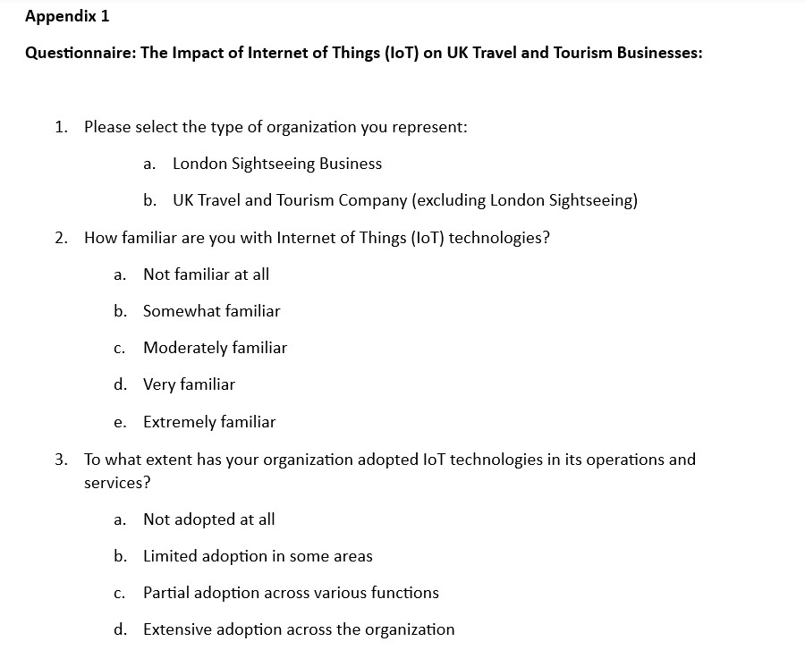
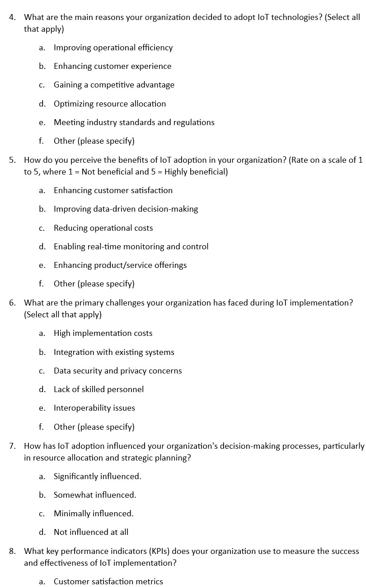
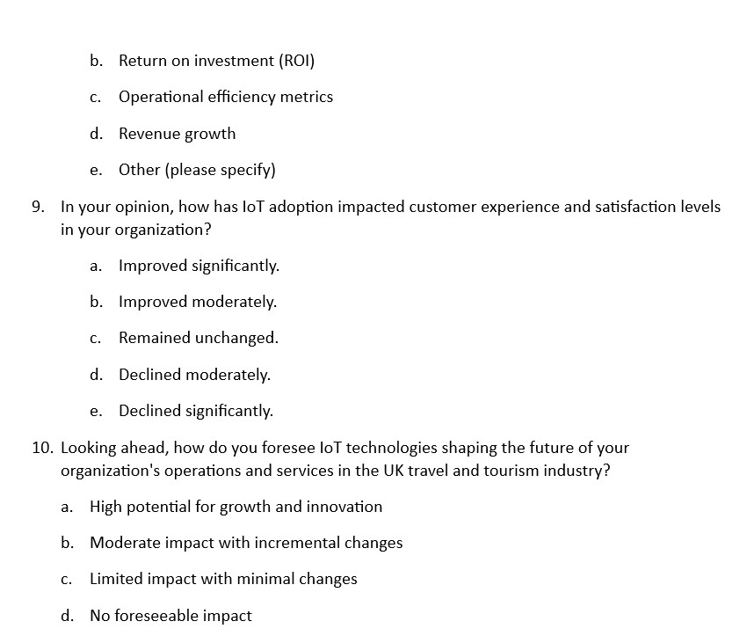Appendix 2.
Time prospect:
Appendix 3
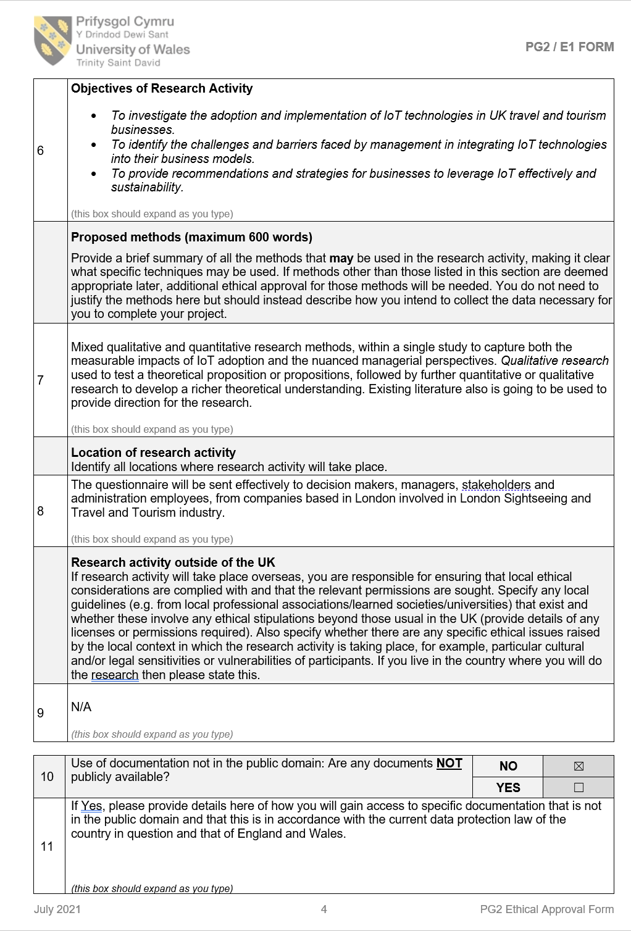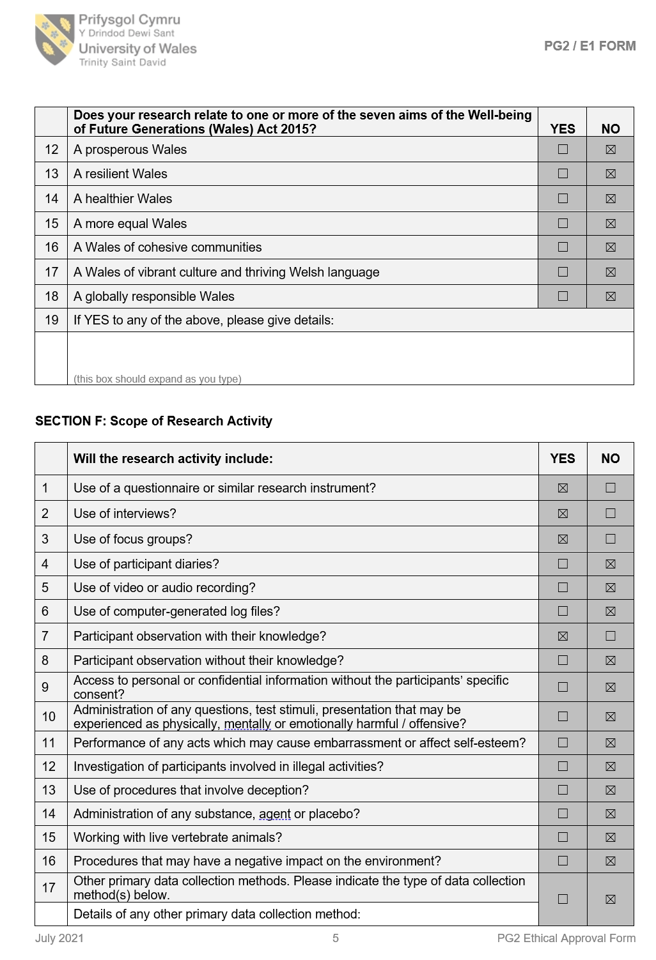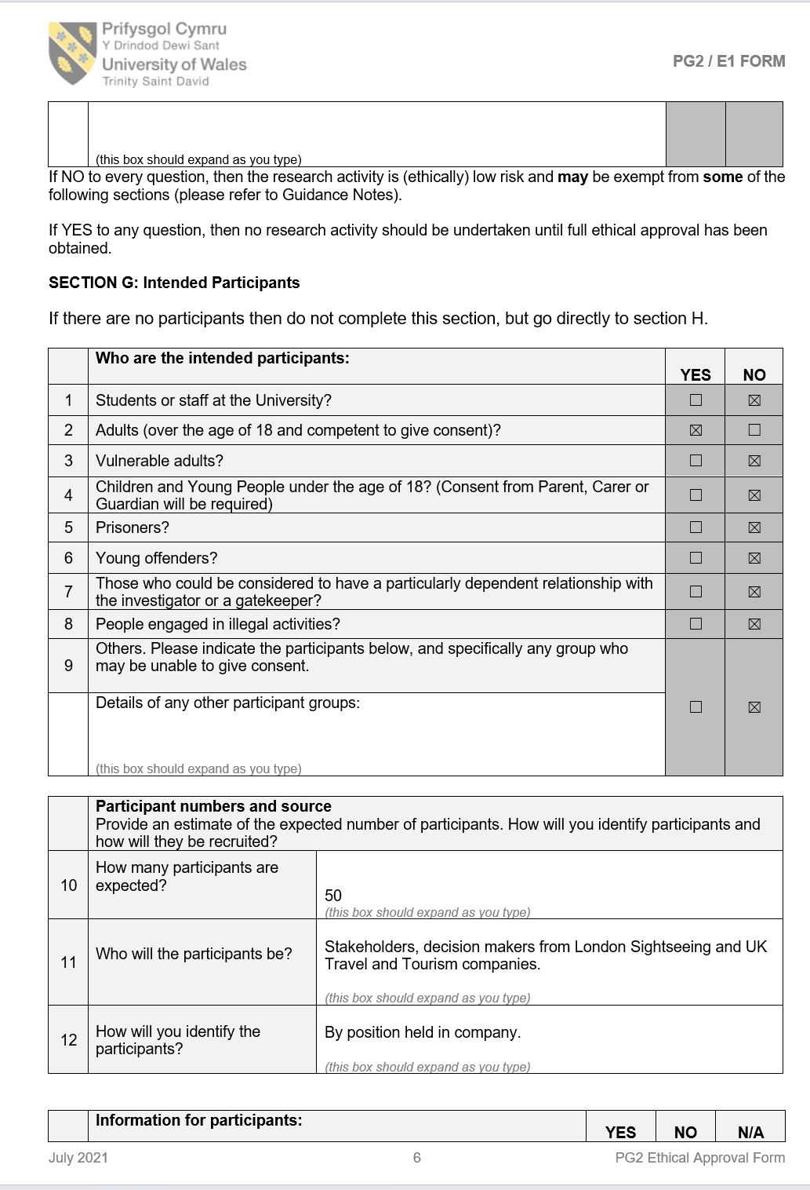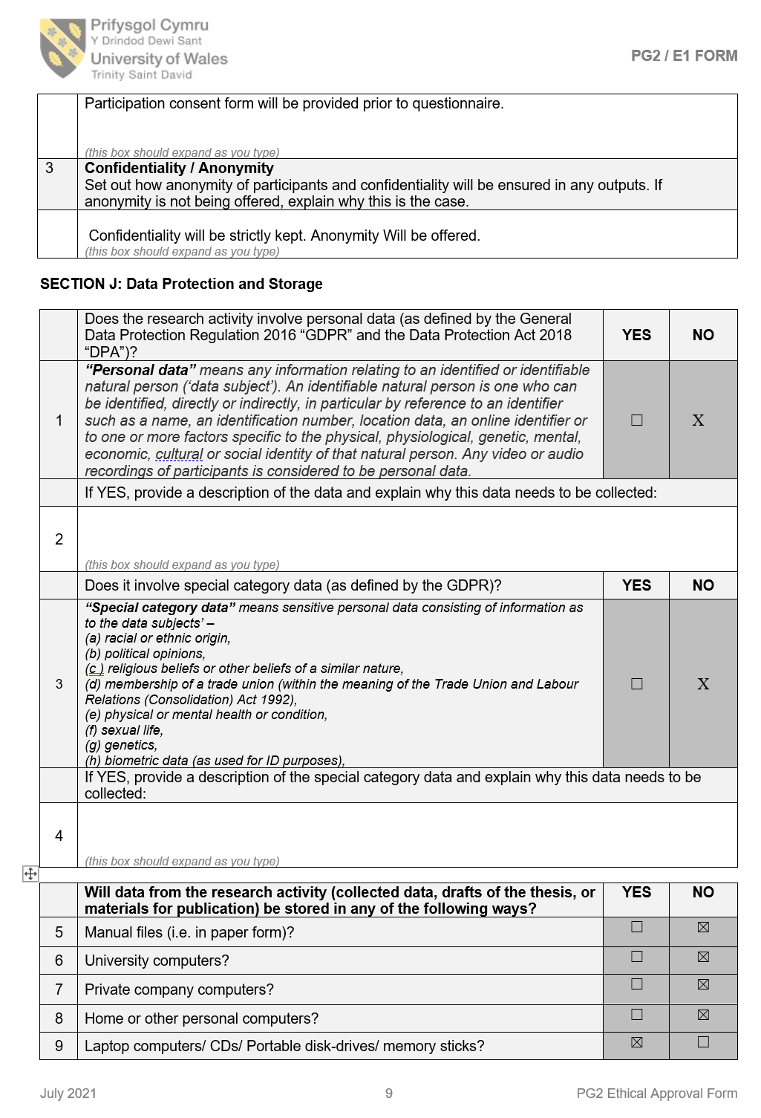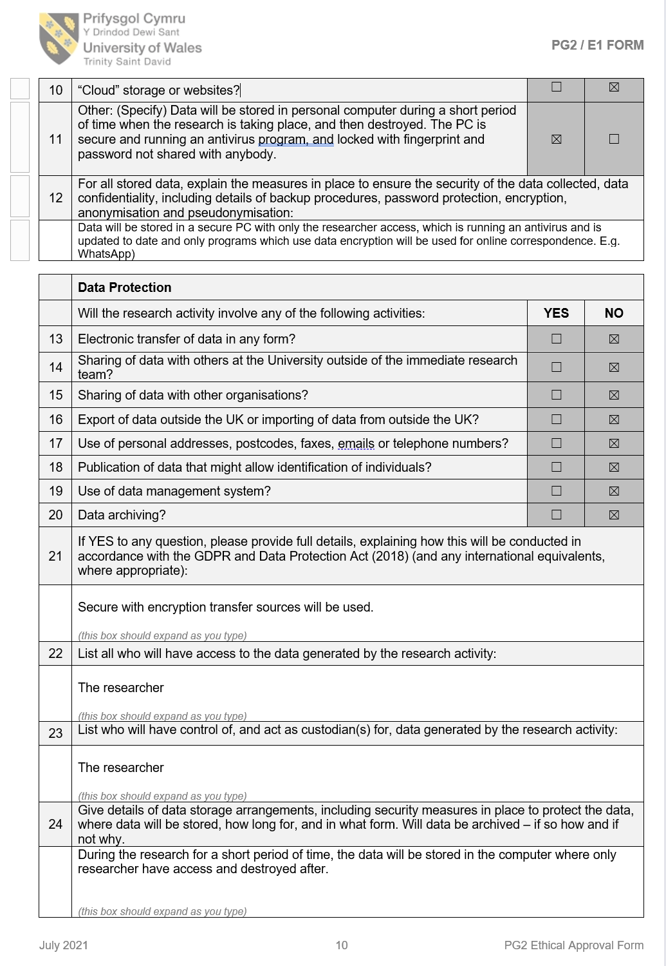
Appendix 4:


