ETHICAL RISKS

Here are 8 potential doctoral research project ideas in business and management that require examining ethical risks:

1. A study on optimisation of warehouse workforce productivity.

Warehouse Productivity Objectives
Quantify impacts of monitoring practices on output
Assess workforce health and satisfaction outcomes
Determine optimal incentive structures
Research Questions
How do surveillance methods affect productivity and stress?
Is there negative worker impact from reduced compensation?
What incentives align with worker retention and performance?
Warehouse Productivity Justification: With the rapid rise of ecommerce and technological change in warehousing, there is a business need to maximize efficiency. However, worker health, retention, and ethical treatment should remain priorities as well.
Rationale: This study will provide guidance on optimising productivity through testing incentives and monitoring methods while protecting and empowering the workforce.
Participants: Warehouse Productivity
Warehouse workers across multiple sites and roles
Warehouse managers and executives
Labour union representatives
Further information: Explore physical and emotional impacts of increased monitoring, such as worker stress levels, health effects, burnout risks
Assess tradeoffs between productivity gains and compensation reductions in terms of equitable treatment and human rights
Methodology
Focus groups with warehouse employees to assess experience with monitoring and incentives
One-on-one ethnographic interviews documenting worker daily life
Analysis of complaints filed pre and post policy changes

2. Research on viral marketing strategies and influencing consumer behaviour.
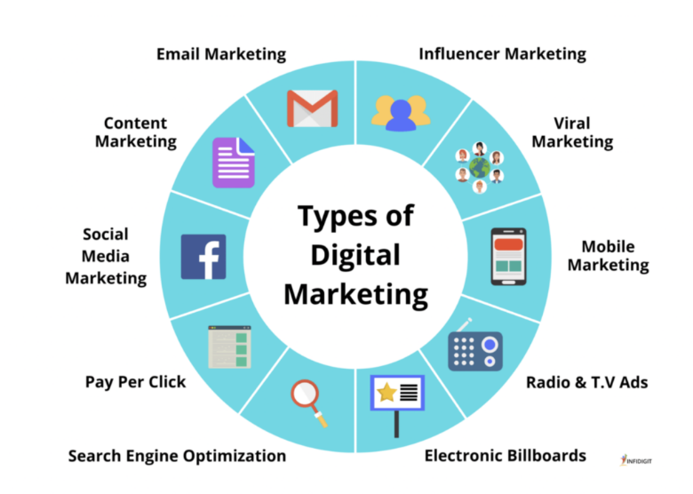
Viral Advertising Objectives
Evaluate emotional manipulation techniques
Detect changes in purchasing decisions
Identify vulnerable demographic groups
Research Questions
Can engineered virality change consumer behaviour?
Are certain groups disproportionately influenced?
What ethics rules apply to viral methodology?
Viral Advertising Justification: Social platforms allow highly targeted promotion, but also enable unethical manipulation if poorly regulated. Academic analysis is required.
Rationale: This research will shed light on the appropriateness of viral approaches and inform policy discussions on ethical standards for protecting vulnerable groups.
Participants: Viral Advertising
Social media users across age groups and demographics
Digital marketing firms specialising in viral campaigns
Consumer advocacy groups focused on ethics
Methodology
Interviews with consumers who were exposed to viral strategies to explore decision journey
Ethnographic observation of social media users sharing and reacting to viral content
Thematic analysis of online comments around viral advertisements

3. Evaluation of the costs and impacts of offshoring certain jobs to international markets.
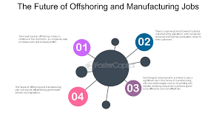
Offshoring Manufacturing Objectives
Model overall employment effects
Compare regional economic impacts
Determine sustainability outcomes
Research Questions
What is net impact on domestic job rates?
How do poor countries benefit from access to jobs?
Are there environmental sustainability consequences?
Offshoring Manufacturing Justification: Globalized supply chains provide complex tradeoffs between costs, domestic job impacts and international opportunities that demand updated academic examination.
Rationale: This study will deliver nuanced data using econometric models clarifying the pros and cons of offshoring decisions to promote ethical, sustainable management.
Participants: Offshoring Manufacturing
Employees across levels of offshoring and non-offshoring plants
Labour economists and policy experts
International manufacturing managers
Methodology
Case studies analyzing offshoring decisions from manager perspective
Focus groups with affected employees to understand personal impacts
Content analysis of media, government reports around offshoring impacts

4. Examining impacts of AI and predictive analytics on hiring practices.
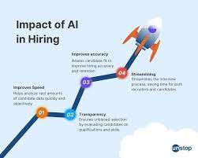
Algorithmic Hiring Platforms Objectives
Audit AI bias by protected classifications
Identify sources of discrimination
Recommend algorithmic improvements
Research Questions
Is racial or gender bias manifest in hiring algorithms?
Can bias be traced to training data deficiencies?
What auditing processes promote algorithmic fairness?
Algorithmic Hiring Platforms Justification: The rapid adoption of AI-based hiring tools requires proactive auditing to prevent embedding and perpetuating structural biases.
Rationale: This experimental analysis will identify and address sources of discrimination in automated hiring systems to prevent exclusion of protected classes.
Participants: Algorithmic Hiring Platforms
Groups of matched job applicants across races/genders
HR professionals using AI hiring tools
Developers and auditors of hiring algorithms
Methodology
Interviews with developers, testers to understand barriers around reducing algorithmic bias
Focus groups with job seekers detailing experience with AI hiring systems
Narrative analysis of hiring complaint scenarios
5. A project assessing effectiveness of subliminal advertising techniques.
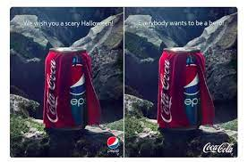
Subliminal Advertising Objectives
Detect influences below levels of consciousness
Identify associated neurobiological pathways
Evaluate consumer ethics implications
Research Questions
Can advertising impact without conscious processing?
Which neural structures are activated by subliminal presentations?
What boundaries apply for consent and awareness?
Subliminal Advertising Justification: Potential subconscious influence raises ethical questions around transparency and consent which should be academically examined before use expands.
Rationale: This research would enhance understanding of unintended persuasion, informing policy standards around ethical permissions for subliminal advertising approaches.
Participants: Subliminal Advertising
Randomly selected shoppers across demographics
Neuromarketing firms testing subliminal techniques
Consumer protection groups
Methodology
Phenomenological interviews surfacing consumers’ unconscious influences
Participant journals tracking purchase decision thoughts over time
Discourse analysis of neuromarketing white papers, presentations
6. Piloting a new corporate wellness program and tracking medical and productivity outcomes.
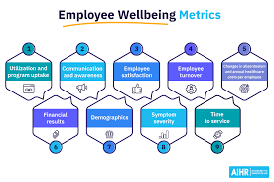
Corporate Wellness Incentives Objectives
Link financial health incentives to productivity
Assess impacts on satisfaction and stress
Ensure protections against discrimination
Research Questions
Do fitness rewards improve measurable performance?
How are employees with disabilities accommodated?
What are unintended consequences on worker health?
Corporate Wellness Incentives Justification: As workplace stress continues rising, employers are investing in wellness initiatives, but ethical oversight is crucial to avoid discrimination or unhealthy pressures.
Rationale: This study will assess the effectiveness of financial fitness incentives while ensuring inclusion and positive impacts on worker satisfaction and health.
Participants: Corporate Wellness Incentives
Employees participating in specialized fitness programs
Disability advocates/occupational health experts
Employers funding and monitoring wellness initiatives
Methodology
Interviews evaluating employee stress, health choices in response to incentives
Thematic analysis of anonymous wellness program feedback
Evaluation of themes in occupational health complaints

7. Researching impacts of gambling elements in mobile gaming apps.

Mobile Gaming Addiction
Objectives
Correlate incentive design with addictive usage
Detect disproportionate impacts by age group
Propose responsible design guidelines
Research Questions
Can variable rewards enable addictive tendencies?
Are adolescents more susceptible to gambling-like mechanisms?
What constitutes ethical game design?
Mobile Gaming Addiction Justification: Concerns over addictive game designs and implications for mental health demand urgent academic review, especially for vulnerable youth demographics.
Rationale: This research aims to correlate incentive structures with addictive usage signals to formulate responsible design recommendations protecting consumers.
Participants: Mobile Gaming Addiction
Gamers of all ages playing popular reward-based games
Gaming app developers and designers
Public health advocates concerned with addiction
Methodology
Interviews with compulsive gamers and families documenting life impacts
Analysis of game tester feedback around reward feature engagement
Focus groups with adolescents revealing perspectives on gaming habit

8. A revenue management study of dynamic and differential pricing models.

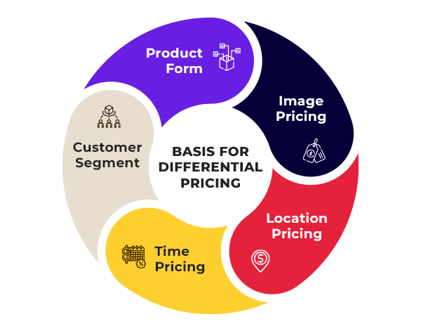

Dynamic Pricing and Fairness Perceptions Objectives
Relate price consistency to goodwill and loyalty
Identify thresholds for acceptable discrimination
Incorporate transparency measures
Research Questions
How much preferential pricing causes equity concerns?
What explanations around discrimination improve acceptance?
Can transparency mitigate negative impacts?
Dynamic Pricing and Fairness Perceptions Justification: Retailers are increasingly using personalized pricing models enabled by data analytics, raising worries around equitable treatment that scholars should preemptively address.
Rationale: This experimental analysis will uncover thresholds where price differentiation causes perceived unfairness and test measures to mitigate customer concerns over discrimination.
Participants: Dynamic Pricing and Fairness Perceptions
Retail shoppers across loyalty tiers/segments
Pricing analytics consultants
Consumer value experts assessing reaction
Methodology
Shopper interviews highlighting price consistency experiences
Consumer diaries tracking perception shifts after pricing revelations
Thematic analysis of loyalty program complaints

ANSWERS

1. A study on optimisation of warehouse workforce productivity. Students would need to analyse ethical issues like worker exploitation, health and safety, privacy intrusions through surveillance and monitoring, equitable compensation when cutting wages and benefits.
Some potential research ethics issues with this warehouse productivity study include:

1. Informed consent - Workers may feel coerced into participating in new monitoring/incentives if implemented top-down without proper consent.
2. Privacy - Increased surveillance could violate reasonable expectations of privacy. Storage/use of data needs protections.
3. Beneficence - Study should optimize benefits while minimising risks to workers. Could incentives or monitoring cross acceptable boundaries?
4. Worker exploitation - With business priorities driving efficiency, what safeguards are in place to prevent detrimental outcomes for workers in terms of compensation, stress, health?
5. Conflicts of interest - Warehouse management team may have self-interests in certain productivity optimisations rather than protecting workers.
6. Health information sensitivity - Collection of any private physical/mental health data from workers requires extra protections around anonymity, storage procedures, access controls.
7. Post-study commitments - If study dismantles current practices or implements experimental techniques, ensure post-study responsibilities around returning sites to normal rather than abandoning interim programs.
The qualitative methods planned seem reasonably designed to surface some of these issues from the workers' perspectives. Further ethics dimensions could emerge from interviews and should inform analysis and recommendations. Ongoing consent procedures also important should study parameters shift over time.

2. Research on viral marketing strategies and influencing consumer behaviour. Ethical considerations include transparency around data collection, avoiding manipulation of vulnerable groups like children, respecting privacy and autonomy.
Here are some potential research ethics concerns with studying viral advertising strategies:
1. Informed consent - If directly experimenting with viral techniques, disclosure and consent procedures crucial for consumers targeted in campaign trials.
2. Manipulation and deception - Emotional manipulation tactics could remove consumer choice/autonomy or exploit vulnerabilities.
3. Privacy and appropriate data usage - Collection and usage of consumer data for targeting requires transparency and permissions around any retention/analysis.

4. Vulnerable population protections - Safeguards vital if research directly interacts with or analyses impact on vulnerable groups like children, elderly, disabled.
5. Conflicts of interest - If research funding coming from digital marketing firms with financial stake in outcomes, disclose/manage COIs appropriately.
6. Transparency in analysis - Clear communication around viral strategies studied needed to inform policy recommendations and future consumer protections. Should not obscure concerning practices.
The planned qualitative methods of exploring consumer reactions could further surface inappropriate manipulation while giving participants agency over their insights/data. Still needs process allowing participants to withdraw consent if uncomfortable.

3. Evaluation of the costs and impacts of offshoring certain jobs to international markets. Analysis would cover unethical exploitation of overseas workers, impacts on domestic job markets, environmental damages, sustainability and wealth inequity between regions.
Some potential research ethics issues with evaluating offshoring manufacturing impacts include:
1. Confidentiality - Protecting proprietary data around costs, operations, and strategic decision-making for companies involved.
2. Labour exploitation - Studying work conditions that may involve unethical treatment of employees overseas due to lax regulations. Must avoid enabling negative practices.
3. Conflicts of interest - Many econometric offshoring analyses funded by interests that benefit from offshoring. Need balanced perspectives.
4. Policy overreach - Modeling should aim to inform not overly influence policy decisions with potentially inaccurate predictions about employment impacts.
5. Vulnerable participants - Interviews/focus groups with affected employees require extra care around consent procedures and anonymity given job precarity fears.
6. Sustainability impacts - Environmental analyses part of full evaluation but constraints around measuring certain damages reliably.
The planned use of multiple qualitative methods to assess experiences balances econometric approaches. However still requires neutral framing of costs/benefits and preventing any unintended exploitation of participant groups like offshore workers.
4. Examining impacts of AI and predictive analytics on hiring practices. Ethical analysis essential around algorithmic bias, stereotyping, discrimination against protected classes in automated recruiting and hiring processes.
Some potential research ethics concerns with examining algorithmic hiring platforms include:
1. Privacy - Protecting applicant personal data used within hiring algorithms and analysis. Anonymisation procedures crucial.
2. Autonomy - Ensuring willing consent if job applicants recruited for controlled testing of biased algorithms. Right to withdraw.
3. Beneficence - Study should aim to balance improving algorithms with minimising any risks/harms to applicants from flawed systems.
4. Transparency - Clear communication to participants and public around true bias findings versus any message manipulation by corporate algorithm sponsors.
5. Conflicts of interest - If AI developers funding research, take steps to preserve objectivity around actual algorithm deficiencies.
6. Legal compliance - Using experimental hiring platforms for tests requires careful review to avoid technical discrimination based on protected attributes during trials.
The qualitative approaches of interviewing various stakeholder groups could provide more human-centered context around barriers to reducing algorithmic bias. However still requires anonymity given industry ties and organisational affiliations that could identify participants through viewpoints.

5. A project assessing effectiveness of subliminal advertising techniques. Informed consent is paramount given lack of transparency. Additional ethical issues around manipulating behaviour against consumer interests.
Some potential research ethics issues with studying subliminal advertising effectiveness include:
1. Informed consent - Recruiting shoppers for randomized trials exposes them to advertising techniques without full transparency or awareness required for consent.
2. Manipulation - Subliminal methods designed to influence decisions while bypassing rational defenses makes true voluntary choice difficult.
3. Privacy - Tracking purchase data, biometrics, or neural responses risks consumer privacy around personal information.

4. Transparency - Neuromarketing industry financial interests could obscure reporting around true effectiveness or health impacts.
5. Beneficence vs. maleficence - Research priorities around unpacking unconscious influence mechanisms conflicts with duty to avoid exposing people to harm.
6. Legal compliance - Subliminal advertising lacks clear regulations, but research trials should proactively honor ethical boundaries around autonomy and consent in methodology.
While planned qualitative approaches aim to capture subjective consumer experiences, the timing and disclosure of the full research methodology requires care not to invalidate responses or observations through demand characteristics revealed later. Truly voluntary ongoing informed consent is challenging here.

6. Piloting a new corporate wellness program and tracking medical and productivity outcomes. Critical to examine informed consent, privacy rights, data protections, coercive participation policies.
Some potential research ethics issues with studying corporate wellness incentives include:
1. Informed consent - Employees may feel pressured by employers to participate in tracking productivity and health metrics for research. Need voluntary recruitment.
2. Privacy - Collecting identifiable medical, fitness and productivity data from employees risks sensitive personal information without sufficient anonymity protections and security controls.
3. Discrimination - Study analysis plans should proactively examine how incentives programs accommodate disabled employees and other groups who may unfairly lose rewards.
4. Beneficence - While aiming to promote wellness, overly aggressive fitness targets could risk increased stress and anxiety for struggling employees.
5. Conflicts of interest - Employer funding for research may introduce bias around effectiveness and obscure pressures that negatively impact workers.
6. Legal compliance - Verify wellness program tracking and incentives comply with medical privacy laws and workplace regulations around autonomy.

The planned qualitative analysis around employee experiences surfaces important subjective impacts. However still requires transparency that participation is optional without career impacts along with anonymity and aggregation of sensitive feedback.

7. Researching impacts of gambling elements in mobile gaming apps. Important ethical analyses include manipulation of addiction tendencies, protection of vulnerable groups, transparency around odds, aggressive monetisation strategies.
Some potential research ethics issues when studying mobile gaming addiction include:
1. Informed consent - Clear disclosures and voluntary opt-in crucial for gamers given addictive harms being evaluated. Right to withdraw.
2. Vulnerable populations - Safeguards vital when including adolescents who require guardian permissions and may not fully understand long-term impacts of overuse.
3. Privacy - Protecting identifiable information of gamers and families documenting sensitive addiction issues or impacts.
4. Transparency - Gaming industry sponsors could attempt to influence framing of results regarding the addictiveness of certain reward mechanism designs.
5. Beneficence vs. maleficence - Directly correlating features to addictive usage patterns conflicts with duty to avoid intentionally exacerbating harms to susceptible groups.
6. Legal compliance - Using underage participants and probing addiction tendencies requires thorough review to confirm ethics rule compliance in methodology.
While qualitative approaches provide direct subjective insights on gaming habit formation, still requires safeguards around emotional distress for those already struggling with compulsive overuse. Participant well-being overrides research priorities.

8. A revenue management study of dynamic and differential pricing models. Ethics review needed regarding price discrimination, inequitable access, and conflicts with fairness perceptions around consistent pricing.
Some potential research ethics issues when studying dynamic pricing models include:
1. Transparency - Clear disclosures and consent required if manipulating or revealing differential pricing experiments to retail shoppers. Right to opt out.

2. Manipulation - Testing thresholds for acceptance of unfair pricing models conflicts with avoiding intentional harm to consumers through deception.
3. Privacy - Collecting and analyzing data around shopper price thresholds requires data protections if identifiable or associated with individuals.
4. Conflicts of interest - Retail industry sponsors may attempt to influence reporting around negative loyalty and fairness impacts from differential pricing.
5. Beneficence vs. Maleficence - While aiming to develop mitigation strategies, directly studying effects of perceived discrimination in pricing risks emotional distress.
6. Legal compliance - Confirm pricing trials honor truth-in-advertising standards when incorporating transparency measures into experiments.
The planned qualitative approaches to capture shopper experiences reveals useful subjective impacts. However, still requires clear debriefing of the full research methodology at the conclusion rather than deceiving participants through any temporary pricing alterations, which overrides academic priorities.

