Salisbury House
Project Management A1
By Cosmin Daniel Popa
University of Wales Trinity Saint David , Student Number 1919080

Table of Contents
Introduction 2
Construct project plan 2
Stakeholders of the construct Project 2
Risk 8
Budget 11
Time 12
Quality 13
Human resource management 14
Benefits realization 15
References 17

Introduction
Project management refers to the process of effectively managing skills, procedures, knowledge, experience, and methods to achieve project goals within agreed-upon parameters, as stated by the project acceptance criteria (Kerzner, 2022). The report will include a summary of a successful construction project management strategy. The project management strategy is effective because it considers several factors such as the risk of creating a business, stakeholders, budget, schedule, quality, HRM, and value realization (Chen et al., 2019).
The project management strategy will be based on the construction of new classroom buildings. The University of Wales Trinity Saint David (UWTSD) London has taken possession of a new facility in the Kennington industrial park, Salisbury House. The construction of new building blocks, such as reception areas, restrooms, lecture halls, classrooms, kitchenettes, student lounges, and administrative offices, is efficient. UWTSD house required an effective plan that could be used to efficiently manage the construction business over a set length of time, to develop the new company in Salisbury House successfully. The development of a new structure necessitates more cash to manage construction operations and anticipate any dangers to management effectively (Aanbari and Kwak, 2018).

Construct project plan

Stakeholders of the construct Project
Stakeholders in constructing a new building refer to the individuals who actively participate in construction operations and devise strategies to attain goals by doing their assigned jobs efficiently (Kerzner, 2022). Stakeholders play a critical role in effectively managing the project and completing tasks on time. It is critical to divide the duties and responsibilities of managers to properly manage the construction of a building and complete tasks on schedule. The table below details the various stakeholders involved in the construction of a building, as well as their actions and roles in achieving goals (Chen et al., 2019).

Stakeholders of the construct Project
Key stakeholders | Roles and responsibility | Interest | Strategies | Contacts
College Trusty | The college trusty plays an essential part in the institution because they donate to the college's growth and provide excellent amenities for students (Kerzner, 2022).  To properly create a new college building, the college trusty will provide gifts in the shape of money or any construction material. | Low | To avoid money being wasted, the college trusty will examine all construction expenses and visit the site for a survey and inspection of construction activity (Chen et al., 2019). | Principal
Accounts department of college | The college's accounts department has been busy processing payments, contributions, and student fees. The department creates a budget for the building's construction and lists all payments and expenses that will be incurred. | Moderate | The college's accounting department can identify all prospective construction and design budget expenses to recognize lump-sum costs. | Facility management of college
Owner of construction business (Contractors) | The college's facility management will pick the contractor or owner of the construction firm, and the contractor will play an important role in construction by appointing a skilled team (Aanbari and Kwak, 2018).  The contractor's major responsibilities are to manage jobs and complete them on time properly. | High | The college's facility management will pick the contractor or owner of the construction firm, and the contractor will play an important role in construction by appointing a skilled team.  The contractor's major responsibilities are to manage jobs and complete them on time properly. | Facility management of college
Architects | Interior infrastructure has been designed, and architecture has led and developed projects from concept to completion. | High | To develop an effective building structure, the architect will design all necessary facilities on paper and manage all rooms and student requirements. | Facility management in college
Workers | Workers play an important role in construction because they perform the primary activity that allows the tasks to be completed efficiently. | High | Workers play an important role in construction because they perform the primary activity that allows the tasks to be completed efficiently (Tereso et al., 2019). | Contractor
College principal | The college principal's primary responsibility is to provide good services and study facilities to students.  The principle will designate one specialised team to construct a new building in the shortest amount of time possible, and the team will successfully oversee all construction management tasks. | Moderate | The principal will employ some strategies to complete the work of constructing a new facility for educational purposes as quickly as possible.  Regularly monitor construction activity  visit the construction site to observe construction activity  provide all necessary facilities to workers to complete the assignment efficiently. | Facility management and college trustee
Facility management department of college | This is one of the most important departments in a college since it monitors the needs of students and provides them with a good learning environment, which improves the college's reputation (Aanbari and Kwak, 2018).  This department has organised everything that students require in the institution, and they keep track of the needs of students and the facilities that are available to them (Tereso et al., 2019). | High | One of the most important roles of the facility management department during the establishment or construction of a new college building is to monitor and supply all required student facilities.  As an approved department that oversees student facilities and constructs according to the needs of students, the department will plan and manage construction work. | Contractor, architecture, accounts department and government
Government | No one can begin any type of development in London without the consent of the government. As a result, UWTSD must keep students informed about the construction of new educational buildings in the United Kingdom.  The government checked the goals of the construction activity before signing all the documents needed to provide approval. | Moderate | The government will send officers to various building sites to conduct surprise inspections.  The government will seek detailed documentation on the sort of construction materials utilised.  If the government discovers any wrongdoing, work will be halted. | Competent Authority
Site agent | The college hires a site agent to monitor all activities and construction activity while also informing college departments. | Moderate | The college shall be informed of any building activity by the site agent.  The site manager will monitor site activities to ensure that they are completed efficiently and without fraud or errors (Müller, Drouin and Sankaran, 2019). | Facility management
Technician | The technician will perform electrical work and wiring in the building to properly set up the college's essential appliances. | High | The facility department appoints the technician, and they work closely with facility management to ensure that their job is done correctly.  To provide smart learning and essential facilities to students, college electricity wiring is required. | Facility management and contractor
Suppliers | Suppliers will deliver raw materials and essential tools for the building's construction. In addition, they will deliver high-quality materials at a condensed cost. Pay on time and follow the regulations (Müller, Drouin and Sankaran, 2019). | High | The providers will create an acquisition strategy that focuses on factors such as time, payment, and so on. | Contractor and facility management of college

Risk
Risk is described as an ambiguous situation or scenario that has a positive or negative impact on the project's objectives (Bond-Barnard, Fletcher and Steyn, 2018). The numerous strategies could be used to produce effective risk management projects. The building's construction will require a significant amount of budget and capital, indicating a substantial financial risk for UWTSD. As a result, the business may successfully develop a risk management plan, which will aid in detecting the company's operational risk. Identifying hazards is beneficial for a construction project because it allows it to efficiently address potential risk and design a strategy based on higher, moderate, or low risk.
Risk management plan
Risks | Likelihoods | Indicators | Effectiveness
Construction Delays | Moderate: It is based on raw material availability, price escalations, weather conditions, and supplier relationships. | Developed project management plan | Moderate
Financial | Moderate: Building construction is considered a megaproject, and any errors could result in increased expenses (Ika et al., 2020). | Use of financial resources that is both sustainable and optional. | Intense effect
UK Council rejects applications | Low: The construction plan must adhere to all building norms and regulations. | Optimal certification and paperwork | Intense effect
Disruption in services | High: The construction will be broken up into smaller pieces (Tereso et al., 2019). | Establishing a strong link between and lower management (Hair and Sarstedt 2021) | Moderate
Health and safety | High: between 40 to 70 people were employed in construction, both on-site and off-site. | Following government guidelines and safety protocols. | Intense effect
Delays in approvals | Low: depends on difficulty rate (Hair and Sarstedt 2021) | Appropriate examination of proposal submission | Moderate effect
Unanticipated additional work | High: Site grounding issues, such as easements, rock, and sewerage, are meted once the project is effectively started (Müller, Drouin and Sankaran, 2019). | Appointing highly qualified and experienced personnel | Intense effect

Budget
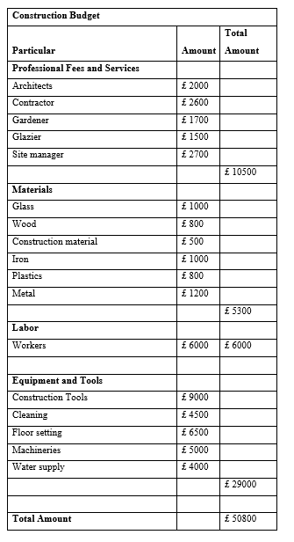

Time
Gantt chart
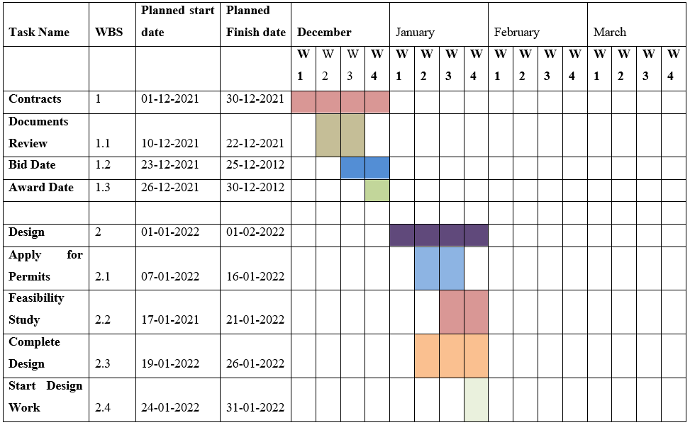
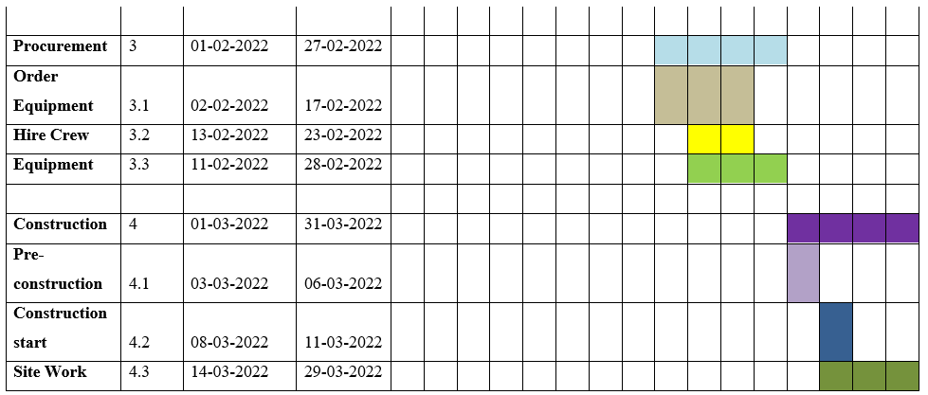

Quality
The achievement of appropriate levels of efficiency from building operations is quality in the construction of the campus (Ika et al., 2020). The owner's efficiency will be realized when the functions and other tasks are completed. Any commodity or service might be of satisfactory quality if it is delivered in the intended condition (Müller, Drouin and Sankaran, 2019). Receiving quality in a building is the most difficult problem to solve. An ineffective quality management procedure will result in a waste of money, material, resources, and time. The designer on the building spot, for example, will describe the precise location of the tangible.
The university's contractor can use the tangible's ingredients if the required grade of tangible is received (Hair and Sarstedt 2021). There are several quality objectives in the construction of the university, such as finishing the project within a specified time frame, following contract requirements, enhancing owner satisfaction, and ignoring chains and disputes. Quality assurance is a plan that should be followed to keep the work's quality and standard high (Ika et al., 2020). It is beneficial to the university since it establishes a vigorous organization structure, and it is necessary to have a superiority assurance diagram, which aids in the identification of different checks at numerous rates.
The quality assurance plan consisting essential key considerations
- A comprehensive plan for career advancement
- A good procurement system is needed to find great vendors and resources.
- Safety programs that are well-organized
- Innovative ideas will be rewarded through a program.
- Managers and employees will benefit from training programs (Armenia et al., 2018)
Factors that affect construction project quality
Construction Organization
It is based on certain research that considered and included in the agreement the management criteria of a successful construction company would impact the project quality (Chawla et al., 2018). The University of Wisconsin-Taylor-Statesman will use it by picking a well-organized construction business and signing a contract with them for high-quality building.
Participation of team members
It is one of the most important variables that affect the quality of construction, which implies that quality team members are required not only during the planning phase but also during the building phase (Chawla et al., 2018). As a result, UWTSD will effectively use this to promote team member participation and motivate them to effectively design a new educational building.
Quality Team
Having quality project and construction personnel successfully provides a planned atmosphere. Continuously and structurally, activities are efficiently carried out with regular quality checks (Armenia et al., 2018). To deliver a quality project, the quality teams would include well-trained personnel, owners, environmental engineers, architects, and civil engineers.
Project requirements
UWTSD University can use this to efficiently construct the building, and meeting project management standards can achieve top-notch construction (Armenia et al., 2018). It would effectively meet the needs of the designers, as well as the needs of the proprietor and the function Object.

Human resource management
Human resource management, or HRM, refers to the process of properly managing a person inside a firm (San Cristóbal et al., 2018). In a construction project, HRM is primarily concerned with ensuring that the project has sufficient human resources to complete the task with the appropriate and practical skill sets to meet the project's objectives. UWTSD will use the HRM to develop structures in a timely manner while maintaining high quality (Bond-Barnard, Fletcher and Steyn, 2018). Facility management at UWTSD University engages in a variety of HRM tasks, and they will engage in the following main activities while managing the construction project:
- Training and development
- Analysis and definition of roles
- Reimbursement (remuneration) (Walker, 2015)
- Workforce planning, selection, and temporary worker recruiting when needed
- Ensure that everyone has an equal chance.
- Management of performance
- Dispute resolution
- Communicating with co-workers
- Managing the relationships between employees (San Cristóbal et al., 2018)
- Concerns about the law
- Managing the wages, benefits, and payroll of employees
- assessing performance, and so on (San Cristóbal et al., 2018)
Facility management at UWTSD University, on the other hand, may confront several potential dangers or obstacles while managing constriction activities, as shown below:
- Countless legal obligations
- There isn't enough time for strategic planning (Walker, 2015).
- Risks to health and safety
- Financial concerns
- The construction company's operational realities
- The employees may be required to work lengthy hours (Bond-Barnard, Fletcher and Steyn, 2018)

Benefits realization
The prominence of making value through the project is broadly explored in management of a project, and this can be effectively articulated. This is an effective method for finding the major benefit of constructing a project that is utilized by firms or project managers. According to the case scenarios, UWTSD University plans to build a building for educational purposes. There are numerous advantages to expanding and developing the university building in different sections, including higher education, literacy level, and offering students efficient education is profitable for career advancements of students while enhancing coaching services and other relevant vacancies, which can lead to the increased employment rate in the United Kingdom.

References
Aanbari, F.T. and Kwak, Y.H., 2018, June. Impact on project management of allied disciplines. Project Management Institute.
Armenia, S., Dangelico, R.M., Nonino, F. and Pompei, A., 2019. Sustainable project management: A conceptualization-oriented review and a framework proposal for future studies. Sustainability, 11(9), p.2664.
Bond-Barnard, T.J., Fletcher, L. and Steyn, H., 2018. Linking trust and collaboration in project teams to project management success. International Journal of Managing Projects in Business.
Chawla, V., Chanda, A., Angra, S. and Chawla, G., 2018. The sustainable project management: A review and future possibilities. Journal of Project Management, 3(3), pp.157-170.
Chen, T., Fu, M., Liu, R., Xu, X., Zhou, S. and Liu, B., 2019. How do project management competencies change within the project management career model in large Chinese construction companies?. International Journal of Project Management, 37(3), pp.485-500.
Hair, J.F. and Sarstedt, M., 2021. Explanation plus prediction—The logical focus of project management research. Project Management Journal, 52(4), pp.319-322.
Ika, L.A., Söderlund, J., Munro, L.T. and Landoni, P., 2020. Cross-learning between project management and international development: Analysis and research agenda. International Journal of Project Management, 38(8), pp.548-558.
Kerzner, H., 2022. Project management case studies. John Wiley & Sons.
Müller, R., Drouin, N. and Sankaran, S., 2019. Modeling organizational project management. Project Management Journal, 50(4), pp.499-513.
San Cristóbal, J.R., Carral, L., Diaz, E., Fraguela, J.A. and Iglesias, G., 2018. Complexity and project management: A general overview. Complexity, 2018.
Tereso, A., Ribeiro, P., Fernandes, G., Loureiro, I. and Ferreira, M., 2019. Project management practices in private organizations. Project Management Journal, 50(1), pp.6-22.
Walker, A., 2015. Project management in construction. John Wiley & Sons.

