MARKETING FUNDAMENTALS
INDIVIDUAL REPORT: GLOBALISATION

Name: Iulian Neagu
Student Number: 2107401
Lecturer: Nazia Saeed
Module code: LCBB4004
Table of Contents
Introduction 3
I. Overview of the Organisation 3
II. Evolution in marketing strategies of Morrisons to take advantage of the new developments within the business environment after Covid-19 to gain a competitive advantage 6
III. Impact of Key Stakeholders on the Marketing Operations of Morrisons PLC 10
Recommendations 14
Conclusion 15
Reference List 16

Introduction
Introduction of new strategies and technologies in marketing tactics have become necessary for business organisations in order to enhance the firm’s competitive advantage as well as competitive positioning. This report will indicate how the changes in the external and internal business environment of the UK retail sector have resulted in the changes and incorporation of new technologies for optimising the marketing strategies of Morrisons. The report will shed light on the fact that the changing business environment has transformed the marketing strategies of Morrisons, wrestling in the firm gaining more profits even during crisis periods like the pandemic situation. In addition, the firm even gained competitive advantage due to its advanced technological incorporation and marketing initiatives as per customer preferences and industrial trends. The key stakeholders of Morrison and their impact on the marketing functions will be discussed in the report as well.

I. Overview of the Organisation
Morrisons is a retailer whose roots can be traced back to Bradford, United Kingdom (Morrisons, 2022). The company was established in 1931 by Sir Ken Morrison to " provide food for everyone” (Morrisons, 2022). Effective management and efficient recruitment have enabled the company to cultivate success and become one of the leading businesses in the retail industry of the UK. The constant profit margin of the company has prompted the management to focus on expanding the company’s market to overseas territories. As a result, Morrisons have recently formed a strategic partnership with the British Corner Shop which has enabled the company to supply foreign retailers located in Hong Kong, Malta, Singapore, and St. Helena, through the B2B model (Morrisons PLC, 2022).
Impact of the Pandemic on Morrisons PLC
The pandemic was a turbulent period for the global economy. The article published by Nicola et al. (2020), states that businesses operating in the UK were obliged to follow the governmental guidelines aimed at safeguarding public health concerns amid the pandemic. The restrictions imposed by the government hampered the profit margin of several businesses which led to the decline in the economy. Moreover, existing studies conducted by scholars point to the fact that the UK economy was already suffering from the implications of Brexit and it was recovering gradually (Latorre et al., 2019). The data provided by Clark (2023), infers that Brexit and the pandemic expedited the rise in the inflation rate in the economy of the UK, which is evident from the chart below.
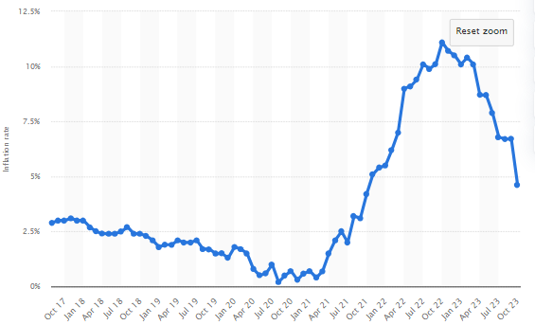
Figure 1: Inflation Rate in the UK Economy
(Source: Clark, 2023)
The rise in inflation rate subsequently affected the prices of various products and services available in the UK and contributed to the decline in the economy of the nation. Several businesses in the UK suffered the consequences of a declining economy and as a result, the unemployment rate experienced steady growth during the pandemic (Lea, 2020). The rise in the unemployment rate can be justified by Maslow’s motivational theory which states that employees are motivated to work if their demands are satisfied (Hopper, 2020). Businesses failed to provide for their staff, which facilitated the rise in the unemployment rate in the UK during the pandemic. The rise in the unemployment rate resulted in the availability of skilled labour, which was capitalised on by Morrisons PLC, which recruited numerous employees during the pandemic (BBC, 2020).
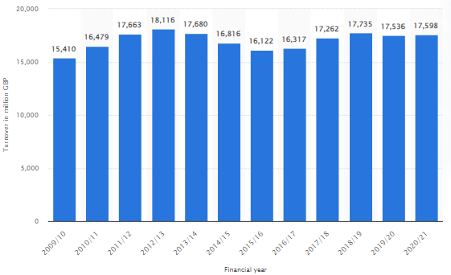
Figure 2: Annual Turnover of Morrisons PLC
(Source: Statista, 2022)
However, the data obtained from Statista (2022), infers that the annual turnover of Morrisons did not experience any significant change. From the figure displayed above, it can be said that the profitability of Morrisons PLC declined marginally compared to the profit margin of other businesses operating in the UK. The ability of the company to manage its operations and maintain profitability even during the pandemic can be attributed to the marketing strategies employed by the management of Morrisons during the pandemic, which will be elaborated extensively in the next sections. The strategies employed by the management of Morrisons PLC while addressing the needs of its stakeholders enabled the company to maintain profitability in its operations and emerge as one of the leading retailers in the United Kingdom (Statista, 2023).
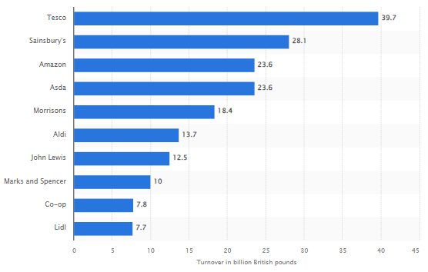
Figure 3: Leading Retailers in the UK
(Source: Statista, 2023)

II. Evolution in marketing strategies of Morrisons to take advantage of the new developments within the business environment after Covid-19 to gain a competitive advantage
Shifts in the Business Environment after Covid-19
Following the Covid-19 outbreak, the UK retail sector experienced substantial changes. E-commerce and online buying increased as consumers migrated to digital platforms for convenience and security. Physical stores experienced issues, prompting a reevaluation of retail environments. Health and safety precautions have become mandatory, influencing in-store experiences. Supply chain disruptions impacted inventory management, emphasising the importance of resilience. Consumer preferences have shifted towards sustainable and local products (Flett et al., 2020). The role of technology, notably contactless payments, has grown in importance. These movements show a dynamic adaptation to the new normal, changing the retail scene in the United Kingdom.
Overview of How Morrisons Adapted to Changing Business Landscape
Morrisons adopted strategic changes in response to the changing business situation post-Covid-19. Capitalising on the growth in digital shopping, the company prioritised e-commerce and strengthened its online presence. Morrisons established health measures in stores to ensure a healthy shopping experience, emphasising safety (Borrero Sánchez, 2023). To handle interruptions, supply chain resilience and inventory management were increased. Morrisons also embraced sustainability and local sourcing to keep up with changing consumer tastes. Morrisons demonstrated adaptability and innovation through these efforts, preparing itself to succeed in a changing retail sector.
Key Strategic Changes Implemented
Following Covid-19, Morrisons implemented significant strategy changes, emphasising on e-commerce expansion to meet rising online demand. The organisation improved its digital capabilities by offering convenient and efficient online buying experiences. Operational changes were made to prioritise safety, such as creating health guidelines and altering store layouts. Morrisons also increased its supply chain resilience, assuring continuous product availability (RASHID, 2020). These strategic revisions demonstrated the company's adaptation to the post-pandemic climate, aligning with growing consumer preferences and promoting long-term resilience in the competitive retail market.
Advancement of Technology in Morrisons' Marketing
Technology is fundamental to Morrisons' post-Covid-19 marketing approach, driving innovation and improving consumer experiences. To address the increased demand for e-commerce, the company exploited digital platforms to build its online presence. Advanced data analytics and artificial intelligence were used to acquire insights into consumer behaviour, enabling for personalised marketing tactics (Cai et al., 2021). Morrisons utilised technology to streamline supply chain processes, assuring effective inventory management and product availability. Furthermore, the introduction of contactless and mobile payment solutions improved in-store purchases while emphasising safety. Embracing innovative technologies has positioned Morrisons as a digitally advanced store, allowing it to remain competitive, responsive to market trends, and more aligned with the increasing demands of modern consumers.
Morrisons strategically embraced e-commerce and digital marketing to broaden its market reach and successfully engage customers, particularly in the aftermath of the Covid-19 outbreak. The company capitalised on the growing trend of online shopping by building a solid web platform that provided clients with easy access to goods. Social media, email, and other online platforms were used to target digital marketing efforts to specific consumer segments. Morrisons used data analytics to determine client preferences, optimising marketing strategies for personalised experiences (Boyle et al., 2020). This omnichannel strategy not only increased Morrisons' customer outreach, but it also increased brand loyalty. Morrisons' competitive position in the retail industry has improved as a result of the incorporation of innovative technologies and sophisticated marketing methods post-Covid-19 (Morrisons-corporate, 2023). The use of data analytics and artificial intelligence has improved customer insights, allowing for personalised marketing methods. Morrisons' excellent response to market upheavals through technological innovation has positioned it as a forward-thinking and customer-centric brand, consolidating its competitive position in the dynamic business landscape.
How Marketing Strategies Contributed to Competitive Edge
Morrisons' marketing strategies have been critical in establishing a competitive edge by connecting with altering customer preferences. Adoption of digital marketing and e-commerce activities increased customer engagement, ensuring a pleasant purchasing experience. Morrisons' emphasis on personalised promotions, data-driven insights, and a dedication to sustainability aligned well with contemporary consumer tastes, solidifying its market position (Sit et al., 2022). The company's flexible and customer-centric strategy, as evidenced by its targeted marketing efforts, has been critical in maintaining a competitive edge in the volatile retail industry.
Morrisons' enhanced Focus on Customer Needs and Preferences
During the epidemic, Morrisons prioritised the expansion of its home delivery services, increasing capacity, cooperating with courier partners, and launching doorstep delivery. These programmes proved Morrisons' agility in responding to changing customer needs, providing community access to key products (Naeem, 2021).
Morrisons altered its marketing strategy by incorporating cutting-edge technology such as Artificial Intelligence (AI), Augmented Reality (AR), and Virtual Reality (VR). AI algorithms gave personalised recommendations, improving the buying experience, while AR and VR developed immersive advertising, providing virtual product encounters. These innovations modernised Morrisons' marketing and met the needs of tech-savvy consumers, establishing the brand as an industry leader. Morrisons has strategically utilised Artificial Intelligence (AI) and Machine Learning (ML) to boost its marketing efforts, harnessing these technologies to acquire a competitive edge in the retail industry. The application of AI and ML is most seen in personalised marketing activities.
AI systems analyse massive databases, such as client preferences, purchasing history, and online behaviour. Morrisons can now understand individual tastes and personalise marketing efforts to specific consumer categories because of this data-driven approach. Personalised recommendations, incentives, and adverts are generated based on AI data, giving customers a more relevant and engaging purchasing experience. Machine Learning enhances these skills by continuously learning and reacting to shifting consumer patterns. Morrisons employs machine learning algorithms to predict client preferences, estimate demand, and optimise pricing tactics. Morrisons is able to respond to market movements and changing client expectations thanks to the dynamic nature of ML (Crick and Crick, 2020).
Furthermore, Morrisons uses AI and ML for inventory management, ensuring efficient supply chain operations. These technologies help to optimise stock levels, reduce waste, and increase overall operating efficiency. Morrisons exhibits its dedication to innovation and keeping at the forefront of technology in the retail sector by using AI and ML into its marketing and operational processes, ultimately giving customers a more personalised and seamless shopping experience.
Morrisons' Environmental and Social Responsibility
Morrisons has prioritized environmental and social responsibility, demonstrating a commitment to sustainability and customer well-being. The company focuses on reducing plastic usage, increasing recyclability, and supporting local communities. Initiatives like the removal of plastic bags, commitment to recyclable packaging, and efforts to tackle food waste underscore Morrisons' dedication to environmental stewardship. Furthermore, the company engages in various community support programs, such as donating unsold food to charity and collaborating with local organizations (Flett et al., 2020). Morrisons' multifaceted approach aligns with contemporary values, reflecting a corporate ethos that extends beyond commerce to positively impact the environment and society.
Morrisons has effortlessly integrated sustainability into their marketing strategy, emphasising eco-friendly projects and responsible practices. Morrisons expresses its commitment to sustainability through marketing efforts ranging from encouraging recyclable packaging to minimising single-use plastics. This integration not only coincides with environmental concern, but it also resonates with consumers who are increasingly appreciating socially responsible enterprises.
Morrisons' Future Marketing Strategies
Morrisons is preparing for future marketing tactics that prioritise both client satisfaction and sustainability. The company's goal is to improve the consumer experience using sophisticated technologies, personalised services, and an omnichannel approach. Simultaneously, Morrisons remains committed to sustainable practices, concentrating on cutting carbon emissions, sourcing sustainably, and minimising environmental effect (Borrero Sánchez, 2023). Morrisons aims to fulfil growing consumer expectations while also contributing positively to the environment, promoting long-term customer loyalty and corporate responsibility by connecting client-centric innovations with a strong sustainability strategy.

III. Impact of Key Stakeholders on the Marketing Operations of Morrisons PLC
It is established that Morrisons PLC operates primarily in the retail industry of the UK. The company maintains transparency with its stakeholders through periodic press releases. The sustainability report for 2020-2021, published by the company states that the key stakeholders of Morrisons PLC are the customers, employees, suppliers, community, shareholders, NGOs and the Government (Morrisons PLC, 2021). The stakeholder matrix provided below portrays the influence of the different stakeholder groups on the operations of Morrisons PLC.
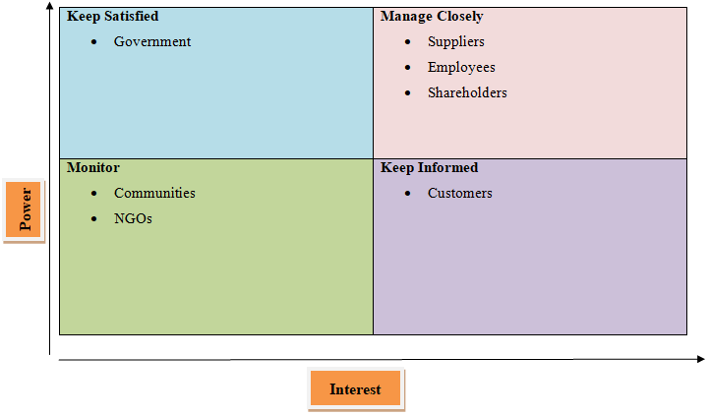
Figure 4: Stakeholder Matrix of Morrisons PLC
(Source: Created by the learner)
According to Freeman (2023), the stakeholder theory posits that businesses will benefit from satisfying the demands of all of their stakeholders. In other words, contemporary businesses should respect the needs and demands of stakeholder groups in order to maintain profitability in their operations. The impact of stakeholder management on the marketing operations of Morrisons PLC is analysed below.
Customers
Customers are the backbone of businesses as they directly account for the profit generation of respective businesses. Morrisons is a retailer, and the majority of the products included in the company’s catalogue are categorised under grocery, food and beverages (Morrisons, 2023).
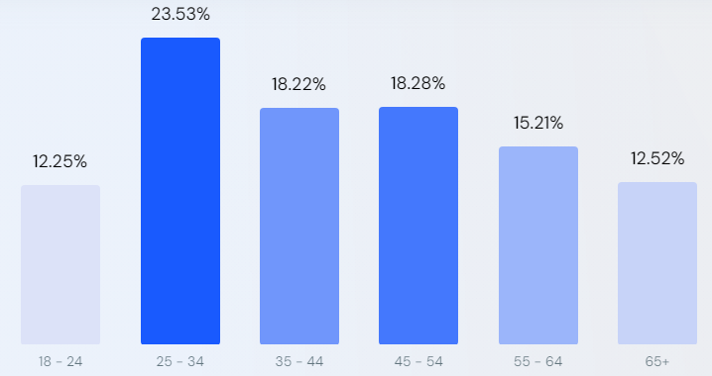
Figure 5: Customer Age Profile of Morrisons PLC
(Source: similarweb, 2023)
The data obtained from web analytics states that the majority of customers of Morrisons are aged between 25-54 (similarweb, 2023). It can be assumed that these individuals account for a significant part of the customer base of Morrisons PLC. Therefore, it can be stated that the customers of Morrisons PLC are mostly millennials. The chart below depicts consumer behaviour concerning grocery shopping in the UK.
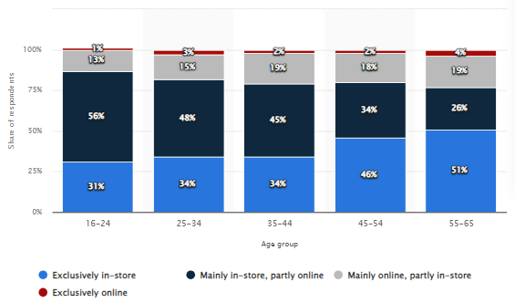
Figure 6: Grocery Shopping Behaviour of Customers in the UK
(Source: Statista, 2022)
The data was published in 2022, which makes it relevant for analysing consumer behaviour in the post-pandemic period. From the bar graph displayed above, it can be stated that the consumer behaviour of millennials aligns with both online shopping as well as conventional brick-and-mortar store visitations (Statista, 2022). However, the data portrays that the millennials in the UK mostly prefer shopping online for groceries. The behaviour can be corroborated by the study conducted by Sheth (2022), who states that businesses are actively shifting to the digital medium in the post-pandemic period because of the growth in the e-commerce sector during the pandemic. This development can be partly attributed to the quarantine restrictions imposed by the government to safeguard public health during the pandemic.
As a result of changing customer behaviour in the post-pandemic period, the management of Morrisons kept track of the concurrent development and aligned their business model to the changing consumer behaviour. The article formulated by Quinn (2021), states that Morrisons PLC used to incentivise traditional brick-and-mortar store shopping through its plastic loyalty card which used to offer considerable discounts and additional benefits to the customers shopping in Morrisons outlets. On the other hand, the management declared that the company has decided to ditch the physical card for a digitalised version of the loyalty card which can be used in physical stores and websites or applications of the company as well (Quinn, 2021). It can be stated that the plastic loyalty card was a marketing strategy of Morrisons PLC to incentivise bulk purchases in the physical store. This strategy aligned with loyalty programmes, which are prevalent in the current business environment. Therefore, the shift to the digitalised version of the loyalty card which is not exclusive to conventional outlets outlines the change in the business dynamics of Morrisons PLC. Hence it can be summarised that the impact of customers’ changing behaviour, prompted by the pandemic pushed the company to focus on the digital outlet of the business and implement marketing strategies that uphold and incentivise the use of the e-commerce segment of the business.
Community
Among the stakeholders, communities include the interested parties within the operational area of the business. As stated earlier, the pandemic imposed severe financial restrictions on the economy of the UK.
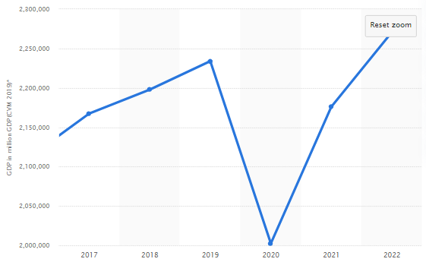
Figure 7: Annual GDP of the UK
(Source: Statista, 2023)
The figure displayed above points to the poor situation of the UK economy during the pandemic. The poor economic situation in the UK affected the profitability of local businesses and also hindered their development. The local businesses in the UK are an essential part of the community which is one of the key stakeholders for Morrisons PLC. The governmental website of the UK states that statistics of closure of local businesses increased by 50% in 2021 and the amount was close to 100,000 (Williams, 2021).
As a response to the declining economy in the UK, the management of Morrisons PLC devised a marketing campaign named ‘Fresh In’, which provided customers with a variety of options in terms of fresh vegetables and fruits (Morrisons PLC, 2021). This marketing campaign acquired fresh produce from local farmers and merchants operating in the UK which enabled the company to enhance its contribution to the development of the economy and subsequently help the local farmers and businesses to regain their financial stability in the post-covid period. Therefore, it can be stated that the management of Morrisons PLC altered its marketing campaigns to focus on the development of local businesses and farmers, who are part of the key stakeholders of Morrisons.
Rest of the Stakeholders
The employees, suppliers, NGOs, shareholders and the government account for the rest of the stakeholders of Morrisons PLC. These stakeholder groups were inflicted by the economic repercussions of the pandemic. However, the impact of the pandemic on the conduct and expectations of these stakeholders was directed towards achieving economic stability. Thus, the management of Morrisons implemented prominent strategies in its marketing operations to generate additional profit and consequently help out the stakeholders suffering from the economic crisis.
It has already been established that the alterations made by the management of Morrisons PLC have been able to minimise the financial losses which were the consequence of the pandemic (Statista, 2022). The minimisation of financial losses can be deemed as a contribution of the management for the benefit of the stakeholders. Therefore, to summarise the key findings of this section, it can be stated that the change in consumer behaviour and the economic crisis faced by the local businesses were averted by the change made by the management of Morrisons PLC to the existing marketing strategy. The main alteration which enabled the management of the business was the shift to the digital medium of business. Thereafter, the management facilitated the acquisition of fresh produce from local businesses and British farmers to support local businesses. By implementing these marketing practices, the company was able to maintain profitability in its operations and minimise losses, which were beneficial for the rest of the stakeholders as well.

Recommendations
The research conducted above yielded significant information regarding the marketing strategies employed by the management of Morrisons PLC to counter the economic crisis during the pandemic. The research yielded that the company is currently focused on driving profits through the e-commerce segment of the business which utilises the website and cell phone application. Although there were no visible flaws in the marketing strategies devised by the management, the company can improve the output of these strategies by inculcating AI within the UI of the application and the website of the business which caters to the e-commerce purchases of the customers. AI can improve productivity by utilising data analytics and machine learning techniques to provide viable suggestions to customers as per their buying behaviour (Ma and Sun, 2020). Providing accurate and relevant suggestions to customers at the right time accounts for influencing consumer behaviour which also generates sales.
Furthermore, the management can improve the output of the marketing strategies by exploring other viable digital marketing channels such as influencer or email marketing. These channels are relatively cheap and require generic digital marketing skills to alter the existing marketing operations. Exploring additional marketing channels which align with the consumer preferences of other customer segments will enable the company to generate additional profit, and subsequently improve the ROI of marketing operations.
Thereafter, the company can generate customer engagement by employing an SEO expert. SEO or Search Engine Optimisation refers to the process of directing organic traffic to the website of a respective business with the inclusion of popular keywords based on the number of web searches (Nagpal and Petersen, 2017). By implementing SEO, the management of the company can facilitate customer acquisition which will complement the profit margin of the company. These are some of the recommendations which can enhance the overall output of Morrisons PLC.

Conclusion
The above report indicated that in order to improve the firm's competitive edge and competitive positioning, commercial organisations must implement new marketing strategies and technology. The research demonstrated how changes in the external and internal business environments of the UK retail industry have resulted in modifications and the inclusion of new technology for optimising Morrisons' marketing tactics. The paper also indicated how the shifting business environment has modified Morrisons' marketing techniques. This resulted in the firm gaining more profits even during the pandemic situation. Furthermore, the company obtained a competitive advantage as a result of its superior technology incorporation and marketing initiatives based on customer preferences and industry trends. The report demonstrated that the key stakeholders in Morrisons played an essential role in enhancing the marketing functions of the firm.

Reference List
BBC, 2020. Coronavirus: Morrisons and Iceland hire thousands. www.bbc.com. [online] 8 Sep. Available at: https://www.bbc.com/news/business-54072287 [Accessed 24 November 2023].
Borrero Sánchez, J.D., 2023. Agri-food Cooperatives’ Online Marketing: Evaluation of the Strategies Utilized by Spanish and UK Food Retailers Pre-and Post-COVID-19 Pandemic.
Boyle, P., Bond, R., Martinez Carracedo, J., Simmons, G., Mulvenna, M. and Hollywood, L., 2022. The impact of the COVID‐19 pandemic on grocery shopper behaviour: Analysis of shopper behaviour change using store transaction data. Journal of Consumer Behaviour, 21(2), pp.259-271.
Cai, M., Tindal, S., Tartanoglu Bennett, S. and Velu, J., 2021. ‘It’s like a war zone’: Jay’s liminal experience of normal and extreme work in a UK supermarket during the COVID-19 pandemic. Work, Employment and Society, 35(2), pp.386-395.
Clark, D., 2023. UK: historical CPI rates 2000-2018 | Statista. [online] Statista. Available at: https://www.statista.com/statistics/306648/inflation-rate-consumer-price-index-cpi-united-kingdom-uk/ [Accessed 24 November 2023].
Crick, J.M. and Crick, D., 2020. Coopetition and COVID-19: Collaborative business-to-business marketing strategies in a pandemic crisis. Industrial Marketing Management, 88, pp.206-213.
Flett, E., Wilson, J. and Gover, R., 2020. Morrisons off the hook as employers welcome clarity on vicarious liability for data breach: WW Morrison Supermarkets plc v Various Claimants [2020] UKSC 12. Journal of Intellectual Property Law & Practice, 15(7), pp.504-506.
Freeman, R.E., 2023. The politics of stakeholder theory: Some future directions. In R. Edward Freeman’s Selected Works on Stakeholder Theory and Business Ethics (pp. 119-132). Cham: Springer International Publishing.
Hopper, E., 2020. Maslow’s hierarchy of needs explained. ThoughtCo, ThoughtCo, 24, pp.1-3.
Latorre, M.C., Olekseyuk, Z., Yonezawa, H. and Robinson, S., 2019. Brexit: Everyone loses, but Britain loses the most. Peterson Institute for International Economics Working Paper, (19-5).
Lea, R., 2020. Coronavirus crisis: Unemployment and redundancies begin to rise. Arbuthnot Banking Group, 21, pp.1-20.
Ma, L. and Sun, B., 2020. Machine learning and AI in marketing–Connecting computing power to human insights. International Journal of Research in Marketing, 37(3), pp.481-504.
Morrisons PLC, 2021. Sustainability Report 2020-2021. [online] www.morrisons-corporate.com. Available at: https://www.morrisons-corporate.com/globalassets/corporatesite/investor-centre/annual-report/24729_morrisons_sr_2021_interactive.pdf [Accessed 24 November 2023].
Morrisons PLC, 2022. Morrisons launches its ‘Fresh In’ campaign. [online] Morrisons. Available at: https://www.morrisons-corporate.com/media-centre/consumer-news/morrisons-launches-its-fresh-in-campaign/ [Accessed 24 November 2023].
Morrisons PLC, 2022. Morrisons Wholesale partners with British Corner Shop to expand global distribution. [online] Morrisons. Available at: https://www.morrisons-corporate.com/media-centre/corporate-news/morrisons-wholesale-partners-with-british-corner-shop-to-expand-global-distribution/#:~:text=Morrisons%20has%20partnered%20with%20British [Accessed 24 November 2023].
Morrisons, 2022. Company History - Morrisons Corporate. [online] Morrisons. Available at: https://www.morrisons-corporate.com/about-us/company-history/ [Accessed 24 November 2023].
Morrisons, 2023. Morrisons | Online Shopping | Food, Drink & More To Your Door. [online] Morrisons.com. Available at: https://groceries.morrisons.com/webshop/startWebshop.do [Accessed 24 November 2023].
Morrisons-corporate, 2023. Morrisons unveils new home delivery measures To Feed The Nation. Available from: https://www.morrisons-corporate.com/media-centre/corporate-news/morrisons-unveils-new-home-delivery-measures-to-feed-the-nation/Accessed 24 November 2023].
Naeem, M., 2021. Do social media platforms develop consumer panic buying during the fear of Covid-19 pandemic. Journal of Retailing and Consumer Services, 58, p.102226.
Nagpal, M. and Petersen, J.A., 2021. Keyword selection strategies in search engine optimization: how relevant is relevance?.Journal of retailing, 97(4), pp.746-763.
Nicola, M., Alsafi, Z., Sohrabi, C., Kerwan, A., Al-Jabir, A., Iosifidis, C., Agha, M. and Agha, R., 2020. The socio-economic implications of the coronavirus pandemic (COVID-19): A review. International journal of surgery, 78, pp.185-193.
Quinn, I., 2021. Morrisons’ digital-only announcement marks a new direction for loyalty. [online] The Grocer. Available at: https://www.thegrocer.co.uk/the-grocer-blog-daily-bread/morrisons-digital-only-announcement-marks-a-new-direction-for-loyalty/654306.article [Accessed 24 November 2023].
RASHID, C.A., 2020. Balanced Score Card and Benchmarking as an Accounting Tool to Evaluate Morrison’s Performance. Journal of Global Economics and Business, 1(3), pp.59-72.
Sheth, J.N., 2022. Post-pandemic marketing: when the peripheral becomes the core. Journal of Research in Interactive Marketing, 16(1), pp.37-44.
similarweb, 2023. Morrisons PLC. [online] www.similarweb.com. Available at: https://www.similarweb.com/website/groceries.morrisons.com/#demographics [Accessed 24 November 2023].
Sit, K.J., Ballantyne, E.E. and Gorst, J., 2022. Profiling shoppers’ coping behaviours during a pandemic crisis: A regulatory focus perspective. Journal of Retailing and Consumer Services, 64, p.102811.
Statista, 2022. Morrisons annual turnover 2021. [online] Statista. Available at: https://www.statista.com/statistics/382306/morrisons-turnover-united-kingdom-uk/#:~:text=Morrisons%20annual%20turnover%20in%20the [Accessed 24 November 2023].
Statista, 2022. UK grocery shopping channels by age 2022. [online] Statista. Available at: https://www.statista.com/statistics/1319410/grocery-shopping-channels-uk-age-group/ [Accessed 24 November 2023].
Statista, 2023. Gross domestic product of the United Kingdom from 1948 to 2021. [online] Statista. Available at: https://www.statista.com/statistics/281744/gdp-of-the-united-kingdom/ [Accessed 24 November 2023].
Statista, 2023. Leading 10 retailers in the UK 2019. [online] Statista. Available at: https://www.statista.com/statistics/462863/leading-ten-retailers-by-sales-uk/#:~:text=The%20United%20Kingdom [Accessed 24 November 2023].
Williams, M., 2021. Business demography, quarterly experimental statistics, UK - Office for National Statistics. [online] www.ons.gov.uk. Available at: https://www.ons.gov.uk/businessindustryandtrade/business/activitysizeandlocation/bulletins/businessdemographyquarterlyexperimentalstatisticsuk/julytoseptember2021 [Accessed 24 November 2023].

