Andreea Olivia Staicu (2021165)

University of Wales Trinity Saint David
Skills for the Workplace (Health and Social Care)]
Lecturer John Malagila
BMSW4003

Digital skills
&
research methods

Digital Skills in healthcare
Contents

1.Introduction
2.Contemporary technology
3.Digital technology in healthcare
4.Digital tools
5.Techniques to improve efficiency in healthcare
6.Digital literacy
7.How did technologies contribute to communication?
8.Use of technology during Covid-19
9.Conclusion
10.References



1.Introduction

Over the years, the adoption of technology in Health Care has contributed to improving medical diagnosis and treatment. Healthcare is probably the most significant of the sectors that have benefited from technological innovation. As a result, the quality of living has changed over time, and many lives have been saved as an outcome of that.
Therefore, IT allows health care providers to record and transfer information from a patient's medical records. It also improves patient communication by including a compact form that anyone can use. Consequently, the probability of prescription errors is reduced. Finally, it facilitates the collection of medical records from a database without the need for new medical tests. Using electronic medical records, common problems can be improved based on previous evidence.
Through this report, I will present the importance and evaluation of using digital technology in Heath Care.

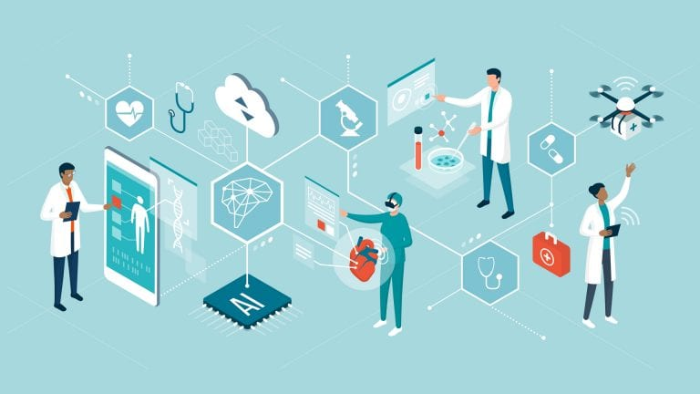

2.Contemporary technology
Contemporary technology is basically a progress of old technologies and new technology's effect on contemporary life is simply unmeasurable.
Contemporary technology simplifies life in so many ways and everyone defines in their own way. With others, modern technology means complicated electronic devices, and for some it means the cause of radical changes in all life stages.
The main reasons of using contemporary technology:
- Easy to access the information
- Save time
- Easy to use
- Better communication
- Cost efficiency
- Improved Health and Social Care
- Improved Banking
- Better learning techniques
- Disable-d are now Able-d

3.Digital technology in healthcare
Through the years, technology has changed our life and our environment. Technology has developed excellent tools and services that provide us with invaluable knowledge.
Multifunctional gadgets like the smart watch and tablet have been the subjects of modern technologies. Computers are faster, more compact, and more powerful than ever. Technology has made our lives smoother, quicker, safer, and more fun with all these revolutions.
4.Digital Tools
- Clinical Apps- People frequently use mobile phone applications and online resources to support their health and wellbeing, as well as to tracking, manage, and treat their condition while they are unwell. Doctors are now heavily focusing on medical applications that run on smartphones or tablet computers to help them with their work.
- Personal health records and patient portals-Personal health records are digital tools that assist individuals in maintaining their wellbeing and managing their treatment.
- Telemedicine and e-consultations- Telemedicine is the delivery of healthcare facilities using technologies to share knowledge for illness and injury detection, recovery, and prevention, study, and assessment, and continuing clinical education. For example, having access to specialist treatment through virtual appointments and the use of monitors (e.g., blood pressure, weight, urine) for long-term condition control.

5.Techniques to improve efficiency in healthcare
Many innovative new technologies in healthcare have occurred over the years, for example:
- 3-D printing- three-dimensional printing has been used in a variety of areas for many years. When it comes to medicine, it develops replacements and even surgical joints. It is mostly used in prosthetics and it allows for the creation of perfectly matched arms, allowing for increased stability and mobility.
- Artificial organs- as in 3D printing, the immune system of patients would not be rejected for individual organs or operating institutions. Other than bio-printing, it is a growing field of healthcare technologies that can save millions of patients annually.
- Robotic surgery- keeps adding control, efficiency, and flexibility into the hands of a surgeon to perform the surgery in a non-invasive way. It has facilitated or even made possible certain operations.
- Health wearables- introduced as a fitness tracker to monitor heart rate and speed. Cardiovascular problems in health wearables can be detected early and severely prevented.
- Virtual reality- has mostly been used for television purposes in past years. The virtual reality will help medical students observe "proper" operations and understand human anatomy digitally.
- Telehealth- is a rapidly growing market where patients can receive medical treatment through digital devices. Patients can quickly contact a doctor to get a prescription as well as medical advice.
Although many innovations have existed in hospitals and medicine, emerging inventions are now available in homecare, as well:
➢ IoT systems are among the best technologies for the protection of the elderly or disabled. The fall detection system is a perfect example. Small devices can recognize when someone is falling by wearables or floor and bed sensors. Just intercoms, or smartphone alarms, inform carers when these sensors go off.
➢ Medical Alert Systems. When the customer requires help, he presses the button and is alerted to a carer or companion in his neighbourhood. Companies like Mobile Help and Medical Guardian provide monitored medical alert systems.

6.Digital Literacy
Digital literacy is the ability to learn, work and develop in a digital workplace and community for all people employed in health care.
We are becoming more digitally literate in our personal lives, whether it be by mobile phones, watching TV and new media, scheduling holidays, or ordering take-away. Many skills are easily transferable to our professional lives, where they can be used to support the best possible results for everyone.
Wearable technology, internet sources, and apps are increasingly motivating us to take an active role in our own health, well-being, and care. Technology is allowing accelerated and improved cooperation between people and those who care about them, resulting in better results.

7.How did technologies contribute to communication?
The technological innovation made contact incredibly fast and easy. It is unbelievable to look back and see how much easier communication over the years has been. Communication systems provide one of the most important examples of the rapid progress of technology.
The simplest way to connect remotely with others was in the past to write a letter, send faxes or use a wired telephone. You have many more effective ways at your fingertips to communicate with everyone in society today. It is possible to deliver a message, fax, video chat, email and call over to the media platforms.

8.Use of technology during Covid-19
Among the most notable advances made during Covid-19 was the increased use of technologies to reduce face-to-face interaction and aid in demand management. This involves expanded usage of existing technology and platforms: further primary and secondary telephone and video consultations; wider use of remote work equipment at home, including virtual wards; increased use of the electronic prescription service; and wider use of the NHS and NHS 111 website.
In addition, COVID-19 has accelerated the use of new technologies and platforms including the NHS app, for booking an appointment and patient recording access; introduction of software for video conferencing, enabling remote work and collaboration, including professional support in the field of clinical decisions; and use of AI-driven image analytics to diagnose and track progress.
While the NHS has been accused of being unable to implement and adopt emerging technology in advance, the latest developments prove that it can do this in an impressive way when circumstances permit and when workers can adapt.

9.Conclusion
In conclusion, I believe that technology will only help and change our lives if we stand on its shoulders and stay two steps ahead of it. However, if we follow this guideline, the collaboration between people and technologies might result in impressive achievements.
Digital technologies in medicine and healthcare will help turn inefficient healthcare services into viable ones, equalise the interaction between medical practitioners and patients, and offer quicker, simpler, and more efficient disease solutions.
Improving digital health and social literacy, we give people more control over their own health and wellbeing and explore technology's potential to close gaps in funding, efficiency, care and quality.

10.References
- Vasilis Bouronikos (2020), Available at: https://ied.eu/blog/importance-of-technology-in-healthcare/#:~:text=Benefits%20of%20Information%20Technology%20in%20Healthcare&text=To%20begin%2C%20IT%20enables%20health,the%20chance%20of%20medication%20errors (Accessed: 25 April 2021)
- iStock-elenabs (2020), Available at: https://www.healtheuropa.eu/four-factors-outlining-healthcare-information-technology-market-trends/102778/ (Accessed: 25 April 2021)
- Gilster Paul. Digital Literacy. New York: Wiley and Computer Publishing, 1997. p. 1 Available at: John Malagila (2021), DSR Week 1, Lecture notes- Digital Skills and Research Methods- Digital Literacy (18.02.2021), University of Wales Trinity Saint David (Accessed: 26 April 2021)
- Aging in Place (2021), Technology In Our Life Today And How It Has Changed, Available at: https://aginginplace.org/technology-in-our-life-today-and-how-it-has-changed/#:~:text=Modern%20technology%20has%20paved%20the,%2C%20better%2C%20and%20more%20fun. (Accessed: 26 April 2021)
- The Medical Futurist (2020), Available at: https://medicalfuturist.com/ten-ways-technology-changing-healthcare/# (Accessed: 26 April 2021)
- Royal College of Physicians, Digital Tools, Available at: https://www.rcpmedicalcare.org.uk/designing-services/themes/health-informatics/digital-tools (Accessed:27 April 2021)
- Ian C. and Janet D. ,The Royal College of Nursing, Improving Digital Literacy, Available at: file:///C:/Users/andre/Downloads/Improving-digital-literacy.pdf ( Accessed :26 April 2021)
- Tim h., Tom H., Shakira m., Will W.(2021), Securing a positive health care technology legacy from COVID-19, Available at: https://www.health.org.uk/publications/long-reads/securing-a-positive-health-care-technology-legacy-from-covid-19 (Accessed: 27 April 2021)
- John Malagila (2021), DSR Week 3, Session 1, Lecture notes- Digital Skills and Research Methods- Contemporary Technology in Health and Social Care (04.03.2021), University of Wales Trinity Saint David (Accessed: 27 April 2021)
- Google.com/Images/University of Wales Trinity Saint David, Available at:
https://images.shiksha.com/mediadata/images/1541152532phpaMbjD5.jpeg (Accessed: 27 April 2021)

