Fundamentals of construction technology
Construction portfolio
Site investigation Study

Morgan Lloyd Davies
1910276

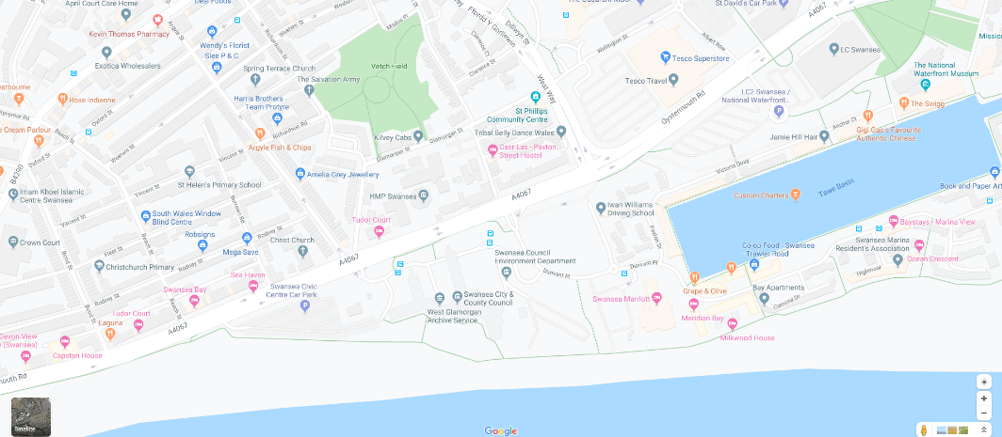

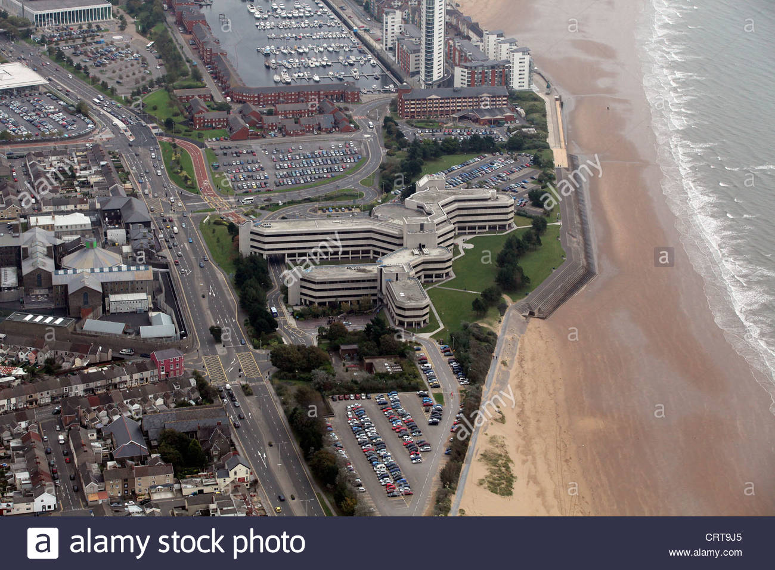

Introduction
For this assignment I will be assuming that i am a junior construction professional where I am employed by the local company tendering for the work.
I will also be considering different foundation methods. On the swansea foreshore.
The city and county of Swansea have entered a joint agreement with Marriott hotels to create a new restaurant and ice-cream parlour on the Swansea foreshore. The site will be located between the country hall and the Marriott Hotel in Swansea. The building is going to be approximately 300 square meters.

In this task I will be researching the historic background of the site and how we will build on the information that i will be retrieving. The target i will be aiming for throughout this task is to see the building regulations/codes of practice.
I will be using various methods of research to gather information for this task for example using DigiMaps which will show a historic map of the surrounding. Taking different surveys to understand the foundations that we will be building on. We will also be looking at secondary research like books and online references so that I can fully understand the best materials, the best method of construction throughout this task.

Task 1
In the first task i will be looking at the historical background of the site. I will be looking at this through desktop study. By looking at the historical background of this building i can then consider what methods are best to use for the foundations, materials and other aspects. One of the biggest elements of this is the health and safety to by looking at archival photographs we can see what the safest ways of construction are possible.

Task 2
For the second task i will be looking at the historical background of the site, and then I will be giving recommendations for the contents of the detailed site investigations. With this he site investigation will be done by other people. And through this I will be advising these people of which different elements of the site investigation I will be considering as being the most significant and applicable to the site which we will be investigating.

Task 3
For the third task i will be looking at the building regulations and the codes of practice for the site that we will be building on. And with this I will go ahead a suggest some recommendations.

Task 4
For the final task i will be sketching a suitable foundation detail for the building after I have gone around and observed the site.

Historical background
After doing some desktop studies about the historical background of this site. I have discovered that there was once a railway passing through the site. Meaning that I need to consider the effect this might have on the site, so there might be bits of metal within the ground because of this. The railway was present for over 150 years dating back to the year 1807 to 1960. This is a big consideration as there might be a vast amount of metal and debris left around the site meaning that We also need to consider that the railway may still be there, and also has the trams carried coal so I am assuming that there may be contaminated coal left on or near the site which we would have to consider.
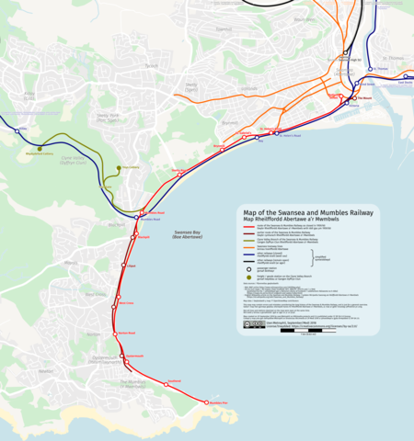
This is where the ice cream parlour will be built
This is a photo of the old railway route from mumbles. By looking at this photo it shows that where the site is and that the old railway would’ve gone through this site. So there may be raw material or fossil fuels left near the site that we will be investigating.

Through more research I found that in World War 2 there was a blitz of bombing on the Swansea bay area meaning there may still be some unexploded bombs within the area. On the blitz more than 30,000 bombs were dropped over 3 nights in the whole of the Swansea area leaving the worst physical damage Swansea has ever seen. We also need to consider that there are still thousands of unexploded bombs still within this area, we know this as a few years ago there was a world war 2 bomb found in Briton Ferry which is 12 miles from the Swansea bay area.

Recommendations for a detailed site investigation
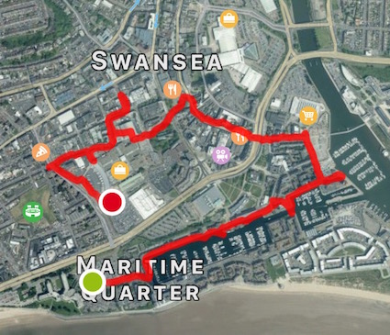
The biggest concern for this ground investigation is the unexploded bomb. So before the ground investigation is been taken we will get out a bomb disposal team who will then go around the area looking for unexploded bombs. Also the permeability of sand is very high meaning that liquid will flow through the sand rapidly, this is a good thing as you can take out oil or natural gas out of the sand as this may cause an explosion so that would need to be removed. Sinkholes need to be considered when investigating this site as well as they can be vital. Sinkholes are formed when the land surface above collapses or sinks into the cavities or when a material is carried downwards into the void. Sand can cause a sinkhole as if there is water within the sand this will then create spaces within the sand meaning that the ground surface no longer has any support so it would cause a sinkhole. When looking at the historical background we saw that there was an old railway that would have passed through the site meaning that there would be contaminated metal within the area so that would need to be removed from the site to ensure that we can build on the site. This would have to be done by a waste disposal team. In terms of what is the most significant part of the site I would have to advise that the first thing they must consider that there may be some unexploded bombs within in the area. This would mean that the skilled team that is hired for this specific task will have to go around the whole area. This picture shows us where the bombs were dropped in the 1941 blitz to Swansea and as you can see it shows that the site that we will be building on was struck by struck by bombs leaving a lot of physical damage to the area. When bombs are dropped they drop vertically down into the ground meaning there will also be more contaminated metal from this and not just from where the old railway was.

Building regulation and codes of practice
When doing building regulations. There are a lot of things that need to be considered in terms of health and safety, deliveries of materials, correct equipment, personnel etc. Other factors we would need to consider are electrical supply, gas supply and water supply. For this I would out and hire experienced personnel who will survey any existing electrical, gas or water supply so when there are people excavating they’re aware of the supplies that lay beneath the ground. This is where you would have a skilled engineer to do a topographic survey to detect any unknown material under the surface so when people are excavating, they are aware of any supply that may be running through the site. Having a survey like this is very important as if excavators didn’t know about these supplies then it could end up in a serious injury or even a fatality. Knowing where the water supply is very important if a fire broke loose on the site then the fire department would know exactly where the water supply is so then they can put the fire out as soon as possible.

Access and egress of the site is very important too as especially for delivery drivers for example concrete waggons, raw material lorries. The access and egress points to be controlled, safe and also big enough so these vehicles can enter the site. As the site is in a busy city where there is constant traffic and congestion, so I would recommend that the deliveries are done at night time to avoid any possible traffic as there could be a load that may be to big for other cars to be on the road.

When on site then, people and machinery should not be crossing paths as It creates a big risk to the builders.

Before workers enter a excavation/ confined space a gas test should be taken everyday before work starts by a qualified personnel.

There should be RAMS (risk assessment and method statement) should be done before anyone entering the location on site with everyone reading and understanding. Permits could also be considered for use with every person signing it before entering a location on site so show that they understand the risks and what they should be aware of.

Where to put waste is also a big consideration as it can be environmentally harmful. This is by having skips and bins on site labelled with what should be put in them for example, wood skips, metal skips, recycling bins. Air pollution should be kept at minimum.

And also residences should also be taken into consideration as the level of noise at a certain time may disturb some people.

(This photo was drawn by Morgan Davies, 2019)

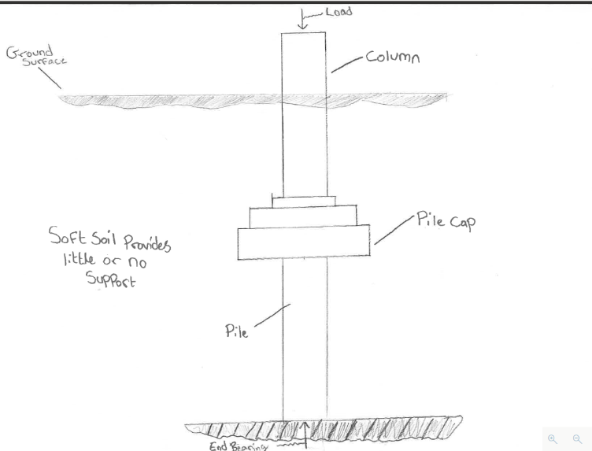
Piling method
After doing a desktop study and investigating the site with a ground investigation. We saw that there was an excess amount of sandy soils which lies deep beneath the site. This would mean that the most suitable pile for this type of foundation is the end- bearing pile. This sort of pile is where most of the friction is developed at the bottom of the pile. The pile then transmits a load directly to firm strata, and also receives a lateral restraint from subsoil. The construction method for this pile is called the bored piles. Bored piles that are augured and then concrete is poured in situ. This sort of pile removes spoil to form a hole for the pile so that concrete can be filled in situ. This piling is used primarily in the cohesive subsoils for the foundation piles for friction piles when forming another pile when near to an existing building. This sort of piling is more popular within urban areas are there is a little vibration, they can also be used where headroom can be a problem and where it is necessary to vary the length. It doesn’t matter whether the excavation is supported or not. On top of these pilings we will use a piling cap.
The piling should be made out of concrete instead of steel because we sandy soils and once the sand will get wet that means the steel will get rusty, this would make the steel lose its shear strength so using concrete would certify that the concrete would be strong under compression. Within the concrete will be a steel. Steel has very high tensile strength, and as concrete has quite a low tensile strength meaning the steal would impede with the concrete making in stronger.
Also for this foundation I’ll be suggesting to use the pile caps and beams, even though it is difficult to drive piles vertically down, the pile cap should be able to accommodate some of the deviation in the final position of the head piles. The caps should be linked with reinforced concrete to create capping beams. The capping beams are used for distributing the weight of the load-bearing wall.

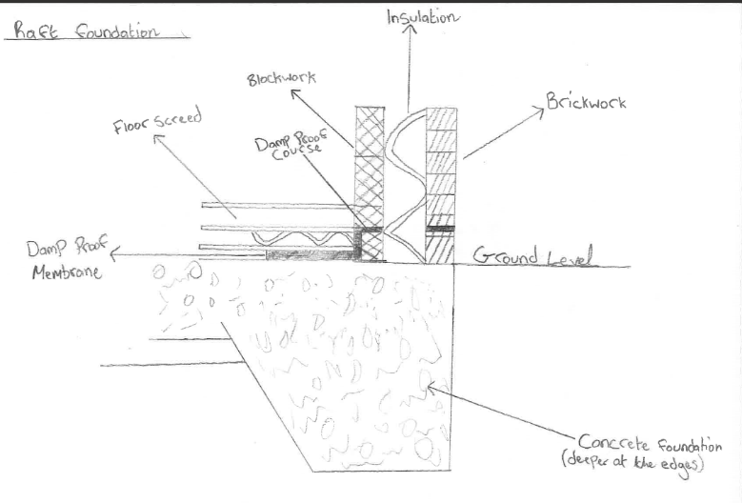
Foundation
For the foundation I recommend that the raft foundation Is used because the raft foundation is used when covering a large area and also where the ground conditions are not very good. And due to the ground being sandy on the site then this implies that the ground is then very poor. Raft foundations also may incorporate beams or thickened areas to provide additional support for the load. This sort of foundation is usually needed on soft or loose soils have a low bearing capacity.
(this photo is drawn by Morgan Davies)

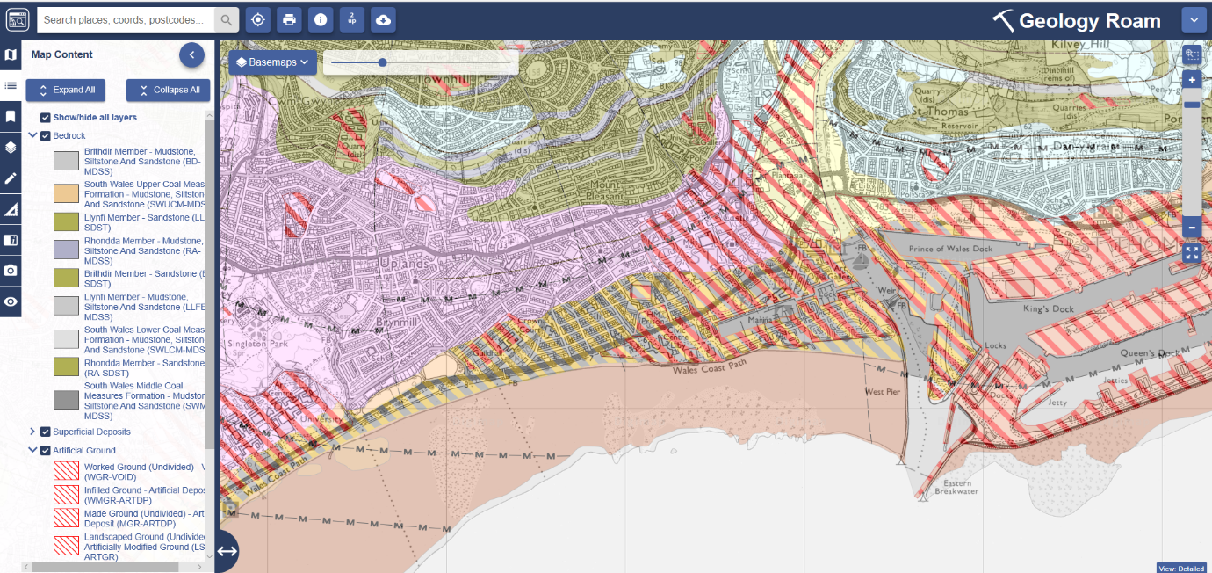
(this photo was captured from Digimaps)

The map of this shows the area is full of blown sand/ sand. This emphasises that there is a deep amount of sand with rock on the bottom. This means that using the end- bearing pile will be the best foundation to use as it is an end point and it can sit vertically into the rock on the bottom with gives leaves a lot of shear strength left for the foundation to sit on. As it transfers all the weight from the building all the way down to the rock laying on the bed.

Bibliography
- Alarmy limited
Stock photo- aerial view of Swansea civic centre and county hall, Oystermouth road, meridian quay Swansea marina
Alarmy
https://www.alamy.com/stock-photo-aerial-view-of-swansea-civic-centre-and-county-hall-oystermouth-road-49092237.html

- Google maps
Google maps
https://www.google.co.uk/maps/@51.613114,-3.9514617,16z

- Swansea and Mumbles railway
En.wikipedia.org
https://en.wikipedia.org/wiki/Swansea_and_Mumbles_Railway

- Walk 89: Swansea City Walk: Does it deliver a knockout punch?
Northhamptonshirewalks
https://northamptonshirewalks.co.uk/walks-outside-northamptonshire/walk-89-does-it-deliver-a-knockout-punch-swansea-city-centre/

- Digimap.edina.ac.uk
https://digimap.edina.ac.uk/roam/map/geology

- Why do we use steel in concrete for construction? – Quora
https://www.quora.com/Why-do-we-put-steel-in-concrete-for-construction

