Economic Crisis, Raising Finances, and Stock Performance during COVID-19: A Case Study of the United Kingdom

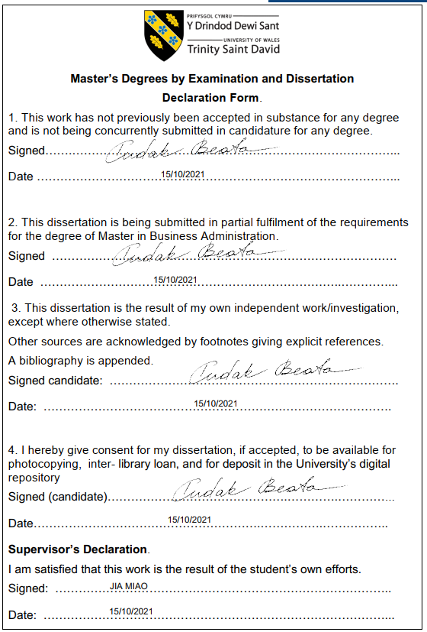

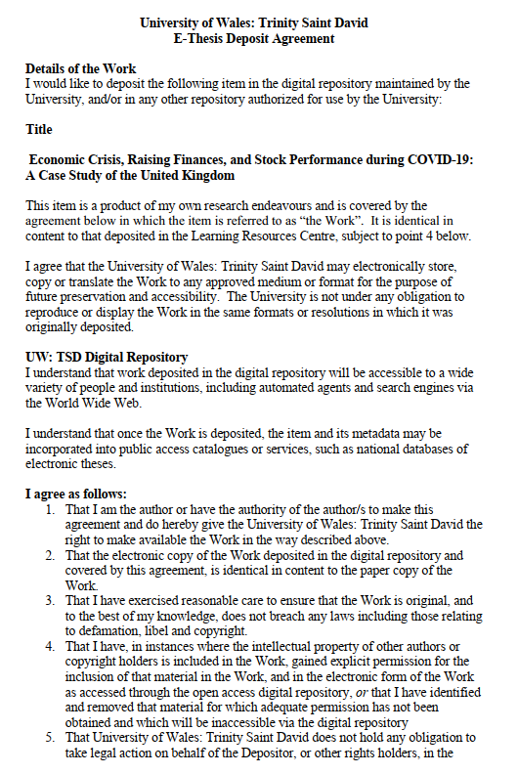

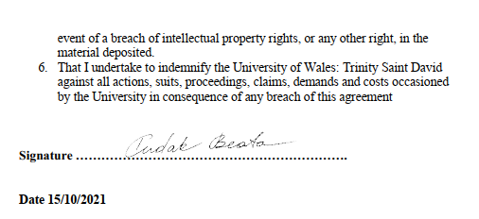

Contents
List of Figure 6
1 Introduction 7
1.1 Background of Research Problem 7
1.1.1 Economic Crisis 8
1.1.2 Raising Finances and Stock Performance 10
1.2 Research Aim 10
1.3 Research Objectives 10
1.4 Research Questions 11
1.5 Significance of the Research 11
1.6 Organisational Structure of the Dissertation 11
2 Literature Review 12
2.1 Introduction 12
2.2 COVID-19 Pandamic and Economic Crisis 13
2.2.1 Health and Socio-economic Conditions 14
2.2.2 The Economy of United Kingdom- Global Assessment 15
2.3 COVID-19 Pandemic and Financial Crisis 16
2.3.1 COVID-19 Pandemic versus Global Financial Crisis 16
2.3.2 Environmental and Financial Crisis 17
2.3.3 Global Financial Crisis and the Pandemic Recession 17
2.3.4 Financial and Economic Impact of the COVID-19 18
2.3.5 Financing Entrepreneurship in Times of Crisis 19
2.3.6 Financial Crisis and Unemployment 20
2.4 COVID-19 Pandemic and Decline in Stock Performance 22
2.4.1 Impact of the Pandemic on Returns and Stock Performance 22
2.4.2 Stock Returns of Hospitality Firms 23
2.5 Conclusion 25
3 Research Methodology 27
3.1 Introduction 27
3.3 Research Philosophy 28
3.3.1 The Choice of Research Philosophy 28
3.5 Research Design 30
3.6 Types of Investigation 30
3.6.1 Explanatory Research Design 30
3.7 Sampling Methods 31
3.8 Data Analysis Techniques 31
3.9 Ethical Considerations 32
3.10 Limitations of Research 33
4 Data Analysis 33
4.1 Introduction 33
4.1.1 Secondary Qualitative Analysis 33
4.1.2 Secondary Quantitative Analysis 42
4.2 Findings and Discussion 47
5 Conclusion 50
5.1 Limitations of the Study 52
5.2 Recommendations of the Study 53
6 References 55

List of Figure

Figure 1. FTSE 100 Index UK from December 13th, 2019 to August 2, 2021 6
Figure 2. Record Growth in the Third Quarter 7
Figure 3. Recession in the G7- The UK 12
Figure 4. Global Uncertainty Index of COVID-19 the Pandemic 14
Figure 5. Aggregate Employment and Average Hours Decline. 16
Figure 6. Number of the U.K Deals by Funding Stage (2007–2020 Q1) 18
Figure 7. Volume of Money Raised by Funding Stage (2007–2020 Q1). 18
Figure 8. Employment and Unemployment Rate 20
Figure 9. COVID-19 Shock 22

Introduction
The financial strength of any country demonstrates the economic strength and development of that state. In the context of the United Kingdom, it has been evaluated that it is considered to be one of the top economic developed kingdoms in the entire world among the list of five largest regions. In 2020, March 11th, the World Health Organization (WHO) announced COVID-19, a pandemic that has been spreading worldwide at a tremendous pace throughout Asia, the United States, and United Kingdom (Ibn-Mohammed et al., 2020). In human history, prior to the formal pandemic announcement, economic indications from numerous sources had indicated that the globe was headed towards a watershed event that had never been seen before in our lifetimes (Ibn-Mohammed et al., 2020). Hence, it has been an important practice to investigate the various effects that have been occurred because of the COVID-19 Pandemic in the United Kingdom.
It has been due to lockdown during COVID-19 Pandemic that the nations were impacted heavily by the economic crisis. As it has been affected, the balance of payments was disrupted, and economic activity was suspended as a result of lockdown (Lea, 2020). Specialists from a variety of fields have been predicting for years that a worldwide pandemic would strain global supply chains and demand, resulting in a cross-border economic calamity because of the linked society we live in today. According to all accounts, the Pandemic's effects were far worse than predicted (Schwab and Malleret, 2020). Therefore, it has been essential for the researcher to study the Economic Crisis, Raising Finances, and Stock Performance during COVID-19 Pandemic in the United Kingdom.

Background of Research Problem
The existing research is based on the economic crisis in the United Kingdom and its impact on raising finances by businesses and stock performances in the period during the COVID-19 Pandemic. It is COVID-19 that is accountable for the world's economic crisis, which has a detrimental influence on the UK economy (Shrestha et al., 2020). Additionally, the stock price variations and their link to the economy can be determined by examining stock performance. It has been observed by the London Stock Exchange crashed during the first wave of COVID-19 that there was an outbreak that shattered the entire economy of the United Kingdom (FTSE 100 index UK 2021 | Statista, 2021). Therefore, the research has to be conducted in the context of studying the Economic Crisis, Raising Finances, and Stock Performance during the COVID-19 Pandemic.

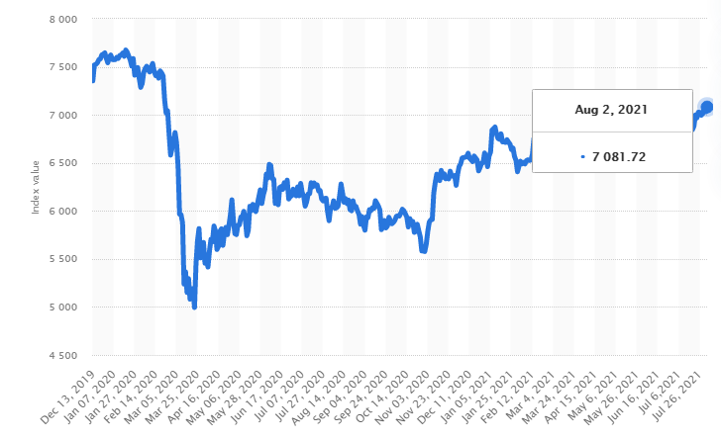
Figure 1. FTSE 100 Index UK from December 13th, 2019 to August 2, 2021 (Source: FTSE 100 index UK 2021 | Statista, 2021)
It has been observed from the above figure that there was a downfall in March 2020 that is clearly seen in the figure. The fall down was because of the COVID-19 Pandemic that forced all the economy to decline towards gravity. The trend shows that now the economy of the United Kingdom is growing gradually, and furthermore, in August 2021, the value of the index is measured to be 7081.72 FTSD.
As a result of the economic crisis, many sectors are experiencing cash flow problems. The COVID-19 economic crisis has had a direct impact on the hospitality, travel, tourist, supply chain, and physical retail chains in the entire United Kingdom since these sectors are unable to earn enough cash to cope with the situation (Jackson et al., 2020). Therefore, the economic crisis and stock performance, as well as boosting funds, are vitally important research problems that must be analysed and developed. Research problem context calls for an in-depth and thorough examination of the economic dilemma caused by COVID-19.

Economic Crisis
In the context of the economic crisis, the value of GDP has been fallen down in the year 2020 by 9.9 per cent, which has been recorded by the Office of National Statistics. The below figure demonstrates the impact of COVID-19 upon job insecurity, diminishing salary and pay, and the fall down in the production of commodities in the industrial sectors. As GDP is all defined by the contribution of numerous variables, the hospitality sector is also showing a tremendous downfall during the peak of the COVID-19 Pandemic (COVID-19: Has the UK economy been hardest hit?, 2021). In contract with this, the public health sectors and other care divisions contribute a sensitive but essential role in the economy of the United Kingdom.
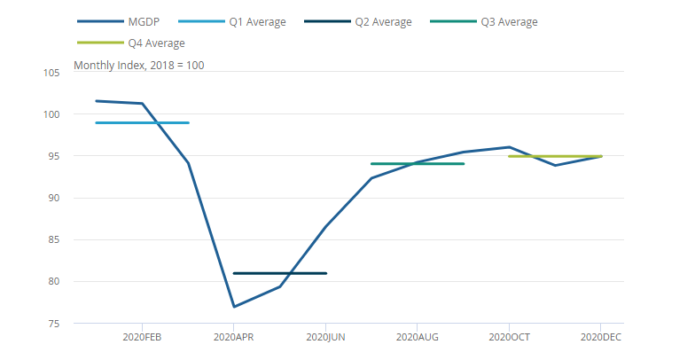

Figure 2. Record Growth in the Third Quarter Source: GDP first quarterly estimate, UK - Office for National Statistics, 2021.
It has been revealed from the above figure that the gross domestic product (GDP) for the United Kingdom has been a great fall in April 2020. Additionally, the GDP is then growing in December 2020, but still, the level of GDP in the UK is now 7.8% which is very low and below as compare with the trend and level in the 4th quarter of the year 2019. Additionally, in the 1st and 2nd quarter of the year 2020, the GDP for the United Kingdom has been shown a decline by 2.9 per cent and 19 per cent respectively. Also, on the other hand, there has been seen a relaxation and smoothness in the growth of the economy in 2021 that is 16.1 per cent of increased GDP as an aggregate of the United Kingdom (COVID-19: Has the UK economy been hardest hit?, 2021). Hence, last year, the economy of the United Kingdom did not do well; even after adjusting for differences in methodology, the UK's economic performance remains towards the bottom of the league.

Raising Finances and Stock Performance
As one of the oldest monetary policy tools, central banks use bank rates to limit excess money supply and credit creation. However, financial transactions and commercial operations have been hindered by the COVID-19 epidemic, causing stock values to fluctuate wildly (Rodrigues and Amaral, 2015). The raised COVID-19 infections and fatalities internationally have delayed stock market indexes and increased negative financial values. Additionally, it has been observed that in the present Pandemic, there has damaged in the debt market, a worldwide financial crisis has emerged (Fallahgoul, 2021). In particular scenarios, in order to combat the growing debt and minimise uncertainty in the entrepreneurial business, decisive government involvement is needed. Therefore, it has become mandatory to conduct research to study the behaviour of raising finances and stock performance in the economy of the United Kingdom during the COVID-19 Pandemic.
As a result of the need to prevent the spread of COVID-19 and maintain the efficiency of the health care system, economic activity was severely restricted. Many service sectors were struck particularly hard by the Pandemic, but manufacturing and agriculture were also impacted in some way by the lockdown. Since the Pandemic has had a significant impact on financial markets, it has been seen that some markets or instruments are more stable than others as a result of this. When it comes to the government's finances, it had been found that monetary policy, and in specific asset purchases, are useful tools (Klose and Tillmann, 2021). The suspension of the growth in the financial sector with stability and development influence has a significant impact on stock market values. A more effective fiscal policy is achieved when monetary statements are made on the same day as fiscal policy announcements. Policy announcements also have significant cross-border consequences.

Research Aim
The existing research study aims to investigate and evaluate the impact of the economic crisis and the background with reasons for raising finances and stock performance during the Pandemic COVID-19. The aim of the researcher is to determine the factors that lead to the economic crisis and the impact of the economic crisis with regard to stock performance and raising in finance in the hospitality sector of the UK.

Research Objectives
The existing dissertation has the following research objectives that have been extracted from the above research aim
- To study the factors that caused the occurrence of the economic crisis because of the COVID-19 Pandemic in the hospitality sector of United Kingdom.
- To determine the stock performances and raising finances in evaluating economic crisis in the UK’s hospitality sector.
- To study the relationship between economic crisis and stock performance and its effect during the Pandemic.
- To investigate the relationship between economic crisis and raising finances that has a positive impact on the economy of the United Kingdom.

Research Questions
The following research questions are established in order to find out the answers in this research study, which has been based upon the research problem and research objectives
- How can the economic crisis be evaluated through stock performances and raising finances?
- What is the impact of COVID-19 on the ongoing economic crisis in the UK’s hospitality sector?
- Is there any relationship between economic crisis and stock performance and raising finances?

Significance of the Research
The prime significance of the proposed research is that the researcher will be able to study the in-depth reasons for the occurrence of economic crisis and the valid reason behind the decline. Furthermore, the study will assess the economic crisis, including its causes, consequences, and impact on stock performance and rising financial indicators. COVID-19 has put the United Kingdom's economy in a constant state of change. Therefore, in order to better comprehend economic crisis elements and reasons for making financial and non-financial actions accordingly, scholars should conduct research.

Organisational Structure of the Dissertation
The present dissertation has consisted of six major chapters. In the first chapter, the researcher introduced the terms and abbreviations related to the research statement. Afterwards, the researcher explained all the research aims, objectives, and research questions related to the research problem. Finally, in the second chapter of the dissertation, the researcher will describe all the past but associated studies that have been conducted by the various researcher in order to take some guidelines and implement them for further analysis.
The chapter of the literature reviewable the researcher to add on some variables that have been missing by the previous researchers. The third chapter will be of research methodology in which the researcher will shed some light about the selected and applied research methods for the present dissertation. Additionally, the chapter on methodology will define all the essential steps required for the application of research methodology in the further analysis section. In the present dissertation, the fourth chapter is of research analysis and findings. The chapter of research analysis and findings consisted of all the vital steps that analyse the research data and present the results by means of tabulation for findings and conclusion purposes. Finally, the last chapter will define the conclusion, and the researcher will give some essential recommendations for the new scholars.

Literature Review

Introduction
In every discipline, field, and subject, a piece of knowledge as to build a base for enhancement and awareness about that specific research from past evidence that is the inclusion of literature review. Thus, the synthesis related to the research study combines all the chunks of sections and conclusion for the development of meaningful thoughts related to the research topic by past, and existing studies of the various researcher are term as the literature review (Frederiksen et al., 2021). Therefore, the segment has been consisted of a past information that is literature review, has been covered with all the essential, significant, and relevant sources based on the aims and objectives of the present research problem statement. Moreover, the literature has to be defined and summarised in such a way that it will support the significant claims and issues which was already discussed in the introduction section. Hence, there has relevancy among the section of literature review with the defined research aims and objectives.
The goal of a literature review in the context of a research study is to show how meaningful the research topic is. In order to have a deeper grasp of the issue, the researcher might also examine the literature of many fields. When the researcher enables to discover anything on the required subject in one area, considering other disciplines is essential for scrutinising the research objectives and aims (Introduction to literature reviews, 2021). Therefore, the researcher has to conduct deeper research on the defined research problems in order to gain some past knowledge for further applied methodology and conclusion.
There are several processes and activities involved in well-developed literature reviews. First, the literature review is an iterative process since the researcher is going to perform at least two of these: a first-hand search to understand what has been published in the selected field and if the literature provides enough support for the selected subject to move further. Additionally, the section of the literature review has consisted of three main parts, the introduction to the literature review, the main body (in which all the relevant and past knowledge based on defined research aims and objectives has been defined with coherency), and in the end, the conclusion has to be defined in the form of summary (The structure of a literature review, 2021). Therefore, the researcher will dig further into the literature to discover more about that particular subject and its problems after the first research that is considered to be based on defined research goals in the introduction section.
In the present section of the literature review, the researcher will add relevant past information based on the impact of COVID-19 Pandemic towards economic crisis, financial crisis, and the decline in the stock performance of the United Kingdom's economy. Finally, the conclusion will be drawn based on all the points catered in the light of past information and knowledge.

COVID-19 Pandamic and Economic Crisis
In recent decades, the COVID-19 Pandemic was declared as the worst and biggest worldwide disaster in the entire history of humanity. It had been declared by the World Health Organisation (WHO) that the coronavirus pandemic was said to affect health. Still, on the other hand, the outbreak impacts several other sectors that are educational, economic, matrimonial, and psychological (Adams‐Prassl et al., 2020). In order to maintain social distancing, immediate and severe implications had been imposed in the major domains of living style; these were the ability to work from home for earning, for maintenance of health, the consumption of goods and services, and the precautionary measures related to secure from the virus (Van Lancker and Parolin, 2020). In addition to this, the Government of the United Kingdom had implemented strong social distance measures at the beginning of the epidemic, resulting in the closure of schools and numerous enterprises and whole industries in the effort to limit the spread of COVID-19 as well as safeguard the health facilities from congestion.
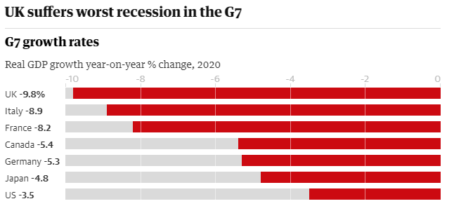
Figure 3. Recession in the G7- The UK Source: OECD Interim Economic Outlook Forecasts March 2021
From the above figure, it had been determined that in addition to one of the world's highest mortality rates for coronaviruses, the United Kingdom's economy was the poorest in last year's G7 group of rich nations when the government came to a lockdown later than other countries and took longer to relax (OECD Economic Outlook, 2021). Furthermore, the organisational structure of the entire economy of the United Kingdom (Hamidi et al., 2020). Therefore, it had been concluded from the study that the economy of the United Kingdom faced a serious downfall regarding to the economic crisis that is a recession because the majority of the economy depended upon the hospitality sector, including local shops, renowned restaurants, and official gathers in the hotels.

Health and Socio-economic Conditions
Emerging evidence of COVID-19 social epidemiology indicates that illness infections and mortality are linked to existing axes of social inequality; that persons from ethnic minorities, weaker socio-economic origins and poorer locations are more likely to suffer. Thus, COVID-19's effects are expected to be socially stratified. During the COVID-19 Pandemic, the disease control measurements used entail that individuals spend more time with lockouts, the necessity to segregate themselves and school and job closures in their local homes (Jordan and Adab, 2020). A study had been conducted in order to study the various factors that were affected due to the impact and consequences of COVID-19 from the perspective of health and socio-economic aspects. The study concluded that there was a sufficient frequency of individuals belongs to the working-age group who had face the consequences of the Pandemic regarding to health issues and employment.

The Economy of United Kingdom- Global Assessment
The maintenance of social distance and disciplinary measures to prevent from the spreading of COVID-19 from human to human had an influence on the health of living organisms with the downfall in the economy of the United Kingdom. Additionally, it has been considered to have a significant impact upon the spoliation of environmental attraction as well (Sarkodie and Owusu, 2021). Therefore, the epidemic in the globe had been the reason for the declining impact upon the healthcare system with also decreased emissions, economic growth that is considered to be increasingly worsening (Sarkodie and Owusu, 2021). Therefore, a qualitative and quantitative empirical study was conducted by the researchers in order to investigate the consequences of COVID-19 Pandamic upon health, economic variables, and global environmental dimensions.

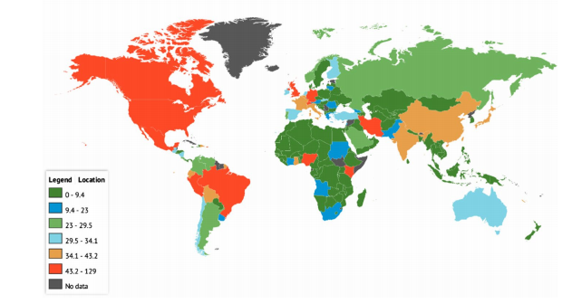
Figure 4. Global Uncertainty Index of COVID-19 the Pandemic Source: Knoema, 2020
It had been determined from the study that the researchers shed light on the critical review of environmental, health and economic development in the boundaries of the United Kingdom. It was studied and seen that during the time period of lockdown inside the United Kingdom, the researchers concluded that there were fluctuations in the patterns of policies regarding health systems, issues concerning environmental sustainability, fiscal policies, monetary policies, and measures of exchange rates (Sarkodie and Owusu, 2021). In addition to this, it had been concluded from the analysis that there was a decline in air pollution along with the increasing trend in community and medical waste.

COVID-19 Pandemic and Financial Crisis
The implementation of lockdown across the boundaries of the United Kingdom had an impact on the entire general market, which is equal to the occurrence of recession. Economists had shown that on 25 March 2020, the financial products had jumped 18 times low and high compared with bad news on the market, except for the contraction in the GDP, rising prices of consumer goods every day, a dramatic drop in industrial production and service output as well as low stock exchange turnover (Su et al., 2020). Therefore, it has been concluded that during the COVID-19, there was a drastic decline in the financial condition of the state.

COVID-19 Pandemic versus Global Financial Crisis
In the foreign exchange currency context, Trade and transactions of foreign currencies items and services are linked to foreign exchange markets. The fluctuations and unforeseen changes in the trend of the cash flow will ultimately affect the operational department of various industries and counterparties as well (Sbeiti, 2021). The profitability had been affected by the globally occurring operations, movements and events by a financial institution in the global market.
In the present era, most international markets now are protected by monetary derivatives against economic vulnerabilities. However, every hedging approach should contain assumptions for currency exchange since currency swings would eventually result in fluctuations in cash flow. There are numerous methods and techniques through which the fluctuations and several trends in the exchange rate had been modelled, that is, standard deviation, EWMA, GARCH, and FIGARCH. In order to determine the level of the financial crisis, one model had been used to evaluate the risk named as (VaR) (Gunay, 2020). It has been studied by the author about the causes of the financial crisis during COVID-19 in the entire globe by analysing the trend and fluctuations in the currency rates of six foreign exchange rates. The Global Financial Crisis from 2008 to 2009 had been discussed under the trends of foreign exchange rates. The researcher applied various tests for the investigation named the Kapetanios m-break unit root test, downside variance, upside risk, volatility skewness, Gaussian VaR, historical VaR, and modified VaR (Gunay, 2020).
It has been concluded that out of 6 foreign exchange rates, the consequences of the COVID-19 Pandemic is assessed to be larger than the risk recorded during the global financial crisis only with the Japanese Yen. The most important shift in the variability of return rates is the Brazilian real. It had also been concluded that according to the normal deviation data, although all exchange rates show greater volatility in the crisis era. Although the Turkish Lira fluctuates most in the pre-crisis phase, it ranks second in the crisis period.

Environmental and Financial Crisis
The crises in the globe had a way of exploding and shattering an entire network of social, economic, financial and, notably, environmental interactions that was working effectively. A study had been conducted to study the impact of environment and financial crisis in the COVID-19 Pandemic with relation to the financial crisis in the year 2007-08 (Kapecki, 2020). It has been concluded that the financial crisis has led hundreds of millions of lives to consider making their investments in their houses more logical so as to make them not only greener but also cheaper to use, that is a sustainable building. The humanitarian catastrophe COVID-19 has only lasted a few months and showed a protracted and very severe economic crisis, with unemployment continuously growing. The current situation of the Pandemic recalled the memory of the start of the financial crisis in the year 2007. In continuation with the previous, the only difference is that the COVID crisis will be considerably stronger in all aspects, and the financial, economic and human losses are impossible to assess.

Global Financial Crisis and the Pandemic Recession
In February 2020, the unemployment rate rose from 3.5% to 14.7%. In terms of employment possibilities, both the global financial crisis as well the current Pandemic recession had an important influence on distribution (Shibata, 2021). An investigation had been conducted in order to study the impact of disturbance created by the recession, and along with the financial crisis in the global context and the COVID-19 epidemic (Shibata, 2021). It had been concluded from the study that the low wage earners were far more likely to lose jobs than the highest-wage workers. In the global financial crisis, the constant loss of employment accounted for a big proportion of newly jobless people. During the pandemic COVID-19, temporary layoffs accounted for a large part of the newly unemployed. In the context of the firm side, it has been concluded that the outbreak of the Pandemic had been considered as the short-term impact, but the loss of human capital would be in the long run.

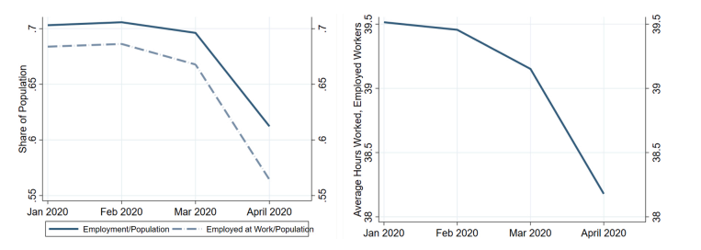
Figure 5. Aggregate Employment and Average Hours Decline. Source: Shibata, 2021.
It had been concluded from the above graph that the recession badly hit the employment of individuals during the drastic outbreak of the virus. In continuation with this, unemployment has risen dramatically during the current Pandemic, approximately double that of non-social occupations. Moreover, the working hours of social workers have also dropped significantly. Additionally, the researcher compared the recession caused in 2008 with the Pandemic and determined that the low-income employees have suffered more than their high-income colleagues in both recessions, which suggests that the recessions had a major distributional impact. Finally, in contrast to the Global Financial Crisis, a substantial proportion of the jobless was on temporary release during the COVID-19 recession.

Financial and Economic Impact of the COVID-19
The brink of a historic disease epidemic in the entire world, as several cities worldwide are under lockout in a reaction termed as COVID-19. The research study had been defined as an analysis framework that was structural and comprehends in order to study the significance and the impact of the spatiotemporal patterns of epidemic diseases on financial market activities (Estrada et al., 2020). The influence of COVID-19 had been seen in the financial market context in the first two months of 2020. Capital markets were become more unsure in the face of a new Pandemic, causing financial markets instability. Therefore, a study had been conducted to introduce the analytical framework to study the patterns of COVID-19 and its impact upon financial activities and market conditions (Estrada et al., 2020). It had been concluded from the analysis of ten dynamic stock markets of developed countries that the impact of the COVID-19 crisis was considered to be the same as that of the 1929 crisis. Therefore, the study revealed another crisis that was held in the early years of the 1900s.

Financing Entrepreneurship in Times of Crisis
In terms of the ability of entrepreneurs to retain the level of personnel and avoid cash flow problems, and prevent widespread bankruptcy as a result of the lockdown, the policymakers inevitably focused their attention and very understandably on the immediate effect of the COVID-19 crisis for existing SMEs (Brown et al., 2020). It had been studied by the researcher that there was a significant decline in the levels and stages of financial deals did by the entrepreneurs during the era of COVID-19 in 2020. In the continuation of this, it had been determined that in the first quarter of 2019, there were a lot of financial deals by the entrepreneurs as compared with that of 2020. However, the researcher also determined that there was a decrease of 31 per cent in the financial deals of entrepreneurs.

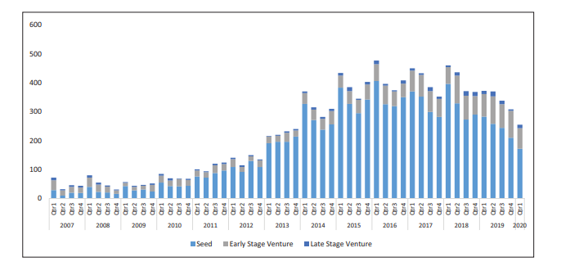
Figure 6. Number of the U.K Deals by Funding Stage (2007–2020 Q1)
Source: Brown et al., 2020

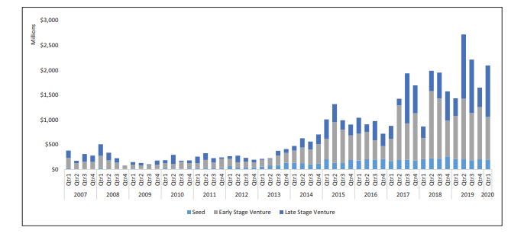
Figure 7. Volume of Money Raised by Funding Stage (2007–2020 Q1).
Source: Brown et al., 2020
It was concluded from the above figures by using the data for the early stage of business ventures, that is, seed finance, that the United Kingdom was considered to be in the list of financial entrepreneurs with significant growth. Notwithstanding, it is additionally crystal clear that this type of beginning phase finance is a lot lower in esteem than beginning phase and late-stage bargains. In continuation to this, it had been compared in the last few years that in the boundaries of the United Kingdom, it was approximately 15 per cent of all the equity had been valued by the fundraising.

Financial Crisis and Unemployment
In the context of the job of an employee and the ability to earn, the consequences of the COVID issue are expected to continue for a long time. During the crisis and before the occurrence of recession, the loss of a job leads employees to a possibly lengthy uphill struggle to the same level of profit and the sort of employment when the demand of labour is considered to be economically disturbed. Furthermore, the terrible possibility of long-term unemployment will probably influence other elements of life, including health, death, and financial crisis (Moffitt and Ziliak, 2020). Hence, it has been determined that the impact of COVID-19 badly impact the economy by the decline in the trend of employment in the United Kingdom. Additionally, the researchers concluded that there had been a long term effect of the crisis on the economy as the turnover rate was high in the case of unemployment which leads to the financial loss of the individuals, investors, and entrepreneurs.
In particular, the situations where the start of the Pandemic meets reduced safety network which is not equipped to provide assistance for families suffering job loss, and significant reductions in take-home income, the distribution impacts of infect containment and compensation coverage policies have an impact. The article by Robert Moffitt and James Ziliak gives an informative report on the redistributive features of the tax and benefit system and how the tax and benefits system has changed over recent decades (Moffitt and Ziliak, 2020). The coverage of the programme varies according to the worker, the firm and the characteristics, which also depend on the situations in the workforce. A very generous policy like this needs to be carefully considered in how employees return to work after meeting minimum security standards, which would probably require coordination with other policy instruments that support the needs of employees returning. At the same time, the rates of infection are still high (Adams‐Prassl et al., 2020). Therefore, work from home by using online, and sufficient software manufactured by respective organisations are considered to be the first and initial step to overcome the declining trend of employment and wages that would ultimately be a step forward towards the diminishing of the financial crisis.
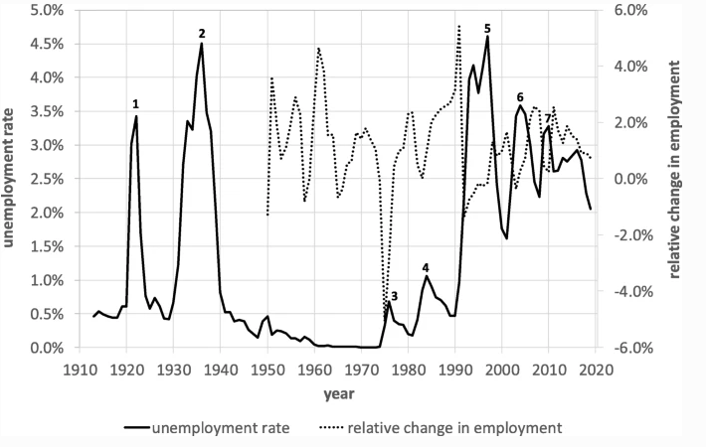
Figure 8. Employment and Unemployment Rate
Source: Su et al., 2021
It had been concluded from the above figure that in the early 2000s, the two last slowdowns followed the explosion of the dot-com bubble and, in 2008/9, respectively, the global financial crisis. Notwithstanding, in contrast to the progressive expansion of the GDP, the reaction of the work on both slumps was relatively restrained. Therefore, it was determined that because of the pattern decrease, underway positions normally respond all the more firmly to business cycle variances.

COVID-19 Pandemic and Decline in Stock Performance
In the context of worldwide monetary business sectors, the quantity of COVID-19 pandemic cases for every million had huge adverse consequences. The antagonistic impacts of the COVID on the stock market exchanges were less in number among liberated nations. All in all, the stock market exchanges without fewer nations were influenced more by a similar size of expansion in the quantity of COVID cases. In continuation with this, for each increment in the development of the number of COVID-19 cases for every million, the stock market exchange returns in more liberated nations had been related with less bring diminishes back. Therefore, despite the fact that the development of the quantity of COVID-19 cases for each million built the unpredictability among several nations, its impact on more liberated nations had not measurably not quite the same as nothing (Erdem, 2020). Therefore, it had been considered as an essential practice to study the impact of COVID-19 regarding to the performance of the stock market.

Impact of the Pandemic on Returns and Stock Performance
There are certain factors that have been considered as essential ones to measure while keep tracking the trend of financial elements, that is, stock market performance, FDI flow, cash in-flow, and financial indices. Therefore, a study was conducted in order to investigate the behaviour of investors in the stock market in the United Kingdom during the time period of COVID-19 from investor point of view. In continuation with this, the researcher wanted to check the association and linkage between the impact of COVID-19 on the stock market (Erdem, 2020). The stock market indices are based on 75 countries that had been exaggerated by the consequences of the COVID-19 Pandemic. Panel Regression Analysis was applied in order to check the association and relationship between the impact of the Pandemic with the rate of stock markets (Erdem, 2020).
It was concluded from the study that there was a negatively significant relationship between the impact of the Pandemic with the rate of stock markets. In addition to this, it had been determined that during the period of the COVID-19 Pandemic, there was a significant decline in the ratio of the returns, and on the other hand increase in the rate of volatility. Moreover, it had been observed through the output of data consisted of investors that it depended upon the developmental condition of a country in order to conduct any investment.
COVID-19 is causing a worldwide economic catastrophe that is not the same as the prior crisis. The Pandemic COVID-19 has generated huge and diverse stock price shifts. There have also been great variations between stock price changes in businesses in the same sector and nation. A study had been conducted in order to evaluate the association between the characteristics of corporate with the fluctuations in the prices of the stock market during the Pandemic. The research had been conducted by considering the data based on more than 6000 firms located in 56 countries (Ding et al., 2020).
It was concluded from the results that monetary conditions, for example, cash property, influence, and productivity, global inventory network and client areas, which gives data on each company's openness to Coronavirus through its worldwide associations, CSR exercises, corporate administration frameworks, for example, antitakeover components, board designs, and leader remuneration arrangements, and possession structures, like the characters of firms' enormous stake holders. These discoveries are reliable with the view that multifaceted investments sell their offers quickly in light of negative data about Coronavirus cases, strengthening lower tension on costs, while proprietors with since a long time ago run, vital responsibilities to firms (counting enormous companies), will in the general hose the antagonistic effect of the Pandemic on stock costs.

Stock Returns of Hospitality Firms
A substantial decrease has been achieved in the international stock market due to the new coronavirus (COVID-19) pandemic, with hospitality firms facing severe financial issues. The preservation of corporate value is a crucial means of helping enterprises withstand the crisis. Therefore, the corporate Social Responsibility (CSR) effect in business value has been extensively explored. Be that as it may, little is thought about the stock value development following CSR action reception during a mechanical emergency (Qiu et al., 2020). Therefore, a study had been conducted in order to investigate the social responsibility of a company, the protection of the firm with the values during the time period of COVID-19 Pandemic. It had been concluded from the study that to be engaged in the activities and process of CSR will ultimately increase the stock returns to generate revenue for the hospitality sector during the duration of the COVID-19 Pandemic. In continuation with this, it had been determined that there was a positive impact of Corporate Social Responsibility on the stock returns.
Additionally, the increased and rapid impact on stock returns from community-based CSR on both consumers and workers is comparable to CSR. Moreover, the local area related CSR has a more grounded and speedier impact on stock returns than CSR toward clients and workers. Therefore, the authentic CRS execution in the context of the hospitality and accommodation sector had a significant impact on the viability of CSR speculation during the Pandemic.
Moreover, it was determined that the hospitality sector of the United Kingdom had a great and dynamic industry with an excellent contribution towards GDP growth. In continuation with this, it has also been considered as the formation of volumes of investment with respect to the finances and revenues. In 2018, the hospitality sector of the United Kingdom had been recorded as positive and significant values towards the financial and revenue performances. Therefore, the main aim of the researcher is to focus on the hospitality sectors and firms for further analysis purposes.

Raise Finance during the Crisis
In the long-run growth of the entire United Kingdom, the range and worth of the hospitality sector has been performing a significant role. The occurrence of major recessions that is of 2008 and 2019 had been associated with the financial crisis in the entire United Kingdom. The global financial crisis of 2008 had been considered as the plagued crisis, as it had brought a significant negative impact upon the tourism sector of the entire European region, specifically in the United Kingdom, as it has been determined as the hub of tourist for attractiveness. A study had been conducted in order to study the impact of the financial crisis of 2008 upon the entire boundaries of the United Kingdom. The study concluded that there had been a great fall in the consumers' and tourist expenditures. Besides this, it has been seen that the financial crisis has been badly affected by the youngsters' tourists (Pappas and Apostolakis, 2020). Generally, it had been identified that during the financial crisis, the demand for consumption of hospitality sectors was declined.

Shares movement during Crisis
In 2008, the Global and Financial Crisis hit the finances and shares of the stock exchange at a very declining pace. The crisis had been shown a sign of deterioration at the end of the summer of 2007. There are many terms that had been associated with the decline in shares that is the decline in the mortgage, lack of credit, the collision of the bank, and bailout of Governmental policies (Hausman and Johnston, 2014). Therefore, the time span of 2007 to 2008 had been considered as the worst for the financial stability of the United Kingdom. Besides the crisis of 2008, financial loss during the COVID-19 Pandemic had been raised drastically. It had been determined that during the era of COVID-19, the number of virally infected people was in dense amount, which decreased the trend of stock market values within few months (Nicola et al., 2020). Therefore, a large frequency of people was very sensitive towards the increment of COVID-19 patients as there were tremendous cases in the neighborhood.
Hence, in a nutshell, it has been concluded that during both crises, the shares and stock market prices and performance were freezing the activities of investors and stakeholders. In continuation with this, international relations had been exploited by the crises.

Equity and Debt during Crisis
In the global recession as well as in the Pandemic, the return on equity, that is, the profitability of banks, had been declined with the gravitational pace. It has been determined that many business models had been destroyed during both crises; that is, central and private banks had been faced a dynamic recession. In the boundaries of the United Kingdom, the entire country had to face demolishing of revenues, including the previous investment linked with the cost of legacy (Erkens et al., 2012). In continuation with this, at the end of the Global Financial Crisis 2008, the worth of equity prices and debt had been estimated by the use of indices. Therefore, the equity, debt, and stock exchange market had been declined in both the Great Recession and Great Pandemic.

Conclusion
The United Kingdom's economy was seriously affected by the recession economic crisis since the bulk of the economy depends on hospitality, including local businesses, renowned restaurants, and formal hotel gatherings. In the present section of the gathering of past information, the researcher shed light on the key and significant points regarding the economic crisis, financial crisis, and the decline in the stock performance in the entire world. The researcher concluded from the past information that the proportion of people who are in the working-age group who faced the effects of the Pandemic on health difficulties and employment was adequate. On the other hand, air pollution has decreased, as has the tendency towards communal and medical waste. In continuation with the economic crisis during the Pandemic, there was a drastic decline in the financial condition of the United Kingdom. It was also concluded by the researcher that the profitability of a worldwide financial institution was influenced by global activities, moves, and occurrences. During the conduction of an investigation to study the exchange rates of currency among various boundaries, it was observed that the most effective currency was Brazilian.
The financial crisis has led to hundreds of millions of people living in their homes considering making their investment more sensible to make them not just greener but cheaper to use, which is a sustainable building. Only a few months have passed since the humanitarian disaster COVID-19, which has shown a long and extremely serious economic crisis with unemployment continually increasing. It was also found that in the 2008th recession triggered the Pandemic, and it found that low-income workers have had a more severe influence on the distribution of the recessions than their high-income fellow workers in both recessions. Finally, a significant number of unemployed people were temporarily released during the COVID-19 recession, in contrast to the global financial crisis.
The research of the ten dynamic stock markets in industrialised nations showed that the impacts of the COVID-19 crisis were the same as in the crisis of 1929. The investigation, therefore, indicated a different problem in the early 1900s. However, the researcher also determined that there was a decrease of 31 per cent in the financial deals of entrepreneurs. In the context of turnover and unemployment, the analysts reasoned that there had been a drawn-out impact of the emergency on the economy as the turnover rate was high on account of joblessness which prompted the monetary loss of the people, financial backers, and business visionaries. In addition to this, the Global Financial Crisis in 2008 is considered to be the same in financial loss as compared with the consequences of the COVID-19 Pandemic.
In the United Kingdom, the Public authority had executed solid social distance measures toward the start of the Pandemic, bringing about the conclusion of schools and various endeavours and entire enterprises in work to restrict the spread of Coronavirus just as shield the well-being of offices from blockage.

Research Methodology

Introduction
Research methodology is described as the methodical yet short processes that the researcher has to follow in explaining and resolving research issues using various methods and procedures, i.e., employing data gathering techniques. It will give the researcher with a thorough framework and guidance on how to evaluate the data and develop dimensional findings on research issues (Snyder, 2019). The study methodology chapter is regarded as a plan for the inquiry by the researcher. The research technique is, therefore, the backbone of academic research or any research project to be performed with a high degree of precision and effectiveness.
The research methodology chapter outlines the way a scientist must travel and guides the scientist on the correct application of the research philosophy, approach, design, data collection method, sample size determination, sample techniques, methods and techniques for data analysis, ethical issues, and restrictions on research. In addition, the research technique advises the scientist about the gaps in research, new perspectives, and guidance on the study issues. The research technique explanation enables the investigator to reduce the defined area of the study and to open new fields for future academics to explore.
In the present research, the researcher will apply secondary qualitative and quantitative that is mixed methodology has been applied in the analysis chapter in order to extract the findings. In the context of mixed design, there are generally four types of mixed methods, that is Triangulation Design, Embedded Design, Explanatory Design, and Exploratory Design. Therefore, in the application of the mixed method for the current dissertation, the researcher will apply Explanatory Design. Moreover, this chapter examines the methodologies and procedures utilised for doing research in every setting and concludes the problem statement by examining ethical problems and making further recommendations for future scholars.
  - Research Approach
Generally, there are two types of research approaches, one is inductive, and the other one is deductive. The collection of quantitative data collection methods is defined in the form of numerical facts and figures. Moreover, the formulation of hypotheses in order to conduct the investigation is called the deductive approach. On the other hand, when a researcher decides to collect the data in the form of a description, that is in the form of qualitative nature of data, and afterward, the hypotheses had been formulated at the end of analysis is termed as deductive approach (Soiferman, 2010). The researcher wanted to apply both qualitative and quantitative that is the mixed approach in order to collect, analyse, conclude, interpret, and discussion of data. Therefore, the defined characteristics for the mixed methodology have been used in the context of both qualitative and quantitative approaches. In continuation with this, deductive as well as the inductive secondary approach will have been used in the present research that would guide the investigator about the dimension of research analysis and further necessary steps for the conduction of research.

Research Philosophy
Research philosophy has been described as the process or frame of ideas that contribute to the accuracy of study and to a new dimension of research in the new field (Saunders et al., 2009). In general, it has been determined that there are four types of research philosophies, that is Positivism, Interpretivism, Realism, and Pragmatism. It has been determined that by the implementation of these theories, the researcher will get a theoretical or conceptual framework for further analysis purposes. In continuation with this, it will also provide the researcher with the selection of research design, collection of data, and application of further onion research steps.
The philosophy of positivist study is characterised as an explanation of theory based on objective facts and figures to assess the problem (Cooper et al., 2006). For subsequent analysis, the positivist technique is thus employed for numerical data collecting. Furthermore, in the examination of research, it is important to examine research philosophy since it emphasises all the crucial issues to be resolved during the research process. It also gives the researcher suggestions on the way (Hatch, 2012). The research philosophy is examined by the investigator and is further implemented to perform the study, depending on the nature and the requirement of the research topic.

The Choice of Research Philosophy
It has been identified by the researcher that in the present situation, interpretivism type of philosophy will have been applied. In addition to this, the researcher wanted to collect the data in the form of qualitative and quantitative by using online secondary sources.

Interpretivism
The concept of interpretativeness is defined as the gathering of secondary data in the framework of research philosophy, utilising diverse approaches and methods that lead to existing data that have to be based on research problems (Myers, 2019). In addition to this, it has been determined that the fundamental objective of the present theory is to collect the explanations and phenomena from the theoretical or numerical aspects through the present investigation. Therefore, for qualitative data gathering, secondary data approaches are used by the researcher.

Qualitative Research
The process of non-numeric data, such as language, text, photos, recordings, films, or audios, for example, is collected, examined, or interpreted. The finest secondary techniques of data collecting are interviews or questionnaires in open-ended style. The researcher also helps to analyse data in a very straightforward and comprehensible way. Secondary data are analysed with topics or hypotheses (Pathak et al., 2013). In continuation with this, the focus of quality research is on the understanding of a research question from a humanistic or idealistic perspective. However, the quantitative approach is a more trustworthy way, based on numeric approaches and methodologies, which other scholars can objectively develop and spread (Flick, 2018). Therefore, it has been concluded that a quality approach is utilised for understanding the beliefs, experiences, positions, conduct, and interactions of individuals. It generates information that is not numeric. Qualitative research is incorporated into interventions is a method of research that receives increasing attention from all fields of study.

Quantitative Research
Quantitative research has been aimed at generating knowledge and understanding of the social environment. It has been identified that social scientists, especially communications investigators, utilise quantitative study to investigate and study in-depth about the phenomena or events that influence people. In continuation to this, the study of individuals has been kept as a priority for social scientists. Moreover, it has been studied that quantitative research is consisted of the learning process by conducting research on the group of individuals known as a population of the samples (Allen, 2017). The process of collection and analysis of numerical data is called quantitative research. In addition to this, it has been used for finding patterns and averages, predicting, testing causes, and generalising results for larger groups. Therefore, in the present dissertation, the researcher has to investigate and study the pattern of the economic and financial crisis with the patterns of stock performance in the entire United Kingdom.
  - Data Collection Methods
In the field of statistics, there are generally two types of data collection methods, one is primary, and the other one is secondary data collection method. Primary data is defined as the collection of data or information either as qualitative or quantitative or in open-ended or close-ended questions by using first-hand sources. Besides this, secondary data collection is defined as the method through which the data has been collected by using some online resources or interviews or any other secondary source. Therefore, in this research, the researcher will use the secondary data collection method that is qualitative and quantitative to gather the data that are Published Sources, Journals, Newspapers, Interviews, Websites, or any other electronic source. As the research design is qualitative in nature, the researcher prefers to collect the data from approved journals in qualitative form.

Research Design
Mixed design is described in research design as the blend of qualitative and quantitative factors in a study. According to Johnson et al. 2007, in the case of mixed design methodology, the researcher collected the information on the basis of both qualitative and quantitative approaches and analysed them by using separate strategies and, after that, interpreted them in a one-sentence structure (Johnson et al. 2007). Therefore, the advantage of mixed methods in the research is to enhance and develop the knowledge by using multiple techniques and tools.
There are four types of mixed-methods designs named Triangulation Design, Embedded Design, Explanatory Design, and Exploratory Design. But in this research, the researcher decides to apply an explanatory research design because it finds out the significance or non-significance of the relationship between variables that is cause and effect association.

Types of Investigation
The type of investigation is an essential part of the research methodology. It is defined as the way that should be adopted by the researcher to conduct the investigation. There are mainly three types of inquiries in research named descriptive, explanatory, and exploratory. As the researcher wants to check the cause and effect relationship among selected variables, so explanatory research design is adapted for further investigation in the context of mixed secondary design.

Explanatory Research Design
In mixed methods, the explanatory design is defined as the two-phase design that is applied to find out qualitative results but has to first apply quantitative results by using qualitative data (Creswell, 2011). When a researcher wants to study the significance or non-significance of the study by using the qualitative approach, it is said to be the best-fitted model. The other application of this design in the context of a mixed approach is when the researcher wants qualitative results by forming groups of respondents on the basis of a quantitative approach. The first step is to collect the data by using a quantitative approach, and then after this implementation of the first phase, the data is collected in the form of qualitative information. Furthermore, in the second phase, qualitative data collection and analysis techniques are applied for the conclusion with in-depth qualitative knowledge.
There are several advantages of explanatory design as it is considered to be the most concise, straightforward, and reliable model in the context of the conclusion. One of the prime advantages of this design is that the data conduct in two phases, and after that, the report is written in two sections which make the reader easier to understand and make new directions or dimensions for the new scholars(Creswell, 2011). Therefore, the researcher wants to investigate and explore new dimensions in the field of quantitative secondary analysis.

Sampling Methods
The sample method or technique is defined as collecting the information from the subset of the population that should have all the characteristics of the population in it. The primary advantage of the adapting sampling method is that researcher has a limited time frame in which he has to collect the information as well as the cost and workload are reduced, besides this the highly correct information can be obtained. Generally, there are two types of sampling techniques
- Probability sampling methods
- Non-probability sampling methods
The probability sampling method is defined as the chances of selection of every individual in the sample, or the selection of every group of individuals in the sample size is the same and equal. There are various sample methods suggested by different researchers for the conduction of research. On the other side, non-probability sampling methods have totally consisted of a favourable outcome.
The well-known probability sampling techniques are simple random sampling, cluster sampling, systematic sampling, and stratified random sampling. In contrast to this, the most prevalent sampling techniques in the context of non-probability are convenience sampling, snowball sampling, and judgemental sampling (Taherdoost, 2016). In this research, the researcher wants to apply convenience sampling for data collection purposes because the researcher has to chose only the information or data that has to be fit the research topic by using secondary sources.

Data Analysis Techniques
For the data analysis in the context of mixed secondary, there are various techniques. In the case of secondary quantitative data, descriptive and other correlational analysis by using Statistical methods and techniques will be applied. In the current dissertation, the researcher aims to study the relationship between economic crisis and stock performance and its effect during the Pandemic and investigate the relationship between economic crisis and raising finances that has a positive impact on the economy of the United Kingdom. Hence, according to the defined objectives, it is necessary to apply correlation and regression analysis to check the relationship and the strength of variables. The significance of the correlational and regression analysis is that it provides the framework about the dimension and strength of variables with a definite value and structured equation, respectively In this analysis, the researcher has collected the secondary data from UK’s hospitality sector.
In the case of the systematic qualitative approach, searching has been done for collecting the information by using primary qualitative analysis and then draw conclusions. The results are based on the inclusion and exclusion criteria (Seers, 2015). Hence, on the basis of existing literature, different point of view are being drawn for conclusion purposes.

Ethical Considerations
The best practice is to keep in mind some ethical considerations during the conduction of research. In the secondary mixed research method, the first and noticeable one is not to harm living things for the sake of research. Don't force someone to be a part of the research as a respondent. Furthermore, the privacy and confidentially of every person can not be avoided, and it is also against the rules that convert the existing results into desirable ones (Fleming, 2018). Therefore, privacy and confidentiality have to be kept at the priority in order to maintain ethical considerations.
In continuation with this, where the data contains no identifying information or is totally barren or correctly coded in such a way that the researchers do not have access to codes, the ethical body does not require a comprehensive assessment. Nevertheless, the Board should still conduct a full examination of the proposal if the data contain information on the members or information which may be connected to identify participation (Tripathy, 2013). In addition to this, there are nevertheless several significant problems with the data used for secondary analyses that are the data should be authentic and has relevancy with the research aims, objectives, and questions. The researcher should also keep in mind that the data has to be limited in number, which does not have to be extended or over-limited. Furthermore, the original data were not gathered in secondary data analysis to reply to the current study topic (Tripathy, 2013). Therefore, the data should thus be reviewed for specific criteria, such as the data collecting process, accuracy, time for gathering, its purpose, and the data substance. Furthermore, in the context of saving the data in the hard form, the researcher must formulate excessive copies in order to maintain the data in the form of a record. The secondary analysis is carried out by the researcher to ensure that additional examination of the data carried out is appropriate.

Limitations of Research
There are some limitations in the study that have to be faced by the researcher. Some are pointed as below
- Due to time constraints and limited resources, only limited existing literature journals had been considered.
- Limited variables had been considered for the data collection.
- For qualitative and quantitative data collection, the convenient sampling method has been applied.
- By using only one method, the results are generated. Further, by applying different methods, the results can be integrated.

Data Analysis

Introduction
In the chapter of analysis, the main aim of the researcher is to shed light on the data that had been gathered for further implementation purposes practically. The present section has been defined the analysis of data in a very comprehensive and compact form for further interpretation purposes. Therefore, the current chapter is further divided into sub-sections that are secondary quantitative and secondary qualitative analysis. The findings are as below:

Secondary Qualitative Analysis
The application of qualitative data by using some external sources that are from online websites, books, articles, and other existing sources is counted in secondary qualitative analysis. In the present section, the researcher will practically implement the secondary qualitative data by using inclusion and exclusion criteria. The inclusion and exclusion criteria have been defined below on the basis of which the researcher selected the journals or articles for further analysis.

Inclusion and Exclusion Criteria
The researcher focused on the latest papers that had been published from the year 2010 to the present. Besides this, the outdated papers had been excluded. The further criteria are being discussed as follow:
Inclusion | Exclusion
Research papers published from the year 2010 to present | Outdated papers had been excluded.
Only those papers had been considered that were easily assessable. | Unapproachable papers had been excluded.
The papers that had shown some relevancy with the research objective were included in the systematic analysis. | Those papers had been excluded that were not related to the defined objectives.
The journals that had been written in the English language were considered in the systemic research analysis. | Papers wrote other than the English language had been excluded.

Systematic Analysis
The collection of all the possible studies and existing pieces of information in a tabulation form that would define the analysis and findings definitely according to the formulated research hypotheses, aims, and objectives are defined as below:
Author(s) | Publication | Theme | Findings
Gunay, 2020 | COVID-19 Pandemic versus global financial crisis: evidence from the currency market. | Supportive in the context of the financial crisis. | In the research study, it has been studied that there was a significant downfall in the foreign exchange rates of the United Kingdom. The peak of the Pandemic was recorded as the decline in the hedging approach of currency rates as there were a lot of fluctuations and swings in the cash flow.
Shibata, 2021 | The distributional impact of recessions: the global financial crisis and the COVID-19 Pandemic recession. | Supportive in the context of the global financial crisis and the occurrence of the recession due to the Pandemic. | It had been determined from the study that low-wage earners and job employees were faced the issues of joblessness. In continuation with this, the loss of jobs and fall down of industrial sector had occurred during the Pandemic. The continuation in the loss of jobs demolishes the generation of revenue that hit the recession and financial crisis. Therefore, temporary layoffs had been introduced to overcome the impact of the crises on the United Kingdom.
Estrada, M.A.R., Koutronas, E. and Lee, M., 2020 | The economic and financial impact of COVID-19 Pandemic. | Supportive in the context of occurrence of the financial and economic impact of the COVID-19 Pandemic. | The study was conducted by using the data of ten dynamic stock markets of developed countries that had been badly affected by the COVID-19 Pandemic crisis. It has been concluded from the analysis that in the boundaries of the United Kingdom, the impact of the great lockdown had been brought out economic as well as financial crises. Therefore, in the first two months of the year 2020, it has been observed that there was an influence of COVID-19 Pandemic in the financial market of the United Kingdom.
Brown, R., Rocha, A., and Cowling, M., 2020. | Financing entrepreneurship in times of crisis: Exploring the impact of COVID-19 on the market for entrepreneurial finance in the United Kingdom | Supportive in the context to define the ability to finance the entrepreneurs during the period of great lockdown. | It had been determined from the study that there was a great and significant decline in the levels and stages of financial deals did by the entrepreneurs during the era of COVID-19 in 2020. During the period of the Pandemic, it had been observed that several financial deals had been demolished. Therefore, in continuation with this, there was a decline of 31% in the financial deals. In addition to this, the seed financing technique had been used to figure out the volume of money raised by levels, and thus, it had been seen that almost 15% of the equity had been valued by the fundraising.
Moffitt, R.A. and Ziliak, J.P., 2020 | COVID‐19 and the UK Safety Net. | Supportive in the context of occurrence of unemployment and joblessness during the financial crisis of COVID-19 Pandemic. | During the period of the Pandemic, the developed countries had to face various crises. In the boundaries of the United Kingdom, there had been a long-term effect of the crisis on the entire economy, that is, the financial crisis. In continuation with this, the turnover rate is very high because of that the rate of unemployment would be increased.
Erdem, O., 2020 | Freedom and stock market performance during Covid-19 outbreak. Finance Research Letters | Supportive in the context of the decline in stock performance and returns during the era of COVID-19 Pandemic. | The impact of COVID-19 on the stock market exchanges had been shown antagonistic swings and fluctuations. After every single day, a new case of the virus had been invented that increased the frequency of COVID cases. Due to the increase in cases, many investors had been faced viral infections that would ultimately lay down the rate of returns, stock market, and performance. Therefore, the researcher suggested studying the impact of the COVID-19 Pandemic in the context of the stock market, performances, and returns.  In continuation with this, it has been determined that there was a negatively significant relationship between the impact of the Pandemic with the rate of stock markets.
Qiu, S.C., Jiang, J., Liu, X., Chen, M.H. and Yuan, X., 2021. | Qiu, S.C., Jiang, J., Liu, X., Chen, M.H. and Yuan, X., 2021. Can corporate social responsibility protect firm value during the COVID-19 Pandemic?. International Journal of Hospitality Management. | Supportive in the context of a decline in the stock returns and performance of the hospitality sector of the United Kingdom. | It had been found out from the study that there was a substantial decline in the international stock market performance in the hospitality sector of the United Kingdom. Therefore, it has been concluded from the study that there was a positive impact of Corporate Social Responsibility on the stock returns of the hospitality sector of the United Kingdom.
Pappas, N. and Apostolakis, A., 2020 | The financial crisis and tourism Activity: Evidence from the UK. In Destination Management and Marketing: Breakthroughs in Research and Practice. | Supportive in the context of the rise in finances during the great recession and great lockdown within the boundaries of the United Kingdom. | It was determined from the existing study that there was an occurrence of recession in the entire hospitality sector of the United Kingdom in the long term. Furthermore, it has been concluded from the study that there the hospitality sector of the United Kingdom had to face two recessions, one was in 2008, and the other one was in 2019.
Hausman, A. and Johnston, W.J., 2014 | The role of innovation in driving the economy: Lessons from the global financial crisis. Journal of Business Research. | Supportive in the context of the impact of two crises that is great recession of 2008 and great lockdown 2019 upon the shares and stakeholders. | The study figured out that both the crises had been hit the finances and shares of the stock exchange at a very declining pace. In addition to this, it has been concluded that due to an increment in the number of cases, there would be a decline in the rate of shares.
Erkens, D.H., Hung, M. and Matos, P., 2012 | Corporate governance in the 2007–2008 financial crisis: Evidence from financial institutions worldwide. Journal of corporate finance, | Supportive in the context of the role of equity and debt in the boundaries of the United Kingdom during the crises of 2008 and 2019. | During the crises, many business models had been failed to bring up-gradation in the boundaries of the United Kingdom. Hence, it had been concluded from the research that there was a decline in the equity, debt, and stock exchange market of the United Kingdom.
Table 1: Systematic Literature Review

Secondary Quantitative Analysis
In the present section of the secondary quantitative analysis, the data has consisted of the industrial sector, that is, hospitality sector data has been exacted for analysis purposes. The data had been gathered in the form of three columns that are defined as the variable of economic crisis had been measured on the basis of GDP in the £ Millions, the variable raising financing had been measured on by using the ratio of debt to equity in TTM units, and lastly, the variable stock performance had been measured by Mkt £ Million. As the aim of the study was to determine the relationship between the economic crisis and stock performance and its effect during the Pandemic and to investigate the relationship between economic crisis and raising finances that has a positive impact on the economy of the United Kingdom. Therefore, the researcher collected the data in the form of numeric facts and figures by using secondary online sources for further analysis. The correlation and regression models are shown as below:

Correlation and Regression Analysis
It has been mentioned that the main aim of the study was to investigate the relationship between economic crisis and stock performance and its effect during the Pandemic. In addition to this, the other aim was to investigate the relationship between economic crisis and raising finances that has a positive impact on the economy of the United Kingdom. Therefore, the researcher applied correlational and regression analysis for the testing of hypotheses for further interpretation and conclusion purposes. The tables below show the output extracted from IBM SPSS:

Relationship between GDP and Stock Performance
In order to investigate the relationship between GDP and stock performance, the researcher investigated the values of the correlation coefficient so that the values will define the relationship in a defined statement.
Hypotheses
H₀: There is no significant relationship between GDP and stock performance.
H₁: There is a significant relationship between GDP and stock performance.
Level of Significance
α = 0.05
Calculations

Table 2: Correlation between GDP and Stock Performance
Correlations
 |  | GDP | Stock Performances
GDP | Pearson Correlation | 1 | .128
GDP | Sig. (2-tailed) |  | .005
GDP | N | 100 | 100
Stock Performances | Pearson Correlation | .128 | 1
Stock Performances | Sig. (2-tailed) | .005
Stock Performances | N | 100 | 100

Interpretation:
From the above table, the two-tailed value is 0.005, which is less than the significant value that is 0.05. Therefore, the researcher rejects the null hypothesis and accepts the alternative hypothesis. In addition to this, it has been concluded from the above analysis that there is a significant relationship between GDP and stock performance. Moreover, the correlation coefficient between GDP and stock performance is 0.128, which indicates that there is a weak but positive linear relationship between GDP and stock performance. . In addition with this, it has been determined from the value of correlation that by increasing the value of stock performance, the value of GDP has been increased as more investment has to be paid by the investors of firms or industry.

Linear Regression Analysis
Furthermore, it has been determined by the researcher for further analysis purposes to investigate the strength and relationship between GDP and stock performance. Thus, the following is the analysis for linear regression as there is only one dependent and one independent variable.

Table 3. Model Summary
Model | R | R Square | Adjusted R Square | Std. Error of the Estimate
1 | .128ª | .016 | .006 | . 2.1084E12
a. Predictors: (Constant), Stock Performances

The above table consists of a model summary that indicates the value of correlation coefficient, R-square, Adjusted R Square, and standard error of the estimates. From the above table, it has been concluded that the value of the correlation coefficient is 0.128, which means that there is a weak positive relationship between GDP and stock performance according to the selected data set.
Hypotheses
H₀: There is no significant relationship between the dependent variable GDP and independent variable stock performance.
H₁: There is a significant relationship between the dependent variable GDP and independent variable stock performance.
Level of Significance
α = 0.05
Calculations

Table 4. Coefficients of Regression Model
Model |  | Unstandardized Coefficients |  | Standardized Coefficients | t | Sig.
 |  | B | Std. Error | Beta | t | Sig.
1 | (Constant) | 2126962313320.740 | 215435565509.249 |  | 9.873 | .000
1 | Stock Performances | 25300200.461 | 19831061.276 | .128 | 1.276 | .005

Interpretation:
From the above table, the two-tailed value is 0.005, which is less than the significant value that is 0.05. Therefore, the researcher rejects the null hypothesis and accepts the alternative hypothesis. In continuation with this, it has been concluded from the regression analysis that there is a significant, linear, and positive relationship between the dependent variable GDP and independent variable stock performance. Furthermore, the value of Beta indicates that by increasing the value of stock performance by one unit, there will be an increment of 25300200.461 units in the GDP of that particular region.
The linear regression model is defined as below:
Estimated GDP = 2126962313320.740 + (25300200.461 * Stock Performances).

Relationship between GDP and the Debt to Equity Ratio
In order to investigate the relationship between GDP and the Debt to Equity Ratio, the researcher investigated the values of the correlation coefficient so that the values will define the relationship in a defined statement.
Hypotheses
H₀: There is no significant relationship between GDP and the Debt to Equity Ratio.
H₁: There is a significant relationship between GDP and the Debt to Equity Ratio.
Level of Significance
α = 0.05
Calculations

Table 5. Correlation between GDP and Debt to Equity Ratio (TTM)
Correlations
 |  | GDP | Debt to Equity Ratio (TTM)
GDP | Pearson Correlation | 1 | -.080
GDP | Sig. (2-tailed) |  | .003
GDP | N | 100 | 100
Debt to Equity Ratio (TTM) | Pearson Correlation | -.080 | 1
Debt to Equity Ratio (TTM) | Sig. (2-tailed) | .003
Debt to Equity Ratio (TTM) | N | 100 | 100

Interpretation:
From the above table, the two-tailed value is 0.003, which is less than the significant value that is 0.05. Therefore, the researcher rejects the null hypothesis and accepts the alternative hypothesis. In addition to this, it has been concluded from the above analysis that there is a significant relationship between GDP and the Debt to Equity Ratio. Moreover, the correlation coefficient between GDP and Debt to Equity Ratio is -0.080, which indicates that there is a weak but negative linear relationship between GDP and Debt to Equity Ratio. In addition to this, it has been determined from the value of correlation that by increasing the value of Debt to Equity Ratio, the value of GDP has been decreased as more debt has to be paid by the firms or industry.

Linear Regression Analysis
Furthermore, it has been determined by the researcher for further analysis purposes to investigate the strength and relationship between GDP and Debt to Equity Ratio (TTM). Thus, the following is the analysis for linear regression as there is only one dependent and one independent variable.
Table 6. Model Summary
Model | R | R Square | Adjusted R Square | Std. Error of the Estimate
1 | -.080 | .006 | -.004 | 2.11907E12
a. Predictors: (Constant), Debt to Equity Ratio (TTM)

The above table consists of a model summary that indicates the value of the Correlation Coefficient, R-square, Adjusted R Square, and Standard Error of the Estimates. From the above table, it has been concluded that the value of the correlation coefficient is -0.080, which means that there is a weak negative relationship between GDP and Debt to Equity Ratio (TTM) according to the selected data set.
Hypotheses
H₀: There is no significant relationship between the dependent variable GDP and the independent variable Debt to Equity Ratio (TTM).
H₁: There is a significant relationship between the dependent variable GDP and the independent variable Debt to Equity Ratio (TTM).
Level of Significance
α = 0.05
Calculations

Table 7. Coefficients of Regression Model
Model |  | Unstandardized Coefficients |  | Standardized Coefficients | t | Sig.
 |  | B | Std. Error | Beta | t | Sig.
1 | (Constant) | 2265533307258.76 | 324941425589.358 |  | 6.972 | .000
1 | Debt to Equity Ratio (TTM) | -2576475861513.36 | 3254136179233.454 | .080 | .792 | .007

Interpretation:
From the above table, the two-tailed value is 0.007, which is less than the significant value that is 0.05. Therefore, the researcher rejects the null hypothesis and accepts the alternative hypothesis. In continuation with this, it has been concluded from the regression analysis that there is a significant, linear but negative relationship between the dependent variable GDP and independent variable Debt to Equity Ratio (TTM). Furthermore, the value of Beta indicates that by increasing the value of Debt to Equity Ratio (TTM) by one unit, there will be a decrease of 2576475861513.36 units in the GDP of that particular region.
The linear regression model is defined as below:
Estimated GDP = 2265533307258.76 - (2576475861513.36* Debt to Equity Ratio (TTM)).

Findings and Discussion
The global financial crisis and the occurrence of the recession due to the Pandemic had been caused a tremendous downfall in almost all the sectors of the United Kingdom. In addition, as mentioned earlier, it has been identified that there was a lot of disturbance created in the stock market that declined the percentage of Gross Domestic Product. Therefore, the researcher performed two analyses. One was based on qualitative analysis, and the other one had consisted of qualitative analysis.
It has been extracted from the results of qualitative analysis that there was a noticeable and significant downfall in the foreign exchange rates of the United Kingdom. In addition to this, when the outbreak Pandemic was at its peak, there had been a great decline in the hedging approach of currency rates because of swings in the stock performances, raises in finance, and cash flow. In the context of unemployment or lost a job due to the spread of the virus, the groups that were earning the low-wage, was considered to be the most affected group by the gravitational trend of unemployment during COVID-19.
In continuation to this, the loss of employment and increasing trend of firing from the job position, the industrial and hospitality sector of the United Kingdom had been badly affected. As a continuous trend of downfall in the hospitality sector, almost zero investment had been studied during the complete lockdown. Therefore, it has been found from the above analysis that the hospitality sector was the most affected sector of the United Kingdom during the period of the Great Pandemic. In addition to this, it demolished the growing trend of Gross Domestic Product within the boundaries of the United Kingdom. Therefore, temporary layoffs had been introduced to overcome the impact of the crises on the United Kingdom.
According to the systematic literature review analysis, the impact of the Great Lockdown has resulted in economic and financial crises inside the borders of the United Kingdom. As a result, it has been noted that the COVID-19 Pandemic impacted the United Kingdom's financial market in the first two months of 2020. According to the above analysis, there was a substantial decrease in the amounts and stages of financial transactions done by enterprises during the COVID-19 era in 2020. In addition, several financial transactions were discovered to have been destroyed during the Pandemic. On the other hand, it has also been found out from the above secondary qualitative analysis that the industrialised countries faced a number of difficulties during the Pandemic. Therefore, the financial crisis has had a long-term influence on the whole economy inside the limits of the United Kingdom.
In addition, the turnover rate is quite high, which means that the unemployment rate would rise. Moreover, COVID-19's influence on stock market exchanges has demonstrated hostile swings and volatility. Every day, a new instance of the virus was discovered, increasing the incidence of COVID cases. As the number of instances increased, many investors were exposed to viral infections, eventually determining the rate of return, stock market, and performance. Furthermore, there has been a significant drop in the worldwide stock market performance in the United Kingdom's hospitality industry. Hence, it has been determined that there is a negative relationship between the raises in finances and the growth rate of the GDP of the United Kingdom.
During the outbreak trend of the virus, it has also been determined that Corporate Social Responsibility had a favourable influence on the stock returns of the United Kingdom's hospitality industry. However, on the other hand, the researcher also concluded that there would be a recession in the whole hospitality industry of the United Kingdom in the long run. Furthermore, the study found that the hotel industry in the United Kingdom had two recessions, one in 2008 and the other in 2019. According to the above analysis, both crises have had a negative impact on the economy and stock market shares. Furthermore, it has been determined that when the number of cases increases, the rate of shares will decrease. As a result of the investigation, it was found that the United Kingdom's equity, debt, and stock exchange markets were declining.
It has been found out from the secondary quantitative analysis that there is a significant, positive, and linear relationship between GDP and stock performance. However, on the other hand, it has been determined from the correlational and regression analysis that there is a significant, positive, and linear relationship between GDP and raises in finances, that is, debt to equity ratio (TTM).
The increasing trend of the COVID-19 Pandemic had been affected the entire stock market. The cause of the outbreak of the Pandemic had also been badly affected the growth of GDP and rise in finances. In addition to this, it has been found out from the analysis that there is a direct and positive linear relationship between the variables GDP and stock performances. In addition to this, if there were an increment in the stock performances, it would definitely affect the rate of GDP, and afterward, there has been an increase in the ratio of Gross Domestic Products. On the other hand, it has been extracted from the literature that during the era of COVID-19, there had been a downfall in the hospitality sector of the entire United Kingdom (Jackson et al., 2020). Moreover, it declines the ratio of GDP of the United Kingdom as non of the investor invested in any sector of hospitality that is travel, tourist, supply chain, and physical retail chains in the entire United Kingdom. Therefore, it has been identified from the statistical analysis and systematic analysis that there is a direct relationship between the stock performance in the financial market with the growth rate of GDP. Thus, it is also identified that in the economic crisis, the stock performance had been declined. Hence, The impact of COVID-19 on the stock market exchanges had been shown antagonistic swings and fluctuations in the boundaries of the United States.
It has been studied from the existing researches that during the era of the COVID-19 Pandemic, there were a number of people that had been affected by the outbreak. In these cases, there were numerous investors that had not been able to invest in any of the hospitality sectors; hence, there had been a great decline in the entire sector (Erdem, O., 2020). In addition to this, it has also been quoted as an evidence study from the analysis that there is a linear relationship between the stock performance and the growth rate of GDP.
In the context of the above analysis, there is a negative linear but significant relationship between GDP and rise in finance. In the current dissertation, the raises in finance had been calculated by the Debt to Equity Ratio (TTM). In continuation with this, it has been identified from the systematic analysis that during the pandemic COVID-19, there was a loss of capital that had not been overcome in the short-term mending. On the other hand, it has been recognised from the present analysis that there was a tremendous decline in the indexes of debt to equity ratio that would decrease the percentage of Gross Domestic Products in the United Kingdom. Additionally, it has been observed that in the present Pandemic, there has damaged in the debt market, a worldwide financial crisis has emerged (Fallahgoul, 2021). Therefore, according to the current data set values and data analysis, for the combatting of increment for the ratio of Gross Domestic Product, there must be some a need of implementation of strong entrepreneurial business strategies. The benefit of these strategies would be the decline in the trend of debt to equity ratio and an increase in the growth of stock performance that would gradually escalate the growing ratio of Gross Domestic Product of the United Kingdom.
The unemployment rate increased from 3.5 percent to 14.7 percent in February 2020. Both the global financial crisis and the current Pandemic recession have significantly impacted the distribution of work opportunities in the context of the hospitality sector. According to the study conducted by Shibata, 2021 it has been concluded that low-wage workers were significantly more likely to lose their employment than high-wage ones. Furthermore, the continuous loss of work accounted for a large proportion of newly unemployed persons during the global financial crisis. Therefore, due to loss in the job areas of hospitality sectors, the stock performance had been declined, and there was an increase in the debt to equity ratio, due to which the growth rate of the United Kingdom has been decreased.

Conclusion
In the present dissertation, the main theme was to analyse and investigate the pattern of various factors that caused the occurrence of the economic crisis because of the COVID-19 Pandemic in the United Kingdom. In addition to this, the further aim was to investigate the relationship between economic crisis, stock performance, and economic crisis with raising finances with the effect upon economy during the Pandemic.
It has been concluded from the above analysis that due to the spread of the virus, the entire globe had to face an economic crisis. In addition to this, it is all because of the crisis that directly impacted the hospitality sector, travel, tourism sector, supply chain management, and physical retail chains throughout the United Kingdom since these industries cannot generate enough money to cope with the issue. Besides this, the Global Financial Crisis of 2008 had also been included in the study, and furthermore, the quantitative data
Because of changes in stock performance, increases in finance, and cash flow, there had been a significant decrease in the hedging strategy of currency rates. In the context of unemployment or job loss due to the virus's spread, low-wage earners were thought to be the most impacted group by the gravitational trend of unemployment during COVID-19. In addition to this, it has also been concluded from the findings that the manufacturing and hospitality sectors of the United Kingdom had been severely impacted by job losses and a growing tendency of dismissal from work positions. As part of a continuing downward trend in the hotel sector, practically no investment was examined during the complete lockdown. As a result of the findings that had been identified above, the hospitality industry was the most affected sector in the United Kingdom during the Great Pandemic. Furthermore, it destroyed the increasing tendency of Gross Domestic Product inside the limits of the United Kingdom. As a result, temporary layoffs were implemented to mitigate the impact of the crises on the United Kingdom.
It has been determined from the above examination that there is a huge connection between Gross domestic product and stock performances. Also, the correlation coefficient between Gross domestic product and stock performance is 0.128, which demonstrates that there is a feeble yet sure straight connection between Gross Domestic Product and stock performance. Moreover, with this, it is not really set in stone from the worth of connection that by expanding the worth of stock performance, the worth of Gross Domestic Product has been expanded as greater venture must be paid by the financial backers of firms or industry.
In continuation with this, it has been concluded from the regression analysis that there is a significant, linear, and positive relationship between the dependent variable GDP and independent variable stock performance. Furthermore, the value of Beta indicates that by increasing the value of stock performance by one unit, there will be an increment of 25300200.461 units in the GDP of that particular region.
In addition to this, the researcher wanted to further analyse the relationship between Gross Domestic Product and raising finances, that is, Debt to Equity Ratio. Hence, the preceding study revealed that there is a strong link between GDP and the Debt to Equity Ratio. Furthermore, the correlation coefficient between GDP and Debt to Equity Ratio is -0.080, indicating that GDP and Debt to Equity Ratio have a modest but negative linear association. Furthermore, it has been discovered from the value of correlation that raising the value of Debt to Equity Ratio decreases the value of GDP as more debt needs to be serviced by the businesses or industry.
In continuation with this, it has been finished up from the regression investigation that there is a huge, straight yet regrettable connection between the dependent variable GDP and the independent variable Debt to Equity Ratio (TTM). Moreover, the value of Beta shows that by expanding the value of Debt to Equity Ratio (TTM) by one unit, there will be a reduction of 2576475861513.36 units in the GDP of that specific locale.
In the worldwide downturn, just as in the Pandemic, the profit from value, that is, the productivity of banks, firms, industrial and hospitality sectors, had been declined with the gravitational speed. It is still up in the air that numerous plans of action had been obliterated during the two emergencies; that is, focal and private banks confronted a powerful downturn. In the limits of the United Kingdom, the whole nation needed to confront the wrecking of incomes, including the past venture connected with the expense of inheritance. Therefore, it has been concluded from the systematic analysis that some strong strategical patterns have to be introduced to overcome the financial and economic growth of the economy of the United Kingdom.
The analysis of the systematic literature review also concluded that in certain circumstances, strong government action is required to counteract rising debt and reduce uncertainty in the entrepreneurial firm. Furthermore, it has been determined that during the current Pandemic, there has been damaged in the debt market, resulting in global financial devastation.

Limitations of the Study
In the present dissertation, the researcher used secondary data for the analysis and conclusion purposes. In addition to this, the collection of secondary data has been considered as a time and budget-saving technique. Therefore, it has been determined by the researcher that there are some limitations of the present research study based on the selection of methodology and data analysis techniques. Hence, some of the limitations of the study are defined as below:
- As the researcher used secondary data, so it has been identified that the companies and other hospitality sectors of the United Kingdom will not have been followed the results extracted from the secondary data.
- On the other hand, the researcher selected a small sample size as it was easy for data handling and data analysis.
- In the present dissertation, the secondary data has been extracted from the official websites due to time constrain. However, if there were more time span, then the researcher would extend the data by adding more hospitality sectors.
- Besides this, in the current study, the researcher applied a secondary systematic approach for qualitative data analysis. Some of the research papers are outdated because the researcher shed light on the Global Financial Crisis of 2007-2008.
- In addition to this, in the present study, the researcher applied correlational and regression analysis that had been considered as the sufficient secondary quantitative data analysis technique. Moreover, the applied statistical techniques revealed the strength and dimensions among the three variables.

Recommendations of the Study
In the present dissertation, the researcher extracted some recommendations in order to fill the research gaps for further analysis purposes. In addition to this, the researcher will recommend some points for further scholars and researchers. Moreover, the significance of the recommendation is that it defined the solutions to the issues that had been occurred or faced by the researcher. Therefore, the section based on recommendations would highlight the compact and defined solutions in order to measure the literature gap for fulfillment. The few but significant recommendations are as below, that would be defined by the researcher according to the dimension and direction of the current dissertation:
- In the present research analysis, the researcher selected the Global Financial Crisis and the Great Pandemic in order to investigate the factors that caused the economic and financial crises in the region of the United Kingdom. Hence for further investigation, the scholars might be selected the region of the United States.
- The researcher added only 100 values as a sample size for the secondary quantitative analysis; hence more than 100 values will have been selected for future research.
- There were only two regression models in the present dissertation; however, more than two or multiple linear regression models have been applied for further research analyses.

References

Adams‐Prassl, A., Cloyne, J., Dias, M.C., Parey, M. and Ziliak, J.P., 2020. The COVID‐19 Economic Crisis. Fiscal Studies, 41(3), p.489.
Allen, M., 2017. Quantitative research, the purpose of. The sage encyclopedia of communication research methods (Vols. 1-4). Thousand Oaks, CA: SAGE Publications Ltd doi, 10, p.9781483381411.
BBC News. 2021. COVID-19: Has the UK economy been hardest hit?. [online] Available at: <https://www.bbc.com/news/56042270> [Accessed 8 August 2021].
Brown, R., Rocha, A. and Cowling, M., 2020. Financing entrepreneurship in times of crisis: Exploring the impact of COVID-19 on the market for entrepreneurial finance in the United Kingdom. International Small Business Journal, 38(5), pp.380-390.
Cooper, D.R., Schindler, P.S. and Sun, J., 2006. Business research methods (Vol. 9, pp. 1-744). New York: Mcgraw-hill.
Creswell, J.W., 2011. Controversies in mixed methods research. The Sage handbook of qualitative research, 4, pp.269-284.
Ding, W., Levine, R., Lin, C. and Xie, W., 2020. Corporate immunity to the COVID-19 Pandemic (No. w27055). National Bureau of Economic Research.
Erdem, O., 2020. Freedom and stock market performance during Covid-19 outbreak. Finance Research Letters, 36, p.101671.
Erkens, D.H., Hung, M. and Matos, P., 2012. Corporate governance in the 2007–2008 financial crisis: Evidence from financial institutions worldwide. Journal of corporate finance, 18(2), pp.389-411.
Estrada, M.A.R., Koutronas, E. and Lee, M., 2020. Stagpression: The economic and financial impact of COVID-19 Pandemic. SSRN Electronic Journal· January.
Fallahgoul, H., 2021. Inside the mind of investors during the COVID-19 Pandemic: Evidence from the stocktwits data. The Journal of Financial Data Science, 3(2), pp.134-148.
Flick, U., 2018. An introduction to qualitative research. sage.
Frederiksen, L., Phelps, S. and Kimmons, R., 2021. Introduction to Literature Reviews. [online] Edtechbooks.org. Available at: <https://edtechbooks.org/rapidwriting/lit_rev_intro> [Accessed 19 August 2021].
Gunay, S., 2020. COVID-19 Pandemic versus global financial crisis: evidence from the currency market. Available at SSRN 3584249.
Hamidi, S., Sabouri, S., and Ewing, R., 2020. Does density aggravate the COVID-19Pandemic? Early findings and lessons for planners. Journal of the American Planning Association, 86(4), pp.495-509.
Hausman, A. and Johnston, W.J., 2014. The role of innovation in driving the economy: Lessons from the global financial crisis. Journal of Business Research, 67(1), pp.2720-2726.
Ibn-Mohammed, T., Mustapha, K.B., Godsell, J.M., Adamu, Z., Babatunde, K.A., Akintade, D.D., Acquaye, A., Fujii, H., Ndiaye, M.M., Yamoah, F.A. and Koh, S.C.L., 2020. A critical review of the impacts of COVID-19 on the global economy and ecosystems and opportunities for circular economy strategies. Resources, Conservation and Recycling, p.105169.
Jackson, J.K., Weiss, M.A., Schwarzenberg, A.B. and Nelson, R.M., 2020. Global Economic Effects of COVID-19 [Updated July 21, 2020].
Jaworek, M., Karaszewski, W. and Kuczmarska, M., 2020. Pandemic risk: doesn’t it really matter? Foreign direct investment after COVID-19. Ekonomia i Prawo. Economics and Law, 19(2), pp.275-290.
Johnson, R.B., Onwuegbuzie, A.J. and Turner, L.A., 2007. Toward a definition of mixed methods research. Journal of mixed methods research, 1(2), pp.112-133.
Jordan, R.E. and Adab, P., 2020. Who is most likely to be infected with SARS-CoV-2?. The Lancet Infectious Diseases, 20(9), pp.995-996.
Kapecki, T., 2020. Elements of Sustainable Development in the Context of the Environmental and Financial Crisis and the COVID-19 Pandemic. Sustainability, 12(15), p.6188.
Klose, J. and Tillmann, P., 2021. COVID-19 and financial markets: A panel analysis for european countries. Jahrbücher für Nationalökonomie und Statistik, 241(3), pp.297-347.
Knoema., 2020. World Pandemic Uncertainty Index.
Lea, R., 2020. UK's record 20.4% drop in GDP in 2020Q2: worse than the Eurozone and the USA. Arbuthnot Banking Group, 24.
Moffitt, R.A. and Ziliak, J.P., 2020. COVID‐19 and the UK Safety Net. Fiscal Studies, 41(3), pp.515-548.
Myers, M.D., 2019. Qualitative research in business and management. Sage.
Nicola, M., Alsafi, Z., Sohrabi, C., Kerwan, A., Al-Jabir, A., Iosifidis, C., Agha, M. and Agha, R., 2020. The socio-economic implications of the coronavirus pandemic (COVID-19): A review. International journal of surgery, 78, pp.185-193.
Notteboom, T., Pallis, T. and Rodrigue, J.P., 2021. Disruptions and resilience in global container shipping and ports: the COVID-19 Pandemic versus the 2008–2009 financial crisis. Maritime Economics & Logistics, 23(2), pp.179-210.
OECD. 2021. OECD Economic Outlook. [online] Available at: <https://www.oecd.org/economic-outlook/> [Accessed 19 August 2021].
Pappas, N. and Apostolakis, A., 2020. Financial crisis and tourism Activity: Evidence from the UK. In Destination Management and Marketing: Breakthroughs in Research and Practice (pp. 784-801). IGI Global.
Pathak, V., Jena, B. and Kalra, S., 2013. Qualitative research. Perspectives in clinical research, 4(3).
Qiu, S.C., Jiang, J., Liu, X., Chen, M.H. and Yuan, X., 2021. Can corporate social responsibility protect firm value during the COVID-19 Pandemic?. International Journal of Hospitality Management, 93, p.102759.
Research & Learning Online. 2021. Introduction to literature reviews. [online] Available at: <https://www.monash.edu/rlo/graduate-research-writing/write-the-thesis/introduction-literature-reviews> [Accessed 19 August 2021].
Rodrigues, L.A.Z.J.F. and do Amaral, J.A.R., 2015. Social tagging for e-learning: an approach based on the triplet of learners, learning objects and tags. In International Workshop on Learning Technology for Education in Cloud; Springer: Cham, Switzerland.
Sarkodie, S.A. and Owusu, P.A., 2021. Global assessment of environment, health and economic impact of the novel Coronavirus (COVID-19). Environment, Development and Sustainability, 23, pp.5005-5015.
Saunders, M., Lewis, P. and Thornhill, A., 2009. Understanding research philosophies and approaches. Research methods for business students, 4(1), pp.106-135.
Sbeiti, W., 2021. Financial Markets and Institutions, McGraw-Hill.
Schwab, K. and Malleret, T., 2020. The Great Reset. In World Economic Forum: Geneva, Switzerland.
Seers, K., 2015. Qualitative systematic reviews: their importance for our understanding of research relevant to pain. British journal of pain, 9(1), pp.36-40.
Shibata, I., 2021. The distributional impact of recessions: the global financial crisis and the COVID-19 pandemic recession. Journal of Economics and Business, 115, p.105971.
Shrestha, N., Shad, M.Y., Ulvi, O., Khan, M.H., Karamehic-Muratovic, A., Nguyen, U.S.D., Baghbanzadeh, M., Wardrup, R., Aghamohammadi, N., Cervantes, D. and Nahiduzzaman, K.M., 2020. The impact of COVID-19 on globalisation. One health, 11, p.100180.
Snyder, H., 2019. Literature review as a research methodology: An overview and guidelines. Journal of Business Research, 104, pp.333-339.
Soiferman, L.K., 2010. Compare and Contrast Inductive and Deductive Research Approaches. Online Submission.
Statista. 2021. FTSE 100 index UK 2021 | Statista. [online] Available at: <https://www.statista.com/statistics/1103739/ftse-100-index-uk/> [Accessed 8 August 2021].
Su, C.W., Dai, K., Ullah, S. and Andlib, Z., 2021. COVID-19 Pandemic and unemployment dynamics in European economies. Economic Research-Ekonomska Istraživanja, pp.1-13.
Su, C.W., Qin, M., Tao, R. and Umar, M., 2020. Financial implications of fourth industrial revolution: Can bitcoin improve prospects of energy investment?. Technological Forecasting and Social Change, 158, p.120178.
Taherdoost, H., 2016. Sampling methods in research methodology; how to choose a sampling technique for research. How to Choose a Sampling Technique for Research (April 10, 2016).
The Royal Literary Fund. 2021. The structure of a literature review. [online] Available at: <https://www.rlf.org.uk/resources/the-structure-of-a-literature-review/> [Accessed 19 August 2021].
Tripathy, J.P., 2013. Secondary data analysis: Ethical issues and challenges. Iranian journal of public health, 42(12), p.1478.

