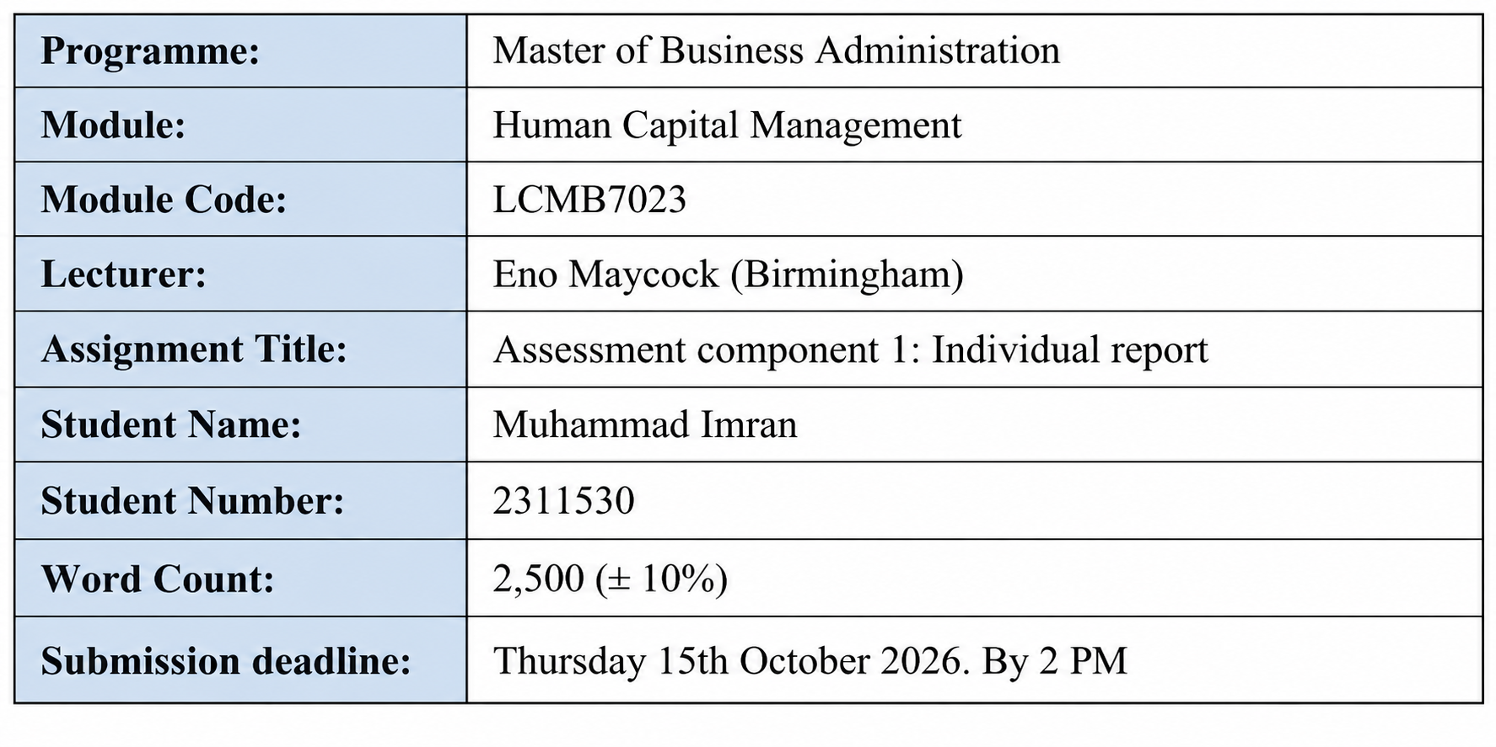

Table of Contents
…………………………………………………………………………………………………2
Innovating New Working Practices and Breeding an Environment Where Talent May Grow 3
Introduction 3
TASK 1: Designing Innovative Working Practices 4
1.Critical Evaluation of Traditional and Contemporary Working Practices 4
2. Recommended Innovative Working Practices suitable for Nexspace Health Systems 7
TASK B: Breeding an Environment Where Talent May Grow 10
1. Critical Evaluation of Talent Development 10
2. Develop a Comprehensive talent growth strategy for Nexspace Health System 13
NHSX Challenges and Justification – Task B 16
TASK C: Reflective Report 17
Conclusion 22
References 23

Innovating New Working Practices and Breeding an Environment Where Talent May Grow

Introduction
NexSpace Health Systems (NHSX) is a rapidly growing healthcare technology organisation employing approximately 600 employees across the United Kingdom, India, and the United Arab Emirates. The organisation develops AI-enabled digital health platforms, remote patient monitoring systems and clinical decision-support technologies for hospitals and healthcare providers.
Following significant international expansion and increased investment in artificial intelligence (AI), NHSX faces several workforce challenges, including hierarchical decision-making, restricted creativity, fragmented hybrid collaboration, employee turnover and wellbeing pressures.
These challenges demonstrate that technological investment alone cannot guarantee organisational success. NHSX must establish innovative working practices alongside effective talent development strategies. This report critically evaluates these challenges using relevant Human Resource Management (HRM) theories and recommends practical solutions to strengthen innovation, collaboration, employee development, and sustainable organisational performance.

TASK 1: Designing Innovative Working Practices

1.Critical Evaluation of Traditional and Contemporary Working Practices
Traditional Hierarchical Working Practices
Traditional work design emphasises hierarchical authority, specialised responsibilities, standardisation, and managerial supervision. These practices can strengthen accountability and consistency, particularly in healthcare technology, where patient safety and regulatory compliance are essential.
However, excessive hierarchy can restrict employee participation and delay innovation.
For example, an NHSX software engineer identifying an improvement to a remote patient monitoring platform may require approval from several managers before implementing changes. This could delay product development and reduce responsiveness to healthcare providers.
High-Performance Work Systems (HPWS) offer an alternative through employee participation, development, and integrated performance management.
Appelbaum et al. (2000) argue that organisational performance depends on employees possessing the ability, motivation, and opportunity to contribute.
Similarly, Jiang et al. (2012) demonstrate that effective HR systems influence organisational outcomes through employee capabilities and motivation.
Nevertheless, Boxall and Macky (2014) warn that high-involvement practices may increase work intensification when performance expectations become excessive.
Therefore, NHSX should decentralise routine operational decisions while retaining appropriate clinical and regulatory oversight.

Employee Creativity and Experimentation
Traditional working practices frequently prioritise established procedures over experimentation. Although standardisation supports operational reliability, excessive control can discourage innovative thinking.
Self-Determination Theory (SDT) identifies autonomy, competence and relatedness as important psychological needs supporting employee motivation (Deci, Olafsen and Ryan, 2017).
Ryan and Deci (2017) further emphasise that supportive environments encourage individuals to develop capabilities and engage meaningfully in work.
For NHSX, limited autonomy may discourage employees from proposing improvements to AI-enabled healthcare technologies.
For example, a data scientist might identify a more effective AI model for predicting patient deterioration but avoid suggesting it because experimentation is discouraged.
High-Involvement Work Systems (HIWS) could address this problem by increasing employee participation in decision-making.
However, unrestricted experimentation could introduce clinical and ethical risks.
Parker and Grote (2022) highlight the importance of effective work design when digital technologies and algorithms influence organisational responsibilities.
Therefore, NHSX should provide structured innovation opportunities supported by technical testing, ethical governance and clinical evaluation.
Hybrid Working and International Collaboration
Hybrid working offers flexibility and access to international talent but may weaken informal communication and knowledge exchange.
Gibbs, Mengel and Siemroth (2024) found that poorly coordinated hybrid working arrangements can negatively affect employee innovation.
This is particularly relevant to NHSX because employees collaborate across three countries.
For example, developers in India may implement software changes without adequately communicating with UK clinical specialists or UAE implementation teams.
Such communication failures could delay product delivery and create operational misunderstandings.
Sociotechnical Systems Theory emphasises the importance of aligning technological systems with organisational structures and employee relationships (Trist and Bamforth, 1951).
Therefore, introducing digital collaboration tools alone will not resolve communication problems.
NHSX must establish shared communication standards, coordinated collaboration periods and effective knowledge-management practices.
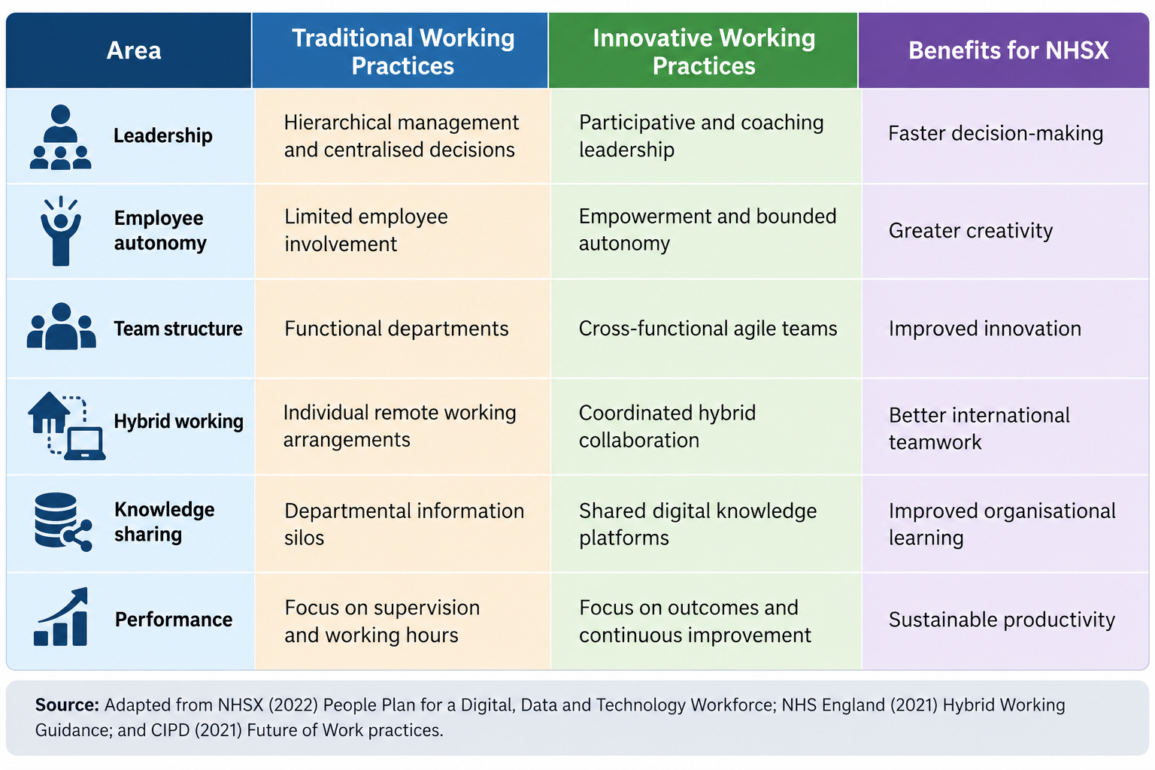
Figure 1: Comparison of Traditional and Innovative Working Practices at NHSX

2. Recommended Innovative Working Practices suitable for Nexspace Health Systems
Cross-Functional Collaboration
NHSX should establish multidisciplinary teams comprising software engineers, clinicians, data scientists, cybersecurity specialists and product managers.
For example, an AI clinical decision-support team could collectively identify patient requirements, develop technological solutions and evaluate clinical risks.
This approach would reduce departmental silos and improve knowledge sharing.
However, cross-functional teams require clearly defined responsibilities to prevent confusion and duplicated work.
Agile Project Teams
NHSX should introduce agile project management through short development cycles, regular feedback and continuous improvement.
For example, a remote patient monitoring team could test software improvements with selected healthcare providers before wider implementation.
Agile working may accelerate innovation, but unrealistic deadlines could increase employee pressure.
Managers should therefore monitor project quality, workload and employee wellbeing alongside delivery speed.
Employee Autonomy
Employees should receive greater responsibility for operational decisions within established clinical, ethical and cybersecurity boundaries.
Managers should adopt coaching-oriented leadership rather than relying exclusively on supervision.
For example, software engineers could select appropriate development methods independently, while changes affecting clinical recommendations would require specialist approval.
This would strengthen employee ownership without compromising patient safety.
Hybrid and Flexible Working
NHSX should coordinate activities requiring collaboration while maintaining flexibility for individual tasks.
For example, international teams could schedule shared product-development discussions while completing coding, analysis and documentation asynchronously.
Meeting times should rotate fairly across countries to prevent excessive inconvenience.
Digital Collaboration Technologies
NHSX should introduce secure communication platforms, shared project boards, searchable knowledge repositories and documented decision-making processes.
Armstrong and Taylor (2023) emphasise the importance of aligning HR practices with organisational objectives.
Consequently, digital technologies should support effective collaboration rather than replace responsible leadership.

Selected NHSX Challenges and Justification – Task 1
I selected challenges A, B and C because they directly concern how employees work, make decisions, share knowledge and contribute to organisational innovation.
Challenge A: Traditional hierarchical working practices have slowed innovation and decision-making.
I selected this challenge because excessive managerial control can restrict organisational agility. HPWS emphasises employee participation and opportunities to contribute (Appelbaum et al., 2000). For example, NHSX could introduce cross-functional teams authorised to make routine operational decisions while maintaining clinical governance. This would improve decision-making efficiency and organisational agility.
Challenge B: Employees report limited opportunities for creativity and experimentation.
I selected this challenge because creativity is essential for developing innovative healthcare technologies. SDT suggests that autonomy supports employee motivation (Deci, Olafsen and Ryan, 2017). For example, NHSX could introduce innovation workshops where employees develop and test improvements to AI-enabled healthcare platforms. This would encourage experimentation while maintaining appropriate clinical and ethical standards.
Challenge C: Hybrid working has weakened collaboration and knowledge sharing across international teams.
I selected this challenge because NHSX operates across the UK, India and UAE, making effective communication essential. Sociotechnical Systems Theory emphasises aligning technology with working practices (Trist and Bamforth, 1951). For example, shared digital platforms and coordinated collaboration periods could improve international knowledge exchange.
Overall, addressing these challenges would strengthen NHSX’s innovation, organisational agility and operational performance.

TASK B: Breeding an Environment Where Talent May Grow

1. Critical Evaluation of Talent Development
Employee Career Growth and Learning Opportunities
Employee development is essential for retaining skilled professionals and maintaining organisational competitiveness.
NHSX faces a significant challenge because several high-performing employees have left due to limited career progression and inadequate learning opportunities.
Senge’s (1990) Learning Organisation Theory proposes that organisations should continuously develop capabilities through personal mastery, shared vision, team learning, mental models and systems thinking.
This theory is particularly relevant to NHSX because healthcare technology requires continuous professional development.
For example, an experienced software engineer may wish to develop expertise in responsible AI or clinical informatics. Without suitable learning opportunities, the employee may seek employment elsewhere.
However, learning organisation principles may become ineffective when employers encourage development without providing sufficient time or resources.
Growth Mindset Theory also supports continuous development.
Dweck (2006) argues that individuals who believe abilities can develop through learning and effort are more likely to embrace challenges.
NHSX could encourage employees to seek feedback, develop new capabilities and learn from responsible experimentation.
Nevertheless, promoting a growth mindset cannot compensate for inadequate career structures.
Strategic Talent Management Theory suggests that organisations should identify positions contributing significantly to competitive advantage (Collings and Mellahi, 2009).
For NHSX, clinical AI specialists, cybersecurity experts and digital product leaders may represent strategically important talent groups.
However, exclusively prioritising selected employees could create perceptions of unfairness.
Gallardo-Gallardo, Dries and González-Cruz (2013) distinguish between inclusive and exclusive approaches to talent management.
Therefore, NHSX should provide development opportunities to all employees while offering additional specialist training where organisational needs justify it.
Employee Wellbeing and High-Performance Expectations
NHSX managers also struggle to balance employee wellbeing with demanding performance expectations.
This challenge is particularly important because healthcare technology employees frequently face tight deadlines, regulatory responsibilities and continuous innovation pressures.
Job Demands-Resources (JD-R) Theory explains that employee wellbeing depends partly on the relationship between workplace demands and available resources (Bakker and Demerouti, 2017).
Bakker, Demerouti and Sanz-Vergel (2023) further emphasise that adequate resources can support engagement and sustainable performance.
For example, NHSX developers may experience pressure to deliver an AI-enabled healthcare platform before a hospital implementation deadline.
Although challenging objectives may encourage productivity, excessive workloads without appropriate support can increase exhaustion and turnover risks.
Psychological Safety Theory provides another relevant perspective.
Edmondson (1999) demonstrates that psychological safety encourages employee learning behaviours.
Edmondson and Bransby (2023) further highlight its importance for organisational learning and performance.
For example, an NHSX employee identifying an error in an AI clinical recommendation should feel confident raising concerns without fear of humiliation.
However, psychological safety must coexist with accountability. Employees should feel safe reporting mistakes while remaining responsible for professional standards and patient safety.
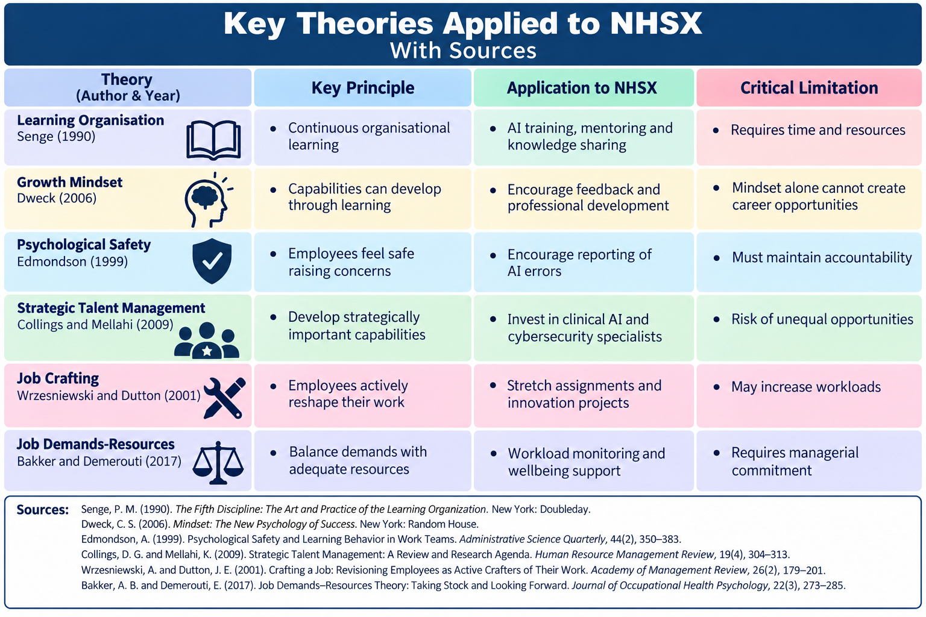
Figure 2. Application of Talent Development Theories at NHSX

2. Develop a Comprehensive talent growth strategy for Nexspace Health System
Continuous Learning and Development
NHSX should establish a structured learning framework identifying existing employee capabilities and future skills requirements.
Priority development areas should include AI governance, cybersecurity, clinical informatics, digital product management and international leadership.
Every employee should receive an Individual Development Plan outlining learning objectives and career aspirations.
For example, an Indian software engineer could complete AI governance training and contribute to a UK clinical technology project.
Managers should conduct regular career development discussions to evaluate progress.
This would strengthen employee capabilities while demonstrating organisational commitment to professional growth.
Internal Mobility and Career Progression
NHSX should introduce an internal talent marketplace advertising vacancies, secondments and cross-functional projects.
For example, a UAE implementation specialist could participate in a UK product development initiative to gain international experience.
Job Crafting Theory suggests that employees can reshape aspects of their responsibilities to improve work meaning and development (Wrzesniewski and Dutton, 2001).
NHSX could therefore encourage stretch assignments and employee-led improvement projects.
However, these opportunities should not create excessive additional workloads.
Separate technical and managerial career pathways would also allow specialists to progress without entering management positions.
Cascio and Boudreau (2016) emphasise the strategic importance of developing talent capabilities within international organisations.
Therefore, internal mobility could improve employee retention while strengthening NHSX’s global workforce.
Psychological Safety and Supportive Leadership
Managers should receive training in coaching, constructive feedback, inclusive leadership and conflict management.
For example, following an unsuccessful AI development pilot, managers could conduct a learning review examining technical challenges and improvement opportunities rather than assigning personal blame.
Employees should also have confidential channels for raising ethical, clinical or workplace concerns.
This would encourage responsible experimentation and continuous learning.
Employee Wellbeing and Sustainable Performance
NHSX should regularly assess employee workloads, wellbeing, meeting demands and work-life balance.
For example, international teams could rotate early-morning and late-evening meetings to distribute inconvenience fairly.
Managers should establish realistic project deadlines and provide adequate recovery opportunities.
Performance evaluations should consider innovation, collaboration, product quality and professional development rather than working hours alone.
Measuring Talent Development Outcomes
NHSX should monitor employee retention, internal promotions, skills development, engagement, psychological safety and regretted turnover.
For example, HR could examine whether employees participating in development programmes demonstrate improved career progression and organisational commitment.
However, training participation alone does not demonstrate improved performance.
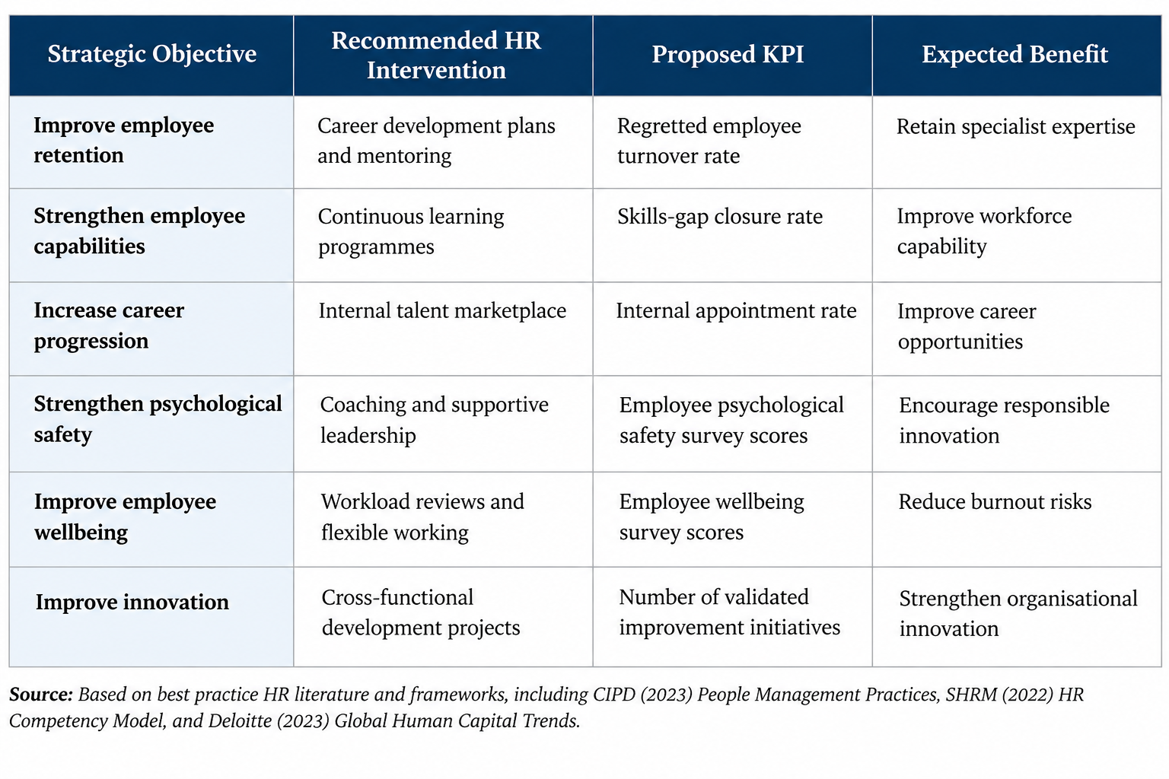
Therefore, NHSX should assess whether development contributes to innovation, service quality and organisational capabilities.
Figure 3. Proposed Talent Growth Strategy and Key Performance Indicators

NHSX Challenges and Justification – Task B
I selected challenges D and E because they directly concern employee development, talent retention, wellbeing and sustainable organisational performance.
Challenge D: Several high-performing employees have left because they perceive limited career growth and inadequate learning opportunities.
I selected this challenge because losing talented employees threatens organisational knowledge and competitiveness. Senge’s (1990) Learning Organisation Theory emphasises continuous development, while Strategic Talent Management Theory highlights the importance of developing employees in strategically significant roles (Collings and Mellahi, 2009). For example, NHSX could introduce mentoring, individual development plans and international career opportunities to improve retention.
Challenge E: Managers struggle to balance employee wellbeing with high-performance expectations.
I selected this challenge because excessive workloads can negatively affect employee wellbeing and long-term productivity. JD-R Theory explains that employees require adequate resources and organisational support to manage demanding responsibilities (Bakker and Demerouti, 2017). For example, NHSX could introduce regular wellbeing discussions, realistic project deadlines and flexible working arrangements to reduce burnout risks.
Overall, addressing these challenges would help NHSX retain skilled employees, strengthen professional development and maintain sustainable organisational performance.

TASK C: Reflective Report

Figure 4: Gibbs’s Reflective Cycle (On my use of AI in HR Studies)
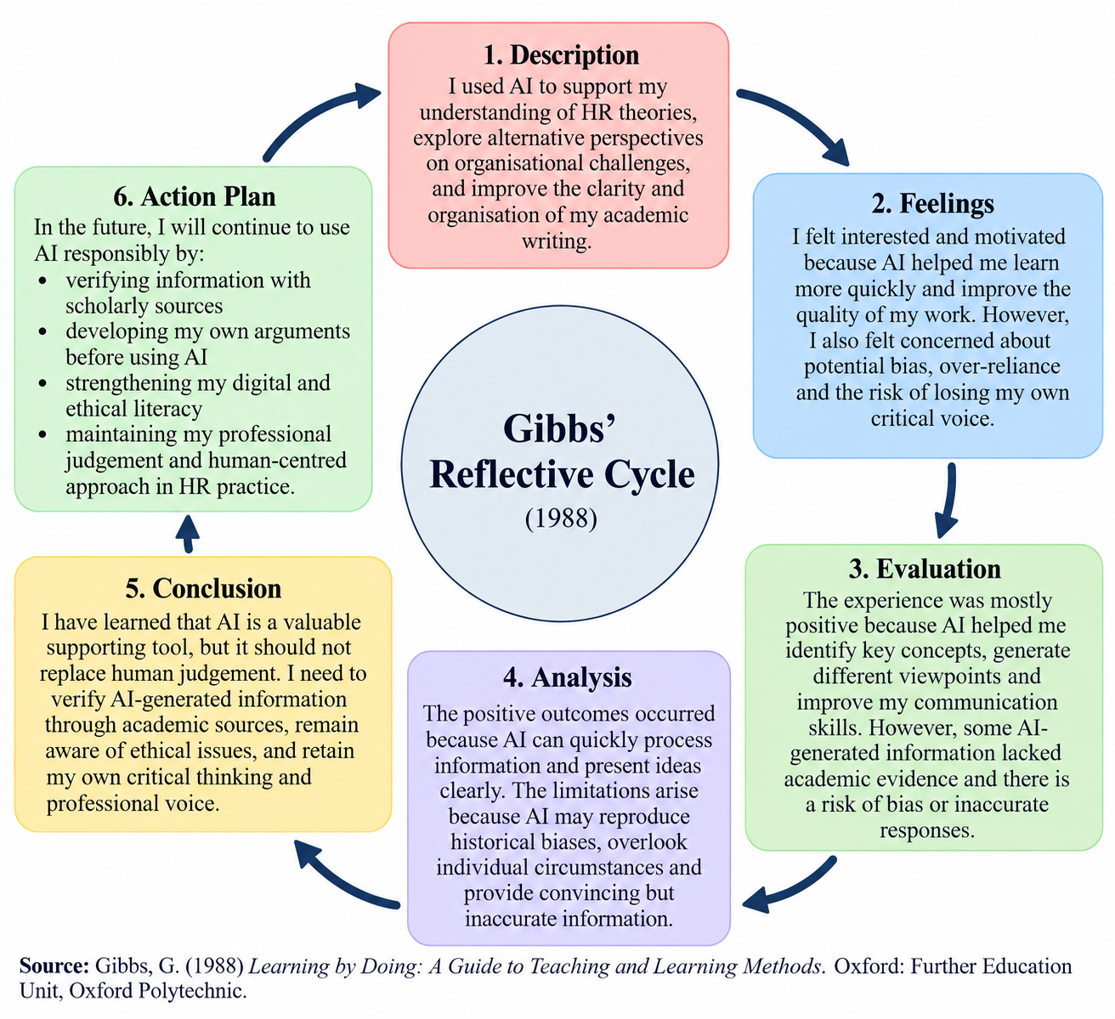
1. AI as a Strategic Decision-Support Tool in Human Resource Management
As a future HR professional, I recognise that artificial intelligence can strengthen strategic decision-making through workforce analytics, recruitment support, skills identification and employee development planning.
For example, AI could help NHSX identify emerging cybersecurity skills shortages and forecast future recruitment requirements.
Budhwar et al. (2022) highlight significant opportunities for AI within international HRM while recognising ethical and operational challenges.
However, AI-generated recommendations may reproduce historical biases, provide inaccurate information or overlook individual circumstances.
For example, automated recruitment systems could unintentionally disadvantage applicants when historical hiring data contains discriminatory patterns.
Therefore, HR professionals must retain responsibility for employment decisions.
Human empathy remains essential when managing employee wellbeing, conflict and redundancy.
I believe effective HR practice requires combining AI-supported evidence with ethical judgement, transparency and professional accountability.
2. Reflective Analysis: Three Examples of AI Use
Example One: Understanding HR Theories
I have used AI to support my understanding of HR theories, including Self-Determination Theory and Job Demands-Resources Theory.
AI helped me identify relationships between motivation, employee wellbeing and organisational performance.
However, AI-generated explanations sometimes appeared convincing without providing sufficient academic evidence.
This experience encouraged me to verify information through scholarly publications and strengthen my independent research skills.
Example Two: Developing Critical Thinking
I have used AI to explore alternative perspectives on organisational challenges.
For example, AI helped me recognise that employee autonomy can improve motivation while potentially creating governance risks.
This supported my ability to evaluate advantages and limitations.
However, excessive dependence on AI could weaken independent reasoning.
Therefore, I intend to develop my own arguments before using AI to challenge or refine them.
Example Three: Improving Professional Communication
I have used AI to improve the clarity and organisation of academic writing.
For example, AI helped me simplify complicated explanations and organise recommendations logically.
This is relevant to HR because professionals must communicate evidence clearly to managers.
Nevertheless, excessive AI editing can reduce originality and personal expression.
Consequently, I have learned to use AI as a supporting tool while retaining my professional voice.

3. Personal Capability Development Plan
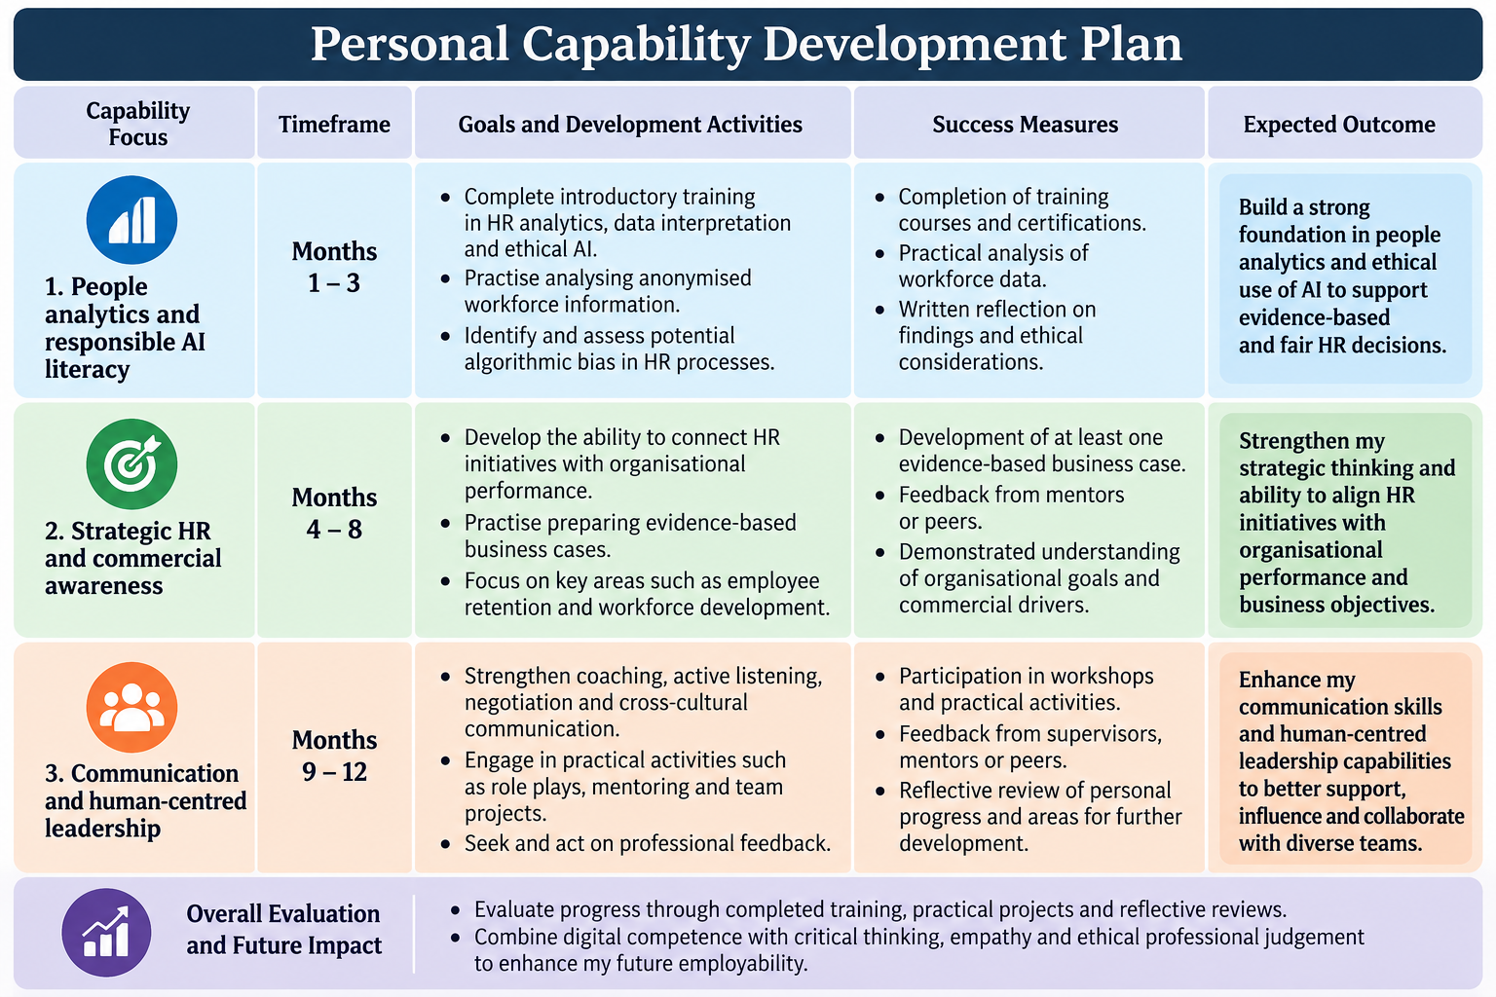
Figure 5. Personal Capability Development Plan for the Next 12 Months

Source: Author’s own work (2026).
Over the next twelve months, I intend to strengthen three professional capabilities.
First, people analytics and responsible AI literacy: During the first three months, I will complete introductory training in HR analytics, data interpretation and ethical AI. I will practise analysing anonymised workforce information and identifying potential algorithmic bias.
Second, strategic HR and commercial awareness: Between months four and eight, I will develop my ability to connect HR initiatives with organisational performance. I will practise preparing evidence-based business cases addressing employee retention and workforce development.
Third, communication and human-centred leadership: Between months nine and twelve, I will strengthen coaching, active listening, negotiation and cross-cultural communication through practical activities and professional feedback.
I will evaluate my progress through completed training, practical projects and reflective reviews.
My future employability will depend on combining digital competence with critical thinking, empathy and ethical professional judgement.

Conclusion
NexSpace Health Systems requires an integrated approach to innovative working practices and strategic talent development.
Task A demonstrates that excessive hierarchy, restricted creativity and fragmented hybrid collaboration can weaken innovation. Cross-functional teams, employee autonomy, agile working and digital collaboration offer practical solutions.
Task B demonstrates that limited career development and excessive performance expectations threaten employee retention and wellbeing. Continuous learning, internal mobility, psychological safety and supportive leadership can create an environment where talent flourishes.
Task C highlights that AI can strengthen HR decision-making when combined with human judgement and ethical responsibility.
Ultimately, NHSX’s competitive advantage will depend on developing an innovative, collaborative and continuously learning workforce while maintaining healthcare accountability.

References

Appelbaum, E., Bailey, T., Berg, P., Kalleberg, A.L. and Bailey, T.A., 2000. Manufacturing advantage: Why high-performance work systems pay off (pp. 129-165). ILR Press: Ithaca, NY.
Taylor, M.A.S., 2014. Armstrongs handbook of human resource management practice. Kogan Page Limited.
Bakker, A.B. and Demerouti, E., 2017. Job demands–resources theory: Taking stock and looking forward. Journal of occupational health psychology, 22(3), p.273.
Bakker, A.B., Demerouti, E. and Sanz-Vergel, A., 2023. Job demands–resources theory: Ten years later. Annual review of organizational psychology and organizational behaviour, 10(1), pp.25-53.
Boxall, P. and Macky, K., 2014. High-involvement work processes, work intensification, and employee well-being. Work, employment and society, 28(6), pp.963-984.
Budhwar, P., Malik, A., De Silva, M.T. and Thevisuthan, P., 2022. Artificial intelligence–challenges and opportunities for international HRM: a review and research agenda. The International Journal of human resource management, 33(6), pp.1065-1097.
Cascio, W.F. and Boudreau, J.W., 2016. The search for global competence: From international HR to talent management. Journal of World Business, 51(1), pp.103-114.
Collings, D.G. and Mellahi, K., 2009. Strategic talent management: A review and research agenda. Human resource management review, 19(4), pp.304-313.
Deci, E.L., Olafsen, A.H., and Ryan, R.M., 2017. Self-determination theory in work organisations: The state of a science. Annual review of organizational psychology and organizational behaviour, 4, pp.19-43.
Dweck, C.S. and Yeager, D.S., 2019. Mindsets: A view from two eras. Perspectives on Psychological science, 14(3), pp.481-496.
Edmondson, A., 1999. Psychological safety and learning behaviour in work teams. Administrative science quarterly, 44(2), pp.350-383.
Edmondson, A.C. and Bransby, D.P., 2023. Psychological safety comes of age: Observed themes in an established literature. Annual review of organizational psychology and organizational behaviour, 10(1), pp.55-78.
Gallardo-Gallardo, E. and Collings, D.G., 2021. Talent management for the future of work.
Gibbs, M., Mengel, F. and Siemroth, C., 2024. Employee innovation during office work, work from home and hybrid work. Scientific Reports, 14(1), p.17117.
Jiang, K., Lepak, D.P., Hu, J. and Baer, J.C., 2012. How does human resource management influence organizational outcomes? A meta-analytic investigation of mediating mechanisms. Academy of management Journal, 55(6), pp.1264-1294.
Parker, S.K. and Grote, G., 2022. Automation, algorithms, and beyond: Why work design matters more than ever in a digital world. Applied psychology, 71(4), pp.1171-1204.
Ryan, R.M. and Deci, E.L., 2021. Self-determination theory: Basic psychological needs in motivation, development, and wellness. Rajagiri Management Journal, 15(1), pp.88-90.
Senge, P.M. (1990) The fifth discipline: The art and practice of the learning organization. New York: Doubleday.
Trist, E.L. and Bamforth, K.W., 1951. Some social and psychological consequences of the longwall method of coal-getting: An examination of the psychological situation and defences of a work group in relation to the social structure and technological content of the work system. Human relations, 4(1), pp.3-38.
Wrzesniewski, A. and Dutton, J.E., 2001. Crafting a job: Revisioning employees as active crafters of their work. Academy of management review, 26(2), pp.179-201.

