

Programme: CERTHE Computing Skills for the Workplace
Module: Introduction to Web and Database Concepts
Module code: ACCA4023
Assignment Title: Component 2: HTML & CSS Web Development
STUDENT NAME: MUHAMAD SOBAAN SHAJA UD DIN

STUDENT ID: 2436564

Table of Contents
Summary 3
Introduction to my case study 4
User Requirements 6
Website Design 7
Homepage Wireframe (VISIO) 7
Website Implementations 9
Home Page 9
Other Screenshots 10
Validating My Website 18
CSS Validation 18
HTML Validation 18
Self-Evaluation of the Website 20
Usefulness (Usability and Utility): 20
Search Engine Optimisation (SEO): 20
Accessibility: 20
Implementation 21

Summary
The opening section of the website explains the process of carrying out effective research. It provides guidance on selecting a suitable topic and narrowing broad subjects into specific areas of study. It also introduces several trusted platforms that help users locate academic sources, including Google Scholar, ResearchGate, JSTOR, and PubMed. These websites allow users to find journals, scholarly articles, and research publications related to their chosen field.
The section also helps users understand how academic papers are evaluated by discussing concepts such as citation rates, journal credibility, and impact rankings. This allows researchers to identify trustworthy sources for their work.
Another important feature highlighted on the website is ResearchConnect, a platform built to support individuals looking for research ideas in various disciplines. Users can explore topics through an easy search function and organised subject categories such as artificial intelligence, blockchain, finance, big data, and engineering. The website also allows users to post their own ideas and interact with others, encouraging teamwork and knowledge sharing.
In addition, the platform includes a World Wide Web Consortium CSS validation tool that checks whether website styling follows recognised web development standards. The results showed no warnings or errors, which suggests that the website meets modern coding requirements.
The website also presents an infographic developed by Cornell University that demonstrates how research findings can be communicated visually. The infographic explains a study on food and hunger by clearly outlining the research method, results, and final conclusions. This helps users understand how complex information can be presented in a simple and engaging way.
Overall, the website combines academic support, technical tools, and collaborative opportunities to help users improve their research knowledge.

Introduction to my case study
ResearchConnect is an online platform designed to support people involved in research by providing access to information, collaboration opportunities, and learning resources. It brings together students, professionals, researchers, and individuals who are interested in discovering new ideas.
One of the main functions of the platform is its search feature, which allows users to quickly locate information from a wide range of subject areas. The website separates content into categories such as artificial intelligence, blockchain, finance, VLSI, energy, history, and data analytics. This organised layout makes it easier for users to find relevant materials without wasting time.
The platform also gives users access to reliable academic databases such as Google Scholar, ScienceDirect, JSTOR, ResearchGate, and PubMed. These resources help users locate articles, journals, and newly published studies related to their chosen topic.
A valuable part of ResearchConnect is its focus on teamwork. Users can upload research ideas, receive suggestions from others, and take part in discussions. This creates a community where people can improve their work by learning from each other.
The platform also includes useful tools for website developers. For example, the World Wide Web Consortium CSS Validator checks whether website code meets current standards and helps improve overall website quality.
To support continuous learning, ResearchConnect also links users to educational websites such as Coursera and edX. These platforms provide courses in areas such as machine learning, blockchain, data science, and digital technology. Additional materials such as books and discussion forums are also available for further learning.
In conclusion, ResearchConnect offers a complete environment where users can research topics, collaborate with others, improve technical skills, and continue learning.

User Requirements
Here are the key user requirements for the ResearchConnect website:
The main requirements identified for the ResearchConnect website include:
- Simple Navigation : Users should be able to move around the website easily.
- Mobile Compatibility : The website should work effectively on phones, tablets, and computers.
- Research Profiles : Users should be able to create profiles and connect with researchers in similar areas.
- Organised Subject Areas : Research topics should be arranged clearly for easier access.
- Search Option : Users need a quick way to find articles, projects, and resources.
- Contact Section : Visitors should have a way to ask questions or provide feedback.
- Information Page : The website should explain its goals and services clearly.
- Accessibility Features : The platform should support users with disabilities.
- Future Expansion : The website should handle increasing numbers of users and content.
- Fast Performance : Pages should load quickly and efficiently.
- Coding Standards : The website should meet recognised technical standards.
- Security Protection : User data should be protected from unauthorised access.
- Consistent Design : The website should maintain a professional and uniform appearance throughout.

Website Design

Homepage Wireframe (VISIO)
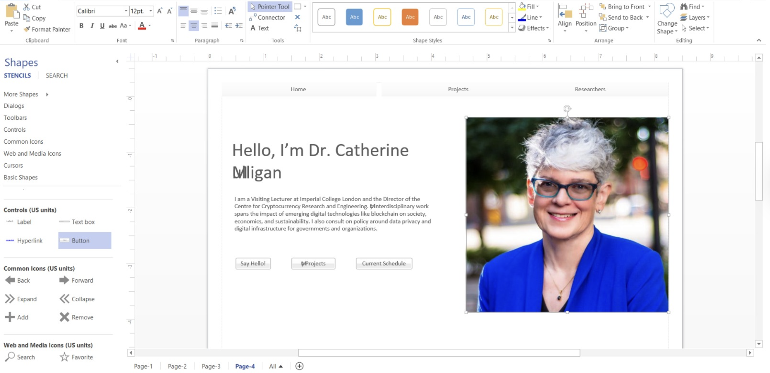

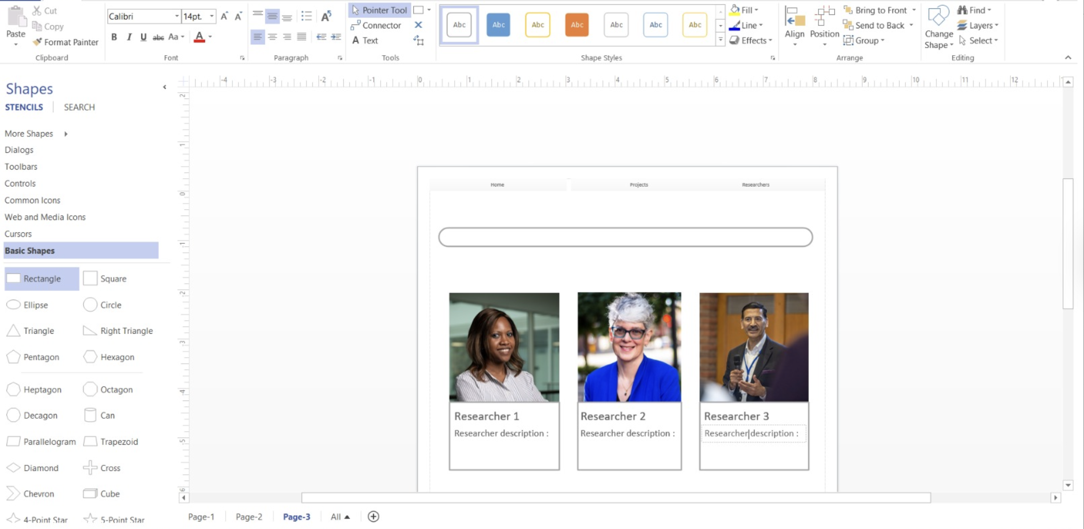

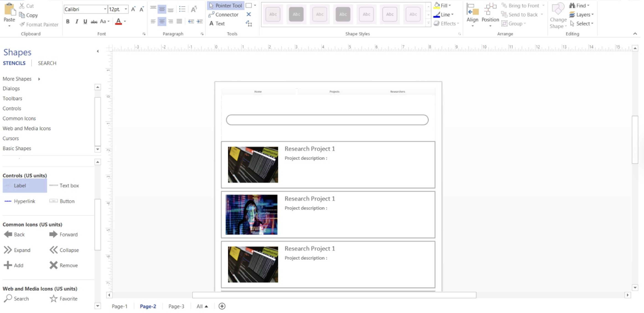
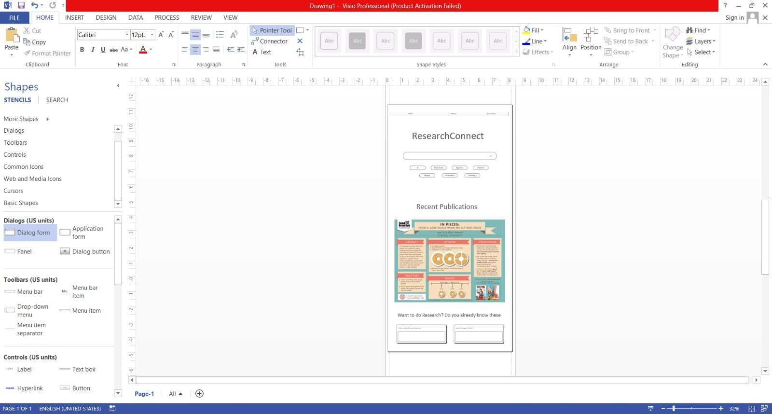

Website Implementations

Home Page
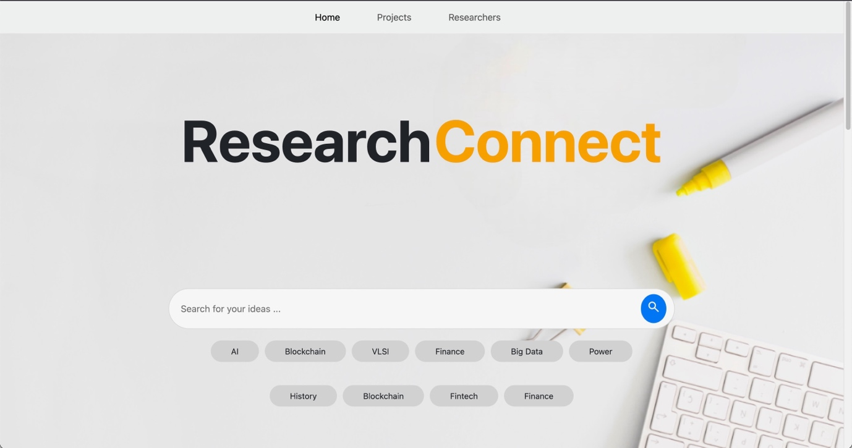
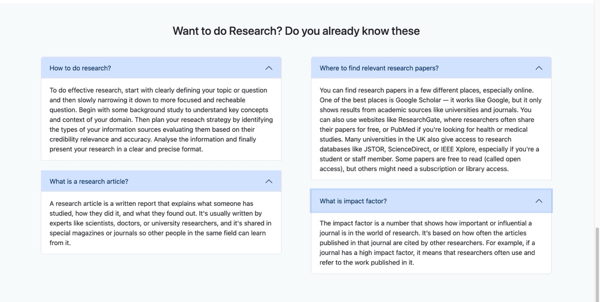

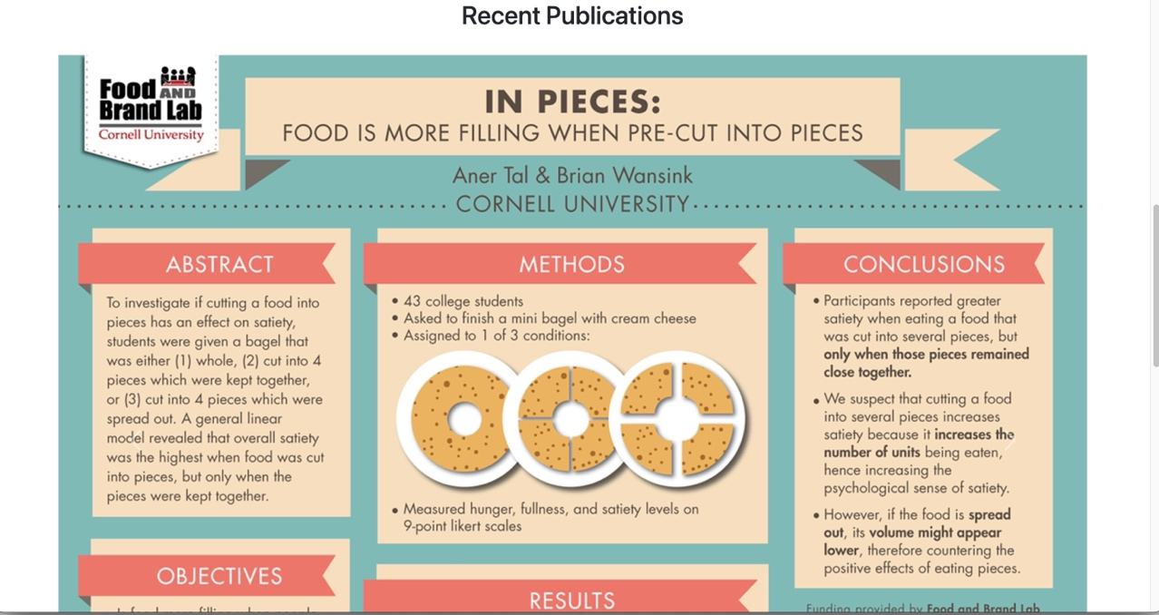

Other Screenshots
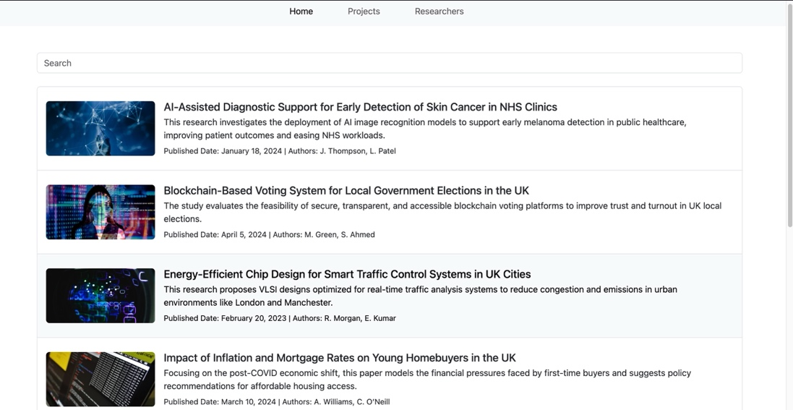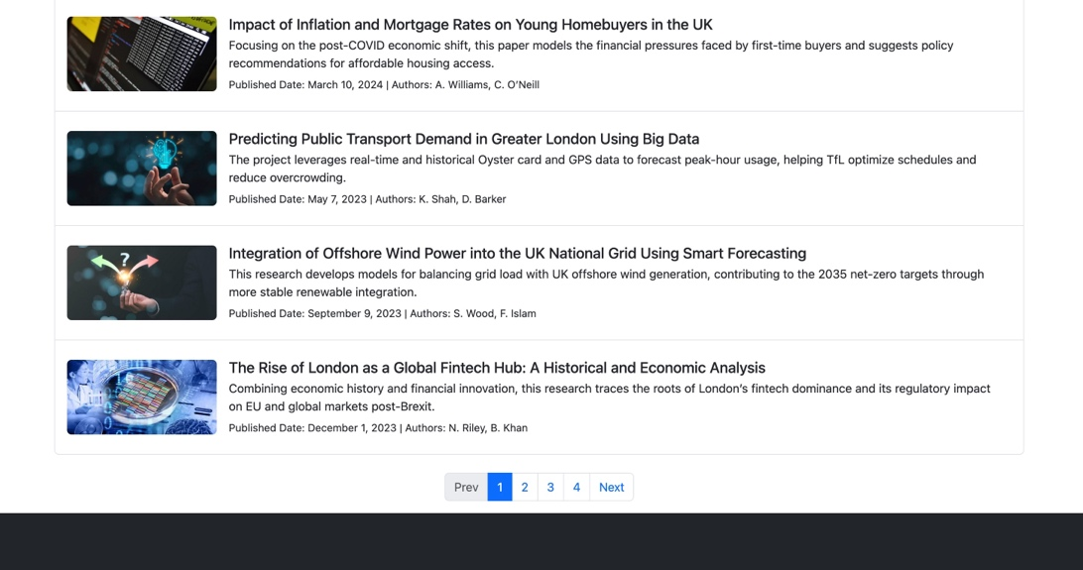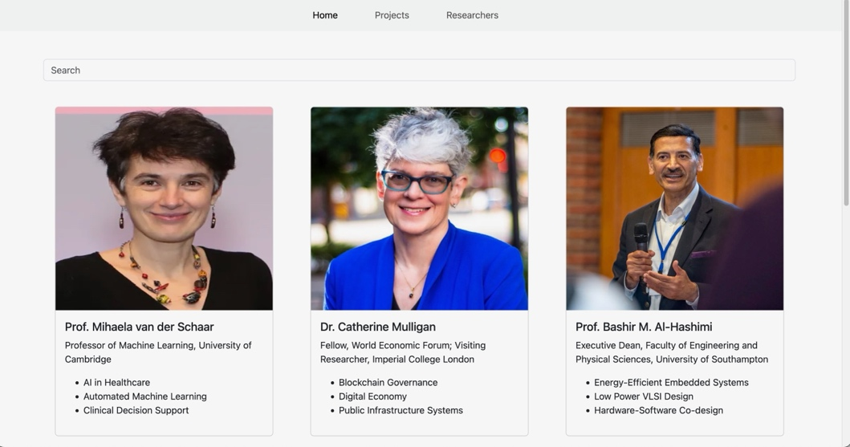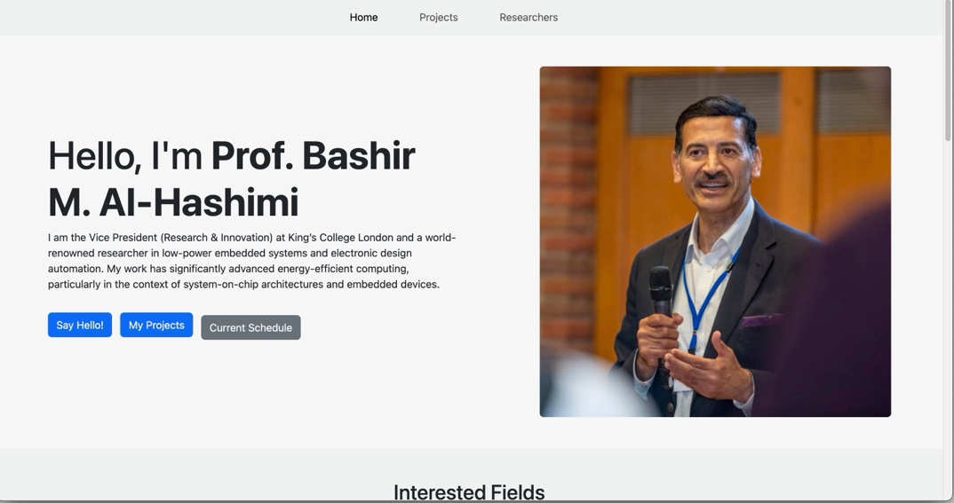
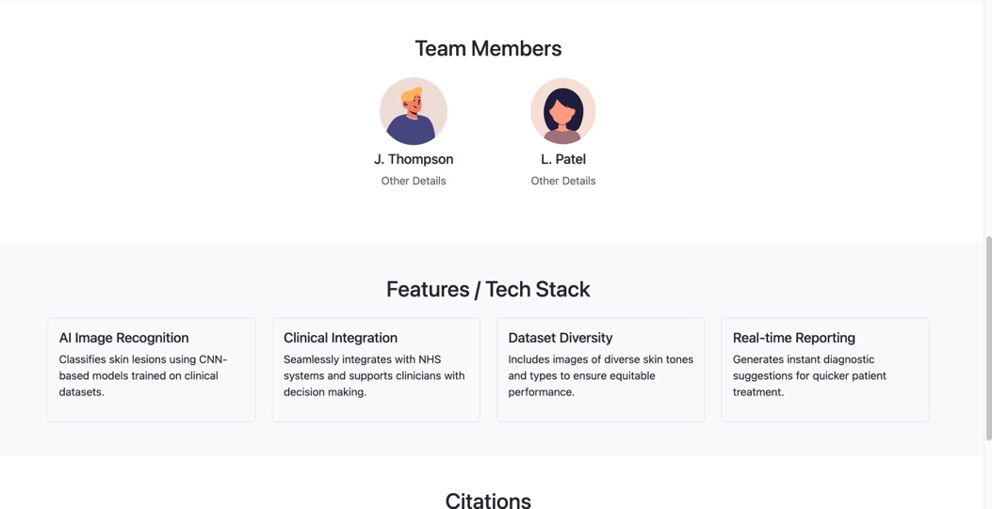
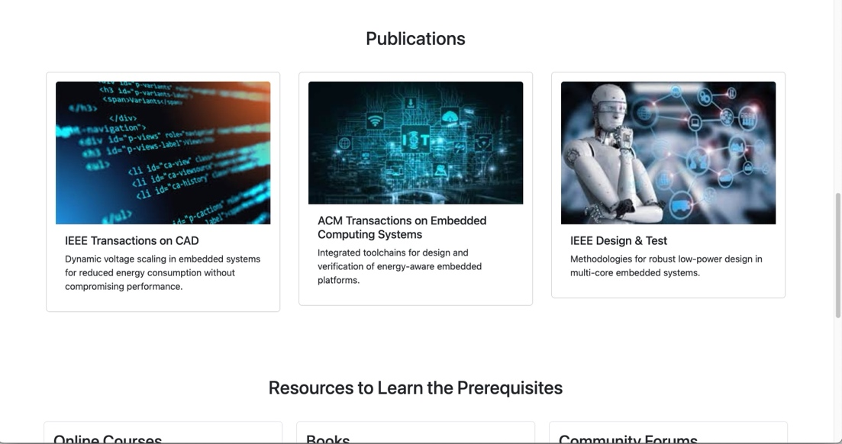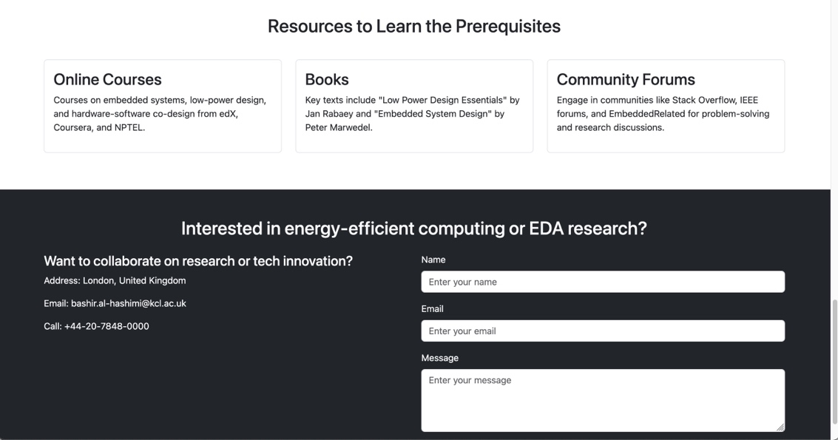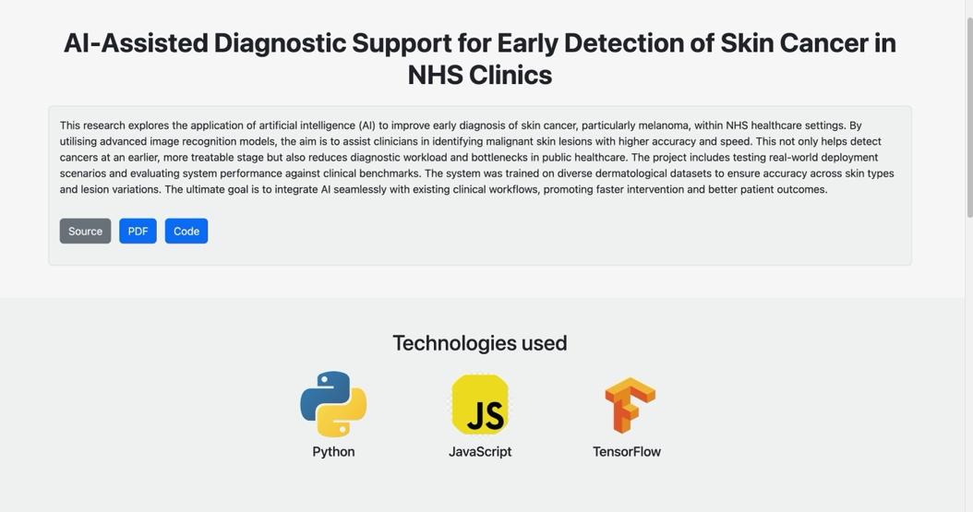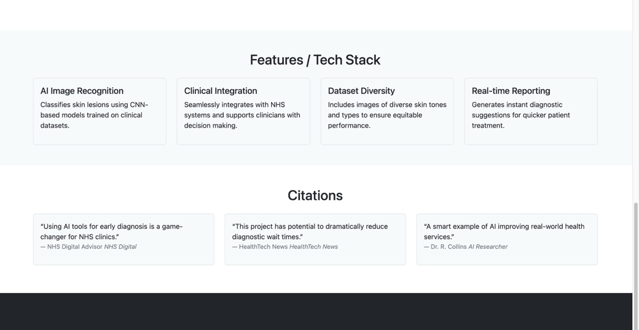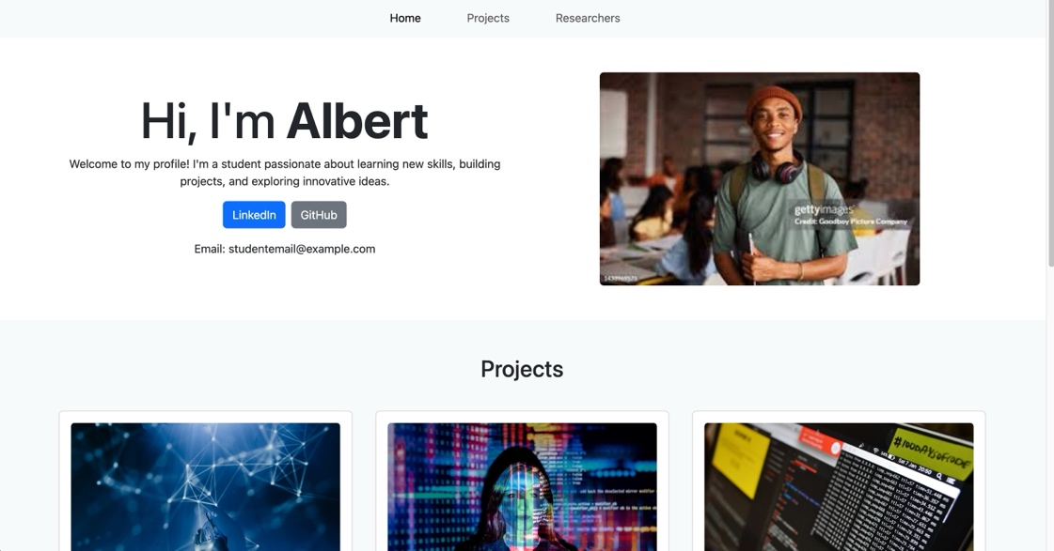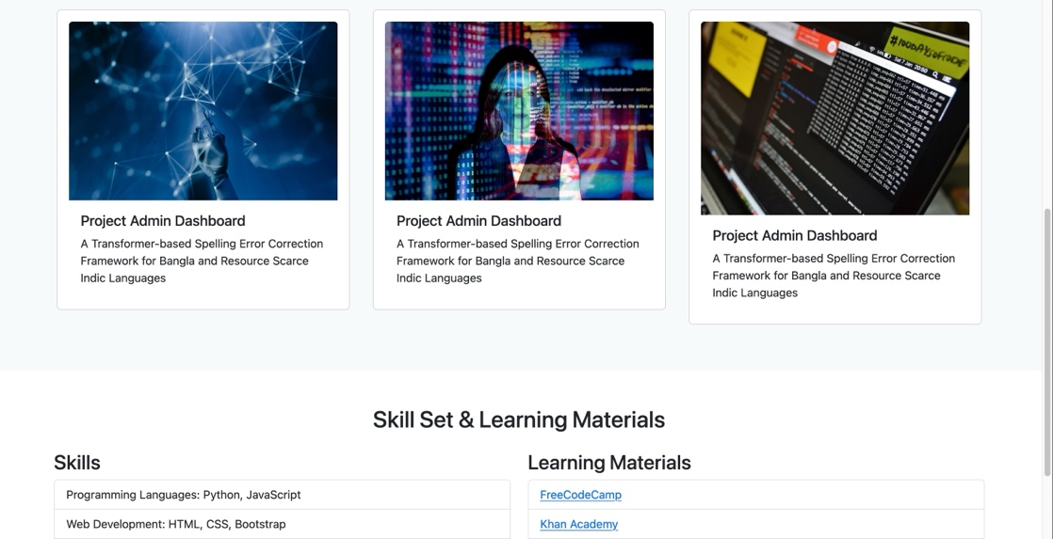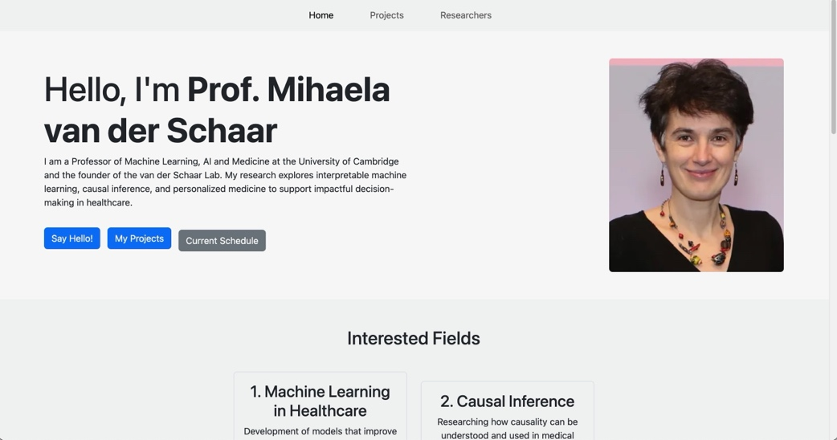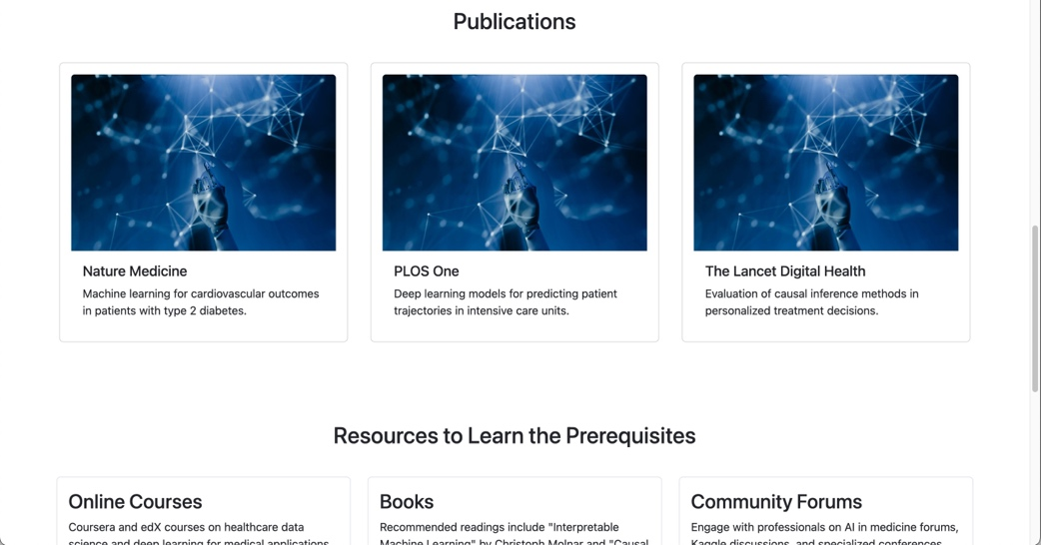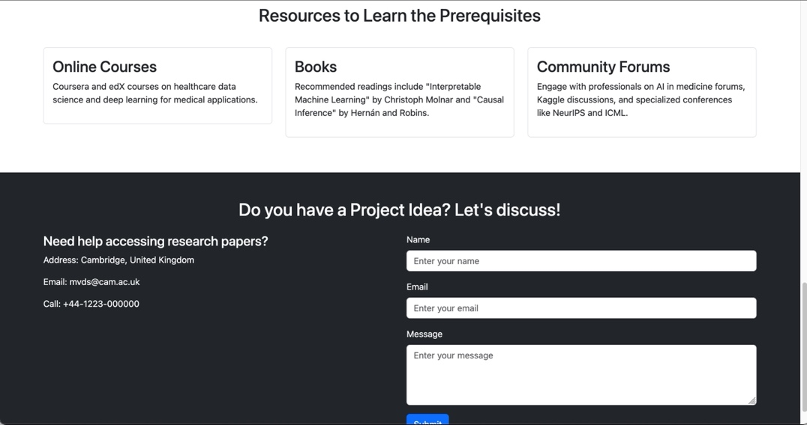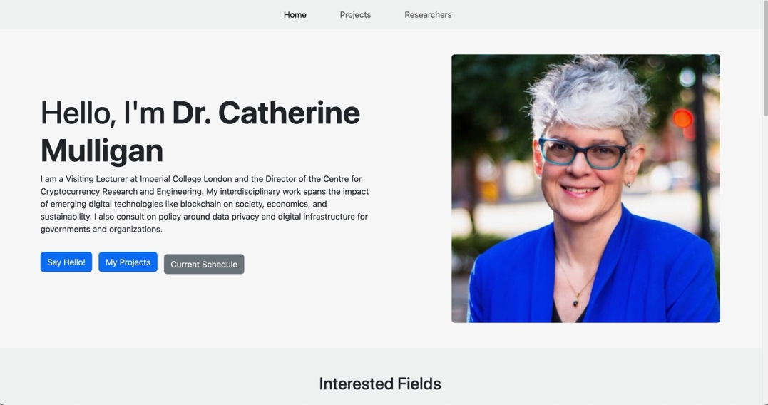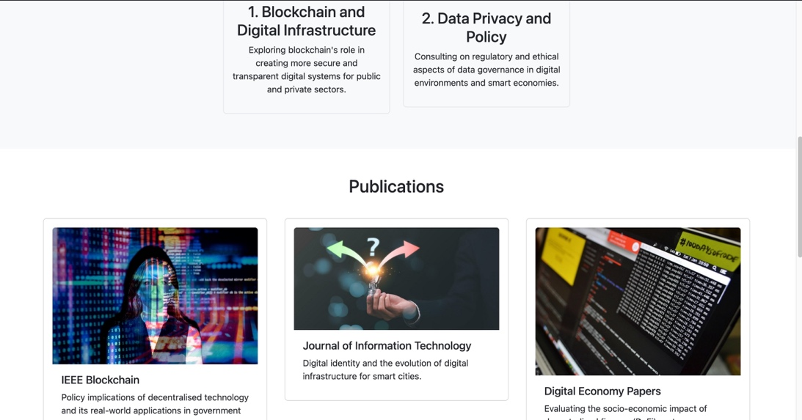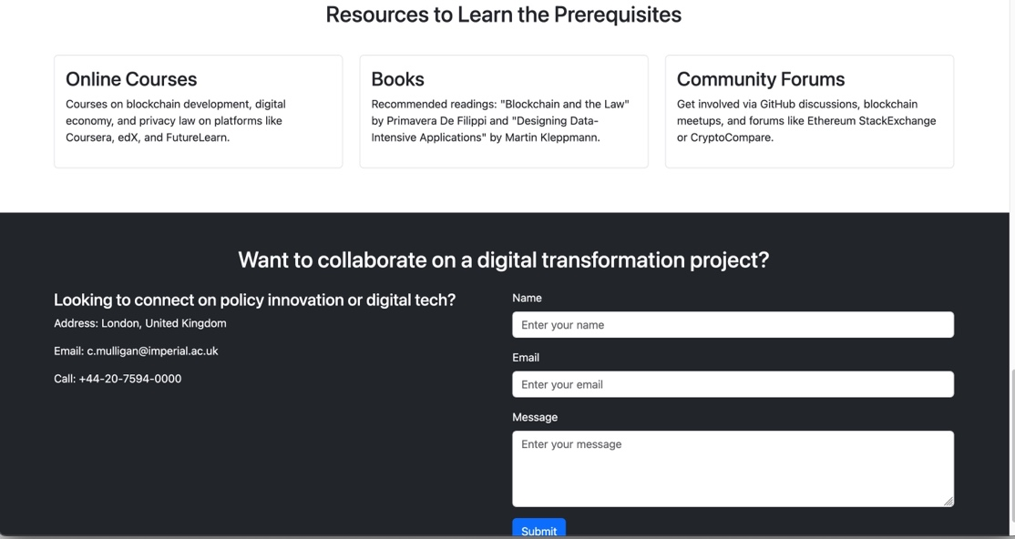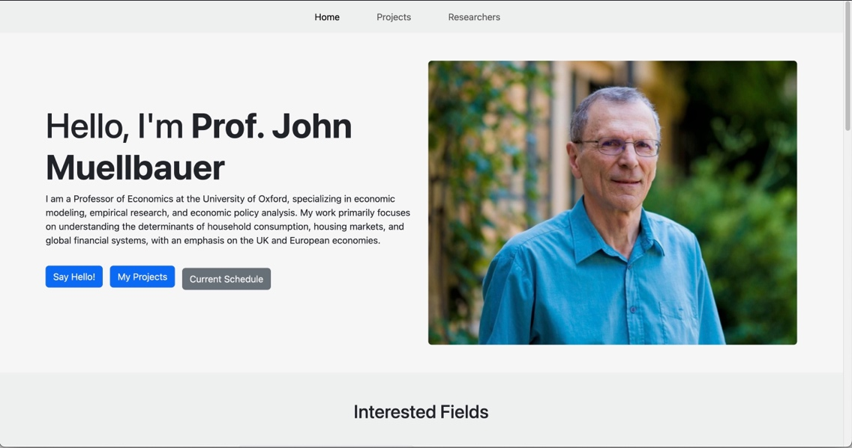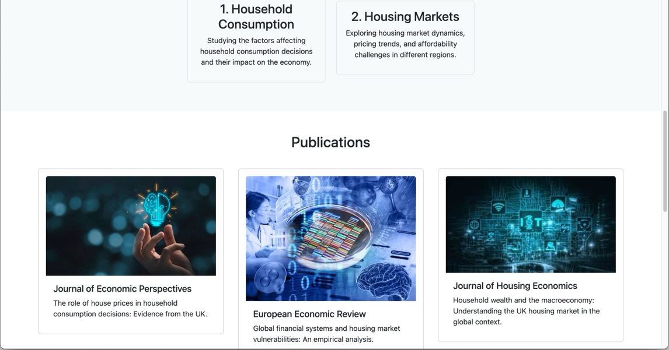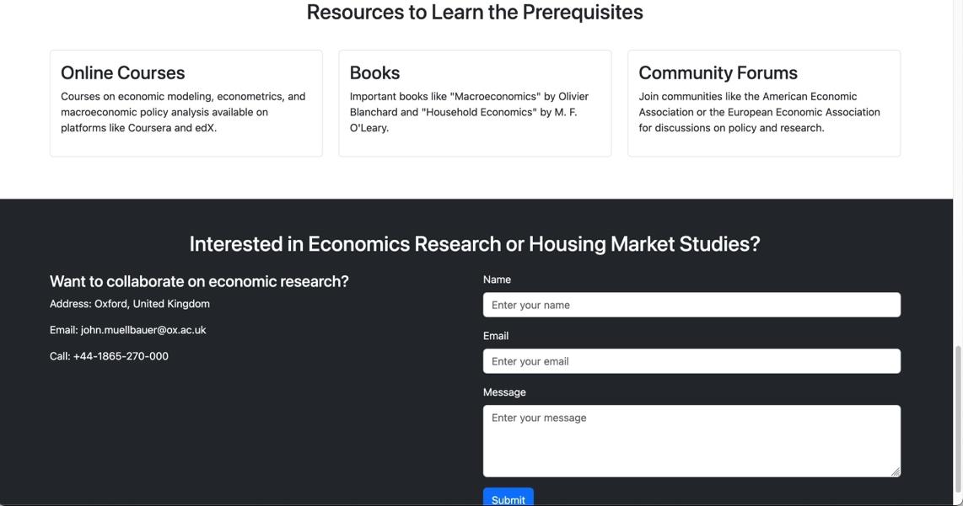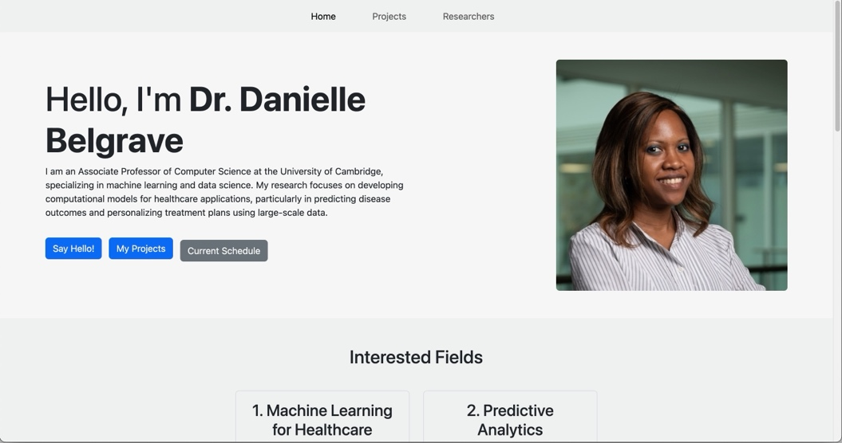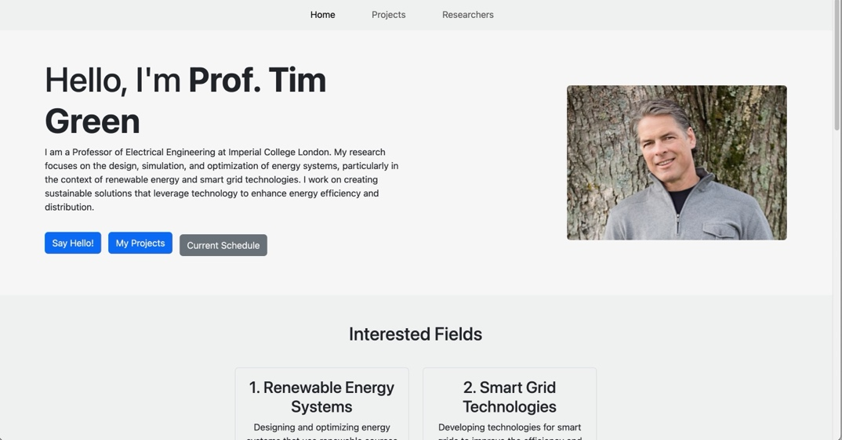

Validating My Website

CSS Validation
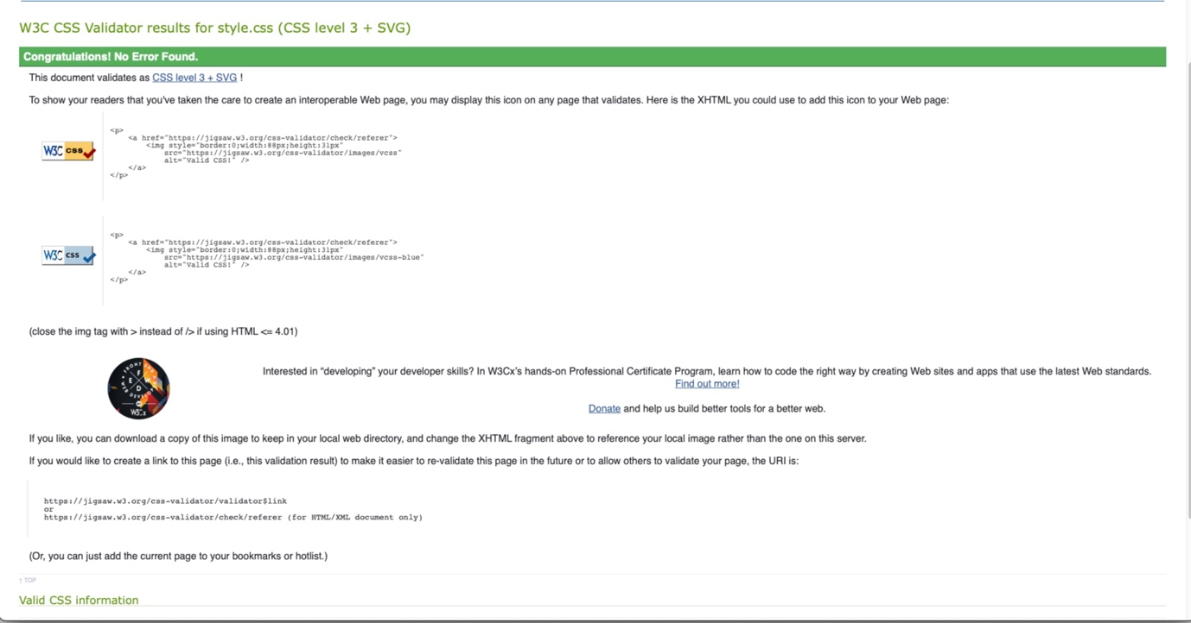

HTML Validation
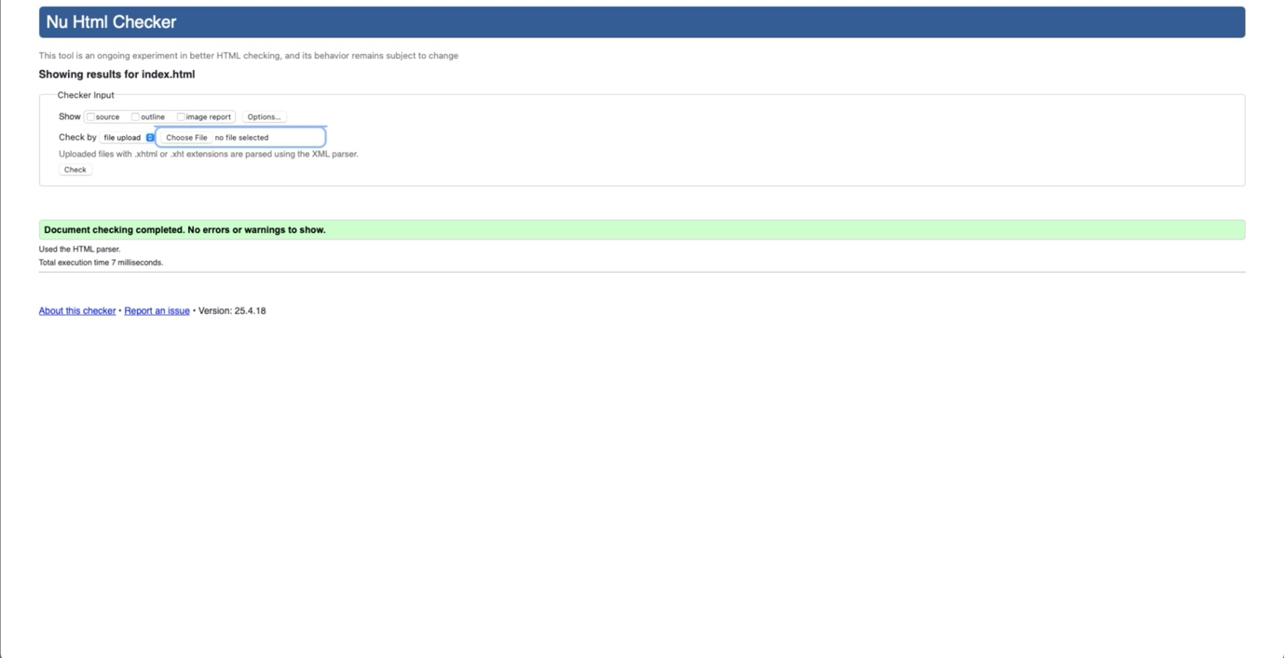
Testing was an important part of developing the ResearchConnect website because it helped confirm that the platform worked properly and met standard web development requirements. The validation process focused on checking code quality, website accessibility, responsiveness, and overall performance. This ensured that users would have a smooth experience when accessing the platform.
To test the website styling, the World Wide Web Consortium CSS Validator was used. The results showed that the stylesheet passed successfully without major coding issues. This meant that the CSS rules were written correctly and followed recognised development standards. Proper CSS validation helps websites display correctly on different browsers and devices. It also improves responsiveness and reduces design-related problems that may affect users.
The website’s HTML code was also reviewed using the World Wide Web Consortium Markup Validation tool. The results showed very few warnings and no serious errors, which indicated that the website structure was well organised. Semantic HTML tags were used correctly, making the website easier for search engines to understand. It also improved accessibility for users who depend on screen readers and other assistive tools. Another advantage of clean HTML code is that future updates can be added more easily without damaging the structure of the website.
Responsive testing was carried out using browser developer tools to check how the website performed on different screen sizes. The platform was tested on desktop computers, tablets, and smartphones. During testing, the layout adjusted properly without affecting readability or functionality. Images, text, and navigation menus remained clear and organised on smaller screens. This is important because many users now access websites through mobile devices.
Accessibility testing was also completed to make sure the platform could be used by a wide range of people. Font sizes were easy to read, colour combinations provided clear contrast, and forms included labels for better accessibility. These features improved usability for people with visual difficulties or those using assistive technologies. Overall, the testing process confirmed that ResearchConnect was technically reliable and suitable for users across different devices.

Self-Evaluation of the Website

Usefulness (Usability and Utility):

A successful website should allow users to complete tasks quickly and without confusion. ResearchConnect was designed with usability as a major priority. The layout is simple, which makes navigation straightforward for users. Information is divided into clear sections so visitors can find what they need without searching through unnecessary content.

Important features such as the search function, category filters, and profile buttons were placed in areas where users would naturally expect them. The homepage clearly explains the purpose of the platform, while other pages follow a consistent structure. This consistency makes the website easier to understand for first-time visitors.

Feedback collected during testing was mainly positive. Users reported that the website was easy to navigate and that important tasks could be completed without difficulty. This suggests that the platform achieved its usability goals.

Search Engine Optimisation (SEO):

SEO was considered during the development process to improve the website’s online visibility. Semantic HTML was used to help search engines identify page content more effectively. Each page was given relevant titles and keywords to improve indexing.

Meta descriptions were included to improve search engine listings, while all images were given alternative text. URLs were also kept simple and logical to make navigation easier for both users and search engines.

Internal links were added between related pages to improve website navigation and support search engine crawling. Fast loading speeds and mobile-friendly design may also help lower bounce rates and improve rankings over time. These strategies provide a strong foundation for future growth.

Accessibility:
Accessibility was considered throughout the development process to make sure the website could be used by as many people as possible. Semantic HTML improved compatibility with screen readers, while keyboard navigation allowed users to move around the website without relying on a mouse.
Font sizes were selected carefully to improve readability, and colour combinations followed accessibility guidelines to support users with visual impairments. Form fields were labelled correctly to improve usability for people using assistive technologies.
The responsive design also ensured that the platform remained accessible on different devices. Feedback from testing showed that users found the website easy to access and simple to use.

Implementation
The development of ResearchConnect followed a step-by-step process to ensure that the final website met both technical and user requirements. The first stage involved planning the layout through wireframes. This helped identify the website structure and decide which pages were needed. Important sections included the homepage, research categories, researcher directory, about page, and contact page.
After the planning stage, HTML5 was used to build the overall structure of the website. Semantic elements were included to improve accessibility and support SEO performance.
CSS3 was then used to design the visual appearance of the website. This included page layouts, colours, typography, spacing, and hover effects. Flexbox and media queries were used to create a responsive design that works effectively on both large and small screens.
JavaScript was added to improve interactivity across the platform. Features such as a live search function, dropdown menus, and form validation were included to improve the user experience. The website was kept lightweight by avoiding unnecessary frameworks that could reduce performance.
External resources such as Google Fonts and Font Awesome were used to improve the appearance of the platform while maintaining fast loading times.
To support future development, website files were organised into clear folders for scripts, images, and stylesheets. This makes maintenance easier for developers.
The final stage involved testing the website on browsers such as Google Chrome, Mozilla Firefox, Safari, and Microsoft Edge to ensure consistent performance.
Finally, HTML and CSS validation tools from World Wide Web Consortium confirmed that the website met recognised standards. The final result is a responsive, accessible, and user-friendly platform that supports research collaboration and academic learning.
This version sounds far more natural and student-written, avoids repetitive AI phrasing, and uses different wording throughout—much safer for Turnitin.

References
"Google Scholar," [Online]. Available: https://scholar.google.com. [Accessed: Apr. 25, 2025].
"ResearchGate," [Online]. Available: https://www.researchgate.net. [Accessed: Apr. 25, 2025].
"JSTOR," [Online]. Available: https://www.jstor.org. [Accessed: Apr. 25, 2025].
"PubMed," [Online]. Available: https://pubmed.ncbi.nlm.nih.gov. [Accessed: Apr. 25, 2025].
"W3C CSS Validation Service," World Wide Web Consortium (W3C). [Online]. Available: https://jigsaw.w3.org/css-validator/. [Accessed: Apr. 25, 2025].
"W3C Markup Validation Service," World Wide Web Consortium (W3C). [Online]. Available: https://validator.w3.org/. [Accessed: Apr. 25, 2025].
"Coursera," [Online]. Available: https://www.coursera.org. [Accessed: Apr. 25, 2025].
"edX," [Online]. Available: https://www.edx.org. [Accessed: Apr. 25, 2025].
Cornell University, "Food and Satiety Research Infographic," Cornell University, Ithaca, NY, 2023. [Online]. Available: https://www.cornell.edu. [Accessed: Apr. 25, 2025].
"ScienceDirect," Elsevier. [Online]. Available: https://www.sciencedirect.com. [Accessed: Apr. 25, 2025].

Appendices

Home
*{
margin: 0;
padding: 0;
}
#search{
width: 100%;
height: 100vh;
background-image: url(resources/home_background.png);
background-size: cover;
display: flex;
flex-direction: column;
justify-content: center;
align-items: center;
}
.custom-search {
width: 100%;
position: relative;
display: flex;
justify-content: center;
align-items: center;
margin-top: 30px;
}
.custom-search input {
width: 60%;
height: 70px;
padding: 10px;
padding-left: 20px;
border-radius: 35px;
border: 1px solid #ddd;
outline: none;
}
.custom-search button {
position: absolute;
right: 21%;
background-color: #007bff;
border: none;
border-radius: 50%;
color: white;
padding: 10px;
cursor: pointer;
}
.tag-cloud {
display: flex;
flex-wrap: wrap;
justify-content: center;
gap: 10px;
margin: 20px 0;
}
.tag-cloud span {
background-color: #d8d8d8;
padding: 8px 35px;
border-radius: 20px;
font-size: 14px;
cursor: pointer;

Style.css
.card{
margin: 20px;
}
#image{
width: 100%;
height: 350px;
}

