Name of the Team: BCRD
Team Members
Student Name | Student ID
Benjamin | 2003557
charlie wilkinson | 2104032
rhys davies | 2104756
dylan jones | 2106499

Team Evaluation (Self Evaluate your Team) (1 – Worst, 5 – Best)
 | 1 | 2 |  | 3 |  | 4 |  | 5
Benjamin |  |  |  |  | x
Charlie |  |  |  |  | x
Rhys |  |  |  |  |  |  | x
Dylan |  |  | x
N/A
Rate your Teams Contribution with a scale of 1 to 5 (1 No Contribution and 5 Excellent Contribution)
Add your comments on Team Evaluation: (Justify your evaluation)
N/A:
Rhys: will contribute with the screenshots and writing
Dylan: will help with the screenshots
Charlie: will contribute to the work and help out
Benjamin: highly motivated and will get his work done

Table of Contents
Abstract 4
Introduction 4
Task 1 4
Task 2 11
Task 3: OBSERVATIONAL TASK 15
On a SOHO (Small Office/ Home Office) Network, if you want to consider enhancing security, what actions could you do? Write on your own words in the context of your worksheet activities to demonstrate security policies. 15
Failover Clustering for high availability systems/services 16
Completing the worksheets 1 and 2 as a Team, use your knowledge and understanding to draft a network policy for an Enterprise Network which operates in multiple locations, considering critical business applications high availability practices and security practices. State all assumptions made. 17
Write a brief reflection on the tasks completed in this worksheet. (Not more than 200 words) 20
References 20

Figure 1 This screenshot shows the windows computer accessing the local drive 5
Figure 2 This screenshot shows the folder being created in the local drive 5
Figure 3 This image shows the confidential file having its permissions changed 6
Figure 4 This image shows the full list of permissions and what permissions each user has for that specific file 6
Figure 5 This screenshot shows the user having their permissions changed 7
Figure 6 This screenshot shows the inside of the text document 7
Figure 7 This screenshot shows a user setting up a server in server manager 8
Figure 8 This screenshot shows the group policy management application being used to manage different policies for each user so they don’t access stuff they are not supposed to 8
Figure 9 This image proves that the main user cannot access the control panel after having their permissions revoked 9
Figure 10 This image shows the user adding a new organisational unit to the folder in the group policy managment program 9
Figure 11 This shows that the PC is the domain controller 10
Figure 12 This image shows the folder for the active directory and computer program being created 10
Figure 13 This shows the folder being moved 11
Figure 14 This image proves that the main PC cannot install programs onto the computer itself becuase there were restrictions put in place 11
Figure 15 This image shows the network cards information 12
Figure 16 This image shows the route the network traffic will take 12
Figure 17 This image shows an additional server being created 13
Figure 18 This image shows the computer management software on server 2 13
Figure 19 This image shows the internet information services manager options 14
Figure 20 This shows a successful ping has been completed 14

Abstract
In this report, our team focused on enhancing security in a small office/home office (SOHO) network, with recommended actions such as using strong passwords, implementing encryption, updating software and hardware, and limiting network access. We also worked together to draft a network policy for an Enterprise Network operating in multiple locations, taking into account critical business applications, high availability practices, and security practices.

Through this worksheet, we were able to apply our knowledge and understanding of network security to practical scenarios, and collaboratively work towards creating effective policies and protocols. Our tasks involved configuring virtual machines, applying various security measures, and drafting a comprehensive network policy, which allowed us to develop our skills in areas such as network configuration, security practices, and policy development.

Overall, this worksheet provided us with valuable experience and insight into network security and allowed us to work together as a team to develop practical solutions and policies.

Introduction
In this report, the team and I have used virtual machines with two clients and two servers to demonstrate a network policy for an Enterprise Network.
Then we applied protocols and policies and created the screenshots of each stage.
Task 3 detailed actions to enhance security.

Task 1

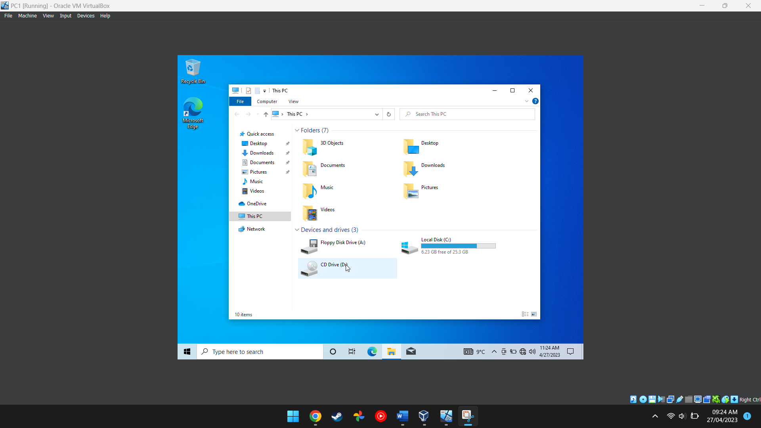
Figure 1. This screenshot shows the windows computer accessing the local drive.
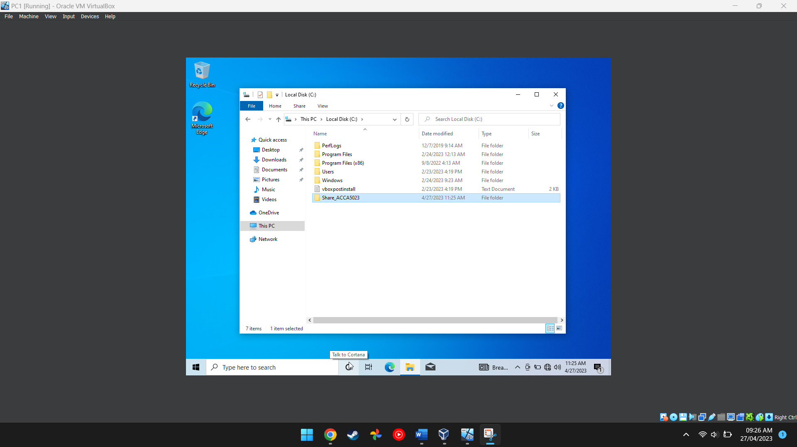
Figure 2. This screenshot shows the folder being created in the local drive.

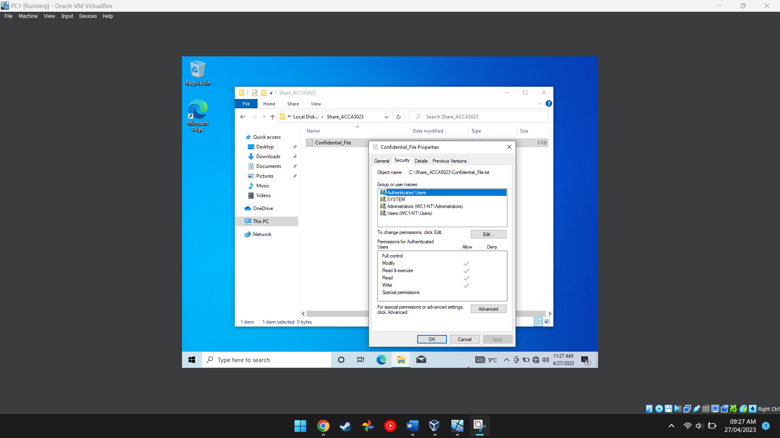
Figure 3. This image shows the confidential file having its permissions changed.
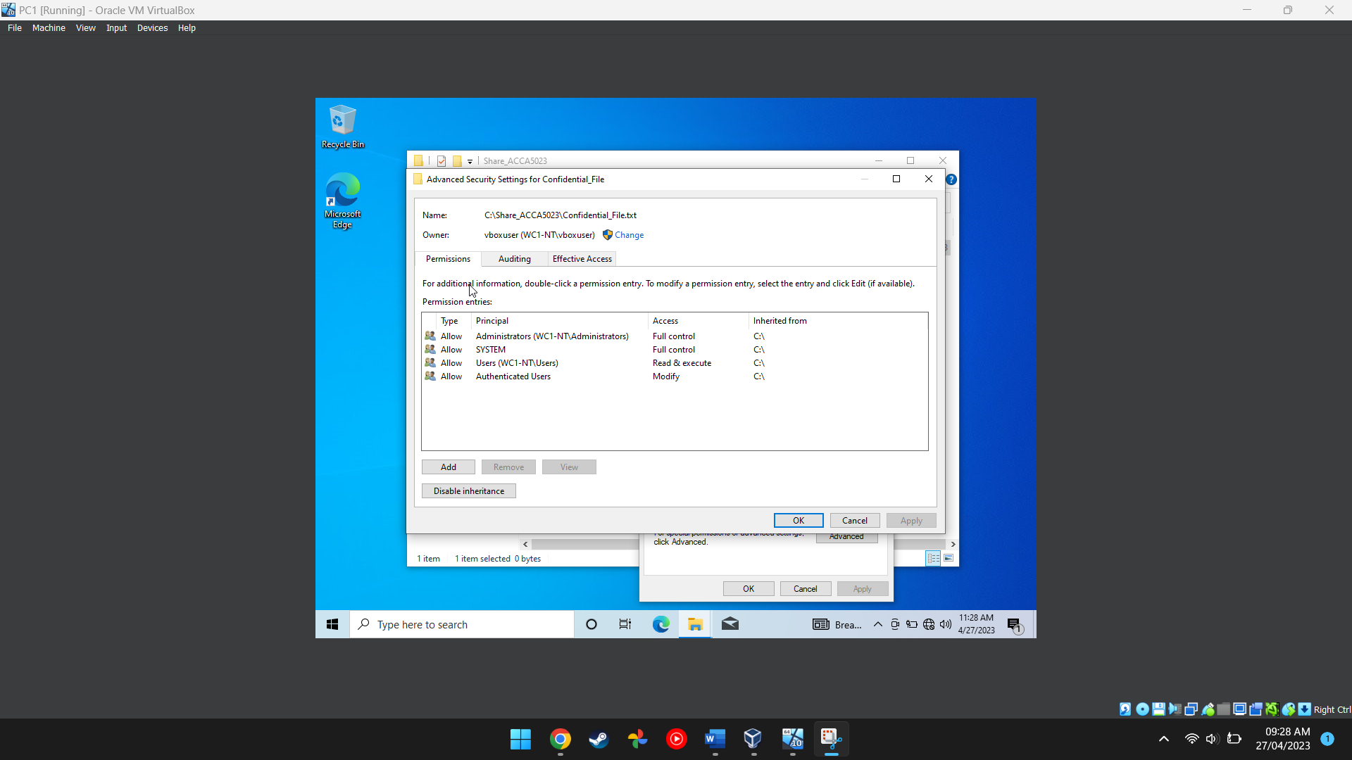
Figure 4. This image shows the full list of permissions and what permissions each user has for that specific file.

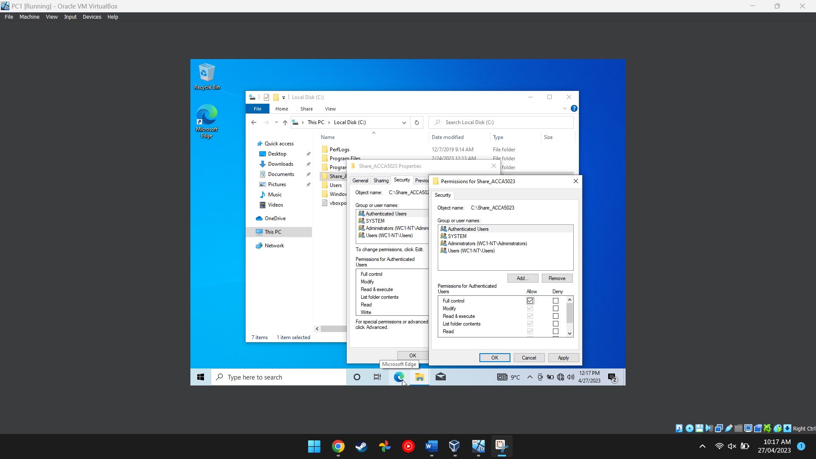
Figure 5 This screenshot shows the user having their permissions changed.
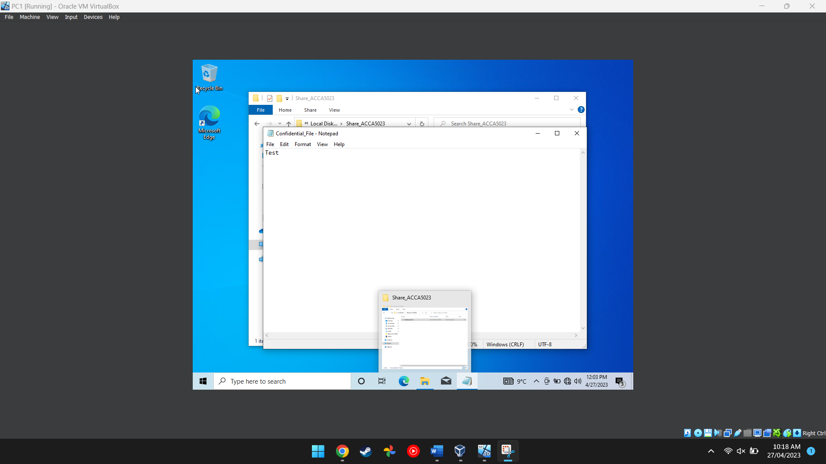
Figure 6. This screenshot shows the inside of the text document.

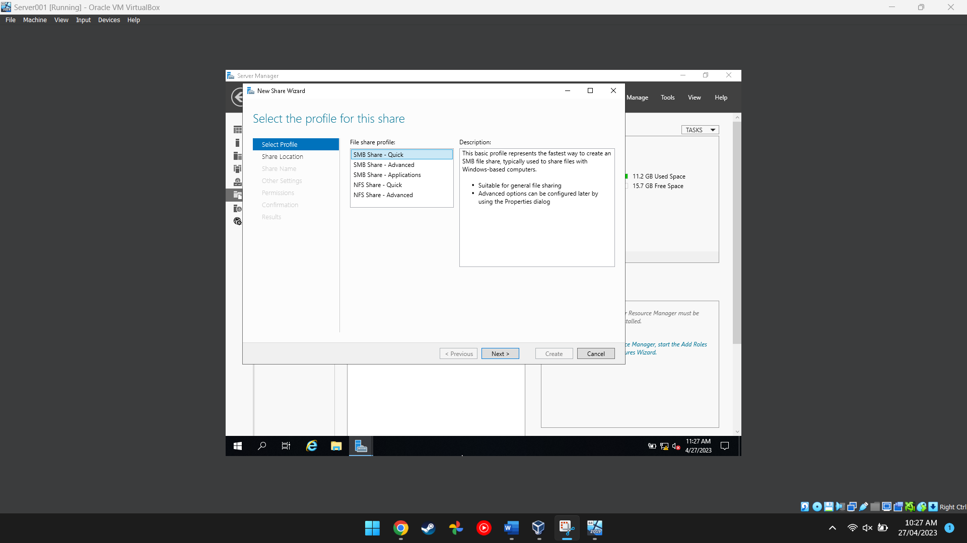
Figure 7. This screenshot shows a user setting up a server in server manager.
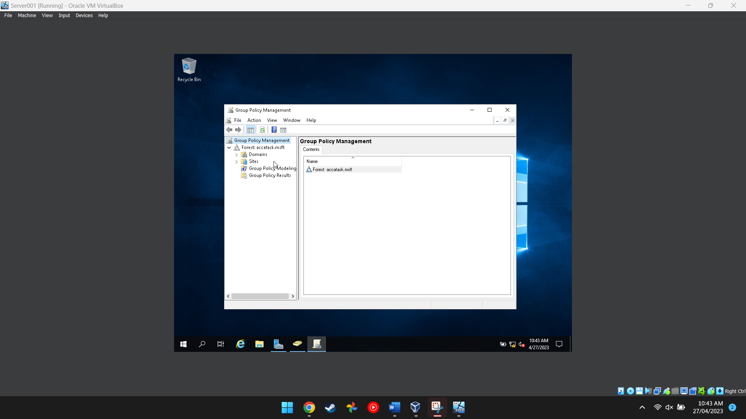
Figure 8. This screenshot shows the group policy management application being used to manage different policies for each user, so they don’t access stuff they are not supposed to.

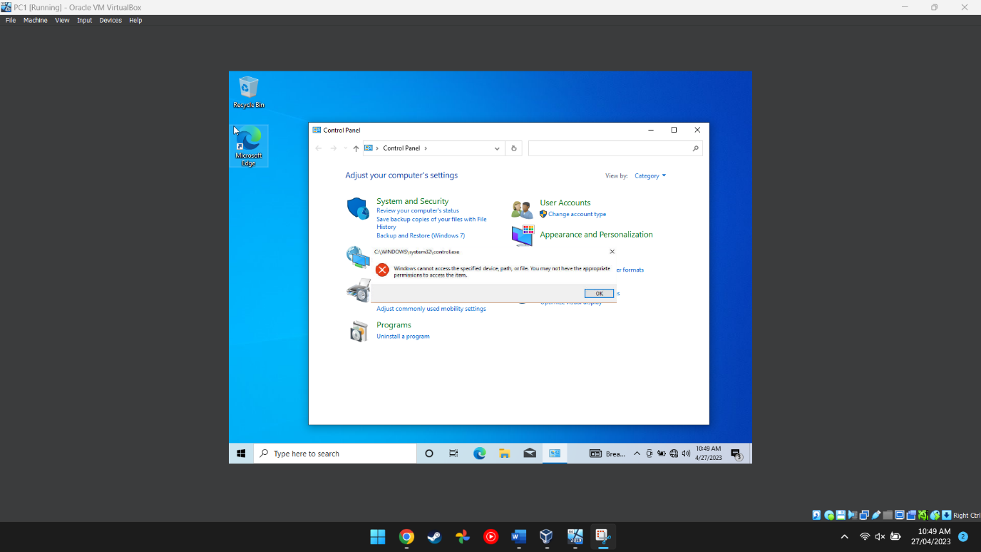
Figure 9. This image proves that the main user cannot access the control panel after having their permissions revoked.

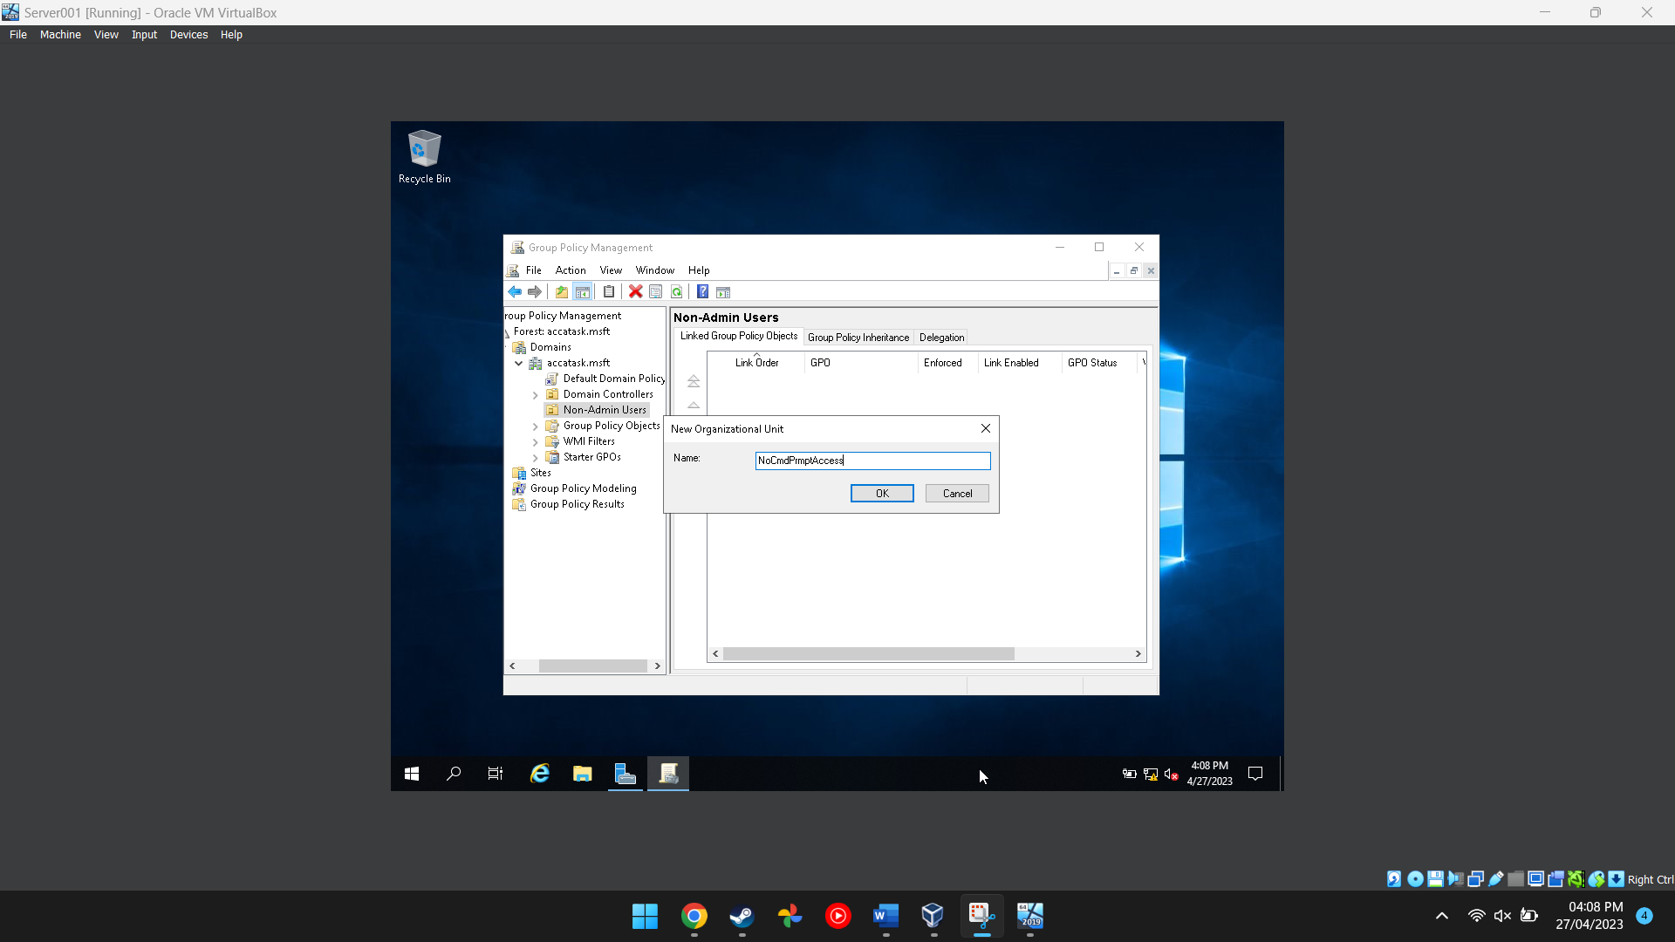
Figure 10. This image shows the user adding a new organisational unit to the folder in the group policy management program.

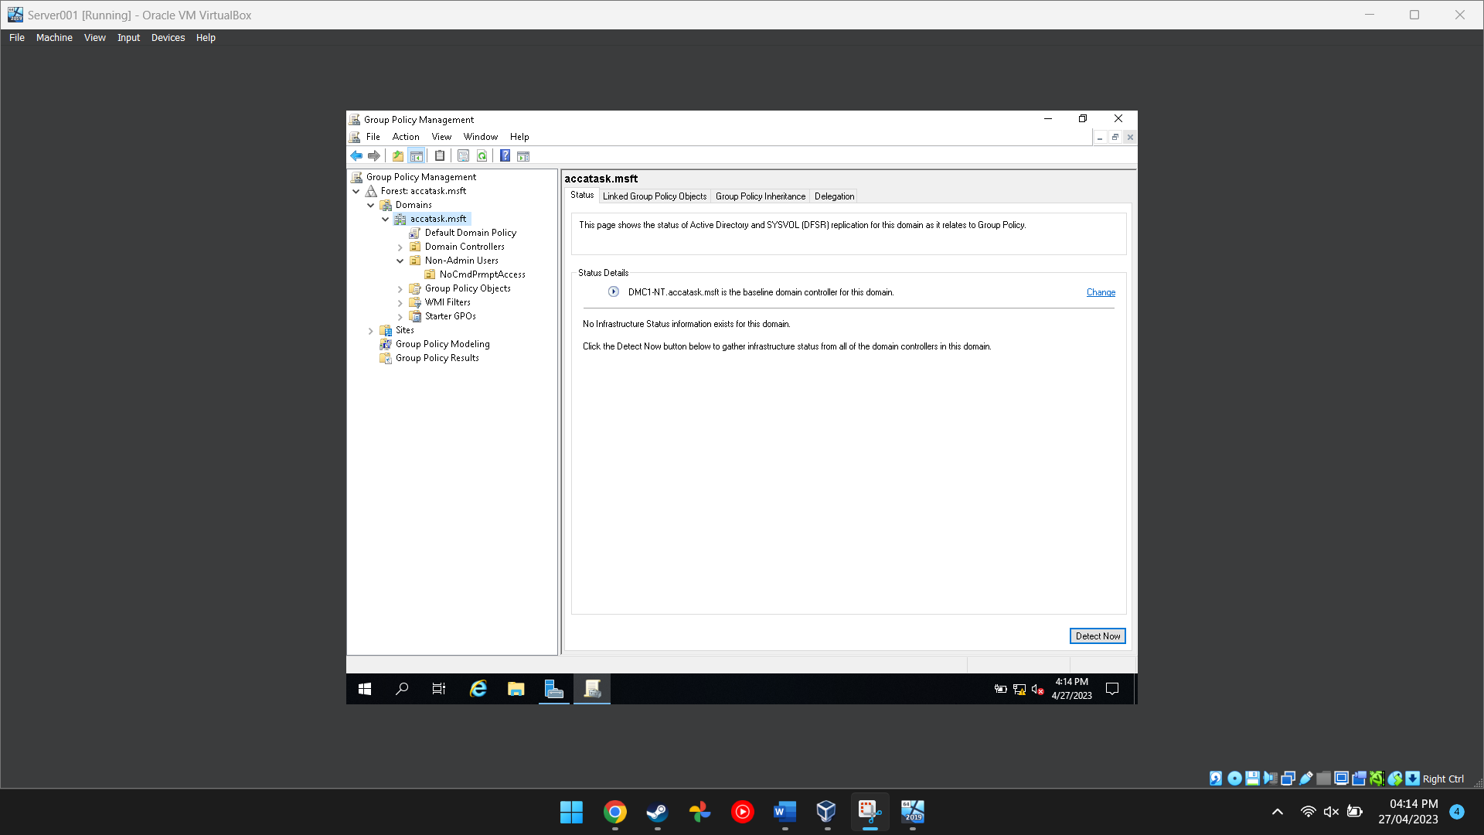
Figure 11. This shows that the PC is the domain controller.

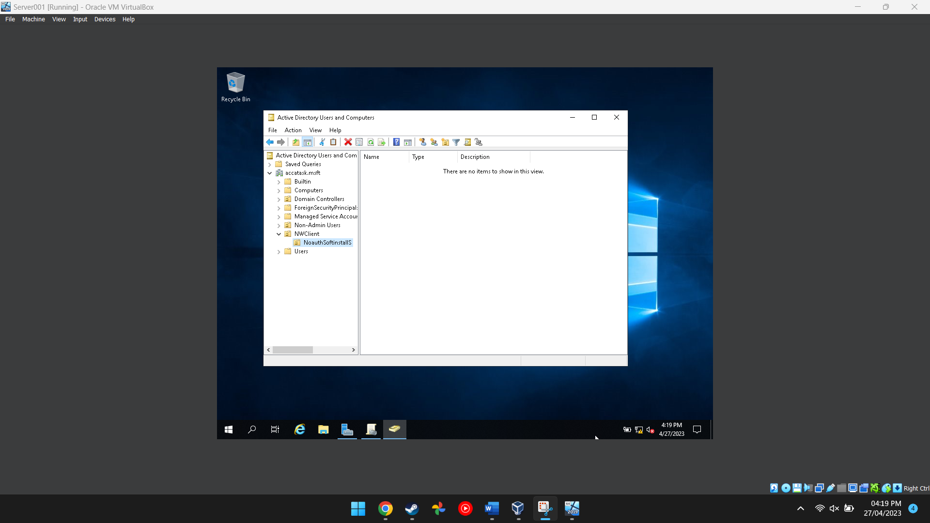
Figure 12. This image shows the folder for the active directory and computer program being created.

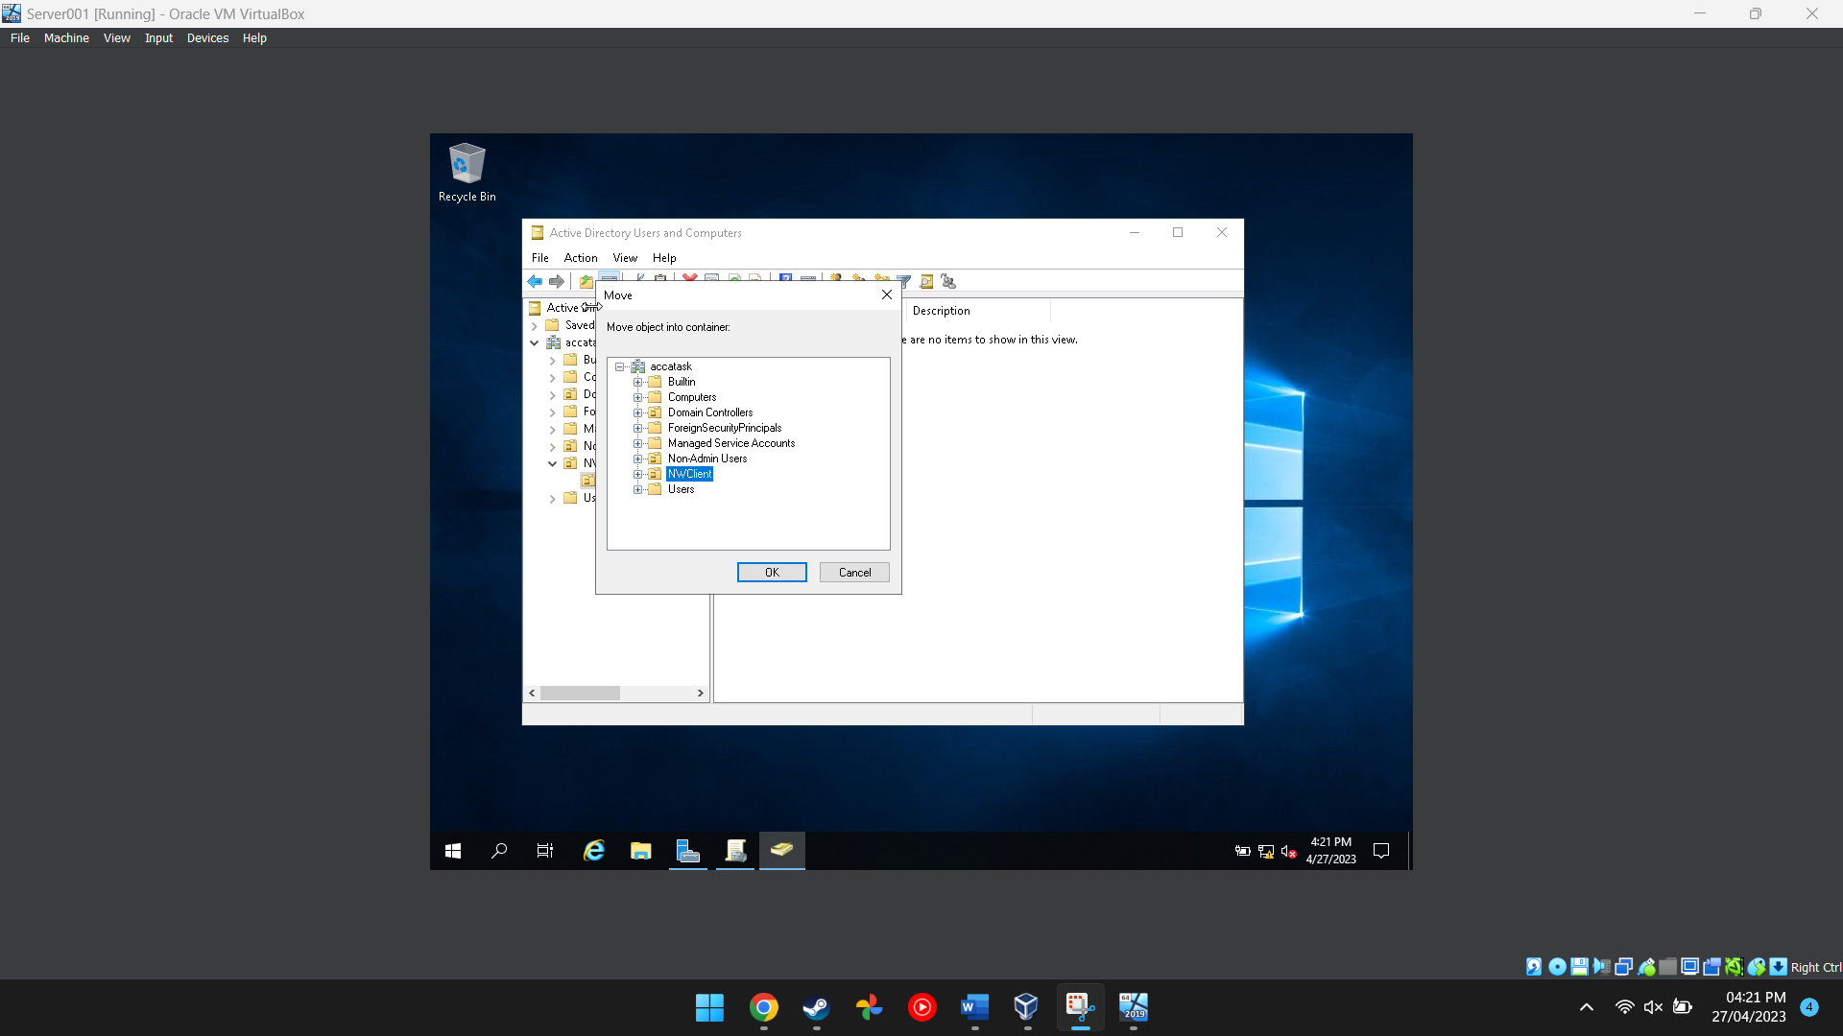
Figure 13. This shows the folder being moved.

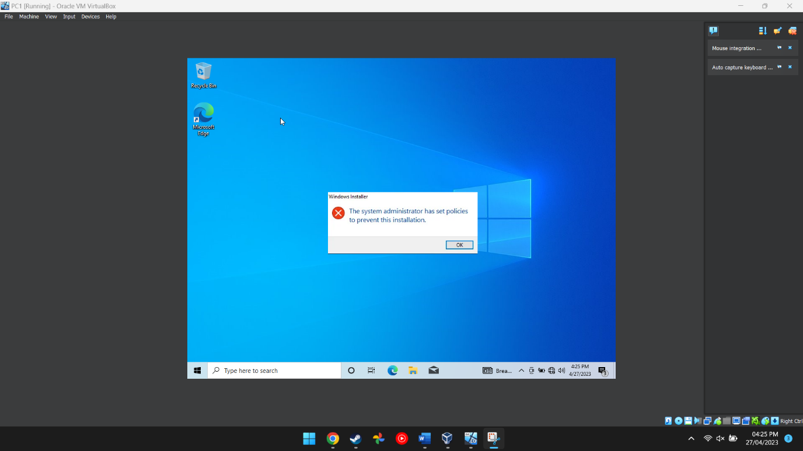
Figure 14. This image proves that the main PC cannot install programs onto the computer itself because there were restrictions put in place.

Task 2
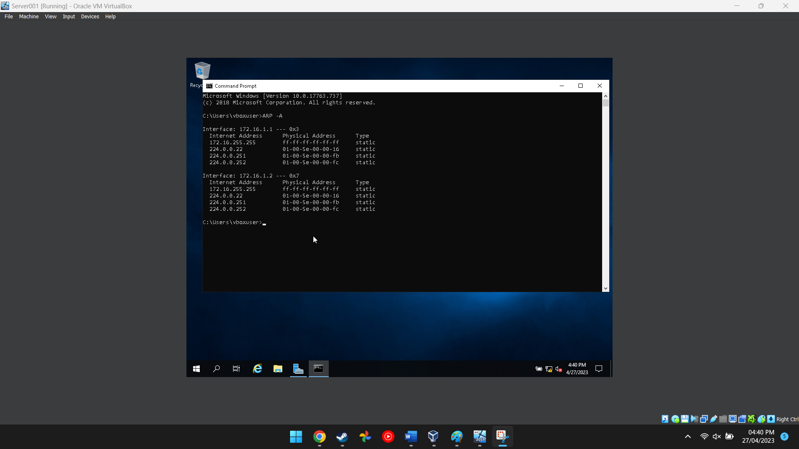
Figure 15. This image shows the network cards information.
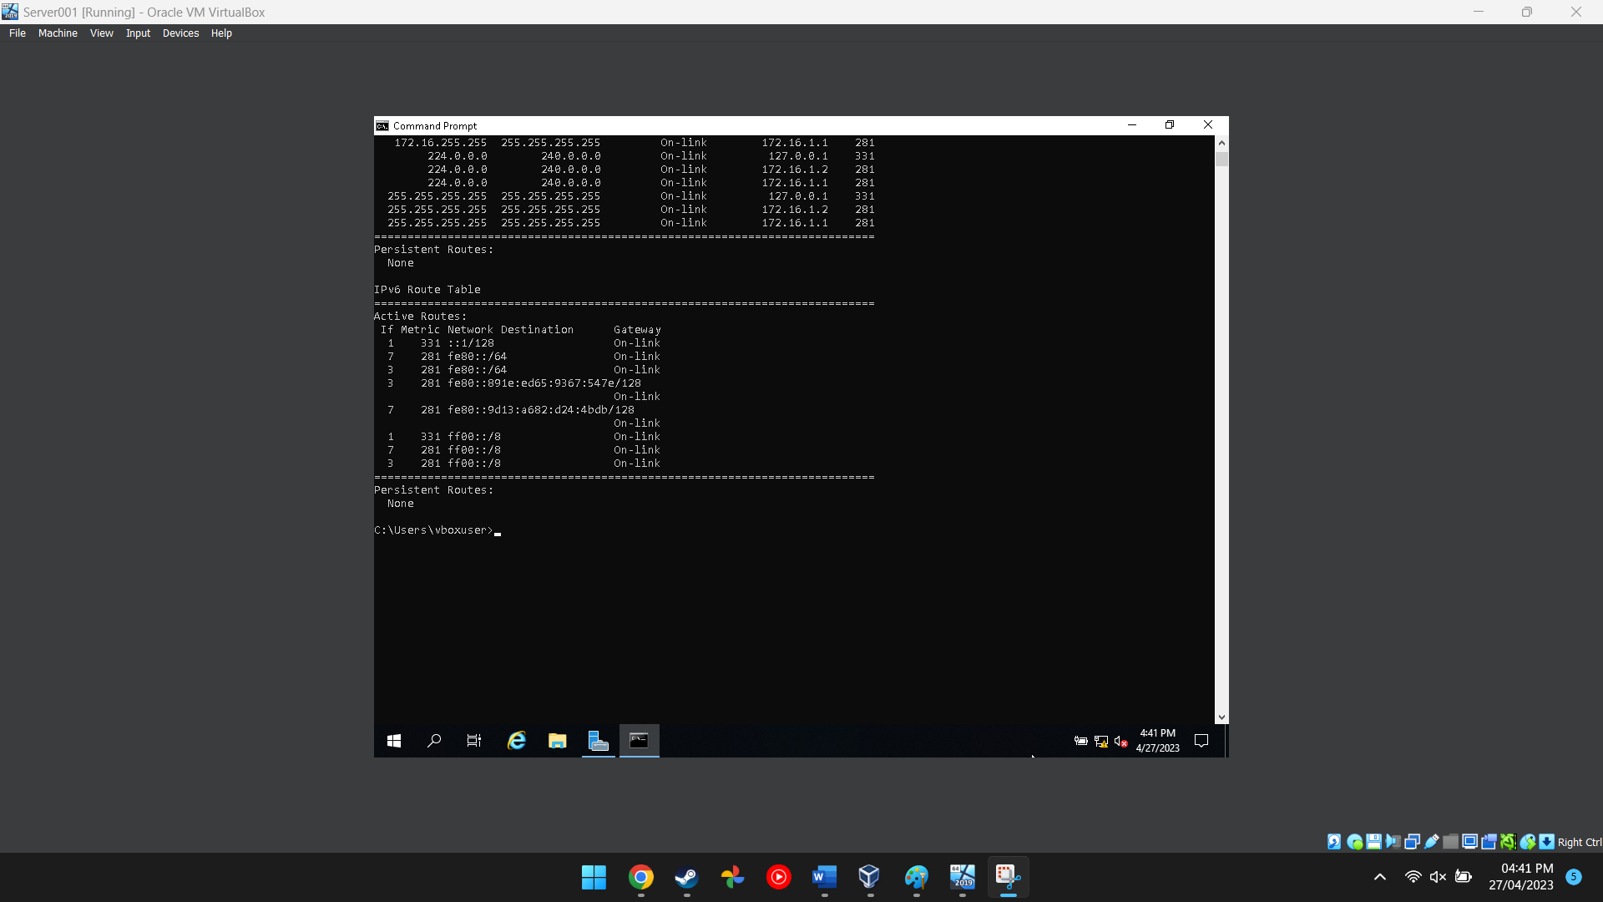
Figure 16. This image shows the route the network traffic will take.

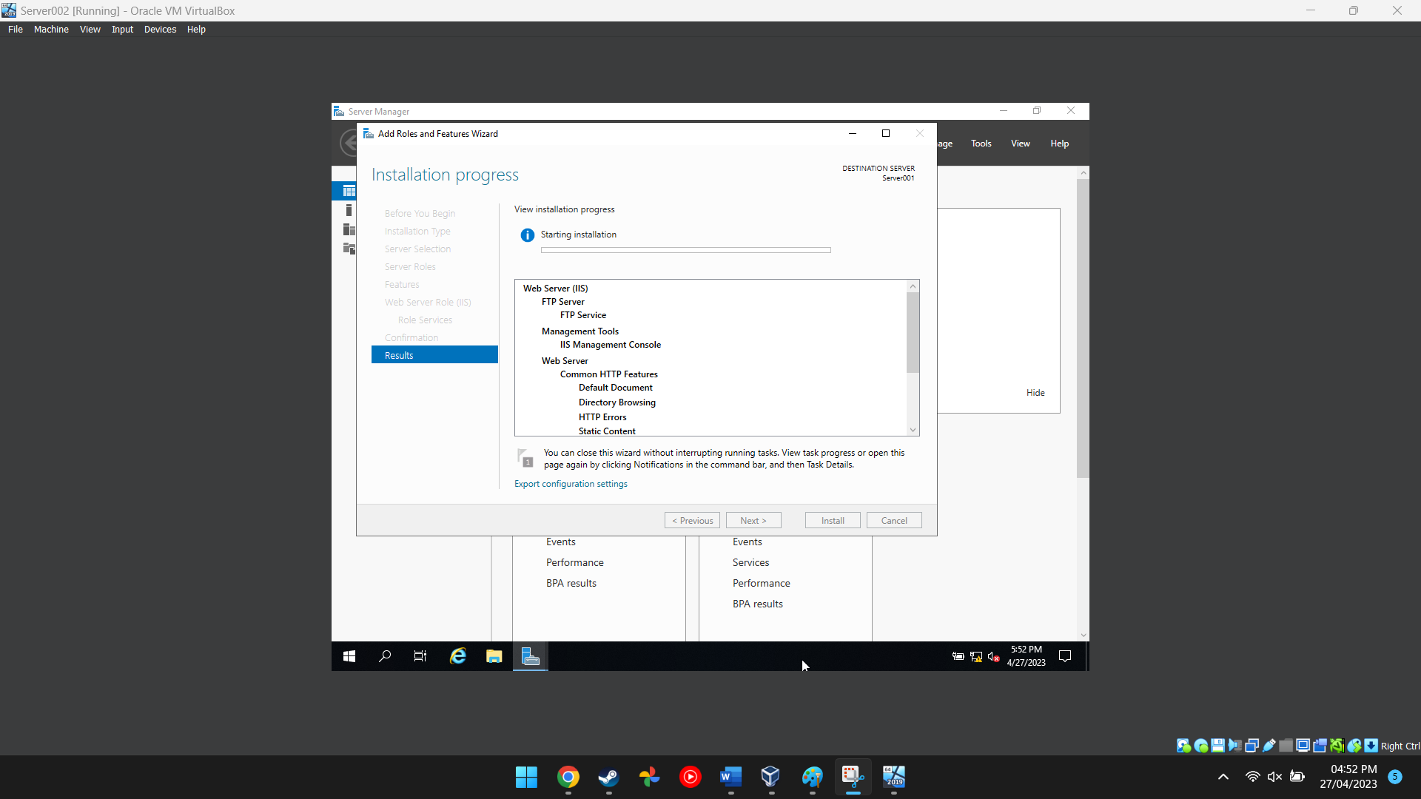
Figure 17. This image shows an additional server being created.
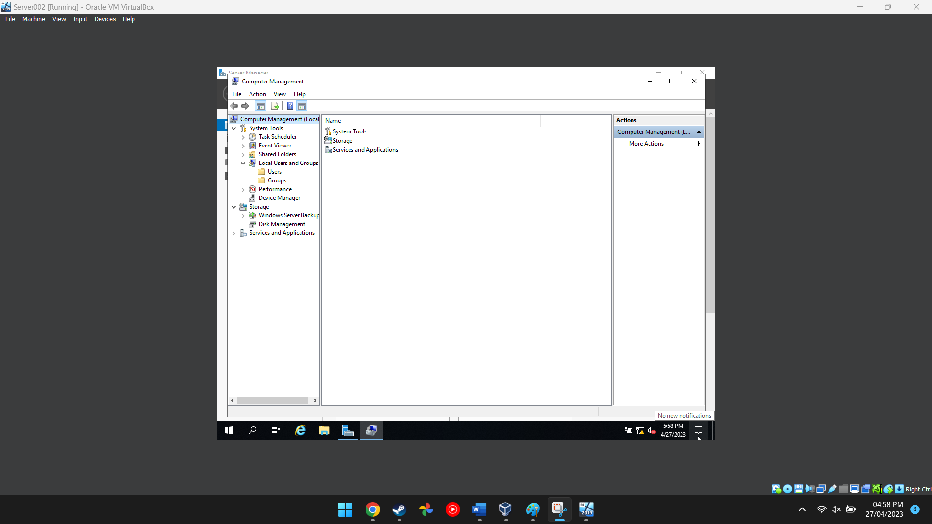
Figure 18. This image shows the computer management software on server 2.

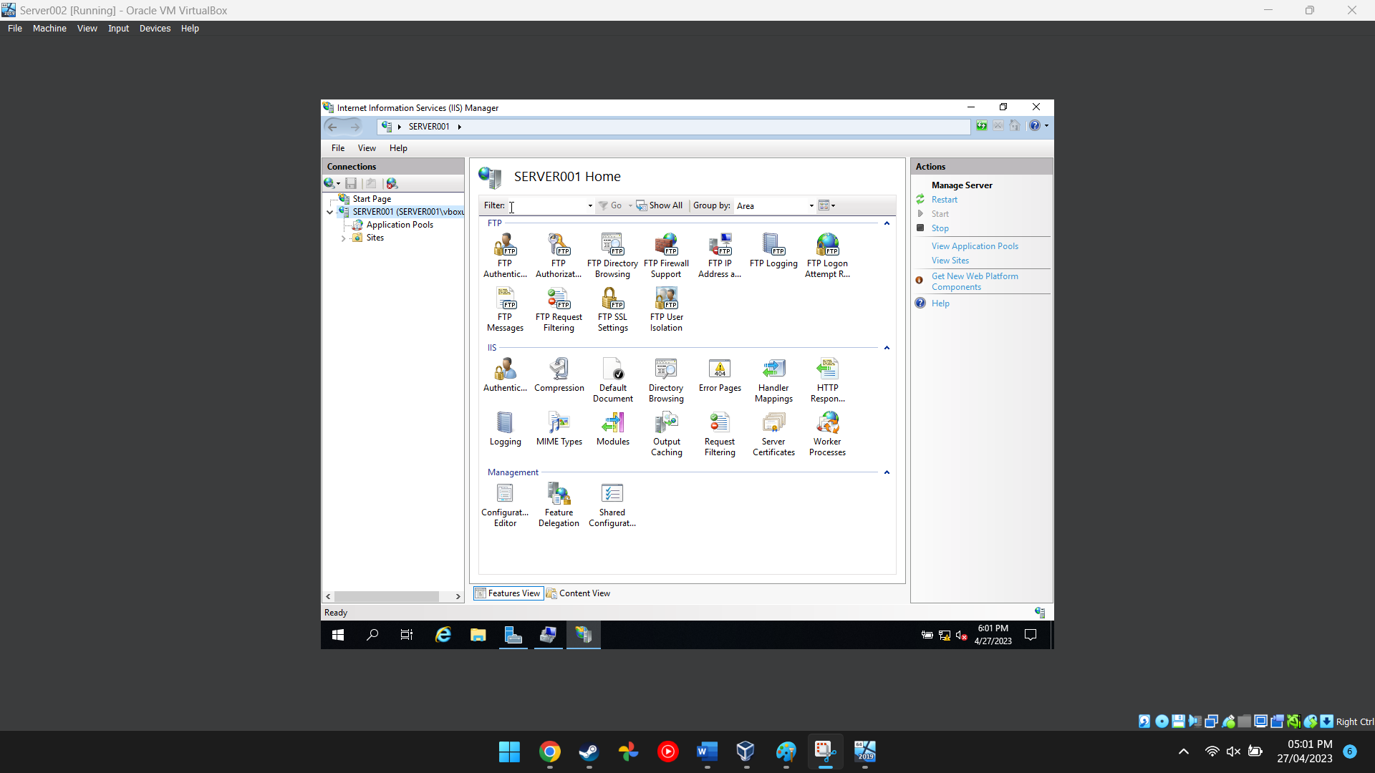
Figure 19. This image shows the internet information services manager options.
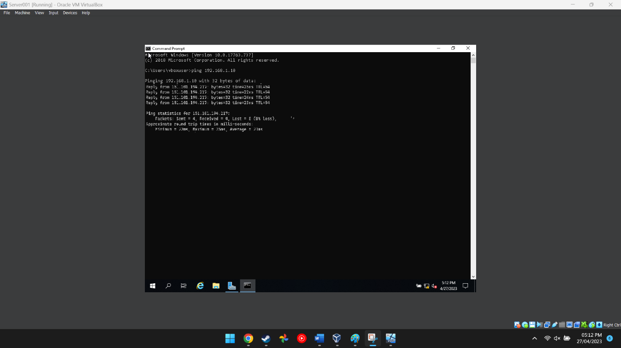
Figure 20. This shows a successful ping has been completed.

Task 3: OBSERVATIONAL TASK

Actions taken to enhance security on a SOHO (Small Office/ Home Office) Network; worksheet activities to demonstrate security policies.

SOHO network security must be effective to safeguard sensitive data and stop unauthorised access to the network. If the network security is not sufficient it may be improved by taking the following steps: [1] [2] [3] [4] [5]

- Protect the wireless network: The router's default login information should be modified, and strong passwords created. WPA2 or WPA3 encryption should be used to protect the wireless network and WPS (Wi-Fi Protected Setup) turned off to prevent unauthorised access.

- Secure passwords: All networked devices and accounts must have passwords that are secure. These should be a mixture of capital and lowercase characters, digits, and symbols.

- Limit network access: Network access must be restricted to authorized users. This can be done with MAC filtering or a guest network can be created.

- Install antivirus software: Antivirus software is widely available and should be installed and kept updated on all networked computers and gadgets. Regular virus scans should be conducted to detect and remove any malware.

- Implement a firewall: A firewall should be installed to prevent unauthorised access to the network. This can be configured to allow certain types of traffic or just using the default settings.

- Network encryption. SSL (Secure Sockets Layer) or TLS (Transport Layer Security) should be used to encrypt data sent over the internet, to protect private information.

- Routine software and firmware updates. Regular maintenance of the systems is necessary to ensure that all networked devices have the most recent security updates and bug fixes.

- Implement a backup system: A backup system should be created so data loss is prevented in the event of a security breach or hardware failure.

This commonly accepted list of security measures is simple to implement and will guarantee the protection of critical data and safeguard the SOHO network against security risks.

Failover Clustering for high-availability systems/services
A failover cluster is a group of actual or virtual computer servers. This enables the multiple applications and services that make up a business network to function in a High Availability (HA) or Continuous Availability (CA) environment.
[6] [7] [8] [9] [10]

Concepts to consider
When considering the usage of a failover cluster for high availability systems/services, there are several concepts that need careful consideration, these include:

- Hardware Redundancy: All hardware components used in the failover cluster must have redundant counterparts. This means having duplicate network adapters, power supplies, storage controllers, and other critical hardware components.

- Network Configuration: Failover clusters rely on the network to ensure continuous availability of services. It is important to have a robust network configuration with redundant switches, routers, and firewalls to avoid network downtime.

- Storage Configuration: Failover clusters store the data that is required for the services to function so storage is a critical component. The storage subsystem must have redundant controllers, disks, and paths to avoid data loss and ensure continuous availability.

- Failover Configuration: Failover settings must be carefully configured to avoid service interruption and data loss. Failover clustering involves configuring the failover behavior of services and applications in the event of a failure.

- Continuous monitoring and maintenance. Frequent health checks, patching, and upgrading of hardware and software components must be done regularly to make sure all of the components of the failover clusters are operating properly. Failover situations should be regularly tested.

The Windows Server Failover Clustering feature
One potential solution that might meet these requirements inside the Windows Server OS environment is the failover clustering functionality. It is possible to build a failover cluster using this capability, which also provides the resources needed to manage and administer it.
The Windows Server Failover Clustering feature can be configure following these steps:

  - Opening the Server Manager interface and choose the Features option. Click Add function to install the Failover Clustering function. Install the selected Failover Clustering option.

  - After installing the Failover Clustering feature, open the Failover Cluster Manager interface, and establish a fresh failover cluster.

  - Configure Networks: Select the Networks option in the Failover Cluster Manager console, and then configure the cluster's network settings.

  - Configure storage by selecting the Storage option in the Failover Cluster Manager console, then entering the cluster's storage specifications.

  - Add Nodes: Select Nodes from the Failover Cluster Manager console, then enter the nodes you want to be a part of the cluster.

  - Configure Applications/Services: Select the Roles option in the Failover Cluster Manager console and set the failover settings for the applications/services that will be running on the cluster.

  - Test Failover Scenarios: Test failover scenarios to make that the cluster is operating effectively and that failover behaviour is set up correctly.

Critical importance of the Failover Cluster
The failover clustering feature ensures continuous availability and failover capabilities in the case of a system breakdown or security breach. Correctly configuring and maintaining the failover cluster is essential so that organisations and users always have access to crucial services and apps for high availability systems and services.

Completing the worksheets 1 and 2 as a Team

Use your knowledge and understanding to draft a network policy for an Enterprise Network which operates in multiple locations, considering critical business applications high availability practices and security practices. State all assumptions made.
[11] [12] [13]

- Network Access Control: 1.1. All network access must be authorized and authenticated using strong passwords or multi-factor authentication 1.2. Permissions and access privileges for users must be assigned in accordance with their job descriptions. When an employee, contractor, or vendor leaves the company or no longer needs access, network access must be immediately terminated.

- Second, network security 2.1. All network communication must be encrypted using the SSL or TLS protocols. 2.2. Firewalls, intrusion detection and prevention systems, and antivirus software must be installed and kept up to date. 2.3. The IT security team must be notified immediately of any suspicious activity or unauthorised attempts to access the network.Data Protection: 3.1. Data must be classified according to its sensitivity level and access must be restricted accordingly. 3.2. Regular data backups must be taken and stored in a secure location offsite. 3.3. Encryption must be used to protect data at rest and in transit.

- Device Management: 4.1. All devices connected to the network must be registered, monitored, and updated regularly. 4.2. Only authorized devices must be allowed to connect to the network. 4.3. Unapproved software installations or modifications must not be permitted.

- Incident Management: 5.1. Security incidents must be reported immediately to the IT security team. 5.2. The IT security team must investigate incidents and respond promptly to mitigate the impact. 5.3. Incident reports must be generated and documented to improve future incident response.

- User Awareness: 6.1. All users must receive regular training and awareness programs on network security policies and best practices. 6.2. Users must be informed about their responsibilities and obligations when accessing the network. 6.3. Users must be encouraged to report any security incidents or suspicious activity to the IT security team.

- Compliance: 7.1. The network team must comply with all relevant laws, regulations, and industry standards. 7.2. All network changes must be approved and documented in compliance with change management procedures. 7.3. The network team must perform regular security risk assessments and audits to identify and mitigate potential threats.

Assumptions:
- The Enterprise Network is designed to connect all locations using a hub-and-spoke topology.
- The network is designed using industry-standard security protocols and technologies.
- The network team consists of experienced network administrators, security analysts, and engineers.
- The network team will perform regular security risk assessments and audits to identify and mitigate potential threats.
- The network team will enforce security policies and procedures to prevent unauthorized access, data loss, and other security incidents.
- The network team will monitor network operations to detect and respond to security incidents promptly.
- The network team will provide training and awareness programs to educate employees about network security policies and best practices.

Scope of Security improvements
The network team will deploy security improvements as needed to address identified risks and vulnerabilities. The implementation of new security measures, modifying access controls, updating software and hardware are all examples of security modifications. To make sure that all security modifications are evaluated, authorised, and tested prior to deployment, the network team will adhere to a rigorous change management approach.

Monitoring Security Operations:
The network team will keep an eye on security operations to quickly identify and address security problems.

Reflection
[14] [15]
The worksheet directed us to follow a series of tasks in a sequence which led us through a process of setting up virtual computers to act as users and servers. These were all communicating, and we then applied processes and policies to configure the set-up. These network policies are necessary to “safeguard the company's network and guarantee the privacy, accuracy, and accessibility of crucial business applications, data, and systems… apply to all employees, independent contractors, suppliers, and visitors for the purpose of preserving the security and accessibility of the network.” It was helpful to work in a team so that we could discuss the task and find out the requirements together. My role was initially researching the API but we did all the tasks together and everyone contributed. I have learnt from completing this task and the practical setting of actually doing it was better that reading about the task or hearing others talk about it. It is helpful to follow the steps on actual/virtual computers.

References

[1] | [Online]. Available: https://www.techtarget.com/whatis/definition/syntax. [Accessed 31 3 2023].
[2] | [Online]. Available: https://learn.microsoft.com/en-us/azure/architecture/best-practices/api-implementation. [Accessed 31 3 2023].
[3] | [Online]. Available: https://www.tricentis.com/state-of-open-source-2020/. [Accessed 31 3 2023].
[4] | [Online]. Available: https://www.lambdatest.com/blog/what-is-continuous-integration-and-continuous-delivery/. [Accessed 31 3 2023].
[5] | [Online]. Available: https://www.cisco.com/c/en/us/solutions/collateral/executive-perspectives/network-automation-strategy-wp.html#_ftn10. [Accessed 31 3 2023].
[6] | [Online]. Available: https://blogs.cisco.com/networking/defining-network-programmability. [Accessed 31 3 2023].
[7] | [Online]. Available: https://developer.cisco.com. [Accessed 31 3 2023].
[8] | [Online]. Available: https://developer.cisco.com. [Accessed 31 3 2023].
[9] | [Online]. Available: https://developer.cisco.com. [Accessed 31 3 2023].
[10] | [Online]. Available: https://www.clariontech.com/blog/author/bhavana-bhavar. [Accessed 31 3 2023].
[11] | [Online]. Available: https://www.theserverside.com/definition/HTML-Hypertext-Markup-Language. [Accessed 1 3 2023].
[12] | [Online]. Available: https://www.techtarget.com/iotagenda/definition/Internet-of-Things-IoT. [Accessed 31 3 2023].
[13] | [Online]. Available: https://learn.microsoft.com/en-us/azure/architecture/best-practices/api-design. [Accessed 31 3 2023].
[14] | [Online]. Available: https://42crunch.com/automate-api-protection-with-security-as-code-webinar-recording/. [Accessed 31 3 2023].
[15] | [Online]. Available: https://www.lambdatest.com/automation-testing. [Accessed 31 3 2023].

