  Task 2 Reflective review on Employability skills (report)  BMSW4001 | Visan Bianca Elena;Student ID: 2108538  Coordinator: Giridhar Katti

Contents
Introduction 2
Schön model 2
Employability skills: 2
Note Taking: 2
Research skills: 3
Time management: 3
Team Work Skills: 4
Discussion: 4
Personal Development Plan (PDP): 5
Conclusion 5

Introduction

Self reflection is a tool that help the individual to develop itself and also it give the individual the key for success. And for a good structured self reflection the best think an individual can use is the feedback! Feedback coming from employer; teacher; instructor are very welcome especially for self reflection by giving the individual some aspects that him itself can’t always see but an outside person can. This report will cover the employability skills I own and self reflection due to teacher feedback. In order to create my self reflection report and discuss about my employability skills I will use Schön model. (The Open University & Unison in Partnership, 2021)
Schön model
is about taking in consideration two things: 1) Reflection in action and 2) reflection on Action. It may sound the same but there are two different thing and in order for a better understanding I will apply them in the employability skills. (Edwards, 2007)

Employability skills:
Employability skills are a set of abilities that an individual need to posed according with employers demands in all industry. Those skills as required in any type of job and play a crucial role in order to achieve a job of any kind. (FutureLearn - Learning For Life, 2021)

Note Taking:
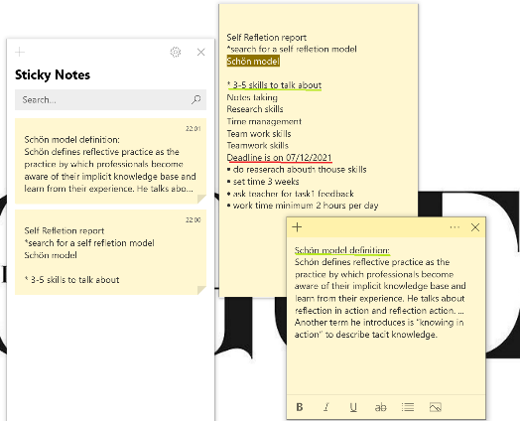
Is the ability of recording information from different type sources and platforms. taking notes, the individual record in writing the information summarized or extract the essential of the information, in order to not recapitulate everything in order to find the part of the information need. For a better understanding of the skill, as individuals wee need to collect the information we need in order to create , learn or do something and without taking properly notes that can cause a fail. From my own experience in order to be able to learn at my courses I am taking notes in class about the information of the teacher give. Applying Schön model, while my teacher explain us about how to create a report I am taking notes about how to structure the report; what the report need to include; what is the deadline and etc… After doing that I am reflecting on the notes I take in order to ensure that I written down everything I need in order to complete the report satisfactory ( reflection in action) and then looking at my preview notes taken to see how a develop my skill ( reflection on action). This model it help me as an individual to reflet upon my skill in order to see how I develop to be able to see what I still need to improve. Then an another important step is asking the teacher for feedback which will also help me to see what’s ok and what’s not. For further development I also do research to advance the way I am taking notes. For example while I am taking notes I like to highlight using colour some of the most important information. Notes taking is also helping me to do my job. I am currently working for DHL as an FLT driver and in order to do my job I receive a list of location where I need to take items and place them in other location for the colleagues who will pick them to sent to the store. In order to do my job sometimes happen the location to give me error and to avoid the items to show in the system as lost and the company to lose money, I am taking notes with those location to report the issues to be fix. (University of York, 2021)

Research skills:

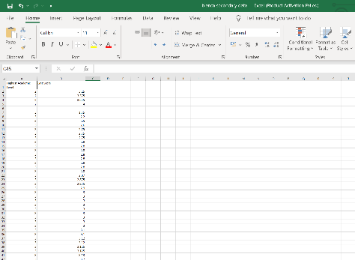
Is the ability of the individual to search for information by using different sources for a specific purpose and achieve knowledge. The information it can be extracted in multiple ways, like books, articles, online, using primary data and secondary data. As a student is crucial to learn how to do your own research in order to extract the information you need to complete university task and have a better understanding during the courses. Also for one of the reports I needed to do for university was included research methodology and in order to complete the report I was needed to do research using tools like CRAAP Test. CRAAP Test Is an research evaluation model. The name of CRAAP is an acronym standing for Currency, Relevance, Authority, Accuracy and Purpose. In order to complete that report using CRAAP test I had to use 2 data in order to transform them in information. The data used was primary data and secondary data. This report help me to have a better understanding regarding the research and in the time I was doing it I was needed to reflet over the information I was searching for and the information I was created to follow the expectations of the report. After the report was done I reflect over my achievement which was experience of collecting data and information, practice over my research skills and a clear understanding about the meaning of the research. Also an another research I was needed to do it was for this reflective report in order to documentation my self for a better understanding of those skills and about self reflation and models. (Libary Soton , 2021) (University of the West of Scotland, 2021)

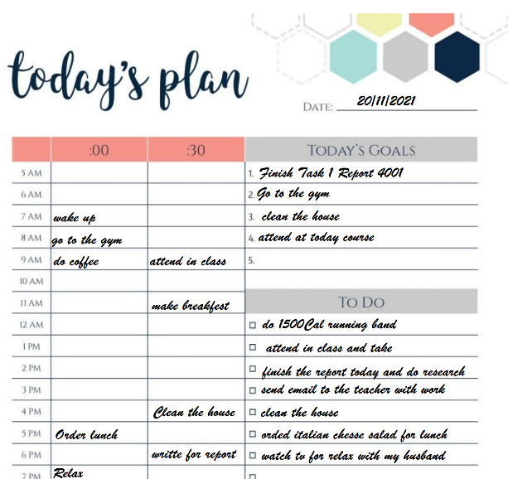
Time management:
The time management skills is the individual ability of divided time in order to use it productively and efficient. As a student learning to manage your time is a necessity in order to avoid stress and depression; to avoid to fail the exam and deadlines or even work to fail the course or year. In order to succeed and use your potential at maximum as a student I was needed to calculate my time to be able to do everything I need and have time for myself because if I will negligee my self it can end up with depression and if I am not using my time correctly and I do my university task in the last moment I will be loaded with stress and I will lose my potential on the way. To ensure my self that I will be aware of everything I want to do and in order to use my time efficiently I like to use an online plan of things I have to do daily. Also in order to use time management skills properly is best to use tools such as 4D. This tool refere about an very effective scheme which can be apply in times of task prioritization. This tool has been created in order to facilitate the productivity and is composed by ‘Do’ ; ‘Delay’ ; ‘Delegate’ and ‘Delete’ where the name come from of 4D. This tool can be very efficient when you run out of time and have too many task to do by prioritize the urgent tasks , then delay the task that are not that important for lets say that day ; then to allow you more time if is possible delegate some of the task to someone who can help and the task that are not important, that task which you have to do just because you want to do you can delete them in order to earn more time for the important task. (SkillsYouNeed.com, 2021) (airfocus.com, 2021)

Team Work Skills:
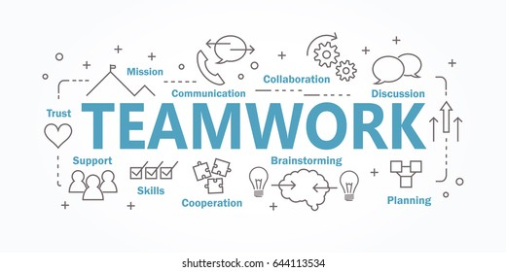
Is the ability of an individual to work with other individual to complete and achieve the same goal by working together. This skill is required at any workplace and working with others sharing knowledge and information and help each other in order to achieve the group goal is one of the experience which you have to receive best from others and develop yourself. As a student it really help me to achieve experience in working with people and develop my teamwork skills as in class we have to do different activities in group or do group reports. Also working as a group you all have something to learn by learning for the same goal and learning from each other. Working as a group it also benefit by reducing stress as there are more then one person who it doing the task and there are more ideas about how things should be done. And that not the only advantage that working as a group you will have, working as a group make me also to develop my interpersonal skills and adapt to work with different cultures and understand people better which its also a demand in all of the organisations in now days. (Tanner, 2018)

Discussion:
Having a clear view at the skills I achieve during my first year of university it look impressive but there are still plenty of employability skills which I need to achieve and goals to set before to graduate and in order to do that I also need to have a better understanding about my self and for that I create a SWOT analysis which will help me to see my strength and weaknesses and understand my threats and what can be my opportunities . SWOT analysis is an very simple and powerful tool that help you to develop yourself but is also help in companies development by helping the business to create a good strategy or whether building a start up or guiding an existing company. In my case this tool it will help myself to have a better understanding upon my self reflation to see what I can do to maximize my potential and develop further . (Parsons, 2021)
Strenghts  Working with others | Weaknesses  I need to improve my presentation skills
Opportunity  Learning how to present and speak in public | Threats  My threats is to speak in public as I am overthinking
Now having the SWOT analysis done I discover my weaknesses and transform them in opportunities. This is one of the SWOT Analysis advantages by helping myself to convert my weaknesses and fears and transform them in strengths and opportunities.

Personal Development Plan (PDP):
As an individual in order to develop myself is good to use a Personal Development Plan to achieve more awareness and set goals. A Personal Development Plan is a process of self reflection by an structured plan in order to support and undertaken upon my own learning, performance and/or achievement and to plan for my personal career development. And to be able to achieve my set goals and see my achievements I create my own personal development plan. To create it I take in consideration that the goals set need to be realizable and fit to your needs of career development.
Goal Set | Time allowed | Support and resources needed | How? | Date set
Pass all my university Reports | 3 years | Books; laptop; teachers advise; internet | Study and do research and attend to courses | 01/01/2024
Get a degree from university | 3 years | Books; journals; laptop; | Study; attending to classes and do research | 01/01/2024
Achieve experience | 2 years | Internet; a strong CV and Strong employability skills | Doing apprenticeship | 01/01/2026
Search for a job in my degree industry and apply for it | 6 months | Internet; a strong CV and Strong employability skills; experience; cover letter | Looking on indeed or other jobs websites or directly on the company I want website | 01/07/2026
Promote at the workplace | 2 years | Properly training | Working hard and smart | 01/07/2028

Conclusion
Looking on my development I am proud of myself and that is because of everything I see now I achieve and also it give me the confidence for further development. Also the goals I set and the achievements I have till now it motivate myself and I will still continue to do my self reflection from time to time to see if I am on the good path and see what I need to Improve for further development. Also using models for self reflection it help myself to understand my own way I think and my learning strategy. Also receiving feedback from others it help myself to have a view from ‘outside’. And seen that there will be always a way to improve by using SWOT Analysis it also motivate me .

References
airfocus.com, 2021. How do product managers use the 4 Ds of time management technique?. [Online]
Available at: https://airfocus.com/glossary/what-are-the-four-ds-of-time-management/
[Accessed 25 11 2021].
Edwards, J.-A., 2007. PRIMARY TRAINEES’ REFLECTION-IN-ACTION. [Online]
Available at: https://www.cumbria.ac.uk/media/university-of-cumbria-website/content-assets/public/education/images/documents/research/escalatedocuments/ReflectionInAction.pdf
[Accessed 12 11 2021].
FutureLearn - Learning For Life, 2021. What is employability and why is it important?. [Online]
Available at: https://www.futurelearn.com/info/courses/prepare-career-success/0/steps/21285
[Accessed 21 11 2021].
Libary Soton , 2021. Introduction to research skills. [Online]
Available at: https://library.soton.ac.uk/sash/introduction-to-research-skills
[Accessed 22 11 2021].
Parsons, N., 2021. What Is a SWOT Analysis and How to Do It Right (With Examples). [Online]
Available at: https://www.liveplan.com/blog/what-is-a-swot-analysis-and-how-to-do-it-right-with-examples/
[Accessed 05 12 2021].
SkillsYouNeed.com, 2021. Time Management Skills. [Online]
Available at: https://www.skillsyouneed.com/ps/time-management.html
[Accessed 27 11 2021].
Tanner, O., 2018. The teamwork definition and fostering collaboration at work. [Online]
Available at: https://www.octanner.com/insights/articles/2018/9/13/the_teamwork_definit.html
[Accessed 1 12 2021].
The Open University & Unison in Partnership, 2021. What is self reflection?. [Online]
Available at: https://www.open.ac.uk/choose/unison/develop/my-skills/self-reflection
[Accessed 12 11 2021].
University of the West of Scotland, 2021. Evaluating Sources: CRAAP Test. [Online]
Available at: https://uws-uk.libguides.com/evaluating_sources/craap_test
[Accessed 19 11 2021].
University of York, 2021. Note taking. [Online]
Available at: https://subjectguides.york.ac.uk/skills/note-taking
[Accessed 18 11 2021].

