 |  | Charles Hadley  DE&S OME Degree Student  +44 7919977349  Charles.Hadley104@mod.gov.uk  UWTSD IQ Campus,  Waterfront,  University of Wales Trinity,  Swansea  SA1 8EW
Charles Hadley | 12-Jan-25 Our Reference: APCW_01

EXPLORING THE AFFCET OF DIFEREING ENERGETICS ON AN LK SHAPED CHARGE WITH COMPUTATONAL MODELING

References. See footnotes and references section 20.

Abstract

The intent of this report is to demonstrate that the student has fully explored the computational modelling of a shaped charge and developed and understanding of the Abaqus Toolset. This report explores how, Material models, Meshing and other modelling techniques affect the tip velocity of a shaped charge in both 2D and 3D Models.

Table of Contents

Abstract 1
1. Table of Contents 2
2. Introduction and Background 4
3. Assumptions and Decisions List 6
4. Model Geometry 7
5. Materials 8
6. 2D Introduction 9
7. 2D Initial Model 9
8. 2D Material Validation 9
8.1. TNT 10
8.2. PETN 10
8.3. RDX-C4 11
8.4. HMX 11
8.5. Detonation Velocities 11
9. 2D Mesh Study 12
9.1. Course Mesh 12
9.2. Medium Mesh 13
9.3. Fine Mesh 14
9.4. Super Fine Mesh 15
9.5. Mixed Mesh V1 16
9.6. Mixed Mesh V2 17
9.7. Mesh Comparison 18
10. 2D Liner Collapse Theory 19
11. 2D Results 20
11.1. TNT 20
11.2. PETN 21
11.3. RDX-C4 22
11.4. HMX 23
13. 2D Conclusions 24
14. 3D Introduction 24
15. 3D Initial Model Setup 24
16. 3D Mesh Study 25
16.1. Initial Mesh 25
16.2. Mixed Mesh 25
16.3. Shortened Case Mesh 26
16.4. Meshes Compared 26
17. 3D Results 27
18. 3D Improvement Trials 29
18.1. 3D Altered Geometry Trial: Flatten Tip 29
18.2. 3D Adaptive Meshing 29
18.3. 3D Wave Smoothing 30
18.4. Unexplored Methods 31
19. Conclusion 31
20. References 32
21. Annex A: 2D Model Parts 33
22. Annex B – Initial Results 34
23. Annex C: Material Validation Results 37
23.1. TNT 37
23.2. PETN 38
23.3. RDX-C4 39
23.4. HMX 40
24. Annex D – 2D Results 41
24.1. TNT 41
24.2. PETN 44
24.3. RDX 46
24.4. HMX 48
25. Annex E 3D Parts 51
26. Annex F - 3D Results 52
27. Annex G - Mesh Study Tip Velocity Graphs 55

Introduction and Background

This report will explore the impact of differing energetics on an LK Shaped Charge. It will begin by simulating the charge in 2D before progressing to 3D simulation with a selected sample. The intent of this will be to understand if it is possible to simulate the detonation and jet formation of the charge and compare the perceived difficulty in 2D vs 3D.

The LK Shaped Charge is a simple shaped charge with a plastic or metal case that contains a copper liner and a small amount of High explosive. This type of charge is mainly used and manufactured in Poland where it is used as a destructive device in Explosive Ordnance Disposal Operations and as a cutting or breaching tool.

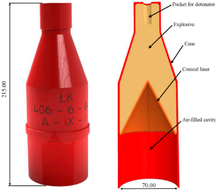
Figure 1 - LK Shaped Charge Parts [1]

This type of charge has been specifically chosen due to its simplicity and available design information.

There are two main approaches that could be used for this type of simulation, Lagrangian and Eulerian.

“The Lagrangian approach focuses on individual particles and tracks their trajectories, velocities, and accelerations. It provides a microscopic view of fluid motion, enabling the analysis of phenomena involving particle interactions and transports. On the other hand, the Eulerian approach considers fixed points in space and tracks changes in fluid properties at those points. It provides a macroscopic view of fluid behaviour and is suitable for analysing overall flow patterns and properties.” [2]

The approach methodology that has been chosen for this evaluation is a Lagrangian approach. This was chosen because of the finer detail and particle interaction possibilities that come with this approach. Whilst a Eulerian approach would have been possible the difficulty in graphical representation and comparison of results would have presented significant issues.

Assumptions and Decisions List

Ref | Title | Description
1 | Geometry Software Selection | ABAQUS inbuilt geometry software has been chosen as the geometry creation method for this report due to the ease of use and integration into the wider abacus system.  This was chosen over SolidWorks due to software availability on respective systems. Had Solidworks been easily available on the same system this would have been the obvious chouse for geometry creation and editing.
2 | Case Geometry | No references could be found to the thickness of the case, this was assumed to be 2mm.
3 | Liner Geometry | No references could be found to the thickness of the Liner, this was assumed to be 2mm.
4 | General Geometry | Certain points of the charge and case geometry where assumed to be vertical, horizontal and parallel to each other despite not being specifically dictated.
5 | Model Setup | Air has been excluded from this model to simplify the simulation as although minimal the presence of air will have an effect on the formation of the shaped charge jet.
6 | FEA Software | Abaqus was selected as the programme for this simulation due to its availability and stability for this level of complex simulation.  Whilst Ansys was available the Lagrangian solver used is not as advanced and therefore suitable as that available in ABAQUS.
7 | 2D Simulation | An assumption has been made that the charge is symmetrical and could be rotates symmetrically around the direction of detonation.
8 | Simulations | Reduced simulation time was favoured above slight increases in results as the ability to work in an Agile manner allowed for a compressed simulation timeframe when access to the resources was limited.
9 | 3D Energetic | It was decides to use the TNT energetic to move forward to 3D as although the TNT is less than an ideal material for this shaped charge it is the most likely material to be well understood and have the correct material model.
Table 1 - Assumptions List

Model Geometry

Throughout this investigation the same geometry will be used. This will best standardise the results and enable more effective cross comparison of results.

The 2D geometry detailed below shows the geometry used in ABAQUS, Left and the Solidworks drawing with detailed dimensions for clarity, right.

In the right hand drawing the individual parts are, Case (Red), HE Fill (Beige) and Liner (Orange).

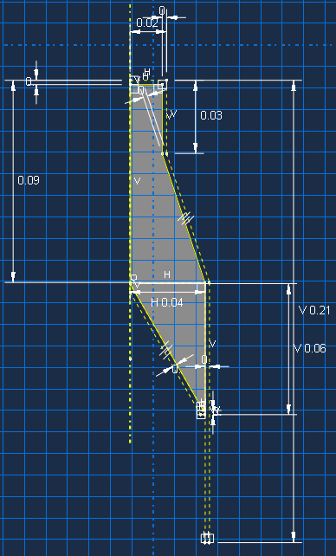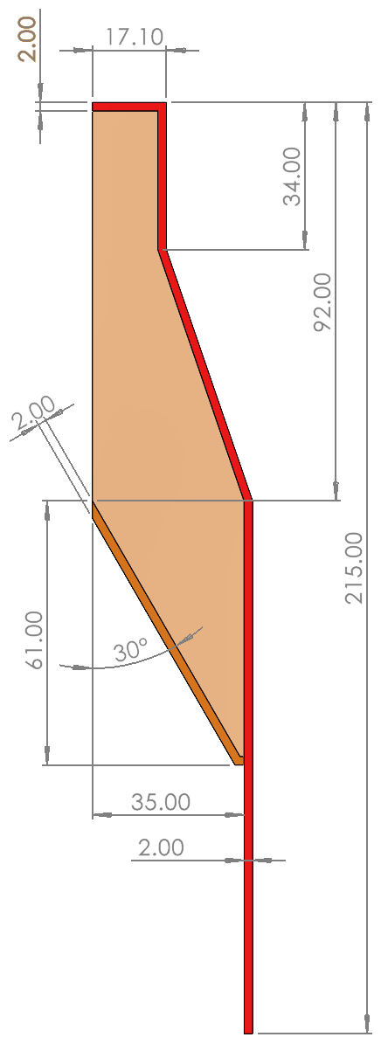

Figure 2 - Model Geometry, ABAQUS and Solidworks.

Several assumptions have been made at this stage these are detailed in Table 1 - Assumptions List.
The geometry for 2D and 3D simulations have been kept the same with the 3D simulations simply revolving the 2D drawings by 180º.

Materials

Below are the material properties that have been used in these models, the liner and case materials are standard throughout and only the fill materials have been changed to understand how different energetics impact the jet formation of the LK Shaped Charge.

Material | Steel | Copper
Component | Case | Liner
Density ($kgm^{-3}$) | 7896 | 8930
Shear Modulus | - | 47000000000
Johnson Cook
A (Pa) | 350000000 | 120000000
B (Pa) | 275000000 | 292000000
N | 0.36 | 0.31
M | 1 | 1.09
Melting Temp ($℃$) | 1811 | 1356
Transition Temp ($℃$) | 293 | 293
C | 0.022 | 0.025
$\dot{ε_{0}}$ ($s^{-1}$) | 1 | 1
Equation of State
$c_{0} (ms^{-1})$ | 4596 | 3940
S | 1.49 | 1.489
Gruneisen Coefficient | 2.17 | 2.02
Table 2 - Static Materials [3]

Table 3 below shows the four energetics that will be considered. These provide a broad range of energetic performances that are readily available and could be used for these type of charges.

Material | TNT | PETN | RDX-C4 |  | HMX
Component | HE Fill | HE Fill | HE Fill |  | HE Fill
Density ($kgm^{-3}$) | 1630 | 1500 | 1600 |  | 1890
Equation of State JWL
Detonation Wave Speed | 6930 | 7450 | 8193 | 9110
A (Pa) | 374000000 | 625000000 | 610000000 | 778000000
B (Pa) | 3750000 | 23300000 | 13000000 | 70700000
R1 | 4.15 | 5.25 | 4.50 | 4.20
R2 | 0.90 | 1.60 | 1.40 | 1.00
$$ω$$ | 0.35 | 0.28 | 0.25 | 0.30
Detonation Energy Density ${kJm}^{-3}$ | 6000000 | 8560000 | 9000000 | 1050000
Pre-detonation Bulk Modulus / Pressure (kPa) | 21000000 | 220000000 | 28000000 | 42000000
Table 3 - Energetic Materials [4]

2D Introduction

First the models will be simulated using a 2D approach. This should provide a faster and more effective way to simulate the jet formation of the charge as limiting the dimensions and creating planes of symmetry allow for more detail to be gathered.

2D Initial Model

The model was created in ABACUS and initially setup with a basic 1mm even mesh, A plane of symmetry along the YZ axis and standard general interaction properties. Lastly a maximum simulation time of 0.0001s was used.

The initial results which can be seen fully in Annex B – Initial Results are summarised below.

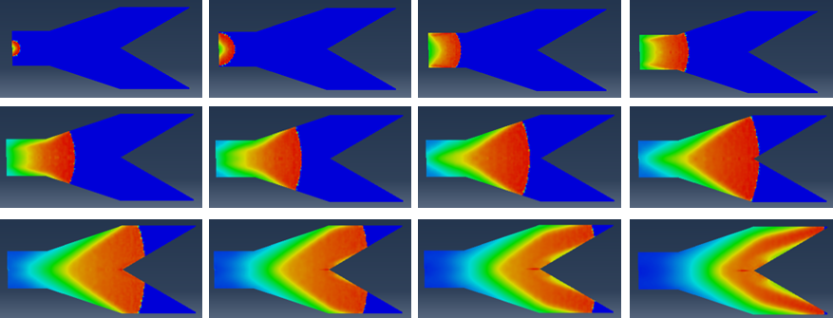
Figure 3 - Initial Results Summary

In this initial simulation the aim was to get the model to run and for the detonation to successfully propagate through the energetic material. As can be seen in Figure 3 the detonation starts and then progresses through the energetic.

The initial jet formation can be seen below, the deformed shape is plotted on top of the undeformed shape and the HE is not shown.

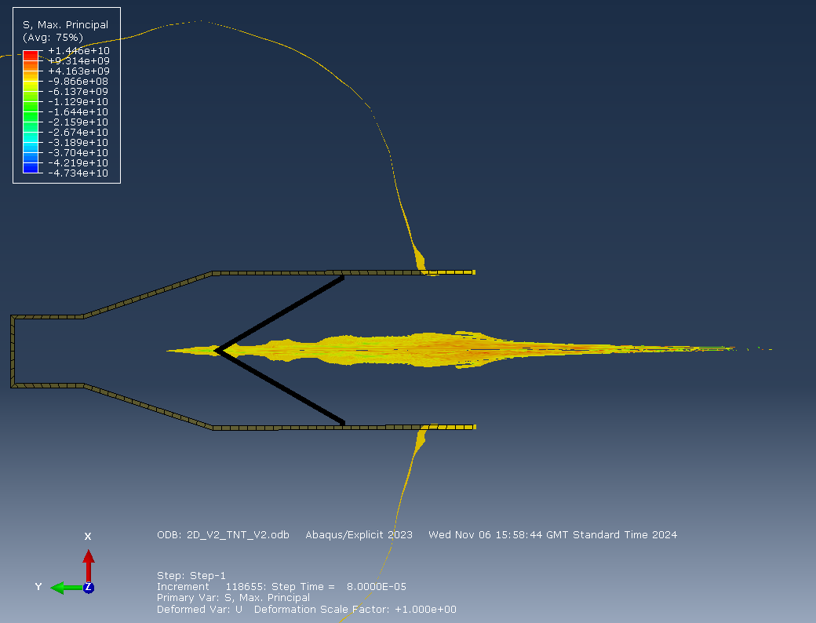
Figure 4 - Initial Jet

The initial performance of this model indicated a successful result but the model failed to reach further than this stage due to excessively distorted elements.

2D Material Validation

This section will perform some basic material validation studies for the energetic materials. It was chosen not to perform validation studies on the Static materials due to time constraints and confidence in the source of the material data.

Using the initial setup and even mesh size the model was run with each differing energetic material. At around 1.4e-5 a screen shot was taken on the detonation wave showing the detonation front. This image could then be used in an online tool [5] to measure the distances and then calculate the velocity of detonation.

TNT
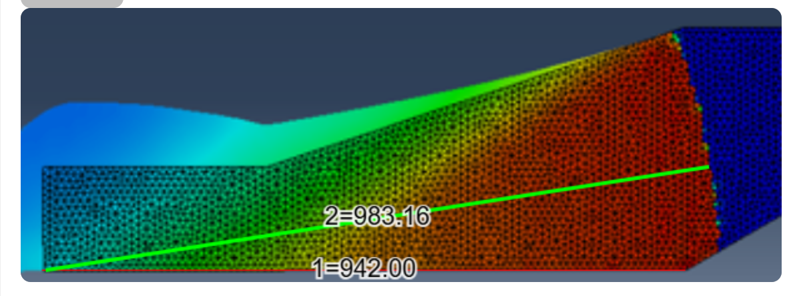
Figure 5 - TNT Detonation Velocity

PETN
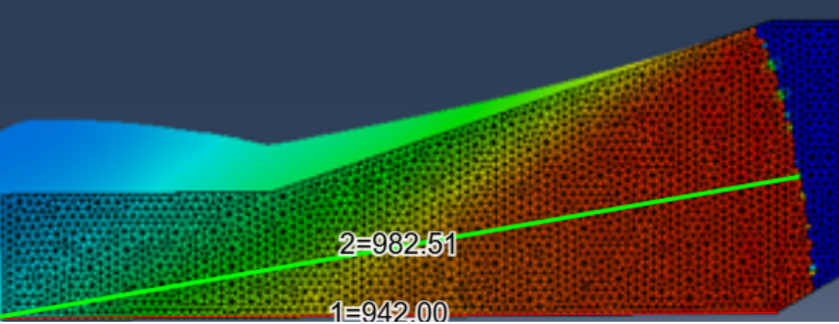
Figure 6 - PETN Detonation Velocity

RDX-C4
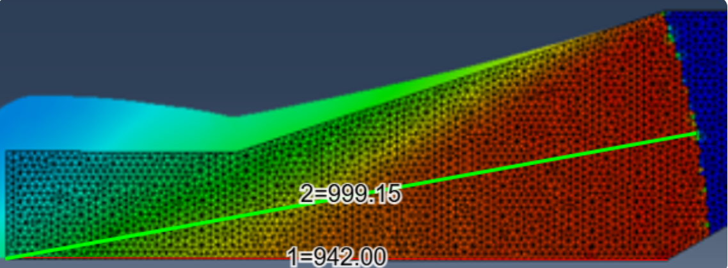
Figure 7 - RDX-C4 Detonation Velocity

HMX
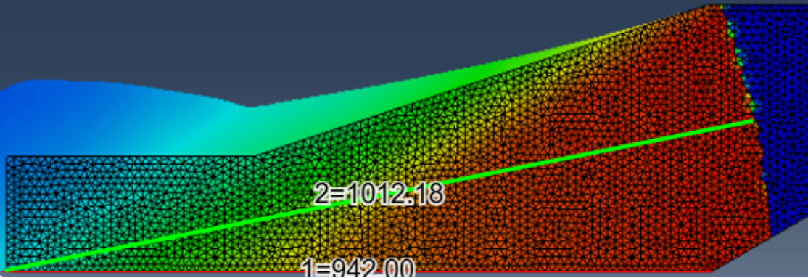
Figure 8 - HMX Detonation Velocity

Detonation Velocities
From these measurements with the below table can be created of the detonation velocities.

Material | Theoretical Detonation Velocity (m/s) | Simulated Detonation Velocity (m/s) | Percentage Deviation
HMX | 9110 | 9195.78 | 0.93%
PETN | 7450 | 7553.7 | 1.37%
RDX | 8193 | 8317.24 | 1.49%
TNT | 6930 | 7017.65 | 1.25%
Table 4 - Detonation Velocities

The results above provide strong confidence in the efficacy of the energetic material models as with only a small deviation from the theoretical and ideal velocity.

2D Mesh Study

Whilst performing the initial simulations and material validation trials it was noted that there where a significant number of nodes that where being ineffectively utilised. They were consuming processing power and time but not substantively contributing to the outcome of the model.

To best use the available computing power whilst minimising simulation time a mesh study was performed. In this mesh study a variety of options where considered and a conclusion reached that will allowed the balance of both granularity of fine detail where necessary and less detail where possible.

To evaluate the performance of each mesh, the tip velocity of the jet will be considered in comparison to simulation time. In this model only the mesh will be changed, and the energetic material will remain the same, TNT.

The below meshes will be compared in a final table

Course Mesh
After the materials validation trials a courser mesh was explored to reduce the simulation time. The result below is a 4x greater mesh size than the original, this mesh was less ideal as a single mesh element spanned the with of both the case and the liner. Whilst this is less of an issue for the case the elements in the liner do not have sufficient detail leading to a greatly reduced tip velocity as shown in Figure 10.

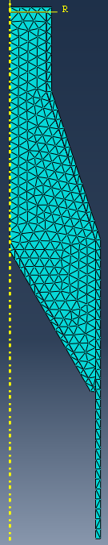
Figure 9 - Course Mesh

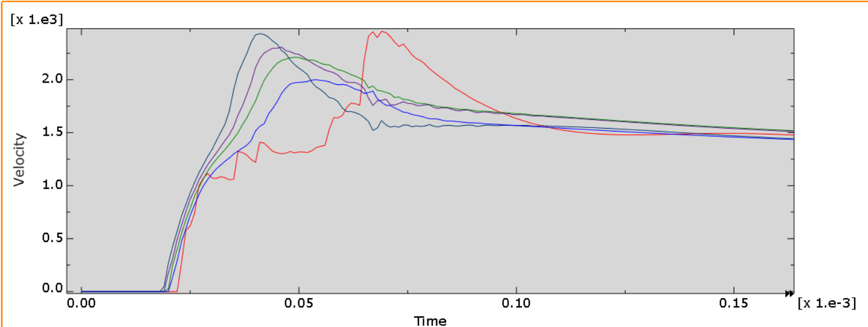
Figure 10 - Course Mesh Tip Velocity

The initial results of this mesh show that although the job completed very quickly (9s) the tip velocity achieved can be considered considerably below what would be expected.

Medium Mesh
This mesh was used in the materials validation studies as it provided a good starting point for the simulations, it had sufficient detail to accurately represent the geometry and allowed for sufficient detail on the liner for a full development of the jet.

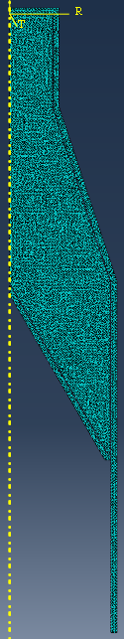
Figure 11 - Medium Mesh
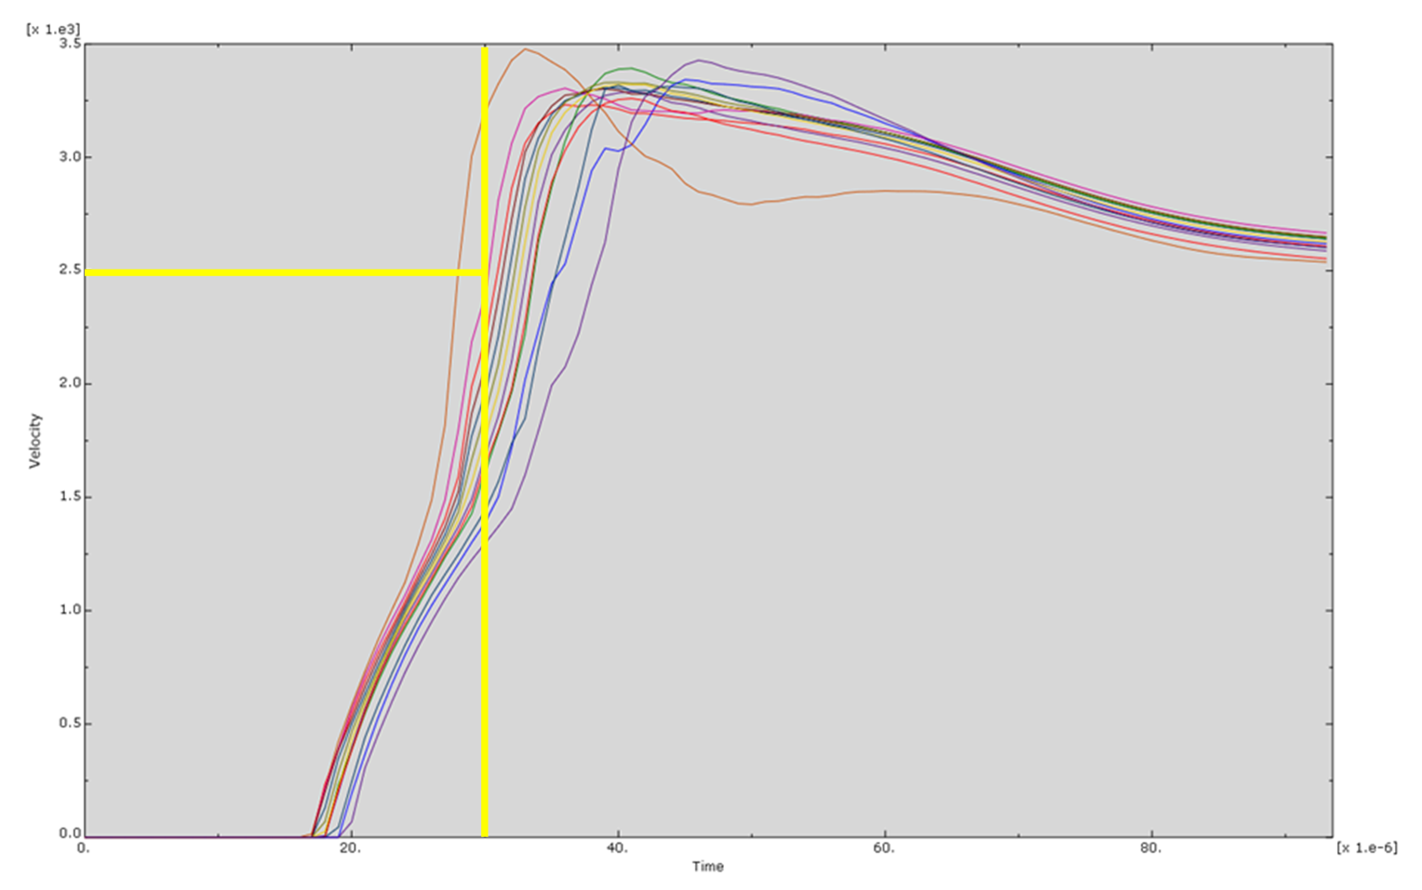
Figure 12 - Medium Mesh Tip Velocity

The results from this model provided a slight increase on tip velocity and simulation time as well as job time.

Fine Mesh
To understand if smaller elements would equate to a greater tip velocity this finer mesh was created with a 0.5mm seed, half the size of the original mesh.

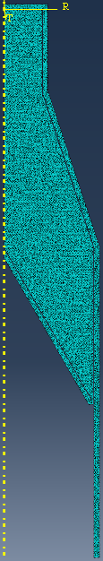
Figure 13 - Fine Mesh

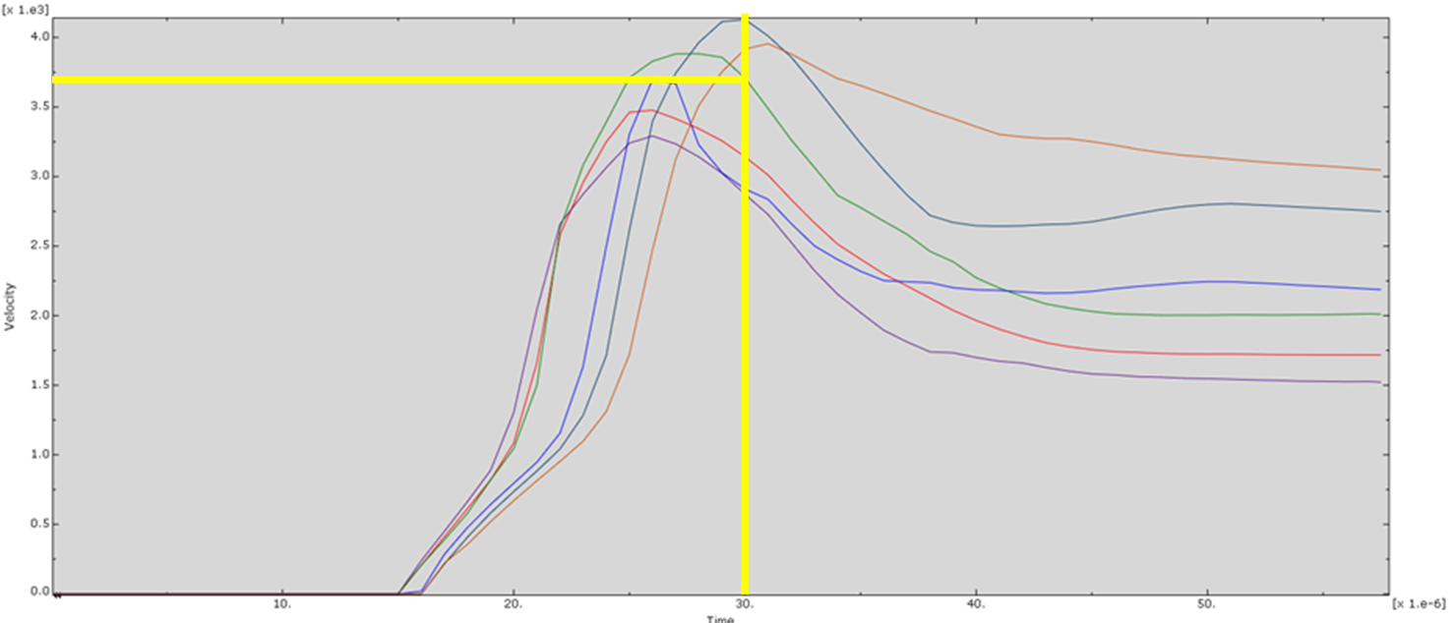
Figure 14 - Fine Mesh Tip Velocity

From the results above the tip velocity of 3400m/s can be taken. This is a slight increase on the previous highest velocity of 2500 m/s and demonstrates that the finer mesh is beneficial. Despite the increase in tip velocity the overall simulation time reduces, and the job time was significantly extended.

Super Fine Mesh
As an increase in tip velocity was observed with the Fine mesh a smaller mesh was created to find the limit of this increase.

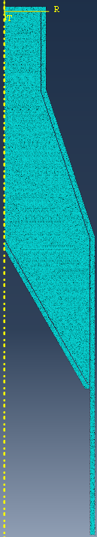
Figure 15 - Super Fine Mesh

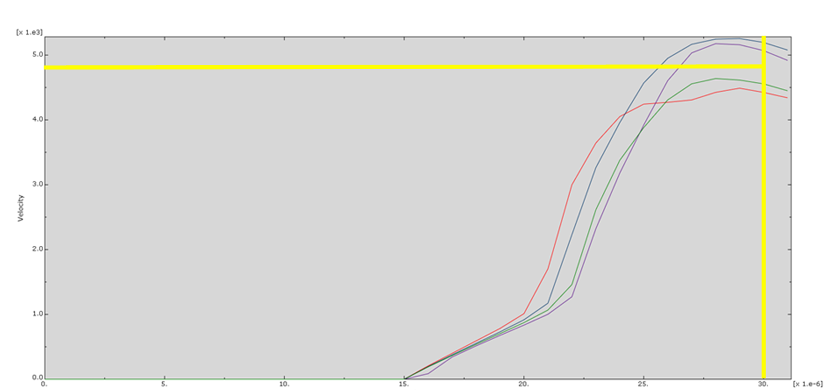
Figure 16 – S97uper Fine Met Tip Velocity

From the results above the tip velocity of 4800m/s can be taken. This is another significant increase on the previous highest velocity of 3400 m/s and demonstrates that the even finer mesh is beneficial. Despite the increase in tip velocity the overall simulation time reduces further, and the job time was significantly extended.

Mixed Mesh V1
This mesh was the first trial to balance the mesh to best utilise differing mesh sizes.
The intent was to have a fine mesh in the liner and HE fill close to the liner and then a larger mesh everywhere else. This focusses the computing power on the liner which is the key component.

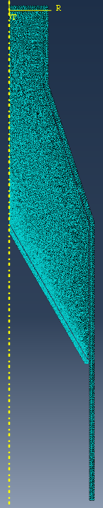
Figure 17 - Mixed Mesh V1

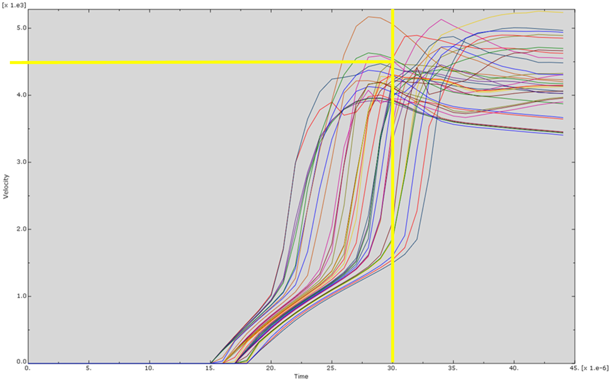
Figure 18 - Mixed Mesh V1 Tip Velocity

The results of the initial mixed mesh where successful showing a slight decrease in tip velocity but both a significant decrease in Job time and increase in simulation time.

Mixed Mesh V2
The next stage was to further reduce the mesh size in the case and outer shell of the HE whilst keeping the fine detail of the liner and close to the HE.

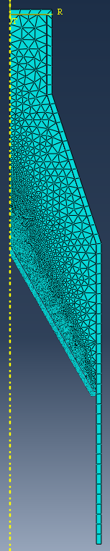
Figure 19 - Mixed Mesh V2

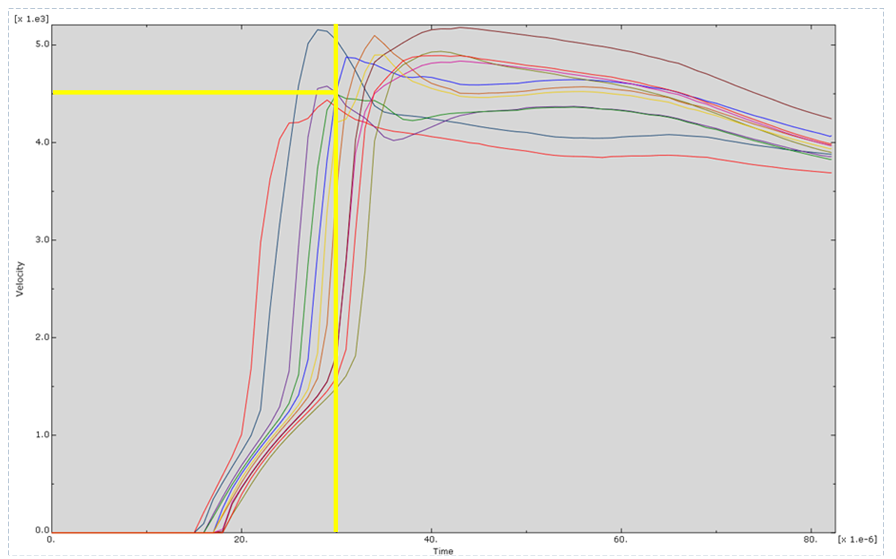
Figure 20 - Mesh V2 Tip Velocity

The results achieved from this model increased the simulation time, reduced the Job time and maintained the tip velocity. This was the final mesh that was used for the remainder of the simulations as it was determined to balance job time, and simulation results.

Mesh Comparison

Mesh Name | Mesh Size (m) | Simulation Time (s) | Job Time (s) | Tip Velocity (m/s) at Time 3e-5
Course | 0.004 General | 1.6636E-4 | 9 | Sim time not reached  Max velocity 2000
Medium | 0.001 General | 9.3077E-5 | 61 | 2500
Fine | 0.0005 General | 5.4000E-5 | 269 | 3400
Super Fine Mesh | 0.0002 General | 3.0000E-5 | 1500 | 4800
Mixed Mesh V1 | 0.001 Max  0.001 General 0.0002 Min | 4.4033E-5 | 690 | 4500
Mixed Mesh V2 | 0.004 Max  0.001 General  0.0002 Min | 8.2000E-5 | 206 | 4500
Table 5 – 2D Mesh Comparison

The above table shows the numerical data obtained from the mesh study simulations. It clearly demonstrates how a balanced mesh can perform equally to a fine mesh whilst significantly reducing simulation time.

2D Liner Collapse Theory

The Birkhoff Liner collapse theory broadly states that the elements that make up the tip of the jet come from the inside surface of the liner. [6]

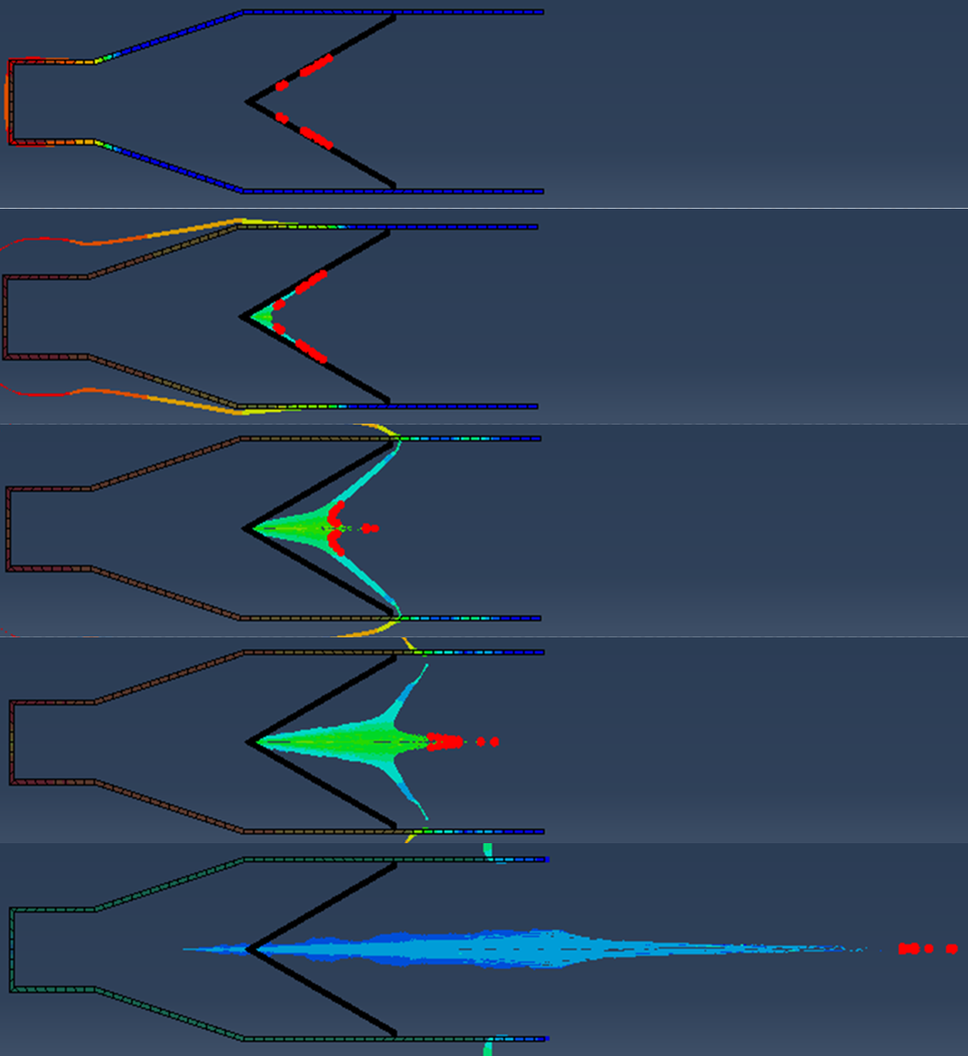
Figure 21 - Liner Collapse

By selecting the nodes that form the tip of the jet it is possible to track them backwards to the surface of the liner. This allows for the graphical representation of the Birkhoff theory and confirms what would be expected of the charge. In addition the final step shows the rearward projection of material that is indicative of this theory.

2D Results

The full 2D results for each energetic can be found in Annex D

TNT
The final 2D results for the TNT can be seen below, they show the final jet achieved by the shaped charge along with the jet progression in relation to tip velocity.

Looking at the tip velocity of the formed jet it broadly follows the same graph shape as that laid out in literature [1] but considerably slower. This is likely due to the charge not being designed for TNT and thus the slower detonation speed and energy density of TNT would equate to a reduced jet velocity.

Figure 22 - 2D TNT Final Jet

The shape of the achieved jet is comparable to what would be expected as the jet is clearly formed with a following slug and tail that is indicative of shaped charges. Interestingly the outer edges of the liner seem to fold inwards to join the jet, this is likely a simulation error due to the liner not being sufficiently connected to the case across multiple elements. Additionally the use of a significantly larger case mesh compared to the liner mesh could cause issues when modelling case – liner interactions as the gross disparity between the two causes the calculations to break down and become unreliable. This is the trade off that has been made to save simulation time in the compressed timeframe of the work being carried out.
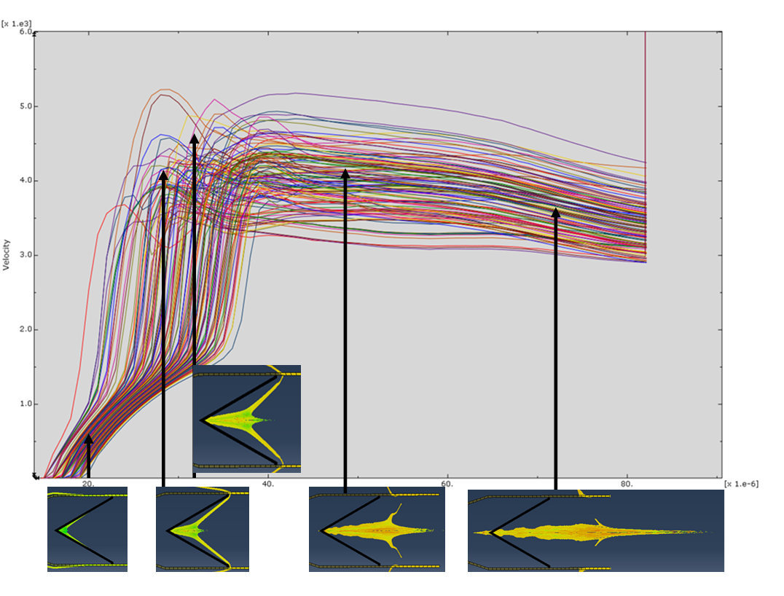
Figure 23 - 2D TNT Tip Velocity with Progression

PETN
The results from the PETN trial where graphically positive as the jet formed correctly and seemed to progress well with a significant simulation time of 0.02s compared to the 0.00008s that the TNT achieved. Despite this the jet velocity was significantly lower than that would have been expected. As with TNT this could be due to numerous reasons.

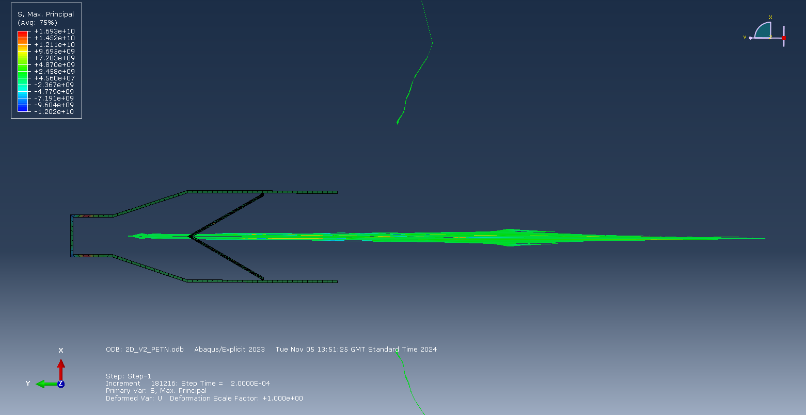
Figure 24 - PETN Final Jet

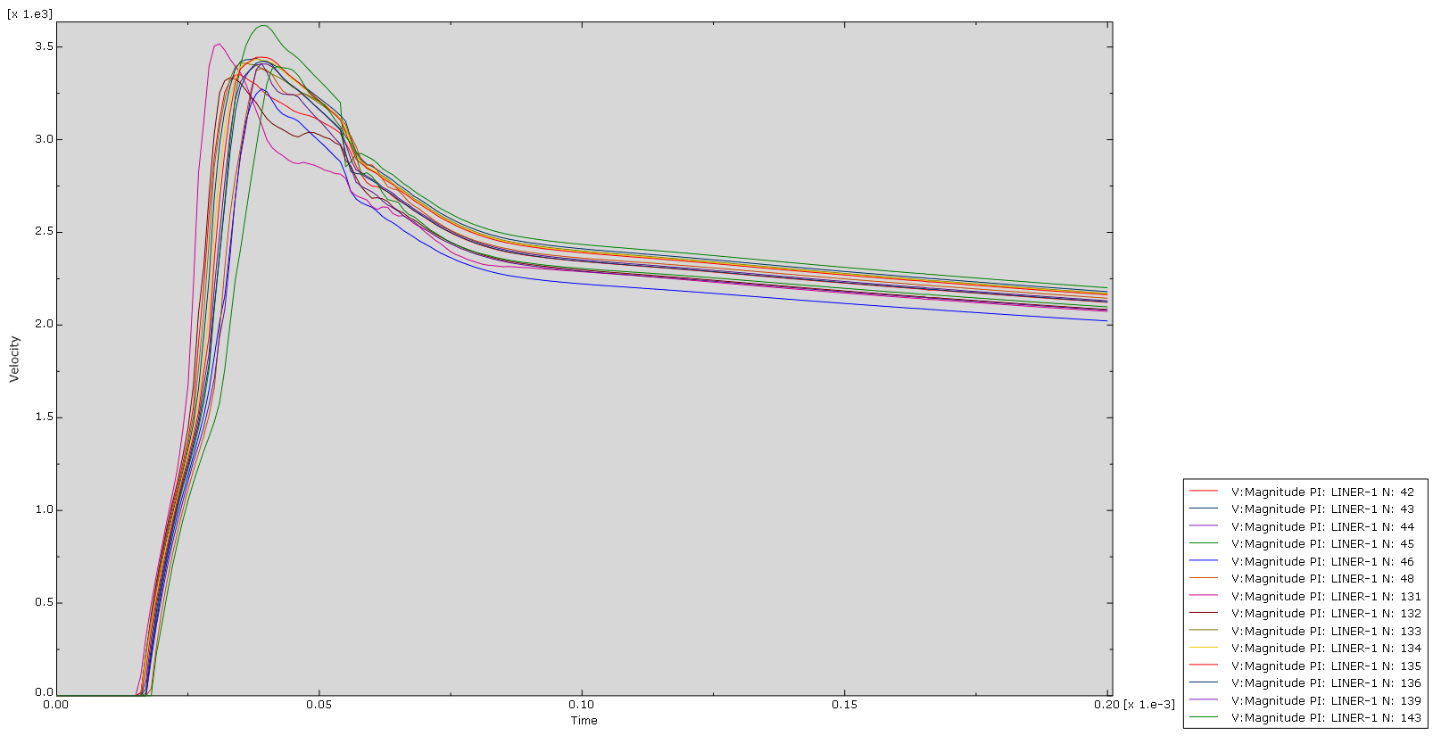
Figure 25 - PETN Tip Velocity

RDX-C4
The RDX results shown below are significantly similar to the PETN results. Despite the increased power of the RDX over TNT the final jet velocity is less. This is unexpected and indicates a faulty in the model or calculations.

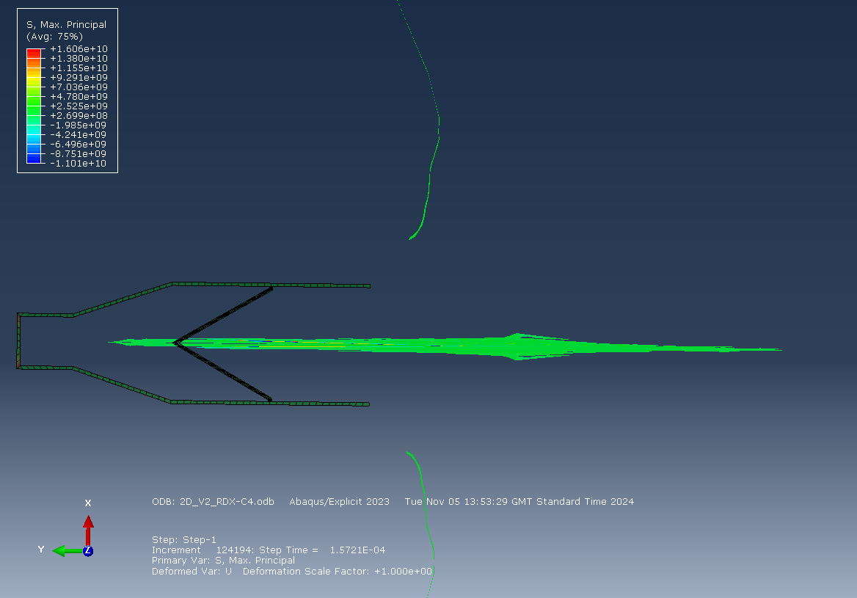
Figure 26 - RDX-C4 Final Jet

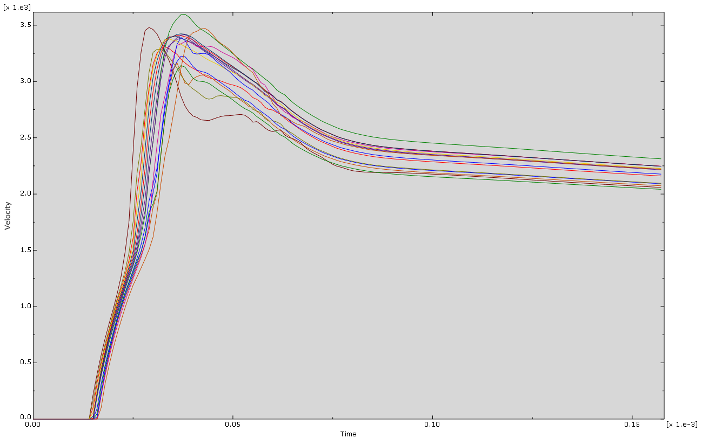
Figure 27 - RDX-C4 Tip Velocity

HMX
Lastly the results for HMX showed a more positive outcome for the jet. The final HMX jet had a similar shape to the previous energetic examples but resulted in a greatly higher tip velocity. Much closer to that found in literature. [1]

Despite this the final jet velocity is still lower than the 7000m/s to 8000m/s that would be expected.

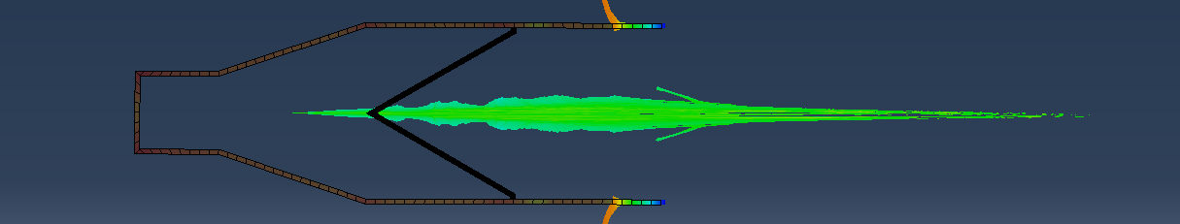
Figure 28 - HMX Final Jet

\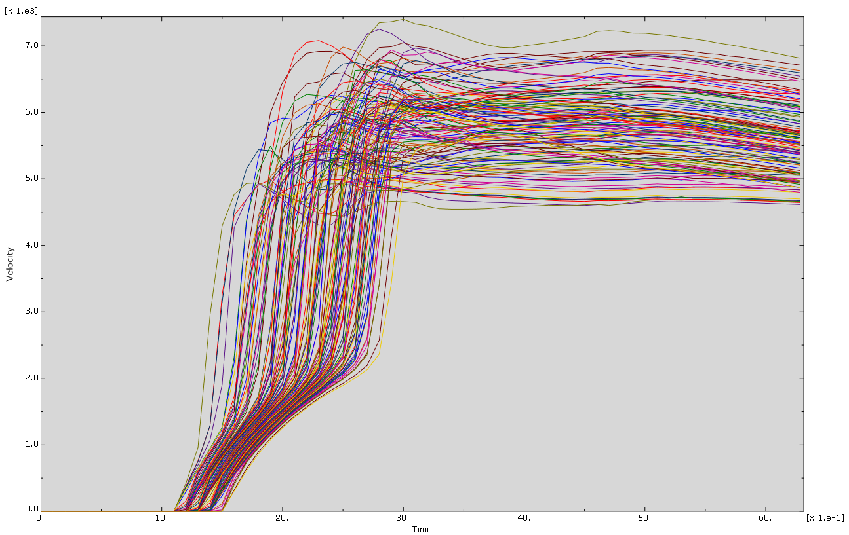
Figure 29 - HMX Tip Velocity

The shape of the achieved jet is again comparable to what would be expected as the jet is clearly formed with a following slug and tail that is indicative of shaped charges. Like the TNT the outer edges of the liner seem to fold inwards to join the jet, this is likely a simulation error due to the liner not being sufficiently connected to the case across multiple elements. Additionally the use of a significantly larger case mesh compared to the liner mesh could cause issues when modelling case – liner interactions as the gross disparity between the two causes the calculations to break down and become unreliable. This is the trade off that has been made to save simulation time in the compressed timeframe of the work being carried out. This results is the most successful of the 2D results.

2D Conclusions

From the results of the 2D simulations the below table can be created that numerically evaluates each of the simulations.

Model Name | Simulation Time (s) | Max Tip Velocity (m/s) | Tip Velocity (m/s) at Time 6e-5s | TNT Equivalence [7]
2D TNT | 0.00008 | 5200 | 4000 | 1
2D PETN | 0.00020 | 3600 | 2600 | 1.5
2D RDX-C4 | 0.00015 | 3600 | 2600 | 1.52
2D HMX | 0.00006 | 7400 | 6500 | 1.5
Table 6 - 2D Results Summary

This table clearly shows how the performance of the PETN and RDX is significantly below that of the TNT despite this energetics having a higher TNT equivalence than TNT. As the material models were validated within a few percent of the expected result the simulation issue is likely to be else where.

The next stage of this report will be to take the TNT model forward to 3D to understand if another dimension of simulation will better evaluate the jet. This will then be compared to the 2D simulation.

3D Introduction

Following on from the 2D simulations the next stage was to take the most successful simulations into 3D, in this case the TNT simulation will be considered. Although the HMX Simulation is well understood this would have been considered if time allowed.

3D Initial Model Setup

For the initial trials of the 3D model TNT was used. Much trial and error was required to get the model to run as there seemed to be numerous issues with the setup that were eventually solved. These where mostly user errors.

The geometry used in these 3D studies is the same as that in the 2D simulations except they are revolved 180 degrees to create the 3D shape. These can be seen in Annex E

3D Mesh Study
As with the 2D a mesh study was created to make best use of the simulation time available.
The Tip velocity graphs for these meshes can be found in Annex G

Initial Mesh
The initial mesh used was a 0.0015m even mesh seen below. Tet mesh was used as it best mapped itself to the curvature of the design with minimal artefacts.

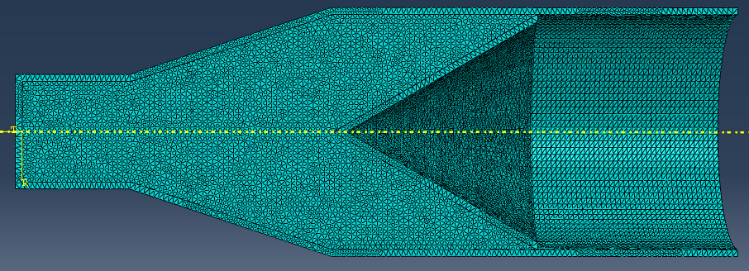
Figure 30 - 3D Initial Mesh

This mesh had a node count of 69563 which was significantly below the max number of nodes for the ABAQUS student edition of 250000.

Mixed Mesh
As the number of nodes from the course mesh was significantly below that of the maximum acceptable limit it was chosen to increase the resolution around the liner as this was demonstrated to be successful in the 2D simulations.
The below mesh was created with minor artefacts and a much greater resolution in and around the liner.

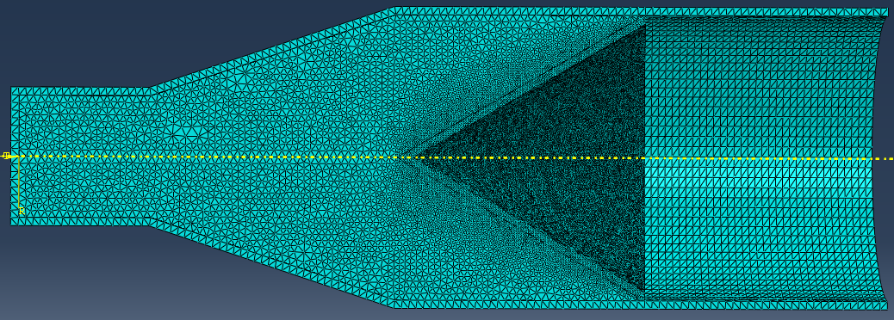
Figure 31 - 3D Mixed Mesh

Shortened Case Mesh
To reduce the node count whilst maintaining sufficient resolution in the element size the case of the charge was shortened to eliminate the nodes that are beyond the end of the liner. These nodes form no part of the jet and do not contribute to the confinement so are assumed to have no effect on the result of the jet.

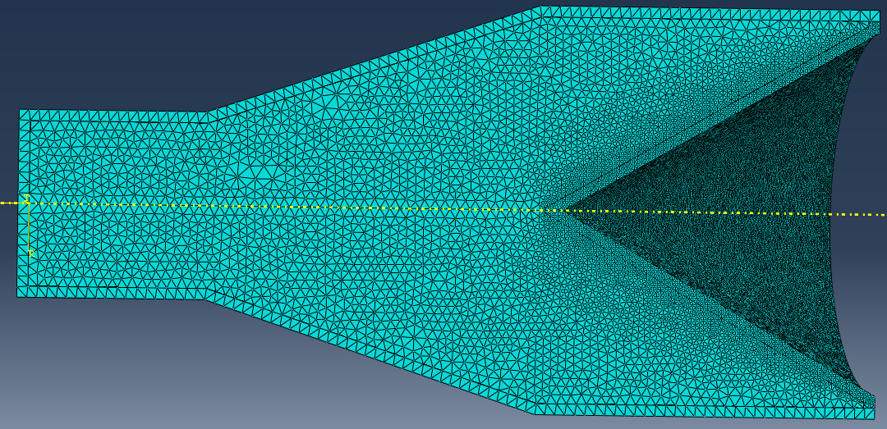
Figure 32 - 3D Shortened Case Mixed Mesh

Meshes Compared
From the full results and graphs in Annex G the below table can be created

Mesh Name | Mesh Size (m) | Node Count | Simulation Time (s) | Job Time (s) | Max Tip Velocity
Course | 0.0015 General | 69563 | 76257e-5 | 4118 | 3250
Mixed Mesh | 0.0018 General  0.00075 Min | 169102 | 5.9538E-05 | 18189 | 3800
Shortened Case Mixed Mesh | 0.0018 General  0.00075 Min | 165632 | 5.1766E-05 | 6745 | 4000
Table 7 - 3D Mesh Comparison

This data demonstrated that as with the 2D simulations the model benefits for more specific application of the nodes and elements. Allowing more computing time to be spent on the liner and HE close by rather than the case.

3D Results

Using the shortened case and mixed mesh, the below jet results were achieved. The full results can be found in Annex F. the images below represent velocity of the jet.

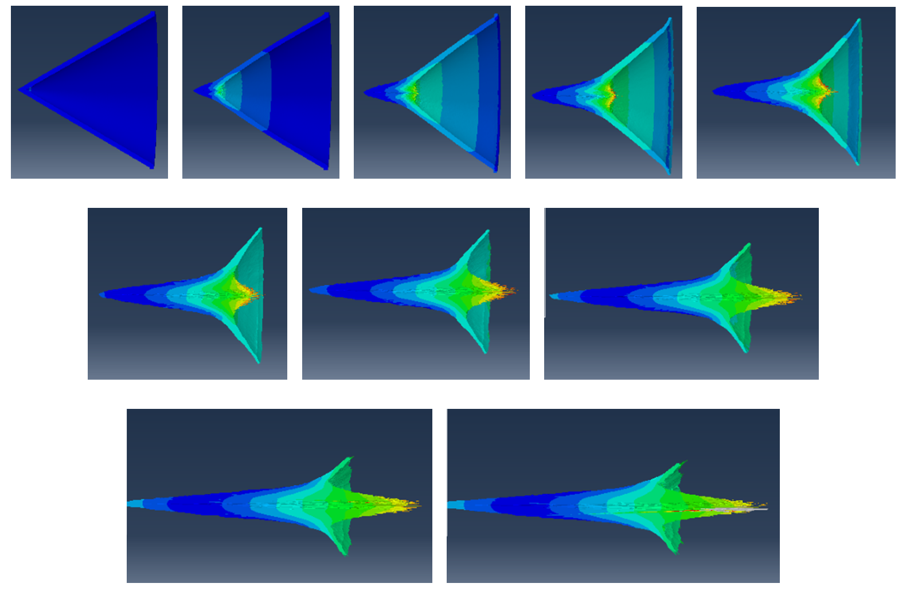
Figure 33 - 3D TNT Jet Progression

As can be seen from the progression the jet begins to form as the liner collapses per the liner collapse theory explored in 2D. Unfortunately as the jet tip emerges the elements within distort excessively and cause the simulation to crash, these are highlighted by the grey in the final image. Plotting the tip velocity of the jet it can be seen that the achieved velocity is significantly below that what would have been expected. In addition comparing the 3D TNT tip velocity to that of the 2D the 3D is slightly lower. This further indicates that the material models that have been used are either implemented incorrectly or are faulty in themselves. It is expected that the material models for the Steel and Copper used for the case and liner respectively are ;ess than ideal and consequently lead to a loss of energy and tip velocity.
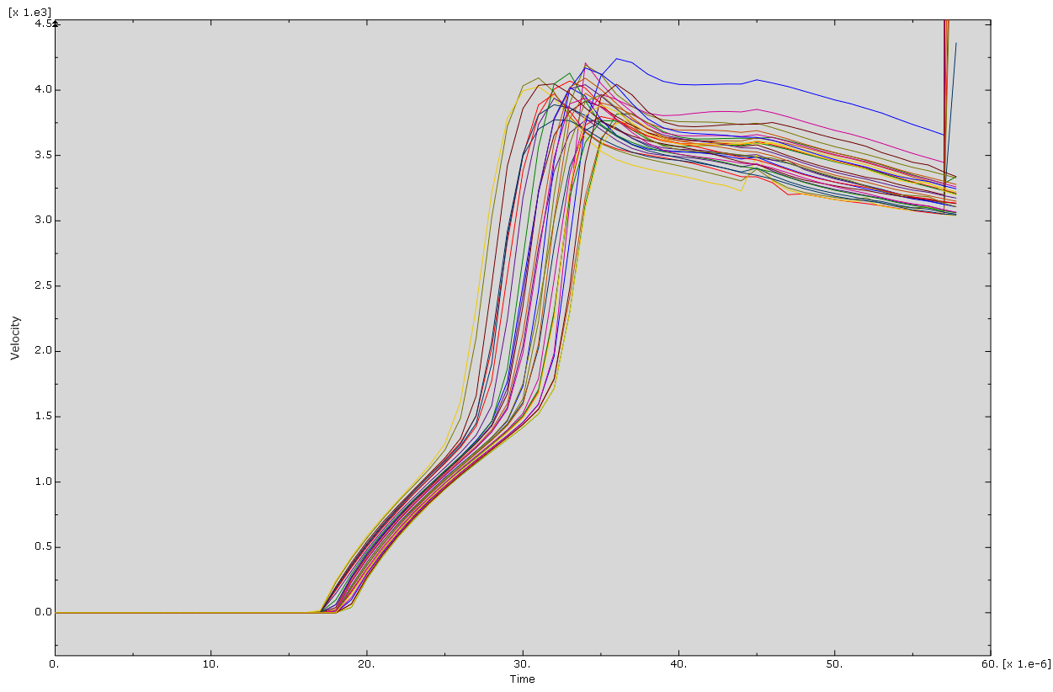
Figure 34 - 3D TNT Tip Velocity

The next stage of these simulations was to consider different ways that this model could be improved.

3D Improvement Trials

3D Altered Geometry Trial: Flatten Tip
Upon conversing with colleagues, it was hypothesised that as the simulated shock wave was impacting the tip of the liner it was causing a small number of nodes to distort massively due to their acceleration. As the liner comes to a finme point a single node is placed at the tip during meshing. This is less ideal as the shockwave is an arc meaning only a few nodes of shoch wave impact the tip. This could be the reason why the model was crashing. To try and resolve this a blunt tip liner was created, this actually closely mimics the real world as an sharp point of copper sticking in to HE is less than ideal from a safety standpoint.

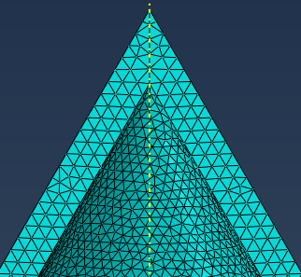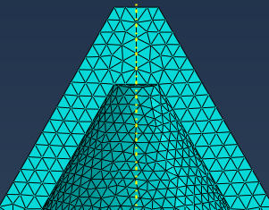
Figure 35 - Liner Tip Geometry

Despite the theory of this geometry change the results of the simulations showed that the simulation time post geometry change was slightly less than the original, again crashing at the Shockwave interface between the HE and Liner. This Change was therefore Abandoned.

3D Adaptive Meshing
A method that could be used to improve the simulation is adaptive meshing. Adaptive meshing is a procedure where a model is paused after a selected time frame and re-meshed in its distorted shape. This in theory allows the reallocation of new nodes and elements whilst maintaining the deformed geometry. In this example remeshing the HE and liner around the point that the shock wave impacts the liner would be the ideal point. Remeshing at this stage could in theory lead to a smoother transition of energy from the HE to the liner and create a good jet. Unfortunately, despite much effort adaptive meshing could not be achieved with these models. The model simply crashed at the start of the adaptive meshing. The reason for this is unknown.

3D Wave Smoothing
During different trials to improve the 3D model the detonation wave progression through the HE was considered to be turbulent and could therefore cause issues when the wave impacted the liner. By including a level of smoothing this shockwave can be made to be less turbulent. This would in theory support the development of a better less fragmented jet. This can be seen in the images below.

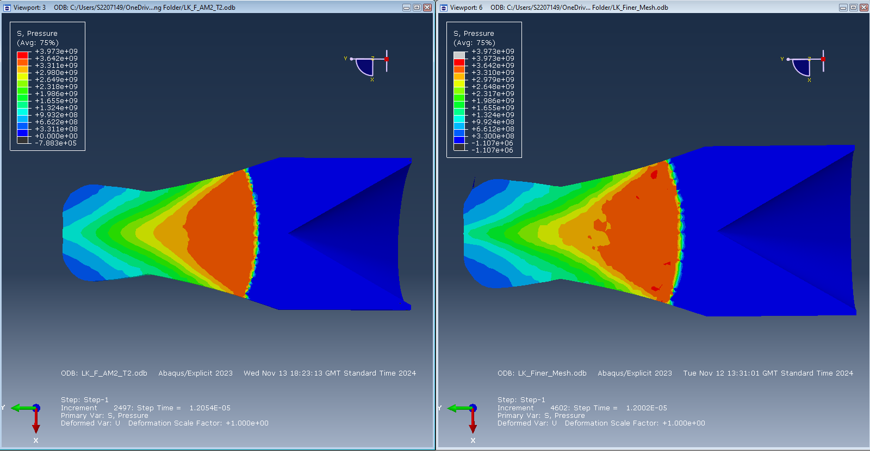
Figure 36 - 3D Wave Smoothing

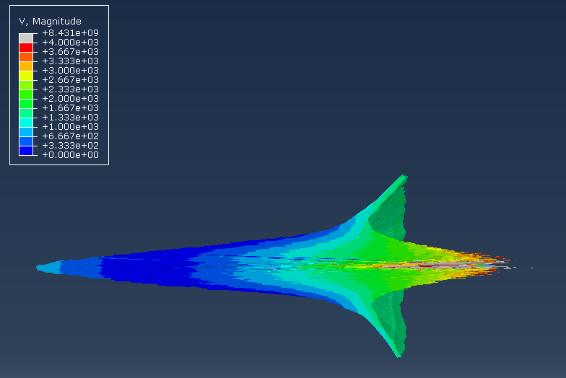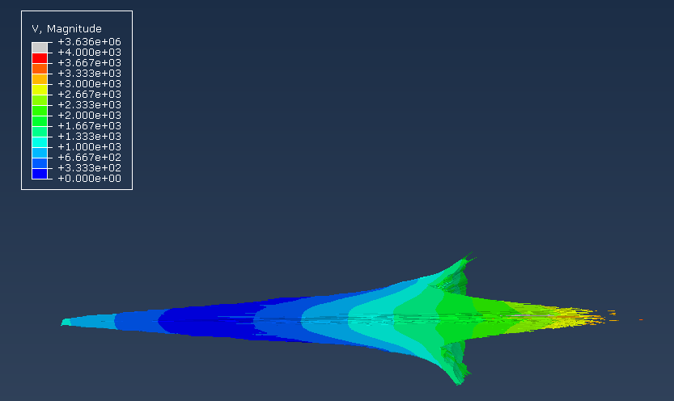
Figure 37 - Jet With and Without Smoothing

The theory was supported by an obvious increase in smoothness on the velocity of the jet this method but this did not seem to have a positive outcome on the jet. It reduced the velocity of the jet. This smoothing was considered positive and therefore included in the final 3D results.

Unexplored Methods
Smoothed Particle Hydrodynamics (SPH) is a method of Lagrangian modelling that creates a set of discrete particles within a mass. Each particle can then interact with other particles, wall boundaries and body forces. This method of often used to model fluids such as water but can be applied to shaped charges as although the materials within are solid at the start they almost instantaneously become a fluid.

Examples of SPH with shaped charges can be seen below in Figure 38. As it shows the SPH model creates a basic jet example that provides good indication of the jet velocities and mass but not to the overall shape. This can be seen by comparing the The SPH shape below shows jet breakup sooner and in places where it would be unexpected at this stage. This is due to the standard size of the particles that cannot be changed and therefore will ‘clump’ together where in reality they would stretch.

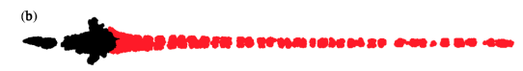
Figure 38 - SPH Example [1]

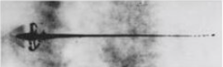

Figure 39 - Held X-Ray Jet Formation [8]

SPH was not explored for this model set due to time constraints but would have supported further evaluation of the models.

Conclusion

In conclusion the models run have demonstrated how simulating small, shaped charges is extremely complex. Requiring detailed knowledge and understanding of the system being used but also the materials as these can have such a large effect on any model run. In an ideal world individual material models would be created in conjunction physical material testing to best create data sets that mimic the model being simulated. This is often referred to as a digital twin. A digital twin is an ideal scenario and is often used for larger pieces of equipment cush as aircraft that can absorb the large effort and cost associated with creating it. When it comes to smaller equipment and ‘cheap’ shaped charges it is often simpler to perform physical trials to understand the performance of the jet. In the case of the LK shaped charge its low cost and adequate performance leads it to being effective at its job but not easily simulated. It would be more cost effective to simply create a few of these charges with differing energetics to detonate and image for the jet formation. Despite this the models created have shown the importance of a good material model and how drastically this can affect the end result.

References

[1] | E. a. Dariusz Pyka, “Numerical and Experimental Studies of the ŁK Type,” Applied Sciences, Wroclaw, 2020.
[2] | Resolved Analytics, “lagrangian vs eulerian phase models,” Resolved Analytics, [Online]. Available: https://www.resolvedanalytics.com/cfd-physics-models/lagrangian-vs-eulerian-phase-models. [Accessed 04 01 2025].
[3] | W. C. Xu Wenlong, “Formation of a bore-center annular shaped charge and its penetration into steel Targets,” International Journal of Impact Engineering, vol. 127, no. 1, pp. 122-134, 2019.
[4] | A. E. ,. a. T. M. K. Tamer Elshenawya, “A Numerical Method for the Determination of the Virtual OriginPoint of Shaped Charge Jets Instead of Using Flash X-rayRadiography,” JOURNAL OF ENERGETIC MATERIALS, vol. 36, no. 2, pp. 127-140, 2018.
[5] | eleif.net, “Photo measure,” eleif, [Online]. Available: https://eleif.net/photomeasure. [Accessed 05 01 2025].
[6] | G.Birkhoff, “Explosives with Lined Cavities,” Journal of Applied Physics, vol. 19, no. 6, pp. 563-582, 1948.
[7] | J. Akhavan, The Chemistry of Explosives, Royal Society of Explosives, 2022.
[8] | H. M, “ Shaped Charge Jet Section in Hazard Studies for Rocket Propellant Motors,,” NATO, SEINE, 1990.
[9] | D. E. T. a. R. Trebinski, “ON THE INFLUENCE OF FRACTURE CRITERION ON PERFORATION OF HIGH-STRENGTH STEEL PLATES SUBJECTED TO ARMOUR PIERCING PROJECTILE,” Archive of Mechanical Engineering, vol. LXII, no. 2, pp. 157 - 179, 2015.
[10] | J. J. Michał GRĄZKA, “Identification of Johnson-Cook Equation Constants,” Military University of Technology, Warszawa, 2012.
[11] | W. H. C. a. G. R. Johnson, “A CONSTITUTIVE MODEL AND DATA FOR METALS SUBJECTED TO LARGE STRAINS, HIGH STRAIN RATES AND HIGH TEMPERATURES,” AFAL.
[12] | W. P. Schonberg, “Control of Shaped Charge Jets Through Non-uniform Confinement,” Procedia Engineering, vol. 103, no. 1, pp. 302-3091, 2015.
[13] | Ansys Inc, “Autodyn Material Library,” 2016.

Annex A: 2D Model Parts

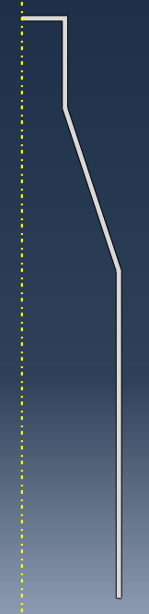
Figure 40 - 2D Case

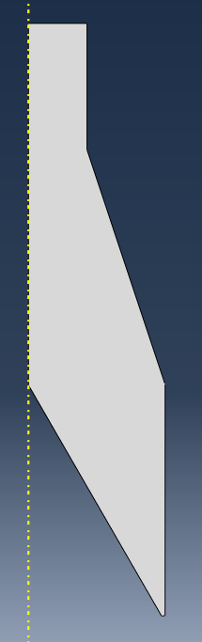
Figure 41 - 2D HE Fill

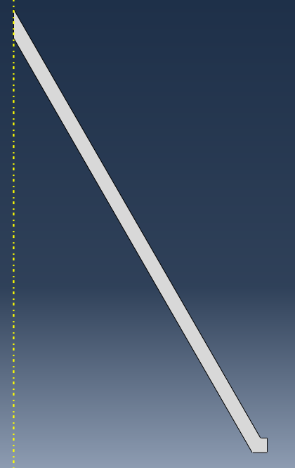
Figure 42 - 2D Liner

Annex B – Initial Results

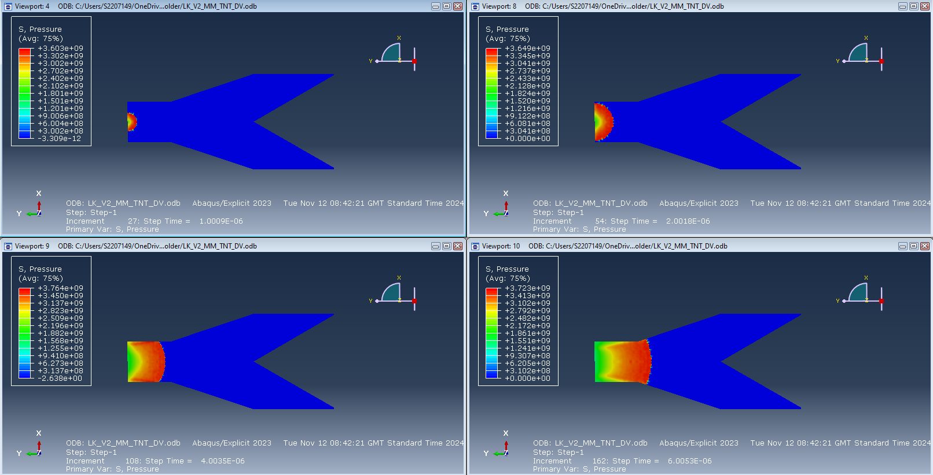
Figure 43 - Initial Results Steps 1-4
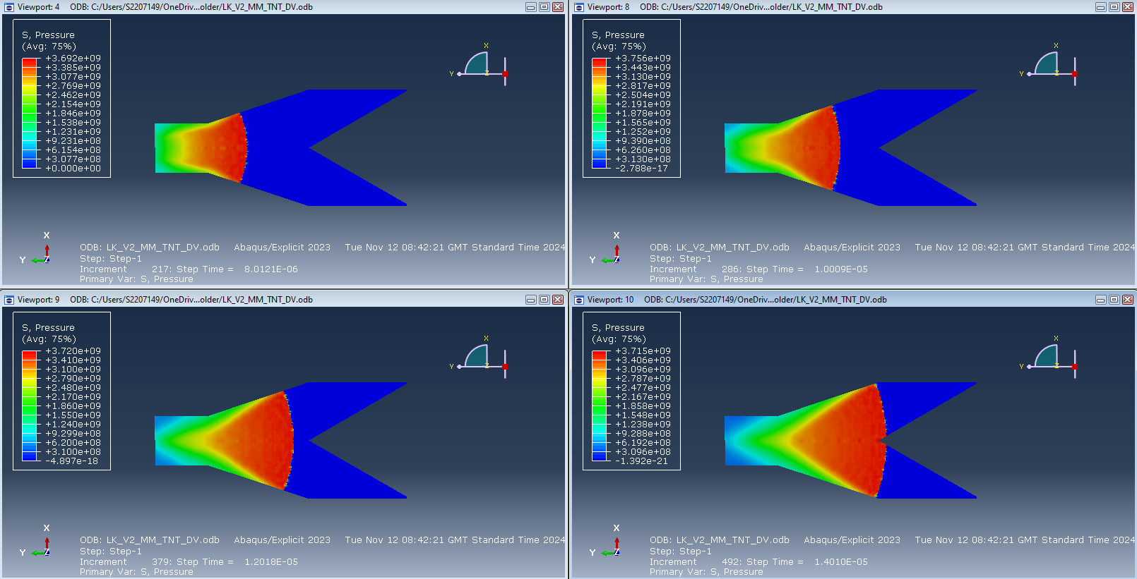
Figure 44 - Initial Results Steps 5-8
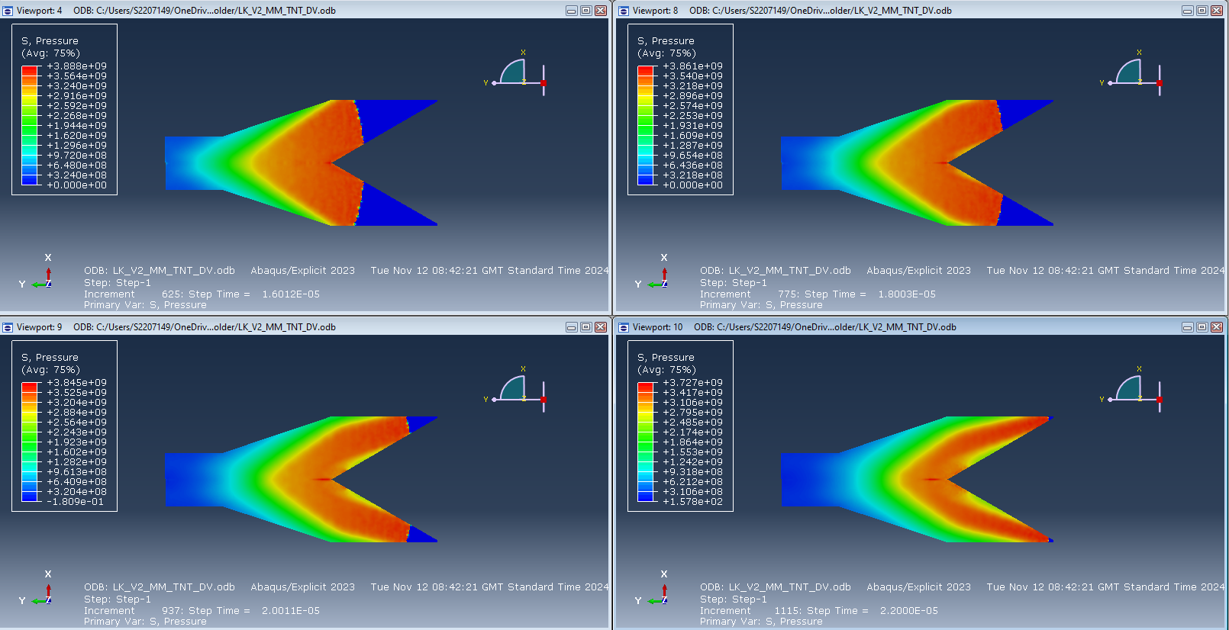
Figure 45 - Initial Results Steps 9-12

Annex C: Material Validation Results

TNT
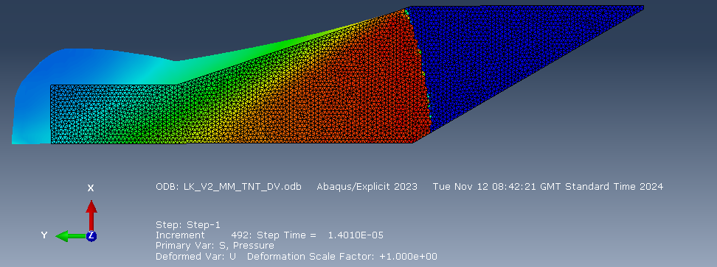
Figure 46 - TNT MV Trial

Figure 47 - TNT Det V Measurements

PETN
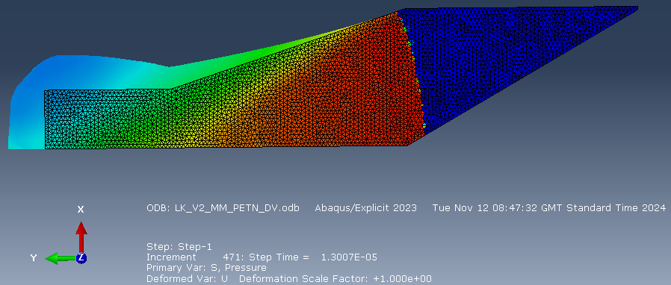
Figure 48 - PETN MV Trial
Figure 49 - PETN Det V Measurements

RDX-C4
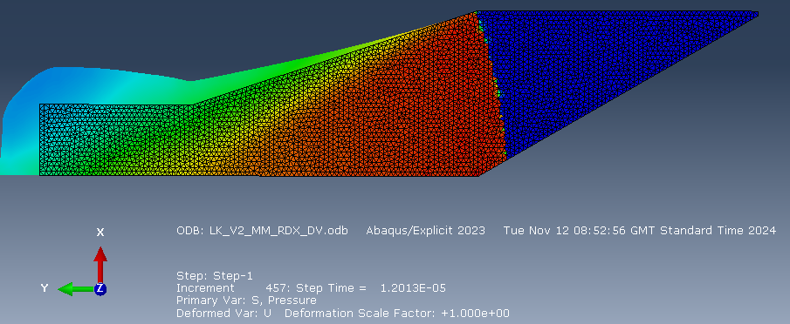
Figure 50 - RDX-C4 MV Trial
Figure 51 - RDX-C4 Det V Measurements

HMX
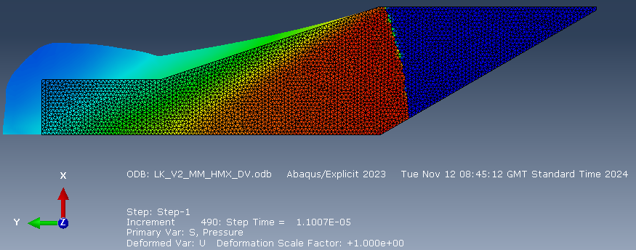
Figure 52 - HMX MV Trial
Figure 53 - HMX Det V Measurements

Annex D – 2D Results

TNT
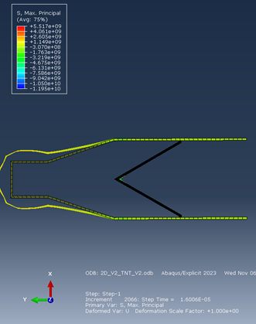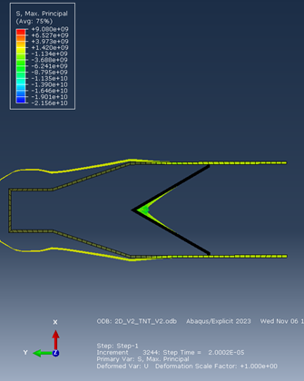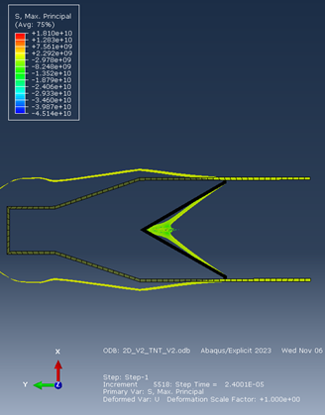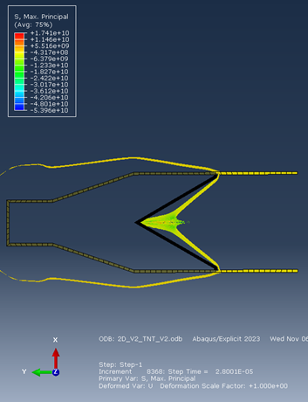
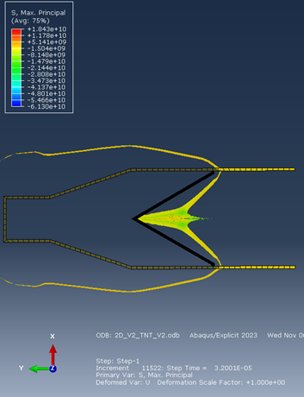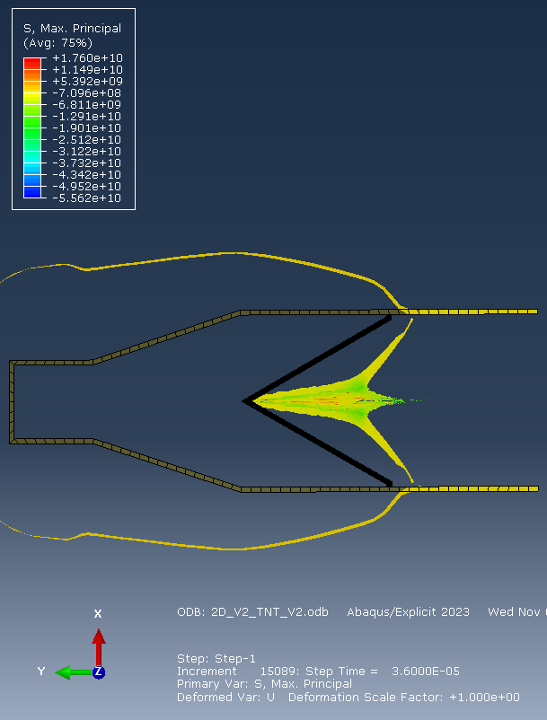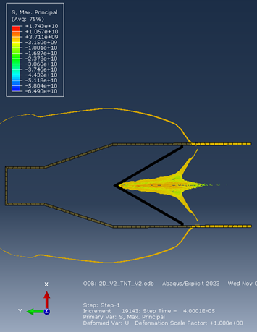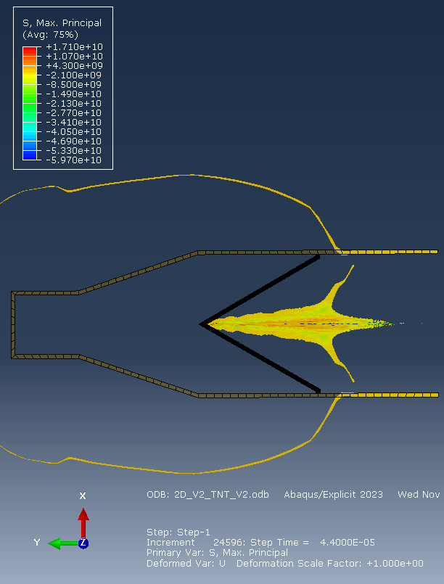
Figure 54 - 2D TNT Steps 1 - 8
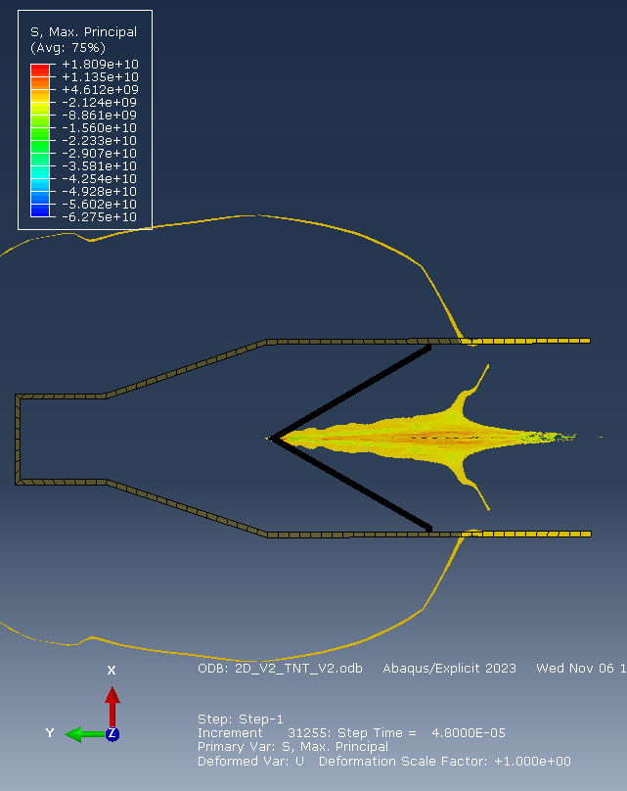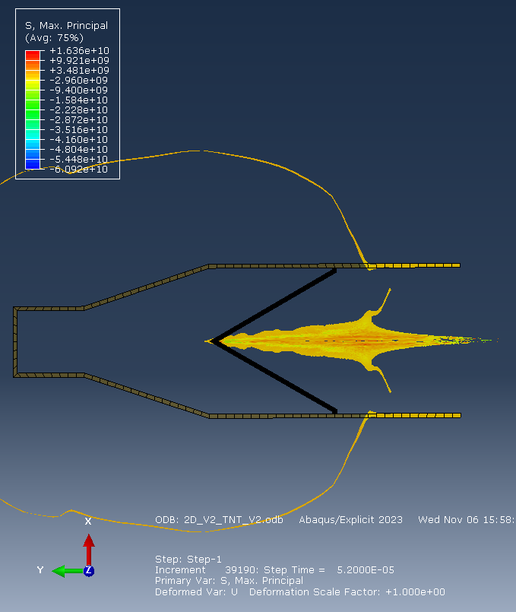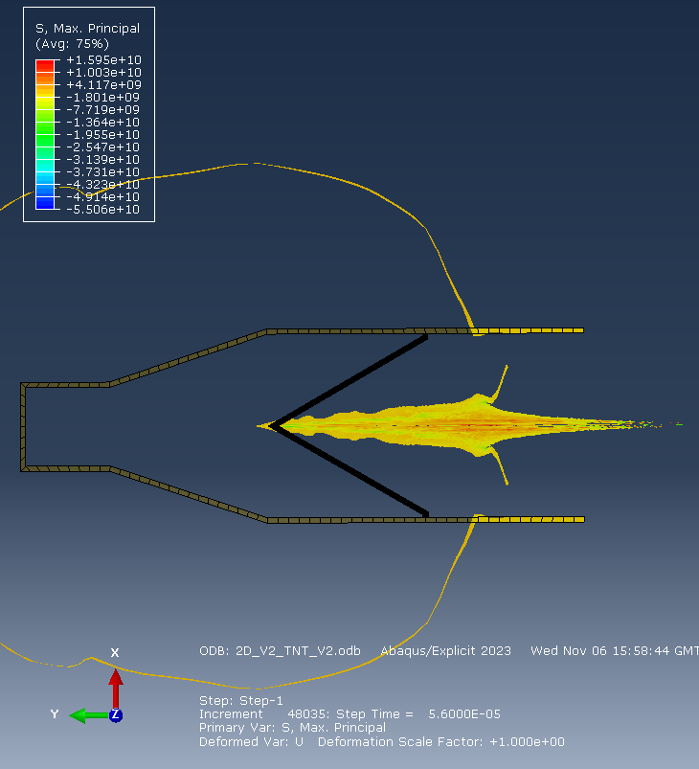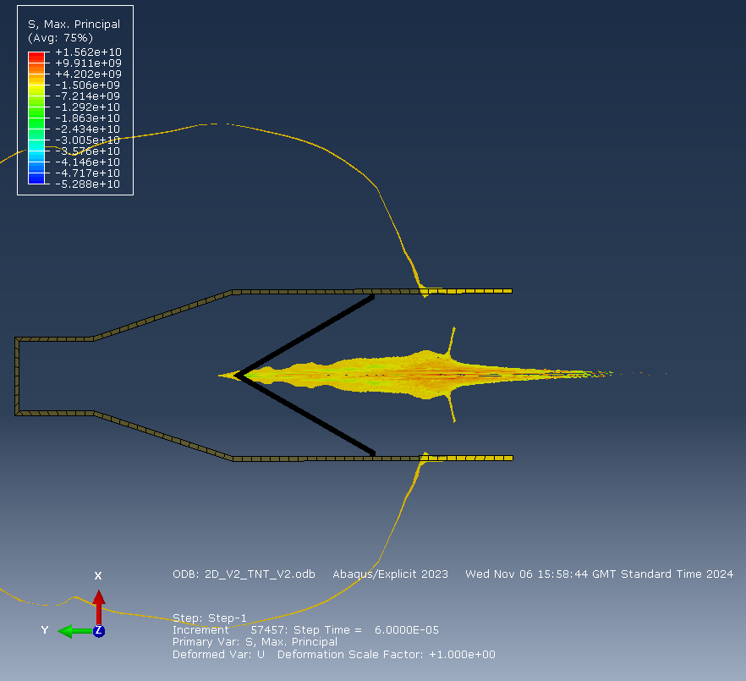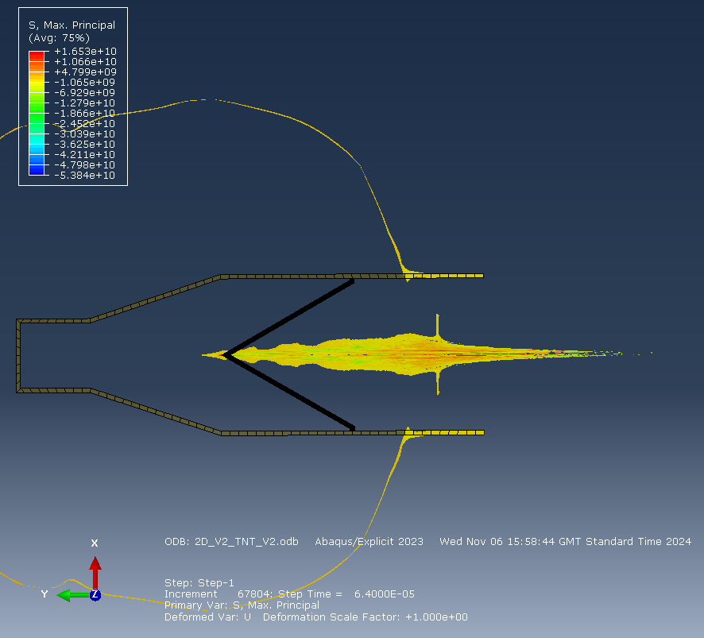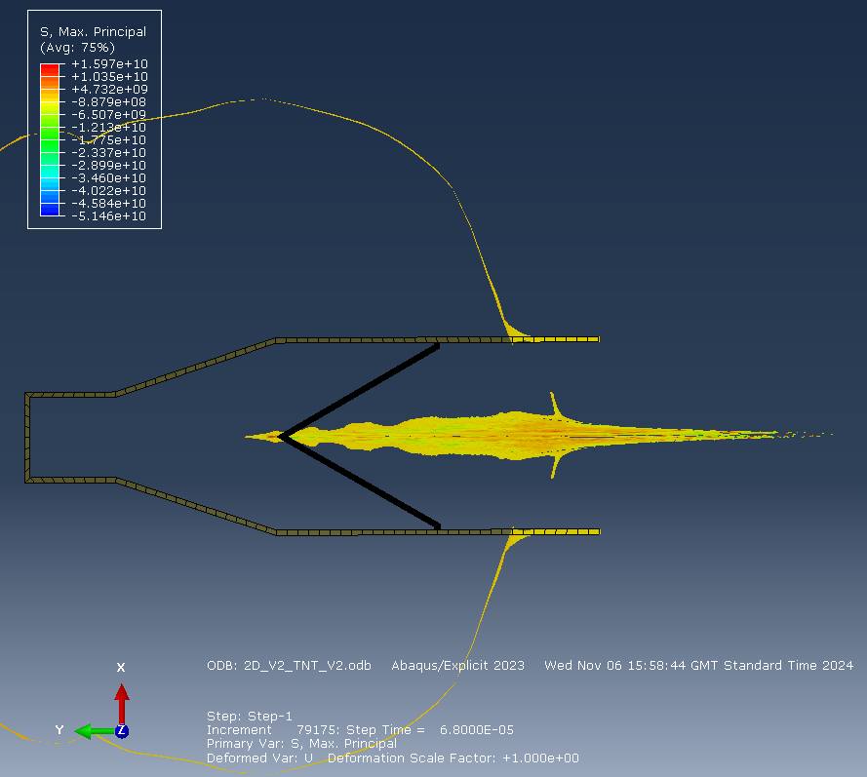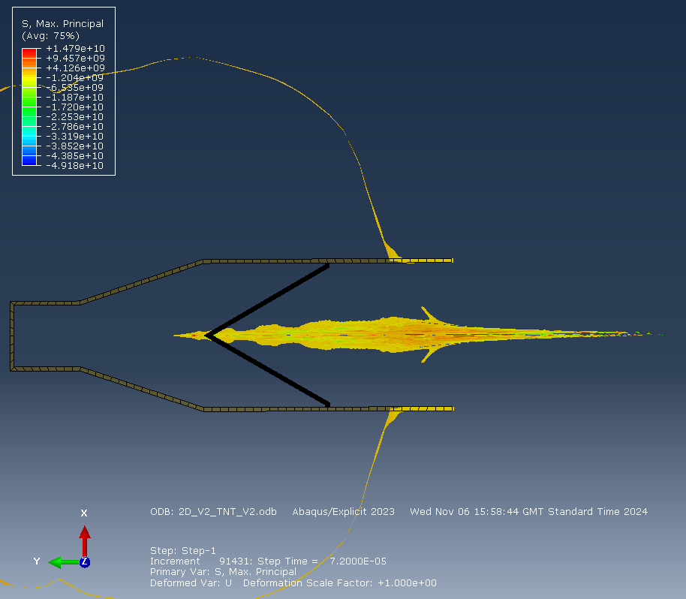
Figure 55 - 2D TNT Steps 9 - 15
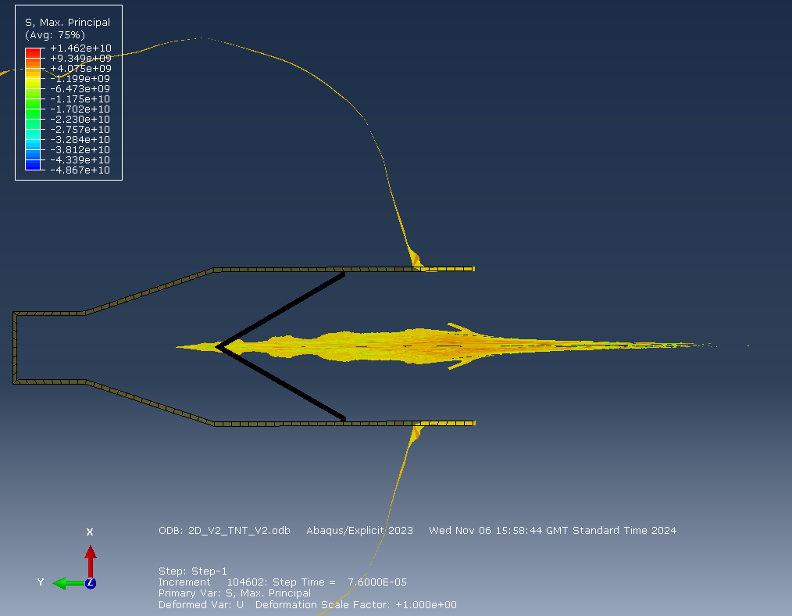
Figure 56 - 2D TNT Steps 16 - 17
Figure 57 - 2D TNT Tip Velocity

PETN
Figure 58 - 2D PETN Final Jet

Figure 59 - 2D PETN Tip Velocity

RDX
Figure 60 - 2D RDX-C4 Final Jet

Figure 61 - 2D RDX-C4 Tip Velocity

HMX
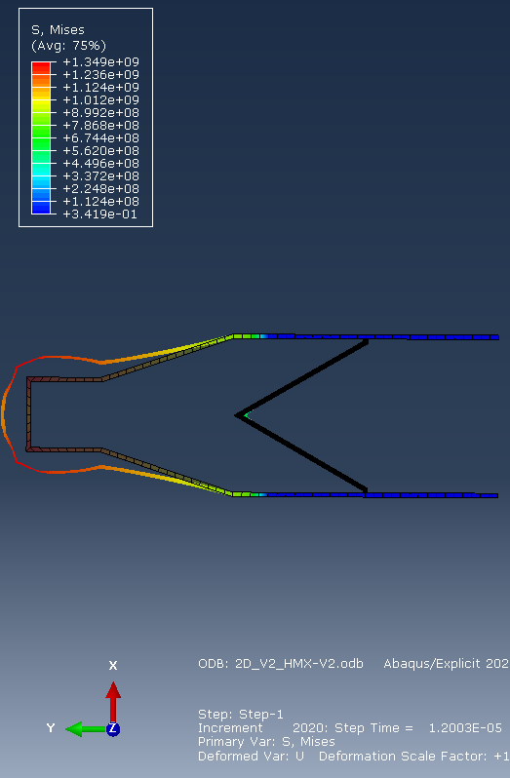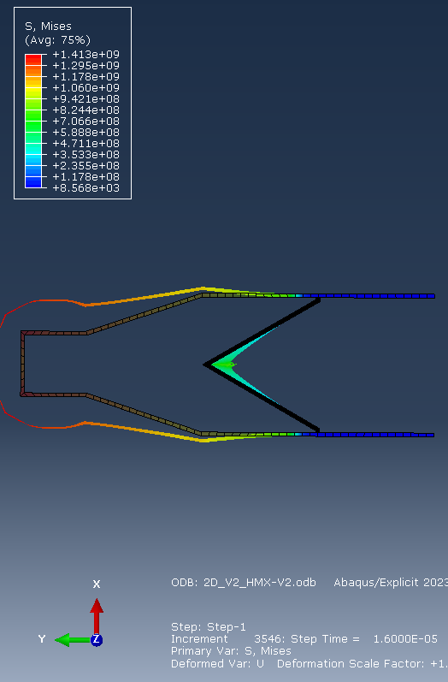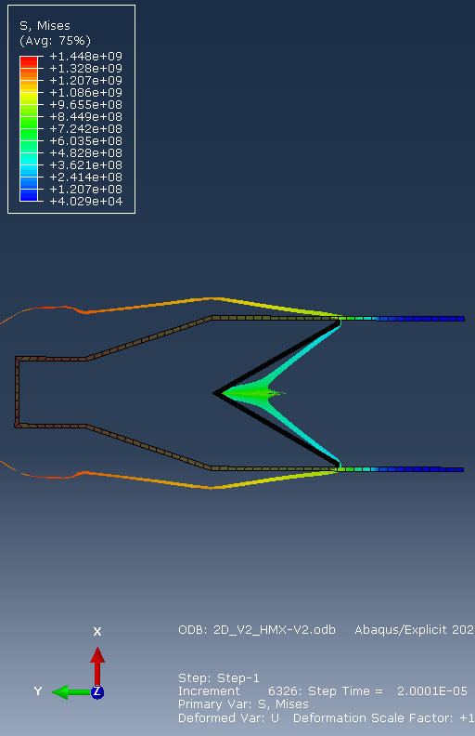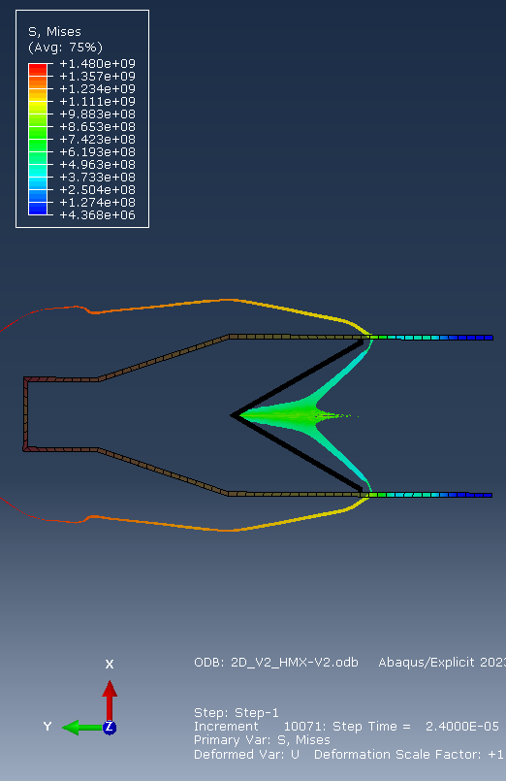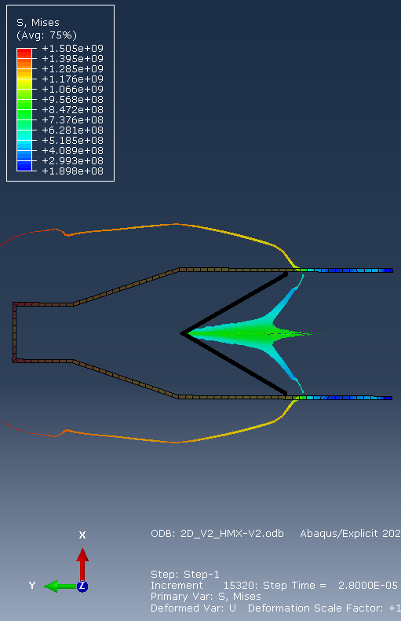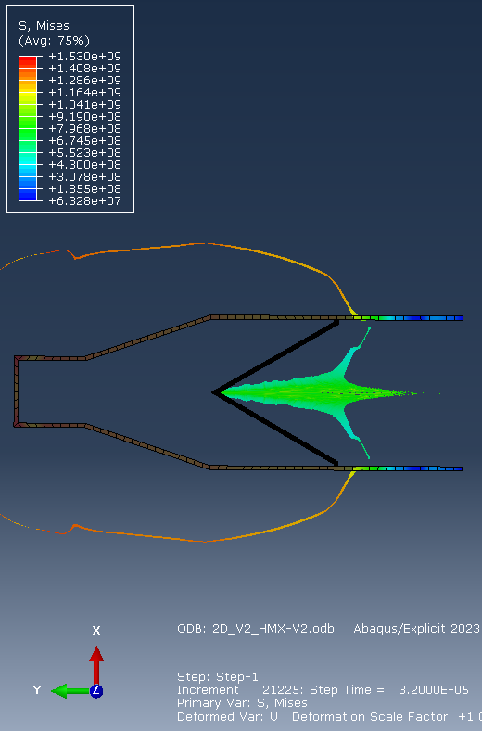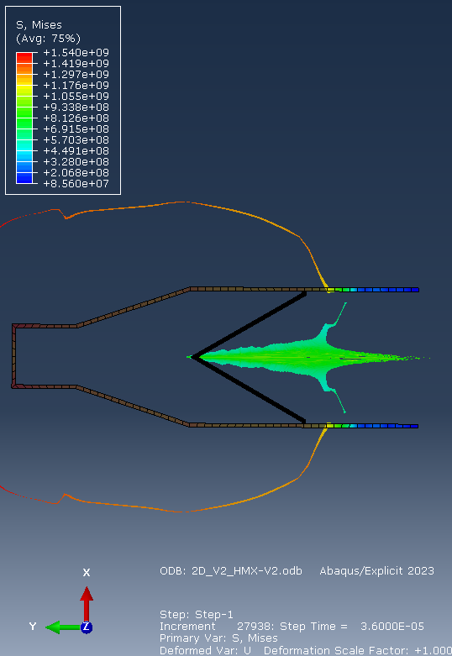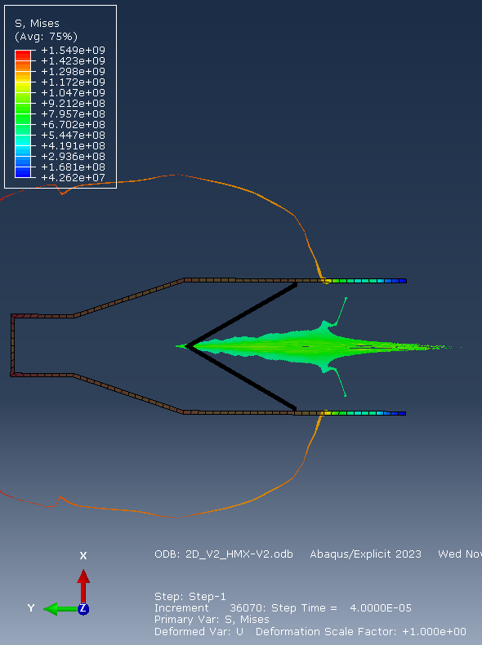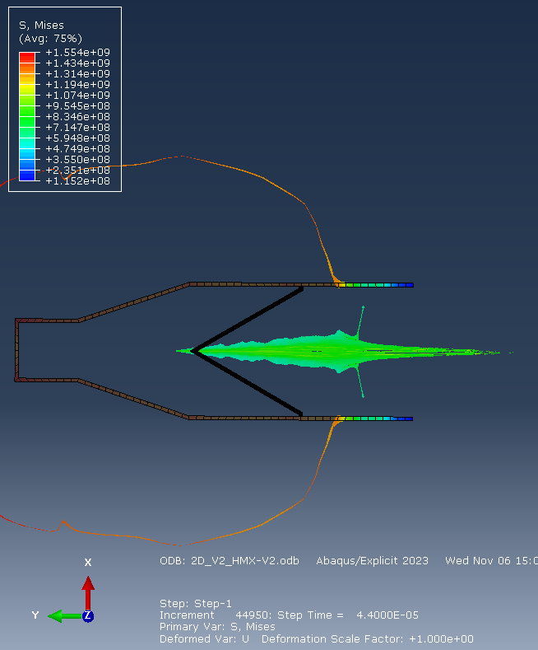
Figure 62 - RDX Steps 1 – 9
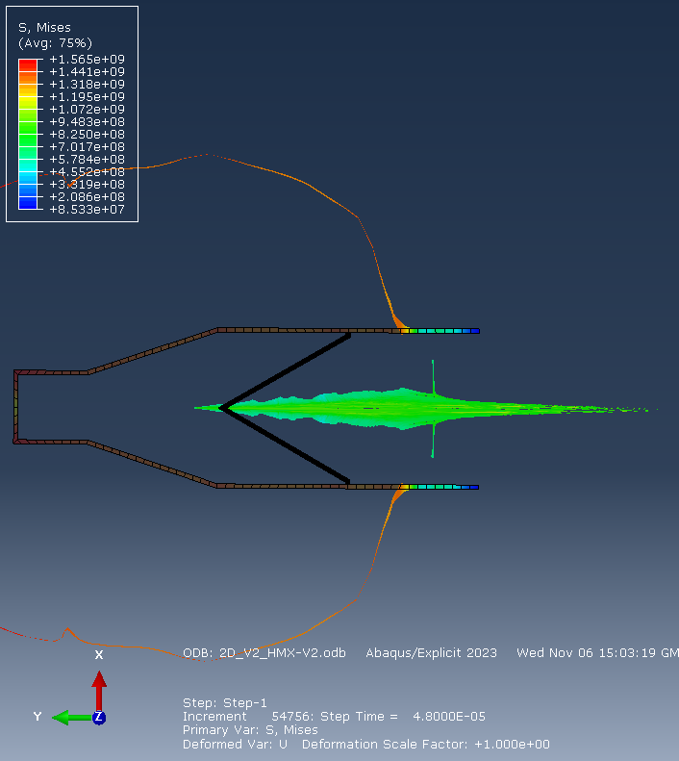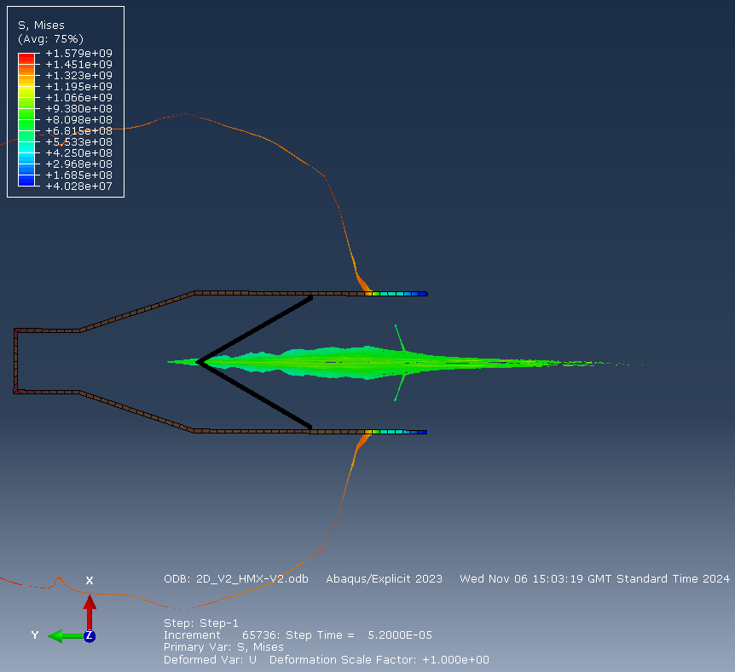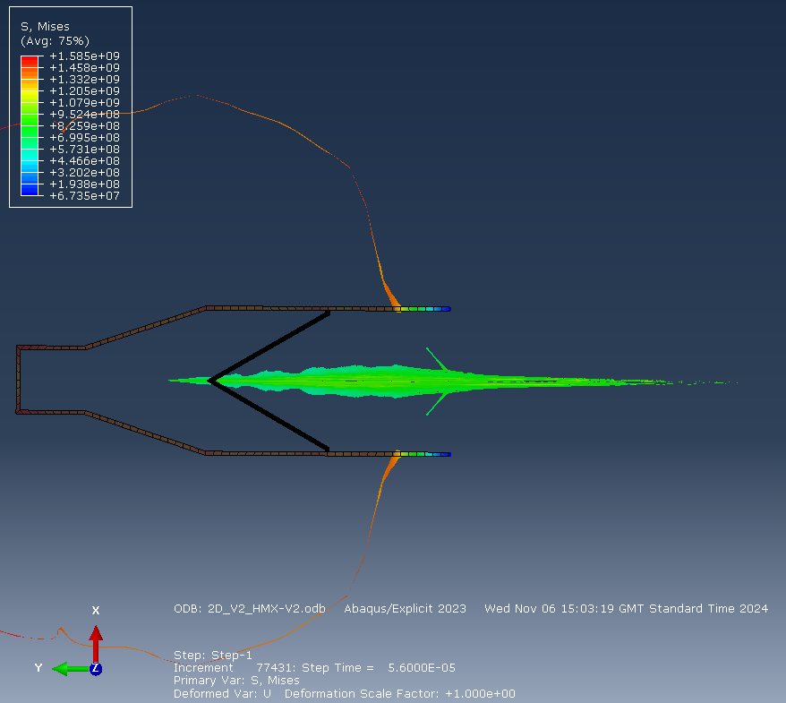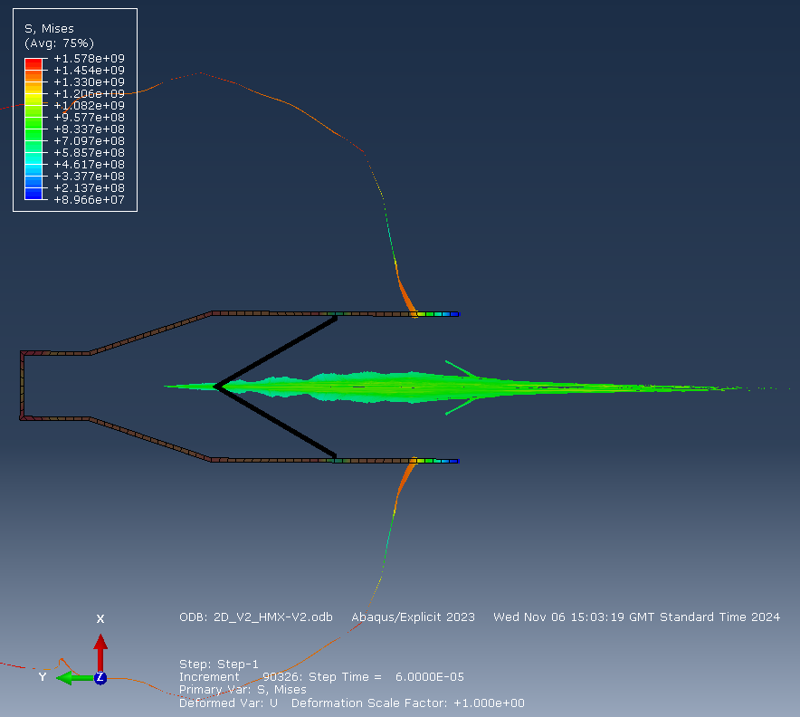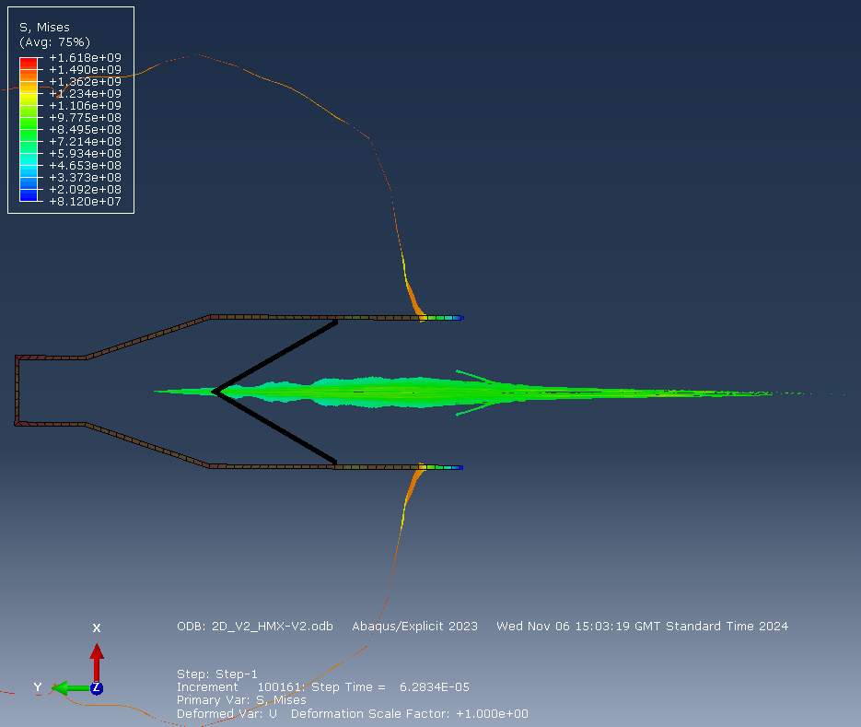
Figure 63 - HMX Steps 10 - 14
Figure 64 - HMX Tip Velocity

Annex E 3D Parts

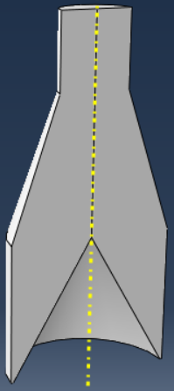
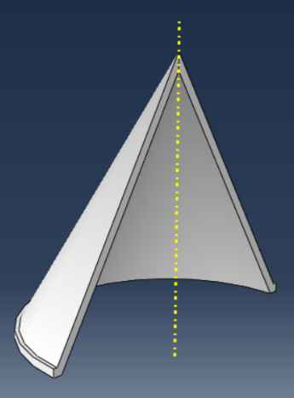
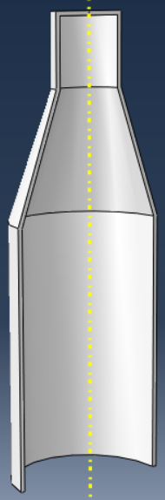Figure 65 - 3D Parts Geometry

Annex F - 3D Results

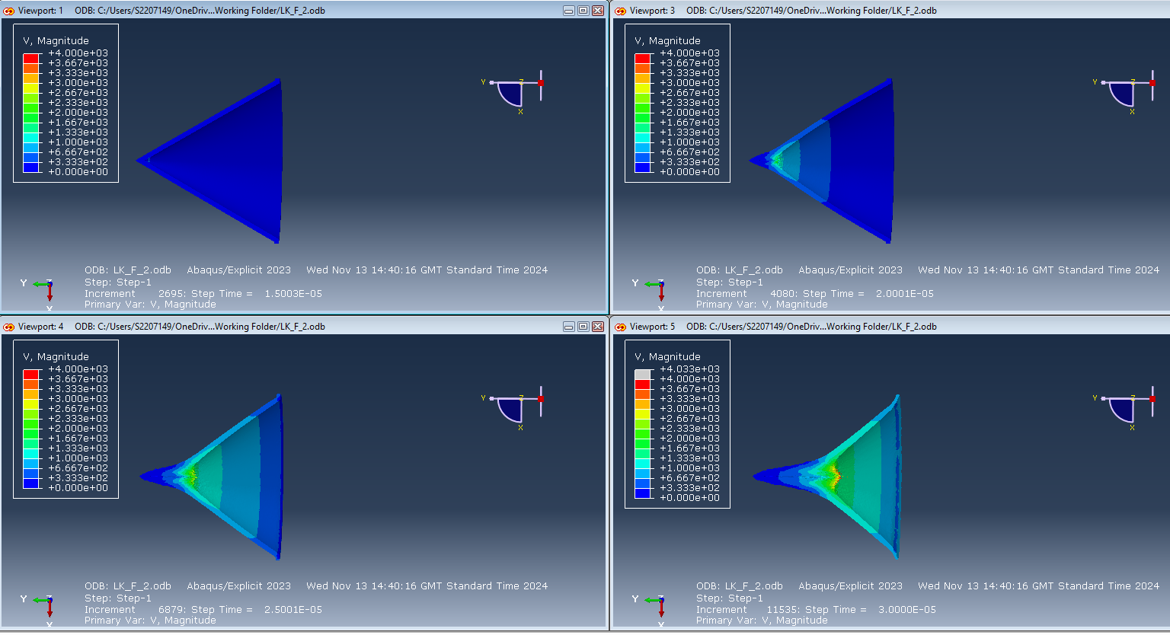
Figure 66 - 3D TNT Steps 1 - 4

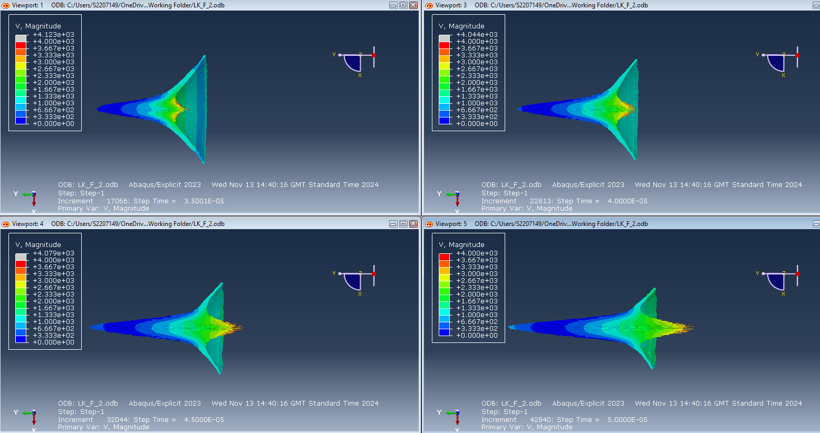
Figure 67 - 3D TNT Steps 5 - 8

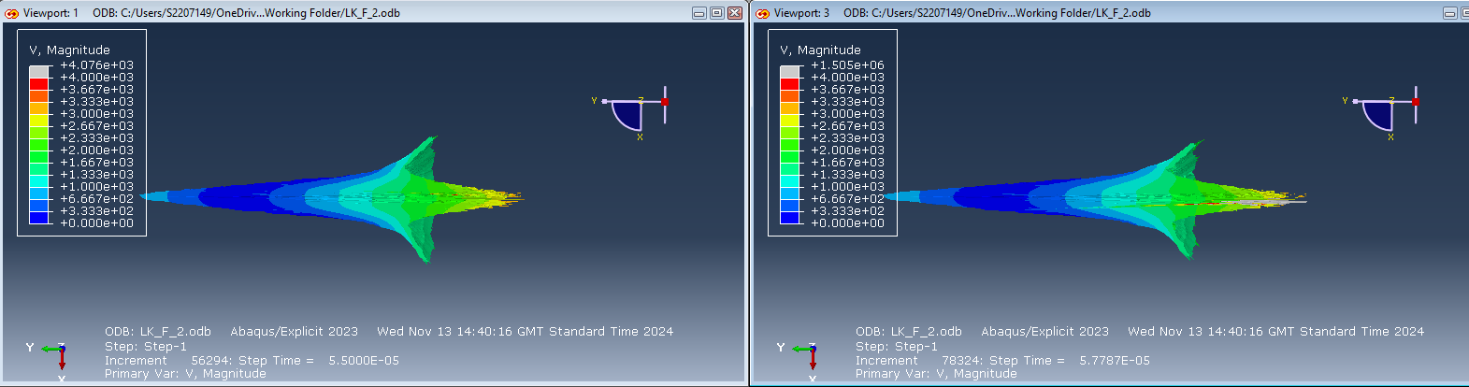
Figure 68 - 3D TNT Steps 9 - 10

Annex G - Mesh Study Tip Velocity Graphs

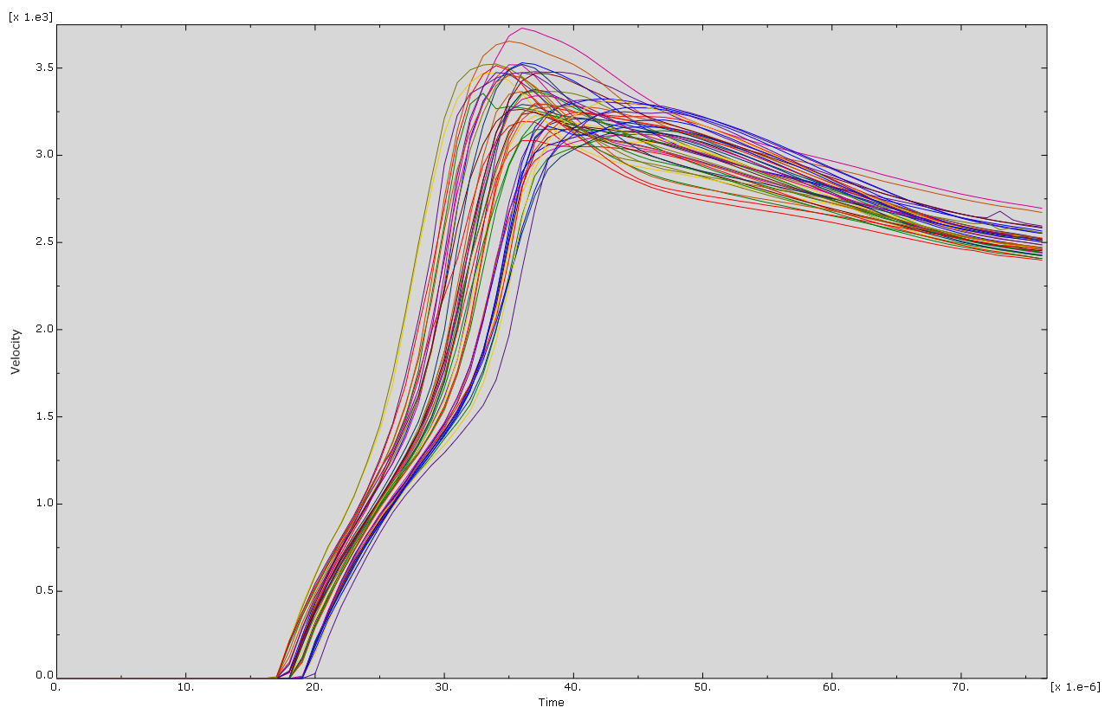

Figure 69 - 3D Initial Mesh Tip Velocity
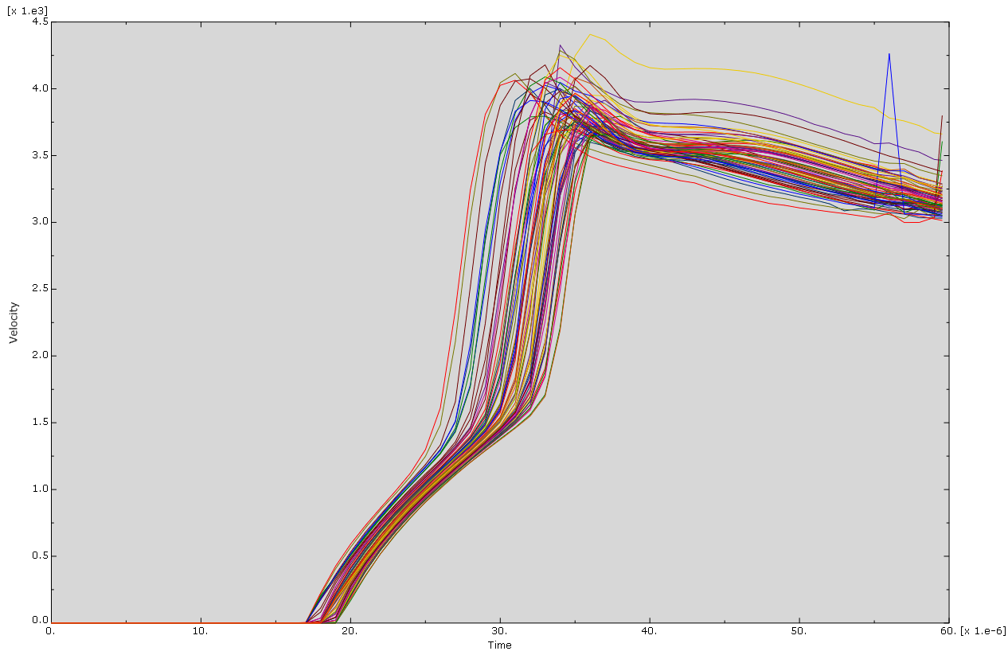
Figure 70 - 3D Mixed Mesh Tip Velocity
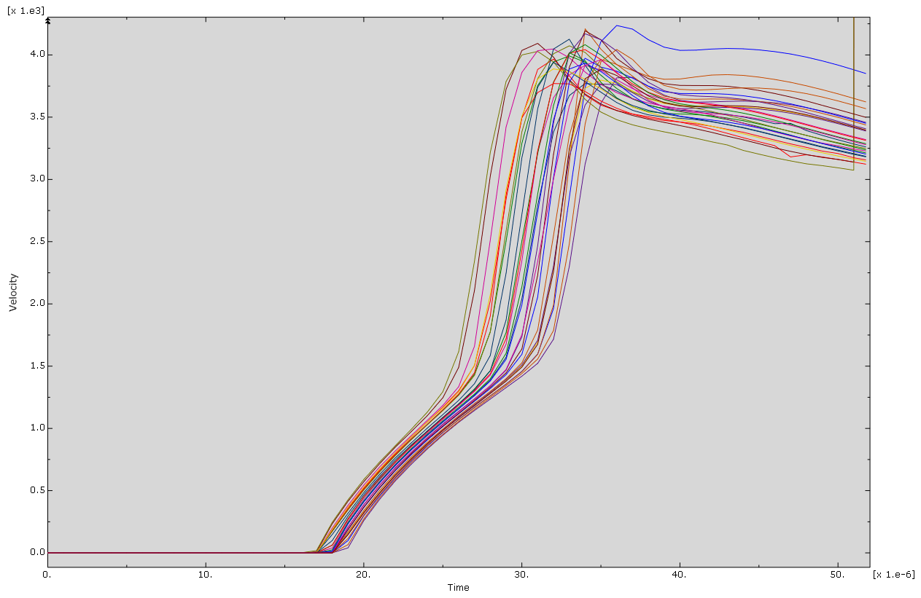
Figure 71 - 3D Shortened Case Tip Velocity

This representation shows no deformation of the HE only. In addition it has been mirrored to provide a cross sectional view of the shaped charge as the detonation progresses for clearer representation
Note these inages have been mirrored along the X axis to create the illusion of a cross sectional cut along the charge.

