Name:______Olcay Sivas___________________________

Student Number: _____2331962___________________
__________________________________________________________

WORKSHEET 5 – TESTING (Battleships)

For this worksheet, the program can be implemented in a number of different ways and demonstrate different features.
Create your own test set to demonstrate strengths and/or limitations of your solution. Use as many of the template boxes below as you need.
Test i. Randomization test. Run the program twice and check if the battleship’s placement randomized or not.
Test ii. Round progression test. Run the program and sink all ships in level 1 (6 ships) and see if the column gets bigger or not.
Test iii. Power up logic. Buy horizontal shot power up and shoot the very right of the column and see if program crashes or not.
Test iv. Shop and gold carry over test. Get gold on first level and beat the level then see if gold still there in level 2 or not.

Test: Test i. Randomization test. Run the program twice and check if the battleship’s placement randomized or not.

Screenshot(s) of output: 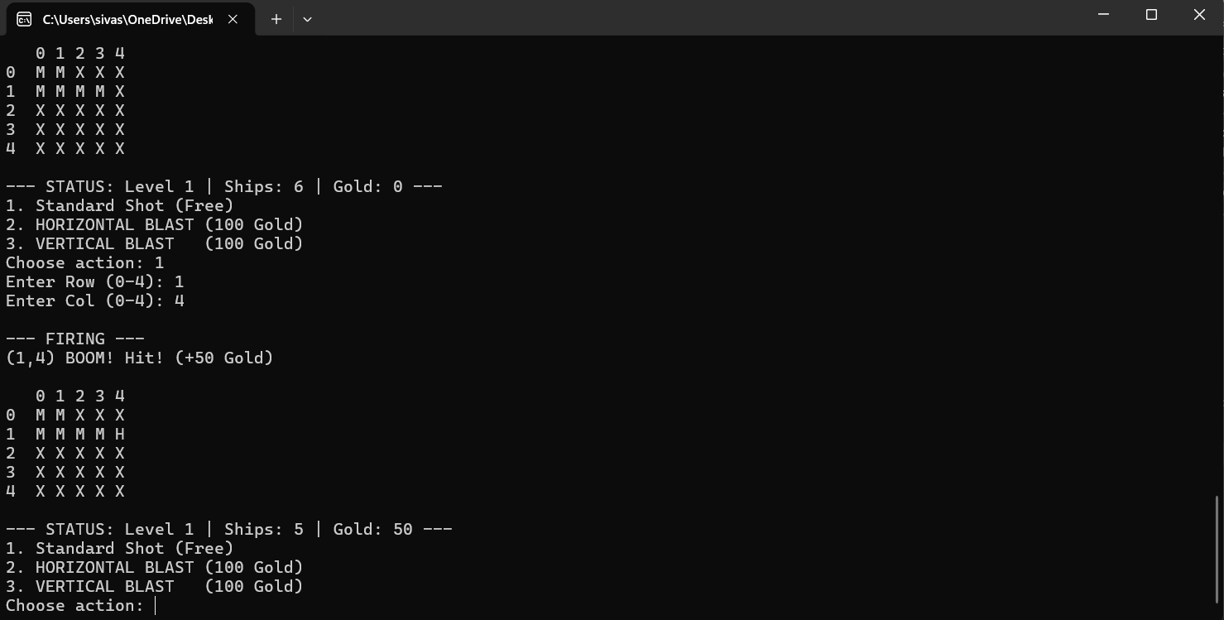

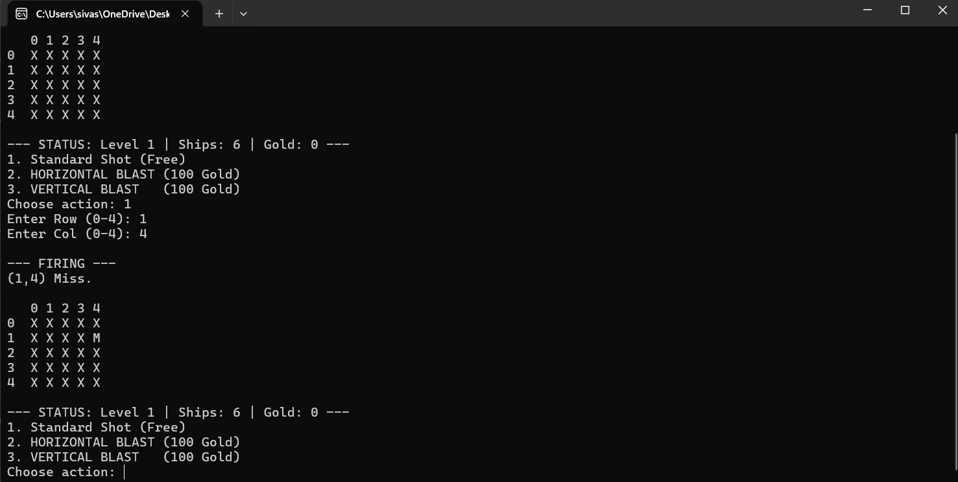
Result: Did the programme behave as expected ie syntactically and logically correct?
Yes, the ships were generated in different coordinates every time the program ran and randomization was confirmed.

Test: Test ii. Round progression test. Run the program and sink all ships in level 1 (6 ships) and see if the column gets bigger or not.

Screenshot(s) of output:
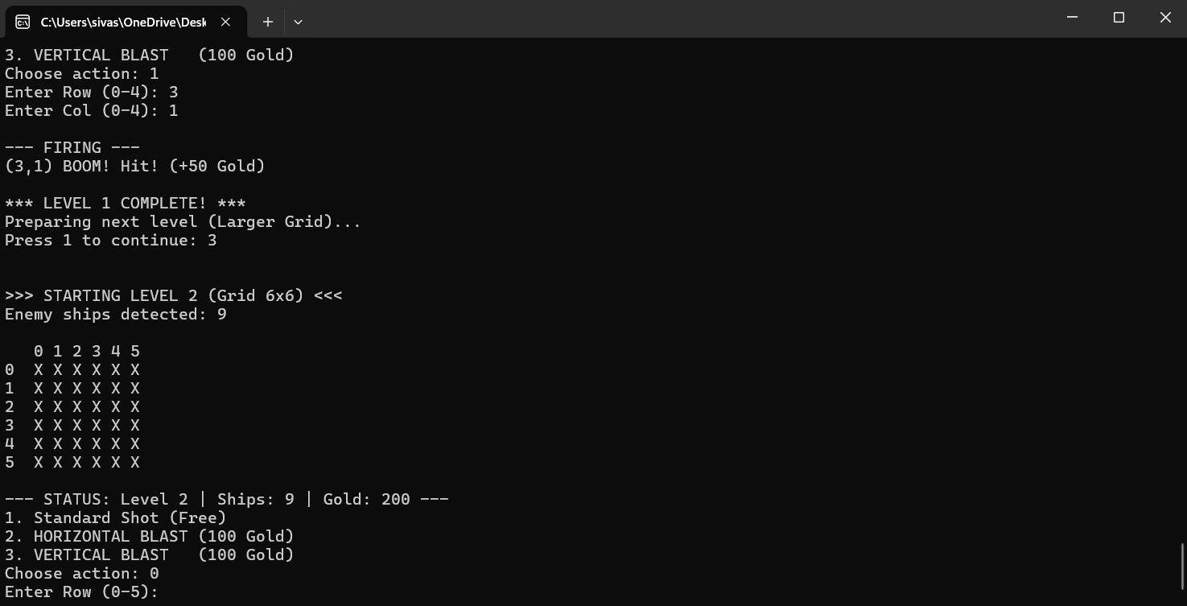

Result: Did the programme behave as expected ie syntactically and logically correct?
Yes, after level 1 had been cleared, the game correctly advanced to Level 2 and the grid was expanded to 6x6.

Test: Test iii. Power up logic. Buy horizontal shot power up and shoot the very right of the column and see if the program crashes or not.

Screenshot(s) of output: 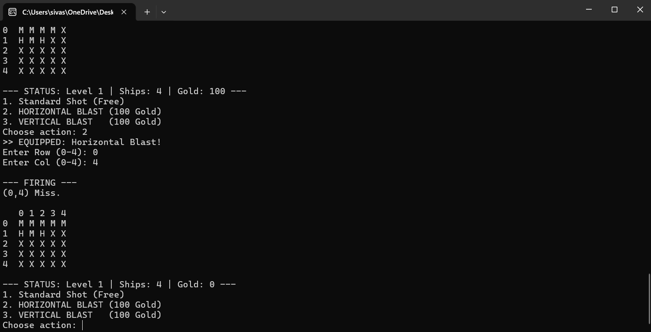

Result: Did the programme behave as expected ie syntactically and logically correct?
Yes, the grid edge was correctly handled by the horizontal shoot power-up and it didn't crash.

Test: Test iv. Shop and gold carry over test. Get gold on first level and beat the level then see if gold still there in level 2 or not.

Screenshot(s) of output: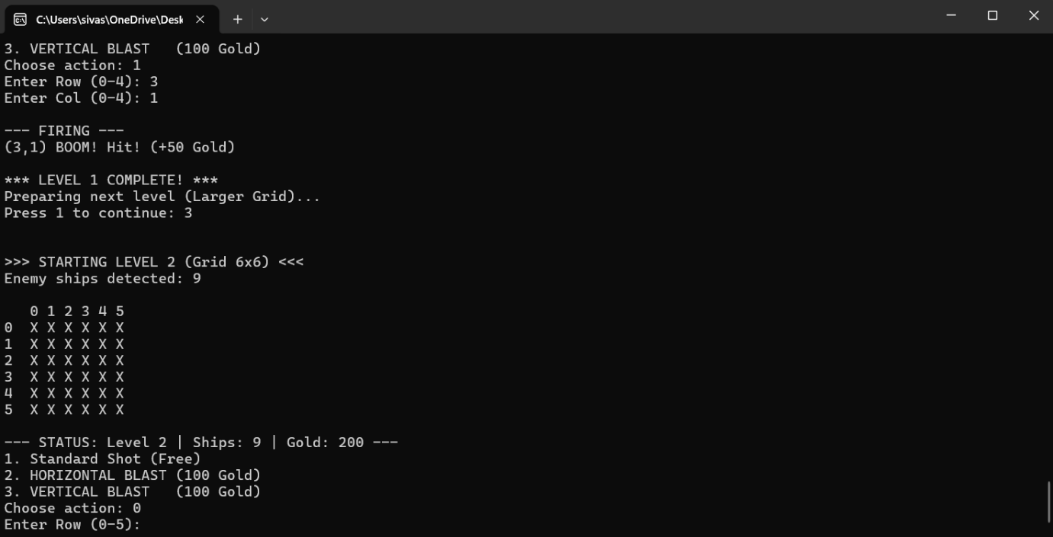

Result: Did the programme behave as expected ie syntactically and logically correct?
Yes, gold earned in Level 1 was successfully saved and available for use in the Level 2 shop.

Final code:

#define _CRT_SECURE_NO_WARNINGS
#include <stdio.h>
#include <stdlib.h>
#include <time.h>
#define MAX_SIZE 10

void main()
{
char grid[MAX_SIZE][MAX_SIZE];
int row, col;
int gold = 0;
int level, choice, shotType, turns, gridSize, totalShips, shipsLeft;

srand(time(NULL));

printf("=========================================\n");
printf(" ULTIMATE BATTLESHIPS: CAMPAIGN \n");
printf("=========================================\n");

for (level = 1; level <= 3; level++)
{
if (level == 1) { gridSize = 5; totalShips = 6; }
if (level == 2) { gridSize = 6; totalShips = 9; }
if (level == 3) { gridSize = 7; totalShips = 12; }

shipsLeft = totalShips;
turns = 0;

for (int i = 0; i < gridSize; i++)
{
for (int j = 0; j < gridSize; j++)
{
grid[i][j] = 'X';
}
}

int shipsPlaced = 0;
while (shipsPlaced < totalShips)
{
int rShip = rand() % gridSize;
int cShip = rand() % gridSize;

if (grid[rShip][cShip] != 'S')
{
grid[rShip][cShip] = 'S';
shipsPlaced++;
}
}

printf("\n\n>>> STARTING LEVEL %d (Grid %dx%d) <<<\n", level, gridSize, gridSize);
printf("Enemy ships detected: %d\n", totalShips);

while (shipsLeft > 0)
{
printf("\n ");
for (int j = 0; j < gridSize; j++) printf("%d ", j);
printf("\n");

for (int i = 0; i < gridSize; i++)
{
printf("%d ", i);
for (int j = 0; j < gridSize; j++)
{
if (grid[i][j] == 'S')
{
printf("X ");
}
else
{
printf("%c ", grid[i][j]);
}
}
printf("\n");
}

printf("\n--- STATUS: Level %d | Ships: %d | Gold: %d ---\n", level, shipsLeft, gold);
printf("1. Standard Shot (Free)\n");
printf("2. HORIZONTAL BLAST (100 Gold)\n");
printf("3. VERTICAL BLAST (100 Gold)\n");
printf("Choose action: ");
scanf("%d", &choice);

shotType = 1;

if (choice == 2)
{
if (gold >= 100) {
gold -= 100; shotType = 2;
printf(">> EQUIPPED: Horizontal Blast!\n");
}
else printf(">> NOT ENOUGH GOLD!\n");
}
else if (choice == 3)
{
if (gold >= 100) {
gold -= 100; shotType = 3;
printf(">> EQUIPPED: Vertical Blast!\n");
}
else printf(">> NOT ENOUGH GOLD!\n");
}

printf("Enter Row (0-%d): ", gridSize - 1);
scanf("%d", &row);
printf("Enter Col (0-%d): ", gridSize - 1);
scanf("%d", &col);

if (row < 0 || row >= gridSize || col < 0 || col >= gridSize)
{
printf("Invalid coordinates!\n");
continue;
}

int shots = 1;
if (shotType > 1) shots = 2;

printf("\n--- FIRING ---\n");
for (int k = 0; k < shots; k++)
{
int r = row;
int c = col;

if (k == 1)
{
if (shotType == 2) c++;
if (shotType == 3) r++;
}

if (r >= 0 && r < gridSize && c >= 0 && c < gridSize)
{
if (grid[r][c] == 'S')
{
printf("(%d,%d) BOOM! Hit! (+50 Gold)\n", r, c);
grid[r][c] = 'H';
shipsLeft--;
gold += 50;
}
else if (grid[r][c] == 'X')
{
printf("(%d,%d) Miss.\n", r, c);
grid[r][c] = 'M';
}
else
{
printf("(%d,%d) Already hit.\n", r, c);
}
}
}
turns++;
}
printf("\n*** LEVEL %d COMPLETE! ***\n", level);
if (level < 3)
{
printf("Preparing next level (Larger Grid)...\n");
printf("Press 1 to continue: ");
scanf("%d", &choice);
}
}

printf("\n=========================================\n");
printf(" CAMPAIGN VICTORY! YOU WON! \n");
printf("=========================================\n");
}

