Marketing plan is written for

(Marriott Hotel)

Student Name

Florin-Alexandru Iftimie

Student ID number

2211106

Marketing Essentials BMIH4005

Table of Contents

1. Introduction 1
2. Situation Analysis 1
2.1 Company: SWOT analysis 1
2.2 Customers: Segmentation and Targeting/ Customer profile' 2
2.3 Competitors: Porter's five forces, Perceptual positioning map 2
2.4 Perceptual Map of Marriott Hotel 3
2.5 Collaborators 4
2.6 Climate: PESTLE (Macro analysis) 4
3. Objectives 5
4. Strategy 5
4.1 Bowman’s strategy clock 5
5. Tactics 5
5.1 Marketing mix 5
6. Action 6
6.1 Gantt of marketing activities 6
7. Control 7
8. Conclusion 8
References 9
Appendix-A: Presentation 10

1. Introduction
The purpose of the marketing plan is to assure the activities of the market which will mandate the aims and objectives of the Marriott Hotel. The marketing plan is prepared for the customers. The marketing plan has introduced the framework of Swot analysis, Porter's five forces, pestle analysis, 4p’s of marketing and the theory of Bowman’s strategy clock.

2. Situation Analysis

2.1 Company: SWOT analysis

Swot Analysis
Strength | - Present in the global market.  - Follows the theme of global leadership (Uysal et al., 2018).  - The Marriott hotel possesses a great reputation.
Weaknesses | - Avoidance of data protection of the customers.  - Improper positioning.  - Negative lead in publicity
Opportunities | - Imply in emerging economies.  - Offerings of diversified services (Kryukova and Khetagurova, 2020).  - Expansion of the franchise of the brand in the international market.
Threats | - High level of competition.  - Influence of the global pandemic of Covid-19.  - Risk of terrorism.
Table 1: Swot Analysis (Source: Created by learner)

2.2 Customers: Segmentation and Targeting/ Customer profile'
The customers of Marriott the hotel chain business are attracted through segmenting and target positioning. Based on the demographic segmentation, the hotel targets the group of travellers, families, millennial and business travellers (Dolnicar et al., 2018). The Marriott hotel also plans to utilise the market segmentation of behavioural, geographic and psychographics to target their global and domestic audiences.

Geographic | Location: United Kingdom
Demographics | Name: Sarah  Age: 45  Gender: Female  Education: Bachelors  Family: Nuclear
Behaviours | Online marketing, opinionists and habitual.
Interests | Luxurious hotels, customer services, scenic locations, travelling
Feedbacks | Maintenance of hygiene, providing offers on various customer services.
Table 2: Customer profile (Source: Created by Learner)

2.3 Competitors: Porter's five forces, Perceptual positioning map
Porter’s Five Forces
Competitive Rivalry | - The major competition in the hotel chain industry is Hilton.  - Marriott has more access to rooms.
Threat of New Entrants | - The top-end competition is Hilton.  - The entry cost creates a barrier for the new entrants.
Threat of Substitutes | - New form of substitutes signifying Airbnb.  - This deprives the bookings by adapting the strong identification of the brand Marriott (Research.Deepak and Jeyakumar, 2019).
Bargaining power of buyers | - Consumers demand high-quality hotels in luxury form.  - Various alternative brands in the hotel industry.
Bargaining power of suppliers | - Low supplier power.  - A high reputation of the brand gets access to other suppliers.
Table 3: Porter’s Five Forces (Source: Created by the learner)

2.4 Perceptual Map of Marriott Hotel

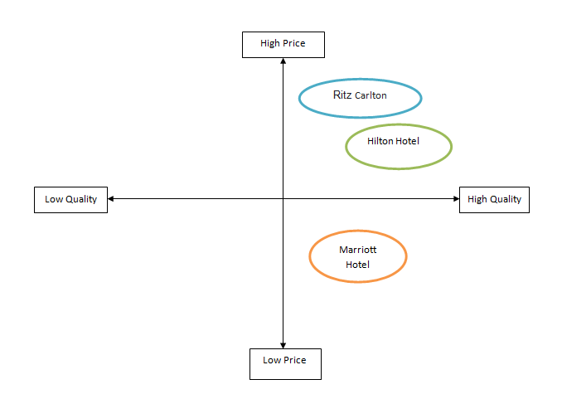

Figure 1: Perceptual Map of Marriott Hotel (Source: Created by Learner)

2.5 Collaborators
The B2B relationship of the Marriott Hotel can be achieved through communicating and interacting with the customers on digital and social media platforms. Through advertisements, brand awareness can be necessitated. Partnerships can be enhanced in the business through producing and promoting webinars with key stakeholders of the organisation (Ferrell et al., 2021). The franchising can be effectively enhanced with the help of maintaining relationships with the stakeholders.

2.6 Climate: PESTLE (Macro analysis)
PESTLE Analysis
Political factor | - Impact of Brexit (Bloom et al., 2019).  - Threat of terrorism.
Economic factor | - High inflation rate.  - Expansion of economic growth in the UK.
Social factor | - Change in the demographic area in the UK and international countries.  - Transformation in the pattern of family and shifting of societal values.
Technological factor | - Increase in the advancement of technologies (Porcu et al., 2019).  - Advancement in hotel bookings.
Legal factor | - Change in rules and regulations of the UK focusing on the hotel industry.  - Immigration rules in the UK.
Environmental factor | - Impact of natural disasters.  - Seasonality of the hotel industry.
Table 4: PESTLE Analysis(Source: Porcu et al., 2019)

3. Objectives
-SMART target: Summarise the aims of your marketing plan in one sentence.
Specific: The Marriott Hotel aims to accomplish its brand value in the global marketplace.
Measurable: They aim to target increasing their direct bookings functionality in the organisation.
Achievable: The hotel plans in attending to the improvisation of their rate parity and negotiate contracts to attain better terms.
Relevant: They plan to increase the broader commission arising from third parties.
Time-bound: This depends on the time-bund so direct booking of the hotel increases.

4. Strategy
The value proposition of the organisation focuses on the offerings which the organisation persists in delivering to its guests. Their value proposition is customisation, accessibility, cost reduction, and brand reputation. The hotel communicates with the customers by analysing their demands and needs in the hotel industry (Bala and Verma, 2018). This is also done by establishing memorable experiences for them in the hotel. The value proposition of Marriott hotel is delivered to the customers through customer segmentation.

4.1 Bowman’s strategy clock
The value proposition is related to the customer segment of Marriott hotel as it caters to their requirements and needs in the hotel. This works in improving engagement and understanding with the customers. Bowman’s strategy clock is used to create product and service positions for the customers of the market (Villagrasa et al., 2021). The framework comprises price and value. The price attracts the customer to utilise the services of the hotels which intends the organisation to inculcate value through price reduction.

5. Tactics

5.1 Marketing mix
-Product - The destination of Marriott hotel currently offers 24-hour room services with various benefits for the customers. It also includes breakfasts, cleanliness, parking benefits and security and safety for the customer visiting the hotel.
-Place (Distribution) – The customers will attribute to the online modes of the digital platform to locate the area by tracking the location (Morrison, 2022). The medium of social media will be used for booking and other purposes.
-Price – The pricing strategy of the hotel revolves around cost reduction and cost leadership. The Marriott hotel has introduced the Bonvoy points of rewards based on their per spending (Thabit and Raewf, 2018). This will deliver revenue growth for the hotel business.
-Promotion – The Marriott hotel is promoted on various levels of advertisements, promotional events and endorsement of the brand on social media platforms. The use of digital media will increase the reputation and reach of the brand to the audience. This will help in elevating the image of the brand. The organisation can implement the strategy of a communications mix to attract customers (De Pelsmacker et al., 2018). This will develop in creating a strong base of communication with the potential attribute of the customers.

6. Action

6.1 Gantt of marketing activities
Activities | Start date | end date | duration
Preparation | 15-Oct | 19-Oct | 5
Market research | 20-Oct | 29-Oct | 10
Marketing channels schedule | 30-Oct | 1-Nov | 3
Gathering feedback | 2-Nov | 6-Nov | 7
Table 5: Work breakdown structure
(Source: Created by learner)
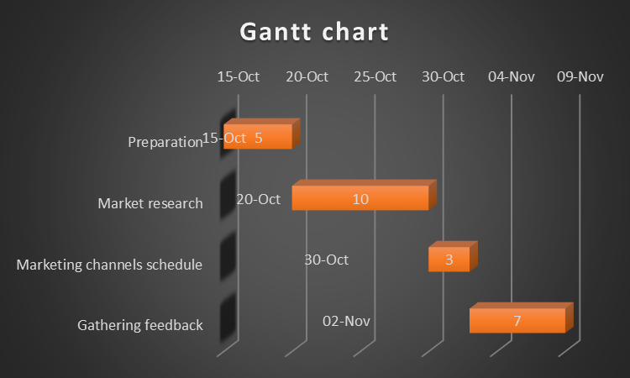
Figure 2: Gantt chart (Source: Created by learner)

7. Control
The USP of Marriott Hotels is the offering of superior services they offer to their customers. These were framed to attract potential customers to the brand value of the organisation. Their primary USP is the location in which they establish their business portfolio based on geographical location. The features of the hotels are the luxurious services with definite locations for the customers who reach their services (Altinay and Arici, 2021). They provide hotel reservations, hotel and flight packages, car-rental services and accommodations. There are wide various benefits for the organisation as they franchise 30 brands of hotels under its name tag (Camilleri, 2018). They offer more properties in participating for the customers which offers flexibility to the customers while assuring travel endeavours.
The Marriott hotel can measure its accomplishment in the hotel business by classifying and distinguishing its overall revenue. They can work on increasing the customer rate of satisfaction which will increase the level of experience of the new customers (Blakeman, 2018). The hotel can target new potential customers by endorsing the brand on social platforms and on digital media. They can also assist in planning and strategizing feedback to the customers and through survey mediums.

8. Conclusion
The challenges which were encountered in the thorough process of the marketing plan were the insufficient budget and maintaining the budget. While initiating the plan the challenge of moving into the new market was also encountered. Maintaining the level of satisfaction for the customer was also a key challenge that was faced in the whole process of the marketing plan. This can be ensured through proper research of the market and the industry. Customer satisfaction can be ensured by segmenting the customer and delivering customer services.

References
Altinay, L. and Arici, H.E., 2021. Transformation of the hospitality services marketing structure: a chaos theory perspective. Journal of Services Marketing.
Bala, M. and Verma, D., 2018. A critical review of digital marketing. M. Bala, D. Verma (2018). A Critical Review of Digital Marketing. International Journal of Management, IT & Engineering, 8(10), pp.321-339.
Blakeman, R., 2018. Integrated marketing communication: creative strategy from idea to implementation. Rowman & Littlefield.
Camilleri, M.A. ed., 2018. Strategic perspectives in destination marketing. IGI Global.
Chernev, A., 2018. Strategic marketing management. Cerebellum Press.
De Pelsmacker, P., Van Tilburg, S. and Holthof, C., 2018. Digital marketing strategies, online reviews and hotel performance. International Journal of Hospitality Management, 72, pp.47-55.
Deepak, R.K.A. and Jeyakumar, S., 2019. Marketing management. Educreation Publishing.
Dolnicar, S., Grün, B. and Leisch, F., 2018. Market segmentation analysis: Understanding it, doing it, and making it useful (p. 324). Springer Nature.
Ferrell, O.C., Hartline, M. and Hochstein, B.W., 2021. Marketing strategy. Cengage Learning.
Kryukova, E.M. and Khetagurova, V.S., 2020. Modern methods and approaches to the management of the hotel services promotion. Revista Turismo Estudos & Práticas, (S3), pp.2-2.
Morrison, A.M., 2022. Hospitality and travel marketing. Taylor & Francis.
Porcu, L., del Barrio-Garcia, S., Alcántara-Pilar, J.M. and Crespo-Almendros, E., 2019. Analyzing the influence of firm-wide integrated marketing communication on market performance in the hospitality industry. International Journal of Hospitality Management, 80, pp.13-24.
Thabit, T. and Raewf, M., 2018. The evaluation of marketing mix elements: A case study. International Journal of Social Sciences & Educational Studies, 4(4).
Uysal, M., Sirgy, M.J. and Kruger, S. eds., 2018. Managing quality of life in tourism and hospitality. CABI.
Villagrasa, J., Sánchez, F. and Donaldson, C., 2021. DECIPHERING THE STRATEGIC CLOCK HANDS: FROM THEORY TO REALITY. In INTED2021 Proceedings (pp. 9571-9584). IATED.

Appendix-A: Presentation
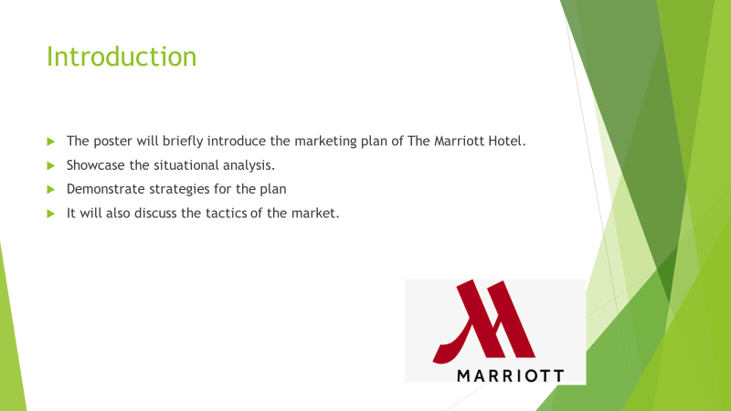
Speakers Note: The poster will introduce the marketing plan of The Marriott Hotel by analysing strategies and planning those strategies for the implementation of the business. It will discuss situational analysis by accessing the internal and external environment of the business.
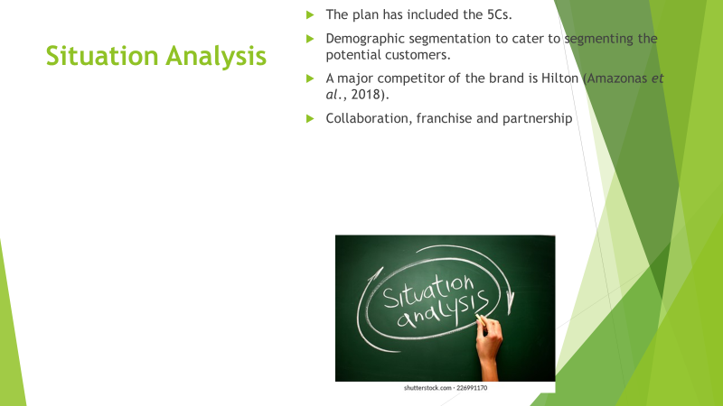
Speakers Note: The marketing plan is being assessed through the efficiency of the 5C’s while understanding the basic significance of the potential strength of the Marriott Hotel. Demographic segmentation is attained by segmenting the customers based on their age group, profession and interests. The major competitor of the organisation is Hilton which offers the same customer service (Amazonas et al., 2018).
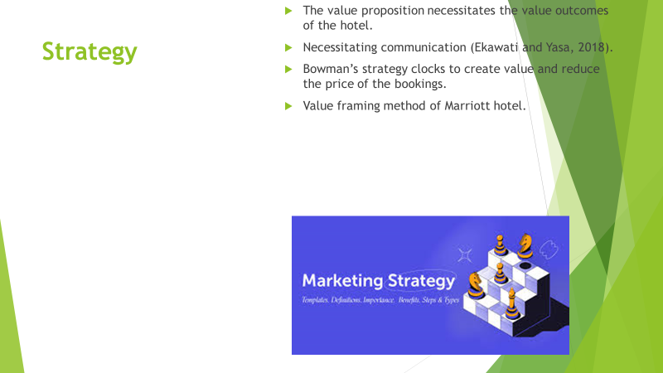
Speakers Note: The strategy of the planning of the marketing is done through value proposition which the hotel entrusts to their customers. They also plan in strategising the business through communicating with the customers and accessing the plans of the business. The plan has included Bowman’s strategy clock to access the plan (Ekawati and Yasa, 2018).
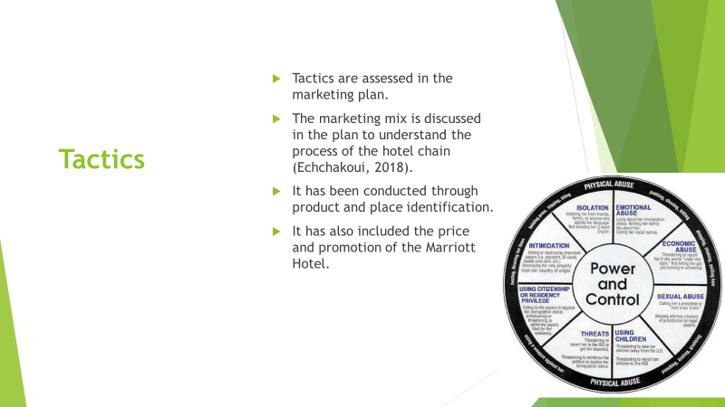
Speakers Note: The tactics in the marketing plan will be attained by necessitating the marketing mix of identifying and strengthening the product base (Echchakoui, 2018). This will also be done through product, place identification, price and promotion of the brand and its services which are delivered to the customers.
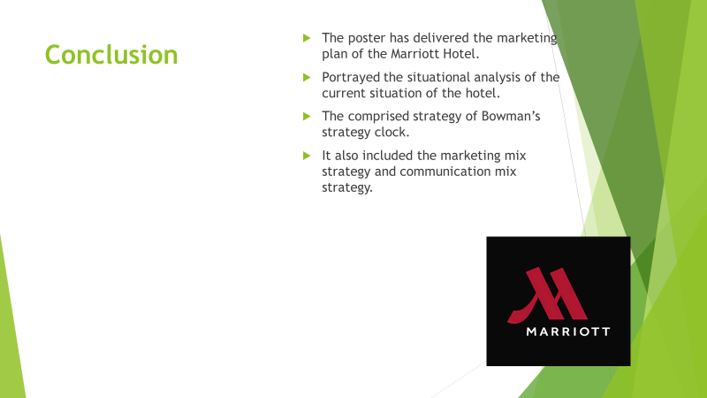
Speakers Note: In conclusion, the poster has discussed the marketing plan in detail introducing several strategies and tactics. It has included the situation analysis through 5C’s focusing on the internal and external analysis of the business environment of Marriott Hotel.



