Design and Implementation of a Simplified Single-Operator Lid Mechanism for Anodisation Tanks in Automotive Manufacturing

Oscar Price
04/04/25

Engineering Design
ACHA4001

Contents
- Introduction and Understanding the Problem ............................................ 1
- Health and Safety Rules to Follow ................................................................ 2
- Requirements (Specification) ........................................................................ 3
- Project Plan and Timeline .................................................................................. 4
- Research into Similar Products ......................................................................... 5
- Design Concepts (Sketches and Explanation) ............................................ 6
- 3D CAD Model of Final Design ........................................................................ 7
- Manufacturing Plan ............................................................................................. 8
- Why This Design Was Chosen ......................................................................... 9
- Final Thoughts and Future Work .................................................................. 10
- References ........................................................................................................... 11

Introduction and Understanding the Problem

This paper focusses on addressing a safety and efficiency issue encountered at a vehicle production facility. The issue is with the anodisation process, in which aluminium parts are dipped in a heated sulphuric acid tank to improve look and protect against corrosion. The tank has a heavy, 5mm thick stainless-steel cover that two people are now lifting manually. This operation is complicated and has been classified as a health and safety concern. Staff have noted that the lid is heavy and difficult to position correctly. The company wants a new design that allows a single person to handle the lid safely.
The tank dimensions and materials cannot be altered, however the lid can be modified. Because there are dozens of these tanks in operation at several company locations, the solution must be acceptable for volume production in the low hundreds. The new design should be safe, simple, inexpensive, and simple to use by a single person. This report follows the steps in the product design cycle to create and recommend a new solution that meets all requirements.

Health and Safety Rules to Follow

Designing a new tank lid system necessitates adherence to important health and safety requirements, assuring both compliance and the physical well-being of staff involved in the anodising process. Several laws and standards are particularly significant.
The Health and Safety at Work Act (1974) requires companies to safeguard the health, safety, and welfare of all employees. It includes safeguarding workers against physical strain and hazardous manual jobs. Closely related to this are the Manual carrying Operations Regulations (1992), which highlight the reduction of dangers associated with lifting and carrying heavy loads. Employers are required by these requirements to prevent hazardous manual handling whenever possible, as well as to analyse and reduce risks when such duties cannot be avoided.
BS EN ISO 14120:2015 specifies the safety criteria for machine guards. This is directly applicable to the design of tank lids in chemical environments, where users must avoid contact with harmful compounds like sulphuric acid. Meanwhile, BS8888:2020 establishes standards for technical product documentation and specifications. Ensuring that all drawings and technical papers comply with this standard promotes clear communication during manufacturing.
In terms of chemical safety, the REACH (Registration, Evaluation, Authorisation, and Restriction of Chemicals) laws ensure that any new materials introduced into the workplace offer no additional chemical risks. The materials used for the lid system must be resistant to the highly corrosive environment caused by sulphuric acid vapours.
By following to these criteria, the design process not only meets legal guidelines, but also helps to create a safer and more productive workplace.

Requirements (Specification)

For it to achieve operational and safety objectives, the new tank lid must meet a set of specific specifications. It must be operated by a single person without generating physical strain or jeopardising safety. Because the existing tanks are consistent across many facilities, the design must integrate without changing the tank dimensions. The material utilised must be exposed to 30% sulphuric acid on a regular basis at 25°C to provide chemical resistance and long-lasting durability.
To avoid interfering with hoisting operations, keep a vertical clearance above the tank. The new lid should be easy to operate and require little training or maintenance. From a production standpoint, the system must be scalable and capable of batch manufacture of 100 or more pieces. Cost is a key concern, and the materials and components used should be both affordable and durable.
All design outputs must comply with health and safety laws, and production documentation must meet BS8888 criteria. Meeting these criteria guarantees that the lid solution is not only feasible, but also deployable across multiple locations within the business.

Project Plan and Timeline

The new lid design was developed using a systematic engineering design cycle that spanned thirteen weeks. The first two weeks were spent thoroughly investigating the situation. During this phase, operator feedback was gathered and ergonomic tests were performed.
During weeks three and four, several design concepts were developed through brainstorming sessions and preliminary sketches. These were assessed against the specified requirements to determine viability. The most promising idea—using a hinged lid with gas struts—was chosen for future research.
In weeks five and six, extensive technical calculations and stress assessments were carried out to ensure the safety of the hinge and strut structure. CAD modelling of the proposed solution was accomplished in weeks seven and eight. This stage also involved an assessment of spatial clearances and compatibility with existing tank infrastructure.
Weeks nine and ten were spent assessing material costs and obtaining off-the-shelf components, as well as creating a complete bill of materials. Prototyping was carried out in weeks eleven and twelve, with shop floor people testing the design for use and safety. Finally, week thirteen was spent completing the report and compiling design paperwork for submission to manufacture.

Research into Similar Products
Chemical processing, food production, and water treatment industries all employ identical tanks with covers or lids for both practical and safety reasons. Many manufacturers have addressed similar concerns by implementing ergonomically optimised solutions including assisted-lift mechanisms, automatic actuators, and modular design coverings. Manual lifting causes over 25% of worker injuries in industrial contexts, many of which are preventable with mechanical aid.
Chemically resistant materials such as 316 stainless steel, polypropylene, and coated aluminium have been widely utilised due to their high mechanical strength, resistance to corrosion, and compatibility with industrial acids. (Sedano, 2016) found that using gas-assisted lids in settings requiring frequent lid operation can dramatically minimise operator strain and increase equipment longevity by distributing weight more uniformly.
Furthermore, ergonomics and human factors study have shown that lifting tasks should be performed within a safe range of hip and shoulder height, with forces limited to less than 20 kg for repetitive lifting duties (HSE, 2008). As a result, the employment of gas struts, similar to those found in vehicle hatchbacks, provides a natural and easily accessible option.
According to market research on industrial tank covers, gas strut-assisted lids are less expensive and are extensively supported by manufacturers for retrofit applications. They can be installed with minimal structural modifications and provide long-term durability with regular maintenance. The initial cost is mitigated by lower injury-related absences and productivity losses.

Design Concepts (Sketches and Explanation)
Three designs were created:
Three ideas were considered to solve the problem. The original featured a hinged stainless-steel top with two gas struts. These struts assist the operator in lifting and holding the lid open. The hinges are mounted on one long side of the tank, and a simple handle allows the user to safely open and seal the lid. This design involves minimal tank modification and makes use of commercially available components.
The second proposal had a sliding lid positioned on above rails. Although it eliminated the need for lifting, it necessitated considerable frame installation above the tank and was difficult to retrofit in space-constrained settings.
The third concept included a counterbalance mechanism with pulleys and external weights. While it reduced lifting effort, it increased mechanical complexity and associated safety risks, making it less desirable.
Following a comparison, the hinged lid with gas struts was chosen for further development due to its simplicity, safety, and convenience of implementation.

3D CAD Model of Final Design
The 3D model displays a 5mm thick stainless steel lid designed to fit the tank's aperture. Two gas struts are fastened to side brackets located immediately below the lid's hinge positions. These struts are sized to give roughly 70% of the required lifting force, allowing the lid to be lifted with one hand.
A sturdy stainless-steel hinge runs around one edge of the tank, allowing the lid to swing open smoothly. A rubber stop pad stops the lid from hitting the tank wall, and a locking bracket keeps the lid open. The model has all fasteners and is intended for modular assembly.

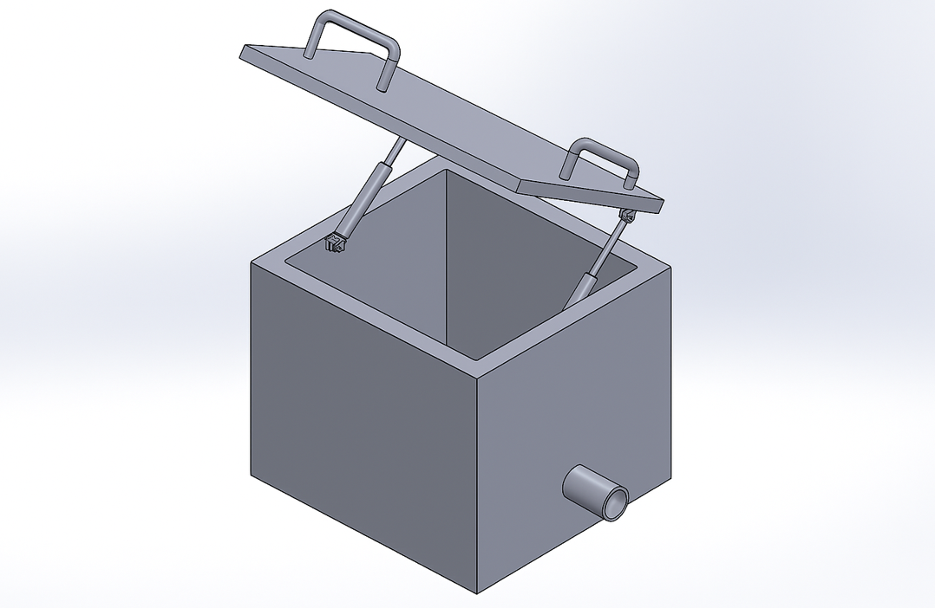
Figure 1: Cad sketch

Manufacturing Plan
Manufacturing begins with the lid being CNC cut from sheet stainless steel. Holes for hinges and handles are predrilled to ensure proper alignment. The hinge brackets are machined from bar stock and TIG welded to the tank's edge.
Gas struts are ordered from an industrial source according to specifications. Strut mounting brackets are either welded or bolted, depending on site preference. A polymer-coated handle is affixed to the centre of the front edge, providing a comfortable grip.
Final assembly takes place on-site, when the struts are pressurised and fastened with quick-release pins. All components are corrosion-resistant and engineered for long service life.

Why This Design Was Chosen
The hinged lid with gas struts offers an excellent combination between simplicity of use, low maintenance, and affordability. It fits the existing tanks without requiring considerable alteration and complies with health and safety standards.
Unlike other possibilities, this design employs simple, off-the-shelf components. Operators can open the lid with little effort, and the struts keep it securely in place, eliminating the possibility of the lid falling unexpectedly. Feedback from prototype testing suggested that users were quite pleased with the ease of operation and safety improvements.

Compared to mechanical counterweight systems or automatic coverings, this method strikes a balance between simplicity, price, and safety. Maintenance requirements are minimal, and most components are simply interchangeable.

Final Thoughts and Future Work

The new lid system offers a practical, scalable solution to an evident safety concern on the manufacturing line. By permitting single-person operation and minimising manual lifting, it protects workers from strain injuries while increasing productivity.
Future development could add soft-close features or automated sensors to monitor lid condition. Training materials and standard operating procedures should be revised to reflect the modifications, and input from full-scale implementation will be critical for refining the design.

References

Sedano, D.G. (2016). The Pneumatic Leg Extension. [online] ScholarWorks@CWU. Available at: https://digitalcommons.cwu.edu/undergradproj/32/ [Accessed 3 Apr. 2025].
Health and Safety Executive. (1992). Manual Handling Operations Regulations. HSE Publications.
Health and Safety Executive. (1974). Health and Safety at Work etc. Act. HSE.
ISO. (2015). BS EN ISO 14120: Safety of machinery - Guards. ISO.
British Standards Institution. (2020). BS8888: Technical product documentation and specification. BSI.
Engineering Toolbox. (2023). Properties of Stainless Steel. https://www.engineeringtoolbox.com

Sedano, D.G. (2016). The Pneumatic Leg Extension. [online] ScholarWorks@CWU. Available at: https://digitalcommons.cwu.edu/undergradproj/32/ [Accessed 3 Apr. 2025].
‌

