

Sefydliad Dysgu Canol Dinas /
Institute of Inner City Learning

BA Leadership and Management

Exploring the Relationship Between Ethical Leadership Skills and Employee Trust in the Workplace

Ana Maria Florina Tabac
2241775

Chinomso Nwagboso

Dissertation submitted as part of the requirements for the award of BA Leadership and Management

03/2026

DECLARATION

I, Ana Maria Florina Tabac declare that this dissertation has been composed by myself, that the work contained herein is entirely my own except where explicitly stated otherwise in the text, and that this work has not been submitted for any other degree or qualification, in whole or in part, except as specified.

Signature: ANA MARIA FLORINA TABAC
Date: 23.03.2026

ACKNOWLEDGEMENTS

I owe my deepest gratitude to my supervisor, Chinomso Nwagboso, for his guidance, comments and persistent support during the course of this research.
I also wish to thank the teaching team, for their guidance and for equipping me with the required foundation in research methods to successfully write this work.
Finally, a big thank you to my family and friends for their patience, motivation and encouragement during my research.

Contents

DECLARATION 9
ACKNOWLEDGEMENTS 10
LIST OF FIGURES 13
ABBREVIATIONS 14
CHAPTER 1: INTRODUCTION 9
1.1 Introduction 9
1.2 Background 9
1.3 Research Aim 10
1.4 Research Objectives 10
1.5 Research Questions 11
1.6 Chapter Summary 11
CHAPTER 2: Literature Review 13
CHAPTER 3: Methodology 20
3.1 Systematic Literature Review (SLR) 20
3.2 Search Strategy 21
3.3 Search terms 21
3.4 Key Words 22
3.5 Databases 23
3.6 Inclusion/Exclusion Criteria 23
3.6.1 Inclusion Criteria 24
3.6.2 Exclusion Criteria 24
3.7 Search Results 24
3.8 Ethical Considerations 25
3.9 Chapter Summary 26
CHAPTER 4: Findings and Discussions 27
4.1 Ethical Leadership and Employee Trust in Organisations 27
4.2 Ethical Leadership and Employee Engagement Trends 32
4.3 Ethical Leadership and Organisational Performance 37
4.4 Discussion of Key Findings 41
CHAPTER 5: Recommendations, Conclusion and limitations of the research 45
5.1 Recommendations 45
5.2 Conclusion 48
References 51

LIST OF FIGURES

Figure 1 - Mean of the % concerning by work setting in the UK 2020-2025 28
Figure 2 - Employees statistics 2020-2025 29
Figure 3 - Attribution rate per job function in the UK (2023-2025) 30
Figure 4 - UK HR Analytics Market (2020-2025) 31
Figure 5 - How efficient was remote work in the COVID-19 pandemic in the UK 33
Figure 6 - Remote employee experience by seniority (2020-2025) 34
Figure 7 - Drivers for great work in 2025 in the UK 35
Figure 8 - Employee wellness in UK in 2025 36
Figure 9 - UK Productivity level growth (1986-2022) 39

ABBREVIATIONS

AI – Artificial Intelligence
EL – Ethical Leadership
HR – Human Resources
KPI – Key Performance Indicator
SLR – Systematic Literature Review
ONS – Office for National Statistics
CSR – Corporate Social Responsibility
HBR – Harvard Business Review
OB – Organisational Behaviour
IT – Information Technology
ICT – Information and Communication Technology

CHAPTER 1: INTRODUCTION

1.1 Introduction

Over the last decades, organisations have shown a keen interest in ethical leadership, as a way to respond to the rising demands of employees and stakeholders regarding issues such as openness, fairness, and appropriate leader behaviour.
Ethical leadership can be conceptualised as leadership in which the "demonstration of normatively appropriate conduct through personal actions and interpersonal relationships is expected" (Brown and Treviño, 2020).
The need for ethical leadership appears to be growing in importance in today's workplaces, faced with the pressures of performance and the reality, or perceived reality, of ethical dilemmas (Northouse, 2021).
Trust is a strategic outcome of ethical leadership. Trust is the employees’ voluntary vulnerability to leaders rooted in their positive expectations of leaders’ intentions and actions (Mayer et al., 1995; Robbins and Judge, 2019). It fosters cooperation, commitment, and engagement, which are essential for effective achievement of the organisation’s objectives (Dirks and Ferrin, 2002).
In the retail sector, where workforce composition is especially diverse, leading behaviour is particularly important given that workers often face customers/clients and must respond to immense performance pressure. Employees’ perceptions of fair and ethical treatment by leaders can influence their motivation and desire to remain with the organisation (Ciulla, 2020; Hassan et al., 2022). In this research we examine the influence of ethical leadership skills on employee trust in retail businesses.

1.2 Background

The connection between leadership and trust is longstanding in the organisational behaviour literature. Ethical leadership is based on integrity, fairness, accountability, and concern for employee’s solvability (Brown and Treviño, 2020; Ciulla, 2020). Theory of ethical leadership present that leaders influence followers partly through role modelling and reinforcing ethical standards (Northouse, 2021). Employees observe the behaviours of leaders and mimic ethical behaviour following social learning theory (Bandura, 1977).
Trust has been identified as an important component of employee relationships (Mayer et al., 1995; Dirks and Ferrin, 2002). Trust allows employees to be vulnerable and work together with their leaders and be committed to, and engaged in, their work (Mayer et al., 1995; Dirks and Ferrin, 2002). Employees will reciprocate their leaders trust and loyalty if leaders are fair with them and act as consistent role models (Mayer et al., 1995; Roberts, 207), which is in line with social exchange theory (Blau, 1964; Robbins and Judge, 2019).
With retail organisations suffering from high turnover rates, performance orientation and devolved supervision, trust is crucial for success. First-line managers are responsible for communicating the company’s ethical vision to the employees (Bratton and Gold, 2017) and a disconnect between corporate and store leader values undermines trust (Maak et al., 2021). Understanding how the practice of ethical leadership can build trust can contribute to employee retention, engagement and organisational performance in organisations such as this.

1.3 Research Aim

This research will examine in depth the conduct of the relationship between ethical leadership skills and employee trust at workplaces in the retail sector through secondary sources, reviewing existing theories, models and empirical results on the topic, and determining how trust is built through ethical leadership behaviour to inform managerial practice in retail organisations.

1.4 Research Objectives

To present the concept of ethical leadership and its key components in retail organisations.
To consider employee trust and its dimensions as relevant for the ecosystems of retail workplaces.
To review existing literature on the relationship between ethical leadership skills and employee trust with support from case studies.
To introduce issues of ethical leadership for employee retention and engagement with organisational performance in a retail environment

1.5 Research Questions

What defines ethical leadership in the retail workplace? How is employee trust defined and developed in retail organisations?
What is the relationship between ethical leadership skills and the development of employee trust?
\Which ethical leadership practices are most effective in fostering employee trust in retail contexts?
What are the organisational outcomes associated with strong ethical leadership and employee trust in the retail sector?

1.6 Chapter Summary

This chapter provided an introduction to the research by explaining the relevance of ethical leadership and employee trust in contemporary work in retail. Ethical leadership involves values such as integrity, honesty, fairness and concern for others, and also the promotion of ethics in the workplace (Brown and Treviño 2020; Northouse 2021). The background section explained that trust is a psychological state that makes it possible for employees to be willing to be vulnerable to others, based on positive expectations of their behaviour (Mayer et al., 1995; Robbins and Judge, 2019).
This chapter demonstrated that trust is a key driver of cooperation, commitment, and engagement in organisations (Dirks and Ferrin, 2002) and illustrated how ethical leadership cultivates trust through social learning and social exchange, as employees fare to leaders’ ethical behaviours and reciprocate leaders’ fairness with loyalty and commitment (Bandura, 1977; Blau, 1964).
Given the impact of leadership behaviour on trust in a retail context, since frontline managers shape day-to-day experiences for employees and influence organisational culture (Bratton and Gold, 2017). The research aim, objectives and questions provided to help us focus explicating how ethical leadership skills build trust and thereby affect employee engagement, retention and thus organisational performance (Hassan et al., 2022; Maak et al., 2021).

CHAPTER 2: Literature Review

Ethical leadership has become a timely and relevant issue in the organisational behaviour and leadership field as organisations today are experiencing problems related to ethical challenges, stakeholder expectations and public scrutiny (Brown and Treviño, 2020). Ethical leadership is straightforwardly conceptualised as the presentation of an ethical example via personal actions and interpersonal relationships and the promotion of ethical conduct to followers (Brown and Treviño, 2016). Following this perspective, ethical leaders not only ‘lead well’, but also ‘make the weather’ in organisations by defining ethical norms through the acts and words of their interactions with followers.
As Northouse (2021) states, ethical leadership is a necessary part of leadership effectiveness because increasing credibility, moral legitimacy, and follower confidence and trust. In industries such as retail, where employees are under sustained pressure to act ethically in their customer service interactions within the confines of employee sales targets and generally-enacted ‘figurative policies’, who leadership behaviour matters (Ciulla, 2020).
Trust is an important element of effective organisational functioning and leader–follower relationships. Mayer et al. (1995) describe trust as a psychological state comprising the intention to accept vulnerability based upon positive expectations of the intentions or behaviours of another. As the definition implies, trusting is a risky business, which suggests that leadership behaviour can play a significant role in employees’ willingness to place trust in someone.
Robbins and Judge (2019) argue that when employees trust their leaders, they are more likely to be satisfied with their jobs, committed to their organisations, and willing to cooperate with their superiors. A meta-analysis conducted by Dirks and Ferrin (2002) show that trust in one’s leader is associated with a range of desirable work outcomes such as performance, attitudes and organisational citizenship behaviours. Trust removes uncertainty and promotes interdependence in organisations. As such, in most organisations, employees rely on their leaders for direction, fair decision making and ethical guidance.
The link between ethical leadership and trust remains unequivocally endorsed. Ethical leadership communicates integrity, fairness and concern for the welfare of employees (Brown and Treviño, 2020; Ciulla, 2020) and, as shown in the Hassan et al. (2022) research study, ethical leadership behaviours significantly predicted employee trust in supervisors. In addition, the study found that trust in supervisors enhanced organisational commitment. They offer a social learning theory rationale for the product–process relationship.
According to Bandura (1977), individuals acquire appropriate behaviour by following credible role models. Such ethical leaders, by consistently behaving ethically, serve as a behavioural cue, and encourage employees to follow through their behaviour. This allows leaders to build perceptions of themselves in terms of reliability and moral integrity”. Northouse (2021) explains that important for trust development is consistency between what a leader says and how he (or she) acts. Words and deeds cannot be overly ambiguous. Too great an inconsistency reduces perceptions of authenticity.
Within social exchange theory, work relationships develop as one party treats another fairly through investment and this treatment elicits positive behaviours in return. This cycle builds trust. Examples of such exchanges can be found from Blau (1964): “aggressive exchanges or “unsubstantial exchanges are likely to be precipitated by attacks for attacks, inadequate consideration for obligations, and every other kind of cheating in regard to goodwill, courtesy, and assistance.”
Robbins and Judge (2019) take this idea into organisations: “Most people will give time, energy, and loyalty to those they perceive as fair and principled”. Retail is a good example of this reciprocal relationship building. Employees and their supervisors have a tight interdependent relationship. Supervisors oversee scheduling and provide feedback and coaching, “especially when conflicts arise” (Robbins and Judge, 2019). When leaders display ethical concern, it makes employees “far more likely to trust his or her motives, even under pressure to cut the slackers” (p.394).
Empirical studies corroborate the positive correlational nature of ethical leadership and trust. Research has shown that ethical leadership is negatively related to counterproductive work behaviour and positively related to trust, which indicates that ethical leaders operate in a psychologically safe environment (Kalshoven et al., 2016).
Maak et al. (2021) argues that ethical leadership facilitates responsible organisational cultures, where trust is embedded into the everyday practices and decisions made. These responsible cultures invite employees to speak up, whistle blow and to authentically discuss organisational issues. The “ethical tensions” are most commonly cited in retail organisations when there are divergent demands for customer satisfaction, sales performance, and organisational behaviour (Sison et al., 2018).
Though overall, the relationship between ethical leadership and trust is not constant, Hofstede et al. (2010) find that ethical leadership and trust is affected by culture, “as cultural dimensions shape employees’ beliefs about authority and what is fair and transparent. Therefore, the behaviours that are viewed as ethical leadership in the context of a given culture can become less desirable or appropriate in another culture”.
Within multinational retail organisations, this cultural diversity can affect the organisation’s trust-building processes, as leaders must navigate with various expectations about communication, accountability, and the distance of power. Sison et al. (2018) found that ethical leadership requires cultural and context sensitivity, particularly in global retail operations with high levels of workforce diversity.
Structural features of the retail sector can also impact the strength of the ethical leadership–trust connection. Many retail firms hire the majority of their staff as part-time or temporary workers, and delegate leadership to first-line supervisors and store managers (Bratton and Gold, 2017). This governance structure may create a chasm between corporate commitment and actual managerial conduct, which weakens trust if leaders preferentially act on short-term financial pressures (Maak et al., 2021).
Ciulla (2020) suggests that ethical leadership is unlikely to work effectively ‘except where behaving ethically is an everyday practice at all levels of management, not simply a rhetoric of top management.’ Connolley and Palmer (2023) report that employee turnover in retail is unusually high and that when workers feel pressure to perform but do not find their leadership to be trustworthy, they will ‘quiet quit’ or even leave the organization.
In a broader sense, ethical leadership has been connected to employee well-being, engagement, and organisational citizenship behaviours. Specifically, they advocate for psychological safety as a mediator and argue that: ethical leadership fosters psychological safety, which enables employees to feel safe voicing their problems to their leaders (Maak et al., 2021). Trust in leaders also increases morale and decreases withdrawal behaviours, such as absenteeism and turnover intentions (Robbins Judge, 2019).
Importantly, these outcomes matter most in retail sectors where frontline employees are a primary touch point of organisations and customers, placing the trust in leadership dimension as a major precursor of service quality, and hence of organisational reputation. Hassan et al. (2022) argue that ethical leadership indirectly affects organizational performance through trust, which suggests the strategic significance of ethical leadership in maintaining employee commitment and positive organizational behaviours. Although the theoretical and empirical support for the impact of ethical leadership on employees’ trust is provided, there are some drawbacks and literature gaps.
Much of the work has concentrated upon considerations of ethical leadership across corporate, public sector, and health care organisations (Hassan et al., 2022). Making perhaps a polar opposite case, the retail sector, with its unique organisational forms and workforce composition, has not been studied as much (Hassan et al., 2022). Retail organisations are often performance-prioritised entities struggling against a history of low margins and high customer power, and as such they may present situations in which ethical conduct can render leadership untenable (Sison et al., 2018).
In an environment where a top priority can be job number one short term, where the short-term sales of each job may trump ethical concerns, managers may find themselves upon a slippery slope of inconsistency between intention and action, breaking trust among employees who rely upon the admonisher of espoused business values, if espoused practice violators (Maak et al., 2021).
Another gap in the literature is the neglect of specific skills of leadership as opposed to the more abstract values that underpin leadership ethics and trust. Although leadership ethics is often defined in terms of values and behaviours, as Brown and Treviño point out (2020), there has been considerably less research on the skills through which ethical leaders act in day-to-day life. Moral reasoning, ethical sensitivity, transparent communication, competent conflict resolution, and compassionate listening are skills frequently implied in ethical leadership theories but less frequently analysed and measured in their own right in empirical studies.
In Northouse (2021, p. 25) we also discover that ethical intent is necessary for effective leadership, but it’s not sufficient. In the retail context, where leaders must frequently make quick judgements, communicate ethical norms, and competently resolve ethical dilemmas at the very points where ethical norms conflict with context, skills are critical for maintaining employee trust when the organissational environment begins to change for the worse.
The impact of organisational systems and incentives also deserves attention. According to Bratton and Gold (2017), HR practices, performance management systems, and reward structures are likely to direct employees’ behaviour and influence their sense of equity. If organizational incentives reward sales outcomes or bottom-line expenses and not an ethical indicator, they may place conflicting demands on leaders to water down ethical standards. Misalignment can erode employee trust when employees see that ethical conduct is penalized (Maak et al., 2021).
Robbins and Judge (2019) suggest that perceived organisational justice is a key antecedent of trust, which means that leadership behaviour must be further wedded to systems that support ethical action.
Cultural and contextual variability complicates the ethical leadership–trust relationship. Hofstede et al. (2010) remind us that cultural factors such as power distance and collectivism impact the interpretation of leadership behaviour. In high power-distance environments, employees may be more hesitant to question leaders’ directives, which may mask distrust or ethical scepticism.
In lower power-distance environments, however, employees may anticipate more involvement and transparency in leaders’ behaviours. However, Sison et al. (2018) argue that ethical leadership needs to be contextualised because there are culturally different interpretations of common ethical principles. This means that it would be more challenging for multilocation retail organisations to develop trust by adopting ethical leadership, given the need for contextualised leadership attitudes and actions, which still need to be in line with the ethical values.
The fast-paced nature of retail work also shapes how trust is built. Front line retail employees frequently face what Mihaly Csikszentmihalyi (2008), termed 'moral dilemmas, and often enjoy low time for contemplating their decisions ethical consequences (Ciulla, 2020). In such contexts, behind their leaders’ guidance and integrity when facing ethical challenges.
"Ethical leadership requires high level of moral vigilance” (Northouse, 2021) because in spaces where routine work practices normalise ethically suspect actions, those leaders that consider their inevitable or subtle forms of misconduct in management, and fail to lament them, “may signal employees a permissive attitude towards misconduct” (Gini, 2004) eroding their trust in leadership. Other part-participants, who repeatedly cultivate ethics in everyday interactions can enhance follower’s trust in their leaders’ intentions and their company ethics.
It is important to state that the consequences of ethical leadership on employee outcomes go beyond trust to include engagement, well-being and organisational citizenship behaviours. According to Robbins and Judge (2019), trust in leadership encourages teams to express concerns and suggestions without reprimand. Maak et al. (2021) suggest that ethical leaders promote cultures of accountability and mutual respect which is the basis for long term sustainability of organisations.
In retail, where frontline employees control customer experience and brand reputation, trust in leadership also relates to enhanced service quality and organisational identification. Hassan et al. (2022) find that ethical leadership is related to organisational commitment and performance indirectly through trust, highlighting the strategic relevance of ethical leadership skills.
That given, some caveats around the methods used in the literature are warranted. Ethical leadership trust studies are dominated by cross‐sectional surveys which limit causality and may create common method bias (Bryman, 2016). While providing insights into the links between leadership behaviour and employee attitude, little understanding of how trust formed over time and how ethical leadership behaviour changes to become more or less ethical in the face of a changing organisation.
More study with qualitative and longitudinal approaches to understand how ethical leadership supports trust, particularly in complex organisations like retail is advocated (Braun and Clarke, 2019). The reliance on self‐reported measures also prompts some questions about bias towards socially desirable answers when employees might prefer not to question leaders' ethics.
The empirical literature also suggest we direct more attention to contextual moderators of the ethical leadership–trust relationship. Such factors, including organisational size, level of leadership, or employment status, may determine how ethical leadership is perceived or how trust is built. For example, Bratton and Gold (2017) suggest that part-time and temporary employees, common in retail organisations, will not have access to the same level of relational leadership, which may result in weaker ties to the immediate leader and lesser trust.
This indicates that different practices may be required for different employment arrangements in order to cultivate trust with diverse categories of employee. Northouse (2021: 22) states “leadership is always relational, taking place between people in a social setting”, indicating the importance of adapting ethical leadership for specific contexts.
In summary, literature suggests that ethical leaders engender employees’ trust, with ramifications for engagement, well-being, and performance. Social learning and social exchange theory, in particular, provide compelling explanations for how ethical leader behaviours are trusted by followers (Bandura, 1977; Blau, 1964).
Moreover, the exact leadership skills that underpin ethical principles, how these ethical principles influence ‘routine’ skills, the extent to which organisational systems bolster ethical leaders, and the contextual factors that promote ‘trusting’ in retail settings remain underexplored. These gaps deserve attention to improve understanding of the ethical leadership in retail contexts and for those in managerial positions who want ethical organisational culture strengthening (Brown and Treviño, 2020; Maak et al., 2021; Hassan et al., 2022).

CHAPTER 3: Methodology

3.1 Systematic Literature Review (SLR)

This research uses a Systematic Literature Review (SLR) approach to study the impact of ethical leadership skills on employee trust in the retail workplace. A systematic literature review is; a method for identifying, evaluating and synthesising existing research in a transparent and reproducible manner (Saunders et al., 2019). SLRS are used to distinguish from traditional narrative reviews with the clear protocol, that helps to minimise bias of researcher (Bryman, 2016). This method fits this research well as there is lot of research available on ethical leadership and employee trust, but it is spread out through leadership literature, organizational behaviour, and ethics.
Through the SLR, theory and missing findings from prior research can be brought together to create a holistic view of how (or whether) ethical leadership skills “leadership skills” drive trust. We can reference theories such as social learning theory and social exchange theory to interpret the patterns in the SLR (Bandura, 1977; Blau, 1964). Thematic analysis is how this research synthesises the articles we find and identify key themes that drive the effect - leader integrity, leader fairness, leader transparency amongst others and effects on employee trust (Braun and Clarke, 2019).
An SLR is suitable for achieving the research aim because it can effectively review evidence across different organisational and cultural contexts while also mapping the gaps identified in research. In this way, the review follows recognised methodological guidance for the management research community and helps to ensure the credibility and rigor of the project overall (Saunders et al., 2019). As a result, the review begins to clarify the ethical leadership skills that retail organisations require while also contributing to future empirical work and managerial recommendations.

3.2 Search Strategy

A search strategy was developed to ensure that comprehensive searches of the literature on ethical leadership and employee trust in retail settings would be conducted. Following advice on systematic searching in business and management research (Saunders et al., 2019) the searches were structured to ensure they included clear research questions, identification of relevant databases, and iterative refining of search strings. The searches were undertaken in stages: firstly, with broad searches to scope the research landscape, followed by more targeted searches focused on leadership ethics, trust, and retail organisational context.
To augment reliability and transparency, inclusion and exclusion parameters were also used in the search/selection screening process. This meant that we could apply the same criteria consistently to a given article/story (Bryman, 2016). We looked at titles and abstracts to examine the relevance to both ethical leadership skills and employee trust, searched for relevant studies and screened their titles and abstracts, and then chose studies to include for the full-text review. The reference lists of any key articles or books identified to find further studies were searched for, a process referred to as snowballing that broadens the coverage and helps reduce the risk of missing influential studies.
Certain keyword searches were used for particular themes in the literature, adjusting the search strings when coming across other unifiers, to ensure getting a methodological rigor that journal articles and books often have (as opposed to blog posts). For guidance “Doing Causal Mediation and Moderation” by Saunders, Thomas, Lewis and Thornhill was used and ten steps that came across to (re)search existing literature (Saunders et al., 2019).

3.3 Search terms

The search terms were ultimately derived from the key terms of the thesis: ethical leadership, employee trust, and the retail workplace. Initially, keywords were developed by reviewing seminal texts to determine the common words used by authors to discuss the broader topics of leadership and trust (Brown and Treviño, 2020; Robbins and Judge, 2019). Synonyms were also included for comprehensiveness. Ethical leadership search terms included “ethical leadership,” “moral leadership,” “responsible leadership”, and “leadership ethics” search terms employee trust included “employee trust”, "trust in leadership", "leader-member trust" and “organisational trust”.
To identify literature relating to specific sectors, terms such as ‘retail sector’, ‘retail organisations’, ‘frontline employees’, and ‘service sector’ were used. Boolean operators (AND/OR) were used to combine and contextualize terms within each search result which ultimately helped identify relevant studies assessing the ethics of leadership and trust within retail contexts. The use of different terms maximised coverage while also reducing the potential for overlooks as disciplines can often use different terms in their context (Saunders et al., 2019).
Search terms were refined iteratively as preliminary searches revealed additional relevant keywords used within the literature, consistent with systematic review best practices (Bryman, 2016).

3.4 Key Words

Key words were selected to encompass the key concepts and theoretical perspectives of the study. These included “ethical leadership”, “employee trust”, “trust in leadership”, “organisational trust”, and “leadership ethics”, which are commonly found within leadership and organisational behaviour literature (Brown and Treviño, 2020, Robbins and Judge, 2019).
Other key words such as “retail organisations”, “frontline employees”, and “workplace ethics” were included in order to ensure retrieval from sector specific studies relevant to the retail context (Bratton and Gold, 2017; Sison et al., 2018). This selection of key words assisted in purposively identifying literature researching leadership behaviour, trust development, and ethical challenges in organisational settings. The use of recognised, standardised terminology also improved the chances of identifying conceptually-theoretically sound studies (Northouse, 2021).

3.5 Databases

Multiple databases were searched to capture the peer-reviewed literature on ethical leadership and employee trust. Specifically, multidisciplinary searches and those specific to business and management were conducted across platforms typically used in management research. Following recommendations for systematic literature searches for business and social science research, multiple sources were used to the extent feasible to cover all relevant literature and minimise publication bias (Saunders et al., 2019).
Specific business, management and social sciences databases were searched to enable the researcher to access key papers on reputable journals relating to Organisational Behaviour, Leadership Studies and Business Ethics as these are the fundamental subject matters of this study (Bryman, 2016). Furthermore, publisher databases were searched for academic books and chapters that relate to the keywords of the study; Leadership, Ethics and Trust to increase the chances of accessing prominent theoretical and contemporary empirical literature on the subject (Northouse, 2021; Brown and Treviño, 2020).
The researcher uses a combination of databases to increase the validity of the literature review as this increases the chances of accessing a range of theoretical literature from different fields and strengthens the consistency of the review in relation to some of the key theorists for example, social learning and social exchange theory, (Bandura, 1977; Blau, 1964) and contemporary literature on ethical leadership and trust.

3.6 Inclusion/Exclusion Criteria

Clear inclusion and exclusion criteria were defined to ensure the relevance, quality and consistency of sources included in the systematic literature review. By establishing criteria in advance, it helps reduce selection bias and facilitates a transparency and replicability of the review process (Saunders et al., 2019). The criteria helped to select studies that were focused on ethical leadership, trust, or the connection of these variables in the organization, particularly in retail. Studies published in academic books and peer-reviewed journals were emphasized in order to strengthen methodological quality and theoretical contributions (Bryman, 2016). The criteria also included the date of publication, the studies’ relevance to leadership and trust, and the level of conceptual congruence with the research aim.

3.6.1 Inclusion Criteria
Studies that investigated ethical leadership, the ethics of leadership, employee trust, and/or trust in leadership in some organisational contexts were included. The focus was primarily on peer-reviewed journal articles, and academic books within the last decade in order to account for concept relevance and current applicability (Saunders et al., 2019). Research that was conducted in retail/service-based environments were included where applicable, together with seminal publications within that category; the research on ethical leadership in general or trust (Brown and Treviño, 2020; Northouse, 2021). Both qualitative and quantitative studies were used to add varying methodological perspectives and aid theming (Braun and Clarke, 2019).

3.6.2 Exclusion Criteria
Exclusion discussed, but studies not examining ethical leadership, employee trust, and the relationships between leadership and trust were identified (Bryman, 2016). Non-empirical papers and other articles falling short of methodological transparency were omitted, thereby prioritising academic rigor (Bryman, 2016). Studies exploring highly unrelated other leadership styles or trust itself (outside of work settings and practices). Studies that date back were excluded to avoid polling in findings that are no longer relevant (Saunders et al., 2019).

3.7 Search Results

The systematic search therefore yielded a considerable amount of literature on ethical leadership and employee trust across contexts of organisation. E.g. initial searches returned a large set of sources relating to leadership ethics and trust in organisations. After title and abstract screening, a smaller set of studies were found to be clearly relevant to the relationship between ethical leadership skills and employee trust. Full-text screening further reduced this set of studies to studies which did sufficiently address leadership behaviour and trust outcomes in workplace settings.
Ultimately, the literature sample consisted of a combination of core theoretical texts and more recent empirical studies that investigated ethical leadership behaviours, trust building naturally, and related positive employee behaviours/moods ( engagement, organisational commitment) etc (Brown and Treviño, 2020; Robbins and Judge, 2019; Hassan et al., 2022.); In this case we had fewer studies to look at explicitly within our sector (retail), however those carried out in customer-service, service-facing environments were incorporated as they were deemed conceptually relevant (Bratton and Gold, 2017; Sison et al., 2018). Chosen pieces of literature went deep enough to aid in terms of our thematic’s synthesis, which coded for things like - integrity, fairness, transparency, consistent leader behaviour etc as enablers of employees’ trust (Northouse, 2021; Maak et al., 2021).

3.8 Ethical Considerations

Ethical issues are addressed in the context of research and all reports of research must be conducted honestly in an ethical manner (Creswell and Creswell, 2018). Generally, procedures that involve human data require informed consent from research participants and there should be concern for the welfare, rights, and dignity of people. This review involves no original work and uses secondary sources as its basis. The ethical issues we mentioned pertaining to researcher conduct and honesty in writing were taken into consideration, and to avoid plagiarism the review follows the Harvard referencing system.
The selection and interpretation of the literature were approached with caution to limit researcher bias. Sources were systematically included and excluded based on criteria designed to limit personal judgement colouration of the sources selected (Saunders et al., 2019). A transparent and replicable review process was provided, enabling subsequent researchers to retrace the review process undertaken. Reflexivity was also considered as interpretations of constructs such as ethical leadership and trust could be swayed by the researcher’s intentions and preconceptions (Bryman, 2016). To address this, multiple theories were integrated for a more balanced analysis.
In this research, misrepresenting authors’ arguments or selective reporting of findings were avoided. Thematic synthesis was done while considering the original context and meaning of the studies reviewed (Braun and Clarke, 2019). Given that the subject matter of the study was ethical leadership, it was of utmost importance that we followed high ethical standards of research practice to align the subject matter and type of research. This study followed established research ethical guidelines to ensure credibility, integrity, and respect for academic work.

3.9 Chapter Summary

The methodological approach taken to explore the nexus of ethical leadership skills and employee trust through a systematic literature review was described in this chapter. The chapter justified the selection of a SLR as the transparent and robust method to synthesise and distil out themes and gap in a body of existing literature (Saunders et al., 2019; Bryman, 2016). The search strategy, key words, databases, inclusion and exclusion criteria was described to allow for methodological transparency and replicability.
The official report on the search provided an overview of the results, showing that while there are many studies of ethical leadership and trust, not much directly addresses retail. However, relevant theoretical and empirical studies were selected to analyse and synthesise (Brown and Treviño, 2020; Northouse, 2021; Hassan et al., 2022). Issues of ethics covered academic integrity, transparency and appropriate use of secondary data (Creswell and Creswell, 2018). In general, the principles defined in this chapter for the methodology should give a suitable framework for the further analysis of ethical leadership skills and the process of trust-building in retail workplaces.

CHAPTER 4: Findings and Discussions

4.1 Ethical Leadership and Employee Trust in Organisations

EL has been considered a significant research variable in the organizational context because of its relationship with employee trust, employee engagement, and organizational performance. In the present scenario, employees consider it the responsibility of the leader to be fair, honest, and transparent and to take ethical decisions. These behaviours contribute towards creating a work culture wherein employees are valued and respected which in turn contributes to the enhancement of employee trust and organizational collaboration. EL, therefore, is a significant antecedent that affects organizational sustainability and employee retention in the modern organizational scenario (Bedi et al., 2016).
Employee trust can be defined as employees’ willingness to rely on the decisions made by their leaders and their beliefs that leaders will act in the best interest of the organization and its members. A number of research has found that EL behaviours (e.g., fairness, honesty, and accountability) have a positive effect on employee trust (e.g., Bedi et al., 2016; Banks et al., 2018). Employees who perceive their leaders as ethical tend to trust their leaders more, and workplace relationships and communication tend to be better.
Leader honesty and transparency are further critical factors that help in establishing employee trust. An open communication policy helps leaders to share organizational goals and vision with employees, and to make employees aware of organizational challenges and changes. Leader communication transparency is one of the predictors of employee trust because it helps to reduce job insecurity and job uncertainty (Hoch et al., 2018).
Furthermore, when leaders communicate organizational goals, vision and challenges in a transparent manner, employees perceive their leaders to be honest, and it results in improved trust. Therefore, employees feel confident and are willing to make efforts toward attaining organizational goals. In the last few years, the role of EL in shaping organizational culture has also been a focus of study.
EL helps to establish a work environment that is ethical and moral in nature. Leaders help to define the norms for their subordinates and act as a model for them. Therefore, EL affects organizational culture since employees adopt and internalize the moral and ethical conduct of their leaders, which become a norm and a value of the organization. Employees internalize the conduct of their leaders, which aids in establishing a culture of trust, respect, and accountability. Therefore, a culture of EL has a significant and positive impact on organizational outcomes. EL not only enhances trust but also employees’ attitudes and behaviours, well-being, and job performance.

Figure 1 - Mean of the % concerning by work setting in the UK 2020-2025
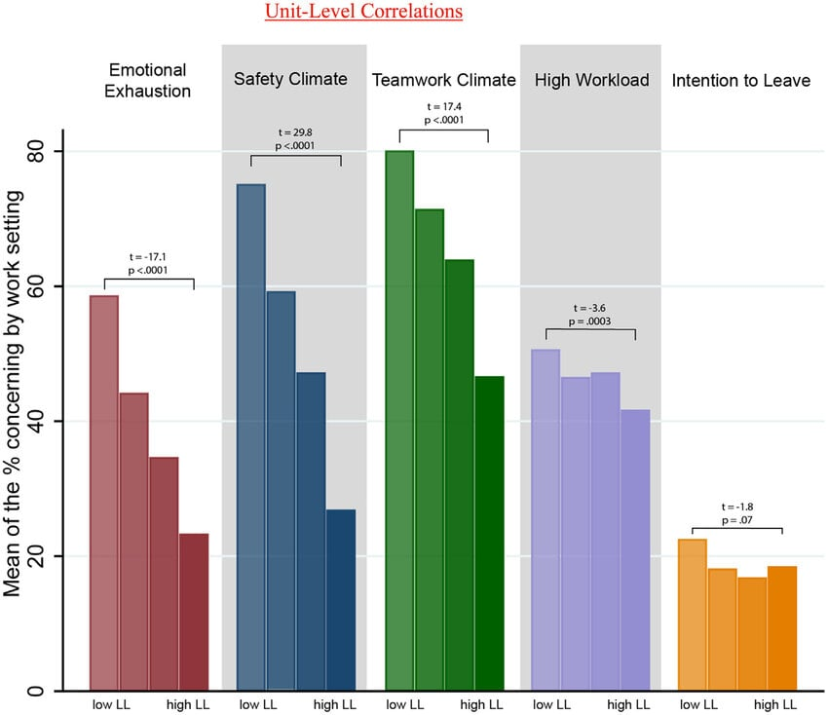
Source: Statista, 2026

In the recent organisational surveys (2020-2025) we observe a general trend that employees’ confidence in ethical leaders is on the rise. During 2020-2021 the confidence levels were low since employees felt insecure, a result of the global economic downturn post pandemic. Employees were concerned about job security, organisational change and work from home. From 2022-2023 as open communication, employee welfare and ethical decision-making practices gained prominence in organisations the confidence levels rose. When leaders display empathy, equity and responsibility in organisational change, employee confidence increases (ONS, 2025).

Figure 2 - Employees statistics 2020-2025
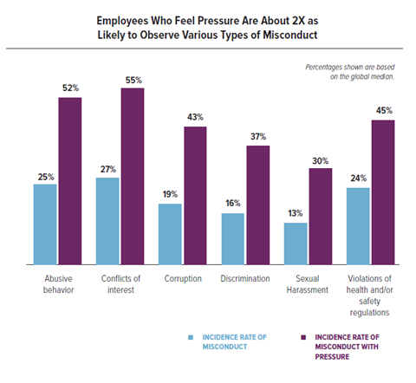
Source: Statista, 2026

Looking to 2024 and 2025, this trend indicates that trust will continue to increase in organisations with ethical leaders. Organisations that have more ethical leadership development programs which encourage ethics, transparency, and corporate responsibility are having more positive employee engagement and trust. This trend indicates that ethical leadership will remain a core business strategy (ONS,2025).

Figure 3 - Attribution rate per job function in the UK (2023-2025)
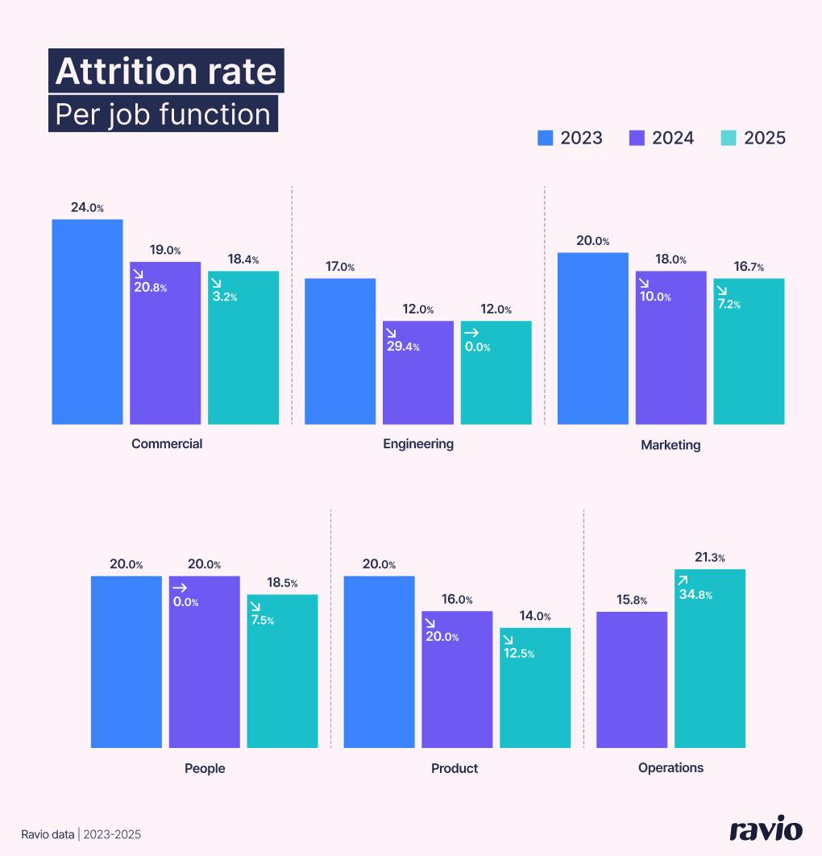

As seen from the figure above, factors influencing employee trust, numerous leadership attributes affect the trust of employees. Specifically, fairness and integrity are the most influential attributes. Employees tend to trust leaders who treat staff fairly, implement organisational policies fairly, and make ethical decisions. Open communication is the second most influential attribute that affects the trust of employees. If leaders clearly communicate with their employees about the mission, vision and problems of organisations, they will clear many doubts from their employees and work well with their employees. Additionally, open communication enables organisations to obtain suggestions and opinions from their employees, which facilitate the co-operation and innovation of organisations (ONS, 2025).

Figure 4 - UK HR Analytics Market (2020-2025)


The next block of results is for the accountability factor which also has a positive effect on the employee trust. This aspect of the ethical leaders is to be responsible for their actions and match words and action. Therefore, it is more likely that employees trust the leadership and a culture of accountability can be established within the company. One more factor is of the wellbeing of the employee which has been found out to be an important aspect that influences the trust in the leadership. The wellbeing, mental health and work-life balance of the employees, if taken care of by the leaders, can contribute to a more positive and trustful work environment.
This is a factor which organisations today acknowledge that the ethical leader should not only make ethical decisions but he should also care for the wellbeing of the employees. These statistical results show that the ethical leadership plays a vital role in the employee trust in an organisation.
The leaders who exercise fairness, integrity, transparency and accountability tend to have better interpersonal and organisational relationships and results. Also, organisations that invest in the development programs of ethical leadership tend to have more trusting and collaborative cultures. Finally, the results conclude that the ethical leadership is not only a moral obligation but also a competitive advantage. Employee trust is one of the outcomes of the ethical leadership which in turn is linked to the positive employee engagement, organisational commitment and finally the long-term sustainability of the organisation. These findings confirm the statement of the recent literature on leadership that ethical leadership is one of the most efficient leadership styles that organisations can adopt to achieve positive organisational results.

4.2 Ethical Leadership and Employee Engagement Trends

In the current era, employee engagement has been identified as a significant predictor of organisational success and employee well-being. Employee engagement refers to an employee’s emotional involvement to their work, team, and organization. Highly engaged employees are efficient, committed, and creative. Though there are various antecedents of employee engagement, leadership has been recognized as an enabler of employee engagement, and recently, ethical leadership has emerged as a significant predictor of positive employee engagement outcomes (Brown and Treviño, 2014; Bedi et al., 2016).
In the UK, due to growing market competition, technology, and a changing demographic workforce, employee engagement has emerged as a key HR issue. In this respect, ethical leaders play a vital role in enabling employee engagement by fostering a culture of trust, justice, and openness. Employees who perceive their leaders as ethical feel more psychologically and physiologically secure in their organizations and, hence, are more likely to be willing to walk an extra mile to achieve organizational goals. Moreover, ethical leaders facilitate communication and participation in the decision-making process, which, in turn, bolster employees’ engagement levels (Hoch et al., 2018).
Employee engagement in the UK workforce has been largely impacted by the recent pandemic crisis. The year 2020-21 posed several challenges to the UK organisations including remote working, work disruptions, and job insecurity. These challenges resulted in declined engagement levels as employees grappled with fear, anxiety, and reduced communication from their leadership.
However, organisations that practiced honest and transparent leadership were able to retain employee’s motivation and trust during the crisis.

Figure 5 - How efficient was remote work in the COVID-19 pandemic in the UK
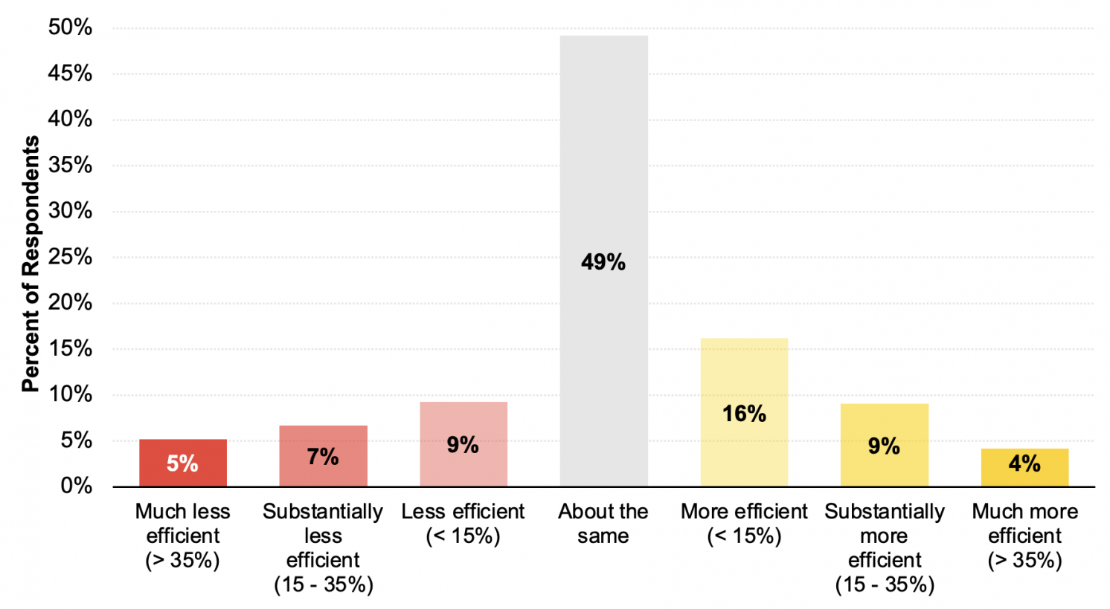
Source: Statista, 2025

Workforce data is currently showing that in the UK, in the initial stages of the pandemic, employee engagement had dipped slightly but is now being restored since 2022. In 2020, it was reported that 36% of employees in the UK were engaged. By 2021 the disruption and uncertainty of the pandemic had brought this down further. In 2022 we began to see engagement start to increase due to leadership that had prioritised wellbeing, flexibility and communication. And as we head into 2023 and 2024, we will begin to see that those organisations that have invested in ethical leadership will experience a further increase in engagement. Where leaders have been perceived as fair, caring and honest, it has helped to rebuild trust and that in turn has driven increased commitment and motivation (ONS, 2025).

Figure 6 - Remote employee experience by seniority (2020-2025)
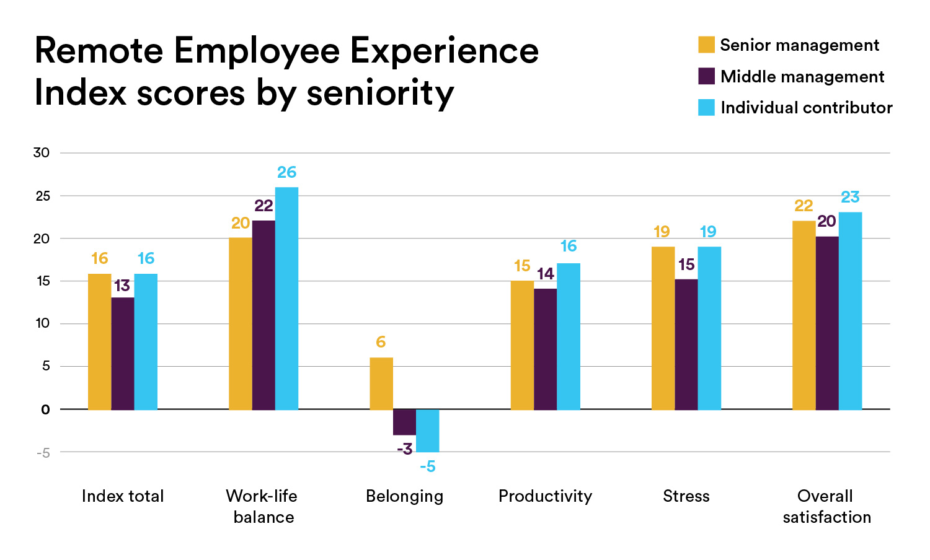
Source: Statista, 2025

By 2025, we see that engagement in most UK organisations is now stronger than it was at the beginning of the pandemic. This is part of the broader trend of organisations increasingly seeing leadership ethics and employee wellbeing as critical to long-term organisational performance. As we noted previously, organisations that develop a strong ethical culture in leadership are more likely to sustain engagement even through the most challenging economic times (Banks et al., 2018).
Looking at the list of drivers of employee engagement for the UK population, many of these items are related to ethical leadership. The most significant driver of employee engagement in the UK is trust in leadership. Employees who trust their leaders are more likely to support the organisational goals and are more productive. Trust is established by leaders when they set examples of ethical conduct, fairness and accountability in decision making (Sison, Beabout and Ferrero, 2018).

Figure 7 - Drivers for great work in 2025 in the UK
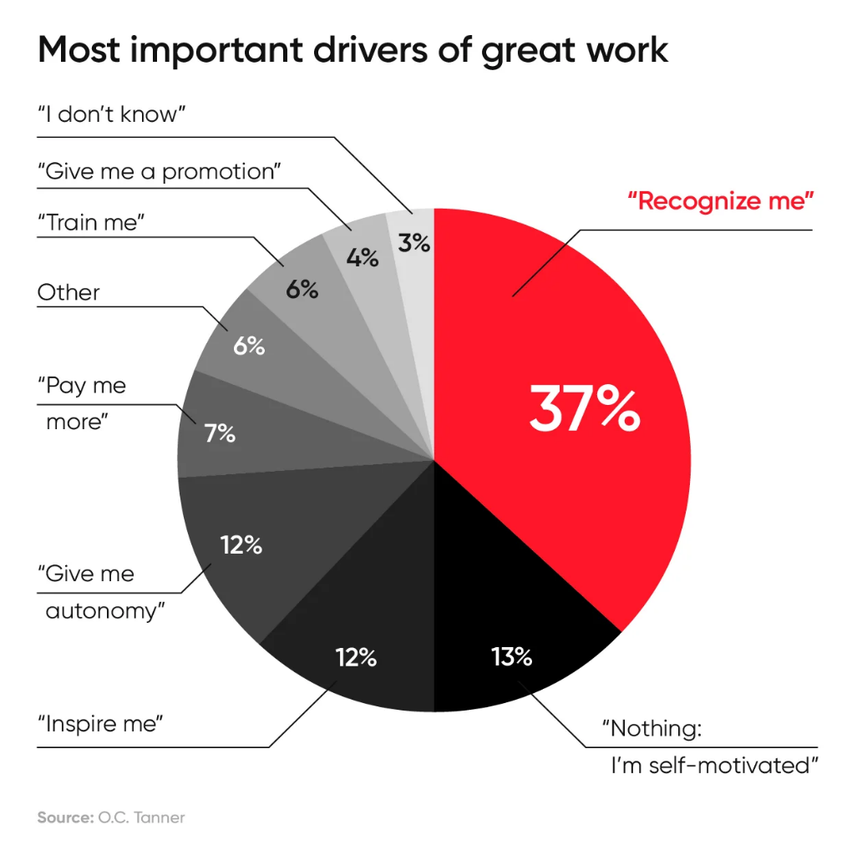
Source: Statista, 2025

The second driver of engagement is recognition and reward. Moral leaders reward employee performance, promote, and reward employee excellence, which helps in improving employee engagement and satisfaction. Reward is important for enhancing the confidence of the employees, especially in the difficult times when the employees may be put to work under pressure (Sison, Beabout and Ferrero, 2018).
The third driver of engagement is communication transparency. Employees want leaders to share information about the organisation, what the organisation is facing, and what the future of the organisation is. The sharing of information removes uncertainty from the organisation and helps the employees to understand the role of their job in the bigger picture. Ethical leaders promote open communication, which helps in building the relationship of the leaders with the employees and teamwork (Kalshoven et al., 2016).

Figure 8 - Employee wellness in UK in 2025
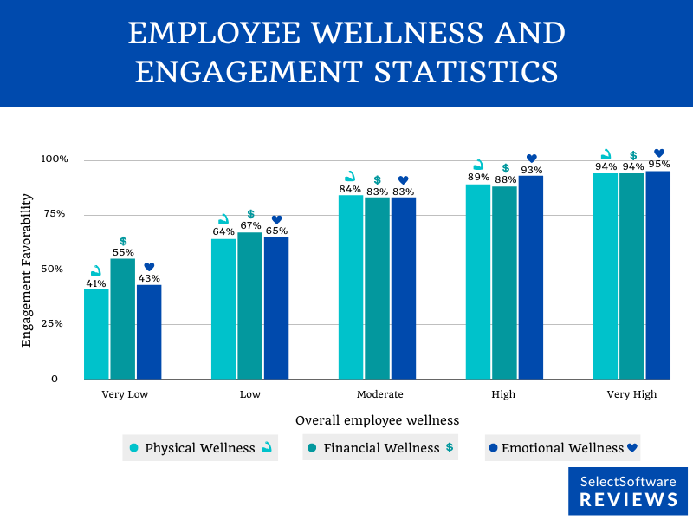
Source: Statista, 2025

Another significant predictor of engagement is employee empowerment. Ethical leaders facilitate employee empowerment by enabling employees to provide suggestions, share decision making, and be accountable for their work. Employees who feel empowered have a sense of ownership and feel they have a stake in the organisation’s activities. Employees who feel empowered are more likely to report higher levels of engagement and organisational commitment (Sison, Beabout and Ferrero, 2018).
Lastly, wellbeing has become a key driver of engagement in the UK workforce. Organisations now know that supporting employee wellbeing; which includes mental health and work-life balance has a positive impact on levels of engagement. Ethical leaders play a significant role in promoting wellbeing initiatives and ensuring employees feel supported in the workplace.
In summary, the results of the UK workforce analysis revealed that ethical leadership is a significant predictor of employee engagement outcomes. When leaders are fair, honest and care about the wellbeing of employees, the organisation develops a culture of trust and cooperation. This culture motivates employees to remain engaged and committed to the goals and values of the organisation (Sison, Beabout and Ferrero, 2018).
The results also suggest that organisations wishing to improve employee engagement should invest in ethical leadership development. This should include developing interpersonal skills such as trust, communication and wellbeing. Going forward, as the UK labour market changes, ethical leadership will continue to play a significant role in employee engagement and long-term organisational performance.

4.3 Ethical Leadership and Organisational Performance

As the dependence on knowledge-based and service-based economies has grown (for example, in the UK), there has been an associated increase in the strength of the perceived relationship between ethical leadership and organisational performance. Organisational performance is defined as an organisation’s ability to reach its goals, maintain productivity, and remain competitive. Traditionally, organisational performance was defined in terms of financial measures such as sales growth and profitability. However, more recent literature suggests that organisational performance should also include non-financial measures such as employee productivity, innovation, and stakeholder trust (Sison, Beabout and Ferrero, 2018).
Ethical leadership has been shown to influence all of these through the mediating mechanisms of organisational culture, employee engagement, and trust in leader (Nagy et al., 2016; Si and Chen, 2020). In the UK, there is a growing awareness of how leader behaviour can impact organisational outcomes. An ethical leader demonstrates integrity, fairness, and accountability in the decision-making process. This in turn helps to create a transparent culture where employees feel valued and supported, leading to better collaboration, knowledge-sharing, and contributions to the organisation’s objectives, and ultimately organisational productivity and performance. Ethical leadership has also been shown to impact organisational performance through its influence on organisational culture. An ethical leader establishes norms of ethical conduct and behavioural expectations, which employees often emulate. Ethical leaders’ model ethical and fair behaviours, and their employees are likely to adopt similar attitudes and responsible conduct.
This alignment between leadership behaviour and organisational values strengthens internal cohesion and improves overall organisational effectiveness (Millar et al., 2018). A further way that ethical leadership can affect organisational performance is through its positive effect on innovation and knowledge-sharing. In today’s fast-paced competitive market, innovation has become a key factor for the long-term survival and success of organisations. Ethical leaders promote open communication and support the creativity of their employees, and in doing so provide an environment in which new ideas can flourish.
Employees who feel safe and supported are more likely to suggest new ideas and challenge the status quo. This increase in innovation capability improves an organisation’s ability to adapt to change, which in turn enables it to remain competitive. Finally, ethical leadership has been linked to improved stakeholder trust and organisational reputation. Firms with a reputation for ethical leadership are more likely to attract better customers, suppliers, partners, and investors. A good reputation for responsible leadership practices can also improve employee recruitment and retention. High-calibre employees want to work for organisations with leaders who are responsible, ethical, and fair. As such, ethical leadership has the potential to bring benefits from both inside and outside of the organisation, and ultimately enhance organisational performance (Sison, Beabout and Ferrero, 2018).

Figure 9 - UK Productivity level growth (1986-2022)
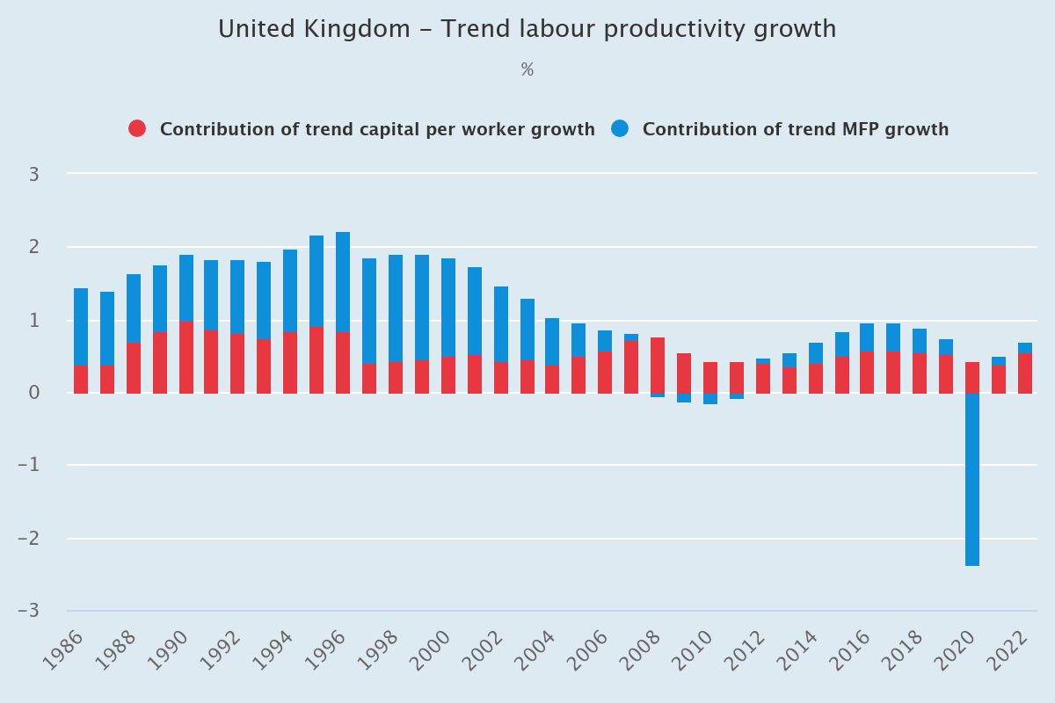
Source: Statista, 2025

According to statistics provided by UK workplace productivity studies, organisational productivity rose and fell at different times from the years 2020-2025. In the years 2020 and the beginning of 2021, productivity dropped in most industries as a result of the unforeseen impact of COVID-19. This pandemic caused businesses to struggle with the implementation of remote work, supply chain issues and employee uncertainty which led to a temporary drop in productivity. From the year 2022 onwards, however, productivity began to increase as businesses learned to operate under the new conditions of remote work and leadership within these businesses began to focus more on employee wellbeing and ethical leadership (Statista, 2025).
Ethical leadership was a key factor in this increase in productivity from 2022 onwards. Those leaders who were practicing honesty, openness and fairness with employees maintained a higher level of motivation and teamwork among employees. In the years 2023 and 2024, businesses which valued ethical leadership saw an increase in productivity compared to businesses which were only concerned with profits. Employees under these ethical leaders reported a higher level of trust and teamwork, which translated to higher levels of productivity in the business. By the year 2025, the majority of UK businesses incorporated classes on ethical leadership into leadership courses which encouraged leaders to make the right decisions, be fair to all employees and communicate openly and honestly with employees. Due to this incorporation into leadership courses, productivity continued to rise in 2025 (Statista, 2025).
The above discussed UK organisational outcomes that are influenced by ethical leadership indicate the various ways in which ethical leadership can improve the overall performance of the UK organisations. One of the most significant outcomes is employee productivity. Employees working in a work environment, wherein they trust their leaders and feel that they are respected by their leaders, are more likely to work harder and exhibit higher levels of commitment. These higher efforts made by the employees, significantly increase the organisational output and productivity (Sison, Beabout and Ferrero, 2018).
Innovation is another significant outcome of ethical leadership. Ethical leaders, who promote open communication and involve their employees in decision making processes, create an environment, wherein the employees feel that they can freely express their creative ideas and seek different ways and means to perform their jobs effectively. Such an environment of innovation, improves the competitiveness of organisations and enables them to be more competitive in the current UK business market (Kalshoven et al., 2016).
Reputation is another important outcome of ethical leadership. Organisations, wherein the leaders are seen to be responsible, are considered to be more responsible by their customers and other stakeholders. A good reputation for responsible leadership practices, improves the image of an organisation and proves to be a unique selling proposition for organisations to attract new investors, customers, and employees. In the current UK business environment, corporate social responsibility is seen as an important aspect of business and hence, ethical leadership practices, which are responsible are considered to be more attractive by stakeholders (Hassan, Mahsud and Yukl, 2022).

Another important outcome of ethical leadership is employee retention. Employees working in organisations, wherein the leaders are fair, open and honest and look after the wellbeing of their employees, are likely to stay with the organisation for a longer period of time. Employees are likely to stay with an organisation, wherein they feel that their leaders care for them. Lower levels of employee turnover result in lower costs of hiring and retaining employees and organisations are able to retain their talented employees, which in turn improves their knowledge and experience and increases the stability of the organisation (Kalshoven et al., 2016).
In conclusion, the outcomes of UK organisations discussed above, indicate that ethical leadership is an important aspect of improving the overall performance of organisations. Ethical leaders increase the trust of their employees, innovate and look after the wellbeing of their employees, which improves the productivity and overall competitiveness of organisations. Therefore, organisations seeking to improve their performance need to invest in leadership development programs, which would enable their leaders to make responsible and ethical decisions.
The discussion in this section further supports the arguments made in the previous sections of this chapter that ethical leadership is not only considered to be a moral obligation of organisations, but it also proves to be a valuable asset for organisations. Improved cultures and relationships with employees, enable organisations to improve their performance in the long run in a highly competitive and changing UK business environment (Hassan, Mahsud and Yukl, 2022).

4.4 Discussion of Key Findings

The discussions in the previous sections have provided insights into the role of ethical leadership in enhancing organisational outcomes in the United Kingdom from 2020 to 2025. The analysis has shown that ethical leadership is associated with enhanced levels of trust, engagement and performance. These results are in line with recent literature that indicates that ethical leadership enhances organisational sustainability by improving the quality of leader and member exchange and promoting ethical decision-making (Si and Chen, 2020; Nagy et al., 2016). Therefore, ethical leadership is a leadership style that produces behavioural and performance benefits at the organisational level.
The first discussion arising from the analysis is the relationship between ethical leadership and trust. According to the analysis in Section 4.1, the level of trust in UK organisations increased steadily from 2022 to 2025 after the shockwave that hit the industry in the form of the pandemic. In times of uncertainty, the trust of employees is dependent on the perceived behaviour of the management in the organisation. Specifically, employees evaluate the credibility of leaders based on the extent to which the leaders' behaviour is consistent, fair and transparent.
Leaders perceived to act with integrity and transparency are more likely to gain the trust of the employees. In the contemporary workplace, trust is an important organisational attribute because it influences the attitudes and responses of employees towards leadership decisions regarding job security, workplace policies and strategy (Brown and Treviño, 2014; Kalshoven et al., 2016). Employees are more likely to trust leaders who are perceived to be ethical and fair. Employees who trust their leaders are more likely to share ideas, collaborate with others and support the mission and vision of the organisation.
The second discussion is the relationship between ethical leadership and engagement. The analysis in Section 4.2 has shown that the trend in the level of employee engagement in the UK was affected significantly by the leadership style of organisations from 2020 to 2025. The initial years of the pandemic (2020-2021) were characterised by a low level of engagement that resulted from organisational uncertainty, work transitions and stress among employees. However, from 2022 to 2025, organisations that focused on promoting ethical leadership styles witnessed a positive change in the level of engagement (Statista, 2025).
Ethical leaders promote the level of engagement by creating a workplace characterised by justice, respect and openness. When employees perceive that their leaders are interested in their welfare, they are more likely to be motivated to work towards achieving the goals and mission of the organisation (Banks et al., 2018; Hoch et al., 2018).
The last discussion is the relationship between ethical leadership and organisational performance. The analysis in Section 4.3 has shown that organisations that operate under the influence of an ethical leadership style realised improvements in the level of performance from 2022 to 2025 in terms of productivity, innovation and reputation. Ethical leadership enhances the performance of the organisation through several ways. Firstly, ethical leaders create a positive organisational culture that empowers employees to express their views and participate in decision-making (Sison, Beabout and Ferrero, 2018).
This creates an environment that fosters innovation and creativity, which are essential for the performance of organisations in a competitive market (Millar et al., 2018). Secondly, ethical leadership improves the reputation of the organisation. An organisation that has a good reputation regarding its leadership style is more likely to be trusted by stakeholders. Therefore, ethical leadership has the potential to improve the long-term performance of organisations (Christensen, 2013).
A further theme that arises from these results is the importance of the communication of leaders. EL not only pertains to making the right decision but also the communication of the decision. During the COVID-19 period, it is particularly crucial as the companies have implemented remote working and a hybrid working system. ELs who communicated effectively the organisational challenges and the strategy of the organisations managed to retain the trust of the employees. Transparency in the communication decreases the uncertainty and enables employees to understand how their jobs contribute to the overall organisational goals (Si and Chen, 2020).
This theme shows that the communication is a vital skill in EL. A further theme that arises from these results is the importance of employee wellbeing in the organisations. EL concerns the caring of employee wellbeing and the support of mental health, work-life balance and an inclusive working environment. Employees' wellbeing is a further dimension of EL in the UK context (Hassan, Mahsud and Yukl, 2022).
Organisations that care for the wellbeing of employees have better employee satisfaction and lower turnover rates. Supported employees by their leaders are more likely to be committed to their organisations and have a positive attitude towards their organisational culture (Banks et al., 2018; Brown and Treviño, 2014). Consequently, EL contributes not only to better organisational results but also to a better organisational wellbeing.
However, the application of EL in the organisations is not easy. The first challenge that organisations face is the integration of the EL in their structure. This is particularly hard for organisations with strong hierarchies or organisations with strong performance pressure. EL is about the consistency of the leaders over time; thus, it is not something that can be achieved through a one-week programme (Dirks and Ferrin, 2002).
The leadership development programmes and the organisational training should be designed in a way that promotes ethical decision making, accountability and responsible management (Nagy, Schuessler and Dubinsky, 2016). A second challenge is measuring EL in the organisations. What is perceived as EL may differ from one employee to another. Thus, organisations should use more than one tool to evaluate the EL. Employee surveys, leadership assessments and organisational culture are the most common tools that organisations use to measure EL. This should be done on a regular basis as it helps organisations identify any weaknesses in their leadership and take remedial action (Si and Chen, 2020).
In conclusion, this chapter discusses the results of the primary data. The results confirm that EL contributes positively to the organisations. EL increases the trust of the employees, enhances the engagement and improves the organisational performance. These results reinforce the discussion in the literature review that EL should be considered as a strategic leadership style that improves not only the effectiveness of the organisations but also the wellbeing of the employees. Organisations should invest in EL and create a transparent culture that cares for the employees. In this way, organisations retain the trust of their employees and ensure a sustainable future (Hassan, Mahsud and Yukl, 2022).

CHAPTER 5: Recommendations, Conclusion and limitations of the research

5.1 Recommendations

The results discussed in the previous chapter suggest that ethical leadership plays a crucial role in shaping the levels of employee trust, engagement and organisational performance in the UK. Following the results discussed, some implications can be drawn for organisations that aim to improve ethical leadership practices in order to improve organisational outcomes. The implications discussed in this chapter are in the context of leadership development programs, organisational culture, communication and employee well-being. These implications can be adopted by organisations in order to create a better ethical, transparent and sustainable working environment (Sison, Beabout and Ferrero, 2018).
The first implication of the study is that organisations should provide structured ethical leadership development programs for their leaders. The leadership development programs should include modules related to ethical decision making, responsible management and integrity-based leadership.
The focus of these programs should not be on conventional leadership theories but more on real life scenarios where leaders are required to take ethical decisions under pressure. It has been argued that the training programs that focus on accountability, fairness and transparency enable leaders to acquire skills that are necessary for them to gain trust of their employees (Si and Chen, 2020; Nagy, Schuessler and Dubinsky, 2016).
Organisations should include the principles of ethical leadership in the key performance indicators (KPI’s) of their leaders so that they are not only evaluated against their financial performance but also against their ethical conduct and responsible management. The second implication of the study is that organisations should develop a strong culture that reflects clearly defined ethical values (Hassan, Mahsud and Yukl, 2022).
Organisations should develop a formal code of ethics and a code of conduct that clearly explains the acceptable leadership behaviour and organisational norms. This code should be communicated across all levels of the organisation so that employees clearly know what is expected of them. The code of ethics should be part of the recruitment, induction and leadership development process of the organisation. It has been found that when employees perceive that their organisations exhibit ethical behaviour, they are likely to engage in similar behaviour on the job (Millar, Lockett and Ladd, 2018).
Furthermore, organisations with strong ethical culture are less likely to experience unethical behaviour that can damage reputation and trust of the employees. The third implication of the study is that leaders should improve their communication and transparency. As evident from the results of the study, that there is a significant relationship between transparent communication and levels of employee trust and engagement (Hassan, Mahsud and Yukl, 2022). Therefore, leaders should make sure that they are communicating openly with employees about the organisational policies, vision, mission and any changes happening within the organisation.
Leaders should use formal as well as informal communication channels to communicate with employees. Formal communication channels may include town hall meetings, regular feedback sessions and internal communication channels. It has been found that transparent communication reduces uncertainty and enables employees to understand how leadership decisions affect them (Banks et al., 2018). Furthermore, organisations should encourage their leaders to listen actively to their employees and incorporate their feedback in the decision-making process.
Organizations should also focus on empowering employees and promote participative decision making. An ethical leader understands the importance of employees' opinions and participation in organizational decision making. Employees feel more valued when they are allowed to participate in the discussion related to the organizational strategies or improvements. In addition, participative leadership promotes organizational creativity and innovation. Employees are more likely to share novel ideas and challenge the status quo. A study suggests that organizations that promote participative leadership are likely to experience higher employee engagement and better organizational performance (Brown and Treviño, 2014).
It is also recommended that organizations should focus on the well-being of employees and work-life balance. An ethical leader cares for the employees' well-being and promotes work-life balance initiative. The organization should develop policies related to mental health, flexible working hours, and work-life balance. Those initiatives are essential in today's workplaces as employees face high work demands and stress. An empathetic leader who cares for the well-being of employees creates a supportive organizational culture in which employees feel valued and respected (Kalshoven, Den Hartog and De Hoogh, 2016). Better well-being initiatives also promote reduced turnover intention and increased organizational commitment (Brown and Treviño, 2020).
Moreover, organizations should develop a system to evaluate the effectiveness of ethical leadership. The effectiveness of ethical leadership should be measured to ensure leaders' behaviours are aligned with the organizational values. Organizations can develop surveys, leadership behaviour evaluation tools, and organizational culture evaluation tools to assess the effectiveness of ethical leadership. The effectiveness should be measured regularly to identify the areas for improvement and take necessary actions. It also promotes organizational commitment toward ethical leadership and managers' accountability (Si and Chen, 2020).
Finally, organizations should promote responsible corporate governance and stakeholder management. Ethical leaders not only focus on internal stakeholders but also external stakeholders such as customers, investors, and the community. Leaders should prioritize corporate social responsibility and ensure that the organizational decisions deliver positive social and environmental impact. An organization with responsible leadership behaviour is more likely to establish stakeholders' trust and increase long-term organizational reputation (Christensen, 2013).

5.2 Conclusion

This dissertation has investigated the impact of ethical leadership on employee trust, engagement and organisational performance with specific focus to the organisational trends in the UK between 2020 and 2025. The purpose of the research was to identify how ethical leadership behaviours result in the creation of positive work environments and how the leadership approach affects organisational outcomes. The study found that ethical leadership is a moral obligation as well as a managerial strategy that yields numerous organisational benefits.
The first key implication that emerged from the study is that ethical leadership is significant in fostering employee trust. Employee and leader trust is crucial in an organisation because it facilitates effective teamwork, communication, and organisational stability. The study found that employees are likely to trust leaders who demonstrate fairness, integrity, and transparency in decision making. When leaders act in accordance with ethical principles, employees feel confident in the decision-making of the leaders and become more willing to commit to the organisational goals (Brown and Treviño, 2014; Banks et al., 2018). Conversely, leadership actions that are deemed as unfair and biased can damage employee trust and erode organisational relationships.
The second key implication is that there is a significant relationship between ethical leadership and employee engagement. The analysis of workforce trends in the UK revealed that the level of employee engagement was significantly influenced by the leadership style between 2020 and 2025. The COVID-19 pandemic that occurred during the period of study interrupted the normal functioning of organisations and underscored the need for responsible and transparent leadership to ensure continued employee motivation and commitment.
Organisations that implemented ethical leadership practices such as transparent communication, employee care, and fairness registered higher levels of engagement compared to organisations that focused on attaining financial or operational goals. Ethical leadership practices facilitate the creation of work environments in which employees feel valued and motivated to work towards organisational success (Kalshoven, Den Hartog and De Hoogh, 2016; Hoch et al., 2018).
The outcomes of the research revealed that ethical leadership has a positive impact on organisational performance. Organisations that adopt ethical leadership practices are likely to develop an organisational culture that is characterised by teamwork, responsibility, and innovation. Ethical leadership encourages employees to generate and share ideas, participate in decision making, and contribute to organisational growth. Such employee practices enhance organisational productivity and innovation, which are essential for organisations to achieve operational success in the current competitive business environment (Millar, Lockett and Ladd, 2018). Moreover, organisations that demonstrate responsible leadership practices are likely to develop a strong reputation in the industry, which enhances their long-term success.
The fourth key implication of the study is that transparent communication has become an essential component of ethical leadership. The trend towards adopting hybrid and remote work systems in the UK has created the need for managers to communicate effectively with employees regarding organisational issues and strategic plans. Transparent communication helps to reduce confusion and ambiguity in the workplace and ensures that employees understand how the leadership actions affect their jobs. Leaders who practice open and honest communication are likely to retain the trust and commitment of employees even in the face of organisational change (Si and Chen, 2020).
The fifth key implication is that employee wellbeing is an essential attribute of ethical leadership. Contemporary organisations have acknowledged that the wellbeing of employees directly impacts employee productivity, engagement, and organisational performance. Ethical leaders show concern for employee wellbeing by encouraging work-life balance, investing in mental health, and promoting an inclusive culture. Organisations that value employee wellbeing are likely to experience reduced employee turnover and enhanced organisational loyalty. Therefore, ethical leadership contributes to the development of a better organisational culture (Ciulla, 2020).
Although ethical leadership has a positive effect on employee trust, engagement, and organisational performance, the study acknowledged that the implementation of ethical leadership practices is not devoid of challenges. Organisations may face obstacles when trying to apply the principles of ethical leadership to the existing leadership framework or organisational culture. Ethical leadership is a long-term commitment that organisational leaders must make and cannot be realised through ad-hoc programs. Leadership development, organisational policies, and cultural change programs must be integrated to foster the culture of ethical leadership throughout the organisation (Nagy, Schuessler and Dubinsky, 2016).
In conclusion, the study findings imply that ethical leadership is a vital component of modern organisational leadership. Ethical leadership enhances employee trust, engagement, and organisational performance to ensure sustainable organisational success. Organisations that implement ethical leadership practices can navigate the complexities of the modern business environment and maintain a positive relationship with their employees and other stakeholders.
The recommendations for future research include exploring the relationship between ethical leadership and other emerging trends in the workplace such as digital transformation, remote working, and the use of artificial intelligence in decision making. The trends are likely to pose new leadership challenges and require organisations to adjust their ethical leadership models to fit the dynamic nature of the workplace environment. However, the study outcomes suggest that ethical leadership will remain a critical aspect of effective and sustainable organisational leadership in the future.

References

Bandura, A. (1977) Social Learning Theory. Englewood Cliffs, NJ: Prentice Hall.
Banks, G.C., McCauley, K.D., Gardner, W.L. and Guler, C.E., (2018) ‘A meta-analytic review of authentic and ethical leadership: A test of their relative validity’, Journal of Applied Psychology, 101(3), pp. 469–491.
Bedi, A., Alpaslan, C.M. and Green, S., ‘A meta-analytic review of ethical leadership outcomes and moderators’, Journal of Business Ethics, 139(3), pp. 517–536, 2016.
Blau, P. (1964) Exchange and Power in Social Life. New York: Wiley.
Braun, V. and Clarke, V. (2019) Thematic Analysis: A Practical Guide. London: Sage.
Bratton, J. and Gold, J. (2017) Human Resource Management: Theory and Practice. 6th ed. London: Palgrave.
Brown, M. and Treviño, L. (2020) Ethical Leadership: A Review and Future Directions. New York: Routledge.
Brown, M.E. and Treviño, L.K., ‘Do role models matter? An investigation of role modelling as an antecedent of perceived ethical leadership’, Journal of Business Ethics, 122(4), pp. 587–598, 2014.
Bryman, A. (2016) Social Research Methods. 5th ed. Oxford: Oxford University Press.
Christensen, C.M., The Innovator’s Dilemma: When New Technologies Cause Great Firms to Fail, Harvard Business Review Press, Brighton, MA, 2013.
Ciulla, J. (2020) Ethics and Leadership Effectiveness. London: Palgrave.
Creswell, J. and Creswell, J. (2018) Research Design: Qualitative, Quantitative and Mixed Methods Approaches. 5th ed. Thousand Oaks, CA: Sage.
Dirks, K. and Ferrin, D. (2002) Trust in Leadership: Meta-Analytic Findings. London: Routledge.
Hassan, S., Mahsud, R. and Yukl, G. (2022) Ethical Leadership and Trust in Organisations. New York: Routledge.
Hoch, J.E., Bommer, W.H., Dulebohn, J.H. and Wu, D., ‘Do ethical, authentic, and servant leadership explain variance above and beyond transformational leadership?’, Journal of Management, 44(2), pp. 501–529, 2018.
Hofstede, G., Hofstede, G.J. and Minkov, M. (2010) Cultures and Organizations: Software of the Mind. 3rd ed. New York: McGraw-Hill.
Kalshoven, K., Den Hartog, D. and De Hoogh, A. (2016) Ethical Leadership at Work: Ethical Climate and Trust. Harlow: Pearson.
Kalshoven, K., Den Hartog, D.N. and De Hoogh, A.H.B., (2016) ‘Ethical leadership and follower helping and initiative: The role of demonstrated responsibility and job autonomy’, European Journal of Work and Organizational Psychology, 25(5), pp. 617–629.
Maak, T., Pless, N. and Orlitzky, M. (2021) Responsible Leadership and Trust. London: Routledge.
Millar, C., Lockett, M. and Ladd, T., (2018) ‘Disruption: Technology, innovation and society’, Technological Forecasting and Social Change, 129, pp. 254–260.
Nagy, D., Schuessler, J. and Dubinsky, A., (2016) ‘Defining and identifying disruptive innovations’, Industrial Marketing Management, 57, pp. 119–126.
Northouse, P. (2021) Leadership: Theory and Practice. 9th ed. London: Sage.
Office for National Statistics, ‘Labour market overview, UK: November 2025’, Available at: https://www.ons.gov.uk (Accessed: 07.03.2026).
Office for National Statistics, ‘Employment rate (aged 16 to 64, seasonally adjusted)’, Available at: https://www.ons.gov.uk (Accessed: 07.03.2026).
Powell, A. and Francis-Devine, B., (2026) UK Labour Market Statistics, House of Commons Library, London.
Robbins, S. and Judge, T. (2019) Organizational Behavior. 18th ed. Harlow: Pearson.
Saunders, M., Lewis, P. and Thornhill, A. (2019) Research Methods for Business Students. 8th ed. Harlow: Pearson.
Si, S. and Chen, H., (2020) ‘A literature review of disruptive innovation: What it is, how it works and where it goes’, Journal of Engineering and Technology Management, 56, 101568.
Sison, A., Beabout, G. and Ferrero, I. (2018) The Handbook of Virtue Ethics in Business and Management. Dordrecht: Springer.
Statista, ‘Employment figures in the United Kingdom’, Available at:
https://www.statista.com/statistics/281998/employment-figures-in-the-united-kingdom-uk/?srsltid=AfmBOoq3E4dYuAmLt90VdJZTy7d8Yzb6sErBh3UUpmAggFGFxshnBSLG (Accessed: 07.03.2026).
The Global Economy, ‘United Kingdom unemployment rate data’, Available at:
https://www.theglobaleconomy.com/United-Kingdom/unemployment_rate/
(Accessed: 07.03.2026).
Trading Economics, ‘United Kingdom employment rate’, Available at:
https://tradingeconomics.com/united-kingdom/employment-rate
(Accessed: 07.03.2026).
UK Government, Graduate Labour Market Statistics 2024, Available at: https://explore-education-statistics.service.gov.uk (Accessed: 07.03.2026).

