
introduction to pysiology bmhp5003_birm
Cardiovascular system

name: mohammed belal ahmed
student number:1810818
TUTOR NAME: MUMTAZ GOOLAM
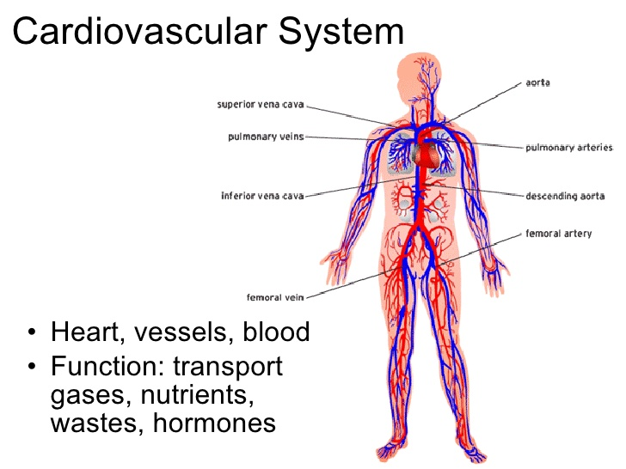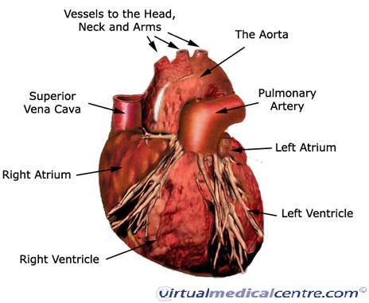
https://www.tes.com/lessons/VbxG07TGr0aXsQ/circulatory-system
https://healthengine.com.au/info/cardiovascular-system-heart#C3
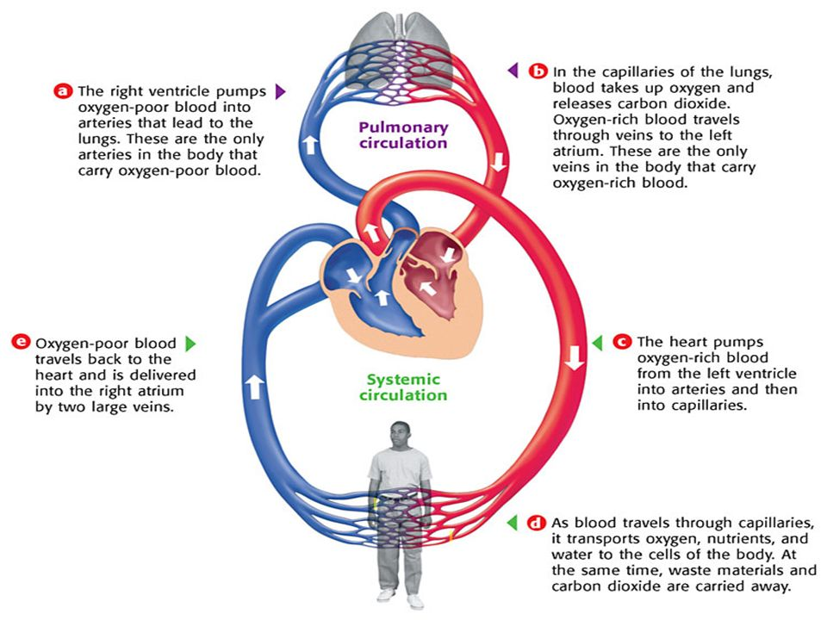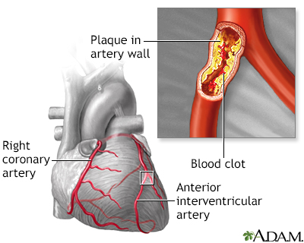
https://slideplayer.com/slide/8916752/
https://www.mountsinai.org/health-library/diseases-conditions/hardening-of-the-arteries

Cardiovascular system: The cardiovascular system is operated by the human body’s hardest-working functioning muscle/organ the heart, which is the size of a persons closed fist. Even at rest the heart pumps around five litres of blood every minute. The human heart is working 24 hours a day. The cardiovascular system is a makeup of the human heart, blood vessels, and veins and roughly five litres of blood which the blood vessels transport. The human body’s veins and blood vessels are Responsible for moving nutrients, oxygen, hormones, and cellular waste throughout the body (NIH, 2020).
The heart: The human heart is a muscular organ that pumps blood around the body to keep you alive. It is an organ/ muscle, approximately the size of a person fist, the heart is located roughly in the middle of your chest slightly tilted to the left 2/3 the bottom of the heart (apex) and 1/3 to the right the top of the heart commonly known as heart’s base and along the midline of the thoracic area. The right side of the heart receives blood and transports it to the lungs to be oxygenated, while the left side receives the oxygenated blood from the lungs and directs it out to the tissues of the body. The Heart has three layers; the MYOCARDIUM (outer layer), EPICARDIUM (middle layer), and ENDOCARDIUM (inner layer). The heart is protected by the PERICARDIUM which is the protective membrane surrounding it. Every day the human heart beats around 100,000 times. This process pumps blood continuously. approximately five litres of blood around the human body through a system of blood vessels called the circulatory system. The heart base which connects to the great blood vessels of the body the aorta, pulmonary trunk, vena cava, and pulmonary veins which delivers nutrients and oxygen to the whole human body and takes away unwelcomed waste products and carbon dioxide. the heart and circulatory system that works stimulatingly to deliver blood to the organs so they can function (Inner body research, 2020).
The structure of the heart: The heart is one of the most amazing organs. The heart is a muscular pump and is split in two parts the right side and the left side. The right-side job is to pump deoxygenated blood to the lungs and the left sides job is to pump oxygenated blood to the body. both sides of the heart have an atrium and ventricle they are both connected chambers the atria (plural atrium) is where the blood collects when it enters the heart and the ventricles pumps blood away from the heart and in to the lungs .the right hand and left hand are separated by the septum. The tricuspid valve is found between the right ventricle and atrium which opens when pressure builds up from the atrium. The bicuspid valve is found on the left side and opens when pressure build up from the atrium and ventricle on the left. The semilunar valve has the job to stop the back flow of blood from entering back into the heart. the semilunar valves are located where the aorta exits the left ventricle and on the right ventricle where the pulmonary artery exits (BBC, 2020).
Pulmonary circulation and systematic circulation: The human body is made up of circulatory systems and is split in two parts pulmonary and systematic circulation each has its own job and operated by the heart. The pulmonary system job is to provide oxygen and release carbon dioxide from and to the heart and systematic circulation job is to transport blood from the heart to a system of cells in the body and it’s a repeat cycle (Health engine, 2020).
Blood vessels: There are three important types of Blood vessels arteries, veins, and capillaries. the blood vessels are the motorway for blood to travel efficiently and fast from the heart to all over the body and back again. they all have a different structure and function arteries have a thick outer muscular wall with a small inner tube and is designed to carry deoxygenated blood from the heart to the lungs to be oxygenated blood. A vein is a blood vessel that conducts blood toward the heart. Compared to arteries, veins are thin-walled vessels with large and irregular lumens. Because they are low-pressure vessels, larger veins are commonly equipped with valves that promote the unidirectional flow of blood toward the heart and prevent backflow toward the capillaries caused by the inherent low blood pressure in veins as well as the pull of gravity. Capillaries are small thin vessels and can located in every tissue of the human body. Capillaries carry blood very close to the cells of the tissues of the body in order to exchange gases, nutrients, and waste products (NHS, 2020).
Cardiovascular disease: there are many cardiovascular disease(CVDs) it is a disfunction of the of the heart and blood vessels such as cerebrovascular disease ,coronary heart disease ,and deep vein thrombosis most of these disease are due to blood vessels not being able to provide the required amount of blood and oxygen to the requires organ. There is more common cardiovascular disease such as heart attacks, strokes, angina they are mainly caused by blockage or narrowing of the arteries which slows the flow of blood coming and going from the heart. This is caused by gradual build-up of fat in the arteries or blood vessels. The cause of a heart attack and angina has many risk factors such as smoking, alcohol consumption, no physical exercise, poor diet, and obesity. Diabetes and stress can also cause heart problems (World health organisation, 2020).
Suggestion and recommendations: my suggestions on how to prevent heart attacks and angina is to have a controlled balanced diet, eat healthy food, control your daily salt, and sugar consumption. Exercise regularly and go for a walk every day. Have a regular blood test and control your cholesterol level. all off these steps are recommended by your GP and NHS England.

References
BBC, (2020). https://www.bbc.co.uk/bitesize/guides (accessed on 3rd November)
Blend space, (2020). https://www.tes.com/lessons/VbxG07TGr0aXsQ/circulatory-system (accessed on 29th October)
Hannah, B. Side players, (2016). https://slideplayer.com/slide/8916752/ (accessed on 30th October)
Health engine, (2020). https://healthengine.com.au/info/cardiovascular-system-heart#C3 (accessed on 25th October)
Heart Rhythm Society, (2020). https://www.hrsonline.org/publications/heart-rhythm-journal?gclid= (accessed on 3rd November)
Inner body research, (2020). https://www.innerbody.com/image/cardov.html (accessed on 4th November)
Medical Terminology for Cancer, (1996). http://www.cancerindex.org/medterm/medtm8.htm (accessed on 27th October)
Mount Sinai, (2020). https://www.mountsinai.org/health-library/diseases-conditions/hardening-of-the-arteries (accessed on 22nd October)
NHS, (2019). https://www.nhs.uk/conditions/heart-attack/ (accessed on 4th November)
NHS, (2020). mft.nhs.uk/mri/services/vascular-surgery/vascular-laboratory/blood-vessels/ (accessed on 1ST November)
NIH, (2020). https://training.seer.cancer.gov/anatomy/cardiovascular/ (accessed on 26th October)
Nursing Times, (2020). https://www.nursingtimes.net/clinical-archive/cardiovascular-clinical-archive/cardiac-system-1-anatomy-and-physiology-29-01-2018/ (accessed on 26th October)
World health organisation, (2020). https://www.who.int/news-room/fact-sheets/detail/cardiovascular-diseases-(cvds) (accessed on 3rd November)

