Digital Skills and Research Methods
DSR Assessment 2 Individual Report
The impact of Virtual Learning Environment (VLE) - Moodle on students’ learning experience at the University of Wales Trinity Saint David London Campus
Abstract
A brief study of how small-scale research can be conducted and what procedures one can/must follow for the completion of appropriate research were discussed in this study. In consideration of the research topic, the research focused on developing good objectives and rationale for the study followed by a brief review of the literature on the topic. It then described the methodologies adopted by the researcher along with data findings, analysis, discussion and a summary of the entire research along with a recommendation.
Table of Contents
Introduction 4
Rationale 4
Research Objectives 4
Literature Review 4
Research Methodology 6
Research method and methodology 6
Qualitative, quantitative, and combined approach 6
Data: Primary and Secondary 6
Population, Sample, and Sample Size 6
Ethics in data collection 7
Findings, analysis and discussion 7
Primary Data Analysis 7
Secondary Data Analysis 9
Summarising findings 11
Conclusion and Recommendation 11
References 12
Appendices 13
Appendix 1 - Questionnaire 13
Primary Data Analysis 13
Appendix 2 - Excel table 14

Introduction
The topic question discussed in this research project is how the Virtual Learning Environment has influenced the learning experience of students. This study focuses specifically on Moodle, a widely used VLE in the UK and its impact on the learning experience of students of the University of Wales Trinity Saint David (UWTSD) London Campus. Keeping the focus of this study into consideration, this research project will demonstrate the proper conduction of a small-scale research study along with the selection of proper research methodology and data collection. The collected data will be analysed using appropriate techniques and through analysis and discussion, the information will be evaluated. It will then draw an appropriate conclusion based on the overall study by achieving the objectives effectively.

Rationale
Virtual Learning Environment (VLE) has brought about a significant improvement in how students were taught in educational settings. Positive learning experiences for students allow them to develop significantly and negative experiences can prevent them from accomplishing their feats (Al Yafaei and Attamimi, 2019). Therefore, education settings started promoting active learning through the introduction of VLEs for assisting the students' progress. It was established to promote the skills of critical thinking of students which is an essential skill for transferring or using knowledge acquired from the classroom in practice (Sáiz-Manzanares et al., 2020). Therefore, understanding how effective it has been since its implementation is an essential topic to research which is why the researcher has chosen to study this topic.

Research Objectives
- To examine the effectiveness of VLE on the learning experience of students.
- To analyse how Moodle has influenced the learning experience of students at UWTSD London Campus.
- To determine the effectiveness of VLE like Moodle in improving the learning experience of students so far.

Literature Review
The literature review is mainly based on highlighting certain journals and articles that can help the researchers in obtaining the data for the above topic.
Virtual Learning Environment
According to Annansingh (2019), the virtual learning environment helps the educators in providing certain resources through the digital platforms for the students of the university. The learners within higher education can easily complete their individual learning needs with the help of the VLE. The virtual learning environment can provide a certain amount of flexibility for the learners so that they can mitigate the demographic barriers easily and increase their learning capability. This environment is created by using certain teaching and learning tools which provides an opportunity for the learner to enhance the knowledge of the topic that is being taught within the university. The recent Pandemic has shown the influence that the virtual learning environment can have on the education of a learner. When the UK was in complete lockdown, the virtual learning environment helped the students in the university to continue their education and gain the knowledge that they needed.
The positive impact of VLE
As per Racheva (2018), the pace that the learner sets for themselves help them in obtaining greater Heights within the educational process. The VLE provides this flexibility in terms of recording the education materials for revising them later. Often learners forget the educational information that has been given within the class by the Lecturer during the assessment. Starting through the virtual learning environment can help the learners revise these notes at a later time as the classes have been recorded within the digital platforms. The accessibility of the educational process has become very easy for the learners. Even the educators have the flexibility of teaching from different parts of the world by using the digital platforms and tools that are available within the virtual learning environment. The understanding of time management also increases with the use of a virtual learning environment. This process also includes a feedback system that can be helpful for the learners in understanding the mistakes that they are making.
The negative impact of VLE
As stated by Ryan and Poole (2019), studying within a virtual learning environment can create a certain amount of isolation for the learners. This isolation develops because of the lack of socialisation that the students can have within the classroom. Also, the learners must have a certain amount of motivational and time management skills from the beginning to use the virtual learning environment effectively. Learners that do not possess the above skills might Slow Down within the virtual learning environment and the overall educational process can get hindered for the learner. Several technical issues may arise while the technological tools are being used within the virtual learning environment. This can create a certain gap within the educational process that can be faced by the learner. It is essential to understand the positive and negative factors that a virtual learning environment has. It has the learners plan the learning process accordingly.

Research Methodology

Research method and methodology
A research method can be described as the behaviours or tools used for the selection of appropriate research techniques whereas. Methodology in research refers to the analysis of procedures and methods of investigation. The research methods are usually applied in a research process later than the methodology (Scherman et al., 2018). It is so because methodology begins as the initial stage of any research process to determine that it is going in the right direction and reach methods help complete the methodology. Every study requires identifying effective methodology along with methods to accomplish successful research.

Qualitative, quantitative, and combined approach
There are three main types of research studies which are quantitative, qualitative, and mixed/combined. Qualitative research includes non-numerical data that measures the truth of information based on quality. Quantitative research involves numerical/statistical data collection that measures truth based on quantity. The mixed research method uses both types of data collection to ensure the reliability and validity of research findings (Sahin and Öztürk, 2019). Nevertheless, each type of research is effective for different types of research topics. For this particular study, the researcher has used mixed-method through which both qualitative and quantitative data have been collected.

Data: Primary and Secondary
There are two key sources of data - secondary and primary. Secondary sources involve the collection of data from existing sources, someone else’s work relevant to the topic published by other authors or researchers (Amarasinghe et al., 2020). Data gathered through sources can be from existing pieces of research, journals, articles, and so on. Primary sources involve the collection of data directly from the key sources through interviews, questionnaires, focus groups, government documents, and so on. The researcher has used both primary and secondary sources for collecting data in this research. The Primary source is used for collecting quantitative data through an online questionnaire survey and the Secondary source is used to collect qualitative data from existing works.

Population, Sample, and Sample Size
The population sought for collecting primary quantitative data were 100 students of UWTSD London Campus amongst whom 20 students were selected through random sampling using an e-mail recruitment strategy. Using the inclusion criteria, 7 secondary sources were reviewed and 2 journal articles published on Google Scholar were selected for collecting secondary qualitative data.

Ethics in data collection
Ethical considerations are mandatory research principles that every researcher must abide by. Considering the involvement of human participants in primary data collection, the researcher has ensured the consent of all the respondents by providing them with a complete debrief document and consent form attached with the recruitment mail sent to them (Reid et al., 2018). Their participation was completely voluntary and their anonymity and confidentiality were maintained by providing them with participant codes that helped them participate or withdraw from the online survey.

Findings, analysis and discussion

Primary Data Analysis
Questionnaire Survey
Q 1) Does your classroom use Moodle effectively?
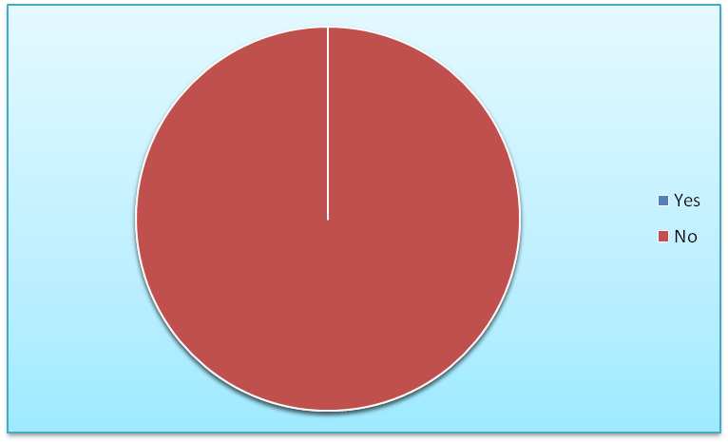
Figure 1 - Pie Chart for Table 1
(Developed by the learner)
Analysis: It was found through this data that 100% of the students agreed on their classrooms use VLE effectively which means that everyone has access to and information on VLE.
Q 2) Do you think VLE like Moodle has helped you improve your learning progress and critical thinking?
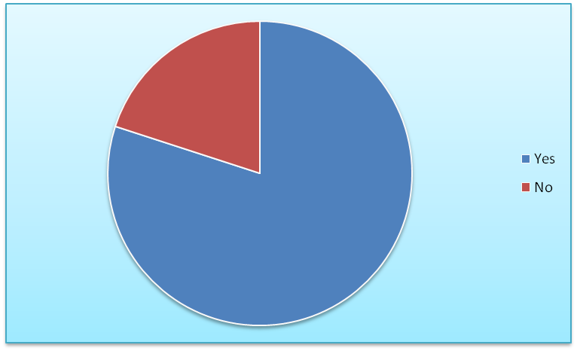
Figure 2 - Pie Chart for Table 2
(Developed by the learner)
Analysis: In this data, 80% of the students agreed that Moodle has helped them improve their learning process and critical thinking and 20% disagreed.
Q 3) Do you feel that VLE Moodle has effectively enhanced your learning experience?
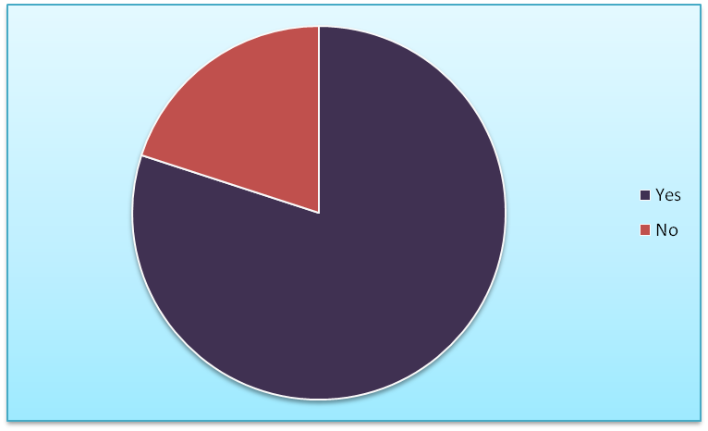
Figure 3 - Pie Chart for Table 3
(Developed by the learner)
Analysis: Through this data, it is understood that 80% of students find VLE like Moodle has enhanced their learning experience effectively while 20% of them disagree.
Q 4) Do you think VLEs like Moodle have satisfied your learning requirements, engagement, and recall?
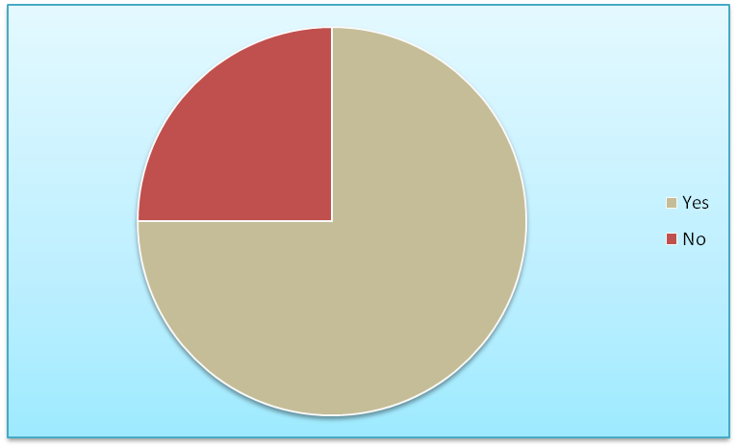
Figure 4 - Pie Chart for Table 4
(Developed by the learner)
Analysis: In this data, it is found that 75% of students find Moodle to provide them with learning satisfaction, engagement, and recall while 25% of them do not find it that highly effective.

Secondary Data Analysis
Key Theme | Authors and years of published | Journal Article
Impact of VLEs in improving the learning experience of students. | - Raftery and Risquez (2018)  - Wicaksono et al. (2020) | - “Engaging students through the VLE: comparing like with like using the# VLEIreland student survey. Irish Journal of Technology Enhanced Learning, 3(2), pp.24-34.”  - “Development of E-learning in web programming subjects for moodle based vocational students. Innovative Journal of Curriculum and Educational Technology, 9(1), pp.1-9.”
Table 5 - Thematic analysis of the impact of VLE on students’ learning experience
(Developed by the learner)
Impact of VLEs in improving the learning experience of students
As stated by Raftery and Risquez (2018), VLEs have become a productive way of learning for the students and have been positively impacting the education system. One of the major positive impacts that have been brought upon by VLEs is that most of the students do not feel comfortable communicating physically. Lack of communication leads the students to express their needs. However, in the VLEs students tend to be extroverted in nature and show their participation in the classroom. It helps the students to understand better in the classroom and improves the learning experience.
According to Wicaksono et al. (2020), VLEs also allow software-enabled collaborations between learners and teachers which allow the students to improve their analytical skills. It also allows the students to have flexibility and accessibility as the students comfortably learn in their own place. By using the VLEs, the technological skills of the students are impacted significantly. However, certain risks are related to VLES and one major risk is that the communication and social skills of the students can be negatively impacted. It is because there is a lack of social activities in the case of VLEs.

Summarising findings
It can be summarised through the findings from both primary and secondary findings and their analysis that the majority of the students feel Moodle be highly useful in improving their learning experience. However, a minority of students feel that it is not completely effective in enhancing their learning needs. VLEs like Moodle are effectively being used in the University and many students have developed significantly but some feel the need for improvement in the VLEs.

Conclusion and Recommendation
The overall study provided a brief understanding of research conduction, data collection, and data analysis by focusing on the topic of VLE - Moodle and its impact on the learning experience of students. It also provided an understanding of how UWTSD London Campus provides VLE learning to its students and how they feel about it. The research study also provided a brief understanding of the topic and the process of analysing data to gather information.
For further research studies, the researcher recommends using lengthy forms of data collection like interviews that will help understand the reason for students feeling the need for improvement of VLES.

References
Al Yafaei, Y. and Attamimi, R., 2019. Understanding Teachers' Integration of Moodle in EFL Classrooms: A Case Study. English Language Teaching, 12(4), pp.1-6.
Amarasinghe, S.L., Su, S., Dong, X., Zappia, L., Ritchie, M.E. and Gouil, Q., 2020. Opportunities and challenges in long-read sequencing data analysis. Genome biology, 21(1), pp.1-16.
Annansingh, F., 2019. Mind the gap: Cognitive active learning in virtual learning environment perception of instructors and students. Education and Information Technologies, 24(6), pp.3669-3688.
Elihami, E., Musdalifah, M. and Hasan, H., 2021, February. Increasing the Higher of Think through Moodle Application: The Effects of Learning Procees in the Higher Education System. In Journal of Physics: Conference Series (Vol. 1783, No. 1, p. 012054). IOP Publishing.
Racheva, V., 2018, December. Social aspects of synchronous virtual learning environments. In AIP Conference Proceedings (Vol. 2048, No. 1, p. 020032). AIP Publishing LLC.
Raftery, D. and Risquez, A., 2018. Engaging students through the VLE: comparing like with like using the# VLEIreland student survey. Irish Journal of Technology Enhanced Learning, 3(2), pp.24-34.
Reid, A.M., Brown, J.M., Smith, J.M., Cope, A.C. and Jamieson, S., 2018. Ethical dilemmas and reflexivity in qualitative research. Perspectives on medical education, 7(2), pp.69-75.
Ryan, E. and Poole, C., 2019. Impact of virtual learning environment on students’ satisfaction, engagement, recall, and retention. Journal of medical imaging and radiation sciences, 50(3), pp.408-415.
Sahin, M.D. and Öztürk, G., 2019. Mixed Method Research: Theoretical Foundations, Designs and Its Use in Educational Research. International Journal of Contemporary Educational Research, 6(2), pp.301-310.
Sáiz-Manzanares, M.C., Marticorena-Sánchez, R. and García-Osorio, C.I., 2020. Monitoring students at the university: Design and application of a moodle plugin. Applied Sciences, 10(10), p.3469.
Scherman, V., Zimmerman, L. and Smit, B., 2018. Mixed method data analysis: An exploratory approach to strengthening inferences about relationships and affinities. International Journal of Multiple Research Approaches, 10(1), pp.57-76.
Wicaksono, A., Florentinus, T.S. and Ahmadi, F., 2020. Development of E-learning in web programming subjects for moodle based vocational students. Innovative Journal of Curriculum and Educational Technology, 9(1), pp.1-9.

Appendices

Appendix 1 - Questionnaire

Primary Data Analysis
Questionnaire Survey
Q 1) Does your classroom use Moodle effectively?
Total no. of respondents | Divisions | Responses | Percentage (%)
20 | Agree | 20 | 100
20 | Disagree | 0 | 0
Table 1 - Effective use of Moodle in the classroom
(Developed by the learner)
Q 2) Do you think VLE like Moodle has helped you improve your learning progress and critical thinking?
Total no. of respondents | Divisions | Responses | Percentage (%)
20 | Agree | 18 | 80
20 | Disagree | 2 | 20
Table 2 - improvement of learning progress and critical thinking through VLEs like Moodle
(Developed by the learner)
Q 3) Do you feel that VLE Moodle has effectively enhanced your learning experience?
Total no. of respondents | Divisions |  | Responses | Percentage (%)
20 | Agree |  | 18 | 80
20 | Disagree |  | 2 | 20
Table 3 - Effective enhancement of students’ learning experience through Moodle
(Developed by the learner)
Q 4) Do you think VLEs like Moodle have satisfied your learning requirements, engagement, and recall?
Total no. of respondents | Divisions | Responses | Percentage (%)
20 | Agree | 15 | 75
20 | Disagree | 5 | 25
Table 4 - Usefulness of Moodle for satisfying students’ learning requirements, engagement, and recall?
(Developed by the learner)

Appendix 2 - Excel table

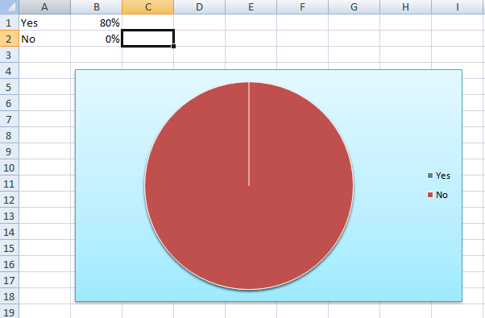
Excel table for - Figure 1
(Developed by the learner)
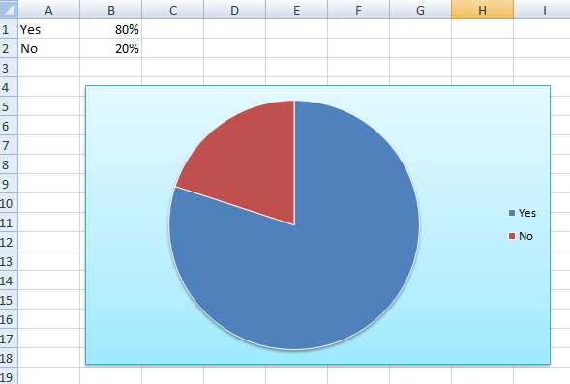
Excel table for - Figure 2
(Developed by the learner)
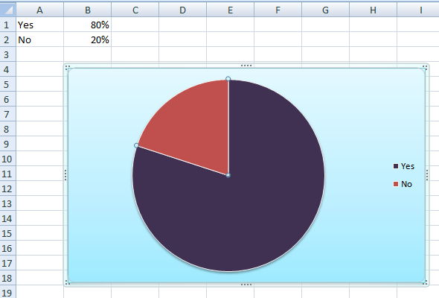
Excel table for - Figure 3
(Developed by the learner)
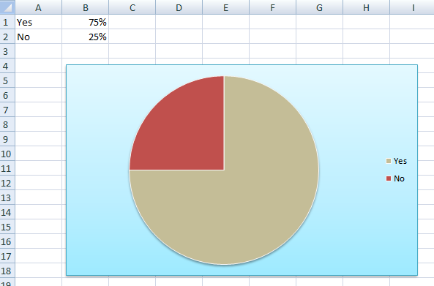
Excel table for - Figure 4
(Developed by the learner)

