Component 1 - Report

"Enhancing Workplace Culture and Organizational Efficiency: A Case Study of Jaguar Land Rover (JLR)"

Student Name: Samir Mhanna
Student Number: 2119514
Lecturer Name: Abdi Rahman
Module Code: BMSW 5105

2023

Abstract
This report examines the workplace culture at Jaguar Land Rover (JLR) and its impact on organizational efficiency. It explores the application of various workplace culture theories, including Organizational Culture Theory, Competing Values Framework, and Person-Organization Fit Theory, in shaping JLR's positive and effective organizational environment. The report analyses JLR's internal strengths, weaknesses, external opportunities, and threats through the use of SWOT analysis, highlighting its significance in strategic planning and risk mitigation. Additionally, Porter's Five Forces analysis is employed o evaluate the dynamics of competition of the automotive industry and identify areas for differentiation. Furthermore, the importance of ethical behaviour and its integration into JLR's culture is emphasized, along with the application of Kotler's 8 Step Plan for ethical decision-making. The report concludes by recommending strategies to enhance workplace culture and organizational efficiency at JLR, including the strengthening of ethical training programs, conducting additional research to complement SWOT analysis, and considering the impact of external factors through Porter's Five Forces analysis. Overall, this report underscores the significance of workplace culture, strategic analysis, and ethical considerations in driving JLR's success and sustainability in a highly competitive industry.

Contents
Abstract 2
Introduction 4
Workplace Culture at Jaguar Land Rover (JLR) 5
The Organizational Environment of Jaguar Land Rover (JLR) 7
Analysing Internal Factors Impacting (JLR) through SWOT Analysis 7
SWOT Analysis for Jaguar Land Rover (JLR) 7
Impact of External Environmental Factors on JLR's Culture Applying Porter's Five Forces 10
Ethical Behaviour and Culture at Jaguar Land Rover 12
Key Ethical Elements within JLR's Culture and Their Promotion 12
Fostering Ethical Decision-Making at Jaguar Land Rover: Applying Kotler's 8-Step Plan 12
Barriers to Effective Functioning of JLR's Ethical Culture 14
Recommendations 15
Conclusion 16
References 17

Introduction
Jaguar Land Rover (JLR) is a prominent automotive company with a rich heritage and global recognition. While Jaguar originated in Coventry and Land Rover in Solihull, both brands have established a significant presence in the West Midlands region, including Birmingham (Pathak, 2016). This introduction will provide a brief background of the chosen organization, Jaguar Land Rover, and set the purpose and context of the report.
Jaguar Land Rover is a company cantered on two renowned British automotive manufacturers, which have their design, engineering, and manufacturing operations based in the United Kingdom. The company falls under the umbrella of Tata Motors, the biggest in India vehicle manufacturer, and maintains an extensive network of dealerships worldwide to distribute its vehicles to consumers (Saunders,2011). They employ approximately 29,000 people worldwide and provide support to various businesses and dealerships. The vehicles are designed and engineered in Britain, and the company maintains its dedication to the UK while pursuing global expansion. With significant investments in production and research and development facilities, Jaguar Land Rover is widely acknowledged as a top investor in the manufacturing sector in the UK. The company's impressive sales of 425,000 vehicles across more than 170 countries solidify its standing as a major exporter from the UK (Media. Jaguar Land Rover, 2023).
The objective of this report is to obtain an enhanced comprehension of the workplace culture within Jaguar Land Rover. Workplace culture shapes the organisational environment and affects employee conduct, ultimately impacting performance and success (Wilcoxson and Millett, 2000). By exploring the culture of Jaguar Land Rover, we aim to critically assess its impact on organisational Efficiency
By delving into the workplace culture of Jaguar Land Rover, we will analyse the influence of environmental factors on the organization's culture, and explore key ethical elements within its culture and their promotion. Identify potential ethical dilemmas that influence the organization and discuss barriers to the effective functioning of the culture. Finally, provide recommendations for enhancing workplace culture and organizational efficiency. In the subsequent sections of this report, we will discuss these aspects in detail, drawing upon relevant theories, and frameworks such as SWOT Analysis, Porter’s 5 Factors, and 8 Step Plan models to provide a comprehensive analysis of Jaguar Land Rover's workplace culture and its significance.

Workplace Culture at Jaguar Land Rover (JLR)
Workplace culture plays a vital role in shaping the organizational environment of Jaguar Land Rover (JLR). The culture at JLR encompasses the shared values, beliefs, norms, and behaviours that define how employees interact, collaborate, and pursue the company's objectives (Hajaj and others, 2021). A strong and positive workplace culture contributes to employee engagement, productivity, and organizational success. Jaguar Land Rover (JLR), as an esteemed automotive company, likely integrates a blend of culture theories to shape its workplace dynamics. This section explores three key theories of workplace culture that JLR applies to cultivate a positive and effective organizational environment. These theories include Organizational Culture Theory, Competing Values Framework, and Person-Organization Fit Theory. By examining the evidence of their application at JLR, we can assess the advantages and disadvantages of these theories for the company.

(Source design by the Author, 2023)

Organizational Culture Theory at JLR
Developed by Edgar H. Schein(1980), emphasizes the importance of shared beliefs, values, and assumptions within an organization. At Jaguar Land Rover (JLR), this theory is evident through the celebration of its rich heritage and commitment to British craftsmanship. The company communicates its core values and mission, fostering a sense of pride and identity among employees. By investing in employee training and development programs that reinforce cultural norms and values, JLR maintains a unified workforce (Nath and Dwivedi, 2021). Applying the Organizational Culture Theory at Jaguar Land Rover can lead to high employee engagement and commitment to the company's objectives. However, potential challenges include resistance to change and the risk of overemphasizing tradition, which may hinder adaptability and innovation in the fast-evolving automotive industry (Davis and Martin, 2017). Organizational Culture Theory posits that a strong and well-defined culture contributes to enhanced employee engagement and commitment.
Competing Values Framework at JLR:
Introduced by Robert E. Quinn and John Rohrbaugh(1983), proposes a model with four cultural orientations: Clan, Adhocracy, Market, and Hierarchy. Jaguar Land Rover applies this theory by promoting cross-functional collaboration and encouraging employees to share ideas and expertise across departments (Hajaj and others, 2021). The company's focus on market-oriented goals is balanced by prioritizing employee well-being to create a supportive work environment. This framework enhances innovation, adaptability, and customer-centricity at JLR (Batra and Khairajani, 2012). However, managing diverse cultural orientations may lead to conflicts in decision-making, and effectively implementing and managing a blended culture can be complex. The Competing Values Framework emphasizes the importance of a balanced cultural orientation that combines collaboration and innovation (Davis, 2017).
Person-Organization Fit Theory at JLR
Developed by Benjamin Schneider (1987), emphasizes the compatibility between individuals and the organization's culture. At Jaguar Land Rover, this theory is reflected in the recruitment process, where the company assesses candidates not only for their skills but also for their alignment with JLR's culture (Johnson, 2008). Comprehensive onboarding programs help new employees assimilate into the culture and understand the company's core values (Zhang and Iles, 2014). This practice results in higher job satisfaction and productivity among employees who fit well with JLR's organizational culture. Nevertheless, there is a risk of reduced workforce diversity and potential resistance to change if the organization becomes overly focused on cultural fit, hindering innovation and adaptability (Batra and Khairajani, 2012).

The Organizational Environment of Jaguar Land Rover (JLR)
Jaguar Land Rover (JLR) operates in a dynamic organizational environment characterized by various internal and external factors. As a prominent automotive manufacturer, JLR combines the heritage and legacy of two venerable companies: Jaguar and Land Rover (BALI, 2016). The organizational environment of JLR is shaped by industry competition, global markets, technology, suppliers, and employees (Davis, 2017). The company emphasizes innovation, customer-centricity, and compliance to thrive in the automotive industry. JLR's culture fosters collaboration, trust, and employee empowerment, recognizing its vital role in the company's success (Batra and Khairajani, 2012).

Analysing Internal Factors Impacting (JLR) through SWOT Analysis
Organisations utilise the SWOT analysis, a technique for organisational strategy, to analyse their internal strengths and weaknesses as well as external opportunities and threats. (Gurl, 2017). It specifies a constructed frame to identify and evaluate critical considerations that can affect the organization's performance and help in developing effective strategies (Zhao and Liu, 2020).

SWOT Analysis for Jaguar Land Rover (JLR)
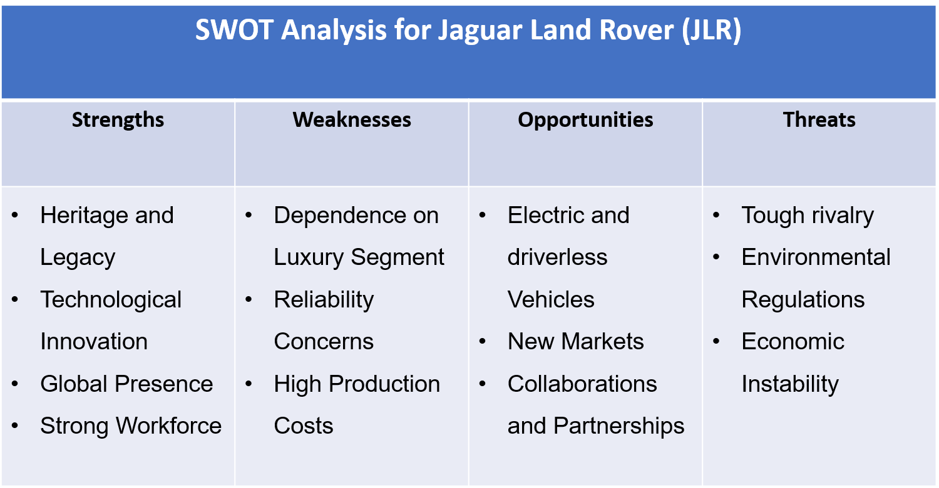
(Source design by the Author, 2023)
Strengths:
- Heritage and Legacy: JLR's rich heritage and iconic British brands, Jaguar and Land Rover, provide a strong foundation and brand recognition in the automotive industry.
- Technological Innovation: JLR's commitment to embracing cutting-edge technologies in vehicle design, manufacturing, and customer experiences allows the company to stay competitive and meet customer demands (Pathak, 2016).
- Global Presence: Operating in diverse global markets enables JLR to reach a wide range of customers and diversify its revenue streams (Colbert, 2016).
- Strong Workforce: JLR's skilled and dedicated workforce contributes to the company's reputation for quality and craftsmanship.
Weaknesses:
- Dependence on Luxury Segment: JLR's focus on the luxury segment makes the company vulnerable to economic downturns and fluctuations in consumer spending (Colbert, 2016).
- Reliability Concerns: Historically, JLR has faced challenges with reliability and quality issues, impacting customer perception and brand loyalty (Saunders,2011).
- High Production Costs: Manufacturing luxury vehicles and investing in advanced technologies can lead to higher production costs, affecting profitability.
Opportunities:
- Electric and driverless Vehicles: The increasing need for electric and driverless vehicles provides an opportunity for JLR to broaden its product portfolio and enter the sustainable transportation sector (Nath and Dwivedi, 2021).
- New Markets: With increased affluence and demand for luxury vehicles, JLR can explore the potential in emerging markets.
- Collaborations and Partnerships: Strategic partnerships and collaborations with technology companies can accelerate innovation and product development (Zhao and Liu, 2020).
Threats:
- Tough rivalry: JLR confronts stiff rivalry from other premium automakers, which can influence market share and pricing tactics.
- Environmental Regulations: Stringent environmental regulations and emission standards may require significant investments in research and development to comply (Colbert, 2016).
- Economic Instability: Global economic fluctuations and geopolitical uncertainties can affect consumer spending and impact JLR's sales.
Advantages of SWOT Analysis for Jaguar Land Rover (JLR)
- Comprehensive Assessment: SWOT analysis allows JLR to conduct a comprehensive evaluation of its internal capabilities and limitations. By identifying strengths and weaknesses, JLR can capitalize on its competitive advantages and address areas that need improvement (Zhao and Liu, 2020).
- Strategic Planning: The analysis helps JLR align its strategies with market opportunities. By identifying potential growth areas and market trends, the company can make informed decisions on product development, market expansion, and resource allocation.
- Risk Mitigation: Understanding external threats enables JLR to develop risk mitigation strategies. By proactively addressing challenges such as economic fluctuations, industry competition, and regulatory changes, the company can better protect its interests (Goffin and others, 2014).
- Decision Making: SWOT analysis provides a structured approach to decision-making. It helps JLR's management make well-informed choices based on a thorough understanding of the company's position and the external environment (Colbert, 2016).
Disadvantages of SWOT Analysis for Jaguar Land Rover (JLR)
- Subjectivity: SWOT analysis relies on subjective judgments and opinions. Different stakeholders may have varying perspectives, leading to biased or incomplete assessments (Gurl, 2017).
- Lack of Prioritization: The model may not provide a clear prioritization of factors. JLR could find it challenging to focus on the most critical issues to address when dealing with a long list of strengths, weaknesses, opportunities, and threats (Goffin and others, 2014).
- Limited in Scope: While SWOT analysis provides a useful overview, it may not consider all factors impacting JLR comprehensively. External factors, such as geopolitical events or disruptive technological advancements, may not be adequately accounted for in the analysis (Zhao and Liu, 2020).
- Lack of Quantitative Data: SWOT analysis often lacks quantitative data, making it challenging to quantify the impact of identified factors on JLR's performance accurately (Gurl, 2017).

Impact of External Environmental Factors on JLR's Culture Applying Porter's Five Forces
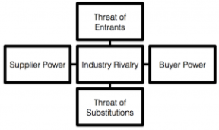
External environmental factors significantly impact JLR's organizational culture (Goffin and others, 2014). These factors can be analysed using the framework of Porter's Five Forces. In (1979), Michael Porter created Porter's Five Dynamics framework to assess the competitive dynamics within an industry. It helps businesses, including Jaguar Land Rover (JLR), understand the dynamics of their industry and make strategic decisions (Dobbs, 2014). The five forces are:
(Source design by Hopper, 2014)
- Bargaining Power of Suppliers: This power investigates the bargaining power of suppliers and its impact. have on JLR. By assessing the supplier landscape and their power to set prices or control the supply of critical components, JLR can negotiate favourable terms, maintain quality, and ensure a stable supply chain (Kumar, 2008).
- Bargaining Power of Buyers: This force focuses on the power of JLR's customers. Understanding customer preferences, demands, and their ability to negotiate prices and switch to alternative brands allows JLR to customise its goods, services, and client interactions to fulfill and surpass customer expectations (Dobbs, 2014).
- 3. Competition: The amount of competitiveness in the automobile business is assessed by this force. JLR analyzes the strategies, market share, and capabilities of its competitors to position itself effectively (Zhang and Iles, 2014). It helps JLR identify areas for differentiation, improve its competitive advantage, and stay ahead in the market.
- Threat of New Entrants: This influence evaluates the probability of new competitors arriving in the automotive industry. JLR needs to be aware of potential new entrants and their ability to disrupt the market. By understanding the barriers to entry, JLR can develop strategies to protect its market share and strengthen its position (Pandey, A. and Kumar, nd).
- Threat of Substitutes: This group investigates alternate products or services. potentially replace JLR's offerings. By understanding substitute products, such as electric vehicles or ride-sharing services, JLR can adapt its product portfolio and develop strategies to differentiate its offerings and maintain customer loyalty (Gomes and others, 2007).
Advantages of using Porter's Five Forces for JLR:
- Industry Analysis: It provides a systematic framework to assess the competitive forces and industry structure, helping JLR understand its market position.
- Strategic Decision-Making: The analysis helps JLR identify areas of opportunity, develop effective strategies, and allocate resources to enhance its competitive advantage (Dobbs, 2014).
- Risk Assessment: By analyzing the forces, JLR can identify potential risks and take proactive measures to mitigate them.
- Market Differentiation: The analysis highlights areas for differentiation, allowing JLR to develop unique features and experiences that set it apart from competitors (Herbane and others, 2014).
Disadvantages of using Porter's Five Forces for JLR:
- Simplified View: The model provides a high-level overview and may not capture all complexities of JLR's specific industry or market dynamics.
- Dynamic Industry: The analysis may not fully account for the rapid changes and disruptions in the automotive industry, potentially leading to incomplete insights (Pandey, A. and Kumar, nd).
- Internal Factors: The model focuses primarily on external factors, overlooking internal factors such as organizational culture, capabilities, and resources that also influence JLR's competitiveness.

Ethical Behaviour and Culture at Jaguar Land Rover
Ethical behaviour is an integral aspect of any organization's culture, guiding decision-making, shaping values, and influencing stakeholders' perceptions (Man‐Fong Ho, 2011). For companies like Jaguar Land Rover (JLR), a renowned automotive manufacturer, embracing strong ethical principles is crucial in sustaining long-term success and ensuring responsible business practices (Barraquier, 2011). This section delves into the general theories of ethical behaviour and their impact on JLR's culture. Subsequently, it explores key ethical elements within the company's culture, identifies potential ethical dilemmas, applies an appropriate ethical framework, discusses barriers to effective functioning, and finally provides recommendations for enhancing workplace culture and organizational efficiency, drawing inspiration from Kotler's 8-Step Plan for ethical decision-making.

Key Ethical Elements within JLR's Culture and Their Promotion
Within JLR's culture, several key ethical elements form the foundation of the company's commitment to responsible and sustainable business practices. These elements include:
Integrity: JLR places great importance on maintaining honesty and transparency in its operations, dealings with stakeholders, and interactions with customers (Media. Jaguar Land Rover, 2023). The company's ethical guidelines emphasize the significance of acting with integrity even in challenging situations.
Environmental Sustainability: JLR actively promotes environmentally friendly practices, such as reducing emissions, investing in electric vehicle technology, and implementing sustainable manufacturing processes (Davis, 2017). Environmental stewardship is ingrained in the company's values and decision-making.
Inclusivity and Diversity: JLR fosters a culture that respects and values individuals from diverse backgrounds, ensuring equal opportunities for all employees (Pathak, 2016). The company believes that embracing diversity enhances creativity, innovation, and overall organizational performance.

Fostering Ethical Decision-Making at Jaguar Land Rover: Applying Kotler's 8-Step Plan
Ethical behaviour is the cornerstone of responsible corporate conduct and vital for sustaining enduring success in the current global corporate environment (Zhang and Iles, 2014). Jaguar Land Rover (JLR), a prominent automotive manufacturer, recognizes the significance of ethical decision-making in shaping its corporate culture and maintaining a positive reputation. The Kotler's 8 Step Plan model, an effective framework for ethical decision-making, to analyse how JLR can nurture an ethical culture and overcome potential dilemmas.
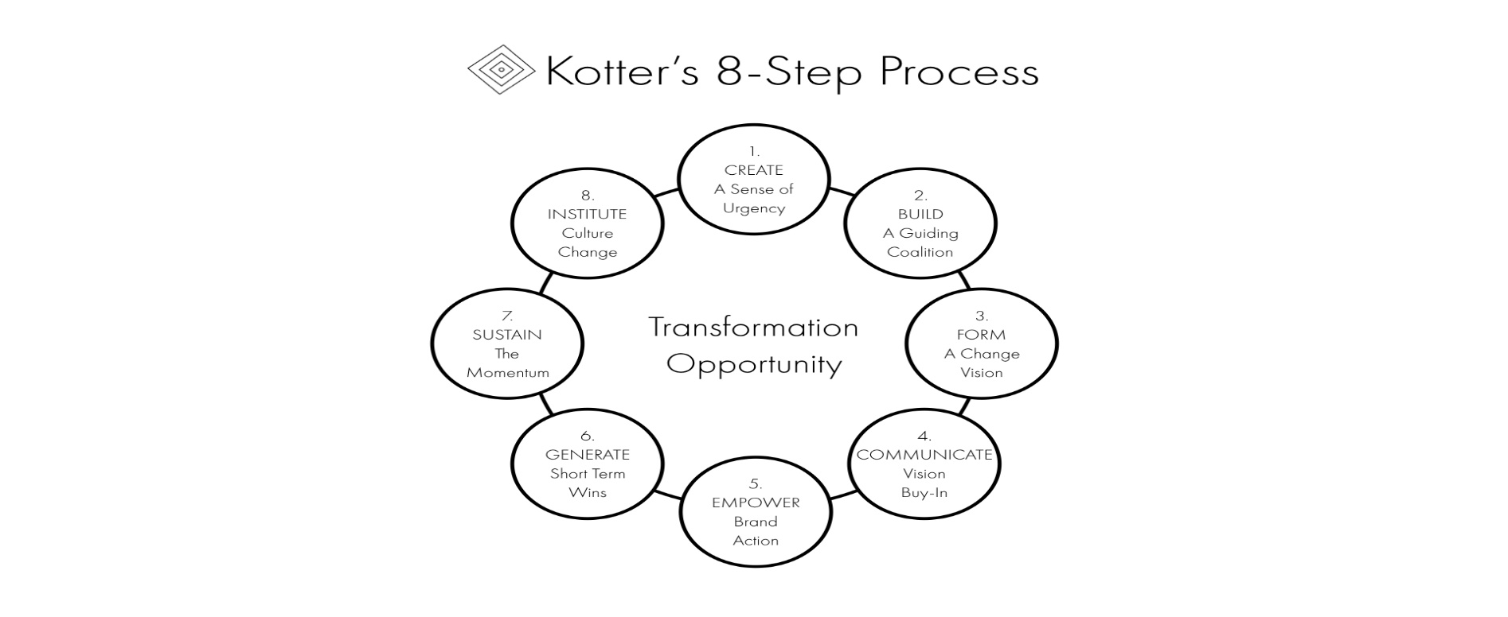
(Source design by Strategyumwelt, 2019)
I. Step 1: Define the Ethical Problem and Key Issues
JLR must clearly define ethical problems and key issues to address potential dilemmas. For instance, the company may face dilemmas related to environmental impact, supplier relationships, or customer safety (Dobbs, 2014). By identifying these challenges, JLR can proactively devise ethical strategies.
II. Step 2: Identify Stakeholders' Interests
Understanding stakeholders' interests is paramount for JLR's ethical decision-making. Stakeholders include customers, employees, investors, suppliers, and the wider community. For example, customers may value eco-friendly vehicles, while employees may prioritize a diverse and inclusive work environment (Zhao and Liu, 2020).
III. Step 3: Consider All Legal and Industry Norms
JLR must align its ethical decisions with relevant laws and industry norms. Compliance with regulations ensures ethical practices. For instance, JLR's commitment to safety standards in vehicle manufacturing reflects its adherence to industry norms (Dobbs, 2014).
IV. Step 4: Develop Ethical Action Plans
Incorporate ethical action plans to address identified issues. For example, JLR can establish stringent sustainability practices, such as reducing carbon emissions and promoting recycling in its manufacturing processes (Pandey, A. and Kumar, nd).
V. Step 5: Communicate Ethical Decisions Transparently
Effective communication is vital for ethical decision-making. JLR should transparently communicate its ethical initiatives internally and externally. Transparent communication builds trust with stakeholders, fostering a positive corporate image (Saunders,2011).
VI. Step 6: Monitor and Evaluate Ethical Performance
Regular monitoring and evaluation of ethical performance enable JLR to assess the effectiveness of its initiatives. Tracking progress against ethical goals helps the company stay accountable (Pandey, A. and Kumar, nd).
VII. Step 7: Address Ethical Breaches Swiftly
In the event of an ethical breach, JLR must respond promptly. Swift and appropriate action showcases the company's commitment to ethical standards and strengthens trust with stakeholders (Smit and Bierman, 2017).
VIII. Step 8: Continuous Improvement of Ethical Practices
JLR should continually improve its ethical practices by learning from past experiences and industry developments. Emphasizing continuous improvement fosters a culture of ethical awareness and adaptability (Nath and Dwivedi, 2021).

Barriers to Effective Functioning of JLR's Ethical Culture
While Jaguar Land Rover (JLR) has demonstrated a commitment to ethical behaviour, certain barriers may hinder the effective functioning of its ethical culture. These barriers can include:
- Lack of Clear Communication and Guidance: Without clear communication and guidance on ethical guidelines and principles, employees may face difficulty in understanding and navigating ethical dilemmas (Dobbs, 2014). It is essential for JLR's leadership to communicate ethical expectations explicitly and provide practical examples to help employees make ethical decisions in their day-to-day roles.
- Inadequate Training and Awareness Programs: Employees need to be equipped with the necessary knowledge and skills to handle ethical challenges effectively. Inadequate training and awareness programs may impede their ability to identify and address ethical issues appropriately (Pathak, 2016). Regular and comprehensive ethical training sessions are crucial to ensure that employees understand the company's ethical values and have the tools to apply them in real-world situations.
- Pressure to Meet Business Targets: In a competitive industry, there may be pressure on employees to achieve business targets, which could potentially lead to ethical compromises ( Nath and Dwivedi, 2021). JLR must strike a balance between driving performance and upholding ethical standards, reinforcing the importance of ethical behaviour even in challenging circumstances.

Recommendations
To enhance workplace culture and organizational efficiency, JLR can implement the following recommendations:
- Strengthen Ethical Training: Implement comprehensive training programs that provide practical guidance on ethical decision-making, including real-life scenarios and case studies.
- Establish Ethical Committees: Form dedicated ethical committees within the organization to provide insights and recommendations on complex ethical dilemmas.
- Implement an Ethical Decision-Making Framework: Adopt a structured ethical decision-making framework, such as Kotler's 8 Step Plan, to analyse ethical problems and develop appropriate action plans.
- Monitor Ethical Outcomes: Regularly assess the outcomes of ethical decisions and actions to ensure alignment with ethical goals and make data-driven improvements as needed.

Conclusion
Applying workplace culture theories at Jaguar Land Rover (JLR) fosters a positive and effective organizational environment. Organizational Culture Theory promotes employee engagement and unity, Competing Values Framework enhances innovation and customer-centricity, and Person-Organization Fit Theory ensures employees align with the company's values. By striking a balance and leveraging the advantages of these theories, JLR can thrive as a leading premium automotive manufacturer. SWOT analysis provides valuable insights into JLR's internal strengths, weaknesses, external opportunities, and threats. It aids in strategic planning, risk mitigation, and informed decision-making. JLR should be mindful of potential subjectivity, limited scope, and lack of prioritization in applying the SWOT model. Complementing the analysis with additional research can enhance its understanding of the competitive landscape. Porter's Five Forces analysis helps JLR assess competitive dynamics, make strategic decisions, and identify areas for differentiation. It should be complemented with an analysis of internal factors to develop a comprehensive understanding of JLR's competitive position. Embracing ethical behavior is crucial for JLR's success and sustainability. By nurturing a culture of integrity, environmental sustainability, inclusivity, and diversity, JLR ensures responsible decision-making. Applying Kotler's 8 Step Plan and overcoming barriers enhances JLR's workplace culture and organizational efficiency.

References

Allaire, Y. and Firsirotu, M.E. (1984). ‘Theories of organizational culture’, Organization studies, 5(3), (pp).193-226.
BALI, S. (2016). COMPARATIVE ANALYSIS OF TATA-JLR AND VOLKSWAGEN-SKODA MERGER. Doctoral dissertation, Christ University.
Barraquier, A. (2011). ‘Ethical behaviour in practice: Decision outcomes and strategic implications’, British Journal of Management, 22, (pp).S28-S46.
Batra, B.S. and Khairajani, D.B. (2012). ‘An Understanding of TATA-JLR deal with the concepts of Downsizing, Corporate Culture and Leveraged Buyout’, Management, 2(3).
Broughton, A. and Strebler, M. (2008). ‘Reaping benefits from diversity’, Strategic HR Review, 7(5), (pp)5-10.
Colbert, C. (2016). Case Study of TATA Motors: SWOT Analysis and Strategy Suggestions, Doctoral dissertation.
Davis, M. (2017). Effective vehicle attribute delivery at Jaguar Land Rover: innovation report, Doctoral dissertation, University of Warwick.
Dobbs, M.E. (2014). ‘Guidelines for applying Porter's five forces framework: a set of industry analysis templates’, Competitiveness review, 24(1), (pp).32-45.
Fassin, Y. (2005). ‘The reasons behind non-ethical behaviour in business and entrepreneurship’, Journal of business ethics, 60, (pp).265-279.
Goffin, K., Hopkin, P., Szwejczewski, M. and Kutsch, E. (2014). Roads to resilience: Building dynamic approaches to risk to achieve future success. Airmic.
Gomes, E., Donnelly, T., Morris, D. and Collis, C. (2007). ‘Improving Merger Process Management Skills Over Time: A Comparison Between the Acquisition Processes of Jaguar and of Land Rover by Ford’, Irish Journal of Management, 28(1).
Gurl, E. (2017). SWOT analysis: A theoretical review. London
Hager, P. (2011). ‘Theories of workplace learning’, The SAGE handbook of workplace learning, (pp).17-31.
Hedley, B. (1976). ‘A fundamental approach to strategy development’, Long Range Planning, 9(6), (pp).2-11.
Herbane, B., Elliott, D. and Swartz, E.M. (2004). ‚Business continuity management: time for a strategic role?’, Long range planning, 37(5), pp.435-457.
Johnson, D.A. (2008). Job satisfaction in the operating room: An analysis of the cultural competence of nurses, Doctoral dissertation, Capella University.
Kumar, N. (2008). ‘Internationalization of Indian enterprises: patterns, strategies, ownership advantages, and implications’, Asian Economic Policy Review, 3(2), (pp).242-261.
Man‐Fong Ho, C. (2011). ‘Ethics management for the construction industry: A review of ethical decision‐making literature’, Engineering, construction and architectural management, 18(5), (pp).516-537.
Nath, K. and Dwivedi, R. (2021). ‘Aesthetic Exploration of Organizational Theatrics: a Case of Tata Motors’ Jaguar Land Rover Acquisition’, Philosophy of Management, 20(3), (pp).369-386.
Pandey, A. and Kumar, A. (nd). ‘Application of Porter Model on Chinese Auto. Science, Technology’, Humanities and Business Management, ICSTHBM-16, (pp).65.
Pathak, A.A. (2016). ‘Tata Motors’ successful cross-border acquisition of Jaguar Land Rover: key take-aways’, Strategic Direction, 32(9), (pp).15-18.
Saunders, D. (2011). ‘Jaguar Land Rover goes for speed’, Strategic HR Review, 10(1).
Smit, A.M. and Bierman, E.J. (2017). ‘An evaluation of the reporting on ethics and integrity of selected listed motor vehicle companies’, African Journal of Business Ethics, 11(1).
Turnbull, P., Oliver, N. and Wilkinson, B.(1992). ‘Buyer‐supplier relations in the UK‐automotive industry: Strategic implications of the Japanese manufacturing model’, Strategic Management Journal, 13(2), (pp).159-168.
Willcoxson, L. and Millett, B. (2000). ‘The management of organisational culture’, Australian Journal of Management and Organisational Behaviour, 3(2), (pp).91-99.
Yin, E., Ansari, S. and Akhtar, N. (2017). ‘Radical Innovation, Paradigm Shift and Incumbent’s Dilemma The Case of the Auto Industry’, Future Studies Research Journal: Trends and Strategies, 9(1), (pp).138-148.
Zhang, C. and Iles, P. (2014). ‘Organizational culture’, Strategic human resource management: An international perspective, (pp).407-457.
Zhao, F., Tan, H. and Liu, Z. (2020). Analysis of the business models of the intelligent and connected vehicle industry. In MATEC Web of Conferences (Vol. 325, p. 04002). EDP Sciences.

