University of Wales Trinity Saint David Birmingham
BA (Hons) Business Management
LCBB5000 Data Handling and Business Intelligence

Individual report
Processing time analysis of different tools used by GreenMed

Author: Elena Turcanu, Student nr 2127547
Lecturer: Zahra Mohammadnazari

Introduction
In this report, we will utilize SPSS statistical software to delve into the GreenMed_Healthcare_2023 dataset. Our analysis will revolve around key metrics that illuminate the performance of various tools and platforms in healthcare data management. Specifically, we aim to answer questions such as the mean processing time with Hadoop, the median processing time with Spark, the date of highest processing time for R, the standard deviation for Python processing time, and which tool boasts the lowest average processing time. Also using SPSS we will determine correlation between processing times of Hadoop and Tableau and will produce a scatterplot of the two variables.
Using Excel, we will create a chart to visualize the average time of processing of each tool.
Through these investigations, we seek to interpret the disparities in processing times among different tools and platforms, providing valuable insights for decision-making in the healthcare data processing realm.
- Let’s proceed with descriptive analysis, for which I will use SPSS software.
- First we will analyse the mean of Hadoop_processing_time:
The "mean" in statistics refers to the average value of a set of numbers. It's calculated by adding up all the values in a dataset and then dividing that sum by the total number of values. In SPSS (Statistical Package for the Social Sciences), we can easily calculate the mean using the following steps:
- Entering Data: Input your data into SPSS in a dataset.
- Calculating Mean in SPSS:
- Go to the "Analyze" menu.
- Select "Descriptive Statistics."
- Choose "Descriptives."
- In the "Descriptives" dialog box, move the variable(s) for which you want to find the mean from the left box to the right box.
- Click on the "Options" button within the "Descriptives" dialog box.
- Check the box next to "Mean" to request the mean value(s).
- Click "OK."
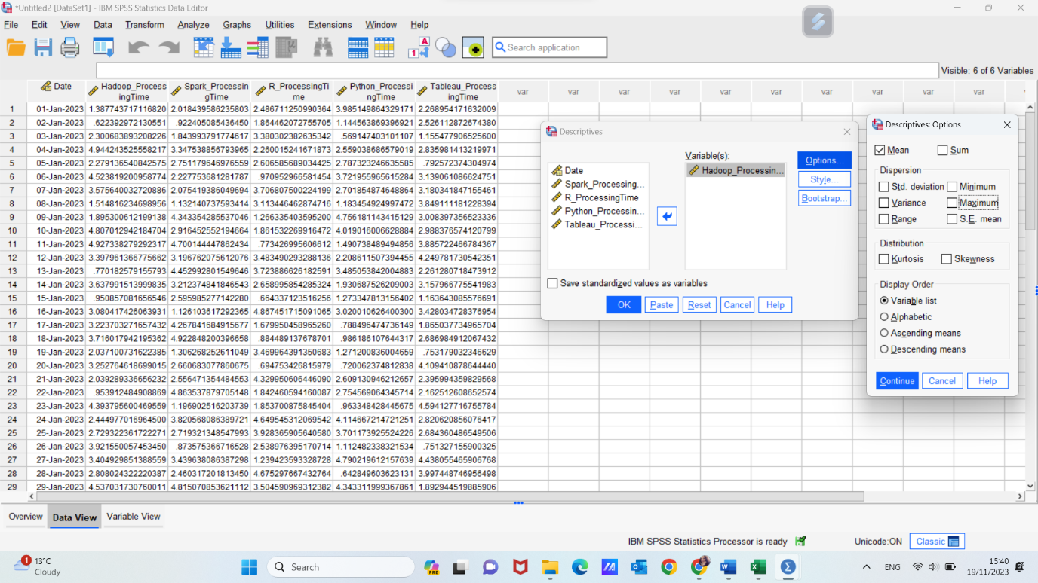
SPSS will generate output that includes the mean value for the variable you selected.
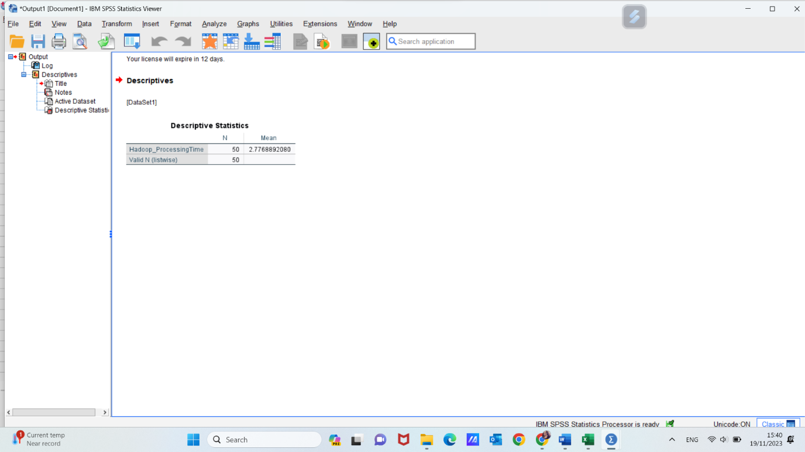
The above result suggests that the average time of processing date when using Hadoop is 2.7768 units.
Remember, the mean is sensitive to outliers in your data, meaning extreme values can significantly affect the average. If your dataset has outliers, you might also want to consider examining the median or other measures of central tendency to better understand the data's typical values.

- Median
The median, a statistical measure of central tendency, represents the midpoint within a dataset once the values are sorted in either ascending or descending order. In instances with an odd number of observations, the median corresponds to the precise middle value. In cases with an even number of observations, the median is determined by calculating the average between the two central values.
To calculate the median in SPSS:
- Go to the "Analyze" menu.
- Select "Descriptive Statistics."
- Choose "Descriptives."
- Move the variable(s) for which you want to find the median from the left box to the right box in the "Descriptives" dialog box.
- Click on the "Options" button within the "Descriptives" dialog box.
- Check the box next to "Median" to request the median value(s).
- Click "OK."
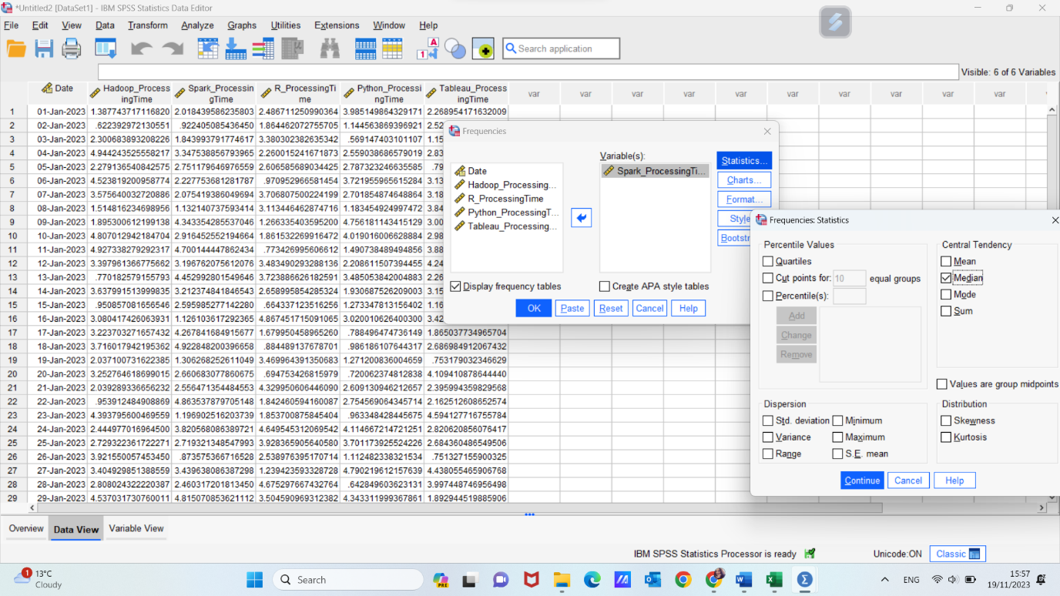

SPSS will generate output that includes the median value for the variable you selected.
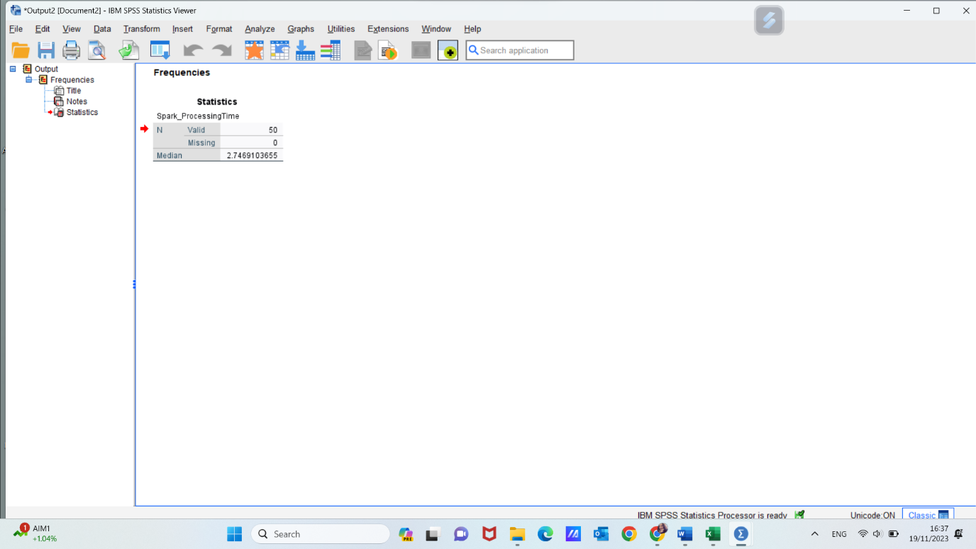

The median processing time for Spark, at 2.7459, suggests that approximately half of the observed Spark processing times in the dataset fall below this value, and the other half fall above it.
The median is particularly useful when dealing with skewed distributions or datasets with outliers, as it's less sensitive to extreme values compared to the mean.

- Farther, using SPSS and descriptive analysis, we will determinate the date when “R” registered the higher processing time.
We will use the AGGREGATE function to find the maximum processing time for "R" while keeping track of the corresponding date.
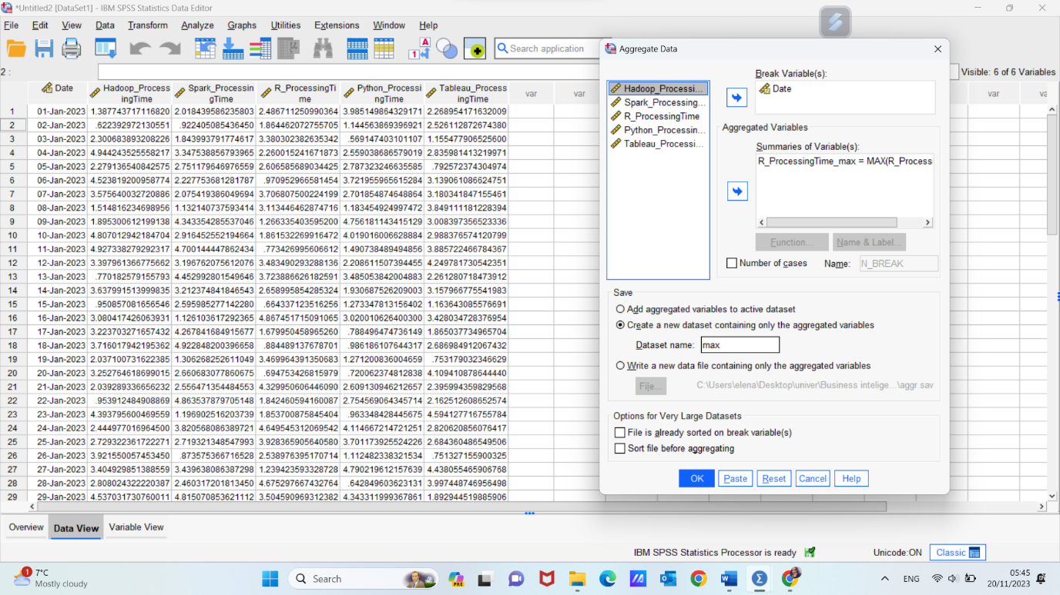
- This function will create a new dataset with the date and maximum "R" processing time.
- Sort this new dataset in descending order of "Max_R_Processing_Time" to bring the highest processing time to the top.
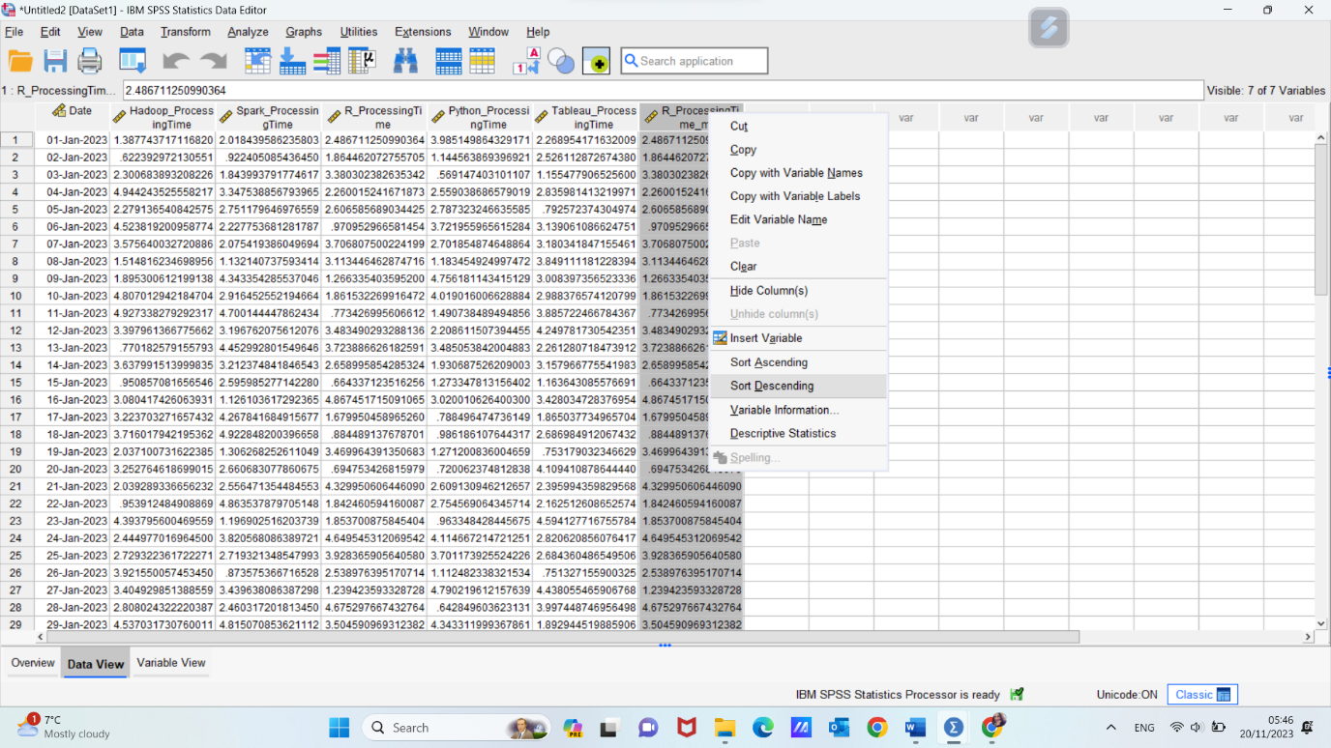
- The first row of the sorted dataset will contain the date on which "R" had the highest processing time.
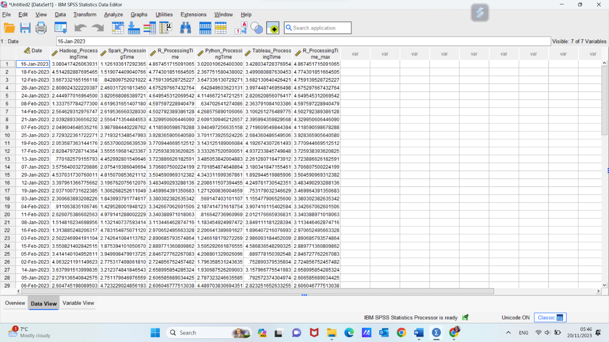

According to our results, tool “R” registered the higher processing time on 16 January 2023.

- Our next step into descriptive analysis of GreenMed data set is to find and interpret standard deviation of Python_Processing_Time.
The standard deviation serves as a metric that gauges the extent of variability or spread within a set of values. It numerically expresses the degree of diversity or dispersion that exists between the values and their mean (average).
Standard deviation Using SPSS:
- Open the "GreenMed_Healthcare_2023" dataset in SPSS.
- Go to the "Analyze" menu and select "Descriptive Statistics," then "Descriptives."
- In the "Descriptives" dialog box, select the "Python_Processing_Time" variable and move it to the "Variables" box.
- In the "Options" tab, check the "Standard deviation" box.
- Click "OK" to generate descriptive statistics, including the standard deviation for Python processing times.

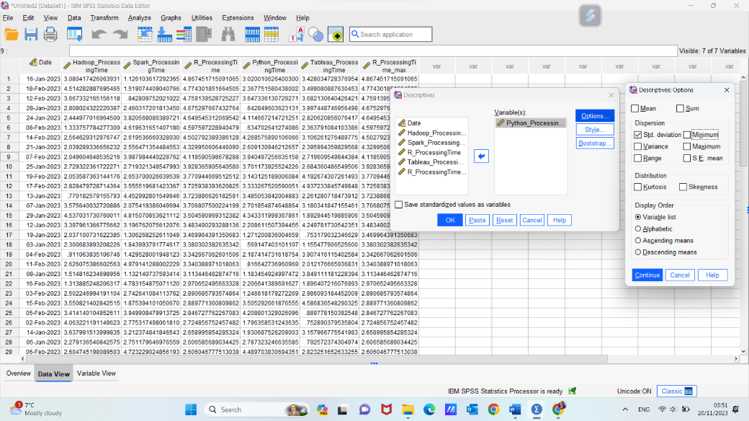

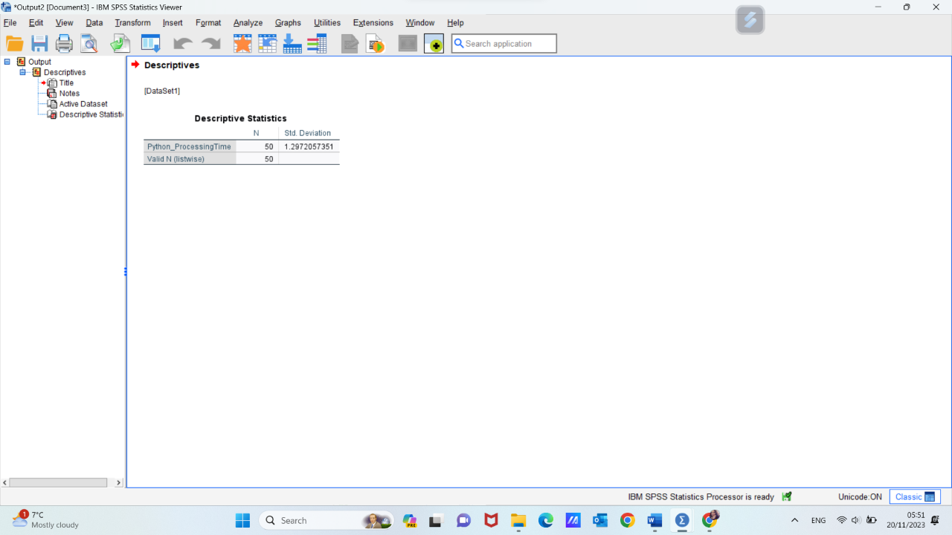

A standard deviation of 1.2972 indicates the average amount of deviation or spread of individual Python processing time values from the mean. In other words:
If the standard deviation is low, like in this case, it suggests that the majority of Python processing times are relatively close to the mean, and there is less variability in the dataset.
If the standard deviation were higher, it would indicate a greater degree of variability, with processing times more widely dispersed from the mean.
In practical terms, a standard deviation of 1.2972 suggests that, on average, Python processing times deviate by approximately 1.2972 units from the mean processing time. This can be useful information for understanding the consistency or variability in Python processing times. A lower standard deviation often implies more stability and predictability in the dataset, while a higher standard deviation may indicate a wider range of processing times with greater unpredictability.

- Our next step in understanding the best tool for healthcare data processing is to determine the average of using time for each tool and then to choose the smaller one, also using SPSS:
- Open the "GreenMed_Healthcare_2023" dataset in SPSS.
- Go to the "Analyze" menu and select "Compare Means," then "Means."
- In the "Means" dialog box, select all the processing time variables for different tools or platforms (e.g., Hadoop, Spark, R, Python, and Tableau). Move them to the "Dependent List" box.
- Click the "Options" button and check the "Descriptive statistics" box, choose mean and display order “ascending means”.
- Click "Continue" and then "OK" to generate means and descriptive statistics for each tool.
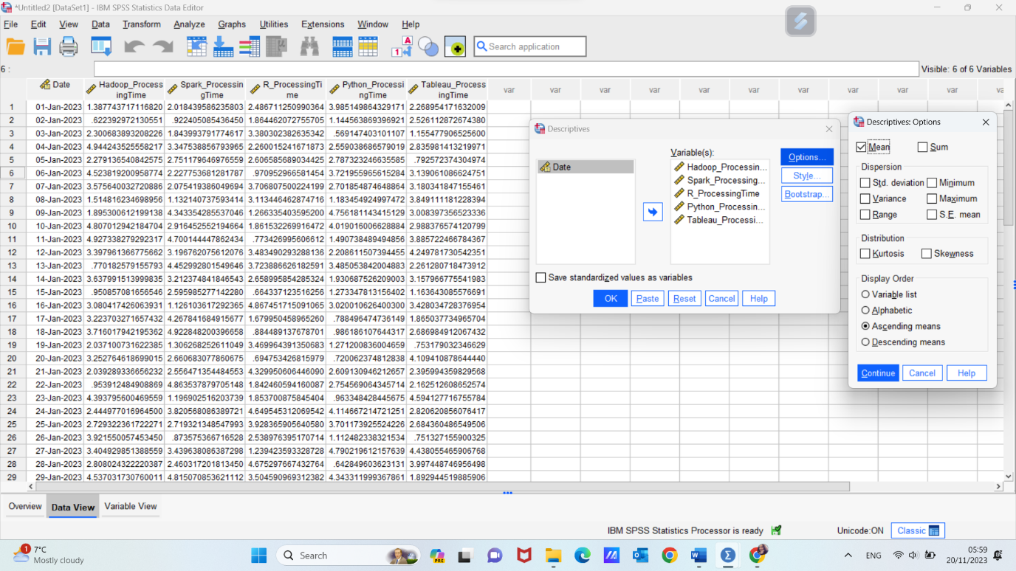

Examine the output to identify the tool or platform with the lowest average processing time, which is on the top of list, due to choosing options to display data ascending.
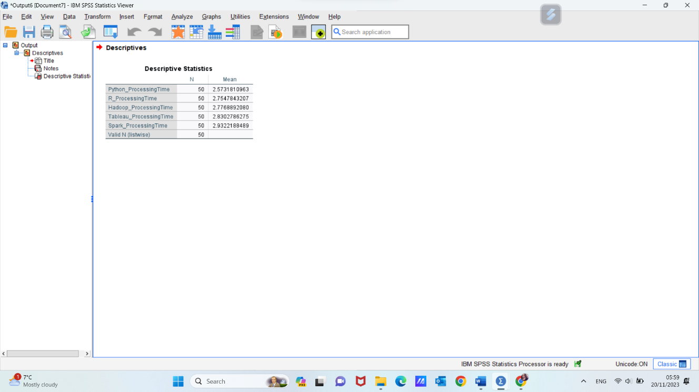
Python, with an average processing time of 2.5731, demonstrates efficiency and speed in the processing of tasks within the given dataset. Organizations often value lower average processing times, as they contribute to faster data analysis and decision-making processes.
This finding suggests that, based on the provided data, Python emerges as a tool with a competitive advantage in terms of processing efficiency compared to other tools in the dataset. Utilizing Python for specific tasks might contribute to streamlined data workflows and improved overall performance within the context of GreenMed Innovations' data analytics.

6. The descriptive statistics generated in the exercise above show the mean processing times for different technologies. Let’s go deeper into the previously results and analyse and other results:
- Python_ProcessingTime:
Mean: 2.573
This suggests that, on average, tasks executed using Python take approximately 2.573 units of processing time.
- R_ProcessingTime:
Mean: 2.755
The mean processing time for tasks executed using R is approximately 2.755 units.
- Hadoop_ProcessingTime:
Mean: 2.777
On average, tasks executed using Hadoop require approximately 2.777 units of processing time.
- Tableau_ProcessingTime:
Mean: 2.830
This represents an average processing time of approximately 2.830 units for tasks executed using Tableau.
- Spark_ProcessingTime:
Mean: 2.932
Tasks executed using Spark have an average processing time of approximately 2.932 units.

Analysis and Comparison:
- Spark vs. Others:
Spark has the highest mean processing time among the listed technologies, indicating that, on average, tasks processed using Spark take longer compared to Python, R, Hadoop, and Tableau.
- Python vs. Others:
Python has the lowest mean processing time among the listed technologies, indicating that, on average, tasks processed using Python take the least amount of time compared to R, Hadoop, Tableau, and Spark.
- Hadoop, R, Tableau:
These technologies fall in the middle range in terms of mean processing times, with Hadoop having a slightly lower mean compared to R and Tableau.
The interpretation might vary depending on the context. A higher processing time doesn't necessarily imply inefficiency; it could be due to the complexity of tasks or the specific nature of the technology.

- In order to perform a better visualization of our analysis, I will use pivot table and charts in MS Excel, by following next steps:
            - Create a Pivot Table
- Select Your Data: Highlight the range of your data, including headers.
- Insert Pivot Table: Go to the "Insert" tab on the Excel ribbon. Click on "PivotTable" and choose where you want to place the pivot table (either a new worksheet or an existing one).
- 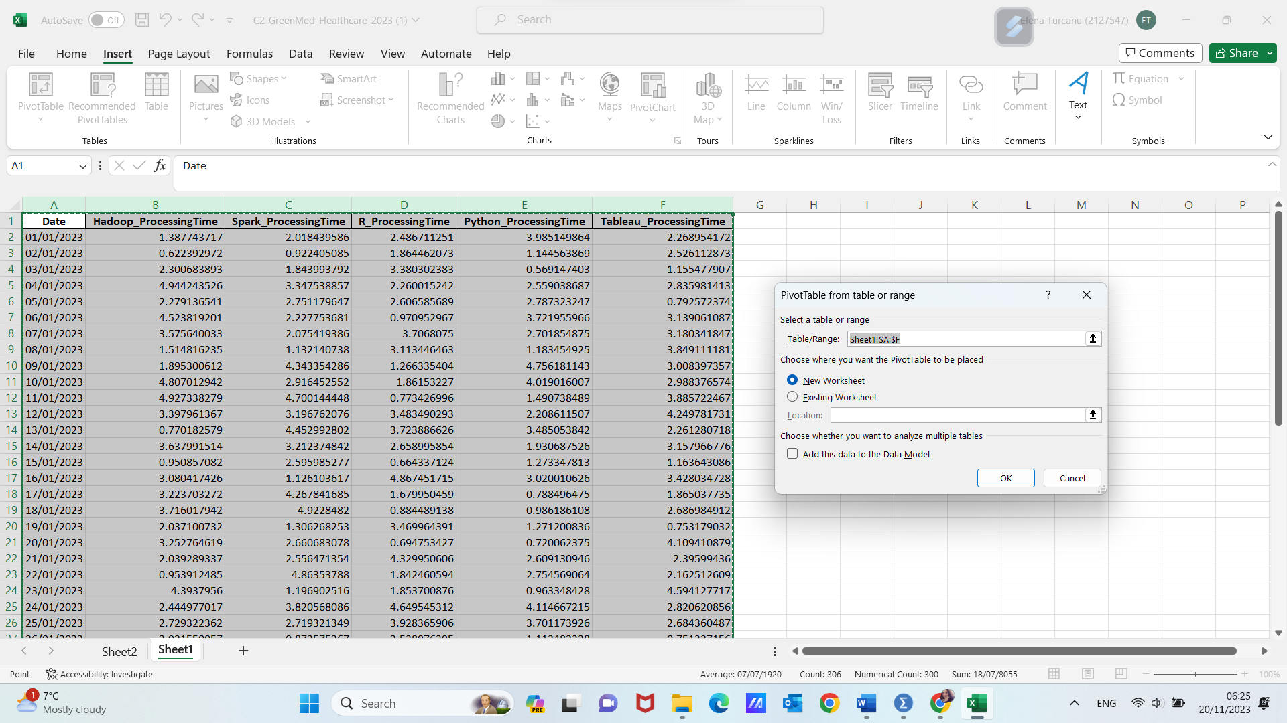

- Configure the Pivot Table:
In the PivotTable Field List: Drag the variable names to the "Rows" area. Drag the same variable names to the "Values" area. For each variable, select "Value Field Settings" and choose "Average" to calculate the mean.
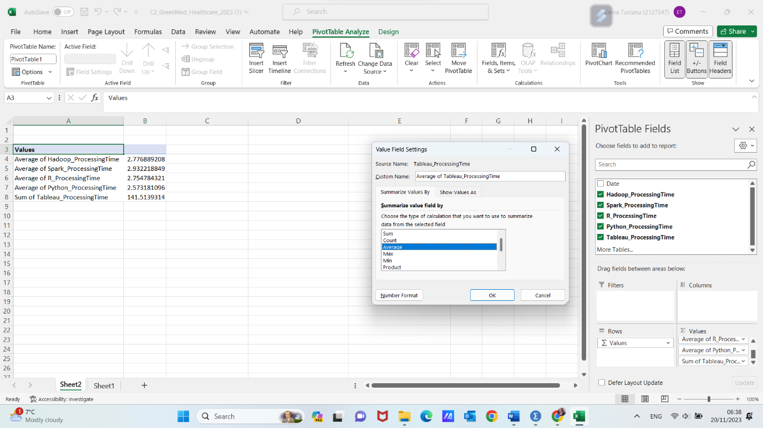

- Create Charts
- Highlight the Pivot Table: Select the cells containing your pivot table.
- Insert a Chart: Go to the "Insert" tab on the Excel ribbon. Choose the type of chart you want. For this example, let's use a bar chart.
- Excel will automatically generate a chart based on your selected data.
- Customize the Chart: Right-click on different elements of the chart to format and customize it according to your preferences.
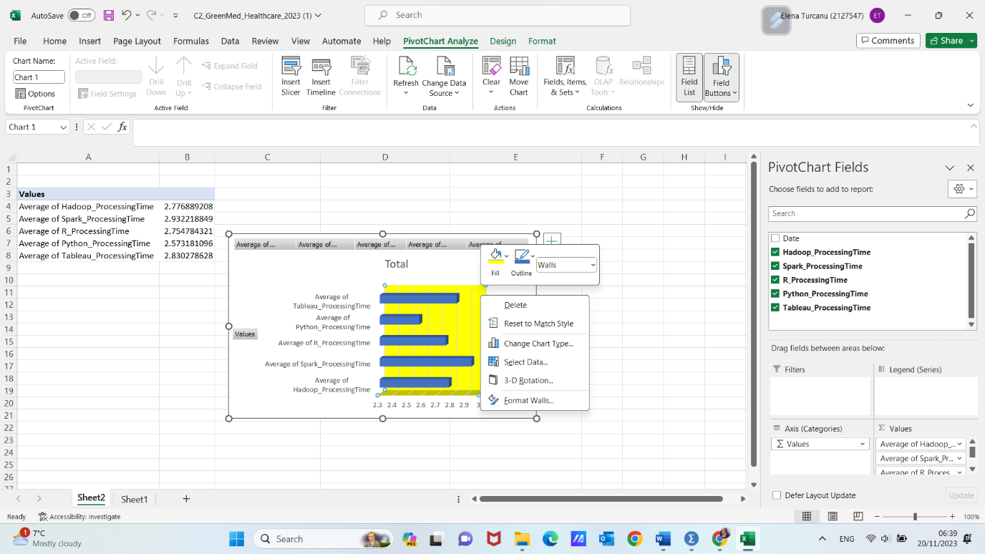
The pivot table calculates the mean for each variable, providing a clear summary of the average processing times.
Charts visually represent this information, making it easier for readers to grasp and compare the processing times for different technologies.
By following these steps, we can effectively present our data using Microsoft Excel, combining pivot tables and charts for a comprehensive and visually appealing analysis.

- Our next step of analysing efficiency of different tools used by GreenMed is to determinate correlation between 2 of the variables using SPSS.
- We are going to explore the correlation between the processing times of Hadoop and Tableau. Correlation measures the strength and direction of a linear relationship between two variables.
Here's how we'll approach this task:
- Data Analysis: Proceed to the "Analyse" menu in SPSS.
- Correlation Procedure: Choose "Correlate" and then select "Bivariate" since we are examining the relationship between two variables.
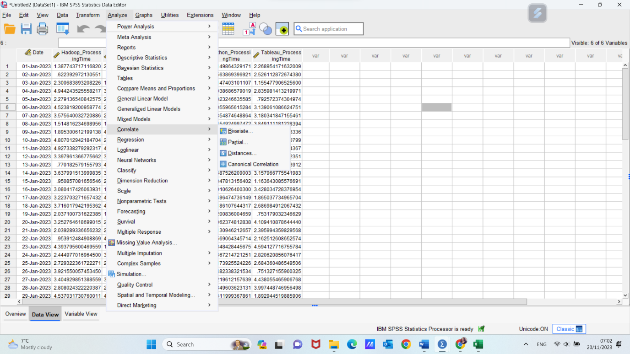
- Variable Selection (Again): In the Bivariate Correlations dialogue box, move the variables of interest (Hadoop_ProcessingTime and Tableau_ProcessingTime) into the "Variables" box.
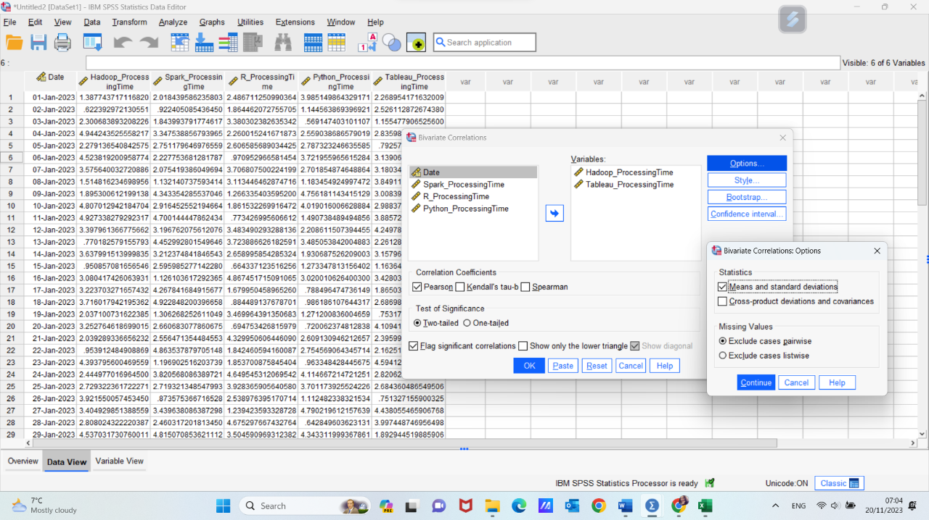
- Correlation Coefficient: SPSS will generate output that includes the correlation coefficient (Pearson correlation coefficient by default) between the processing times of Hadoop and Tableau.
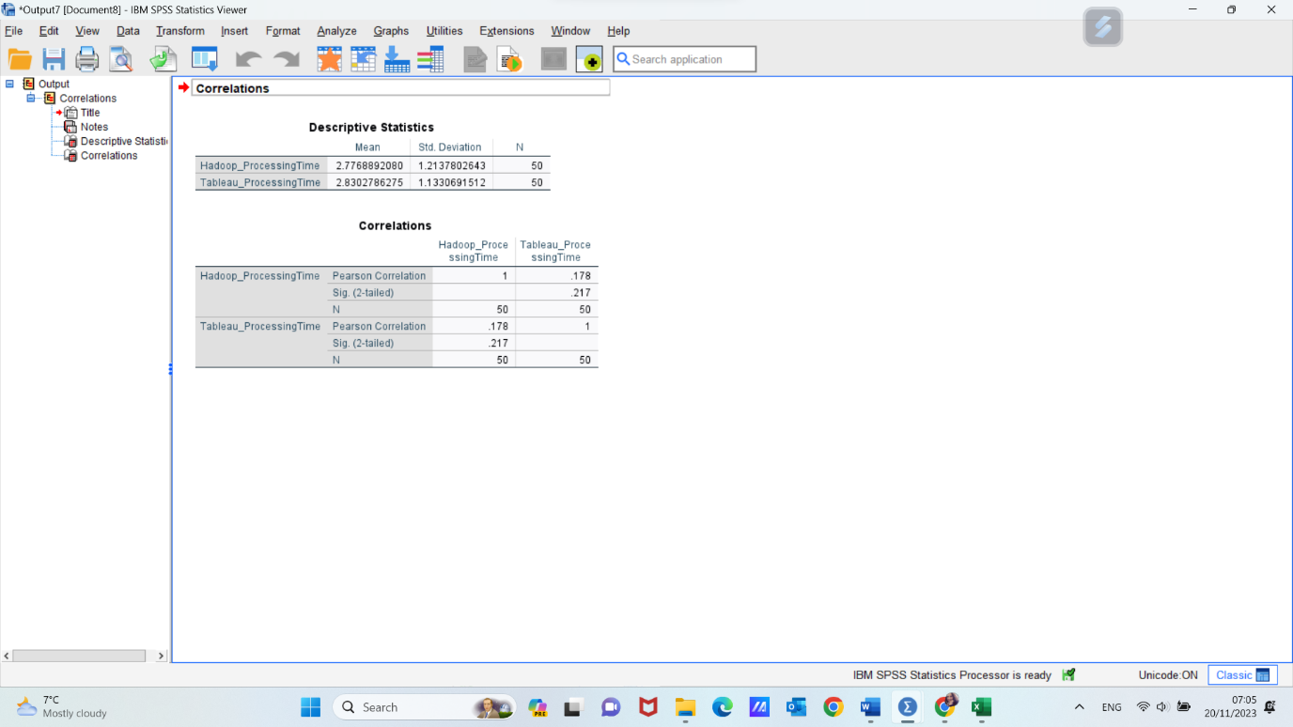
The correlation coefficient between Hadoop_ProcessingTime and Tableau_ProcessingTime is 0.178. The interpretation of this result involves understanding both the direction and strength of the correlation:
- Direction of Correlation (Positive or Negative):
The correlation coefficient is positive (0.178). This indicates a positive correlation between Hadoop_ProcessingTime and Tableau_ProcessingTime. In simpler terms, as the processing time for Hadoop increases, the processing time for Tableau tends to increase as well.
- Strength of Correlation:
The correlation coefficient is a measure of the strength of the linear relationship between two variables. A coefficient of 0.178 suggests a relatively weak positive correlation. While there is a positive tendency, it is not a strong relationship.
- Interpretation of 0.178:
Since the correlation coefficient is less than 0.3, it falls into the category of a weak correlation. This means that there is some degree of positive association between the processing times of Hadoop and Tableau, but the relationship is not strong.
- Practical Implications:
A weak positive correlation suggests that changes in Hadoop processing time are associated with some changes in Tableau processing time, but the impact is not substantial. It is important to note that correlation does not imply causation; the variables might be influenced by other factors.

- Creating a scatterplot can offer a visual representation of the relationship between Hadoop_ProcessingTime and Tableau_ProcessingTime. Here's how you can produce a scatterplot in SPSS and interpret the graph:
Producing a Scatterplot in SPSS:
- Access the "Graphs" Menu: Go to the "Graphs" menu in SPSS. Choose “Chart builder”.
Select "Scatter" and then choose "Simple Scatter."
- Define Variables: In the "Simple Scatter" dialogue box, select Hadoop_ProcessingTime as the "X-Axis" variable and Tableau_ProcessingTime as the "Y-Axis" variable.
- Customize Options (Optional): You can customize the scatterplot by adding titles, axis labels, and other formatting options according to your preferences.
- Tick Linear Fit Lines “Total”
- Generate the Scatterplot: Click "OK" to generate the scatterplot.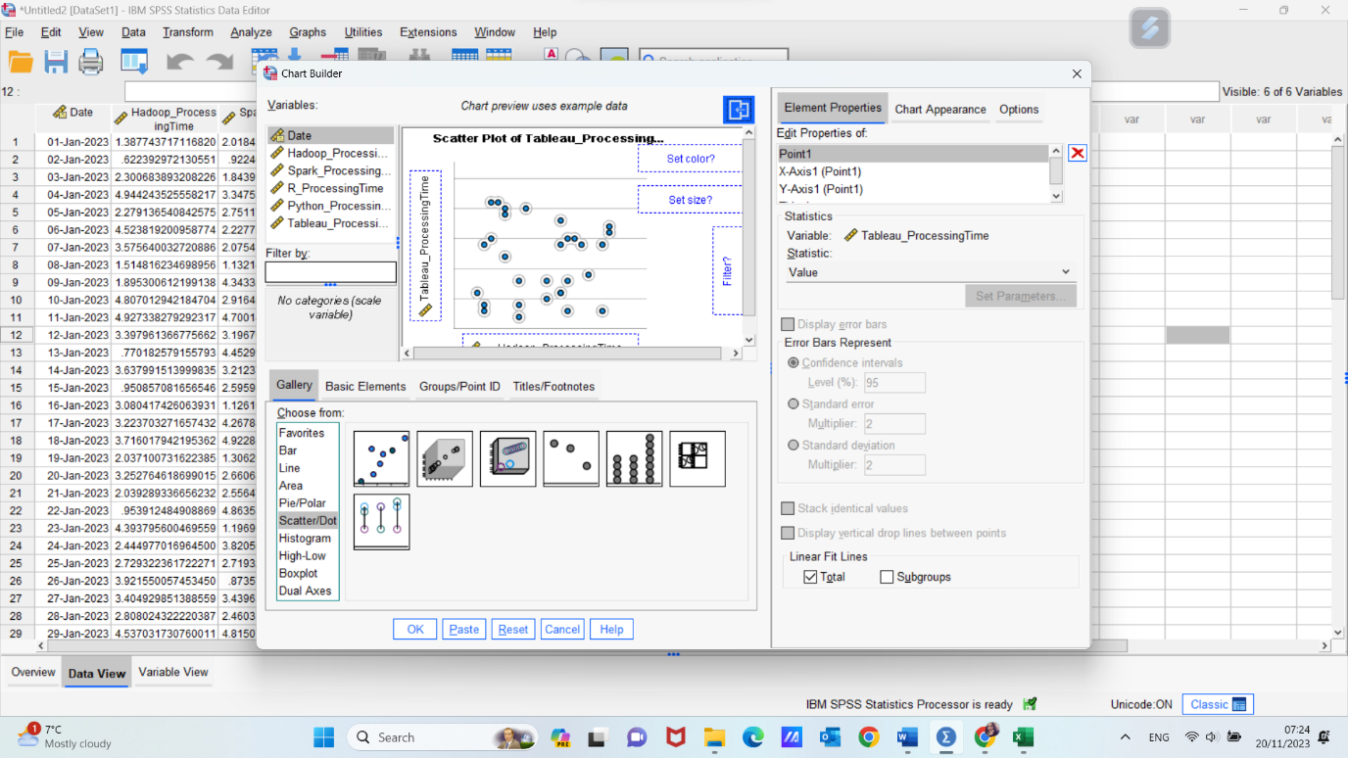
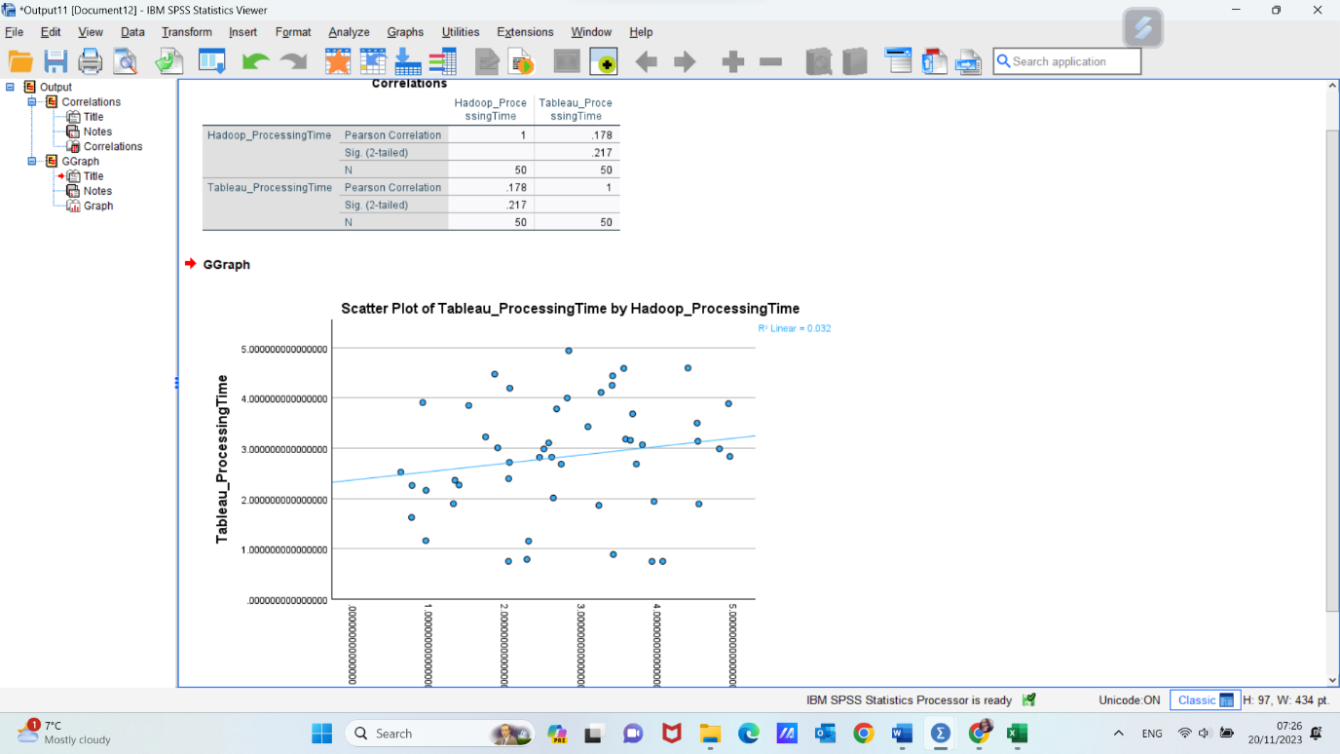

The result is a visualization of corelation determined previously. The scatterplot reflect the weak positive correlation suggested by the correlation coefficient of 0.178. Due to the weak correlation, the points on the scatterplot are somewhat scattered, and there is not a clear and tight clustering of points along the trend line.

Conclusion:
In conducting a thorough analysis of the "GreenMed_Healthcare_2023" dataset, we've embarked on a journey to unlock insights crucial for GreenMed Innovations' data-driven healthcare approach. Leveraging the capabilities of both Microsoft Excel and SPSS, our exploration holds significance beyond numerical metrics; it's about shaping the future of patient care through informed decision-making.
The integration of Microsoft Excel and SPSS demonstrates the versatility of combining practical tools with advanced statistical methodologies. This harmonious approach unlocks a spectrum of analytical possibilities.
Beyond the numerical outcomes, this analysis is about enhancing GreenMed's ability to leverage big data for optimal patient outcomes. It's a strategic initiative that aligns data processing strategies with the organization's commitment to innovation and excellence in healthcare.
In essence, this analysis is not just about numbers; it's about the transformative power of data in healthcare. It's about harnessing the potential within the dataset to drive positive change, fostering a future where informed decisions based on robust analytics contribute to a healthcare system that prioritizes and optimizes patient well-being.

Reference list:
- Ahmed, K., Mohammadnazari, Z. (2023) Data Handling & Business Intelligence (LCBB5000_BIRM), Birmingham, UWTSD.
- Carlberg, C. (2014) Statistical Analysis: Microsoft Excel 2013. USA. Pearson Education.
- Galetsi, P. Katsaliaki, K., & Kumar, S. (2020) Big data analytics in health sector: Theoretical framework, techniques and prospects. International Journal of Information Management, 50, 206–216.
- Udemy. (2023) Microsoft Excel - Excel with The Ultimate Excel Course. www.udemy.com
- Mamia, T. (2006) Quantitative research methods. General studies. ISSS.
- Landau, S., Everitt, B. S. (2003) A Handbook of Statistical Analyses Using SPSS, New York, Chapman and Hall/CRC, 1st Edition
- Satake EB. Statistical Methods and Reasoning for the Clinical Sciences Evidence-Based Practice. Ist ed. San Diego: Plural Publishing, Inc; 2015. pp. 1–19.

