
LEVEL 4

SEMESTER 2

MODULE CODE: SHSS4066
INTRODUCTION TO HEALTH AND EXERCISE PSYCHOLOGY
aSSESSMENT TYPE: ESSAY
Assessment/Component: 2

COMPONENT WEIGHTING: 50%

WORD COUNT: 1500 WORDS

MODULE TUTOR: ALISON CONNAUGHTON

SUBMISSION DETAILS:
Assignments should be submitted via Turnitin (Moodle) by 3pm on Friday the 4th of May, 2018.

TASK:
Discuss the current literature relating to ONE of the following topics.
- Exercising according to recommended guidelines
- Maintenance of a healthy diet
- Smoking
- Drinking alcohol above the recommended guidelines
- Occupational stress

You should discuss your chosen topic in the context of the implications for mental health for a population group of your choice. Using relevant research resources to support your answer, identify and explain THREE approaches or strategies that could be used to alter the situation in a positive way.

When writing your essay, you should aim to use at least 8 different good quality resources to support your ideas. The task of identifying good quality resources and identifying suitable populations will be discussed during the lectures. You should also refer to any relevant PDP lecture notes.

Submission Date:
Friday the 4th of May, 2018.

School of Sport, Health & Outdoor Education

Assessment Feedback Sheet

Student No./Name:
Module: Introduction to Health and Exercise Psychology
Module Code: SHSS-4066

Personal Evaluation – to support your academic progress please complete the section below BEFORE submitting your work.
What do you consider to be the best aspects of this work? |  |  | Improving my skills to reference evidence through the University Library website. Increasing IT skills to insert documents into Essays or Reports.
Which aspects do you consider could have been improved in this piece of work? |  |  | More specific use of specific Journal data sources, and understanding how to access these through research and the University Library website
What have you found most satisfying whilst undertaking this submission? |  |  | Familiarizing myself with various private and public sponsored campaigns and initiatives linking the Outdoors – particularly Walking – to support the achievement of minimum physical activity guidelines.
ASSESSMENT CRITERIA | Learning  Outcomes |  | GRADE
ASSESSMENT CRITERIA |  |  | Poor  < 20% | Weak  20-29% | Unsatisfactory  30-39% |  | Satisfactory  40 – 49% | Good  50 – 59% | Very Good  60 – 69% | Excellent  70 – 84% |  | Exceptional  85– 100% | %
Discuss the current literature for one of the listed topics as applied to a population of your choice. | 2,3 |  |  |  |  |  |  |  |  |  |  |  | 50%
Identify three approaches / strategies that could be used to alter the situation in a positive way. | 1,3,4 |  |  |  |  |  |  |  |  |  |  |  | 15%
Explain three approaches / strategies that could be used to alter the situation in a positive way. | 1,3,4 |  |  |  |  |  |  |  |  |  |  |  | 15%
Use relevant research resources to support your answer. | 2 |  |  |  |  |  |  |  |  |  |  |  | 20%
It is expected that students will present work that is proof read, correctly referenced and adheres to the Assessment Checklist. Therefore a range of 0 – 10 marks will be deducted for non-completion of any of the points on the checklist below.
TUTOR COMMENTS:

Submission date: 4/5/18  via Turnitin |  | Return date:  (at least within 4 weeks) |  |  |  | Tutor: Alison Connaughton |  |  |  |  | Mark:

Assignment Checklist

- Please complete the Personal Evaluation section of the Assessment Feedback sheet, add your name and details, and paste the whole of this assignment document into the front of your assignment

- Submission is a single word file, clearly labelled with your name and module code
- Font style - Times New Roman, size -12 for text and 14 for headings
- Ink colour – black only
- Line spacing – 1.5 line spacing and 2cm- 2.5cm page margins
- Quotations more than three lines to be indented 1 line spacing
- One line space between paragraphs, paragraphs must be left aligned
- Pagination (your assignment should have page numbers)
- All tables and figures are internally referenced and have a title
- Word count checked and written at end of text (before references and any appendix)
- Assignment is within 10% of the word limit (excluding references and any appendices)
- All references in the text are included in the reference list
- Correct referencing following the Harvard style, as described in the Palgrave study skills book ‘Cite them Right’.
- Correct spelling using UK English
- Correct use of punctuation
- Grammar and syntax correct- double check anything that has a green line under it
- I have read my assignment out loud to myself and it makes sense and is easy to read
- Somebody else has read my work and it makes sense to him or her!
- I have checked and I have not plagiarised
Failure to follow these guidelines will cost you marks!

Discuss the current literature relating to exercising to recommended guidelines, in the context of the implications for mental health, for a population cluster age 30 – 50 years. Using relevant research resources: identify and explain three approaches or strategies that could be used to alter the situation in a positive way.

Information relating to ‘exercising, or physical activity (PA) according to the recommended guidelines’ is provided by the UK Chief Medical Officer, as directed by the World Health Organization (WHO) (World Health Organization, 2018). For Adults this represents 75 minutes per week of aerobic vigorous intensity, or 150 minutes of aerobic moderate intensity – or a combination of both – plus muscle-strengthening involving major muscle groups which should be done 2 or more days a week. (See appendix 1). There are significant relationships and correlates for all demographics between physical activity and mental health, otherwise known as psychological well-being (PWB) (Biddle and Mutrie (2015). The population cluster, age 30 – 50 years are a key work-force group, of which many are office and desk-bound for their typical 8-hour working day, 5 days per week, along with time spent commuting by car or train, predominantly seated.

Physical activity outdoors is often termed as ‘Green Exercise’ (Barton et al, 2016) and reference is made to four variable components: individual, exercise and environment, and the processes component – psychological and physiological processes within the individual – in relation to these three former components. Moderate intensity Green Exercise can be chosen to be ‘Outdoors Walking’ for both leisure and a sport activity, and is also adaptable to be considered a ‘green prescription, as an alternative to prescriptive medication (Calogiuri et al., 2015). Green exercise can be managed to a FITT plan: an acronym for frequency, intensity, time and type; and ‘training’ in the mode of Walking can be during personal ‘free-time’, or incorporated into the ‘work-time’ schedule.

Our personal PWB includes how we feel, think and behave; how we cope with life; and how we feel about ourselves (MHFA England, 2018). There are a range of behaviours and mood states with negative connotations within the boundaries of normal behaviours and depressive states, though could further develop adversely. Specific and collective characteristics may be disorders that require ongoing clinical referral, or could be classified as ‘clinical depression’, (Biddle and Mutrie (2015). A multiplicity of studies have investigated both the effects and benefits of walking, both urban and in the countryside, and the resulting knowledge is far from complete, as concluded by Robertson and Jepson from their 2013 meta-analysis review, Mental Health and Physical Activity, (Jepson et al, 2013).

The National Health Service (NHS) provides online information on their ‘One You’ website (National Health Service, 2018) relating directly and indirectly to conditions which change throughout our lives, depending on many individual circumstances and various ‘Lifestyles’. Physical activity, a topic under ‘Moving’, is combined with ‘Protect Your Mind’ and a signpost for individuals to connect to ‘why’ their PA influences their mental well-being.

Taking exercise in the outdoors through walking in the countryside, can be related to 2 theories to explain the restorative environment of nature, with the positive effects on physical, psychological and social wellbeing. The Psycho-Evolutionary Stress Reduction theory (Ulrich, 1981) focuses on ‘Visual stimuli’, and hypothesises that nature promotes stress recovery (Barton et al, 2016). The Attention Restorative Theory (ART) promotes the use of ‘Involuntary attention’, and that the outdoors provides an opportunity to recover from mental fatigue, (Kaplan, S. 1995).

Depression is a particularly common psychiatric problem in the work-place, and findings from American employee health insurance data show a higher prevalence in women than in men, (Biddle and Mutrie, 2015 ). Information from WHO has projected that by the year 2030 depression will be the leading burden of disease and risk factor for disability-adjusted life expectancy, (Mathers and Loncar, 2006). Additionally WHO has stated that in affluent countries, 26% of men and 35% of women are not taking sufficient recommended guideline exercise, (WHO, 2010). Men and Women age 30 – 50, particularly in the work-place setting, are particularly suited to take advantage of a variety of physical activity initiatives and strategies to meet exercise guidelines, particularly Green Exercise through moderate-intensity Walking, to counter the potential ill-health consequences of a sedentary lifestyle.

Individuals introduced to Green Exercise initiatives may be at different stages of receptiveness to change, according to the ‘Transtheoretical model’ (TTM) theory, (Prochaska & DiClemente, 1992; Prochaska & Marcus 1994), or ‘Health Action Process Approach’ (HAPA) theory, (Schwarzer, 1992, 2001). Additionally, according to ‘Organismic Integration Theory’ (OIT), part of ‘Self-determination Theory’ (SDT) proposed by Deci & Ryan (1985), individuals will have varying levels of extrinsic and intrinsic motivation. Therefore when Physical Activity initiatives are initiated and communicated, it is important to use ‘inclusive Marketing strategies’, perhaps adopted on the company microsite, or similarly when explained face-face, addressed with a broad audience in mind.

The ‘Paths for All’ (pathsforall.org) strategy is a Scottish charity, founded in 1996 and is in partnership with 30 other national organizations, who champion and promote ‘Everyday Walking’. ‘Paths for All’ through its ‘Walking for Health’ projects is a leading delivery agent for the Scottish Government’s Physical Activity Strategy. They have supported over 200 community- based schemes and over 200 workplaces to develop walks. They also work to develop more opportunities and better environments, not just for walking, but also for cycling and other outdoor activities. They communicate digitally and have over 3000 Twitter followers. They presented 3 sessions on walking, physical activity and active travel at a recent ‘International Walk 21’ conference.

‘Paths for All’ recognize that getting colleagues and management on board from the onset is key to a successful workplace walking programme. There is a half-day ‘workplace walk leader’ course aimed at staff who will be involved in leading walks for colleagues. The ‘Workplace Step Count Challenge’ has been held in Spring and Autumn to encourage employees to increase their physical activity levels; the number of employees taking part has totalled almost 5,000, either as individual entrants, or as teams. Promotion and advertising has included radio and Facebook adverts, and direct approaches to Health Board CEO’s and Scottish Government contacts, along with significant social media activity around the challenge. In addition to the national challenges, two successful internal organization challenges have been delivered, one for West Lothian Council and one for Macmillan Cancer Support. There was a 5% increase in the number of challenge participants who reported meeting the physical activity recommendations after taking part.

The National Health Service choices, (NHS 2018) Live Well strategy promotes the ‘Walking for Health’ strategy. This initiative provides a comprehensive training guide for the individual to choose to practice whether in the countryside or in the town, either during the working day, or at leisure. The information explains Beginner preparation instructions regarding attire. It informs the individual to walk briskly, faster than a stroll, about 3 miles per hour. Details are given of digital Apps, such as Active 10 (available from the Apple App Store, or Google Play), which track pace/ speed and the distance walked, and provides both suggestions for goals to work towards, and rewards for progress to increase brisk walking activity. Regarding routes, the site suggests Walkit (Walkit, 2018) as an interactive Walk Planner and also Hikeideas (Hikeideas, 2018).
The site also suggests to ‘Mix it Up’ for inspiring walk ideas, and to view information on the ‘Walk Unlimited’ (Walkengland, 2018) website; here there is an extensive choice of other Walking Services, such as Maps, and Walking Projects, such as Walk4Life (Walk4Life, 2018) now operating on a subscription of £5 per year. A video link is provided to view the social activity Walking Groups. There is a link to the UK’s 15 national parks, (National Parks, 2018) highlighting the number of free guided walks and outlining the significant range of lowland and highland walking routes in which to experience nature. The Live Well (NHS, 2018) site also details ‘outdoor Gyms’, sponsored by the National Trust, encouraging individuals to access traffic-free, natural environments to pursue their outdoors exercise activities.

The Workplace Challenge (Workplace Challenge, 2018) is a programme led and managed nationally by the County Sports Partnership Network (CSP Network), (see Appendix 2), with the aim to increase sports and physical activity participation in inactive employees, of which 41% were age 35 – 50 years. It is a multi-component programme based around a website/app where employees can track their activity levels and take part in online activity challenges, along with locally organized sports events and competitors. The programme promotes all domains of physical activity, including everyday activity such as active travel (walking and cycling); active recreation such as dance; recreational walking and cycling; and all types of sport. The 5 top most popular activities logged by inactive participants were: Walking 44% ; Road cycling 12% ; Running 10% ; Gym 4% ; Swimming 3% , (see Appendix 3) Key results also show 86% of employees meeting recommended guidelines of 150 minutes of physical activity. Workplace Challenge is also linked to First for Wellbeing (First for Wellbeing, 2018), which is a community interest company: a joint venture between three organizations in Northamptonshire – 1) Northamptonshire County Council; 2) Northamptonshire Healthcare; and 3) University of Northampton.

‘Our Health is our Wealth’ and exercising according to the recommended guidelines for all population demographics builds the foundations for a Healthy Mind, Body and Spirit to gain optimum life fulfilment and expectancy. The Scandinavians have a philosophy similarly for a Healthy Mind, Body and Spirit, called ‘Friluftsliv’, which is a means to facilitate connectedness to the environment and nature, and is practiced through a range of outdoor leisure and physical activities.

Word Count: 1550

Appendix 1: Reference: http:bit.ly/startactive

Appendix 2: Workplace Challenge

Appendix 3: Key results from mixed methods evaluation (2013 – 2016)
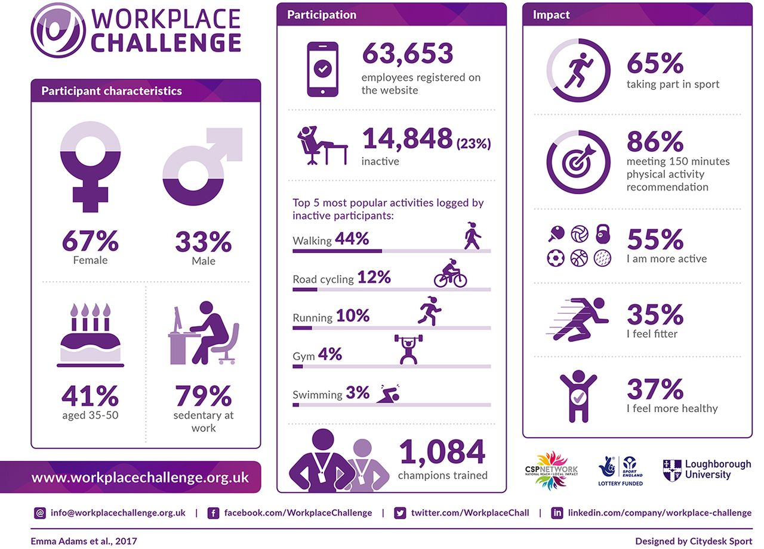

References:

Barton J., Bragg, R., Pretty J. and Wood, C. (2016) Green Exercise. Abingdon: Routledge.

Biddle, S.J.H., Mutrie, N. and Gorely, T. (2015) Psychology of physical activity. Abingdon: Routledge.

Calogiuri, G. et al. (2015). ‘The potential of using exercise in nature as an intervention to enhance exercise behaviour: results from a pilot study’, Perceptual & Motor Skills, 121(2), pp. 350-371.

Deci, E.L. and Ryan, R.M. (1985) Intrinsic Motivation and Self-determination in Human Behaviour. New York: Plenum.

First for Wellbeing (2018) Available at:
https://www.firstforwellbeing.co.uk/about-us/mission-vision (Accessed 02.05.18).

Hikeideas (2018) Available at: https://www.hikideas.co.uk/walk-planner.html (Accessed 02.05.18).

Jepson, R. et al. (2012) ‘Walking for depression or depressive symptoms: A systemic review and meta-analysis’, Mental Health and Physical Activity, 5(1), pp. 66-75.

Kaplan, S. (1985) ‘The restorative benefits of nature: Toward an integrative framework’, Journal of Environmental Psychology, 15(3), pp. 169-182.

Mathers, C., Loncar, D., & Samet, J. (2006) ‘Projections of Global Mortality and Burden of Disease from 2002 to 2030’ (Projections of Global Mortality), PLoS Medicine, 3(11), E442.

Mental Health First Aid (MHFA) England (2018) Resources. Available at: www.mhfaengland.org (Accessed: 02.05.18).

National Health Services (2018) Walking for Health. Available at: https://www.nhs.uk/Livewell/getting-started-guides/Pages/getting-started-walking.aspx. (Accessed 02.05.18).
https://www.nhs.uk/Livewell/fitness/Documents/National%20Trust_outdoor_gym.pdf (Accessed 02.05.18).

National Health Service (2018) One You. Available at: https://www.nhs.uk/oneyou (Accessed: 02.05.18).

National Parks (2018). Available at: http://www.nationalparks.gov.uk/visiting/outdoor-activities/walking (Accessed 02.05.18).

Paths for All (2018). Available at: https://www.pathsforall.org.uk/pfa-home (Accessed 02.05.18).

Prochaska, J.O., DiClemente, C.C. and Norcross, J.C. (1992) ‘In search of how people change: Applications to addictive behaviours. American Psychologist, 47, pp. 1102-1114.

Prochaska, J.O. and Marcus, B.H. (1994) ‘The transtheoretical model: Application to exercise. In R.K. Dishman (ed), Advances in Exercise Adherence, Human Kinetics, pp. 161-180. Champaign, IL.

Schwarzer, R. (1992) ‘Self-efficacy in the adoption and maintenance of health behaviours: Theoretical approaches and a new model. In R. Schwarzer (ed.), Self-efficacy: Thought control of action, (pp. 217-243), Bristol, PA: Taylor & Francis.

Ulrich, R. S. (1981) ‘Natural versus urban scenes: some psychophysiological effects’, Journal of Environment and Behavioiur, 13, pp. 523 -556.

Walkit (2018). Available at: http://walkit.com (Accessed 02.05.18).

Walk 4 Life (2018). Available at: https://www.walk4life.info (Accessed 02.05.18).

Walk Unlimited (2018). Available at: http://www.walkengland.org.uk (Accessed 02.03.18).

Workplace Challenge (2018). Available at: http://www.workplacechallenge.org.uk/2018challenge (Accessed 02.03.18).
and http://bjsm.bmj.com/content/bjsports/early/2017/10/27/bjsports-2017-097716.full.pdf

World Health Organization (2010) ‘Global Recommendations on Physical Activity for Health’. Available at: http://www.ncbi.nlm.nih.gov/books/NBK305057.pdf (Accessed 02.05.18).

World Health Organization (2018) Media centre, Factsheets: Physical Activity. Available at:
http:// www.who.int/mediacentre/factsheets/fs385/en (Accessed: 02.05.18).

