Analyse the role of independent bodies (i.e., IOPC/HMICFRS) in holding the police accountable to those they serve. (1000 words)

The Independent Police Complaints Commission IPCC became the Independent Office for Police Conduct (IOPC). This is due to the IPCC doubling in size since 2013 and taking six times more investigations. On the 8th of January 2018 following a request for structural change, the IOPC was born. (IOPC, 2020)
The Independent Office for Police Conduct (IOPC) is a non-departmental public body and is responsible for managing more serious complaints in England and Wales for the police service. An example of a complaint that the IOPC would deal with would be deaths following police contact or a serious breach of professional behaviour.
All police officers regardless of rank are required to abide by the standard of professional behaviour. These standards are honesty and integrity, challenging and reporting improper conduct, discreditable conduct, making sure your fit for duty, confidentiality, duties and responsibility, orders and instructions, use of force, equality and diversity, authority, respect and courtesy. (Northumbria Police, 2014).
The IOPC have investigated some of the biggest complaints recorded such as the Hillsborough disaster, when they reviewed police actions in 2012. Research shows The IOPC (IOPC, 2018) launched an investigation following the disaster that resulted in the death of 96 football supporters. This particular investigation is the largest independent review into police misconduct and criminality. Study shows the initial inquests in March 1991 returned a verdict of 95 accidental deaths. (Policeconduct.gov.uk 2018) As a result of the investigation criminal charges were brought against the Chief Superintendent David Duckenfield who was the match commander on the day. Following a re-trial he was found not guilty of 95 counts of gross negligence of manslaughter.
The police have powers that can impact people’s lives and liberty. The public must have full confidence that the powers an officer has is not abused. With this authority comes accountability, whom are also subject to the same laws and legislation that every member of the public is. Holding the police accountable is important to maintain the public’s faith that police staff are not above the law. The IOPC are there to increase the public’s confidence when a complaint about the police is received and a clear transparent review is conducted.
The IOPC will investigate a complaint which can originate from a number of means. A member of the public can make a complaint, or the police service can initiate a complaint should they feel the IOPC is more appropriate.
When an IPOC complaint is investigated the officer investigated will have a Regulation 17 notice from The Police Conduct Regulations 2020 (legislation.gov.uk 2020) served on them either in person or by letter. This is a standard practice which notifies the officer that standards may have fallen below the required standard. This process is a worrying time for the officer. Analysis shows that there is no time limit for the IOPC to investigate a complaint so what is a highly stressful job becomes an even more worrying and distracting for the officer.
The IOPC are there to hold the Police service accountable but it is at a high cost to any officers involved mentally. It is important the police service are clear and transparent to keep the publics confidence however this maybe at the cost of the police staff.
Research shows between 2017 – 2018 police forces across England and Wales and local policing bodies referred 31,671 cases (Hnksolicitors) and then between 2019 – 2020 28,223 cases. The Police Federation of England and Wales have conducted a review and estimate that an investigation that lasts up to 6 months costs £15,101 per officer which then increases to £302,012 should it continue for five or more years (polfed.org, 2021). These costs are very high, which costs the general public millions of pounds. In contrast to this information there are alternatives to holding the police service accountable such as the media. With Social media being used daily by everyone it can be seen as an easy target to use as a method of publishing and scrutinising events involving the police, whether for the good or the bad.
Another alternative to the IOPC could be a department that already exists, the Professional Standard Department. However as complaints are managed internally the public may lose trust and confidence in any out comes determined.
In conclusion, the need for these independent bodies is essential to ensure the Police are abiding by the code of ethics and are also held accountable for their actions, good and bad. These organisations are evolving all the time and always trying to ensure they are acting on behalf of the public to ensure a fair outcome where needed. However, many do believe that they are working alongside the Police force, they do not have faith in their investigations and are corrupt.
The IOPC has carried out 1,895 investigations into police cases since it was formed in 2018. 181 investigations have been published, and in total there were 181 cases where the IOPC felt a reasonable tribunal could find misconduct in respect of the individuals involved, including 11 in Wales involving 19 officers or other police staff.
I strongly believe that the IOPC should continue to investigate serious complaints that are referred to them. Police officers have powers and responsibility that normal members of the public do not have and should be scrutinised should they breach the standards. Although the financial costs are high to investigate a complaint, failing to investigate a complaint could cost the police service the confidence the public have in them to police. There has been questions whether the IOPC has fulfilled an objective in order to speed up an investigation, make them more independent and improve justice which needs to be done not only because of the financial impact but also for the welfare of the police staff who are being investigated.

Word Count 962

Bibliography

HR Central Team. (2014). Standards of professional behaviour for police staff. Available: https://beta.northumbria.police.uk/about-us/policies/human-resources/standards-of-professional-behaviour-for-police-staff/#:~:text=The%20Standards%20of%20Professional%20Behaviour%20are%20summarised%20. Last accessed 2nd June 2022.

IOPC (2018) Hillsborough investigation Available: Hillsborough investigation | Independent Office for Police Conduct Accessed 20/3/2022

IOPC (2018) Hillsborough investigation Available: Hillsborough investigation Independent Office for Police ConductAceessed20/3/2022

IOPC (2020) Independent investigations: Information for police officers, staff and their representativesAvailable:independent-investigations-information-for-police-officers-staff-and-their-representatives_IOPC_2020.pdf (policeconduct.gov.uk).Accessed 17/03/2022

IOPC (2020) Independent investigations: Information for police officers, staff and their representativesAvailable:independent-investigations-information-for-police-officers-staff-and-their-representatives_IOPC_2020.pdf (policeconduct.gov.uk).Accessed 17/03/2022

IOPC (2020) Our investigations Available: Our investigations | Independent Office for Police Conduct Accessed 19 / 3/ 2020

IOPC (2020) Our investigations Available: Our investigations | Independent Office for Police Conduct Accessed 19 / 3/ 2020

IOPC. (2020). 6. How long will my complaint take to deal with?. Available: https://policeconduct.gov.uk/6-how-long-will-my-complaint-take-deal. Last accessed 3rd July 2022.

IOPC. (2020).Who we are. Available: https://policeconduct.gov.uk/who-we-areLast accessed March 2022

IOPC.(2020).6.How long will my complaint take to dealwith? Available:https://policeconduct.gov.uk/6-how-long-will-my-complaint-take-deal. Last accessed 3rd July 2022.

IOPC.(2020).Becoming the IOPC. Available: https://www.policeconduct.gov.uk/becoming-iopc. Last accessed 1st June 2022.

IOPC.(2020).Becoming the IOPC. Available: https://www.policeconduct.gov.uk/becoming-iopc. Last accessed 1st June 2022.

Legislation.gov.uk. (2020). The Police (Conduct) Regulations2020. Available:https://www.legislation.gov.uk/uksi/2020/4/regulation/17/made. Last accessed 2 June 2022.

Police federation. (2021). Federation Chair on the staggering costs of IOPC investigations. Available: https://www.polfed.org/cumbria/news/2021/federation-chair-on-the-staggering-costs-of-iopc-investigations/#:~:text=The%20Police%20Federation%20of%20England%20and%20Wales%20has,years%20or%20more%20%E2%8. Last accessed 2nd June 2022.

UK Parliament, (2022). Police Conduct and Complaints. Available: https://publications.parliament.uk/pa/cm5802/cmselect/cmhaff/140/report.html#heading-2. Accessed 17/03/2022.

Examine the ethical dimension of ‘real time’ operational decisions. (1000 words)

Police officers often attend an incident that requires quick decisions that can impact people for the rest of their lives. According to Criminal justice, (2022):
“Police offices are gatekeepers of the criminal court system and must make several critical decisions during their interactions with citizens and in the performance of their duties”
Police officers are required to make “real time” decisions whilst remaining ethical. There are a number of factors that can influence and aide decision making. When confronted with a situation that requires decision machining a police officer cannot allow personal biases to influence decisions but must consider the impact they will have on the public such as public safety, opinion and the forces reputation. According to Simplypsychology.org (2022) there are two types of biases, conscious and non-conscious. A bias can be a tendency to take favour of or against an idea, person or a thing. As a police officer you cannot be led by your biases but, make informed choices by facts.
The police service use a model known as the National Decision Model (NDM) to aid their decision-making process.
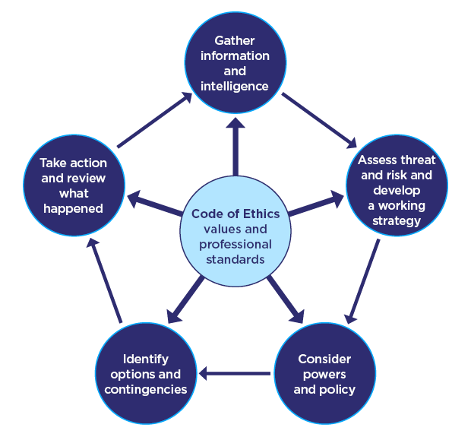

Diagram 1 – National Decision Model (College of Policing, 2014)

The NDM is a model that is suitable for all situations where decisions must be made. It is a model that can be applied to incidents that require quick or spontaneous decisions by a police officer. The model consists of 6 key elements.
At the centre is the code of ethics and research shows there are 9 key parts. The code of ethics are important to all police officers because if they do not meet the high ethical standards the authority of the police service could be undermined and the trust the public has. The NDM is a cycle and the code of ethics is at the centre of the decision making process.

The nine points to the code of ethics are being accountable for your decisions, actions and any omissions. You must treat everyone fairly, be truthful and trust worthy. As a police officer you must have great integrity and always do the right thing and be a good leader. You must lead by example and make choices on evidence and your professional judgment. You have to be open and transparent about your actions and any decisions you make, show respect to everyone and always act in the public interest. (College of Policing 2014).
When confronted with a situation where you have to make a decision the college of policing (College of Policing, 2022) have a mnemonic known as CIAPOAR. This mnemonic will assist officers make the right decision. C stands for the Code of ethics which are 9 crucial stops to maintaining public confidence and confidence in the police force.
I is for information and intelligence. Officers need to gather all information and intelligence available from all available sources at that time. Now you have all the information and intelligence you can move onto the third part of the NDM. Assess threat and risk and develop a strategy that will work. Here you look at the threats and dangers not on physically but mentally also. You must make a plan that works by considering the situation, dangers and vulnerabilities.
Powers and policies. An example of this maybe to use handcuffs to detain someone and using force policy to correct apply them. Another mnemonic when using any force is JPLANE. Your actions must be Justified, proportionate, legal, accountable, necessary and ethical.
Options and contingencies. As a police officer making real time decisions you must consider all the options that are open and what may happen should your plan not go to plan.
Take action. You must respond to the situation you are confronted with and make decisions based on all the evidence. You will be held accountable for the action you take so you must be professional. This, however can be difficult, in the heat of the moment, but using the NDM can help explain why an officer came to that decision.
Situations are often changing or adapting and you must change and adapt with it. When something changes you can use the NDM, along with the Code of Ethics. Police officers are held accountable and scrutinised for their actions often by superior officers who did not attend the scene.
According to mentaltoughness.partners (2017):
“When you feel stressed your brain becomes overloaded, it reacts by retreating into a more defensive self and that limits your high level thinking, analytical ability and your ability to think clearly under stress.”
Holding officers accountable for decisions they make in a stressful and changing environment that does not appear to be fair, the environment they attend can be stressful which can affect your decision making. In this environment you are expected to use the NDM and the Code of Ethics to make a fair outcome. From research this has sometimes been proven to be difficult in the heat of the moment. Officers should be held accountable and scrutinised, The IOPC conducted in an investigation into the Hillsborough disaster and reported the failings by the police. This report has recommendations that prevents further possible failings (Policeconduct.gov.uk, 2018). Although we don’t want to make mistakes it is important we are scrutinised so we avoid making those same mistakes.

In conclusion, should be held accountable for decisions made and scrutinised for these to a high standard?. However, it is important that in real time decision making a police officer makes a balanced decision which is well informed. Considering the NDM, code of ethics and what the situation entailed. It is also important to not treat every incident the same, as there could be several different aspects to consider that may affect a police officer’s decision making. Officers should be held accountable for their actions and scrutinised to ensure the police service correctly protects vulnerable adults and continue to deliver the best level of service. Every decision however should be ethical and responsible.

987 words

Bibliography

Association Against Abuse of Police Powers and Privileges (2020) The code of ethics of the UK police – Explained Available: The Code of Ethics of the UK Police: explained – AAAPPP – Association Against Abuse of Police Powers and Privileges
Accessed – 8/04/2022

Diagram one Collage of policing (2014) National decision model Available: National Decision Model (college.police.uk)Accessed – 8/04/2022

College Of Policing . (2014). National Decision Model. Available:https://www.college.police.uk/app/national-decision-model/national-decision-model. Last accessed 3rd June 2022.

College Of Policing.(2014).Code Of Ethics. Available: https://assets.college.police.uk/s3fs-public/2021-02/code_of_ethics.pdf. Last accessed 3rd June 2022.

Criminal Justice (2022) Police decision making Available: Police Decision Making (Forensic Psychology) - iResearchNet Last accessed 07/04/2022

IOPC. (2018). Hillsborough investigation. Available:https://policeconduct.gov.uk/investigations/hillsborough-investigation. Last accessed 7th June 2022.

Mental Toughness Partners . (2017). How To Think Clearly UnderStress. Available:https://www.mentaltoughness.partners/think-clearly-under-stress/. Last accessed 7th June 2022.

simplypsychology.org. (2022). What is cognitive bias?. Available :https://www.simplypsychology.org/cognitive-bias.html. Last accessed 3rd July 2022 .
simplypsychology.org (2022). What is cognitivebias?. Available:https://www.simplypsychology.org/cognitive-bias.html. Last accessed 3rd July 2022 .

Assess the impact of organisational justice on police agency. (1000 words)

Organisational justice is the study of people’s perceptions of organisational fairness. Organisational justice provides perception of fairness and equity through those affected by change being explored and understood. As police officers we can at the fairness of organisational policies to gain an insight into the type of treatment we will receive working within the police force.
According to Chetty, P (2018):
“Traditionally, there are three broad categories of organizational justice theory”.
The three categories are procedural, distributive and interactional justice.
Procedural. Procedural justice is the public putting their trust into the police force. The police force must give fair treatment to all those interact with including the public and other officers. The police must interact professionally and fairly with the public if they are to win over their support. How these interactions are perceived are done so under four key components of procedural justice.
First of all there is neutrality which is with the absence of any bias and prejudice. Second of all is the voice. This gives the public and the police staff a voice when it comes to decision making. Thirdly is all about respect. This involves behaving in a manner that protects the staff member’s rights, ensuring that staff treat all members with dignity. Lastly is trustworthiness. Here you show concern for the safety and well-being of your colleagues as well as the general public and acting on their behalf. In policing these four stages have the ability to change how the general public respond and perceive the police force. These steps can also change the perception of the public but also police officers as an employee and employer relationship. (Myhill and Quinton 2011).

Distributive justice. This is the fairness of outcomes from your work such as rewards, recognitions and promotions. As an employee you tend to recognise your own outcomes and compare that with those on my team. This is often done when newer in service staff compare their pay scale to those who have longer service. Newer officers have to work a lot more hours to match those who have been employed doing the same role as me which can affect productivity and morale.
Police staff who are newer in service will carry a workload often from the moment they join their team. Being new in service your still learning procedures and law the added pressure of a workload can affect your morale. The 2021 police federation report said of those who left the police service, 58% said they had retired because of morale according to a report completed by the police federation (polfed.org 2021). It is important that staff are not overloaded with work as it is leading to people retiring early.
There are specific coping strategies for police officers and LinkedIn (2022) discusses 5 coping strategies that are available specifically for police staff. The police culture is often a dark humour that some may find upsetting. For many experienced officers this is a organisational culture but its aim is to allow you to discuss what you have experienced in a safe environment.
Although there is a dark humour within the police your behaviour should still fall inline with ethical behaviour and the code of ethics.

Lastly is interactional justice. This is a measure of how staff relate to each other during the working day. It is important you establish the standards of conduct to ensure a high level of respect is shown to staff and to ensure the police force is seen as fair and a safe workplace (Chetty P 2018)
According to the UK Parliament (2022):
“Complaints against police officers take many forms”
These complaints can range from a lack of updates, the involvement in crime, causing the death of a person or causing serious injury. Between 2014 to 2020 the government had to make substantial reforms. The police complaints departments and discipline system had to address the concerns about the public confidence. One of these changes brought about was the Independent Office for Police Conduct (IOPC) in 2018. (IOPC 2020).

In conclusion, evidence has shown that there is a similarity between how the policing system works and the organisational justice aspect of decision making. Employees’ perceptions of fairness in the workplace has proven to be important. Should you not get this part right the financial and reputational consequences can have a big effect.
The College of Policing 2015 Fair Cop 2 has put the relationship between organisational justice and its outcome for the public to see and asked whether the acceptable treatment within the workplace resulted into better behaviour from police staff. This has then resulted in a better world of policing. The discussion that policing is different from any other organisation does have a credible basis.
A majority of research into organisational justice suggests that its impact is indirect which resulted in police staff identifying a stronger connection with its organisation that treated them well. This has resulted in more staff likely to act in the organisational interests and the people it serves. Staff are then more likely to engage in a discretionary effort, feel they are empowered and value the public when they acknowledge their own organisation.
In addition to the effects of this strong organisational sense of belonging, dissimilar elements of organisational justice has had direct effects on the outcomes with the attitude of more senior ranking officer’s shows to be particularly important. Being treated fairly has shown senior officers being more confident in their own authority. This has translated into positive policing outcomes.

(913 words)

Bibliography

Chetty, P (2018) Role of organizational justice theory in performance management Available: Role of organizational justice theory in performance management (projectguru.in) Accessed – 10/04/2022

IOPC. (2020). Who we are . Available: https://policeconduct.gov.uk/who-we-are. Last accessed 7th June 2022.

LinkedIn. (2022). The effects of stress on police officers. Available: https://www.linkedin.com/pulse/effects-stress-police-officers-mac-mclemore. Last accessed 7th June 2022.

Myhill A, and Quinton P(2011). It’s a Fair Cop? Police Legitimacy, Public Cooperation, and Crime Reduction: An Interpretative Evidence Commentary. National Policing Improvement Agency, Police Officer Numbers in England and Wales.

Nicola Chandler . (2019). Leavers’ Survey Headline Report October 2017 – April 2019. Available: https://www.polfed.org/media/15183/leavers-survey-report-2019-02-09-19-v013.pdf. Last accessed 7th July 2022.

Police Federation. (2021). Pay and morale. Available: https://www.polfed.org/payandmorale. Last accessed 8th June 2022.

UK Parliament (2022) Police conduct and complaints Available: Police Conduct and Complaints - Home Affairs Committee (parliament.uk)Accessed: 08/04/2022

Analyse potential links between serious and organised crime and public protection issues (1000 words)

Research shows from Crime stoppers (Crime stoppers 2018) definition of Serious and Organised Crime (SOC) is defined as:
“People who have worked together for an extended period of time to plan, coordinate and conduct serious crime.”
The illustration below shows the impact that SOC has and its wide impact. Often the leaders of SOC remain anonymous and profit from the misery of others.
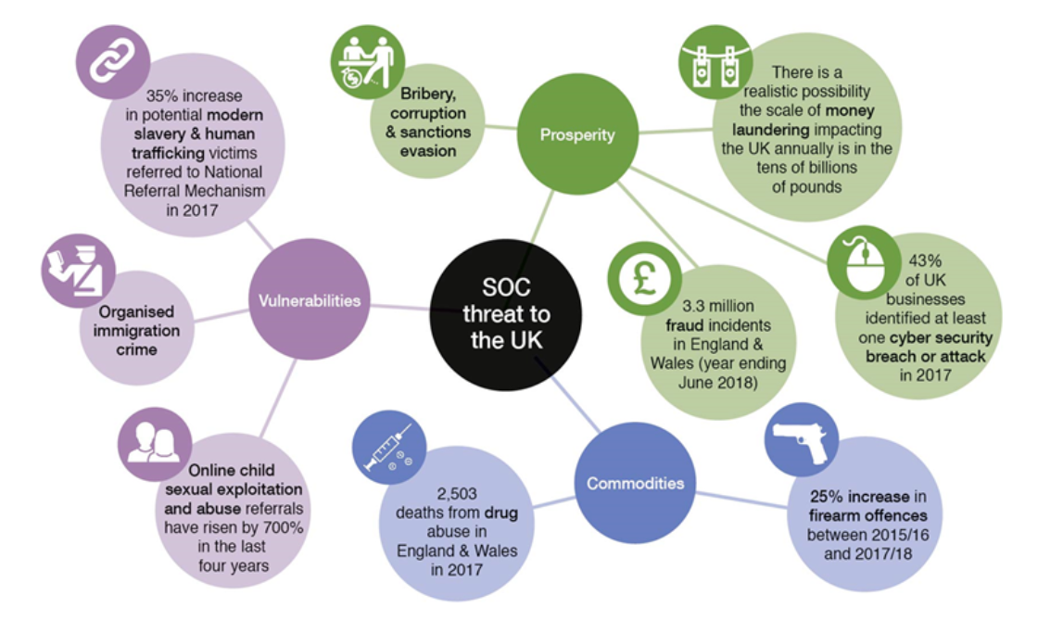
Diagram 1 – SOC threat to the UK, Crime stoppers, 2018

The main categories of SOC are child sexual exploitation and illegal firearms such as shotguns and pistols. According to the diagram above between 2015/2016 and 2017/2018 there was an increase in firearm offences by 25%. Illegal drugs have had a big increase on the amount of drug related deaths. This impacts the community and the family. Fraud is ever adapting and becoming more complex with the banking industry alone reimbursing £147 million which in turn is their loss. Money laundering and other economic crime is about taking the money earnt from the proceeds of crime and processing it through a legitimate business and therefore cleaning the money. The financial Crime Academy defines bribery and corruption as:
“An illegal or improper behaviour aimed at gaining an unfair advantage through unethical means”
(Financial Crime Academy 2022).
Often people with power such as politician and police officers are targeted because of the authority and influenced they hold. Often people in power are exploited and then used by gang members for their own personal needs.
Another way SOC profit is through organised immigration crime. Often vulnerable people will pay thousands to get into the UK via illegal means. This can be on a boat or smuggled into the back of a lorry. This can often be tragic with many lives being lost on the journey to the UK. This brings a big risk to the terrorist threat level in the UK as the people entering illegally do not go through any vetting or any security checks.
Modern slavery and human trafficking is the trade of a person often for cash. This person is then seen as someone’s property and forced to work often for very little or no pay at all.
Cybercrime refers to the use on a computer that is used for illegal activity. An example of a cybercrime would be Malware, this is a virus that attaches itself to your computer which can steal your data or even hold your own computer hostage until you pay to release whatever hold they have on it. Research into this crime has shown that there many other types of cybercrime such as phishing, pharming, keylogging and sniffing. (avast.com, 2022)
Usually SOC aim is to make as much money as possible while maintaining a strong influence and power. Often sexual enjoyment is a motivator. These offences are often committed by Organised Crime Groups (OCG) who will not stop to use violence, corruption, intimidation and threats to ensure there criminal enterprise continues.
Research has shown the National crime Agency (NCA) has commented on SOC by stating that SOC affects the UK population more than any other national security threat. SOC is so big in today’s world that it affects all types of public services, businesses within the UK, our institutions, national reputation, and even infrastructure (Parliament.uk, 2020).
Research has shown The NCA often face severe criticism recently in December 2015. The NCA database has been reported to be slow and often crashes causing delays in the investigation. There has been reports with delays checking transactions which has then resulted in tipping off criminals.
The NCA was setup as a specialist department to target the OCG’s in their criminal activity but this research has shown the NCA are not yet equipped to manage an efficient investigation. (Rahman, R, 2015)
SOC will often target the vulnerable by creating an atmosphere of fear and violence and are now able to use computers to target the vulnerable. Gangs will often exploit the most vulnerable to carry out their illegal crimes. Often the life of a gang member may seem appealing to some, especially young children. Often in poor communities children become drug traffickers. Research from ecpat.org (2018) has shown 10,613 potential victims which is an increase of 10% from last year.
Over time SOC will ruin lives and destroy communities and even drives out legitimate business causing unemployment and further misery. However in some places OCG’s have undermined local governments by providing employment and security (Paoli 2014). SOC and OCG’s are often organisations that we think exist only on an international scale. However, research has shown the impact they have on communities, vulnerable people and businesses. The reach of SOC is not only felt in the cities but also in rural communities. SOC groups are known to sell illegal cigarettes which are often fake and dangerous, illegal alcohol, weapons and drugs. The more vulnerable amongst us are often targeted with children as young as seven running drugs from town to town which is known as county lines. The police service alone cannot deal with SOC. Working in partnership with other organisations as the NCA will target OCG’s and address the vulnerability and exploitation that these gangs use. (NCA, 2020)
In conclusion, communities who see law enforcement agencies tackling serious crime head on builds confidence between the public and the police and law enforcement agencies. This will then demonstrate to the public that if they provide information on serious crime, the information that they have provided will be taken seriously and acted on. However, what is clear with organised crime, is they intimidate communities not to come forward, which leads to the public becoming scared of repercussions due to coming forward than the impact organised and serious crime has on the community. More focus needs to be placed on protecting the people who want change and stop these crimes happening. Only once we have resources in place to tackle these issues will we see a reduction in these groups from developing.

Word count 992.

Bibliography.

Available at: National Strategic Assessment of Serious and Organised Crime 2020 - National Crime AgencyAccessed04/04/2022

Diagram one Crimestoppers (2018) Serious and organised crime Available at: https://crimestoppers-uk.org/keeping-safe/community-family/serious-and-organised-crime.Accessed02/04/2022

Ecpat. (2018). Child trafficking statistics. Available: https://www.ecpat.org.uk/child-trafficking-statistics. Last accessed 8th June 2022.

Financial Crime Academy . (2022). Bribery and Corruption: Definition and Process. Available:https://financialcrimeacademy.org/bribery-and-corruption/.Last accessed8th June 2022.

Katy Worobec. (2021). Fraud - The facts 2021. Available: https://www.ukfinance.org.uk/system/files/Fraud%20The%20Facts%202021-%20FINAL.pdf. Last accessed 7th June 2022.

National crime agency (2020) Commitment to working in partnerships Available at: file (nationalcrimeagency.gov.uk) Accessed 03/04/2022

National Crime Agency (2020) National Strategic assessment of serious and organised crime
Nica Latto. (2022). What is Cybercrime and How Can You Prevent It?. Available: https://www.avast.com/c-cybercrime#:~:text=Cybercrime%20refers%20to%20any%20illegal%20activity%20carried%20out,of%20malware%20as%20part%20of%20their%20cyber%20attacks.. Last accessed 8th June 2022.Gov.uk (2022) Serious and Organised Crime Strategy Available at: Error! Hyperlink reference not valid. Accessed 02/04/2022

Paoli, L (2014) How to Tackle (organized) Crime in Europe? The EU Policy Cycle on Serious and Organized Crime and The New Emphasis On Harm. European Journal of Crime, Criminal Law and Criminal Justice, 22(1), pp. 1-12. Last accessed 02/04/2022

Parliament.uk (2020) Policing in the UK Available at: Policing in the UK: Serious and Organised Crime (parliament.uk)Accessed 03/04/2022

