

Level 5 Assignment – BSc (Hons) / BEng (Hons) - Ordnance, Munitions and Explosives
Advanced Physics for OME – ACDA 5015

Assignment: Modelling of shaped charges
John Boswell
January 2022

Student Number 1906963

Abstract
Shaped charge devices are commonly used in the mining and drilling industries. They are also present in different types of armour defeating weapons used by the military. The focussing of the detonation energy onto a thin metal liner produces a fluid jet which provides the desired outcome, be that cutting, drilling or piercing a target material. This report includes a summary of a literature review that was carried out into the finite element analysis and simulation of shaped charges. The report also describes the modelling of a shaped charge device in ABAQUS. It was found that by modifying the mesh distribution assigned to the model, and changing the material properties of the conical liner, the formation of the fluid jet can be improved.

Table of Contents
List of figures 4
- Introduction 5

- Method 6
  - - Literature review of research on shaped charges and their modelling 6
  - – Modification of existing shaped charge model in ABAQUS 7

- Results
  - - Original model simulation without any modifications 9
  - – Original model simulation with modified mesh 11
  - – Modified model simulation with an aluminium liner and 12 modified mesh

- Discussion 13

- Conclusions 14

- References 15

List of figures
Figure 1. A diagram of a standard shaped design (produced by the author)
Figure 2. An image of the steel casing part of the model (left), and the TNT high explosive part of the model (right). (Images taken from the model built and provided in ABAQUS)
Figure 3. An image of the copper conical liner part of the model (left), and the assembled shaped charge device model (right). (Images taken from the model built and provided in ABAQUS)
Figure 4. Image of the mesh distribution which is consistent across all parts of the modelled shaped charge device (image taken from the model built and provided in ABAQUS)
Figure 5. Image of the finer mesh distribution (0.0015m³) applied to the conical liner part of the model. (Image taken from model modified by the author in ABAQUS)
Figure 6. Front view image of the liner jet produced during the simulation (Image taken from the model provided and simulated in ABAQUS)
Figure 7. Side view image of the liner jet produced during the simulation (Image taken from the model provided and simulated in ABAQUS)
Figure 8. Graph to show the approximate velocity of the jet formed during the detonation simulation (Graph created in ABAQUS)
Figure 9. Front view image of the liner jet produced during the simulation (Image taken from the model modified by the author and simulated in ABAQUS)
Figure 10. Side view image of the liner jet produced during the simulation (Image taken from the model modified by the author and simulated in ABAQUS)
Figure 11. Graph to show the approximate velocity of the jet formed during the detonation simulation (Graph created in ABAQUS)
Figure 12. Front view image of the liner jet produced during the simulation (Image taken from the model modified by the author and simulated in ABAQUS)
Figure 13. Side view image of the liner jet produced during the simulation (Image taken from the model modified by the author and simulated in ABAQUS)
Figure 14. Graph to show the approximate velocity of the jet formed during the detonation simulation (Graph created in ABAQUS)

- Introduction

The geometry of a piece of high explosive material can influence how the shock wave travels through it during detonation, and the magnitude of the resulting blast pressure [1]. This principle of altering the shape of the high explosive is used in both hollow charges and shaped charges.
A cylinder of explosive that is formed so that it has a hollow cavity at one end is known as a hollow charge or an unlined-cavity charge [2]. There are various shapes for this cavity that can be used, with the most common including a hemisphere, cone, or pyramid [3]. If the hollow cavity contains a thin liner made from a metal, an alloy, a ceramic, or another suitable material then it is termed a shaped charge [2]. A diagram of the traditional shaped charge design is shown below in fig. 1.
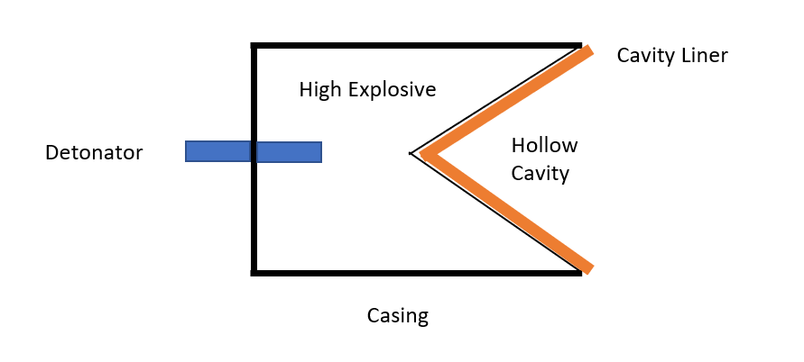
Fig.1. Diagram of a standard shaped design (produced by the author)
During the functioning of a shaped charge device, the shape of the cavity focuses the energy from the detonating high explosive onto the thin cavity liner which collapses and forms a jet of molten material. This fluid jet travels at very high speed (often in excess of 10,000 m/s) [3].
Shaped charge devices are used widely in the oil and mining industries for drilling or cutting. They are also used by the military in weapons that are fired against structures, vehicles, and different types of protective armour [4].
Computer modelling and finite element analysis can be used to simulate a wide variety of explosive detonations. Numerical simulations and modelling for explosives related work vary greatly, with examples ranging from modelling the response of a rock tunnel when exposed to blast loading, to modelling traumatic ocular injuries due to high explosive detonations [5] [6].
This report provides a summary of an initial literature review of research carried out into shaped charges and their modelling. This can be found in section 2.1. The report also details the modelling of a shaped charge using the finite element analysis software ABAQUS. An existing model was modified with the aim of improving jet formation [7]. This can be found in section 2.2.
- Method

2.1 Literature review of research into shaped charges and their modelling
Advances in computer technology and the development of hydrocodes over the past thirty years have revived an interest for more research into the functioning of a shaped charges [8]. Advanced hydrocodes have helped to facilitate a better understanding of liner collapse and fluid metal jet formation [9].
There are two approaches to meshing in numerical modelling, the Lagrangian approach and the Eulerian approach. During a simulation with Lagrangian meshing, the mesh elements are attached to material particles and move with the material as it deforms [10]. In contrast, an Eulerian mesh is fixed in place and the deforming material particles move freely through the mesh [10]. The Lagrangian approach is more suited to small deformations as its accuracy decreases with large deformation and errors in the code can occur, whereas the Eulerian approach works well for large deformations but is expensive in relation to computation time [10]. Numerical models using both approaches are used regularly in explosives related modelling and there is a large amount of research material relating to both.
There are many different variations on the standard shaped charge design and the effect of the cone angle, cone shape, liner material, and stand off distance have been studied, with their results recorded in many different papers from around the world [11]. Common liner materials that have been found in research literature are copper, aluminium and steel [12]. In addition, research into the effect of using bi-metallic liners is also available [4].
The research material relating to shaped charge design and the modelling of shaped charges is extensive, and this short review provides some examples of the key areas of research. The information gathered by the author whilst undertaking this review was used during the modification of a shaped charge model in ABAQUS which is described in section 2.2.

  - Modification of an existing shaped charge model in ABAQUS

A model of a shaped charge device, loosely based upon the standard shaped charge design was built within the finite element analysis software ABAQUS. The model was meshed using Lagrangian code and had a suitable mesh distribution already applied. This model was provided to the author [7]. The model consisted of three individual parts including the casing, the high explosive material, and the conical liner. When assembled, these parts make up the full model of the shaped charge device. Images of the individual parts and the fully assembled device are shown below in Figure 2 and Figure 3.
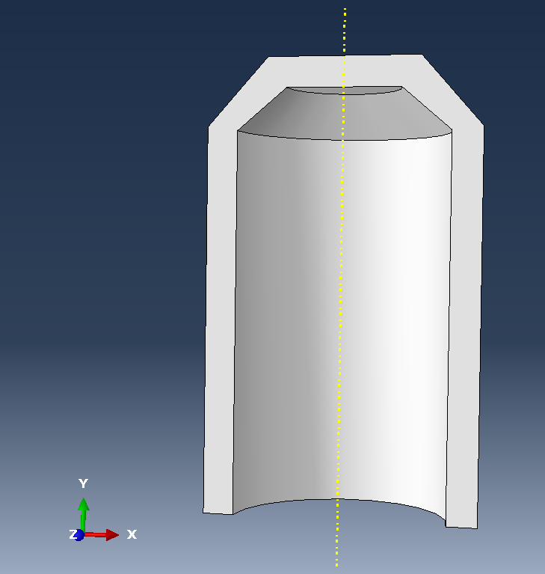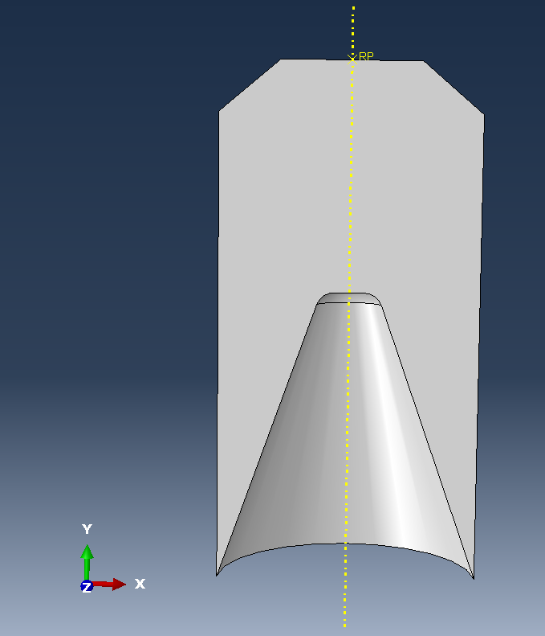

Fig. 2. Images of the steel casing part of the model (left), and the TNT high explosive part of the model (right). (Images taken from the model built and provided in ABAQUS)
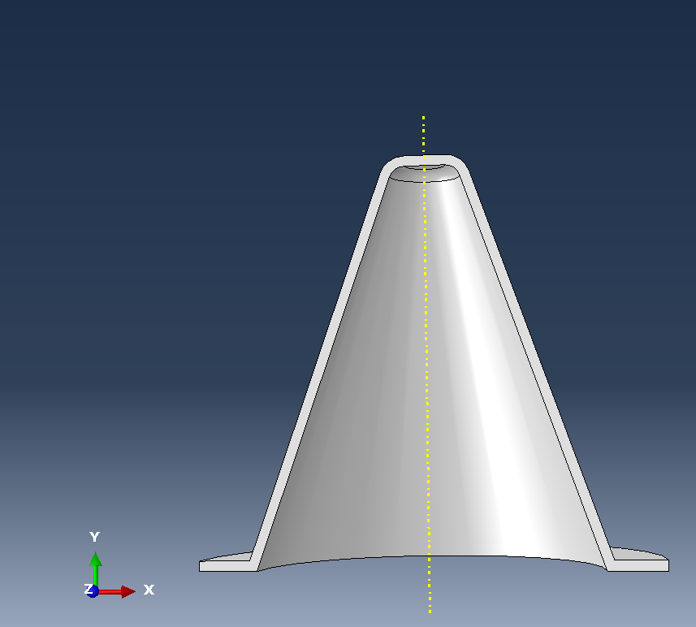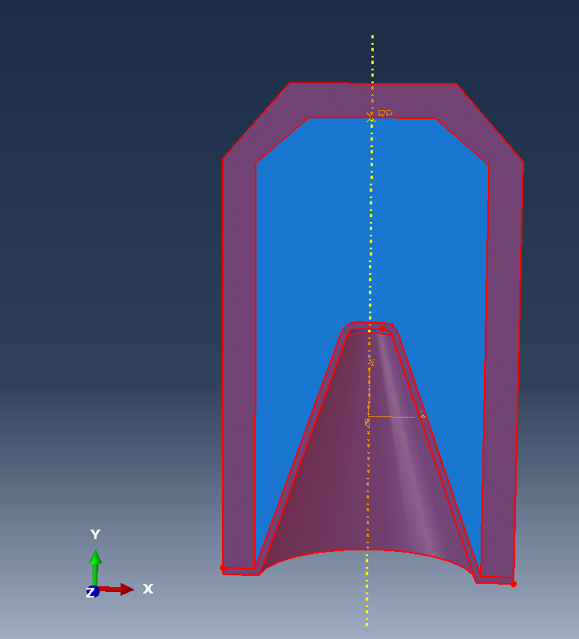
Fig. 3. Images of the copper conical liner part of the model (left), and the assembled shaped charge device model (right). (Images taken from the model built and provided in ABAQUS)
The materials used for the component parts of the device were steel (for the casing), TNT (Trinitrotoluene, for the high explosive material), and copper (for the conical liner). The material properties for these parts had been assigned from data sourced from matweb [7].
The model had been meshed with four node tetrahedral elements which were a consistent size across all parts of the model. An image of the mesh distribution for the provided model is shown below in Figure 4.

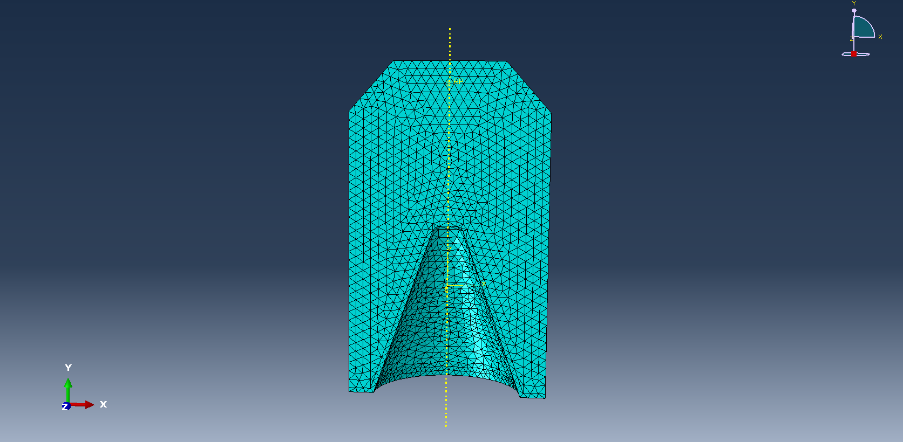
Fig.4 Image of the mesh distribution which is consistent across all parts of the modelled shaped charge device (image taken from the model built and provided in ABAQUS)

Two modifications were made to the original model. The first modification was to apply a finer mesh to the conical liner so that more accurate results of the liner collapsing during detonation could be recorded. Four node tetrahedral elements were used with their size reduced from 0.0071 m³ to 0.0015 m³. A coarser mesh was applied to the casing and the high explosive parts of the model to reduce the computation time required for, as the focus was on the jet formation from the liner.
The materials and properties remained the same and the simulation was run to observe the effect that the change in mesh distribution had on jet formation. The modified mesh distribution can be seen below in Figure 5.

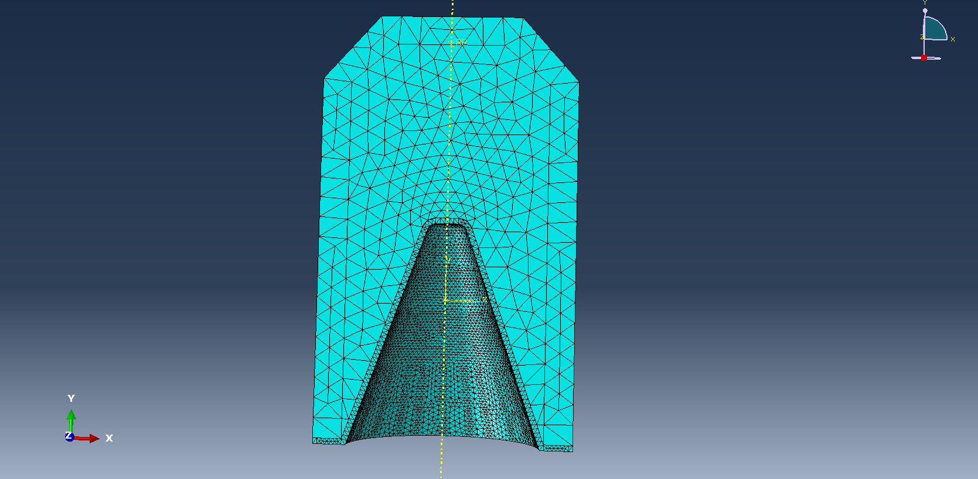
Fig. 5. Image of the finer mesh distribution (0.0015m³) applied to the conical liner part of the model. (Image taken from model modified by the author in ABAQUS)

The second modification to the model was a change in the conical liner material from copper to aluminium. Aluminium was chosen as an alternative liner material from information that was sourced during the literature review [12]. Material properties for Aluminium 1100-H12 were obtained from matweb and then validated using two other material properties websites [8], [9], [10].
The material properties for the aluminium 1100-H12 used for the modified material liner are shown in the table below.

Material Properties | Aluminium 1100-H12
Mass Density | 2710 Kg/M³
Young’s Modulus | 68.9 e9 MPa
Poisson’s Ratio | 0.33
Yield Stress | 75 e6 MPa
Ultimate tensile stress | 110 e6 MPa
Elongation at break | 0.12 %

- Results

Three simulations were run, and results generated for each in order to observe the effect of the modifications on the liner jet formation. Simulation 1 was the original model that had been provided. Simulation 2 was the original model with the modified mesh as described in section 2.2. Simulation 3 was the modified model with the aluminium liner and the modified mesh.
An image of the jet formation that occurred during each of the simulations is included along with a graph to show the approximate velocity of the jet. The results for each of the three simulations are included in this section.
3.1 Original model simulation without any modifications
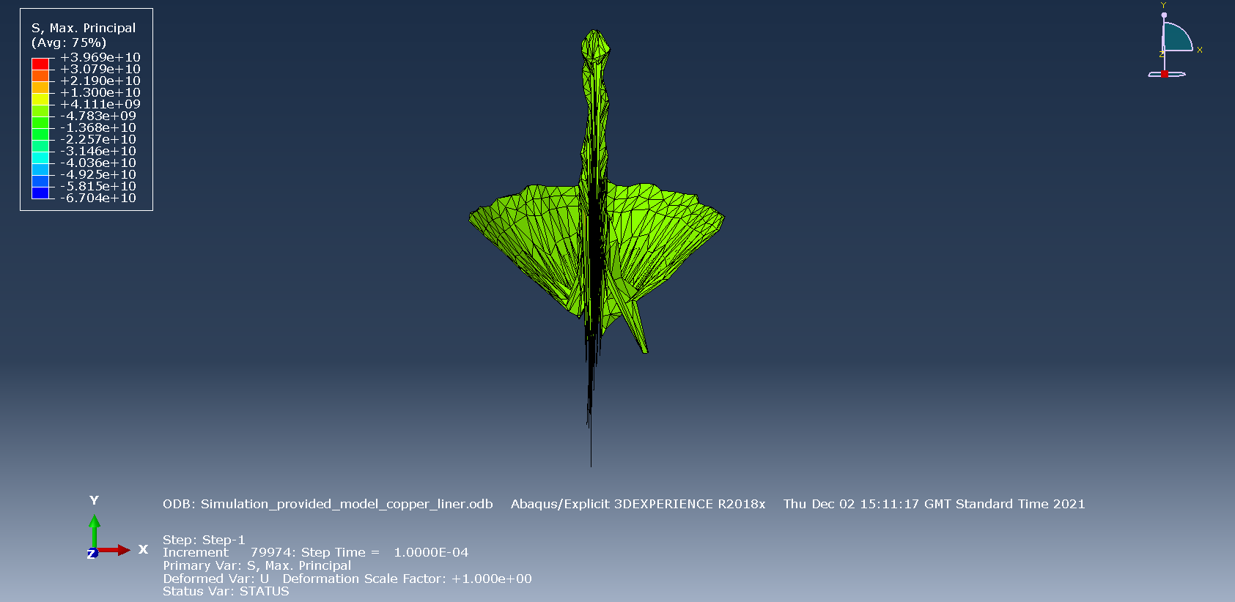
Fig. 6. Front view image of the jet produced during the simulation (Image taken from the model provided and simulated in ABAQUS)
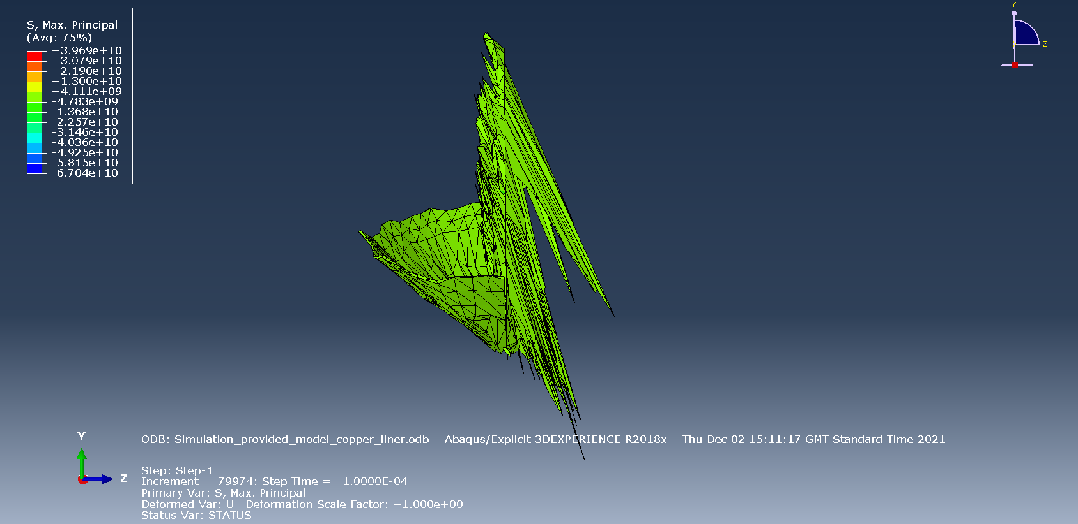
Fig. 7. Side view image of the liner jet produced during the simulation (Image taken from the model provided and simulated in ABAQUS)

A graph to show the approximate velocity in metres per second of the jet formed during the simulated detonation

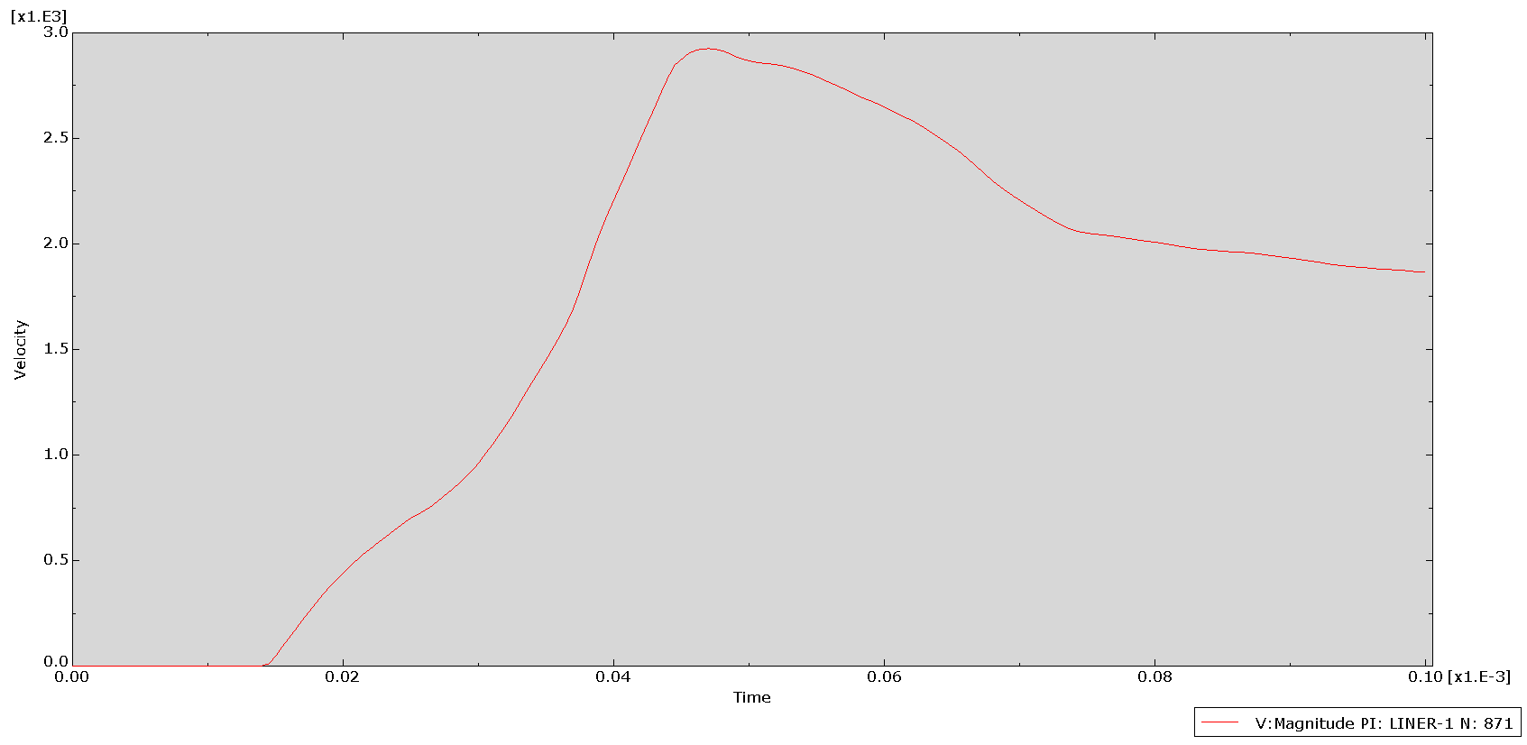
Fig. 8 Graph to show the approximate velocity of the jet formed during the detonation simulation (Graph created in ABAQUS)

  - Original model simulation with modified meshing
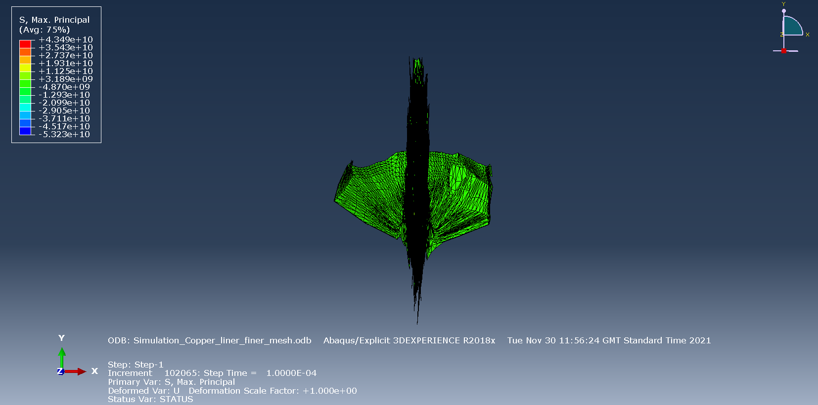
Fig. 9. Front view image of the liner jet produced during the simulation (Image taken from the model modified by the author and simulated in ABAQUS)

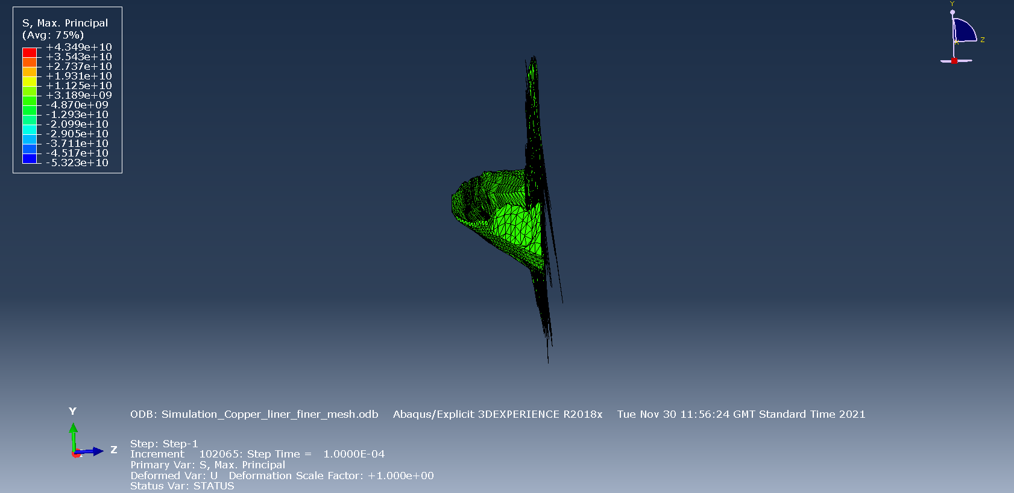
Fig. 10. Side view image of the liner jet produced during the simulation (Image taken from the model modified by the author and simulated in ABAQUS)

A graph to show the approximate velocity in metres per second of the jet formed during the simulated detonation
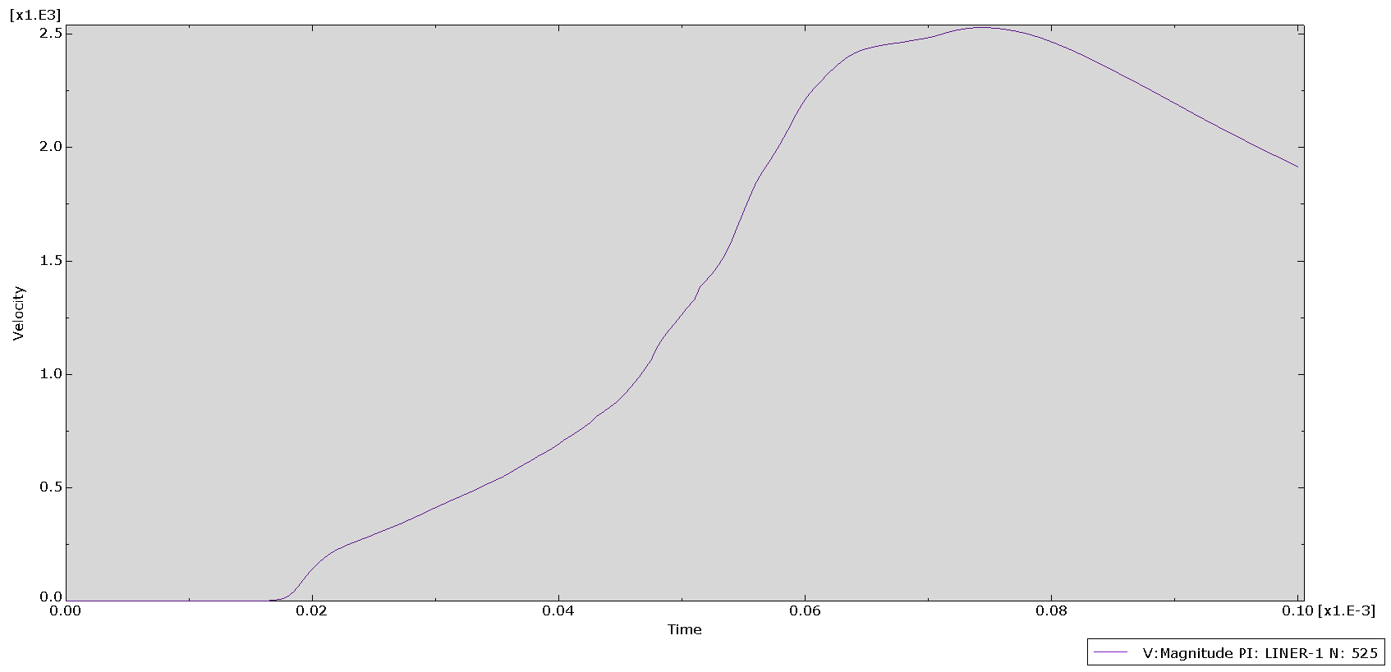
Fig. 11. Graph to show the approximate velocity of the jet formed during detonation (Graph created in ABAQUS)

  - Modified model simulation with an aluminium liner and modified meshing

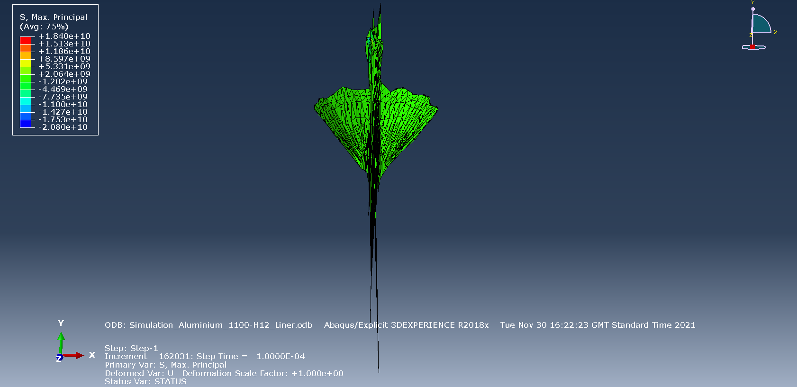
Fig. 12. Front view image of the liner jet produced during the simulation (Image taken from the model modified by the author and simulated in ABAQUS)

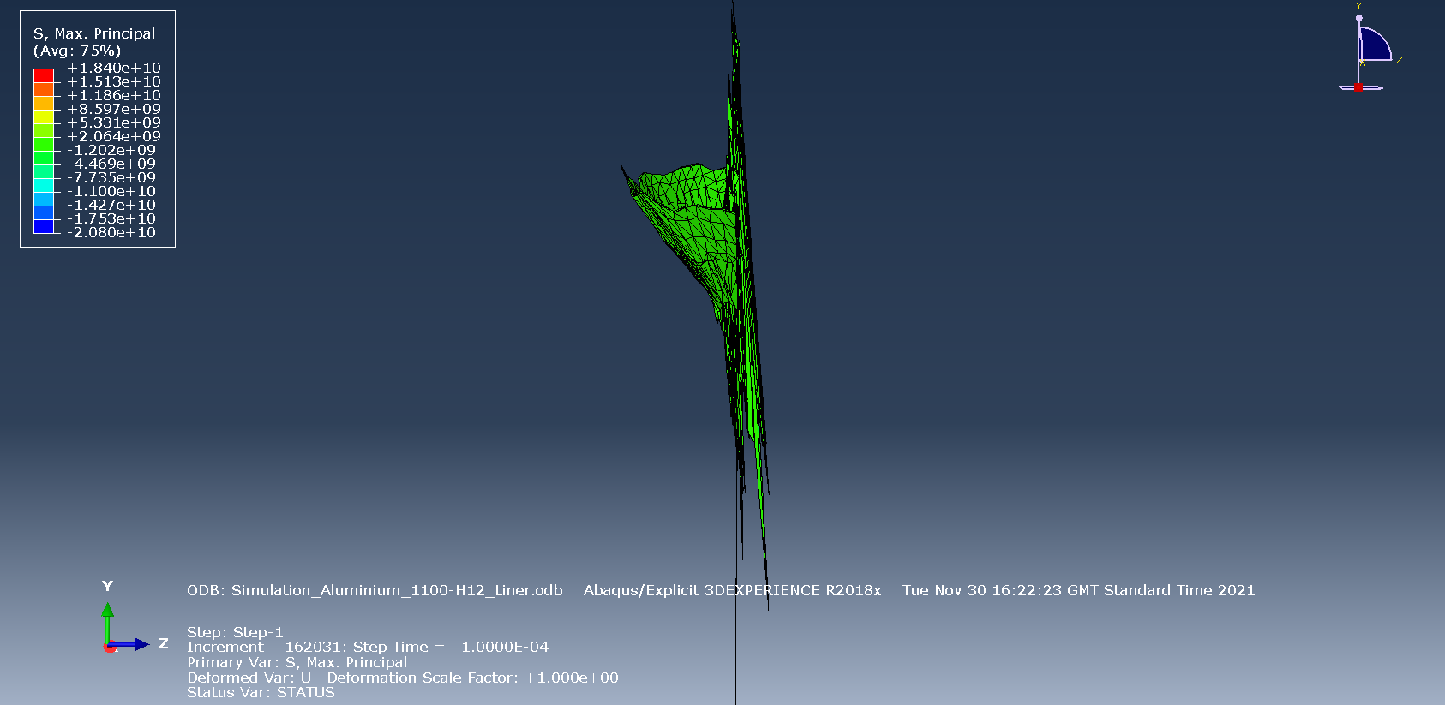
Fig. 13. Side view image of the liner jet produced during the simulation (Image taken from the model modified by the author and simulated in ABAQUS)

A graph to show the approximate velocity in metres per second of the jet formed during the simulated detonation
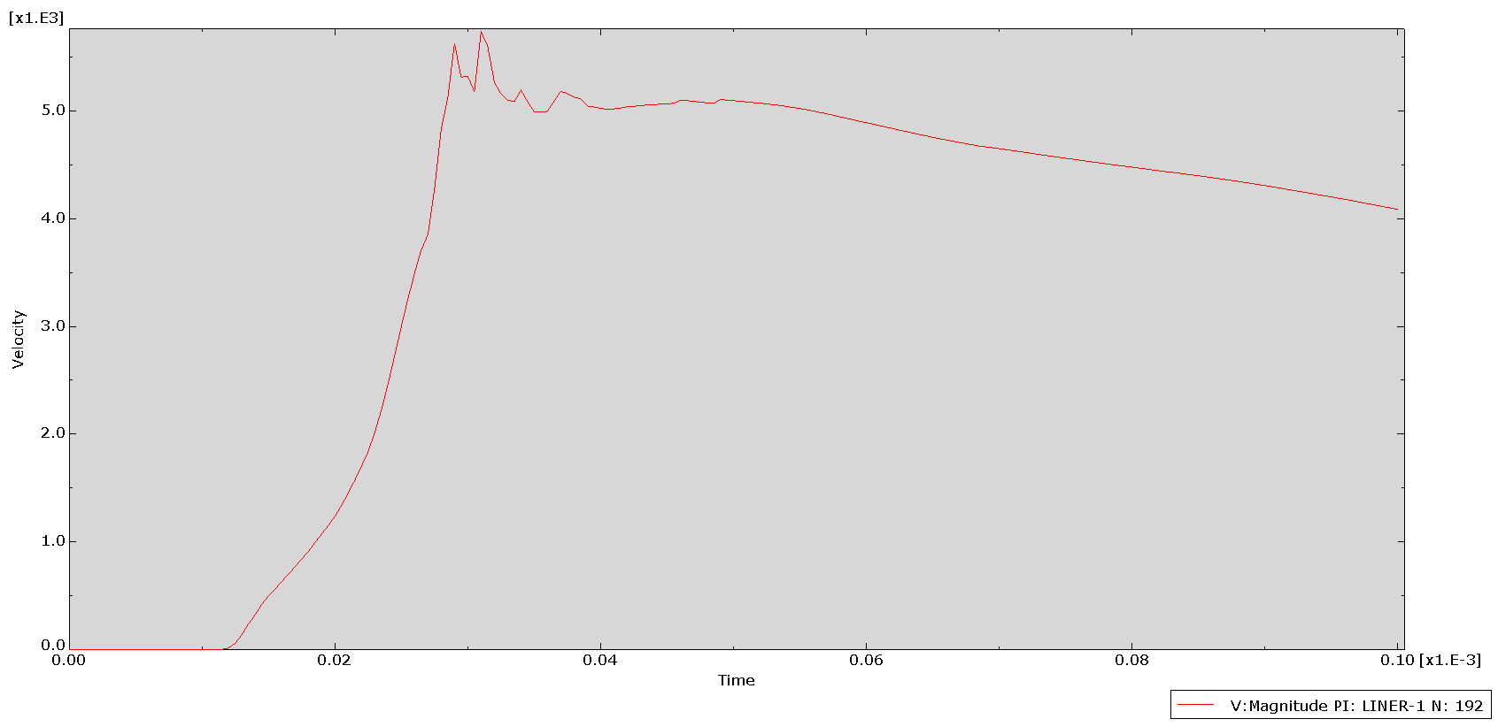
Fig. 14. Graph to show the approximate velocity of the jet formed during detonation (Graph created in ABAQUS)

- Discussion

The results indicate that there was a small improvement in the jet formation during the two simulations with the modified mesh and the aluminium liner, when compared to the original model. The velocity of the jet increased from approximately 2900 metres per second during the simulation without any modifications, to over 5000 metres per second during the simulation with two modifications.
The clarity of the jet shape in the modified simulations also improved in what appears to be greater travel in the downward (Y) direction rather than the forward (Z) direction.
A more detailed analysis of the simulations and results, particularly focussing on the tension and compression forces acting on the liner during the detonations could provide a better understanding of how the liner collapses and how the jet is formed. This information could be used to make further modifications to the model and possibly improve the jet formation further.

- Conclusions

Finite element analysis modelling can provide valuable insights into how explosive devices function and how materials respond to the effects of blast. In this study, it has been found that the type of meshing, and the material properties used for the parts of the model influence the quality of the simulation and consequently, the results that are generated. Careful thought and specific research should be given to preparing any numerical model in order to provide as realistic simulation as possible.
While it is understood that numerical modelling and computer simulations cannot replicate the exact behaviour of shaped charges in practical experiments, when used carefully, they can help to improve understanding in a safe, cost effective, and timely manner.

References

[1] | J. Artero-Guerrero, J. Pernas-Sánchez and F. Teixeira-Dias, “Blast wave dynamics: The influence of the shape of the explosive,” Journal of hazardous materials, vol. 331, pp. 189-199, 2017.
[2] | W. Walters, “A Brief History of Shaped Charges,” in 24th International Symposium on Ballistics, Vol. 1 - Pgs. 2-10, New Orleans, USA, 2008.
[3] | W. Walters, “An Overview of the Shaped Charge Concept,” US Military Academy, West Point, NY, 2003.
[4] | H. Mehmannavaz, A. Ramezani, M. Nabakhteh and G. Liaghat, “A practical review study on shaped charge in the last two decades (2000-2020),” International Journal of Protective Structures, vol. 12, no. 4, pp. 665-693, 2021.
[5] | M. R. S. Mohammad Zaid, “The response of rock tunnel when subjected to blast loading: Finite element analysis,” Engineering Reports, vol. 3, no. 2, 2021.
[6] | R. Razaghi, H. Biglari and A. Karimi, “Finite element modeling of the eyeglass-related traumatic ocular injuries due to high explosive detonation,” Engineering Faliure Analysis, vol. 117, 2020.
[7] | P. K. Donne, Level 5 Assessment Specification: Modelling of shaped charges, Swansea: University of Wales Trinity St. David, 2021.
[8] | J. F. Molinari, “Finite element simulation of shaped charges,” Finite Elements in Analysis and Design, vol. 38, no. 10, pp. 921-936, 2002.
[9] | D. Downes, A. Bouamoul, M. Nejad Ensan and Y. Baillargeon, “Development of an efficient numerical model for shaped charge analysis,” Journal of defence modelling and simulation, vol. 13, no. 3, pp. 366-362, 2016.
[10] | B. M.Esmaeili, “Finite element method simulation of explosive compaction in saturated loose sandy soils,” Soil Dynamics and Earthquake Engineering, vol. 116, pp. 446-459, 2019.
[11] | A. R. M. A. N. G. L. Hossein Mehmannavaz, “A practical review study on shaped charge in the last two decades (2000-2020),” International Jounal of Protective Structures, vol. 12, pp. 665-693, 2021.
[12] | J. D. H. Z. Cheng Wang, “Numerical Simulation on Jet Formation of Shaped Charge with Different Liner Materials,” Defence Science Journal, vol. 65, pp. 279-286, 2015.
[13] | Unknown, “Aluminium 1100-H12 Datasheet,” Matweb, [Online]. Available: www.matweb.com. [Accessed 2 December 2021].
[14] | unknown, “Aluminium 1100-H12,” makeitfrom.com, [Online]. Available: www.makeitfrom.com. [Accessed 2 December 2021].
[15] | Unknown, “AA Standards Grade 1100-H12,” matmatch.com, [Online]. Available: www.matmatch.com. [Accessed 2 December 2021].

