Consider the requirements of formal publication, including standards for writing, editing and style, for a range of archaeological project outputs
Archaeologists have been experimenting with varying styles of publication since the work of antiquarians (Perry 2015). Ranging and oftentimes conflicting theoretical paradigms and epistemological views have moulded the way we publish research (Hodder 1989; Sinclair 1989; Tilley 1989; Huvila 2016; Huvila et al 2021). The ease of interrogation and the reusability of published information are significant factors that have affected the developing standards and requirements of publication. The PUNS Survey, in addition to shedding light on the way in which publications are utilised, found that most respondents view the principal purpose of formal publication to be the “provision of information to facilitate research, and the dissemination of knowledge for public benefit” (Jones et al 2003). In consideration of the perceived shortcomings of the resultant outputs, the formal and informal standards and requirements for a range of publication types are examined in this report.
Structure and Content
The style of excavation reports and monographs employed today have developed from those first used by 19th century archaeologists (Richards and Hardman 2008; Maarleveld 2011). As noted by Bradley (2006) excavation reports and monographs typically follow the same structure, comprising three principal components. They are usually formed by a descriptive account of the excavated features, contributions from environmental and artefactual specialists, and an interpretive discussion. Although conspicuously omitted as essential components by Bradley (2006), there are also the project backgrounds, archival information, and methodological accounts so vital to reusability and reinterrogation. This omission, unfortunately, is somewhat reflective of many publications; it is surprisingly common that project aims and accounts of what was done are omitted, or implied as something to obvious to impart (Collis 2013).
This traditional configuration is specified for in the guidelines of numerous monograph series, including East Anglian Archaeology (EEA 2022), and is apparent in many recent monographs published by units such as NAA (e.g., Ross and Ross 2021) and Albion Archaeology (e.g., Luke and Barker 2021). This structure is not ubiquitous however, and many guidelines are not prescriptive (BAR 2014; BIAA 2022; MA 2022); nevertheless, the traditional structure is still widely employed in these publications (e.g., Butler and Gerrard 2021; Ladle 2022). Grey literature reports, although varying slightly in their structure, typically follow the same layout. Structurally, for example, the reports of Cotswold Archaeology and Wardell Armstrong are almost indistinguishable, excepting the inclusion of specialist reports within the appendix of the former and within the core text of the latter (cf. Wheelan and Howard 2019; Lloyd-Smith 2021). While structural requirements are sometimes prescribed, archaeological publication also appears to be conditioned and moulded by informal and formal rules, principles, and expectations (Huvila 2016; Börjesson 2017).
The segregation of description and interpretation evident in grey literature reports and monographs has been argued to create a barrier for reinterpretation and reuse (Hodder 1989), with many highlighting the need for greater integration and synthesis (Jones et al 2001; Jones et al 2003). The grand print monograph and archival report are perhaps not conducive of the scholarly endeavour of establishing arguments with data, with many investigations relying on inextricably interwoven forms of data attained from ranging forms of analysis (Morgan 2018). The dearth of integration, and the placement of crucial data within appendices or even separate volumes, disjoints the integral links between conclusions and their evidential foundations. Nevertheless, this highly categorised structure must be understood, regardless of the valid critiques, in the context of these publications being the only effective archival record up until the late 20th century; historically, the full published report and the archive were often regarded as the same thing (Jones et al 2003; Richards and Hardman 2008).
Today, the journal article represents the most common vehicle for ‘synthetic’ publication. The structure imposed upon authors nevertheless varies across archaeological journals. Norfolk Archaeology, for example, still broadly adheres to the traditional excavation report format outlined above (e.g., Newton et al 2020). Although not ubiquitous, this appears to be the norm for regional archaeological journals. Indeed, while not stipulated within their guidelines, excavations published in the Proceedings of the Cambridge Antiquarian Society follow this traditional structure (PCAS 2022). Again, this speaks to the plethora of unwritten expectations that restrict authors (Börjesson 2017).
The Medieval Archaeology journal, in contrast, is less prescriptive in its guidance (MA 2022). This has resulted in articles that are more synthetic, with descriptive evidence integrated more thoroughly with interpretive narratives. In relation to the saltern site at Wainfleet, for example, feature descriptions were sequentially interwoven with historical accounts of each stage of the salt production processes – though specialist artefactual reporting was not integrated (McAvoy et al 1994). Nevertheless, the journal publishes very few excavation reports and reserves this for material that is of at least national ‘significance and international interest’ (MA 2022). Arguably, the journals that are more amenable to experimental structures and ways of ‘storytelling’ are those that are concerned with material of greater significance; those that are more likely to accept synthetic research, as opposed to regional journals that accept the results of the single-site excavations typical of commercial archaeology. Moreover, experimental structures and ways of writing generally appear to flourish beyond the confines print peer-reviewed publication, and take place on social media and increasingly in blogs and e-publications (Opitz 2018).
Although e-publications do not necessarily require innovative forms, they give opportunities for new structures to emerge. Indeed, Internet Archaeology, in its guidance, implores authors to “try to think beyond a linear text…” (IA 2022a). Digital publications have the potential to reframe the linear, rigid, and formulaic structures traditionally employed. Digitally-enabled publications do not have to be ‘passive diagrammatic summaries’ but can be interactive mediums that allow for active access to organically connected data and interpretation (Dallas 2015: 317-318). Perhaps more simply put, the reader can navigate data and arguments through hyperlinks that connect, for instance, each stratigraphic unit discussed in the interpretation with the artefactual information that is key to its understanding. Internet Archaeology requires authors to square-bracket words in manuscripts that need hyperlinks so that they can be appropriately linked during in collaboration with the editor (IA 2022a). The virtues of ‘linked’ publication have been widely propagated (Franze et al 2014; Schreibman 2014; Clarke 2016; Early-Spadoni 2017), with the work of Opitz et al (2016) on A Mid-Republican House from Gabii being a particularly good example of the utility of this structure (Fig.1).
Fig.1: A hyperlinked excerpt from A Mid-Republican House (Opitz et al 2016).
Data Presentation
Tables and Catalogues
Environmental and artefactual data is typically published via a series of catalogues or table-heavy appendices within monographs and grey literature reports. This data is almost ubiquitously required in grey literature reports and monograph series, as it is an interrogatable published representation of the archive. The publication of this data in physical print form, or in an often challenging to utilise PDF file, is however extremely challenging and time-consuming to reuse (Evans and Moore 2014; Evans 2015; Opitz 2018; Lodwick 2019a; Moody et al 2021). While earlier publications did not have this capability, today many publication guidelines give authors the choice to include links to electronic supplementary databases (Lodwick 2019a; Lodwick 2019b). This is likewise true for the more synthetic peer-reviewed journal, which often do not contain the extensive in-text data tables, and the inclusion of links to electronic supplementary material has been advocated by the Journal of Archaeological Science (Torrence et al 2015). While the utilisation of such links is preferable to impractical print catalogues, these databases are often not the subject of quality-control and may suffer from link decay (Whitlock 2011; Costello et al 2013; Warinner and d’Alpoim-Guedes 2014; Moore and Richards 2015).
E-publications provide an alternative route to publishing datasets (Kansa and Kansa 2013; Moore and Richards 2015; Lodwick 2019b). The Journal of Open Archaeology Data, for example, publishes data papers that have their own DOI (e.g., Johnson 2014; College 2016). I have personally been involved in such an endeavour, whereby a dataset related to a particularly noteworthy pottery assemblage from Ely is to be published in Internet Archaeology (Thompson and Podbury forthcoming). Guidance from Internet Archaeology prescribes that data papers are to be data dense and textually brief, with the ‘interpretation’ principally being an account for avenues of future analysis and reuse potential (IA 2022b). Publication of entire datasets in this way ensures that the data is peer-reviewed and increases the availability and survivability of the dataset (Kansa and Kansa 2013; Costello et al 2013). The publication of these datasets nevertheless does not resolve the significant problems related to standardised formats and terminology that plague reusability (Kansa and Kansa 2013; Lodwick 2019b).
Visual Communication
The visual communication of interpretations and findings have been an essential part of the archaeological discipline since its inception (Moser 2012; Morgan and Wright 2018). Photographs, drawings, and reconstructions typically adorn the range of formal publications, in order to present or evidence arguments and animate the past. Archaeological illustrators adhere to a myriad of established conventions; combinations of views (Fig.2), the thickness of lines, the types of shading and hatching, and the stylistic representations of materials and forms all facilitate interpretation of images and enable comparisons to be made (Banning 2020: 349-351).
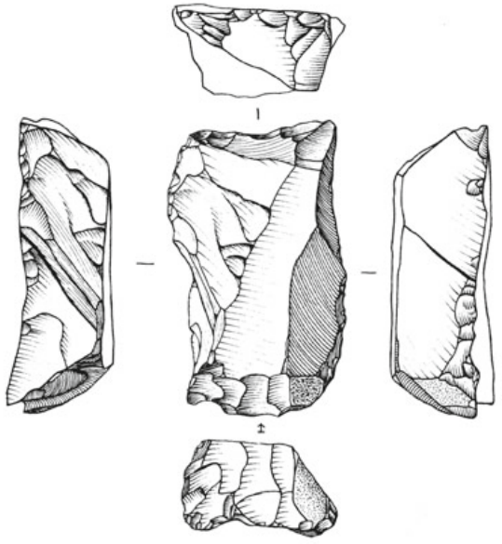
Fig.2: The conventional orthographic views typical of artefactual illustrations (Banning 2020: 353).
Most archaeological units have ‘style sheets’ that outline these conventions or refer to other widely-used handbooks (e.g., Hawker 2001; Steiner 2005; Small 2013; Collett 2017) – specifying for inclusions like scale bars and north arrows – which dictate the styles of drawings and images produced for grey literature reports. The illustrations produced in grey literature reports vary widely across archaeological units. Some plans and illustrations, for example, are initially hand-drawn and then digitally transcribed, while many are ‘born digital’ (Hopkinson and Winters 2003). The difference between the born digital illustrations of DigVentures, which incorporate imagery from a drone survey, and the more traditional digitally transcribed plans of Britannia Archaeology is clear (Fig.3). Although differing, both the plans clearly convey the excavator’s interpretation of the archaeology encountered.
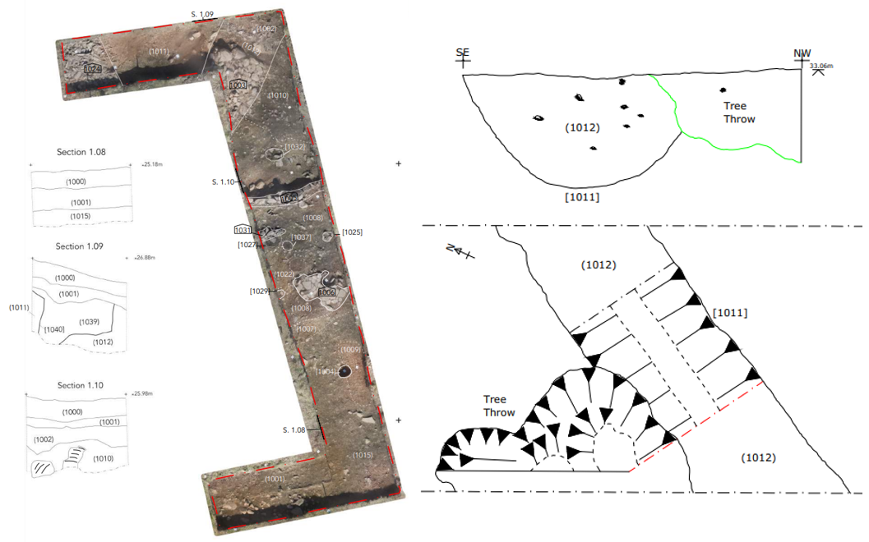
Fig.3: A ‘born digital’ plan (left) (Duensing and Teale 2022) and a digitally transcribed plan (right) (Schofield 2012).
The publishers of monographs, academic books, and journals, as they do for the format of bibliographies and citations, have specifications with regards to illustrations. The Journal of Field Archaeology, for example, has published particularly detailed requirements for figures (JFA n.d.). While the guidelines do not specify conventions as such, the instructions include requirements for image resolution, software and file-type suitability, image size and font, captions and signposting, and the selective use of colour and grayscale images. Comparable requirements are published by Medieval Archaeology journal (MA 2022) and the East Anglian Archaeology monograph (EAA 2022), which likewise largely focus on ensuring that the images reproduced are of good design and of high enough quality for legible reproduction.
Increasingly, grey literature reports, journal articles, and monographs provide links to supplementary material in the form of interactive 3D photorealistic models and videos (Opitz 2018). The e-publication, however, allows authors to make such visual communication integrated within the publication; pushing readers to engage with the digitised data along with the textual narrative (Fig.4). Indeed, the multi-layered e-publication (or ‘digital ecosystem’) of the LEAP II Project which included databases, digital audio, virtual-reality, and video – in addition to facilitating interrogation of interpretations and data – disseminated research to a broad audience (Limp et al 2011). While the inclusion of such multi-media is not a requirement of the e-publication, the flexible and experimental nature of these platforms give rise to the publication of a variety of visual communications. The requirements of Internet Archaeology with regards to multi-media files, notably, are not freely available and the editor must be directly contacted for specifics; this probably speaks to the range of issues, such as digital content preservation and format compatibility, in addition to cost, which restrict this type of visual communication (IA 2022a).
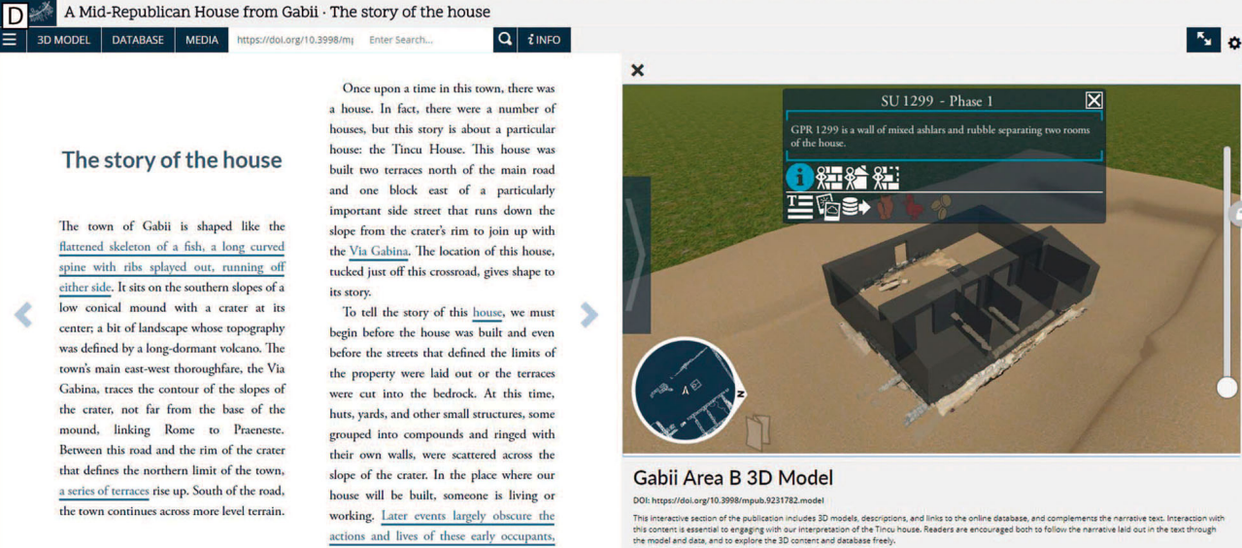
Fig.4: The textual narrative alongside the 3D-model (Opitz et al 2016).
Writing Style
In addition to specifying the format of bibliographies and citations, with many journals and e-publications necessitating DOI hyperlinks (e.g., IA 2022a; JAS 2023), most publishers have terminological guidelines. The guidelines of publishers typically list the expected conventions for communicating dates and periods, radiocarbon dates, abbreviations, measurements, directions, and geographical references (e.g., JFA n.d.; BAR 2014; PCAS 2022; MA 2022; IA 2022a; EAA 2022). These requirements ensure consistency and, to a certain extent, comparability and reusability. Many publications also observe policies that specify against the use of exclusionary language in relation to race, ethnicity, and gender. In the case of East Anglian Archaeology, for example, the terms ‘Neolithic man’ and ‘mankind’ are judged to be inappropriate, and would be replaced with preferable terms such as ‘Neolithic communities’ and ‘the human race’ (EAA 2022).
While the terminological requirements of publications are noteworthy, it is the unwritten expectations with regards to writing style that are perhaps more consequential. The writing styles employed in formal publication have been the subject of considerable discourse (Hodder 1989; Jones et al 2003; Bradley 2006; Joyce 2008; Fagan 2016). Archaeological publications usually employ formal academic language (Lucas 2019) written in the passive anonymous voice (Huvila 2017). This writing style is arguably the result of increasing professionalisation in the humanities (Opitz 2018). While not all publications include uninteresting and disproportionately lengthy description, grey literature reports and print monographs often contain protracted technical descriptions. Hodder (1989) notes that “…at best the reports are dull, excessively long, detailed and expensive and read by no one except the delirious specialist”. Even more concisely, Boivin (1997) describes many archaeological publications as “boring, boring, boring…”. An excerpt from my own work is illustrative of this tedious, and potentially self-evident, descriptive style:
“Sub-circular pit [1023] may represent the earliest feature observed within the trench; however, its stratigraphic relationship with ditch [1025] was not clear. The pit had steep sides with a concave base (1.40m+ x 1.10m x 0.65m). It was filled by deposit (1024), a friable mid grey/red brown silty sand with frequent small sub-angular flints. (Podbury 2022).
Despite the valid critiques of the uninteresting style of these accounts, these descriptions are viewed as key to their later interrogation and are likely related to efforts for such reports to represent the ‘full’ archive. The aim of the modern journal article, on the other hand, is not to represent the full archive; instead, they are synthesised works that point the reader to the wider archive. Within many articles from regional journals, such as those from Norfolk Archaeology, there are no longer lengthy accounts of grouped artefactual or environmental assemblages – they have been replaced with short, summarised sections on the findings. This too has been the subject of significant disapproval. Many of those interviewed from the PUNS Survey were concerned about the disparity between the amount of information published about features and deposits in comparison to the artefactual and environmental findings (Jones et al 2003).
It has also been argued the impersonal style is caused by the perceived necessity to be seen as serious and impartial in all forms of academic writing (Hyland 2001: 208; Culler and Lamb 2003); an observation that is certainly applicable to my own writings. Understandably, however, this unnecessarily dense and impersonal style is not particularly appealing to the wide spectrum of contemporary audiences that archaeologist hope to reach. While these mediums are certainly not immune to this style of writing, several journal articles and e-publications have sought to remedy this perceived shortcoming. For example, the work of Hudson (2010) within the American Journal of Archaeology uses personal pronouns throughout. This article, like many that use the first-person, does not conceal that knowledge is being actively created by the researcher, and is perhaps more likely to include information on how or why particular conclusions were reached (Webb 1992: 748-749). A short excerpt from the article by Hudson (2010: 675) demonstrates the utility of this style of writing:
“With the ceramic assemblages, I make use of existing ceramic typologies to classify vessels but do not rely on these typologies to determine vessel function. This is because typologies are constructed to illustrate chronological evolutions of forms and types within a production tradition”.
Again, however, despite the guidelines for many peer-reviewed journals and monographs not being prescriptive on the ‘grammatical person’ (e.g., JFA n.d.; MA 2022; IA 2022a; IA 2022b; EAA 2022). The impersonal academic tone almost always employed appears to represent a learned behaviour that is reflected in numerous manuals for academic writing (Hyland 2001; Börjesson 2017).
The impersonal and academic tone brings into question the ability to convey information to a broad public audience; one of the principal purposes for publication highlighted in the PUNS Report (Jones et al 2003). Although certainly not a typical output of commercial investigations themselves ‘popular’ archaeological books, like those by Alice Roberts (2021; 2022), are often far more engaging, personable, and readable. Inevitably, the notion of serving a broad audience gives rise to tensions about the potential incompatibility of producing interesting, widely accessible and readable prose, and the necessity for exhaustive scientific rigour (Connah 2010).
While many authors of monographs and journal articles express complex concepts in simple language (Hodder 1989) – with some journals requesting ‘everyday language’ (MA 2022) – it is through these publications that interpretations are most often obfuscated with jargon. The experimental nature of e-publications provides opportunities for authors to diverge from the traditional ways of storytelling. Within A Mid-Republican House from Gabii, in addition to typically detailed and complex narratives, each chapter includes a section that tells the story of the excavation in highly simplified language accessible to those of 13 and older (Opitz et al 2016). This report, more in line with the other publication types and certainly reflective of my own instruction in academic writing, has a Flesch Reading Ease score of 15; thus, being characterised as very difficult to read and best understood by a university graduate.
Quality Control and Editing
Monographs, journal articles, and academic books go through a process of peer-review. Peer-review is a social process of negotiation between editors, reviewers, and authors (Bedeian 2004). Discussing the peer-review processes of American Antiquity and Latin American Antiquity, Lanata et al (2007) states that following submission to the journal reviewers are tasked with appraising theoretical and historical context, the methodological process, and the consistency and accuracy of the conclusions presented. Papers often go through numerous reviews before being accepted for publication, with many requests for significant changes (Lanata et al 2007). Following review, the author can either accept the comments and duly revise or they can dispute the comments and suggestions. Through this process of negotiation, the intended purpose of the peer-review is achieved; the assurance and homologation of the quality of knowledge published (Bedeian 2004; Lanata et al 2007; Salazar et al 2019).
Despite the clear significance of this practice, in contrast to other disciplines, critiques of the peer-review process in archaeology are limited (Salazar et al 2019. Among a plethora of critiques, are the recurring discussions about the biases purportedly inherent to peer-review processes (Benos et al 2007; Lee et al 2013; Jukola 2017); specifically, interpersonal biases and biases that relate to content of the submission. Perhaps even more significantly, it has been argued that peer-review mechanisms have the potential to stifle innovation and restrain the development of new ideas (Armstrong 1997; Bedeian 2004; Bensos et al 2007; Jukola 2017). Regardless of the considerable limitations outlined in the discourse, the method is still the best way to determine the academic quality of formal publications (Young 2003; Bedeian 2004; Lanata et al 2007).
That is not to say that the practice cannot be improved upon, and the experimental e-publication provides an opportunity to adapt the process. Most e-publications go through the traditional peer-review process; however, Internet Archaeology has experimented with ‘open peer review’ in their recent blogging volume (Morgan and Winters 2018). The transparent peer-review process reportedly made interactions more civil, and produced a more meaningful and insightful discourse between the reviewer and the author – this observation is evident upon reading the published peer comments, which largely represent considered essays themselves (e.g., Beale 2015). Open peer-review, however, is not a panacea. Issues related to the stifling of innovative research remain and as relayed by the reviewers of the articles in volume, some were uncomfortable and tentative when publicly publishing a critical review (Morgan and Winters 2018). Nevertheless, the open process would be particularly appropriate when the manuscript is focused on a highly niche topic where a double-blind peer review would impossible. Indeed, Judith Winters, the editor of Internet Archaeology, views the open peer-review as an option to be selectively employed rather than a wholesale replacement (Morgan and Winters 2018).
Although not subject to peer-review, grey literature reports usually go through an internal process of quality-control. At Wardell Armstrong, for example, each report undergoes two internal reviews to correct any errors and to ensure completeness. The report is then submitted to a curatorial archaeologist, who again reviews the document and recommends revisions. Nevertheless, these quality-control procedures are subject to the same personal idiosyncrasies and limitations that afflict the traditional peer-review (Harlan 2009). The shortcomings of these quality-control mechanisms are perhaps one reason many academic archaeologists maintain negative perceptions of grey literature reports (Roth 2010: 339). An internal review may particularly focus on an aspect of the report that would not of great concern to the academic reviewer – the minutiae, for example, of the planning background. In contrast, the peer-reviewer may focus on how theoretically informed the manuscript is, and this is arguably not the focus of many internal reviews (Green and Doershuk 1998). Indeed, Roth (2010) notes that ideas that are not ‘well supported’ are sometimes published in grey literature reports, deriding that these ideas are not published in a forum where they can be challenged or vetted for accuracy. Suggestions on how the perceived shortcomings of the standard quality-control procedures, however, were not proffered.
Conclusion
There are a wide range of requirements and standards, some of which are explicitly prescribed by publishers and some that are unwritten conventions, that mould formal archaeological publications. Authors abide by an assortment of guidelines with regards to structure, data representation, visual communication, terminology and writing style and undergo the rigours of quality control procedures. Arguably, these written and unwritten conventions that shape publications have given rise to a variety of critiques that reflect the way in which readers hope, or expect, to use published resources. In particular, there have been considerable critiques of the style and legacy of monographs, grey literature reports, and to a lesser extent traditional journal articles, accompanied by condemnation on the lack of progress in recent years over the rethinking of these mediums (Opitz 2018). The nascent digital-monograph and e-publications, as dynamic and developing platforms, may remedy these perceived shortcoming as they permit authors to experiment with new ways of communicating their research. Regardless, the e-publications, like the more traditional forms of publication, are required to adhere to the guidelines of the publisher so that certain basic scholarly standards are upheld.

Bibliography
Armstrong, J. S. (1997) 'Peer Review for Journals: Evidence on Quality Control, Fairness, and Innovation', Science and Engineering Ethics, 3, pp.63-84.
Banning, E. B. (2020) The Archaeologist's Laboratory: The Analysis of Archaeological Evidence. Cham: Springer.
BAR Publishing (BAR) (2014) Preparing Your Manuscript for Publication. Available at: https://www.barpublishing.com/pdf/BAR%20Preparing%20your%20Manuscript%20for%20Publication.pdf (Accessed: 10 December 2022).
Beale, G. (2015) 'Peer Comment', Internet Archaeology, 39. DOI: 10.11141/ia.39.2.com1
Bedeian, A. G. (2004) 'Peer Review and the Social Construction of Knowledge in the Management Discipline', Academy of Management Learning and Education, 3(2), pp.198-206.
Benos, D. J., Bashari, E., Chaves, J., Gaggar, A., Kapoor, N. and LaFrance, M. (2007) 'The ups and downs of peer review', Advances in Physiology Education, 31(2), pp.145-152.
Boivin, N. (1997) 'Insidious or just Boring? An Examination of Academic Writing in Archaeology', Archaeological Review from Cambridge, 14, pp.105-125.
Börjesson, L. (2017) Resources for scholarly documentation in professional service organizations: A study of Swedish development-led archaeology report writing. Unpublished PhD thesis. Uppsala University.
Bradley, R. (2006) 'The Excavation Report as a Literary Genre: Traditional Practice in Britain', World Archaeology, 38(4), pp.664-671. DOI: 10.1080/00438240600963338
British Institute at Ankara (BIAA). (2022) Style Guide for all Institute Publications. Available at: https://biaa.ac.uk/wp-content/uploads/2022/01/BIAA_style_guide_Feb_20211.pdf (Accessed: 10 December 2022).
Butler, L. and Gerrard, C. (2021) Faxton: Excavations in a deserted Northamptonshire village 1966–68. The Society for Medieval Archaeology Monograph 42. London: Routledge.
Clarke, J. R. (2016) '3D Model, Linked Database and Born-Digital E-Book: An Ideal Approach to Archaeological Research and Publication', in Munster, S., Pfarr-Harfst, M., Kuroczynski, P. and Ioannides, M (eds.) 3D Research Challenges in Cultural Heritage II. Cham: Springer International Publishing.
Colledge, S. (2016) 'The cultural evolution of Neolithic Europe. EUROEVOL Dataset 3: Archaeobotanical Data', Journal of Open Archaeology Data, 5. DOI: 10.5334/joad.42
Collett, L. (2017) CIfA Professional Practice Paper: Introduction to Drawing Archaeological Pottery. Reading: Chartered Institute Archaeologists.
Collis, J. (2013) 'The development of archaeological thought as evidenced in the Yorkshire Archaeological Journal', Yorkshire Archaeological Journal, 85(1), pp.5-26.
Connah, G. (2010) Writing about Archaeology. Cambridge: Cambridge University Press.
Costello, M.J., Michener, W.K., Gahegan, M., Zhang, Z.Q. and Bourne, P.E. (2013) 'Biodiversity data should be published, cited, and peer reviewed', Trends in Ecology and Evolution, 28(8), pp.454-461.
Culler, J. D. and Lamb, K. (2003) Just Being Difficult?: Academic Writing in the Public Arena. Stanford: Stanford University Press.
Duensing, S.N. and Teale, K. (2022) CHERISH Evaluation Excavation 2021 Penplediau / Caerfai Promontory Fort: Post Excavation Assessment. DigVentures report. Unpublished.
Earley-Spadoni, T. (2017) 'Spatial History, Deep Mapping and Digital Storytelling: Archaeology's Future Imagines Through an Engagament with the Digital Humanities', Journal of Archaeological Science, 84, pp.95-102. DOI: 10.1016/j.jas.2017.05.003
East Anglian Archaeology (EAA). (2022) Notes for Authors. Available at: https://eaareports.org.uk/guidance/eaa-notes-for-authors/#3 (Accessed: 10 December 2022).
Evans, T. (2015) 'A reassessment of archaeological grey literature: semantics and paradoxes', Internet Archaeology, 40. DOI: 10.11141/ia.40.6
Evans, T. and Moore, R. (2014) 'The use of PDF/A in digital archives: a case study from archaeology', International Journal of Digital Curation, 9(2), pp.123-138. DOI: 10.2218/ijdc.v9i2.267
Fagan, B. (2016) Writing Archaeology: Telling Stories about the Past. London: Routledge.
Franze, J., Marriot, K. and Wybrow, M. (2014) 'What Academics Want when Reading Digitally', Smiske, S. (ed.), Proceedings of the 2014 ACM Symposium on Document Engineering. New York: ACM. DOI: 10.1145/2644866.2644894
Green, W. and Doershuk, J.F. (1998) 'Cultural Resource Management and American Archaeology', Journal of Archaeological Research, 6, pp.121-167.
Harlan, M. E. (2009) 'Archaeology's Grey Literature and Proffesional Review', The Grey Journal, 5(2), pp.33-88.
Hawker, J. M. (2001) A Manual of Archaeological Field Drawing. London: RESCUE.
Hodder, I. (1989) 'Writing Archaeology: Site Reports in Context', Antiquity, 63(239), pp.268-274.
Hopkinson, G. and Winters, J. (2003) 'Problems with Permatrace: a note on digital image publication', Internet Archaeology, 14. DOI: 10.11141/ia.14.5
Hudson, N. F. (2010) 'Changing Places: The Archaeology of the Roman "Convivium"', American Journal of Archaeology, 114(4), pp.663-695.
Huvila, I. (2016) 'Awkwardness of becoming a boundary object: mangle and materialities of reports, documentation data and the archaeological work', The Information Society, 32(4), pp.280-297.
Huvila, I. (2017) 'Archaeology of No Names? The Social Productivity of Anonymity in the Archaeological Information Process', Ephemera, 17(2), pp.351-376.
Huvila, I., Skold, O. and Borjesson, L. (2021) 'Documenting Information Making in Archaeological Field Reports', Journal of Documentation, 77(5), pp.1107-1127.
Hyland, K. (2001) 'Humble Servants of the Discipline? Self-Mention in Research Articles', English for Specific Purposes, 20(3), pp.207-226.
Internet Archaeology (IA) (2022a) Information for Authors. Available at: https://www.intarch.ac.uk/authors/index.html (Accessed: 10 December 2022)
Internet Archaeology (IA) (2022b). Data Papers. Available at: https://intarch.ac.uk/authors/data-papers.html (Accessed: 10 December 2022)
Johnston, P. (2014) 'Archaeobotanical data from two Middle and Later Bronze Age round house sites in Cork, Ireland', Journal of Open Archaeology Data, 3. DOI: 10.5334/joad.ac
Jones, S., MacSween, A., Jeffrey, S., Morris, R. and Heyworth, M. (2001) From the Ground Up: the Publication of Archaeological Projects: A User Needs Survey. York: Council for British Archaeology.
Jones, S., MacSween, A., Jeffrey, S., Morris, R. and Heyworth, M. (2003) 'From the Ground Up: The Publication of Archaeological Projects: A User Needs Survey. A Summary', Internet Archaeology, 14. DOI: 10.11141/ia.14.4
Journal of Archaeological Science (JAS) (2023) Author Information Pack. Available at: https://www.elsevier.com/wps/find/journaldescription.cws_home/622854?generatepdf=true (Accessed: 2 January 2023)
Journal of Field Archaeology (JFA). (n.d.). Instructions for Authors. Available at: https://www.tandfonline.com/action/authorSubmission?show=instructions&journalCode=yjfa20 (Accessed: 2 January 2023)
Joyce, R. (2008) The Languages of Archaeology: Dialogue, Narrative, and Writing. Oxford: Blackwell Publishing.
Jukola, S. (2017) 'A social epistemological inquiry into biases in journal peer review', Perspectives on Science, 25(1), pp.124-148.
Kansa, E.C. and Kansa, S.W. (2013) 'Open Archaeology: We All Know That a 14 Is a Sheep: Data Publication and Professionalism in Archaeological Communication', Journal of Eastern Mediterranean Archaeology & Heritage Studies, 1(1), pp.88-97.
Ladle, L. (2022) The Rise and Decline of Druce Farm Roman Villa (60-650 CE): Excavations 2012-2018. BAR British Series 676. London: BAR Publishing.
Lanata, L. J., Aldenderfer, M. and Jochim, M. (2007) 'The peer-review process for American Antiquity and Latin American Antiquity', SAA Archaeological Record, 7(1), pp.12-15.
Lee, C., Sugimoto, C., Zhang, G. and Cronin, B. (2013) 'Bias in peer review', Journal of the American Society for Information Science and Technology, 64, pp.2-17.
Limp, F., Payne, A., Simon, K., Winters, S. and Cothren, J. (2011) 'Developing a 3-D Digital Heritage Ecosystem: from object to representation and the role of a virtual museum in the 21st century', Internet Archaeology, 30. DOI: 10.11141/ia.30.1
Lloyd-Smith, L. (2021) Land South of Quicksie Hill, Wenden Road, Arkesden, Essex: Research and Archive Report. Wardell Armstrong report. Unpublished.
Lodwick, L.A. (2019a) 'Agendas for Archaeobotany in the 21st Century: data, dissemination and new directions', Internet Archaeology, 53. DOI: 10.11141/ia.53.7
Lodwick, L.A. (2019b) 'Sowing the Seeds of Future Research: Data Sharing, Citation and Reuse in Archaeobotany', Open Quaternary, 5(1). DOI: 10.5334/oq.62
Lucas, G. (2019) Writing the Past: Knowledge and Literary Production in Archaeology. Oxford: Routledge.
Luke, M. and Barker, J. (2021) A Roman Farmstead and other Late Neolithic to Post-medieval Land-use at Houghton Regis, Bedfordshire. Albion Archaeology Monograph 7. Bedford: Albion Archaeology
Maarleveld, T.J., Guerin, U. and Egger, B. (2011) Manual for Activities Directed at Underwater Cultural Heritage: Guidelines to the Annex of the UNESCO 2001 Convention. Paris: UNESCO.
Medieval Archaeology (MA) (2022). Instructions for Authors. Medieval Archaeology report. Unpublished.
Moody, B., Dye, T., May, K., Wright, H. and Buck, C. (2021) 'Digital Chronological Data Reuse in Archaeology: three case studies with varying purposes and perspectives'. Journal of Archaeological Science, 40, pp.1-15. DOI: 10.1016/j.jasrep.2021.103188
Moore, R. and Richards, J. (2015) 'Here today, gone tomorrow: open access, open data and digital preservation', in Wilson, A.T and Edwards, B (eds.) Open Source Archaeology: Ethics and Practice. Berlin: De Gruyter Open. DOI: 10.1515/9783110440171-004
Morgan, C. (2013) 'Publishing Archaeological Research: Comparative Perspectives on Common Concerns', Mélanges de la Casa de Velázquez, 43(2), pp.279-288.
Morgan, C. and Wright, H. (2018) 'Pencils and Pixels: Drawing and Digital Media in Archaeological Field Recording', Journal of Field Archaeology, 43(2), pp.136-151.
Moser, S. (2012) 'Archaeological Visualization: Early Artifact Illustration and the Birth of the Archaeological Image' in Hodder, I (ed.) Archaeological Theory Today. Cambridge: Polity.
Newton, A., Lloyd-Smith, L. and Podbury, L. (2020) 'Saxo-Norman and Medieval Buildings and Enclosures at Knapton', Norfolk Archaeology, 48(3), pp.313-334.
Opitz, R. (2018) 'Publishing Archaeological Excavations at the Digital Turn', Journal of Field Archaeology, 43(1), pp.68-82. DOI: 10.1080/00934690.2018.1505409
Opitz, R., Mogetta, M. and Terrenato, N. (2016) A Republican House from Gabii. Ann Arbor: Michigan Press. DOI: 10.3998/mpub.9231782
Perry, S. (2015) 'Changing the Way Archaeologists Work: blogging and the development of expertise', Internet Archaeology, 39. DOI: 10.11141/ia.39.9
Pilaar-Birch, S. (2013) 'Using Social Media for Research Dissemination: The Digital Research Video Project', Internet Archaeology, 35. DOI: 10.11141/ia.35.4
Podbury, L. (2022) Phase 2 & School Extension, Land North and South of Dereham Road, Easton, Norfolk: Archaeological Trial Trenching. Wardell Armstrong report. Unpublished.
Proceedings of the Cambridge Antiquarian Society (PCAS) (2022) Format of Articles and Submissions. Proceedings of the Cambridge Antiquarian Society. Available at: https://www.camantsoc.org/wp-content/uploads/2022/06/PCASsubmissions.pdf (Accessed: 2 January 2023)
Richards, J. and Hardman, C. (2008) 'Stepping back from the trench edge: an archaeological perspective on the development of standards for recording and publication', in Greengrass, M and Hughes, L (eds.) The Virtual Representation of the Past. Farnham: Ashgate Publishing Company.
Roberts, A. (2021) Ancestors: A Prehistory of Britain in Seven Burials. London: Simon & Schuster.
Roberts, A. (2022) Buried: An Alternative History of The First Millennium in Britain. London: Simon & Schuster.
Ross, S. and Ross, C. (2021) Cataractonium: Establishment, Consolidation and Retreat. NAA Monograph Series Volume 6. Barnard Castle: Northern Archaeological Associates.
Roth, B. J. (2010) 'An Academic Perspective on Grey Literature', Archaeologies: Journal of the World Archaeological Congress, 6(2), pp.337-345.
Salazar, D., Ramírez, H., Yrarrazaval, S., Saball, A., Troncoso, A., Rogan, J. and Correa, C. (2019) 'Peer-Review and Academic Archaeology: Quality, Epistemology and Science Policies', Archaeologies, 15, pp.227-253.
Schofield, T. (2012) Land at Main Road, Martlesham, Woodbridge, Suffolk: Archaeological Trial Trench Evaluation. Britainnia Archaeology report. Unpublished.
Schreibman, S. (2014) 'Non-Consumptive Reading' in Segal, N. and Koleva, D. (eds.) From Literature to Cultural Legacy. London: Palgrave Macmillan.
Sinclair, A. (1989) 'This is an article about archaeology as writing in writing archaeology', Archaeological Review from Cambridge, 8(2), pp.212-233.
Small, T. (2013) Archaeological Illustration: Small Finds. British Archaeological Jobs Resource. Available at: http://www.bajr.org/BAJRGuides/32.%20Archaeological%20Illustration%20-%20Small%20Finds/Guide32.pdf (Accessed: 2 January 2023)
Steiner, M. (2005) Approaches to archaeological illustration: a handbook. London: English Heritage / Council for British Archaeology.
Thompson, P. and Podbury, L. (forthcoming) 'Through the Layers of Industry: waster deposits and further insights into the medieval pottery industry at Ely, Cambridgeshire', Internet Archaeology.
Tilley, C. (1989) 'Discourse and Power: The Genre of the Cambridge Inaugural Lecture', in Miller, D., Rowlands, M. and Tilley, C (eds.) Domination and Resistance. London: Routledge.
Torrence, R., Martinón-Torres, M. and Rehren, T. (2015) 'Forty years and still growing: Journal of Archaeological Science looks to the future', Journal of Archaeological Science, 56, pp.1-8. DOI: 10.1016/j.jas.2015.03.001
Wardell Armstrong (WA) (2022) Evaluation Template - November 2022. Wardell Armstrong report. Unpublished
Warinner, C. and d'Alpoim-Guedes, J. (2014) 'Digitizing the archaeobotanical record', in Marston, J.M., d'Alpoim-Guedes, J. and Warinner, C. (eds.) Method and Theory in Paleoethnobotany. Colorado: University Press of Colorado.
Webb, C. (1992) 'The Use of First Person in Academic Writing: Objectivity, Language and Gatekeeping', Journal of Advanced Nursing, 17, pp.747-752.
Wheelan, J. and Howard, A. (2019) Areas 1, 2 & 3, Plot 10 North Whiteley, Fareham, Hampshire: Archaeological Excavation. Cotswold Archaeology report. Unpublished.
Whitlock, M.C. (2014) 'Data archiving in ecology and evolution: best practices', Trends in Ecology and Evolution, 26(2), pp.61-65. DOI: 10.1016/j.tree.2010.11.006
Young, S.N. (2003) 'Peer review of manuscripts: Theory and practice', Journal of Psychiatry and Neuroscience, 28(5), pp.327.

