E-Portfolio
MODULE: ECPS4018

Table of Contents

Table of Contents 1
AI Acknowledgment 2
Summary 3
Infographic 6
Essay Plan 8
Screenshots of library articles and Summary 17

AI Acknowledgment

I confirm that I have not used any AI tools in the research and creation of this assignment. I confirm that I have not presented any AI generated materials as my own work. I confirm I have copies of my drafts, notes, and other resources I used, which I may be asked to provide in evidence.

Summary
How does music make you feel?
Nendick (12 September 2022) asked the question, why do so many people interact with music? And why does listening to different genres of music provoke feelings such as happiness or sadness? Different notes of music recomplicate different emotions including minor and major notes.
Due to the perplexity of the mind, memories can be recalled using music to reminisce and connect with repressed emotions (Belfi et al., 2016). Along with this, music can extract the emotions felt while listening to the song for the first time.
Meyer (1956), in his book Emotion and Meaning in Music coincides with the theory of emotions and rhythm of music, explaining it be met by each individual expectation. Each expectation is in the reward center of the brain and produces good feelings from neutral substrates (Blood & Zatorre, 2001), when associated with music.
In The Book Musical Emotions Explained (Justin, 2019), It points out Western civilizations' music, and how it cannot be used universally to explain the connection between emotion and music. Therefore, the BRECVEMA foundation was introduced (Juslin & Västfjäll, 2008; Juslin, 2013). Even though it is still in development, there has been an identified difference between personality traits and music.
The modes of music have evolved, and it is now primarily apps and online focused which makes listening to music effortless. The platforms are powered by AI and create playlists around personality and listening habits (Juslin & Laukka, 2004).
The positive aspect of music is that it is a natural pain reliver (Finn & Fancourt, 2018) and has a positive impact on memory recall on individuals who have Alzheimer's disease (Fraile et al., 2019).
Music does not have provoke an emotional response in everyone, due to individual differences (Satoh et al., 2011). This can be supported by statics showing that five percent of the population obtain congenital music anhedonia (Mas-Herrero et al., 2013).

Reference list
Nendick, Z. (2022, September 12). How does music make you feel? - The British Psychological Society. Www.bps.org.uk. https://www.bps.org.uk/psychologist/how-does-music-make-you-feel

Infographic

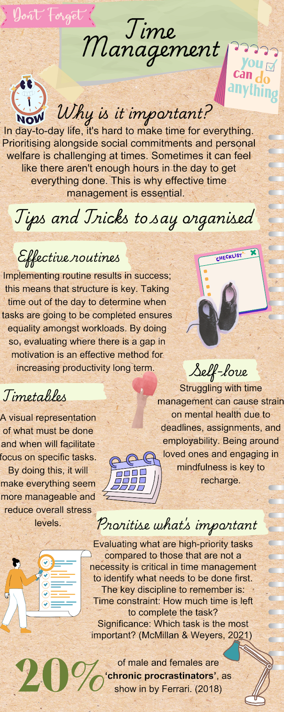

Reference list
Ferrari, J. R. (2018). Introduction to “Procrastination, Clutter, & Hoarding.” Current Psychology (New Brunswick, N.J.), 37(2), 424-425. https://doi.org/10.1007/s12144-018-9803-0

McMillan, K., & Weyers, J. (2021). The study skills book: your essential guide to university success (4th ed.). Pearson Education, Limited.

Essay Plan

(a) Describe and discuss the psychological, social, and physical benefits of owning a pet.

Introduction | General Introductory into pet ownership | - To begin, I will start off with this quote: “If you pick up a starving dog and make him prosperous, he will not bite you. This is the principal difference between a dog and a man” (Twain, 1894, p. 214).  - For this reason, it underpins why pet ownership is sought after. Statistics show that in the UK, sixty percent of households reside with a pet (UK Pet Food, 2024).  - With over half the population being in this category, it emphasises the support people need without subconsciously releasing it.  - To close it off I would say that life is inevitably challenging, so psychological, social, and physical needs to be fulfilled.
Paragraph 1 | Psychological benefits | - Firstly, I will begin my first point by describing the psychological benefits of pet ownership.  - Pets can be seen as buffers for individuals in need of support. Having a non-human animal connection is beneficial because there are no limitations in terms of hindering support. The owner is the pet's main concern, and they focus their lives on them. This is the main difference between a person and a pet. (McNicholas, et al., 2005)
Paragraph 1 | Support  Displaced individuals and their pet attachment. | - Support for the psychological benefits homeless people have from pets.  - The number of people who declare that they are homeless is rising.  - Figures show that pet ownership is between the average values of five (Cronley, et al., 2009), to twenty-five percent (Rhoades, et al., 2015).  - A study conducted by a researcher to create a data analysis raised some important points in this matter. Participants included in this study were among pet owners who were facing homeliness. When asked why they owned pets many responses circled back to their improved personality, and the impact that has had on them. The subject of loneliness was also prevalent, with a reduction of isolation and depression in many individuals across a wide scale (Scanlon, et al., 2021).  - This last point sums up why pet ownership results in positive reinforced behaviors. An individual who is facing a re-lapse needs a meaningful purpose in one’s life. In this case it is looking after a pet, that simultaneously helps their own physiological health (Ivine, 2013).
Paragraph 2 | Social benefits | - In this part of the essay, I would describe the social benefits of owning a pet.  - Pets provide unconditional love, something that humans cannot always do, due to their unpredictable nature.  - A hormone referred to as oxytocin is released during direct time spent with a pet. Socially, this feeling fulfills the bond essential to wellbeing and can also be linked to stages of pregnancy attachment (“John Hopkins Medicine,” n.d.).  - Researchers Taylor and Breen (2013) said pets support personality development including confidence and individualism.
Paragraph 2 | Support  Therapy dogs | - In support of the social benefits, therapy dogs are used within the animal assisted therapy framework to encourage this aspect. The aim is to provide individuals with the opportunity to develop socially, whilst being in a healthy and controlled environment.  - An example of this is the use of therapy dogs in a hospital. Wards such as stroke, cancer and children’s hospital units benefited from this service. Pets bring hope into the hospital setting and reduce pain in patients. When people are struggling it is hard to be optimistic. However, with this therapy the chance to reminisce, but also live in the present is made available. The chance to connect with others and improve overall communal attitudes is valuable because of the instinct of human nature (Stockport National Health Service Trust [NHS], 2024).  - This illustrates why people need pets, and why the social aspect of being with a pet is highly beneficial.
Paragraph 3 | Physical benefits | - In this paragraph I will be relaying the physical benefits of pet ownership.  - Owning a pet is undoubtedly going to increase physical health, due to the pet's physical health.  - As a result, healthy sleeping patterns are implemented. Additionally, lower levels of sickness are identified (Headey et al., 2007).
Paragraph 3 | Support from studies | - To support the point above, I will discuss the physical benefits pets have on pet owners.  - Research conducted concluded that in a cardiovascular rehabilitation program, those who have pets were more likely to stick it out and become healthy, compared to non-pet owners. This is because the participants who had pets are more likely to recover due to the health benefits, and those who do not (Herrald, et al., 2002).  - To support this, pets are said to be able to lower blood pressure and provide energy, to increase overall wellbeing (Wright, et al, 2007).  - The physical benefits are endless, and ongoing research is being conducted to see the scope of effectiveness.
Paragraph 4 | COVID-19 outbreak | - To conclude the essay, I will discuss pet ownership in the epidemic of COVID-19.  - This was a milestone event across the world, and individuals struggled to process the event of lockdowns and isolation. Due to this traumatic time, individuals turned to pet ownership to support them (RSPCA, 2020, as cited in Phillipou et al., 2021).  - As humans have evolved, adaptability to situations has progressed. As a result, they put pets into their home to fulfill their psychological, social, and physical health.
Paragraph 4 | Support  Behavior's in COVID-19 | - In the support aspect of this essay, I will describe the overall benefits and how this resulted in positive behavior.  - Physical activity is crucial to quality of life and keeping the mind balanced. Research conducted showed a clear connection between positive well-being and exercise. Those who did not have a pet produced lower scores, with statistics showing that they exercise thirty minutes less a week as shown in (Christian, et al., 2016).  - At that point, social interaction was limited. Consequently, psychological health decreased because there was no social support available.  - Owners expressed that owning a pet enabled them to make connections with other likeminded people and provided them with a sense of closeness with their pet. (Chopik, et al., 2023)
Conclusion | Summary of main ideas | - State an overall understanding as to why people own pets.  - From an evolutionary standpoint, humans connecting with pets reduces their overall capabilities.  - Nonetheless, in modern society we see pets as part of the family, and they do not hinder life, they elevate it.
Conclusion | Concluding remarks/recommendations | - It is important to remember that every person is individual, nobody knows what each person has gone through and is still going through. Pets provide unique support to everyone whether that be psychological, social, or physical (Taylor & Breen, 2013).  - Pets are intrinsically nonjudgmental and see the good in everyone. No wonder pet ownership is so popular!

References

Anderson, W. P., Reid, C. M., & Jennings, G. L. (1992). Pet ownership and risk factors for cardiovascular disease. The Medical Journal of Australia, 157(5), 298–301. https://pubmed.ncbi.nlm.nih.gov/1435469/

Chopik, W. J., Oh, J., Weidmann, R., Weaver, J., Rhonda Nicole Balzarini, Giulia Zoppolat, & Slatcher, R. B. (2023). The Perks of Pet Ownership? The Effects of Pet Ownership on Well-Being During the COVID-19 Pandemic. Personality and Social Psychology Bulletin. https://doi.org/10.1177/01461672231203417##

Cronley, C., Strand, E. B., Patterson, D. A., & Gwaltney, S. (2009). Homeless People who are Animal Caretakers: A Comparative Study. Psychological Reports, 105(2), 481-499. https://doi.org/10.2466/PR0.105.2.481-499

Christian, H., Wood, L., Nathan, A., Kawachi, I., Houghton, S., Martin, K., & McCune, S. (2016). The association between dog walking, physical activity and owner’s perceptions of safety: cross-sectional evidence from the US and Australia. BMC Public Health, 16(1). https://doi.org/10.1186/s12889-016-3659-8

Headey, B., Na, F., & Zheng, R. (2007). Pet Dogs Benefit Owners’ Health: A “Natural Experiment” in China. Social Indicators Research, 87(3), 481–493. https://doi.org/10.1007/s11205-007-9142-2

Herrald, M. M., Tomaka, J., & Medina, A. Y. (2002). Pet Ownership Predicts Adherence to Cardiovascular Rehabilitation1. Journal of Applied Social Psychology, 32(6), 1107–1123. https://doi.org/10.1111/j.1559-1816.2002.tb01428.x

Irvine, L. (2013). My dog always eats first: Homeless people and their animals. Boulder, CO:L. R. Publishers.

John Hopkins Medicine. (n.d.). The friend who keeps you young. https://www.hopkinsmedicine.org/health/wellness-and-prevention/the-friend-who-keeps-you-young

McNicholas, J., Gilbey, A., Rennie, A., Ahmedzai, S., Dono, J., & Ormerod, E. (2005). Pet ownership and human health: a brief review of evidence and issues. BMJ : British Medical Journal, 331(7527), 1252. https://doi.org/10.1136/bmj.331.7527.1252

Phillipou, A., Tan, E., Toh, W., Van Rheenen, T., Meyer, D., Neill, E., Sumner, P., & Rossell, S. (2021). Pet ownership and mental health during COVID ‐19 lockdown. Australian Veterinary Journal, 99(10). https://doi.org/10.1111/avj.13102

Rhoades, H., Winetrobe, H. & Rice, E. (2015). Pet Ownership Among Homeless Youth: Associations with Mental Health, Service Utilization and Housing Status. Child Psychiatry Hum Dev, 46, 237–244. https://doi.org/10.1007/s10578-014-0463-5

Stockport National Health Service Trust. (2024). Patient pet therapy - perking up patients with dogs Paddy and Pippa. https://www.stockport.nhs.uk/news_22041

Scanlon, L., Hobson-West, P., Cobb, K., McBride, A., & Stavisky, J. (2021). Homeless people and their dogs: Exploring the nature and impact of the human–companion animal bond. Anthrozoös, 34(1), 77–92. https://doi.org/10.1080/08927936.2021.1878683

Twain, M. (1894). The Tragedy of Pudd’nhead Wilson. Project Gutenberg. https://www.gutenberg.org/cache/epub/102/pg102-images.html

Taylor, S. C., & Breen, L. J. (2013). Exploring Pet Loss for Survivors of Child Sexual Abuse: A Hitherto Unchartered Terrain of Trauma Impact and Recovery. Child Abuse Review, 23(5), 353–360. https://doi.org/10.1002/car.2279

UK Pet Food. (2024). UK Pet Food’s Pet Data Report 2024. https://www.ukpetfood.org/resource/paw- some-new-pet-population-data-released-by-uk-pet-food.html

Wright, J. D., Kritz - Silverstein, D., Morton, D. J., Wingard, D. L., & Barrett-Connor, E. (2007). Pet Ownership and Blood Pressure in Old Age. Epidemiology, 18(5), 613–618. https://doi.org/10.1097/ede.0b013e3181271398

Screenshots of library articles and Summary

(1) Pet ownership and mental health during COVID-19 lockdown
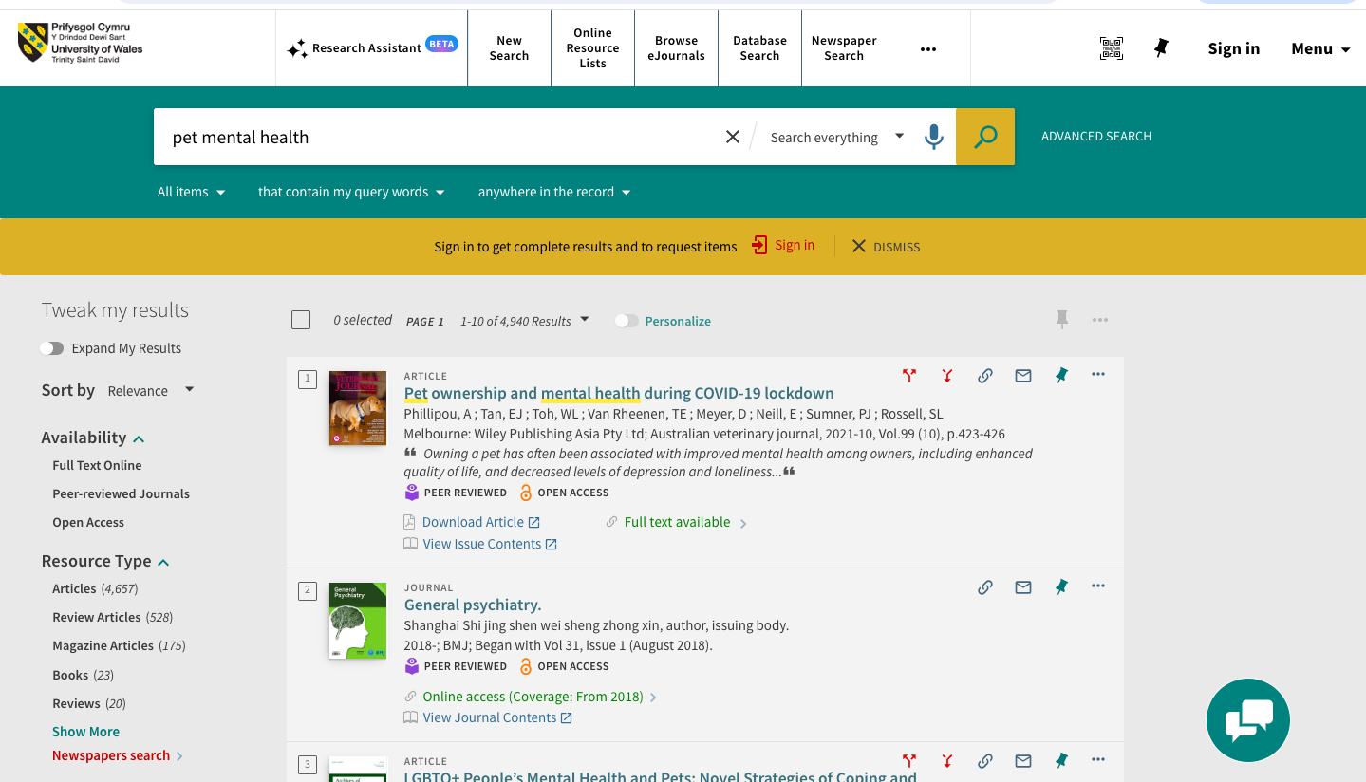
This article was relevant to my research because it provided an in-depth analysis of pet ownership in COVID – 19. It was written in the last five years, which provides up-to-date facts about the relevant topic with many in-text citations. Due to credible sources being cited, I was able to learn from the information. This source was also peer reviewed, meaning that academics and scholars have approved it increasing validity, and the authors teach in universities.
However, the downfall of this article is that it might be biased in terms of trying to fit evidence in to support the research hypothesis. It has only been cited by fifty-one people, decreasing its reliability but it is still reputable.

(2) Pet Dogs Benefit Owners’ Health. A ‘Natural Experiment’ in China
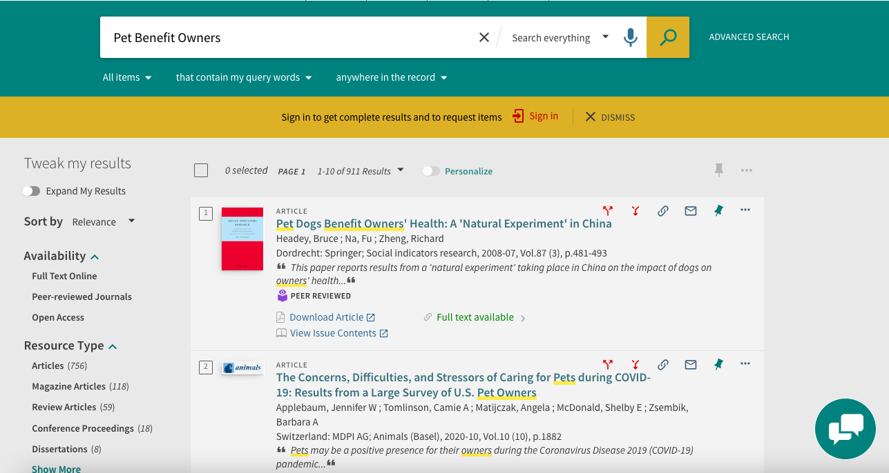
Although this source is not very up to date, it provides the relevant information necessary to support the research aims. It was conducted using a multi-diverse scale, including cultural differences in research. Even though it has only been cited by thirty-six people, it does not make it any less relevant, which is backed by the credibly of the authors.
However, the only drawback of the article was that the research was focused on dog pet ownership, and not pets as a collective. Nevertheless, the research conducted was valuable, and I was able to draw conclusions from it.

